A 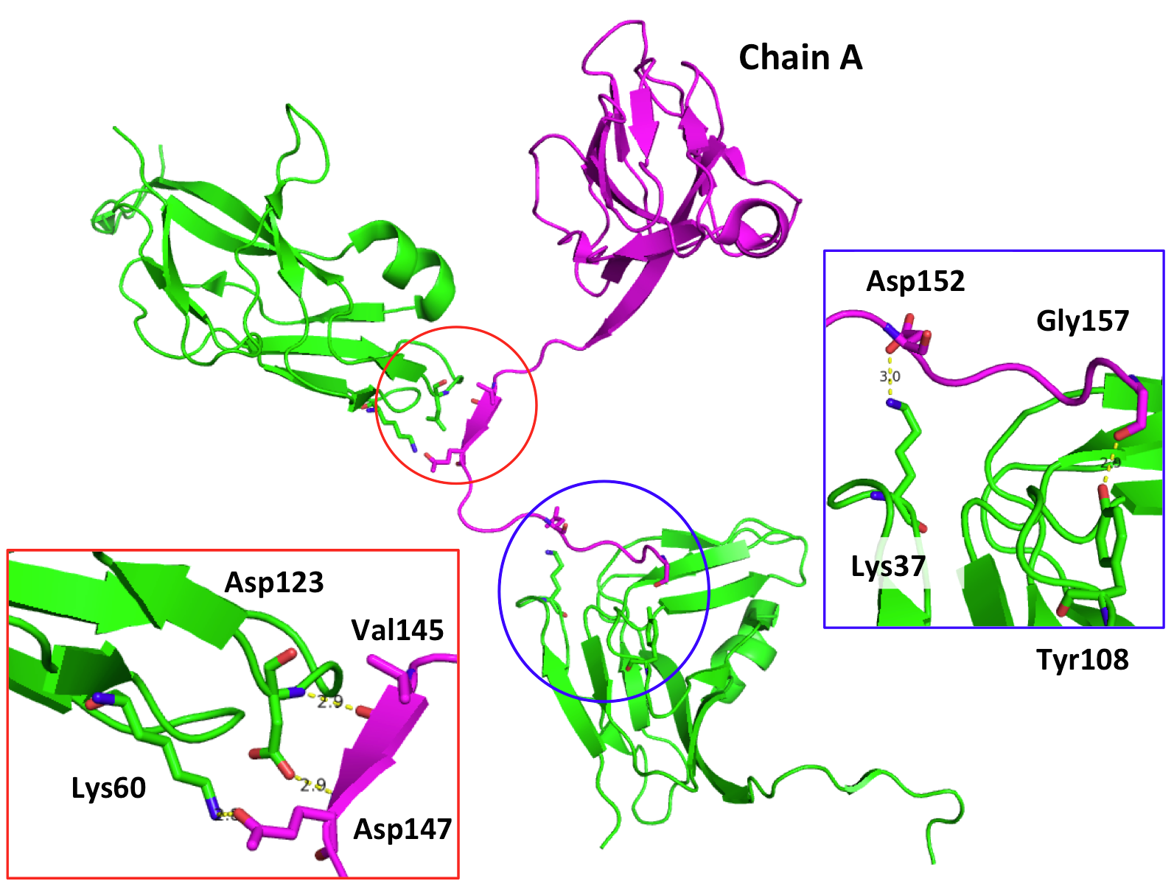 B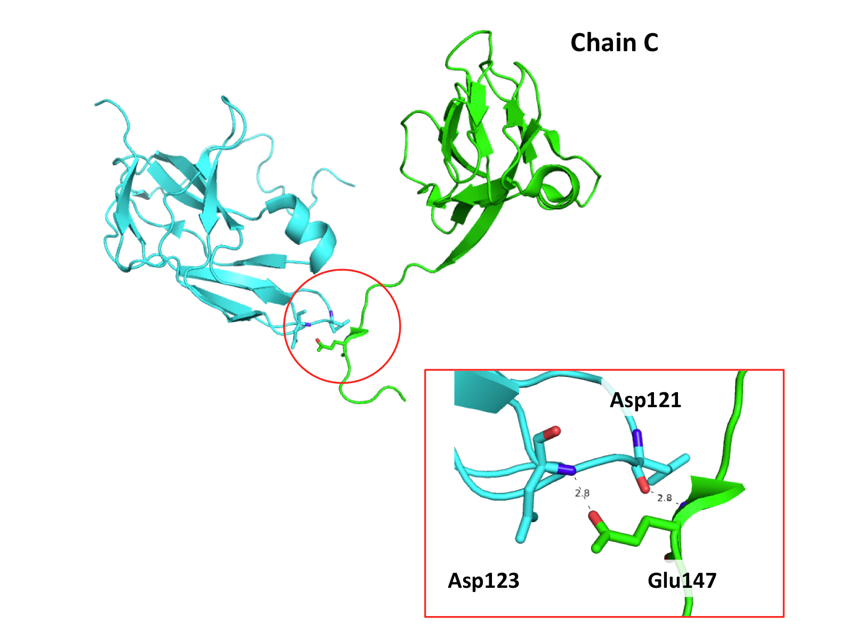

Figure S1. Effect of crystal packing on C-terminal residue coordinates. (A) Intersubunit interactions between chain A and neighboring subunits. Intersubunit interactions were analyzed with Proteins, Interfaces, Structures, and Assemblies (PISA) [56]. Chain A is colored magenta; its interacting subunits were generated by symmetry operations and are colored green. The locations of the interacting residues are circled, and the details of the interactions are shown in the box with the corresponding color. (B) Intersubunit interactions between chain C and a neighboring subunit. Chain C is colored green, and its interacting subunit is colored cyan. The location of the interaction is circled, and the details of the interaction are shown in the box.

