Appendix. Supplementary figures and tables
Supplementary figures on annual expenditures for people with hemophilia by infection of HIV or HCV, annual expenditures of adults with blood-borne viral infection by components of health care for three different groups (HIV only, HCV only, and co-infection group), and tables on descriptive statistics of people with hemophilia by Medicaid eligibility category, prevalence of Medicaid-enrollees by Medicaid eligibility category, and annual expenditures of care by race.
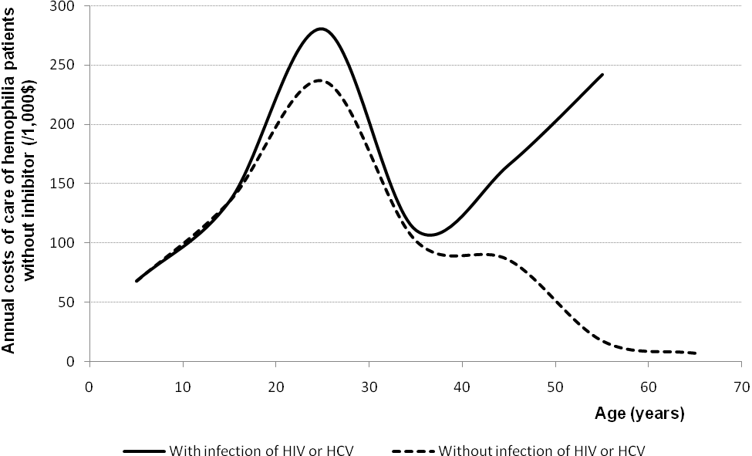Figure A. Annual expenditures of care for people with hemophilia who did not receive bypassing agents by infection of HIV or HCV (in thousands of dollars) in 2008 (N=408)
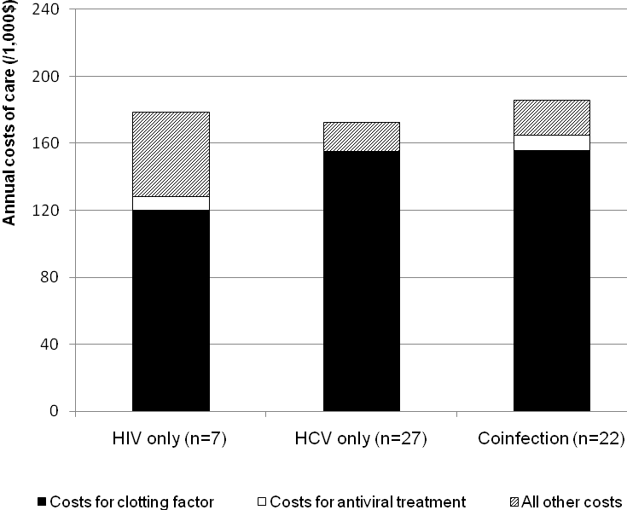
Figure B. Annual expenditures of adults with hemophilia with blood-borne viral infection
by components of health care for three different blood-borne viral infection groups

Note. Among adults with HIV infection only, the expenditures for clotting factors accounted for 67% of total annual costs, while the expenditures for antiviral drugs accounted for only 5% ($8,112). Among adults with HCV infection only, the expenditures for clotting factors accounted for 90% of total annual expenditures, while the expenditures for antiretroviral drugs accounted for only 0.4% ($661). Adults with co-infection of HIV and HCV spent 84% of total annual expenditures for clotting factors.

Table A. Annual costs of care by race of males with hemophilia who were enrolled in Medicaid in 2008
Race | % of males  with Medicaid | n (% of males  with hemophilia) | Median  ($) | Mean  ($) | 95th percentile  ($)
White | 46% | 222 (51%) | 39,108 | 158,412 | 599,417
Black | 32% | 105 (24%) | 48,757 | 122,678 | 421,869
Hispanic | 7% | 15 (3%) | 7,570 | 130,036 | 726,062
Other | 15% | 93 (21%) | 67,487 | 131,184 | 451,911
Note. Statistical tests fail to reject the hypothesis that average annual costs of care are equal by race at a 5% significance level

