**Supplemental materials**

Table S1.Countries and political units that reported no indigenous cases of rabies during 20091

|  |  |
| --- | --- |
| **REGION** | **COUNTRIES** |
| Africa | Cape Verde, Libya, Mauritius, Réunion, Sāo Tomé and Príncipe, and Seychelles |
| Americas | North: Bermuda, Saint Pierre and Miquelon  Caribbean: Antigua and Barbuda, Aruba, the Bahamas, Barbados, Cayman Islands, Dominica, Guadeloupe, Jamaica, Martinique, Montserrat, Netherlands Antilles, Saint Kitts (Saint Christopher) and Nevis, Saint Lucia, Saint Martin, Saint Vincent and Grenadines, Turks and Caicos, and Virgin Islands (UK and US) |
| Asia and the Middle East | Hong Kong, Japan, Kuwait, Lebanon, Malaysia (Sabah), Qatar, Singapore, United Arab Emirates |
| Europe2 | Austria, Belgium, Cyprus, Czech Republic,2 Denmark,2 Finland, Gibraltar, Greece, Iceland, Ireland, Isle of Man, Luxembourg, Netherlands,2 Norway, Portugal, Spain2 (except Ceuta and Melilla), Sweden, Switzerland, and United Kingdom2 |
| Oceania3 | Australia,2 Cook Islands, Fiji, French Polynesia, Guam, Hawaii, Kiribati, Micronesia, New Caledonia, New Zealand, Northern Mariana Islands, Palau, Papua New Guinea, Samoa, and Vanuatu |

1 Bat rabies may exist in some areas that are reportedly free of rabies in other mammals.

2 Bat lyssaviruses are known to exist in these areas that are reportedly free of rabies in other mammals.

3 Most of Pacific Oceania is reportedly rabies-free.

Reference: CDC Yellow Book, 2012 Chapter 3, Table 3-13, p. 273, In: Brunette, G.(ed.), CDC Health Information for International Travel 2012:The Yellow Book. Oxford University Press, New York.

Fig. S1.CDC Form 75.37 (rev. 2006)

C:\Users\bwg5\AppData\Local\Microsoft\Windows\Temporary Internet Files\Content.Outlook\OQFWLUI0\CDC Form 75 37 dog confinement_pre072012.tiff

Fig. S1 shows the required form completed by hand by dog importers in conjunction with airport officials on or prior to arrival for importation of dogs that are not immunized against rabies virus on arrival. This form is sent to state public health or agriculture officials in the destination state and recorded by CDC quarantine station staff in an electronic importation event database.

Fig. S2.CDC Form 75.37 (rev. 2012) 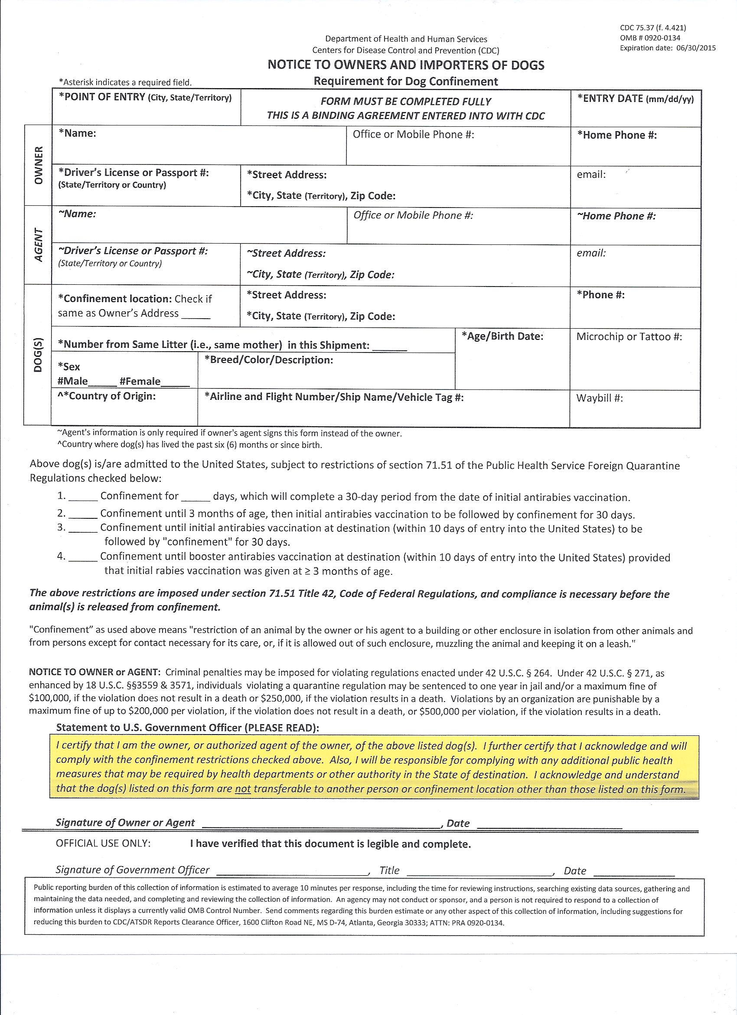

Fig. S2 shows the current dog confinement agreement revised after completion of this study’s data collection.

Table S2. Breeds of imported dogs placed on confinement agreements – United States, June 2011-May 2012

|  |  |  |  |
| --- | --- | --- | --- |
| **AKC Breed Category** | **Breed** | **# dogs** | **% of total** |
| *Toy breed total (14 breeds)* |  | *557* | *20.3%* |
|  | Chihuahua | 196 | 7.1% |
|  | Yorkshire terrier | 136 | 5.0% |
|  | Maltese | 58 | 2.1% |
|  | Shih tzu | 48 | 1.7% |
|  | Toy poodle | 25 | 0.9% |
|  | Pomeranian | 24 | 0.9% |
|  | Other toy (8 breeds) | 70 | 2.5% |
| *Nonsporting breed total (14 breeds)* |  | *451* | *16.4%* |
|  | Standard poodle | 198 | 7.2% |
|  | English bulldog | 97 | 3.5% |
|  | French bulldog | 88 | 3.2% |
|  | Other nonsporting (11 breeds) | 68 | 2.5% |
| *Mixed breed total* |  | *424* | *15.4%* |
|  | Mixed/Unknown | 318 | 11.6% |
|  | Hybrid breed specified\* | 106 | 3.9% |
| *Herding breed total (20 breeds)* |  | *410* | *14.9%* |
|  | German shepherd | 319 | 11.6% |
|  | Other herding (19 breeds) | 91 | 3.3% |
| *Working breed total (27 breeds)* |  | *362* | *13.2%* |
|  | Boxer | 41 | 1.5% |
|  | Rottweiler | 40 | 1.5% |
|  | Standard schnauzer | 35 | 1.3% |
|  | Bernese mountain dog | 30 | 1.1% |
|  | Doberman | 24 | 0.9% |
|  | Great Dane | 20 | 0.7% |
|  | Other working (21 breeds) | 172 | 6.3% |
| *Sporting breed total (17 breeds)* |  | *233* | *8.5%* |
|  | Golden retriever | 80 | 2.9% |
|  | Labrador retriever | 69 | 2.5% |
|  | Cocker spaniel | 31 | 1.1% |
|  | Other sporting (14 breeds) | 53 | 1.9% |
| *Terrier breed total (18 breeds)+* |  | *83* | *3.0%* |
| *Hound breed total (13 breeds)+* |  | *65* | *2.4%* |
| *Other (43 breeds)* |  | *274* | *10.0%* |
| **GRAND TOTAL** |  | **2746** |  |

\*For those listed under hybrid the owner provided specific species mixes. Those mentioned include

- Poodle mixed with each of Australian shepherd, Bernese mountain dog, bichon frise, bouvier des Flanders, Chihuahua, cocker spaniel, Dalmatian, golden retriever, Labrador retriever, Maltese, Pekingese, rat terrier, schnauzer, shih tzu, and West Highland terrier

- Labrador retriever mixed with each of border collie, Boston terrier, cocker spaniel, German shepherd, golden retriever, and husky

- Bichon frise mixed with each of Havanese, Maltese, shih tzu, and Yorkshire terrier

- Chihuahua mixed with each of Pomeranian, rat terrier, shih tzu, and Yorkshire terrier

- Shih tzu mixed with each of Pekingese and Yorkshire terrier

- Maltese mixed with each of cavalier King Charles spaniel and Yorkshire terrier

- Boxer/pit bull terrier, German shepherd/husky, golden retriever/English springer spaniel, Japanese chin/spaniel, Jindo/Akita, pug/beagle

+Percentages so small that breed categories not subdivided further.

Fig. S3. Countries of origin and AKC breed categories of imported dogs placed on confinement agreements – United States, June 2011-May 2012 (N = 2728)

Figure 2 low res.tiff

Countries that were the source of one or more imported dogs placed on confinement agreements are color-coded by region, with North America in green, South America in yellow, Europe in blue, Asia in orange, and Africa in red. Pie charts show the breed distribution of dog imports from each region, with the total number of imports (N) provided at the center of each pie. Country of origin information was missing or illegible for eighteen dogs. AKC = American Kennel Club.

**Addendum**

Herding and working breeds constituted over 50% of European arrivals (298/825, 36.1% and 149/825, 18.1%, respectively) and nearly all herding dogs from Europe were German shepherd puppies (i.e., animals <1 year of age; 254/298, 85.2%), arriving primarily from Germany and the Czech Republic. Toy, nonsporting, and mixed breeds were the majority of DPCAs imported from North America (334/1325, 25.2%; 217/1325, 16.4%; and 266/1325, 20.1%, respectively), South America (82/312, 26.3%; 92/312, 29.5%; and 39/312, 12.5%, respectively), and Asia (97/233, 41.6%; 32/233, 13.7%; and 60/233, 25.8%, respectively). Chihuahuas and standard poodles were common North American arrivals (183/1325, 13.8% and 148/1325, 11.1%, respectively), primarily originating in Mexico, Canada, and the Dominican Republic. In contrast, the most commonly imported breeds from South America included English bulldog, standard poodle, and shih-tzus (45/312, 14.4%; 38/312, 12.2%; and 37/312, 11.9%, respectively), primarily originating in Colombia, Ecuador, and Peru. Yorkshire terrier and Maltese (46/233, 19.7% and 33/233, 14.2%, respectively) from South Korea and French bulldog puppies (16/233, 6.9%) from Russia were the two most commonly imported breeds from Asia. Seventy-five percent (25/33) of DPCAs imported from Africa were South African Boerboel puppies <3 months of age.

Importers of DPCAs appear to prefer breeds only partially reflective of U.S. dog ownership, most notably a diversity of toy, nonsporting, and mixed breeds (including standard poodles, Chihuahuas, Yorkshire terriers, and English and French bulldogs), and German shepherds. Similar to these findings, the American Humane Association (AHA) lists mixed breed dogs as the most popular type in the United States (AHA, 2013). In contrast, the five most popular purebred dogs are Labrador retrievers, German shepherd dogs, beagles, golden retrievers, and Yorkshire terriers (AHA, 2013). These differences may indicate local variability in dog ownership, local access to or preference for certain breeds, or knowledge of and access to overseas sources of dogs. Breed may also influence rabies immunization status as importers may prefer to bring in certain breeds before eligibility for vaccination (i.e., 3 months) because of concerns about socializing an older animal or shipping costs based upon weight, or may prefer to not vaccinate certain breeds even if eligible because of concerns about adverse vaccine reactions.