Supplementary Information
Text S1. Full description of methods used to characterize CNT particles used in this study.
Gross Particle Size Distribution, Dry As-Supplied Form
An acoustically pulsed aerosol generator was used to aerosolize the MWCNTs into a collection chamber, and a Marple, 8-stage personal cascade impactor in the chamber was used to determine the differential particle size distribution of the dispersed material. After sample collection, each of 8 quartz impaction substrates (and the after filter) in the impactor was analyzed for elemental carbon (EC) to determine the MWCNT mass on the stage. The MWCNT masses and size cutpoints for each stage were then used to calculate the size distribution MMAD of the dry material.
Transmission Electron Microscopy (TEM)
A methyl cellulose ester (MCE) filter was prepared for TEM analysis according to the procedure outlined in Method 7402 of the NIOSH Manual of Analytical Methods (NMAM). Briefly, a filter wedge was removed and collapsed with hot acetone vapor. The filter was then carbon coated in a vacuum evaporator. A petri dish was prepared as a Jaffe wick washer with a lens paper wicking substrate. 3mm copper TEM grids were placed on the substrate and small sections from the filter wedge were excised and placed on the grids. A mixture of acetone and dimethylformamide (DMF) was added to the dish, and the dish was covered and allowed to sit for several hours to complete clearing of the filter. A 200-µL aliquot of a diluted (25:1) CNT working suspension was applied to the MCE filter, spreading quickly and evenly over the filter. The filter was dried overnight in a loosely covered petri dish in an oven at 60 °C. After drying, a small portion of the filter was removed and prepared for TEM analysis by treatment in acetone vapor and application of a thin carbon coating. The sample then was examined on a JEOL 2100F TEM/STEM, in bright field mode, at an accelerating voltage of 200kev.
Metal Content
A microwave acid digestion system (MARS, CEM Corporation, Weddington, NC) was used to prepare samples for metals analysis. CNTs (1-10 mg) were fully digested in sealed vessels containing 10 mL of concentrated (60% - 70%) nitric acid. The microwave conditions were as follows: maximum power at 1600 (100% power), ramp 30 minutes, 800 psi, 230 °C, hold time 60 minutes. A sample blank and standard reference material (NIST SRM 2483) were digested and analyzed concurrently to ensure data quality. After digestion, solutions were transferred to flasks and heated on a hot plate at 180 °C to near dryness. A dilute nitric acid solution was then addred to obtain an acid concentration of 5%. The diluted solutions were then analyzed for metals by inductively coupled plasma with atomic emission spectroscopy (ICP-AES). A Spectro Modula EOP (Spectro Analytical Instruments Inc., Mahwah, NJ) was used for the analysis according to NIOSH Manual of Analytical Methods (NMAM) 7300.

BET Surface Area
Samples were degassed under a flow of ultra-high purity (UHP) grade nitrogen using a Micromeritics FlowPrep 060 degasser, with a sample mass of 200 mg or more. All samples were degassed for 30 minutes at 90 C, followed by 90 minutes at 200 C. A Micromeritics TriStarII 3020 instrument was used to measure the BET surface area by a 5-point BET measurement, with UHP nitrogen as the adsorbate and liquid nitrogen as the cryogen. The following relative pressures (P/P_{o)} were used: 0.05, 0.1, 0.15, 0.2, and 0.25. The free space in the analysis tube was measured using UHP helium. The five pressure points were used to calculate the BET surface area. An ASTM carbon black (ASTM D24 SRB B-8 carbon black) of known SSA was included with the sample sets. The mean result (n = 3, RSD = 1%) for the ASTM material was 140.7 m²/g, which is within about 1% of the reported value of 142.6 m²/g. Analytical precision was ±5% or better.
Elemental Carbon
For comparison with the mass concentration, the concentration of the CNT stock suspension also was determined as elemental carbon by NIOSH Method 5040 [Birch, 2004a, 2004b]. The Method is based on a thermal–optical analysis technique for organic and elemental carbon (OC and EC). The thermal–optical analyzer (Sunset Laboratories, Inc., Forest Grove, OR) has been described in detail previously [Birch & Cary, 1996, Birch, 2004a, 2004b]. In its typical application, air samples collected on quartz-fiber filters are analyzed. A 1.5 cm² portion is removed from the filter for analysis, and OC–EC results (in μg/cm²) for the portion are multiplied by the deposit area to calculate the total OC–EC mass on the filter. In this study, 10-uL aliquots of the CNT stock suspension were applied directly to 1.5 cm² portions taken from a pre-cleaned, 37-mm quartz-fiber filter (Pallflex 2500QAT-UP, Pallflex Inc., Putnam, CN). After drying, the portions were analyzed to determine the EC concentration of the suspension.

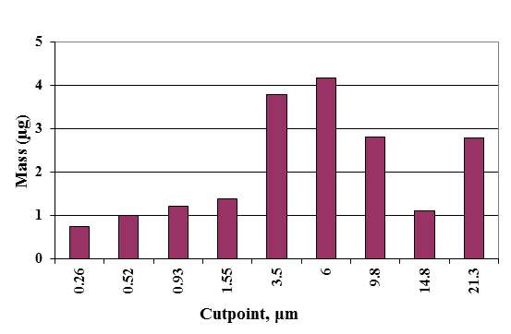
Fig. S1: Particle size distribution of dry, as-supplied MWCNT material in aerosolized form. The MMAD average was about 6µm with a GSD of about 8 µm.

Fig. S2: Control liposomes (without clodronate) did not deplete macrophages or attenuate CNT-induced inflammation. 50µL of 5mg/mL PBS suspension of liposomes were administered to mice 8h prior to exposure to 4mg/kg CNTs and cells were enumerated in BAL fluid. Left: Liposomal PBS [L(pbs)] did not deplete AMs. Right: L(pbs) pretreatment increased neutrophilia over 24h of CNT exposure relative to CNT exposure alone.

Fig S3: CNT exposure caused increased production of pro-inflammatory cytokines in AMs in vitro tested using MH-S cells. Left: AMs in culture were exposed to increasing doses of CNTs for 24h and TNFα and IL-1ß were quantified (A and B, respectively). AMs were exposed to 400µg/mL concentration of CNTs or vehicle (VH) for increasing time points (C and D).

