Supplementary Information of Microbiological method used in Diarrheal Illnesses Surveillance of China, 2009-2013

Table 1. Enteropathogens examined and laboratory methodology for diarrheal illnesses surveillance of China, 2009-2013
Enteropathogens | Method
Viruses
Rotavirus (groups A, B and C) | Commercial immunoasssy and PCR
Norovirus (genogroups I and II) | PCR
Sapovirus | PCR
Astrovirus | PCR
Adenovirus | PCR
Bacteria
Shigella spp | Culture (direct culture)
Non-typhoidal Salmonella spp | Culture (enrichment)
Diarrhea-genic Escherichia coli
ETEC, EAEC, EHEC, EIEC, EPEC | Culture (direct culture and enrichment)
Vibrio spp
V. cholerae (serogroups O1 and O139) | Culture (enrichment)
V. parahaemolyticus, V. mimicus, V. flurialis | Culture (enrichment)
Campylobacter spp
C. jejuni, C. coli | Culture (direct culture)
Aeromonas hydrophila | Culture (enrichment)
Yersinia spp
Y. enterocolitica, Y. pseudotuberculosia | Culture (enrichment)
Plesiomonas shigelloides | Culture (enrichment)
Protozoa
Entamoeba histolytica | Direct microscopy and commercial immunoasssy
Giardia lamblia | Direct microscopy and commercial immunoasssy
Cryptosporidium spp | Direct microscopy and commercial immunoasssy
Abbreviation: ETEC, Enterotoxigenic E. coli; EAEC, Enteroaggregative E. coli; EHEC, Enterohaemorrhagic E. coli; EIEC, Enteroinvasive E. coli; EPEC, Enteropathogenic E. coli; PCR, polymerase chain reaction
Fig 1. Study protocol for diarrheal illnesses surveillance of China, 2009-2013.
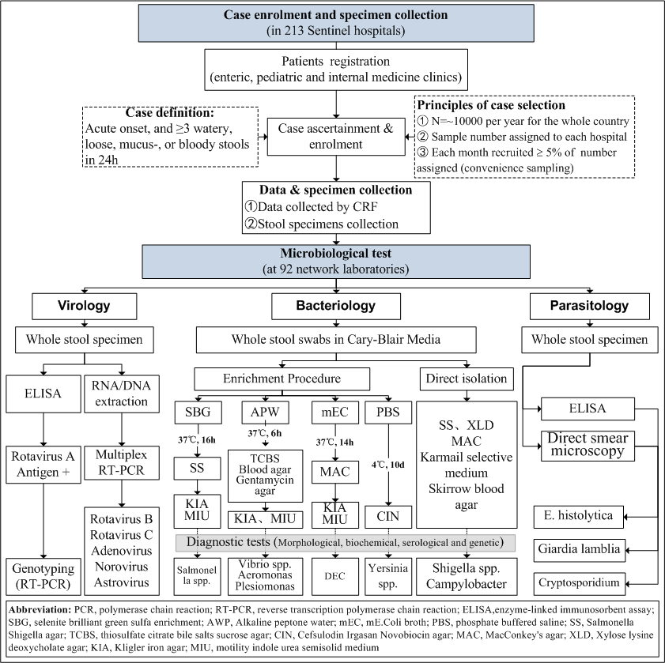
Table 2. Primers and sequence information for PCR used in diarrheal illnesses surveillance of China, 2009-2013.

Table 2-1. Primers and sequence information used for characterizing G/P genotypes of Group A Rotavirus by RT-PCR
 |  | Genotype | Primer | Sequence (5’-3’)^{c} | Product Size (bp) | Position | Reference
G-typing | G |  | VP7Fª | ATGTATGGTATTGAATATACCAC | 881 | 51-71 | [1]
 |  |  | VP7Rª | AACTTGCCACCATTTTTTCC |  | 914-932
 | G1 |  | aBT1 | CAAGTACTCAAATCAATGATGG | 618 | 314-335 | [1, 2]
 | G2 |  | aCT2 | CAATGATATTAACACATTTTCTGTG | 521 | 411-435 | [1, 2]
 | G3 |  | aET3 | ACGAACTCAACACGAGAGG | 682 | 250-269 | [1, 2]
 | G4 |  | aDT4 | CGTTTCTGGTGAGGAGTTG | 452 | 480-499 | [1, 2]
 | G8 |  | aAT8 | GTCACACCATTTGTAAATTCG | 754 | 178-198 | [1, 2]
 | G9 |  | aFT9 | CTTGATGTGACTAYAAATAC | 179 | 757-776 | [1, 2]
P-typing | P |  | VP4F^{b} | TATGCTCCAGTNAATTGG | 663 | 132-149 | [3]
 |  |  | VP4R^{b} | ATTGCATTTCTTTCCATAATG |  | 775-795
 | P[4] |  | 2T-1 | CTATTGTTAGAGGTTAGAGTC | 362 | 474-492 | [3]
 | P[6] |  | 3T-1 | TGTTGATTAGTTGGATTCAA | 146 | 259-278 | [3]
 | P[8] |  | 1T-1D | TCTACTGGRTTRACNTGC | 224 | 339-356 | [3]
 | P[9] |  | 4T-1 | TGAGACATGCAATTGGAC | 270 | 385-402 | [3]
 | P[10] |  | 5T-1 | ATCATAGTTAGTAGTCGG | 462 | 575-594 | [3]
 | P[11] |  | P[11] | GTAAACATCCAGAATGTG | 191 | 305-323 | [3]
a: Primers used to amplify full length of gene encoding VP7 in the first round of semi-nested PCR
b: Primers used to amplify full length of gene encoding VP4 in the first round of semi-nested PCR
c: N = any base; R = A or G; Y = C or T.
Table 2-2. Primers and sequence information used in Multiplex PCR for viral agents
Organism | Primers and sequence information |  |  |  |  |  | Reference
 | Target region | Primer | Polarityª | Sequence (5’-3’)^{b} | Product  Size (bp) | Position
Rotavirus B | VP7 | B5-2 | + | GGCAATAAAATGGCTTCATTGC | 814 |  | [4]
 | VP7 | B3-3 | - | GGGTTTTTACAGCTTCGGCT
Rotavirus C | VP7 | G8NS1 | + | ATTATGCTCAGACTATCGCCAC | 352 | 353-374 | [5]
 | VP7 | G8NA2 | - | GTTTCTGTACTAGCTGGTGAAC |  | 683-704
Norovirus (genogroups I) |  | G1-SKF | + | CTGCCCGAATTYGTAAATGA | 330 | 5342-5361 | [6]
 |  | GI-SKR | - | CCAACCCARCCATTRTACA |  | 5653-5671
Norovirus (genogroups II) |  | CoG2F | + | CARGARBCNATGTTYAGRTGGATGAG | 387 | 5003-5028 | [6]
 |  | G2-SKR | - | CCRCCNGCATRHCCRTTRTACAT |  | 5367-5389
Sapovirus |  | SLV-5317 | + | CTCGCCACCTACRAWGCBTGGTT | 434 | 5083-5105 | [6]
 |  | SLV-5749 | - | CGGRCYTCAAAVSTACCBCCCCA |  | 5494-5516
Astrovirus |  | Mon269 | + | CAACTCAGGAAACAGGGTGT | 449 | 4526-4545 | [7]
 |  | Mon270 | - | TCAGATGCATTGTCATTGGT |  | 4955-4974
Adenovirus（Type 40 and 41） | Hexon | Ad1 | + | TTCCCCATGGCICAYAACAC | 482 | 1834-1853 | [5]
 | Hexon | Ad2 | - | CCCTGGTAKCCRATRTTGTA |  | 2315-2296
a: “+” = forward primer; “-” = reverse primer;
b: B = C, G, or T; H = A, C, or T; K = G or T; N = any base; R = A or G; S = G or C; V = A, C or G; W = A or T; Y = C or T.

Table 2-3. Primers and sequence information used in amplification of diarrhea-genic Escherichia coli genes
Pathogen | Primer | Sequence (5’-3’) | Target  gene | Amplicon  (bp) | Reference
EPEC | eae-F | TCAATGCAGTTCCGTTATCAGTT | eae | 482 | [8]
 | eae-R | GTAAAGTCCGTTACCCCAACCTG
 | bfp-F | GGAAGTCAAATTCATGGGGGTAT | bfp | 300 | [8]
 | bfp-R | GGAATCAGACGCAGACTGGTAGT
ETEC | lt-F | GCACACGGAGCTCCTCAGTC | elt | 218 | [8]
 | lt-R | TCCTTCATCCTTTCAATGGCTTT
 | stII-F | AAAGGAGAGCTTCGTCACATTTT | est | 129 | [8]
 | stII-R | AATGTCCGTCTTGCGTTAGGAC
EHEC | eae-F | TCAATGCAGTTCCGTTATCAGTT | eae | 482 | [8]
 | eae-R | GTAAAGTCCGTTACCCCAACCTG
 | stx1-F | CAGTTAATGTGGTGGCGAAGG | stx1 | 348 | [8]
 | stx1-R | CACCAGACAATGTAACCGCTG
 | stx2-F | ATCCTATTCCCGGGAGTTTACG | stx2 | 584 | [8]
 | stx2-R | GCGTCATCGTATACACAGGAGC
EIEC | virF-F | AGCTCAGGCAATGAAACTTTGAC | virF | 618 | [8]
 | virF-R | TGGGCTTGATATTCCGATAAGTC
 | ipaH-F | CTCGGCACGTTTTAATAGTCTGG | ipaH | 933 | [8]
 | ipaH-R | GTGGAGAGCTGAAGTTTCTCTGC
EAEC | aafII-F | CACAGGCAACTGAAATAAGTCTGG | aafII | 378 | [8]
 | aafII-R | ATTCCCATGATGTCAAGCACTTC

Appendix 1. Conventional culture methods for bacteria identification used in diarrheal illnesses surveillance in China, 2009-2013.
Enterobacteriaceae: Suspicious colonies formed on SS, MAC, XLD and CHROM agar Salmonella Medium were inoculated on Kligler iron agar (KIA) and motility indole urea semisolid medium (MIU) to obtain pure culture. Biochemical tests and serological tests followed. The API 20E biochemical identification System was used to identify biochemical characteristics of suspected isolates, while polyvalent O (A-F) and Vi antisera for Salmonella, and Polyvalent A/B/C/D antisera for Shigella were applied according to manufacturer’s instructions.

Diarrhea-genic Escherichia coli (DEC): Five lactose-fermenting colonies formed on MAC were selected and subcultured on KIA and MIU medium (for specimens producing less than five lactose-fermenting colonies, all were selected). A range of biochemical tests (Indole/Methyl red/V Voges–Proskauer/ Citrate [IMViC]) were followed to identify suspicious isolates. To be labeled as suspicious isolates, the IMViC results had to be (++­-) or (-+--). Serological or molecular biological methods were then applied to characterize suspicious isolates. For serological tests, polyvalent and monovalent O, H and K antisera were used according to manufacturer’s instructions. For molecular biological tests, multiplex polymerase chain reaction (PCR) was used to identify virulence gene loci of five DEC pathotypes as described by previous studies [8], i.e. typical EPEC (eae⁺ and bfp⁺), atypical EPEC (eae⁺ or bfp⁺), ETEC (lt⁺ or stII⁺), EAEC (aafII⁺), EHEC (eae⁺, stx1⁺ and stx2⁺, eae⁺ and stx1⁺, or eae⁺ and stx2⁺), and EIEC (virF⁺ and ipaH⁺). For more detailed information for genes and primers see Appendix 2. For identification of DEC, both serological and molecular biological approaches were acceptable methods.

Diarrhea-genic Vibrio spp, Aeromonas spp and Plesiomonas shigelloides: Cultures from AWP were inoculated on Gentamycin agar, Thiosulfate Citrate Bile Salts sucrose agar (TCBS), and Blood agar for identification of Vibrio spp, Aeromonas spp and Plesiomonas shigelloides. Oxidase tests were performed on all presumptive colonies. Oxidase positive isolates were then serologically tested using O1 and O139 antisera following manufacturer’s instruction. O1 positive isolates were further typed as Inaba or Ogawa serotypes. Both oxidase positive isolates formed on those plates needed to be biochemically confirmed using the API 20E/NE System.

Campylobacter spp: Suspicious colonies formed on Karmail selective medium and Skirrow blood agar were tested for oxidase and catalase. Positive isolates for both tests were then Gram stained and examined under light microscopy. The sodium hippurate hydrolysis test was then performed on Gram-negative “S” shaped isolates. Hippurate hydrolysis positive isolates were considered to be C. jejuni, and negative isolates were C. coli.

Yersinia app: Cultures from PBS were inoculated on Yersinia selective medium Cefsulodin Irgasan Novobiocin agar (CIN) on day 7, 14, and 21 of incubation. Typical colonies (‘bull’s eye’ appearance) formed on CIN were subcultured on KIA. The API 20E biochemical identification system was used to identify and characterize Yersinia spp.
Reference
1. Iturriza Gomara M, Kang G, Mammen A, et al. Characterization of G10P[11] rotaviruses causing acute gastroenteritis in neonates and infants in Vellore, India. J Clin Microbiol 2004; 42:2541-7.
2. Gouvea V, Glass RI, Woods P, et al. Polymerase chain reaction amplification and typing of rotavirus nucleic acid from stool specimens. J Clin Microbiol 1990; 28:276-82.
3. Simmonds MK, Armah G, Asmah R, et al. New oligonucleotide primers for P-typing of rotavirus strains: Strategies for typing previously untypeable strains. Journal of clinical virology 2008; 42:368-73.
4. Phan TG, Nguyen TA, Yan H, et al. Development of a novel protocol for RT-multiplex PCR to detect diarrheal viruses among infants and children with acute gastroenteritis in Eastern Russia. Clinical laboratory 2005; 51:429-35.
5. Yan H, Nguyen TA, Phan TG, Okitsu S, Li Y, Ushijima H. Development of RT-multiplex PCR assay for detection of adenovirus and group A and C rotaviruses in diarrheal fecal specimens from children in China. Kansenshogaku zasshi The Journal of the Japanese Association for Infectious Diseases 2004; 78:699-709.
6. Yan H, Yagyu F, Okitsu S, Nishio O, Ushijima H. Detection of norovirus (GI, GII), Sapovirus and astrovirus in fecal samples using reverse transcription single-round multiplex PCR. J Virol Methods 2003; 114:37-44.
7. Noel JS, Lee TW, Kurtz JB, Glass RI, Monroe SS. Typing of human astroviruses from clinical isolates by enzyme immunoassay and nucleotide sequencing. J Clin Microbiol 1995; 33:797-801.
8. Vidal M, Kruger E, Duran C, et al. Single multiplex PCR assay to identify simultaneously the six categories of diarrheagenic Escherichia coli associated with enteric infections. J Clin Microbiol 2005; 43:5362-5.

