The ARRIVE Guidelines Checklist
Animal Research: Reporting In Vivo Experiments
Carol Kilkenny¹, William J Browne², Innes C Cuthill³, Michael Emerson⁴ and Douglas G Altman⁵
¹The National Centre for the Replacement, Refinement and Reduction of Animals in Research, London, UK, ²School of Veterinary Science, University of Bristol, Bristol, UK, ³School of Biological Sciences, University of Bristol, Bristol, UK, ⁴National Heart and Lung Institute, Imperial College London, UK, ⁵Centre for Statistics in Medicine, University of Oxford, Oxford, UK.

 |  | ITEM | RECOMMENDATION | Section/  Paragraph
 |  |  |  | N/A
 |  |  |  | N/A
 | INTRODUCTION
 | 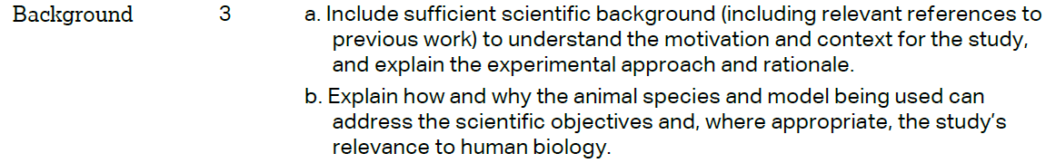 |  |  | N/A
 |  |  |  | Introduction Paragraph 4
 | METHODS
 |  |  |  | Materials and Methods / Paragraph 2 and 3 (Ethics Statement)
 | 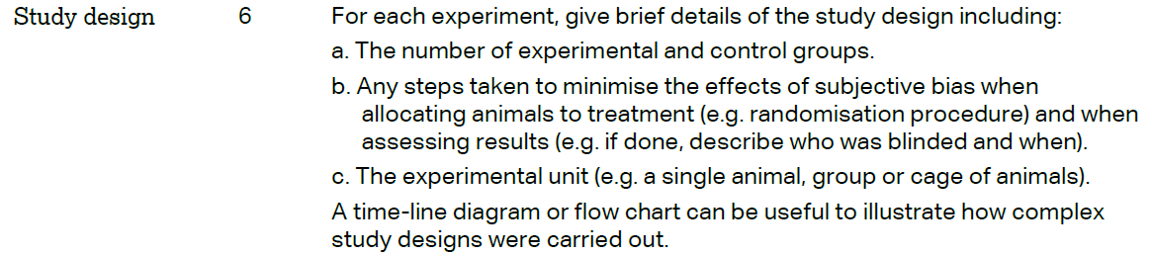 |  |  | Materials and Methods/ Paragraph 13 thorough 15 (Applicable only to ‘a’ & ‘c’)
 | 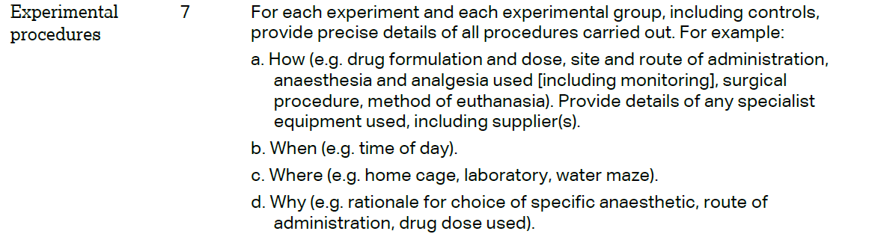 |  |  | Materials and Methods / Paragraph 13 thorough 15 (Applicable to ‘a’, ‘b’ and partially ‘c’)
 | 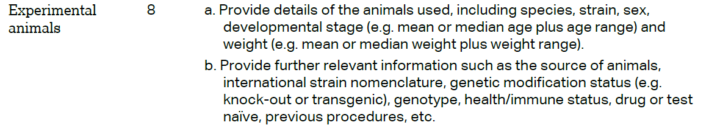 |  |  | Materials and Methods / Paragraph 13 thorough 15 (applicable to ‘a’)
 | 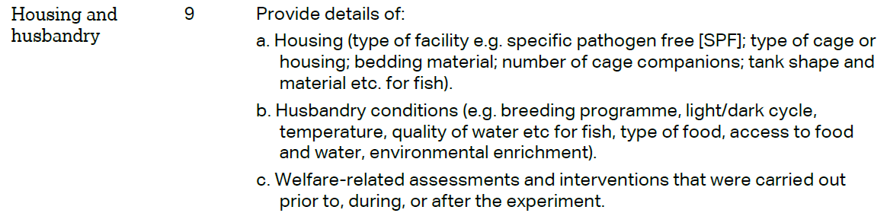 | Materials and Methods / Paragraph 2 and 3 (Ethics Statement, applicable to ‘c’)
 | 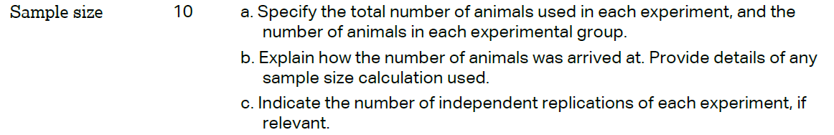 | Materials and Methods/ Paragraph 13 thorough 15 (applicable to ‘a’)
 | 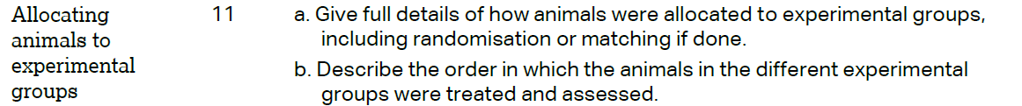 | Materials and Methods/ Paragraph 13 thorough 15 (applicable to ‘a’)
 |  | Materials and Methods/ Paragraph 13 thorough 15
 | 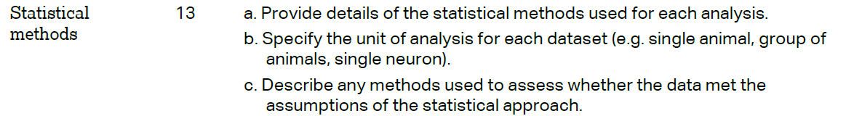 | Materials and Methods/ Paragraph 13 thorough 15 (applicable to ‘a’)
 | RESULTS
 |  | Figure3A (c and d)
 |  | N/A
 |  | Results/ Paragraph 5 and 6
 |  | N/A
 | DISCUSSION
 | 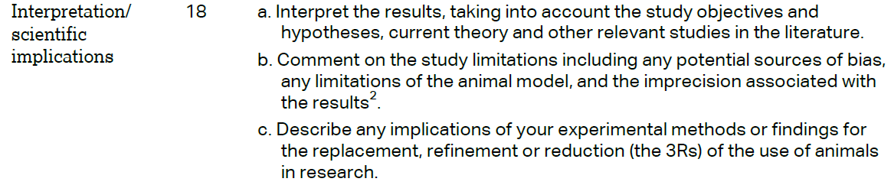 | N/A
 |  | N/A
 |  | N/A
