Supplemental On-line Material

Consider the Lowly Intercept:
Estimation with Vanishing Baseline Risk

Background

Investigators often address the problem of vanishing baseline by defining the lowest exposure stratum in a categorical analysis as the comparison or reference group (1). This approach would cause underestimation of relative and attributable risks, could still be subject to instability, and precludes examination of the exposure response at low doses. Another standard approach would be to utilize additive absolute rate rather than relative rate models, but these have convergence problems that are particularly severe when evaluating multiple, collinear predictors as could occur in a detailed examination of the form of the exposure-response relationship. Modeling exposure response from a mid-range reference point, for example exposure offset by the population mean exposure, would permit reliable estimation in that region and would perhaps suffice for etiologic investigations – demonstrating an association – but would not be useful for low-dose examination as typically needed in risk assessment. Making use of Monte Carlo Markov Chain procedures which establish prior distributions on the baseline risk is another solution but computationally dense (2).

Simulation

Defining follow-up as time since first potential exposure, incident cases were randomly created with a probability per unit time proportional to their accrued cumulative exposure (cumX; time-summation of exposure levels up to time of observation). In creating baseline cases, each unit of follow-up observation in the study population is specified to have the same small probability of producing a new case. At the time that a new case is randomly created, follow-up ceases for that individual, possibly pre-empting a previously generated attributable case occurring at a later time. Although models can be reliably fit using a randomly generated baseline, repeated sets of random baseline cases would produce variation in parameter estimates and model deviances. Accordingly, repetitions with e.g.,100 different random simulated baselines would permit deriving more precise, summary estimates of the exposure associations.

Approximately 60-70 attributable (or baseline) cases were generated in each simulation population. For the first proposed method, 1000 hypothetical populations were constructed and then analyzed with and without a fixed intercept. Another set of populations was generated in the same manner but now with 50 subjects instead of 500 (approximately 6 cases), in order to assess the effect of population size. For the second analytical approach addressing the intercept problem, 100 hypothetical populations of 500 were generated and for each population, 100 sets of baseline (non attributable) cases were produced for 10,000 analyses. This latter procedure was repeated for the small sample case (n=50).

The goal was to investigate how well the proposed treatments for vanishing baseline estimated the known, specified exposure response.

Large sample (n=500) populations: (Tables 1, 2; Figures 1, 2).

Small Population Samples

In the small-sample (n=50) populations, the bias was greater. With fixed intercepts the mean excess rate coefficient (0.00005989) was close to nominal, but biased downward in the standard fitted models (0.00004082) by about 32% (Table 3). The mean (SD) of the log(excess rate ratio coefficient) was 0.633 (1.86) using the standard model but 1.69 (0.436) with fixed intercept. The mean squared deviation of the estimated excess rate coefficients was considerably larger in the small- vs. large-sample populations but again with substantial reduction using fixing intercepts: 8.48 10⁻¹⁰ reduced to 5.76 10⁻¹⁰, a 32% reduction. (Table 3)

The mean average squared deviation of the estimated excess rate coefficient across the 100 study populations with enhanced baseline and fixed intercept (7.34 10⁻¹⁰, SD=14.5 10⁻¹⁰ ; Table 4), was somewhat larger and more variable than that with fixed intercepts and without baseline enhancements (5.76 10⁻¹⁰, SD=9.3 10⁻¹⁰) (Table 3).

Summary

Overall the two treatments for vanishing baseline yield equivalent results demonstrating that simply fixing the intercept is an entirely adequate solution. Variance in the estimate of the excess rate ratio coefficient, β, is greatly reduced compared with the standard estimation procedure. Bias and variance in the estimate of the excess rate coefficient are reduced as well.

Discussion

Statistical modeling of exposure response using the efficient exponential family of relative rate models depends on the simultaneous estimation of a baseline rate. In situations where baseline risk is zero or close to zero, this introduces instability of model fit and widely co-varying joint estimates of intercept and exposure coefficients. The resulting estimate of excess rate is biased, with bias shown here to be 15 and 32 % respectively in the simulated populations with 500 and 50 subjects, each with approximately 60 and 6 observed cases, respectively. Fixing the baseline risk such that the expected number of baseline cases is ~ 1% of observed cases essentially eliminates the bias and substantially reduces the variability in the excess rate coefficient estimate. Fixing the intercept also greatly improves precision of exposure effect estimation and study statistical power, as demonstrated here in the simulation of small study populations. An alternate approach examined here consisting of iteratively introducing non- attributable cases into a dataset produces a similar result but requires much more computation.

The simulation used in this analysis specified a particular distribution of duration of exposure and random variation in exposure level about a subject-specific mean. This specification would reasonably correspond to occupational and probably most environmental exposure situations. It demonstrates model behavior with vanishing baseline risk that one would expect to be quite general. While these methods – or equivalent ones – are essential for the use of relative rate models in the absence of baseline risk, it should be noted that the same problem exists any time an observational dataset fails to include sufficient numbers of truly non attributable cases to produce a robust estimate of baseline risk, whether because of low baseline risk or by chance. If a small number of non-attributable cases are expected, e.g. less than 5, then there is a good chance that estimated baseline rates will be very imprecise. If exposure-response estimates are compared across populations without taking into account the implicit baseline rate estimates, as occurs, for example, in meta-analyses, inappropriate conclusions could follow. Alternatively, it follows that meta-analyses should focus on excess rate coefficient estimates, not rate ratio coefficients. Similarly, if competing exposure metrics are compared within a study dataset, without accounting for estimation variability on baseline risk, inappropriate choices of optimum metric would often result.

References
- Mannetje AT, Steenland K, Attfield M, Boffeta P, Checkoway H, DeKlerk N. Exposure-response analysis and risk assessment for silica and silicosis mortality in a pooled analysis of six cohorts. Occup Environ Med 2002; 59(11):723-728.
- Spiegelhalter D, Best NG, Carlin BP, Van Der Linde A. Bayesian measures of model complexity and fit. Journal of the Royal Statistical Society 2002; Series B 64:583-639.
- Frome EL, Checkoway H. Use of poisson regression models in estimating incidence rates and ratios. Am J Epidemiol 1985; 121(2):309-323.
- Venables WN, Smith DM. An Introduction to R. Network Theory, Bristol, UK. 2002; http://www.r-project.org/ .
- Hirosoft International Corporation. Epicure Users Guide. Seattle, WA: Hirosoft International Corporation; 1993

Table 1 Simulated exposed population (1000 iterations), no baseline cases added: parameter estimates, large sample case (n=500)

N=1000 | mean | sd | range
excess rate ratio coefficient, β | 13.4 | 94.5 | 0.1–2834
excess rate ratio coefficient, β … fixed intercept¹ | 5.90 | 0.76 | 3.7–8.8
log(excess rate ratio coefficient) | 1.54 | 1.34 | -1.8–7.9
log(excess rate ratio coefficient) … fixed intercept | 1.77 | 0.13 | 1.3–2.2
excess rate coefficient, [exp(α)]×β | 5.095 10⁻⁵ | 0.90 10⁻⁵ | 2.6–8.5 10⁻⁵
excess rate coefficient, [exp(α)]×β … fixed intercept | 5.981 10⁻⁵ | 0.77 10⁻⁵ | 3.8–8.9 10⁻⁵
(excess rate coefficient - 6.0×10⁻⁵)² | 1.62 10⁻¹⁰ | 1.77 10⁻¹⁰ | -
(excess rate coefficient - 6.0×10⁻⁵)² … fixed intercept | 0.59 10⁻¹⁰ | 0.87 10⁻¹⁰ | -
Nominal excess rate coefficient: 6.000 10⁻⁵ per unit of cumulative exposure, MetX
rate = [exp(α)] × [1 + βMetX] ; excess rate = [exp(α)]×βMetX; excess rate ratio = βMetX
- Intercept fixed to correspond to about 1% of cases related to exposure.

Table 2 Simulated 100 exposed populations each with 100 sets of simulated baseline cases: parameter estimates, large sample case (n=500)

N=10,000 | mean | sd
- Simulated baseline cases -
excess rate ratio coefficient, β | 0.0431 | 0.0174
excess rate ratio coefficient, β … fixed intercept¹ | 0.0404 | 0.0072
log(excess rate ratio coefficient) | -3.22 | 0.399
log(excess rate ratio coefficient) … fixed intercept | -3.22 | 0.180
excess rate coefficient, [exp(α)]×β | 6.009 10⁻⁵ | 1.41 10⁻⁵
excess rate coefficient, [exp(α)]×β … fixed intercept | 5.964 10⁻⁵ | 0.84 10⁻⁵
avg(excess rate coefficient - 6.0×10⁻⁵)² ⁽²⁾ | 0.70 10⁻¹⁰ | 0.99 10⁻¹⁰
avg(excess rate coefficient - 6.0×10⁻⁵)² … fixed intercept | 0.45 10⁻¹⁰ | 0.46 10⁻¹⁰
Nominal excess rate coefficient: 6.000 10⁻⁵ per unit of cumulative exposure, MetX
rate = [exp(α)] × [1 + βMetX] ; excess rate = [exp(α)]×βMetX; excess rate ratio = βMetX
- Intercept fixed to correspond to known number of randomly generated baseline cases.
- avg: averaged across 100 sets of baseline cases for each simulated population

Table 3 Simulated exposed population (1000 iterations), no baseline cases added: parameter estimates, small sample case (n=50)

N=1000 | Mean | sd | range
excess rate ratio coefficient, β | 4.31 | 5.84 | -0.02–149
excess rate ratio coefficient, β … fixed intercept¹ | 5.91 | 2.37 | 0.63–15.7
log(excess rate ratio coefficient) ² | 0.63 | 1.86 | -9.2–5.0
log(excess rate ratio coefficient) … fixed intercept | 1.69 | 0.44 | -0.46–2.8
excess rate coefficient, [exp(α)]×β | 4.082 10⁻⁵ | 2.19 10⁻⁵ | -1.7–15 10⁻⁵
excess rate coefficient, [exp(α)]×β … fixed intercept | 5.989 10⁻⁵ | 2.40 10⁻⁵ | 0.6–16 10⁻⁵
(excess rate coefficient - 6.0×10⁻⁵)² | 8.48 10⁻¹⁰ | 9.63 10⁻¹⁰ | -
(excess rate coefficient - 6.0×10⁻⁵)² … fixed intercept | 5.76 10⁻¹⁰ | 9.33 10⁻¹⁰ | -
Nominal excess rate coefficient: 6.000 10⁻⁵ per unit of cumulative exposure, MetX
rate = [exp(α)] × [1 + βMetX] ; excess rate = [exp(α)]×βMetX; excess rate ratio = βMetX
- Intercept fixed to correspond to about 1% of cases related to exposure.
- 14 out of 1000 had β<0.0 so that log(β) undefined

Table 4 Simulated 100 exposed populations each with 100 sets of simulated baseline cases: parameter estimates, small sample case (n=50)

N=10,000 | mean | sd
- Simulated baseline cases -
excess rate ratio coefficient, β | 0.611 | 3.31
excess rate ratio coefficient, β … fixed intercept¹ | 0.117 | 5.49
log(excess rate ratio coefficient) | -2.98 | 1.85
log(excess rate ratio coefficient) … fixed intercept | -3.28 | 0.82
excess rate coefficient, [exp(α)]×β | 6.546 10⁻⁵ | 4.70 10⁻⁵
excess rate coefficient, [exp(α)]×β … fixed intercept | 6.278 10⁻⁵ | 3.38 10⁻⁵
avg(excess rate coefficient - 6.0×10⁻⁵)² ⁽²⁾ | 9.32 10⁻¹⁰ | 18.4 10⁻¹⁰
avg(excess rate coefficient - 6.0×10⁻⁵)² … fixed intercept | 7.34 10⁻¹⁰ | 14.5 10⁻¹⁰
Nominal excess rate coefficient: 6.000 10⁻⁵ per unit of cumulative exposure, MetX
rate = [exp(α)] × [1 + βMetX] ; excess rate = [exp(α)]×βMetX; excess rate ratio = βMetX
- Intercept fixed to correspond to known number of randomly generated baseline cases.
- avg: averaged across 100 sets of baseline cases for each simulated population

Figure 1 Squared deviation of the estimated excess rate coefficient in large sample (n=500) populations over 1000 simulations fit with standard linear relative rate model
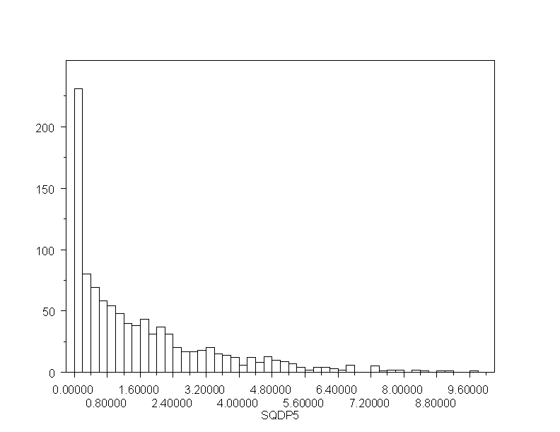

Figure 2 Squared deviation of the estimated excess rate coefficient in large sample (n=500) populations over 1000 simulations fit with linear relative rate model and fixed intercept

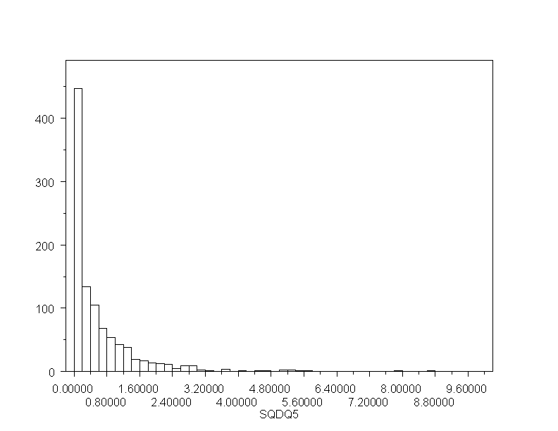

Simulation Code

I Without added baseline cases: large populations (n=500)

The general procedure here was to 1) create a simulated population, 2) assign random exposures and follow subjects over time creating incident cases with probability proportional to cumulative exposure, 3) create an output record for each unit of follow-up of each study subject including exposure and case status, 4) analyze the resulting file with Poisson regression, capturing model parameter estimates, and 5) evaluate estimation under fixed intercept procedure addressing vanishing baseline.

Iteration management (in R)
RBle3.051711.txt

for(i1 in 1:1000){j1=i1*1000
write(c(i1,j1),"R2term1.txt",append=T)
write(c(i1,j1),"R2term2.txt",append=T)
write(c(i1,j1),"R2term3.txt",append=T)
write(c(i1,j1),"R2term4.txt",append=T)
system("c:\\srun\\call.ble6.bat")
}

call.ble6.bat
c:\srun\Psg03sip.exe
c:\srun\AMFIT.exe
c:\srun\Sipcur05.epc

grep 'CON .' Amfit.log >> R2term1.txt
grep ' Deviance =' Amfit.log >> R2term2.txt
grep ' 2 CUMX' Amfit.log >> R2term3.txt
grep ' LR statistic' Amfit.log >> R2term4.txt

Poisson regression classification table with random exposure and case generation (in FORTRAN)

PSG03SIP.for

C PSG03SIP.for: TO GENERATE TOTAL SIMULATION FOR PRG-BLE
C WITH RANDOM FU, CUMULATIVE EXPOSURE, AND CASENESS

REAL CUMXAR(200)
INTEGER CASB,PYT
OPEN(1,FILE='C:\SRUN\SIP1BLE.dat')
OPEN(2,FILE='C:\SRUN\SIP2BLE.dat')
OPEN(3,FILE='C:\SRUN\SIPDRAN.dat')
OPEN(6,FILE='C:\SRUN\SIP1BLE.mgg',POSITION='APPEND')
DATA NC/0/,PYT/0.0/
C DATA BX/0.0001/
DATA BX/0.00006/

READ(3,301) IRAN,INR,INB
IRAN=IRAN+2
IF(IRAN.GT.9999) IRAN=199
IRAN0=IRAN
INR=INR+1
REWIND(3)
WRITE(3,301) IRAN,INR,INB
C WRITE(6,608) IRAN
301 FORMAT(3I4)
608 FORMAT('IRAN STARTING SEED =',I4)
S=RAN(IRAN)

DO 3 J=1,500

CUMXAR=0.0
CUMX=0.0
CASB=0
R=RAN(IRAN)
C 55 IFU=INT(199*R)+1
55 IFU=INT(SQRT(39999*R))+1
XF=RAN(IRAN)+0.0001
C WRITE(6,607) IFU,XF
607 FORMAT('IFU,XF = ',I4,2F8.5)

DO 1 I=1,IFU
IFW=I
XINC=RAN(IRAN)
C WRITE(6,604) XINC
604 FORMAT(F8.4)
C WRITE(6,603) CUMX,XF,XINC
603 FORMAT('CUMX(I),XF,XINC = ',3F8.4)
CUMX=CUMX+XF*XINC
CUMXAR(I)=CUMX
RC=RAN(IRAN)/CUMX
C WRITE(6,605) I,IFU,CUMX,RC
605 FORMAT('I,IFU,CUMX,RC:',2I4,2F8.4)
IF(RC.GT.BX)GOTO 4
CASB=1
WRITE(2,202) CUMX
GOTO 2
4 WRITE(2,201) CUMX
1 CONTINUE

2 WRITE(1,101) CASB,IFW,CUMXAR
NC=NC+CASB
PYT=PYT+IFW

3 CONTINUE

101 FORMAT(I1,I4,200F6.2)
201 FORMAT('0 1',F6.2)
202 FORMAT('1 1',F6.2)

WRITE(6,601) INR,INB,IRAN0,NC,PYT
601 FORMAT('INR,INB,IRAN,NC,PYT = '3I5,I3,3X,I6)
CLOSE(1)
CLOSE(2)
CLOSE(3)
CLOSE(6)

STOP
END

Linear relative rate model (in EPICURE)
SIPCUR05.epc

!SIPCUR05.epc (for SIM R2.Pass 1 with fixed BL added)
NOECHO @
!AMFIT
NOQUERY @

names CASE PYT CUMX @
format '(F1.0,F2.0,F6.2)' @
cases CASE @
pyr PYT @
input C:\Srun\SIP2BLE.dat @
levels CASE @
fit @
null @
fito iter 50 @
line 1 CUMX @
fit @
lrt @
nomo @
para 1=-11.5 @
fit @
null @
line 1 CUMX @
fit @
lrt @
end @

II With Added Baseline Cases: large populations (n=500)

The general procedure here was to 1) create a simulated population, 2) assign random exposures and follow subjects over time creating incident cases with probability proportional to cumulative exposure, 3) create baseline cases by proceeding through all follow-up time in the simulated population, randomly creating new cases with fixed probability per unit observation time independent of all predictors, and terminating follow-up upon creation of a new case, 4) create an output record for each unit of follow-up of each study subject including exposure and case status, 5) analyze the resulting file with Poisson regression, capturing model parameter estimates, and 6) evaluate estimation under enhanced baseline procedure addressing vanishing baseline.

Iteration management (in R)
RBle4.051911.txt

for(i1 in 1:100){j1=i1*1000
write(c(i1,j1),"R4term1.txt",append=T)
write(c(i1,j1),"R4term2.txt",append=T)
write(c(i1,j1),"R4term3.txt",append=T)
write(c(i1,j1),"R4term4.txt",append=T)
system("c:\\srun\\call.ble7.bat")
for(i2 in 1:100){j2=j1+i2
write(c(i1,j2),"R4term1.txt",append=T)
write(c(i1,j2),"R4term2.txt",append=T)
write(c(i1,j2),"R4term3.txt",append=T)
write(c(i1,j2),"R4term4.txt",append=T)
system("c:\\srun\\call.ble8.bat")
}
}

call.ble7.bat

c:\srun\Psg05sip.exe
c:\srun\AMFIT.exe
c:\srun\Sipcur05.epc

grep 'CON .' Amfit.log >> R4term1.txt
grep ' Deviance =' Amfit.log >> R4term2.txt
grep ' 2 CUMX' Amfit.log >> R4term3.txt
grep ' LR statistic' Amfit.log >> R4term4.txt

call.ble8.bat

c:\srun\Psg06sip.exe
c:\srun\AMFIT.exe
c:\srun\Sipcur04.epc

grep 'CON .' Amfit.log >> R4term1.txt
grep ' Deviance =' Amfit.log >> R4term2.txt
grep ' 2 CUMX' Amfit.log >> R4term3.txt
grep ' 3 CUMX' Amfit.log >> R4term3.txt
grep ' LR statistic' Amfit.log >> R4term4.txt

Poisson regression classification table with random exposure and attributable case generation (in FORTRAN)

PSG05SIP.for

C PSG05SIP.for: TO GENERATE TOTAL SIMULATION FOR PRG-BLE
C WITH RANDOM FU, CUMULATIVE EXPOSURE, AND CASENESS
C for N(SPOP)=500

REAL CUMXAR(200)
INTEGER CASB,PYT
OPEN(1,FILE='C:\SRUN\SIP1BLE.dat')
OPEN(2,FILE='C:\SRUN\SIP2BLE.dat')
OPEN(3,FILE='C:\SRUN\SIPDRAN.dat')
OPEN(6,FILE='C:\SRUN\SIP1BLE.mgg',POSITION='APPEND')
DATA NC/0/,PYT/0.0/,INB/0/
C DATA BX/0.0001/
DATA BX/0.00006/

READ(3,301) IRAN,INR
IRAN=IRAN+2
IF(IRAN.GT.9999) IRAN=199
IRAN0=IRAN
INR=INR+1
REWIND(3)
WRITE(3,301) IRAN,INR
C WRITE(6,608) IRAN
301 FORMAT(3I4)
608 FORMAT('IRAN STARTING SEED =',I4)
S=RAN(IRAN)

DO 3 J=1,500

CUMXAR=0.0
CUMX=0.0
CASB=0
R=RAN(IRAN)
C 55 IFU=INT(199*R)+1
55 IFU=INT(SQRT(39999*R))+1
XF=RAN(IRAN)+0.0001
C WRITE(6,607) IFU,XF
607 FORMAT('IFU,XF = ',I4,2F8.5)

DO 1 I=1,IFU
IFW=I
XINC=RAN(IRAN)
C WRITE(6,604) XINC
604 FORMAT(F8.4)
C WRITE(6,603) CUMX,XF,XINC
603 FORMAT('CUMX(I),XF,XINC = ',3F8.4)
CUMX=CUMX+XF*XINC
CUMXAR(I)=CUMX
RC=RAN(IRAN)/CUMX
C WRITE(6,605) I,IFU,CUMX,RC
605 FORMAT('I,IFU,CUMX,RC:',2I4,2F8.4)
IF(RC.GT.BX)GOTO 4
CASB=1
WRITE(2,202) CUMX
GOTO 2
4 WRITE(2,201) CUMX
1 CONTINUE

2 WRITE(1,101) CASB,IFW,CUMXAR
NC=NC+CASB
PYT=PYT+IFW

3 CONTINUE

101 FORMAT(I1,I4,200F6.2)
201 FORMAT('0 1',F6.2)
202 FORMAT('1 1',F6.2)

WRITE(6,601) INR,INB,IRAN0,NC,PYT
601 FORMAT('INR,INB,IRAN,NC,PYT = '3I5,I3,3X,I6)
CLOSE(1)
CLOSE(2)
CLOSE(3)
CLOSE(6)

STOP
END

Poisson regression classification table with added random baseline case generation (in FORTRAN)

Psg06sip.for

C PSG06SIP.for: TO GENERATE BASELINE CASES FOR TOTAL SIMULATION FOR PRG-BLE
C WITH RANDOM FU, CUMULATIVE EXPOSURE, AND CASENESS
C for N(SPOP)=500

REAL CUMXAR(200)
INTEGER CASBE,PYT
CHARACTER*10 BLE2
OPEN(1,FILE='C:\SRUN\SIP1BLE.dat')
OPEN(2,FILE='C:\SRUN\SIP2BLE.dat')
OPEN(3,FILE='C:\SRUN\SIPDRAN.dat')
OPEN(4,FILE='C:\SRUN\SIP4BLE.dat')
OPEN(6,FILE='C:\SRUN\SIP2BLE.mgg',POSITION='APPEND')
DATA BE/0.0015/,NBE/0/,PYT/0.0/

READ(3,301) IRAN,INR,INB
IRAN=IRAN+2
IF(IRAN.GT.9999) IRAN=199
IRAN0=IRAN
INB=INB+1
300 REWIND(3)
WRITE(3,301) IRAN,INR,INB
C WRITE(6,608) IRAN
301 FORMAT(3I4)
608 FORMAT('IRAN STARTING SEED =',I4)
S=RAN(IRAN)

1 READ(1,101,END=998) IC,IFX,CUMXAR

CASBE=0
IFY=IFX-1

DO 3 J=1,IFY

R=RAN(IRAN)
IF(R.GT.BE)GOTO 4
C WRITE(6,607) IFU,XF
607 FORMAT('IFU,XF = ',I4,2F8.5)
CASBE=1
NBE=NBE+CASBE
PYT=PYT+J
WRITE(2,202) CUMXAR(J)
GOTO 1
4 WRITE(2,201) CUMXAR(J)

3 CONTINUE

NC=NC+IC
PYT=PYT+IFX
WRITE(2,203) IC,CUMXAR(IFX)
GOTO 1

998 REWIND(2)
BLT=LOG((FLOAT(NBE)+0.001)/PYT)
600 READ(2,602,END=999) BLE2
602 FORMAT(A10)
WRITE(4,401) BLE2,BLT
GOTO 600

401 FORMAT(A10,F8.4)
101 FORMAT(I1,I4,200F6.2)
201 FORMAT('0 1',F6.2,' ')
202 FORMAT('1 1',F6.2,'1')
203 FORMAT(I1,' 1',F6.2,' ')

999 WRITE(6,601) INR,INB,IRAN0,NC,NBE,PYT
601 FORMAT('INR,INB,IRAN,NC,NBE,PYT = ',3I5,2I3,I6)
CLOSE(1)
CLOSE(2)
CLOSE(3)
CLOSE(6)

STOP
END

Linear relative rate model (in EPICURE)
SIPCUR05.epc

!SIPCUR05.epc (for SIM R2.Pass 1 with fixed intercept)
NOECHO @
!AMFIT
NOQUERY @

names CASE PYT CUMX @
format '(F1.0,F2.0,F6.2)' @
cases CASE @
pyr PYT @
input C:\Srun\SIP2BLE.dat @
levels CASE @
fit @
null @
fito iter 50 @
line 1 CUMX @
fit @
lrt @
nomo @
para 1=-11.5 @
fit @
null @
line 1 CUMX @
fit @
lrt @
end @

SIPCUR04.epc

!SIPCUR04.epc (for SIM R2.Pass 1 with fixed known BL added)
NOECHO @
!AMFIT
NOQUERY @

names CASE PYT CUMX BL @
format '(F1.0,F2.0,F6.2,1X,F8.4)' @
cases CASE @
pyr PYT @
input C:\Srun\SIP4BLE.dat @
levels CASE @
fit @
null @
fito iter 50 @
line 1 CUMX @
fit @
lrt @
nomo @
logl 0 BL @
para 1=0 @
para 2=1.0 @
fit @
null @
line 1 CUMX @
fit @
lrt @

end @

