((Supporting Information can be included here using this template))

Copyright WILEY-VCH Verlag GmbH & Co. KGaA, 69469 Weinheim, Germany, 2013.

Supporting Information

Selective Vaporization of Superheated Nanodroplets for Rapid, Sensitive Acoustic Biosensing

Rajarshi Chattaraj, Praveena Mohan, Jeremy D. Besmer, and Andrew P. Goodwin*

Table 1. Mean size and droplet stock concentration as measured by Nanoparticle Tracking Analysis vs. droplet centrifuge fractionation speed.
Centrifuge fractionation speed (x g) | Mean droplet size (nm) | Approximate droplet concentration (mL⁻¹)
400 | 367.6±2 | 2.8x10¹¹
300 | 435.3±20 | 3.5x10¹¹
200 | 485.6±20 | 6.0x10¹¹
0 | 609.1±8 | 12.8x10¹¹

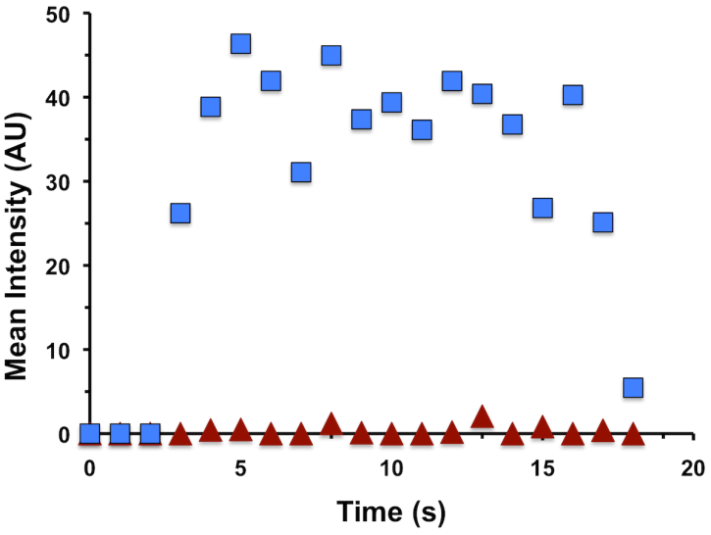
Figure S1. Mean brightness vs. time from HIFU pulsing of droplets as function of time. HIFU is pulsed from 3-17 s. Blue squares indicate 1 µM streptavidin loading; red triangles indicate no streptavidin loading.

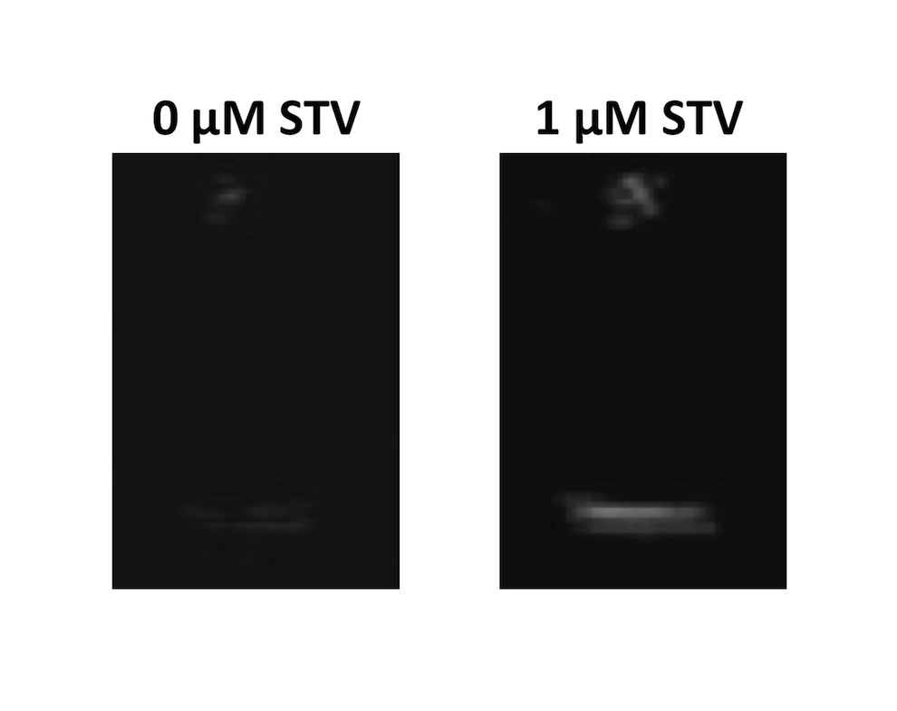
Figure S2. Still images of Neobee oil droplets after HIFU pulsing with either no or 1 µM streptavidin.
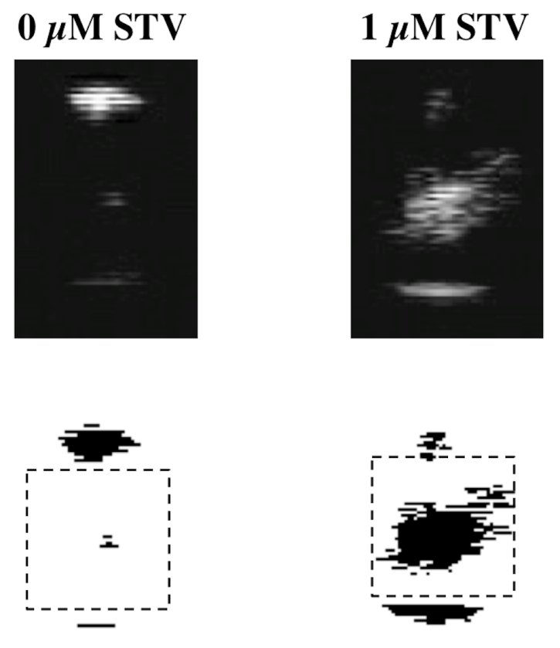
Figure S3: Examples of image processing using ImageJ. Top: still image from video file. Bottom: image after ImageJ processing; dashed rectangle indicates ROI.

