Manuscript Annex I Maps of the implementation and comparison areas in Uganda and Tanzania
Expanded Quality Management Using Information Power (EQUIP): protocol for a quasi-experimental study to improve maternal and newborn health in Tanzania and Uganda
Hanson C, Waiswa P, Marchant T, Marx M, Manzi F, Mbaruku G, Rowe AK, Tomson G, Schellenberg J, Peterson S, and the EQUIP Study Team.
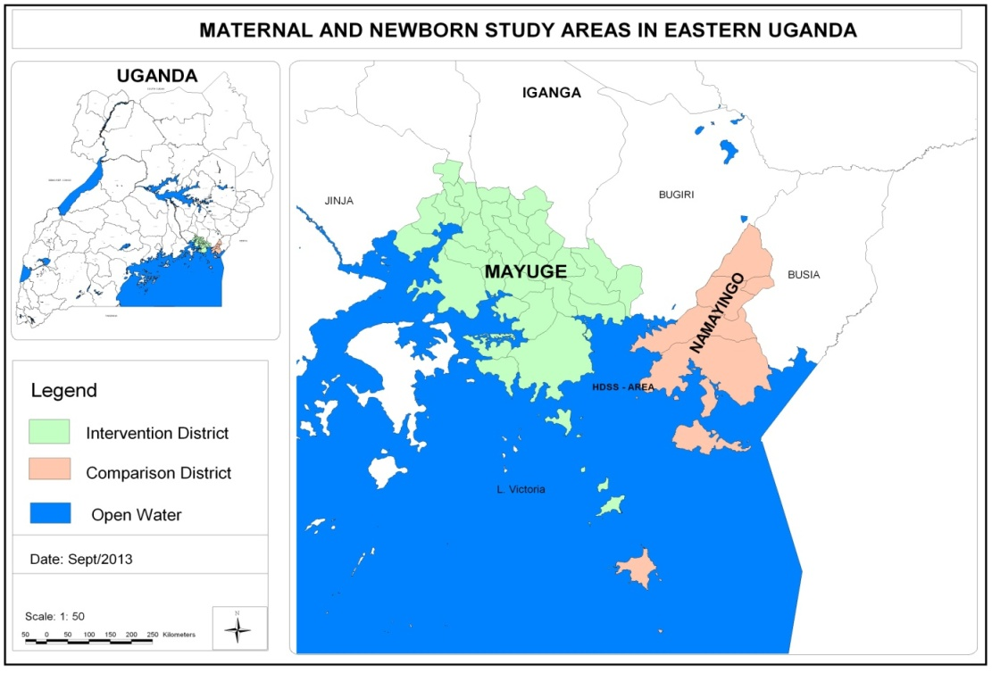
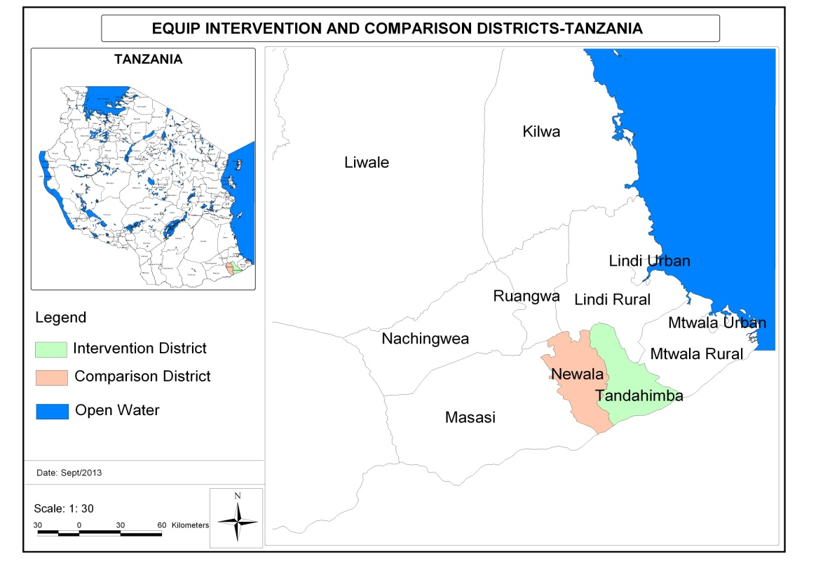
Figure 1: Implementation and comparison districts in Uganda

Figure 2: Implementation and comparison districts in Tanzania

