**Supplementary Methods**

PDMS Preparation:

All PDMS used in this work had a base to crosslinking agent ratio of 10:1. After mixing the appropriate volume (based on number of chips to be made), the mixture is placed in a moderate vacuum chamber at 88 kPa to degas. Once degassed the PDMS is ready to be used.

Fabrication of Chorionic-fluid Chip:

The chorionic-fluid chip is made by replica molding of PDMS in two parts. The first part contains the microchannel that is used to dechorionate the embryo (the mold for this part is referred as mold-I). The second part is basically a slab of PDMS (the mold for this part is referred as mold-II). Both of these parts are bonded together in the end to fully realize the chorionic-fluid chip.

The mold-I is made by laser ablation of adhesive vinyl film (Gerber Instachange Removable Film, Gerber Scientific Products, Tolland, CT, USA) as described in recent a recent publication (Samuel et al. 2014). Once the pattern is cut it is adhered on the internal surface of the Petri dish (Part #. 25384-302, VWR, PA).

Next, an appropriately sized 1.5 mm thick sheet of PMMA (Acrylite FF (clear), 0.06 inch thick, Evonik Industries, Essen, Germany) is bonded to a layer of double-sided tape (Product #. S-17844, 3M, MN) that is ~ 0.1 mm thick (without the carrier). The carrier of the double-sided tape is not removed. Afterwards the same pattern (that was cut in the adhesive vinyl film) is cut through the sheet of PMMA (with an adhered layer of double-sided tape) by laser ablation. The setup for this process is shown in Fig. S1. The laser ablation settings are tuned so that a small amount of tape carrier remains un-ablated. This keeps the cut pattern from falling off into the base of the laser bed. Alternatively a flat thin sheet of any material (that is not transparent to the wavelength of the laser) could be placed in-between the PMMA sheet and the laser bed. After removing tape’s carrier the cut PMMA pattern is adhered on the film pattern by the help of tweezers for the realization of the micromold.

Fig. S2 shows this arrangement of different layers of material to make the micromold. It is possible to directly stick the PMMA pattern to the petri dish surface to make the final mold. However, by having a mold with a previously placed patterned adhesive film can help in creating multi-relief molds by attaching PMMA laser-ablated patterns (or solid object printed patterns) where required. A complete fabrication sequence of the chorionic-fluid chip is shown in Fig. S3. After the mold has been fabricated PDMS is poured over mold-I and into an identical empty petri dish (mold-II) to a thickness of ~ 6 mm from the base of the petri dish. After ensuring that the poured PDMS is free of air bubbles, these molds are placed in the oven at 62 ºC for at least 5 hours. This cures the PDMS into a solid.



**Fig. S1.** Setup of laser ablation for patterning PMMA/double-sided tape



**Fig. S2.** Different layers of material for micromold for chorionic-fluid chip



**Fig. S3.** Fabrication schematic for the chorionic-fluid chip

Later the molded PDMS pieces are removed and holes (3.5 mm diameter) are cored into microchannel using a biopsy punch (Part #. 15079, Ted Pella Inc., CA) for inlet and outlet. In the end the pieces are bonded together (in the arrangement shown in Fig. S3 part (i)) by corona bonding.

3D CO2 Laser Ablation of Adhesive Vinyl Films for Micromolding:

The CO2 laser ablation of adhesive vinyl films for the fabrication of multi-relief micromolds, was previously introduced by Luo et al (Luo et al. 2007). The principle behind this fabrication process is selective laser ablation. Selective laser ablation is a type of subtractive micromachining process in which the laser properties are varied to achieve different depths of cut in the work piece so as to selectively remove material. Selective laser ablation has been already used in processing semiconductor devices.(Dhar et al. 2011; Haase et al. 2011; Knorz et al. 2009) In this case the work piece is a single laminated layer of multiple adhesive vinyl films (Gerber Instachange Removable Film, Gerber Scientific Products, Tolland, CT, USA). Fig. S4 depicts the selective laser ablation process of a laminate of 4 adhesive vinyl films. The laminate is made by peeling of carriers from three films and placing them on top of the 4th film (with its carrier not removed). Then the laminate is placed on the laser ablation bed (Fig. S4 a).

The CO2 laser (VLS 3.60, Universal Laser Systems, AZ) used in this work has three parameters that can be adjusted depending on the material to be ablated. These are power, probe speed, and intensity. Once the laser is focused, tests are carried out by varying one or two of the three laser parameters to achieve the desired depth of cut. In this case for a 4-film laminate of adhesive vinyl film the laser parameter values are:

* Ablation to a depth of two films: power = 6%, probe speed = 10%, and intensity = 1000 pulses/inch
* Ablation to a depth of four films: power = 8%, probe speed = 10%, and intensity = 1000 pulses/inch

In laser ablation systems a 2D ablation pattern is initially drawn in a CAD (computer aided design) program. In this work AutoCAD (Autodesk Inc., CA, USA) was used to design 2D drawing of the pattern. The laser system includes a firmware that provides the flexibility to change the three parameters of a particular laser ablation process by line color of the drawing. Hence, the user can control the depth of cut during the entire laser ablation process of one drawing.

Once the laser is focused and laser parameters are set according to the line color of the drawing, the ablation process is executed (Fig. S4 b and Fig. S4 c). The ablated laminate is taken from the laser bed and placed on top of working bench. Then a single film (with the carrier removed), is stuck on top of the ablated laminate (Fig. S4 d). This film is called the transfer film and it helps in inhibiting “free regions” (where the laminate has been ablated all the way through) from dislocating when the laminate is transferred and stuck inside a petri dish by peeling off the bottom carrier (Fig. S4 e). Then the transfer film along with unwanted laminate material is removed by tweezers (Fig. S4 f). The laminate is rolled by a small roller to improve adhesion to the petri dish. Next, by the help of tweezers the regions that were ablated to a depth of two films are removed (Fig. S4 g). Similarly, an ablated pattern cut all the way through in an adhesive film laminate can be transferred by tweezers on another adhesive film or laminate to make multi-relief micromolds.



**Fig. S4.** Fabrication schematic of 3D CO2 laser ablation of adhesive vinyl films

Fabrication of Fin-clip Chip:

The fin-clip chip is made by replica molding of PDMS. The micromold for the fin-clip chip is made by 3D CO2 laser ablation of 5-film adhesive vinyl films (Gerber Instachange Removable Film, Gerber Scientific Products, Tolland, CT, USA) as described earlier. As shown in Figure 2 the fin-clip chip has two parts: a flow channel (highlighted in white and magenta) and a pneumatic channel (highlighted in cyan). Fig. S5 shows the fabrication schematic of flow channel from part(a) to part(f), pneumatic channel from part(g) to part(i), and the final chip in part(k).



**Fig. S5.** Fabrication schematic for fin-clip chip

The mold for flow channel (Fig. S5 a) is made by fabrication techniques described in the previous section by using a laminate of 5 films (each film ~110 μm thick). Once the mold is made, uncured PDMS is poured in the mold (Fig. S5 b). After ensuring that the poured PDMS is free of air bubbles, the mold is placed in the oven at 62 ºC for at least 5 hours. Then the cured PDMS is removed from the mold (Fig. S5 c). Holes (~1.5 mm diameter) for ports A, X, Y, Z (according to Figure 2) are cored in the molded PDMS piece (Fig. S5 d) to complete the fabrication of flow channel layer. The coring tool is biopsy punch (Part #. BP15, HealthLink, FL).

To make the actuating membrane, 5 ml of uncured PDMS is spun on a PMMA 4-inch wafer at 2800 rpm for 60 seconds at a ramp of 340 rpm/s and then baked in an oven at 62˚C for at least 1.5 hours (Fig. S5 j). This generates a PDMS layer of 16.4 ± 0.9 μm thickness.

The PDMS layer (overlying the PMMA wafer) is bonded (by corona discharge (Samuel et al. 2011)) to the flow channel layer and placed in the oven at 62 ºC for 30 minutes as shown in Fig. S5 e. Afterwards the flow channel layer along with the bonded actuated membrane is separated from the PMMA wafer (Fig. S5 f).

The mold for the pneumatic flow layer is fabricated by laser ablation of a single adhesive vinyl film as described (Samuel et al. 2014) and depicted in Fig. S5 g (mold), Fig. S5 h (uncured PDMS poured in the mold and cured), and Fig. S5 i (cured PDMS pneumatic flow layer separated from the mold).

In the end, the flow channel layer and the pneumatic flow layer are bonded by corona discharge in the arrangement shown in Figure S5 k to fully realize the fin-clip chip.

Supplementary References:

S. Dhar, A. R. Barman, G. X. Ni, X. Wang, X. F. Xu, Y. Zheng, S. Tripathy, Ariando, A. Rusydi, K. P. Loh, M. Rubhausen, A. H. Castro Neto, B. Őzyilmaz, T. Venkatesan, AIP Adv. **1**, 022109 (2011) doi: 10.1063/1.3584204

F. Haase, E. G. Rojas, K. Bothe, R. Brendel, Energy Procedia **8**, 577-580 (2011) doi: 10.1016/j.egypro.2011.06.185

A. Knorz, M. Peters, A. Grohe, C. Harmel, and R. Preu, Prog. in Photovoltaics: Research and Applications **17**, 127-136 (2009) doi: 10.1002/pip.856

L. W. Luo, C. Y. Teo, W. L. Ong, K. C. Tang, L. F. Cheow, and L. Yobas, J. Micromech. Microeng. **17**, N107-N111 (2007) doi: 10.1088/0960-1317/17/12/N02

R. Samuel, H. J. Sant, F. Jiao, C. R. Johnson, and B. K. Gale, J. Micromech. Microeng. **21**, 095027 (2011) doi: 10.1088/0960-1317/21/9/095027

R. Samuel, C. M. Thacker, A V Maricq, and B. K. Gale, J. Micromech. Microeng. **24**, 105007 (2014) doi: 10.1088/0960-1317/24/10/105007

**Supplementary Figures and Tables**

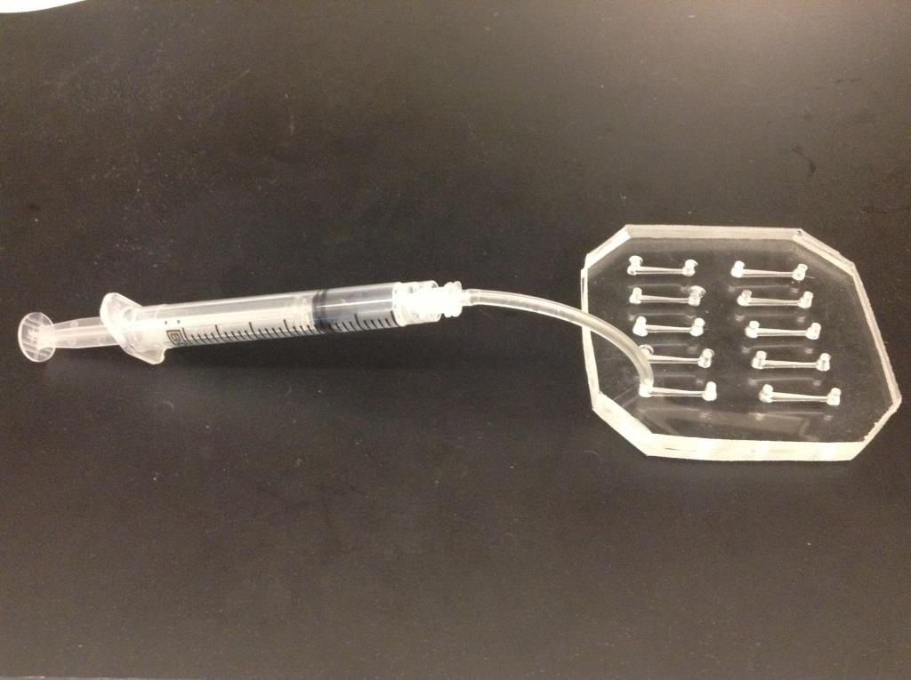

**Supplementary Fig. 1.** Setup for chorionic fluid method in which one channel is being utilized out of ten



**Supplementary Fig. 2.** Setup for Fin-clip chip with syringes and the external pneumatic line

|  |  |  |  |  |  |
| --- | --- | --- | --- | --- | --- |
| **Forward Primer** | **Reverse Primer** | **Amplicon** | **Cycling parameters** | **N (cycles)** | **HRMA temperature range** |
| AAAAACCGAAGTGCGCCAAG  AAAAGCATTGTTAACAGGATTATTTG | CCTCTCATCGCTGTGAGGGGTC  TCAGTCTCCACTGAAGCCAAT | **Gal4**  AAAAACCGAAGTGCGCCAAGTGTCTGAAGATGTTGACCCTCACAGCGATGAGAGG  **eif2B5**  AAAAGCATTGTTAACAGGATTATTTGTACAAGATAATGTGAATAAAGATGCCGTCACAGATAGATTGGCTTCAGTGGAGACTGA | 95ºC for 30 seconds, followed by ‘N’ cycles of 94ºC for 5 seconds, 68ºC for 5 seconds, 72ºC for 5 seconds. Following PCR samples were at 25˚C for 30 seconds, then cooled to 4ºC  95ºC for 2 minutes, followed by ‘N’ cycles of 95ºC for 30 seconds, 70ºC for 30 seconds. Following PCR samples were at 25ºC for 30 seconds; then cooled to 4˚C | 35 (60 for chorionic fluid method)  30 (60 for chorionic fluid method) | 72ºC to 94ºC  65ºC to 95ºC |

**Supplementary Table 1.** PCR and HRMA parameters for the Gal4 and eif2B5 amplicons used in the chorionic fluid and fin-clip methods. Primer sequences are listed 5’ to 3’.

|  |  |  |
| --- | --- | --- |
| Method | Embryos (#) | # embryos at 5 days:live, normal morphology and startle response |
| Chorionic fluid method | 20 | 20 |
| Fin clip method | 16 | 16 |

**Supplementary Table 2.** Embryo viability at age 5 days post-fertilization; embryos were processed as shown, and then morphology, startle response, and viability were measured