**Supplementary Materials**

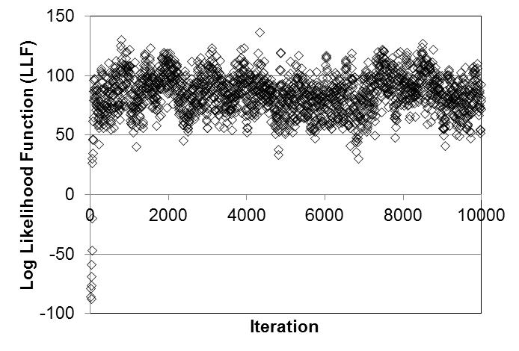

Figure S-1. The changes in the log likelihood function (LLF) during the progression of a chain from the calibration of the model to the data of Semmler et al. (2004)/Semmler-Behnke et al. (2007) and Kreyling et al. (2002, 2009), sampled at every fifth iteration. The initial four values were omitted from the figure so that the scale of the subsequent fluctuation may more readily be observed.

**Table S-1. Statistical model parameters for disposition of metal nanoparticles in rats--Bayesian analysis of Semmler et al. (2004)/Semmler-Behnke et al. (2007)**

|  |  |  |  |  |  |  |  |  |  |  |  |  |  |  |  |  |  |  |  |  |  |  |  |  |  |  |  |  |  |  |  |  |  |  |  |  |  |  |  |  |  |  |
| --- | --- | --- | --- | --- | --- | --- | --- | --- | --- | --- | --- | --- | --- | --- | --- | --- | --- | --- | --- | --- | --- | --- | --- | --- | --- | --- | --- | --- | --- | --- | --- | --- | --- | --- | --- | --- | --- | --- | --- | --- | --- | --- |
| **Data description: all parameters assumed to have lognormal distributions** | | | | | | | | | | | | | | | | | | | | | | | | | | | | | | | | | | | | | | | | | | |
| *Measurement* | | | | | | | | | | | | |  | | | | *Geometric mean* | | | | | | | | | |  | | | | | *Variance* | | | | | |  | | | | |
| AAlvTot (Amount in alveolar region, free or in macrophages) | | | | | | | | | | | | | | | | | AAlvTot (prediction) | | | | | | | | | | | | | | | Ve_AAlvTot | | | | | | | | | | |
| AInter (Amount in interstitial lung tissue) | | | | | | | | | | | | | | | | | AInter (prediction) | | | | | | | | | | | | | | | Ve_AInter | | | | | | | | | | |
| ALymph (Amount in lung-associated lymph nodes [LANL]) | | | | | | | | | | | | | | | | | ALymph (prediction) | | | | | | | | | | | | | | | Ve_ALymph | | | | | | | | | | |
| ALungTot (Amount in upper airways, alveolar region, interstitial tissue, and LANL) | | | | | | | | | | | | | | | | | ALungTot (prediction) | | | | | | | | | | | | | | | Ve_ALungTot | | | | | | | | | | |
| ALiverTot (Amount in liver) | | | | | | | | | | | | | | | | | ALiverTot (prediction) | | | | | | | | | | | | | | | Ve_ALiverTot | | | | | | | | | | |
| AKidTot (Amount in kidneys) | | | | | | | | | | | | | | | | | AKidTot (prediction) | | | | | | | | | | | | | | | Ve_AKidTot | | | | | | | | | | |
| AHeartTot (Amount in heart) | | | | | | | | | | | | | | | | | AHeartTot (prediction) | | | | | | | | | | | | | | | Ve_AHeartTot | | | | | | | | | | |
| ASplTot (Amount in spleen) | | | | | | | | | | | | | | | | | ASplTot (prediction) | | | | | | | | | | | | | | | Ve_ASplTot | | | | | | | | | | |
| ABrTot (Amount in brain) | | | | | | | | | | | | | | | | | ABrTot (prediction) | | | | | | | | | | | | | | | Ve_ABrTot | | | | | | | | | | |
| AOthTot (Amount in other tissues) | | | | | | | | | | | | | | | | | AOthTot (prediction) | | | | | | | | | | | | | | | Ve_AOthTot | | | | | | | | | | |
| AFeces (Cumulative amount excreted in feces) | | | | | | | | | | | | | | | | | AFeces (prediction) | | | | | | | | | | | | | | | Ve_AFeces | | | | | | | | | | |
| CVen (Concentration in venous blood) | | | | | | | | | | | | | | | | | CVen (prediction) | | | | | | | | | | | | | | | Ve_CVen | | | | | | | | | | |
| **Posterior error distributions: Loguniform distribution, prior range of 0.01 (minimum) to 3.3 (maximum)** | | | | | | | | | | | | | | | | | | | | | | | | | | | | | | | | | | | | | |
| *Measurement* | | | | | |  | | |  |  | | |  | | | |  | | |  | | | *Mean* | | | *Avg. Variance* | | | | | | | *R* | | | | | | | | | | |
| Ve_AAlvTot | | | | | |  | | |  |  | | |  | | | |  | | |  | | | 0.695 | | | 0.664 | | | | | | | 1.0 | | | | | | | | | | |
| Ve_AInter | | | | | |  | | |  |  | | |  | | | |  | | |  | | | 0.751 | | | 0.707 | | | | | | | 1.0 | | | | | | | | | | |
| Ve_ALymph | | | | | |  | | |  |  | | |  | | | |  | | |  | | | 0.706 | | | 0.662 | | | | | | | 1.0 | | | | | | | | | | |
| Ve_ALungTot | | | | | |  | | |  |  | | |  | | | |  | | |  | | | 0.0431 | | | 2.54×10-4 | | | | | | | 1.0 | | | | | | | | | | |
| Ve_ALiverTot | | | | | |  | | |  |  | | |  | | | |  | | |  | | | 1.47 | | | 0.485 | | | | | | | 1.0 | | | | | | | | | | |
| Ve_AKidTot | | | | | |  | | |  |  | | |  | | | |  | | |  | | | 0.897 | | | 0.527 | | | | | | | 1.0 | | | | | | | | | | |
| Ve_AHeartTot | | | | | |  | | |  |  | | |  | | | |  | | |  | | | 0.759 | | | 0.745 | | | | | | | 1.0 | | | | | | | | | | |
| Ve_ASplTot | | | | | |  | | |  |  | | |  | | | |  | | |  | | | 1.92 | | | 0.407 | | | | | | | 1.0 | | | | | | | | | | |
| Ve_ABrTot | | | | | |  | | |  |  | | |  | | | |  | | |  | | | 0.839 | | | 0.403 | | | | | | | 1.0 | | | | | | | | | | |
| Ve_AOthTot | | | | | |  | | |  |  | | |  | | | |  | | |  | | | 0.674 | | | 0.615 | | | | | | | 1.0 | | | | | | | | | | |
| Ve_AFeces | | | | | |  | | |  |  | | |  | | | |  | | |  | | | 0.0113 | | | 2.10×10-6 | | | | | | | 1.0 | | | | | | | | | | |
| Ve_CVen | | | | | |  | | |  |  | | |  | | | |  | | |  | | | 0.690 | | | 0.639 | | | | | | | 1.0 | | | | | | | | | | |
| **Model parameters** | | | | | | | | | | | | | | | | | | | | | | | | | | | | | | | | | | | | | | | | | | |
| **Partition coefficients (dimensionless)** | | | | | | Distribution: truncated normal; Mean: M_variable, Prior minimum: -5, Prior maximum: 5, Prior variance: V_variable | | | | | | | | | | | | | | | | | | | | | | | | | | | | | | | |
| *Variable* | | | | | | | | | | | |  | | |  | | |  |  | | | | | *Mean* | | | | *Avg. Variance* | | | | | | *R* | | | | | | | |
| lnλ35 (bile:liver partition coefficient [PC]) | | | | | | | | | | | |  | | |  | | |  |  | | | | | ‑0.0489 | | | | 2.73 | | | | | | 1.0 | | | | | | | |
| lnλ31 (plasma:liver PC) | | | | | | | | | | | |  | | |  | | |  |  | | | | | 0.0108 | | | | 2.11 | | | | | | 1.0 | | | | | | | |
| lnλ41 (plasma:GI tissue PC) | | | | | | | | | | | |  | | |  | | |  |  | | | | | 0.637 | | | | 1.97 | | | | | | 1.0 | | | | | | | |
| lnλ51 (plasma:kidney PC) | | | | | | | | | | | |  | | |  | | |  |  | | | | | -0.901 | | | | 1.99 | | | | | | 1.1 | | | | | | | |
| lnλ61 (plasma:heart PC) | | | | | | | | | | | |  | | |  | | |  |  | | | | | -0.0527 | | | | 2.51 | | | | | | 1.0 | | | | | | | |
| lnλ71 (plasma:spleen PC) | | | | | | | | | | | |  | | |  | | |  |  | | | | | -0.652 | | | | 2.27 | | | | | | 1.0 | | | | | | | |
| lnλ81 (plasma:brain PC) | | | | | | | | | | | |  | | |  | | |  |  | | | | | -0.0185 | | | | 1.56 | | | | | | 1.0 | | | | | | | |
| lnλ91 (plasma:other tissue PC) | | | | | | | | | | | |  | | |  | | |  |  | | | | | 0.690 | | | | 2.59 | | | | | | 1.1 | | | | | | | |
| **Tissue sequestration, clearance of sequestered material, upper airway translocation (day-1)** | | | | | | | | | Distribution: truncated normal; Mean: M_variable, Prior minimum: --10, Prior maximum: 10, Prior variance: V_variable | | | | | | | | | | | | | | | | | | | | | | | | | | | |
|  | | | | | | | | | | | |  | | |  | | |  |  | | | | | *Mean* | | | | *Avg. Variance* | | | | | | *R* | | | | | | | |
| lnκ33 (liver sequestration rate) | | | | | | | | | | | |  | | |  | | |  |  | | | | | 1.03 | | | | 4.03 | | | | | | 1.0 | | | | | | | |
| lnκ43 (GI tissue sequestration rate) | | | | | | | | | | | |  | | |  | | |  |  | | | | | 0.0440 | | | | 11.4 | | | | | | 1.0 | | | | | | | |
| lnκ53 (kidney sequestration rate) | | | | | | | | | | | |  | | |  | | |  |  | | | | | 3.13 | | | | 2.86 | | | | | | 1.2 | | | | | | | |
| lnκ63 (heart sequestration rate) | | | | | | | | | | | |  | | |  | | |  |  | | | | | 1.41 | | | | 13.1 | | | | | | 1.3 | | | | | | | |
| lnκ73 (spleen sequestration rate) | | | | | | | | | | | |  | | |  | | |  |  | | | | | 3.09 | | | | 4.61 | | | | | | 1 | | | | | | | |
| lnκ83 (brain sequestration rate) | | | | | | | | | | | |  | | |  | | |  |  | | | | | 3.7 | | | | 2.53 | | | | | | 1.1 | | | | | | | |
| lnκ93 (other tissue sequestration rate) | | | | | | | | | | | |  | | |  | | |  |  | | | | | 3.91 | | | | 5.00 | | | | | | 1.3 | | | | | | | |
| lnκ334 (clearance of sequestered material in liver) | | | | | | | | | | | |  | | |  | | |  |  | | | | | -4.59 | | | | 1.53 | | | | | | 1.0 | | | | | | | |
| lnκ434 (clearance of sequestered material in GI tissue) | | | | | | | | | | | |  | | |  | | |  |  | | | | | 0.141 | | | | 11.6 | | | | | | 1.0 | | | | | | | |
| lnκ534 (clearance of sequestered material in kidney) | | | | | | | | | | | |  | | |  | | |  |  | | | | | -1.80 | | | | 1.49 | | | | | | 1.0 | | | | | | | |
| lnκ634 (clearance of sequestered material in heart) | | | | | | | | | | | |  | | |  | | |  |  | | | | | 0.637 | | | | 11.8 | | | | | | 1.1 | | | | | | | |
| lnκ734 (clearance of sequestered material in spleen) | | | | | | | | | | | |  | | |  | | |  |  | | | | | -4.45 | | | | 1.96 | | | | | | 1.0 | | | | | | | |
| lnκ834 (clearance of sequestered material in brain) | | | | | | | | | | | |  | | |  | | |  |  | | | | | -2.31 | | | | 0.308 | | | | | | 1.0 | | | | | | | |
| lnκ934 (clearance of sequestered material in other tissue) | | | | | | | | | | | |  | | |  | | |  |  | | | | | 4.99 | | | | 4.95 | | | | | | 1.1 | | | | | | | |
| lnkb (translocation from interstitium to blood) | | | | | | | | | | | |  | | |  | | |  |  | | | | | 5.55 | | | | 1.6 | | | | | | 1.1 | | | | | | | |
| lnku (clearance from upper airways to GI tract) | | | | | | | | | | | |  | | |  | | |  |  | | | | | -1.13 | | | | 0.0897 | | | | | | 1.0 | | | | | | | |
| lnkl (translocation from interstitium to LANL) | | | | | | | | | | | |  | | |  | | |  |  | | | | | 4.33 | | | | 1.7 | | | | | | 1.1 | | | | | | | |
| lnκvi (translocation from blood to interstitium) | | | | | | | | | | | |  | | |  | | |  |  | | | | | 1.15 | | | | 10.2 | | | | | | 1.2 | | | | | | | |
| *Variables with uniform distribution* | | | | | | | | | |  | | |  | | | | *Prior* | | | | | | | | | | *Posterior* | | | | | | | | | | | | | | | |
|  | | |  | | | | *Min.* | | | *Max.* | | | | | *Mean* | | | | *Avg. Variance* | | | | | | *R* | | | | | |
| lnκ46 (GI absorption rate) | | | | | | | | | |  | | |  | | | | -10 | | | 10 | | | | | 4.04 | | | | 13.2 | | | | | | 1.0 | | | | | |
| lnκ44 (fecal elimination rate) | | | | | | | | | |  | | |  | | | | 2.11 | | | 2.11 | | | | | -0.0240 | | | | 3.6 | | | | | | 1.0 | | | | | |
| **Population level parameters** | | | | | | | | | | | | | | | | | | | | | | | | | | | | | | | | | | | | | | | | | | |
| **Partition coefficients (dimensionless), tissue sequestration, upper airway translocation (day-1)** | Means: M_variable, Distribution: truncated normal, Prior mean: 0, Prior minimum: -5 (partition coefficients) or -10 (rate parameters), Prior maximum: 5 (partition coefficients) or 10 (rate parameters), Prior variance: 1.7 (Partition coefficients) or 4 (rate parameters) | | | | | | | | | | | | | | | | | | | | | | | | | | | | | | | | | | | | |
| Variances: V_variable, Distribution: inverse gamma, prior variance shape: 2.25, prior variance scale: 0.3125 | | | | | | | | | | | | | | | | | | | | | | | | | | | | | | | | | | | | |
| *Variable* | | *Posterior mean* | | | | | | | | | | | | *Posterior Variance* | | | | | | | | | | | | | | | | | | | | | | | | |
| *Mean* | | *Avg. Variance* | | | *R* | | | | | | | *Mean* | | | | | | | *Avg. Variance* | | | | | | | | | | *R* | | | | | | | |
| lnλ35 | | | -0.0273 | | 2.55 | | | 1.0 | | |  | | | | | 0.290 | | | | | | 0.129 | | | | | | | | 1.0 | | | | | |  | | | |
| lnλ31 | | | 0.0184 | | 2.03 | | | 1.0 | | |  | | | | | 0.271 | | | | | | 0.116 | | | | | | | | 1.0 | | | | | |  | | | |
| lnλ41 | | | 0.595 | | 1.82 | | | 1.0 | | |  | | | | | 0.310 | | | | | | 0.298 | | | | | | | | 1.0 | | | | | |  | | | |
| lnλ51 | | | -0.816 | | 1.93 | | | 1.1 | | |  | | | | | 0.272 | | | | | | 0.103 | | | | | | | | 1.0 | | | | | |  | | | |
| lnλ61 | | | -0.0540 | | 2.33 | | | 1.0 | | |  | | | | | 0.284 | | | | | | 0.141 | | | | | | | | 1.0 | | | | | |  | | | |
| lnλ71 | | | -0.567 | | 2.10 | | | 1.0 | | |  | | | | | 0.267 | | | | | | 0.0859 | | | | | | | | 1.0 | | | | | |  | | | |
| lnλ81 | | | -0.0277 | | 1.53 | | | 1.0 | | |  | | | | | 0.262 | | | | | | 0.0687 | | | | | | | | 1.0 | | | | | |  | | | |
| lnλ91 | | | 0.626 | | 2.41 | | | 1.1 | | |  | | | | | 0.285 | | | | | | 0.107 | | | | | | | | 1.0 | | | | | |  | | | |
| lnκ33 | | | 1.02 | | 4.22 | | | 1.0 | | |  | | | | | 0.268 | | | | | | 0.0777 | | | | | | | | 1.0 | | | | | |  | | | |
| lnκ43 | | | 0.0441 | | 11.3 | | | 1.0 | | |  | | | | | 0.279 | | | | | | 0.0968 | | | | | | | | 1.0 | | | | | |  | | | |
| lnκ53 | | | 3.09 | | 2.99 | | | 1.2 | | |  | | | | | 0.262 | | | | | | 0.0712 | | | | | | | | 1.0 | | | | | |  | | | |
| lnκ63 | | | 1.39 | | 12.9 | | | 1.3 | | |  | | | | | 0.263 | | | | | | 0.0977 | | | | | | | | 1.0 | | | | | |  | | | |
| lnκ73 | | | 3.02 | | 4.65 | | | 1.0 | | |  | | | | | 0.285 | | | | | | 0.117 | | | | | | | | 1.0 | | | | | |  | | | |
| lnκ83 | | | 3.64 | | 2.66 | | | 1.1 | | |  | | | | | 0.306 | | | | | | 0.166 | | | | | | | | 1.0 | | | | | |  | | | |
| lnκ93 | | | 3.83 | | 5.04 | | | 1.3 | | |  | | | | | 0.278 | | | | | | 0.105 | | | | | | | | 1.0 | | | | | |  | | | |
| lnκ334 | | | -4.51 | | 1.73 | | | 1.0 | | |  | | | | | 0.267 | | | | | | 0.0972 | | | | | | | | 1.0 | | | | | |  | | | |
| lnκ434 | | | 0.123 | | 11.4 | | | 1.0 | | |  | | | | | 0.284 | | | | | | 0.155 | | | | | | | | 1.0 | | | | | |  | | | |
| lnκ534 | | | -1.78 | | 1.64 | | | 1.0 | | |  | | | | | 0.263 | | | | | | 0.0688 | | | | | | | | 1.0 | | | | | |  | | | |
| lnκ634 | | | 0.609 | | 11.4 | | | 1.1 | | |  | | | | | 0.299 | | | | | | 0.130 | | | | | | | | 1.0 | | | | | |  | | | |
| lnκ734 | | | -4.37 | | 2.16 | | | 1.0 | | |  | | | | | 0.261 | | | | | | 0.0887 | | | | | | | | 1.0 | | | | | |  | | | |
| lnκ834 | | | -2.27 | | 0.569 | | | 1.0 | | |  | | | | | 0.276 | | | | | | 0.0872 | | | | | | | | 1.0 | | | | | |  | | | |
| lnκ934 | | | 4.90 | | 4.91 | | | 1.1 | | |  | | | | | 0.278 | | | | | | 0.0938 | | | | | | | | 1.0 | | | | | |  | | | |
| lnkb | | | 5.45 | | 1.81 | | | 1.1 | | |  | | | | | 0.305 | | | | | | 0.181 | | | | | | | | 1.0 | | | | | |  | | | |
| lnku | | | -1.10 | | 0.397 | | | 1.0 | | |  | | | | | 0.327 | | | | | | 0.460 | | | | | | | | 1.0 | | | | | |  | | | |
| lnkl | | | 4.27 | | 1.91 | | | 1.1 | | |  | | | | | 0.262 | | | | | | 0.0825 | | | | | | | | 1.0 | | | | | |  | | | |
| lnkκvi | | | 1.13 | | 10.1 | | | 1.1 | | |  | | | | | 0.297 | | | | | | 0.138 | | | | | | | | 1.0 | | | | | |  | | | |
| lnκ46 (uniform distribution | | | 3.88 | | 14.9 | | | 1.0 | | |  | | | | | 4.68 | | | | | | 38.7 | | | | | | | | 1.0 | | | | | |  | | | |
| lnκ44 (uniform distribution | | |  | |  | | |  | | |  | | | | | 4.10 | | | | | | 16.2 | | | | | | | | 1.0 | | | | | |  | | | |
|  | | | | | |  | | |  |  | | |  | | | |  | | |  | | | | | | |  | | | | |  | | | | | |  | | | | |

**Table S-2. Statistical model parameters for disposition of metal nanoparticles in rats --Bayesian analysis of Semmler et al. (2004)/Semmler-Behnke et al. (2007), Kreyling et al. (2002, 2009), and Lankveld et al. (2010)**

|  |  |  |  |  |  |  |  |  |  |  |  |  |  |  |  |  |  |  |  |  |  |  |  |  |  |  |  |  |  |  |  |  |  |  |  |  |  |  |  |  |  |  |  |  |  |
| --- | --- | --- | --- | --- | --- | --- | --- | --- | --- | --- | --- | --- | --- | --- | --- | --- | --- | --- | --- | --- | --- | --- | --- | --- | --- | --- | --- | --- | --- | --- | --- | --- | --- | --- | --- | --- | --- | --- | --- | --- | --- | --- | --- | --- | --- |
| **Data description: all parameters assumed to have lognormal distribution** | | | | | | | | | | | | | | | | | | | | | | | | | | | | | | | | | | | | | | | | | | | | | |
| *Measurement* | | | | | | | | | | | | | | | | | | | *Geometric mean* | | | | | | | | | | |  | | | | | | *Variance* | | |  | | | | | | |
| AAlvTot (Amount in alveolar region, free or in macrophages) | | | | | | | | | | | | | | | | | | | AAlvTot (prediction) | | | | | | | | | | | | | | | | | Ve_AAlvTot | | | | | | | | | |
| AInter (Amount in interstitial lung tissue) | | | | | | | | | | | | | | | | | | | AInter (prediction) | | | | | | | | | | | | | | | | | Ve_AInter | | | | | | | | | |
| ALymph (Amount in lung-associated lymph nodes [LANL]) | | | | | | | | | | | | | | | | | | | ALymph (prediction) | | | | | | | | | | | | | | | | | Ve_ALymph | | | | | | | | | |
| ALungTot (Amount in upper airways, alveolar region, interstitial tissue, and LANL) | | | | | | | | | | | | | | | | | | | ALungTot (prediction) | | | | | | | | | | | | | | | | | Ve_ALungTot | | | | | | | | | |
| ALiverTot (Amount in liver) | | | | | | | | | | | | | | | | | | | ALiverTot (prediction) | | | | | | | | | | | | | | | | | Ve_ALiverTot | | | | | | | | | |
| AKidTot (Amount in kidneys) | | | | | | | | | | | | | | | | | | | AKidTot (prediction) | | | | | | | | | | | | | | | | | Ve_AKidTot | | | | | | | | | |
| AHeartTot (Amount in heart) | | | | | | | | | | | | | | | | | | | AHeartTot (prediction) | | | | | | | | | | | | | | | | | Ve_AHeartTot | | | | | | | | | |
| ASplTot (Amount in spleen) | | | | | | | | | | | | | | | | | | | ASplTot (prediction) | | | | | | | | | | | | | | | | | Ve_ASplTot | | | | | | | | | |
| ABrTot (Amount in brain) | | | | | | | | | | | | | | | | | | | ABrTot (prediction) | | | | | | | | | | | | | | | | | Ve_ABrTot | | | | | | | | | |
| AOthTot (Amount in other tissues) | | | | | | | | | | | | | | | | | | | AOthTot (prediction) | | | | | | | | | | | | | | | | | Ve_AOthTot | | | | | | | | | |
| AFeces (Cumulative amount excreted in feces) | | | | | | | | | | | | | | | | | | | AFeces (prediction) | | | | | | | | | | | | | | | | | Ve_AFeces | | | | | | | | | |
| CVen (Concentration in venous blood) | | | | | | | | | | | | | | | | | | | CVen (prediction) | | | | | | | | | | | | | | | | | Ve_CVen | | | | | | | | | |
| **Posterior error distributions: Loguniform distribution, prior range of 0.01 (minimum) to 3.3 (maximum)** | | | | | | | | | | | | | | | | | | | | | | | | | | | | | | | | | | | |
| *Measurement* | *Semmler Posterior* | | | | | | | | | | | | | | *Kreyling Posterior* | | | | | | | | | | | | | | | | *Lankveld Posterior* | | | | | | | | | | | | | | | |
| *Mean* | | | | *Avg. Variance* | | | | | | *R* | | | | | *Mean* | | *Avg. Variance* | | | | | | | | *R* | | | *Mean* | | | | | *Avg. Variance* | | | | | | | *R* | | | |
| Ve_AAlvTot | 0.755 | | | | 0.687 | | | | | | 1.0 | | | | | 0.706 | | 0.649 | | | | | | | | 1.0 | | | 0.743 | | | | | 0.722 | | | | | | | 1.0 | | | |
| Ve_AInter | 0.723 | | | | 0.651 | | | | | | 1.0 | | | | | 0.642 | | 0.619 | | | | | | | | 1.0 | | | 0.244 | | | | | 0.115 | | | | | | | 1.0 | | | |
| Ve_ALymph | 0.753 | | | | 0.691 | | | | | | 1.0 | | | | | 0.704 | | 0.670 | | | | | | | | 1.0 | | | 0.664 | | | | | 0.621 | | | | | | | 1.0 | | | |
| Ve_ALungTot | 0.0443 | | | | 2.7× 10-4 | | | | | | 1.0 | | | | | 0.037 | | 0.00114 | | | | | | | | 1.0 | | | 0.739 | | | | | 0.712 | | | | | | | 1.0 | | | |
| Ve_ALiverTot | 1.33 | | | | 0.465 | | | | | | 1.0 | | | | | 0.457 | | 0.337 | | | | | | | | 1.1 | | | 0.493 | | | | | 0.313 | | | | | | | 1.0 | | | |
| Ve_AKidTot | 0.898 | | | | 0.408 | | | | | | 1.0 | | | | | 0.786 | | 0.690 | | | | | | | | 1.0 | | | 0.916 | | | | | 0.469 | | | | | | | 1.0 | | | |
| Ve_AHeartTot | 0.732 | | | | 0.686 | | | | | | 1.0 | | | | | 0.936 | | 0.780 | | | | | | | | 1.0 | | | 0.492 | | | | | 0.299 | | | | | | | 1.0 | | | |
| Ve_ASplTot | 1.91 | | | | 0.452 | | | | | | 1.0 | | | | | 0.581 | | 0.561 | | | | | | | | 1.0 | | | 0.149 | | | | | 0.0691 | | | | | | | 1.0 | | | |
| Ve_ABrTot | 0.854 | | | | 0.479 | | | | | | 1.0 | | | | | 0.592 | | 0.535 | | | | | | | | 1.0 | | | 0.875 | | | | | 0.435 | | | | | | | 1.0 | | | |
| Ve_AOthTot | 0.718 | | | | 0.653 | | | | | | 1.0 | | | | | 0.441 | | 0.416 | | | | | | | | 1.0 | | | 0.701 | | | | | 0.663 | | | | | | | 1.0 | | | |
| Ve_AFeces | 0.0113 | | | | 1.9×10-6 | | | | | | 1.0 | | | | | 0.018 | | 1.0×10-4 | | | | | | | | 1.0 | | | 0.738 | | | | | 0.724 | | | | | | | 1.0 | | | |
| Ve_CVen | 0.699 | | | | 0.647 | | | | | | 1.0 | | | | | 2.03 | | 0.493 | | | | | | | | 1.0 | | | 0.714 | | | | | 0.676 | | | | | | | 1.0 | | | |
| **Model parameters** | | | | | | | | | | | | | | | | | | | | | | | | | | | | | | | | | | | | | | | | | | | |
| **Partition coefficients (dimensionless)** | | | Distribution: truncated normal; Mean: M_variable, Prior minimum: -5, Prior maximum: 5, Prior variance: V_variable | | | | | | | | | | | | | | | | | | | | | | | | | | | | | | | | | | | |
| *Variable* | | | *Semmler Posterior* | | | | | | | | | | | | *Kreyling Posterior* | | | | | | | | | | | | *Lankveld Posterior* | | | | | | | | | | | | | | |
|  | | | *Mean* | | | | *Avg. Variance* | | | | | *R* | | | *Mean* | | | | | *Avg. Variance* | | | *R* | | | | *Mean* | | | | | | | | *Avg. Variance* | | *R* | | | | |
| lnλ35 (bile:liver partition coefficient [PC]) | | | 2.80 | | | | 1.09 | | | | | 1.1 | | | 2.74 | | | | | 1.07 | | | 1.1 | | | | 2.90 | | | | | | | | 0.92 | | 1.1 | | | | |
| lnλ31 (plasma:liver PC) | | | 1.13 | | | | 1.14 | | | | | 1.0 | | | 1.45 | | | | | 0.813 | | | 1.0 | | | | -2.43 | | | | | | | | 1.38 | | 1.1 | | | | |
| lnλ41 (plasma:GI tissue PC) | | | 0.793 | | | | 1.69 | | | | | 1.0 | | | 0.808 | | | | | 1.68 | | | 1.0 | | | | 0.807 | | | | | | | | 1.75 | | 1.0 | | | | |
| lnλ51 (plasma:kidney PC) | | | 0.453 | | | | 1.56 | | | | | 1.1 | | | 0.757 | | | | | 1.58 | | | 1.1 | | | | 0.308 | | | | | | | | 1.45 | | 1.1 | | | | |
| lnλ61 (plasma:heart PC) | | | 0.788 | | | | 1.29 | | | | | 1.1 | | | 0.594 | | | | | 1.31 | | | 1.1 | | | | 1.13 | | | | | | | | 1.03 | | 1.1 | | | | |
| lnλ71 (plasma:spleen PC) | | | -0.240 | | | | 0.885 | | | | | 1.1 | | | -0.242 | | | | | 0.807 | | | 1.1 | | | | -0.221 | | | | | | | | 0.827 | | 1.2 | | | | |
| lnλ81 (plasma:brain PC) | | | 0.515 | | | | 0.979 | | | | | 1.1 | | | 0.640 | | | | | 0.927 | | | 1.1 | | | | 1.28 | | | | | | | | 1.08 | | 1.0 | | | | |
| lnλ91 (plasma:other tissue PC) | | | 1.99 | | | | 1.27 | | | | | 1.1 | | | 2.02 | | | | | 1.19 | | | 1.1 | | | | 1.81 | | | | | | | | 1.99 | | 1.1 | | | | |
| **Tissue sequestration, clearance of sequestered material, upper airway translocation (day1)** | | | | | | | | | Distribution: truncated normal; Mean: M_variable, Prior minimum: --10, Prior maximum: 10, Prior variance: V_variable | | | | | | | | | | | | | | | | | | | | | | | | | | | | | | | | | | |
| *Variable* | | | | | | *Semmler Posterior* | | | | | | | | | | | *Kreyling Posterior* | | | | | | | | | | | *Lankveld Posterior* | | | | | | | | | | | | | | |
|  | | | | | | *Mean* | | | | *Avg. Var.* | | | | *R* | | | *Mean* | | | | | *Avg. Var.* | | | *R* | | | *Mean* | | | | | *Avg. Var.* | | | | | *R* | | | | |
| lnκ33 (liver sequestration rate) | | | | | | -1.19 | | | | 1.95 | | | | 1.2 | | | -0.951 | | | | | 1.99 | | | 1.2 | | | -0.607 | | | | | 2.57 | | | | | 1.2 | | | | |
| lnκ43 (GI tissue sequestration rate) | | | | | | -0.957 | | | | 1.78 | | | | 1.2 | | | -0.973 | | | | | 4.83 | | | 1.2 | | | -1.04 | | | | | 4.46 | | | | | 1.2 | | | | |
| lnκ53 (kidney sequestration rate) | | | | | | 1.43 | | | | 2.13 | | | | 1.1 | | | 1.24 | | | | | 2.08 | | | 1.1 | | | 1.59 | | | | | 2.05 | | | | | 1.1 | | | | |
| lnκ63 (heart sequestration rate) | | | | | | -0.542 | | | | 5.44 | | | | 1.1 | | | -0.527 | | | | | 5.43 | | | 1.1 | | | -0.624 | | | | | 5.07 | | | | | 1.1 | | | | |
| lnκ73 (spleen sequestration rate) | | | | | | -0.0126 | | | | 2.32 | | | | 1.3 | | | 0.123 | | | | | 2.26 | | | 1.3 | | | 0.316 | | | | | 2.08 | | | | | 1.3 | | | | |
| lnκ83 (brain sequestration rate) | | | | | | 0.586 | | | | 2.24 | | | | 1.3 | | | 0.372 | | | | | 2.31 | | | 1.2 | | | -0.00972 | | | | | 2.00 | | | | | 1.2 | | | | |
| lnκ93 (other tissue sequestration rate) | | | | | | -2.35 | | | | 7.15 | | | | 1.1 | | | -2.39 | | | | | 6.75 | | | 1.1 | | | -2.50 | | | | | 6.47 | | | | | 1.1 | | | | |
| lnκ334 (clearance of sequestered material in liver) | | | | | | -4.48 | | | | 1.03 | | | | 1.1 | | | -4.45 | | | | | 1.27 | | | 1.0 | | | -4.46 | | | | | 1.21 | | | | | 1.0 | | | | |
| lnκ434 (clearance of sequestered material in GI tissue) | | | | | | 0.647 | | | | 6.16 | | | | 1.3 | | | 0.629 | | | | | 6.06 | | | 1.3 | | | 0.633 | | | | | 5.98 | | | | | 1.3 | | | | |
| lnκ534 (clearance of sequestered material in kidney) | | | | | | -1.55 | | | | 0.797 | | | | 1.1 | | | -1.59 | | | | | 1.32 | | | 1.1 | | | -1.85 | | | | | 1.11 | | | | | 1.1 | | | | |
| lnκ634 (clearance of sequestered material in heart) | | | | | | 1.47 | | | | 7.24 | | | | 1.0 | | | 1.42 | | | | | 7.20 | | | 1.0 | | | 1.48 | | | | | 7.36 | | | | | 1.0 | | | | |
| lnκ734 (clearance of sequestered material in spleen) | | | | | | -4.13 | | | | 1.63 | | | | 1.0 | | | -4.12 | | | | | 1.97 | | | 1.0 | | | -4.19 | | | | | 1.74 | | | | | 1.0 | | | | |
| lnκ834 (clearance of sequestered material in brain) | | | | | | -1.97 | | | | 1.18 | | | | 1.1 | | | -1.93 | | | | | 1.66 | | | 1.0 | | | -1.88 | | | | | 1.79 | | | | | 1.0 | | | | |
| lnκ934 (clearance of sequestered material in other tissue) | | | | | | 1.09 | | | | 8.0 | | | | 1.1 | | | 1.07 | | | | | 8.03 | | | 1.1 | | | 1.07 | | | | | 8.04 | | | | | 1.1 | | | | |
| lnkb (translocation from interstitium to blood) | | | | | | -1.51 | | | | 0.130 | | | | 1.0 | | | -1.38 | | | | | 0.0976 | | | 1.0 | | | -1.60 | | | | | 0.328 | | | | | 1.0 | | | | |
| lnku (clearance from upper airways to GI tract) | | | | | | 3.13 | | | | 2.59 | | | | 1.2 | | | 3.18 | | | | | 2.49 | | | 1.2 | | | 3.09 | | | | | 2.79 | | | | | 1.2 | | | | |
| lnkl (translocation from interstitium to LANL) | | | | | | -2.65 | | | | 0.151 | | | | 1.0 | | | -2.74 | | | | | 0.490 | | | 1.0 | | | -2.71 | | | | | 0.555 | | | | | 1.0 | | | | |
| lnκvi (translocation from blood to interstitium) | | | | | | -1.19 | | | | 0.755 | | | | 1.1 | | | -1.21 | | | | | 0.753 | | | 1.1 | | | -1.18 | | | | | 0.304 | | | | | 1.1 | | | | |
| lnκ46 (GI absorption rate) (uniform distribution | | | | | | 1.90 | | | | 1.86 | | | | 1.0 | | | 1.67 | | | | | 1.25 | | | 1.1 | | | 1.25 | | | | | 1.62 | | | | | 1.0 | | | | |
| lnκ44 (fecal elimination rate) (uniform distribution) | | | | | | Prior min. | | | | 2.11 | | | | Prior max. | | | 2.11 | | | | | Group | | | Sem. | | | 2.55 | | | | | 1.74 | | | | | 1.3 | | | | |
|  | | | |  | | | | |  | | | Krey. | | | 2.35 | | | | | 0.877 | | | | | 1.3 | | | | |
|  | | | |  | | | |  | | | | |  | | | Lank. | | | -3.97 | | | | | 3.04 | | | | | 1.0 | | | | |
| **Population level parameters** | | | | | | | | | | | | | | | | | | | | | | | | | | | | | | | | | | | | | | |  | | | | | | |
| **Partition coefficients (dimensionless), tissue sequestration (day-1), upper airway translocation (day-1)** | | | Means: M_variable, Distribution: truncated normal, Prior mean: 0, Prior minimum: -5 (partition coefficients) or -10 (rate parameters), Prior maximum: 5 (partition coefficients) or 10 (rate parameters), Prior variance: 1.7 (Partition coefficients) or 4 (rate parameters) | | | | | | | | | | | | | | | | | | | | | | | | | | | | | | | | | | | |
| Variances: V_variable, Distribution: inverse gamma, prior variance shape: 2.25, prior variance scale: 0.3125 | | | | | | | | | | | | | | | | | | | | | | | | | | | | | | | | | | | |
| *Variable* | | *Posterior Mean* | | | | | | | | | | | | | | | | | *Posterior variance* | | | | | | | | | | | | | | | | |
|  | | | | *Mean* | | | | *Avg. Variance* | | | | | *R* | | | | | | | | *Mean* | | | *Avg. Variance* | | | | | | | | *R* | | | | | | | |
| lnλ35 | | | | 2.75 | | | | 0.938 | | | | | 1.1 | | | | | | | | 0.265 | | | 0.113 | | | | | | | | 1.0 | | | | | | | |
| lnλ31 | | | | 0.0562 | | | | 1.08 | | | | | 1.0 | | | | | | | | 3.37 | | | 23.7 | | | | | | | | 1.0 | | | | | | | |
| lnλ41 | | | | 0.776 | | | | 1.54 | | | | | 1.0 | | | | | | | | 0.276 | | | 0.204 | | | | | | | | 1.0 | | | | | | | |
| lnλ51 | | | | 0.498 | | | | 1.40 | | | | | 1.1 | | | | | | | | 0.269 | | | 0.0856 | | | | | | | | 1.0 | | | | | | | |
| lnλ61 | | | | 0.811 | | | | 1.04 | | | | | 1.1 | | | | | | | | 0.326 | | | 0.83 | | | | | | | | 1.0 | | | | | | | |
| lnλ71 | | | | -0.230 | | | | 0.758 | | | | | 1.1 | | | | | | | | 0.231 | | | 0.0554 | | | | | | | | 1.0 | | | | | | | |
| lnλ81 | | | | 0.800 | | | | 0.873 | | | | | 1.0 | | | | | | | | 0.338 | | | 0.184 | | | | | | | | 1.0 | | | | | | | |
| lnλ91 | | | | 1.89 | | | | 1.33 | | | | | 1.1 | | | | | | | | 0.312 | | | 0.277 | | | | | | | | 1.0 | | | | | | | |
| lnκ33 | | | | -0.896 | | | | 2.01 | | | | | 1.2 | | | | | | | | 0.426 | | | 0.425 | | | | | | | | 1.0 | | | | | | | |
| lnκ43 | | | | -0.983 | | | | 4.49 | | | | | 1.2 | | | | | | | | 0.279 | | | 0.0858 | | | | | | | | 1.0 | | | | | | | |
| lnκ53 | | | | 1.42 | | | | 2.01 | | | | | 1.1 | | | | | | | | 0.272 | | | 0.109 | | | | | | | | 1.0 | | | | | | | |
| lnκ63 | | | | -0.555 | | | | 5.18 | | | | | 1.1 | | | | | | | | 0.256 | | | 0.0606 | | | | | | | | 1.0 | | | | | | | |
| lnκ73 | | | | 0.136 | | | | 2.13 | | | | | 1.3 | | | | | | | | 0.290 | | | 0.0949 | | | | | | | | 1.0 | | | | | | | |
| lnκ83 | | | | 0.308 | | | | 2.05 | | | | | 1.2 | | | | | | | | 0.354 | | | 0.217 | | | | | | | | 1.0 | | | | | | | |
| lnκ93 | | | | -2.40 | | | | 6.58 | | | | | 1.1 | | | | | | | | 0.307 | | | 0.211 | | | | | | | | 1.0 | | | | | | | |
| lnκ334 | | | | -4.44 | | | | 1.09 | | | | | 1.1 | | | | | | | | 0.262 | | | 0.0712 | | | | | | | | 1.0 | | | | | | | |
| lnκ434 | | | | 0.628 | | | | 5.81 | | | | | 1.3 | | | | | | | | 0.280 | | | 0.105 | | | | | | | | 1.0 | | | | | | | |
| lnκ534 | | | | -1.65 | | | | 0.947 | | | | | 1.1 | | | | | | | | 0.319 | | | 0.204 | | | | | | | | 1.0 | | | | | | | |
| lnκ634 | | | | 1.45 | | | | 6.99 | | | | | 1.0 | | | | | | | | 0.280 | | | 0.0781 | | | | | | | | 1.0 | | | | | | | |
| lnκ734 | | | | -4.13 | | | | 1.64 | | | | | 1.0 | | | | | | | | 0.304 | | | 0.172 | | | | | | | | 1.0 | | | | | | | |
| lnκ834 | | | | -1.92 | | | | 1.42 | | | | | 1.0 | | | | | | | | 0.295 | | | 0.113 | | | | | | | | 1.0 | | | | | | | |
| lnκ934 | | | | 1.08 | | | | 7.85 | | | | | 1.1 | | | | | | | | 0.265 | | | 0.0703 | | | | | | | | 1.0 | | | | | | | |
| lnkb | | | | -1.5 | | | | 0.178 | | | | | 1.0 | | | | | | | | 0.230 | | | 0.0705 | | | | | | | | 1.0 | | | | | | | |
| lnku | | | | 3.11 | | | | 2.50 | | | | | 1.2 | | | | | | | | 0.266 | | | 0.0832 | | | | | | | | 1.0 | | | | | | | |
| lnkl | | | | -2.68 | | | | 0.337 | | | | | 1.0 | | | | | | | | 0.228 | | | 0.0418 | | | | | | | | 1.0 | | | | | | | |
| lnkκvi | | | | -1.19 | | | | 0.517 | | | | | 1.1 | | | | | | | | 0.272 | | | 0.0957 | | | | | | | | 1.0 | | | | | | | |
| lnκ46 (uniform distribution) | | | | 1.59 | | | | 1.89 | | | | | 1.0 | | | | | | | | 3.08 | | | 9.15 | | | | | | | | 1.0 | | | | | | | |
| lnκ44 (uniform distribution) | | | |  | | | |  | | | | |  | | | | | | | | 9.61 | | | 107 | | | | | | | | 1.1 | | | | | | | |

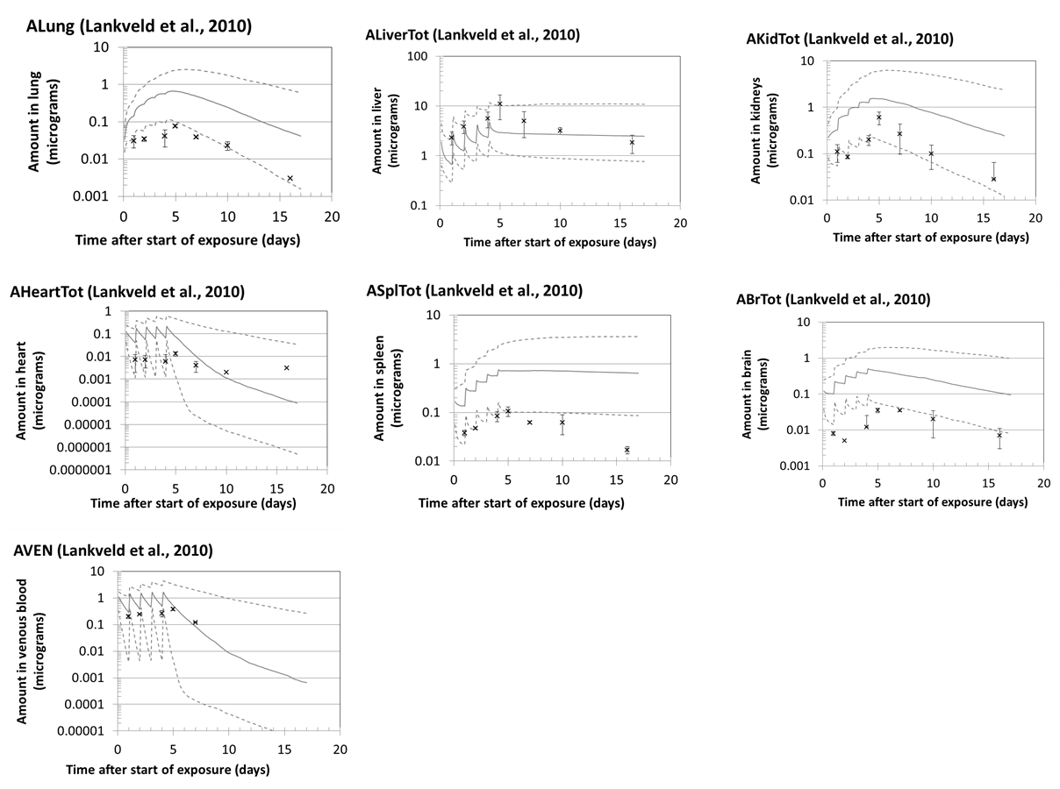**Figure S-2**. Disposition of silver nanoparticles in rats exposed via 5 daily injections of 23.8 µg. Symbols: data of Lankveld et al. (2010) (mean ± standard deviation; n = 3). Lines: PBPK model Monte Carlo simulations; solid line—median; dashed lines—16th and 84th percentiles.

**Table S-3.** Discrepancies between model predictions and experimental data of Fabian et al. (2008).

|  |  |  |
| --- | --- | --- |
| Matrix (n)a | Geometric Mean Discrepancy Indexb | |
|  | SK analysis | SKL analysis |
| Lung (3) | 2.3 | 12 |
| Kidney (1) | 42 | 23 |
| Liver (2) | 25 | 45 |
| Spleen (1) | 2.1 | 6.0 |
| All (8) | 8.0 | 19 |

a n = number of experimental data points for a specific matrix.

b Discrepancy index = maximum of predicted value/measured value or predicted/measured value. Agreement considered acceptable if the discrepancy is, on average, <2 (IPCS, 2010).

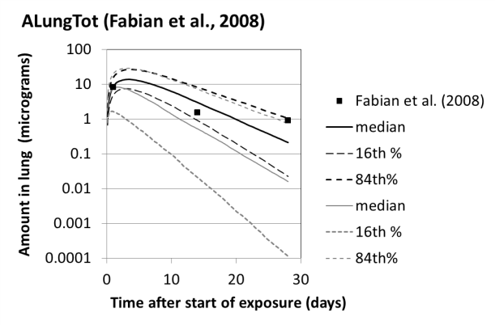

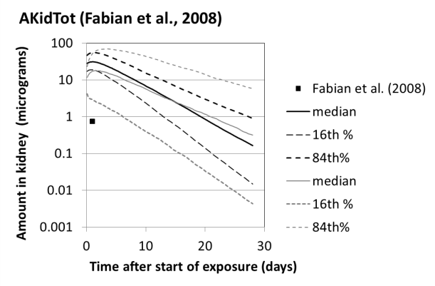

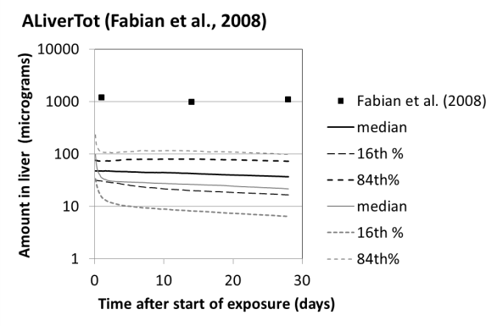

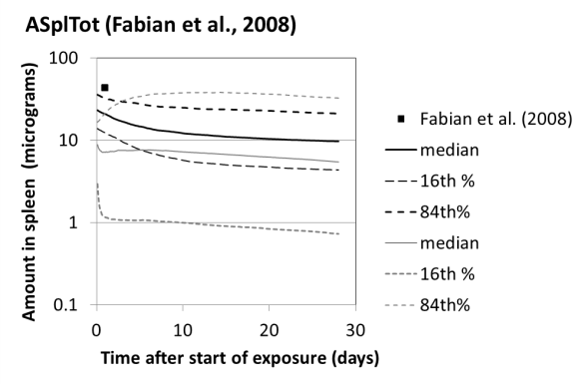

**Figure S-3.** Disposition of titanium dioxide nanoparticles in rats exposed via a single iv injection at 5.0 mg/kg. ◼ Experimental data (Fabian et al., 2008). Lines: PBPK model Monte Carlo simulations. Solid lines: median; dashed lines: 16th and 84th percentiles; black: SK analysis; gray: SKL analysis.