Figure 3: Crosswalk of ICF* classification to development of survey domains**

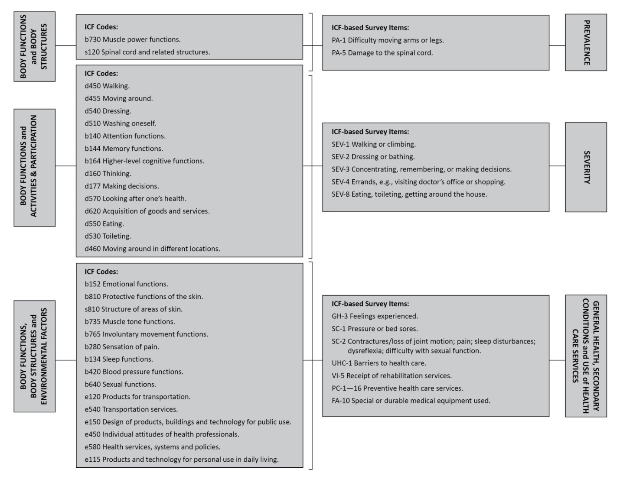

* International classification of functioning, disability and health (ICF). Geneva, Switzerland: World Health Organization; 2007. http://www.who.int/classifications/icf/en/index.html author: Geneva Switzerland.
** The complete survey is available upon request

