Supplementary Table 1: Distribution of covariates for invasive breast cancer diagnosed in 2011 from high quality registries*; original and imputed data
N = 188,824, n = 178,125 | Percent of Cases
Imputation Number | Original | 1 | 2 | 3 | 4 | 5 | 6 | 7 | 8 | 9 | 10
Demographics
Age at diagnosis†
0–34 years | 1.8 | 1.8 | 1.8 | 1.8 | 1.8 | 1.8 | 1.8 | 1.8 | 1.8 | 1.8 | 1.8
35–44 years | 8.8 | 8.8 | 8.8 | 8.8 | 8.8 | 8.8 | 8.8 | 8.8 | 8.8 | 8.8 | 8.8
45–54 years | 22.0 | 22.0 | 22.0 | 22.0 | 22.0 | 22.0 | 22.0 | 22.0 | 22.0 | 22.0 | 22.0
55–64 years | 27.5 | 27.5 | 27.5 | 27.5 | 27.5 | 27.5 | 27.5 | 27.5 | 27.5 | 27.5 | 27.5
65–74 years | 24.4 | 24.4 | 24.4 | 24.4 | 24.4 | 24.4 | 24.4 | 24.4 | 24.4 | 24.4 | 24.4
75–84 years | 15.6 | 15.6 | 15.6 | 15.6 | 15.6 | 15.6 | 15.6 | 15.6 | 15.6 | 15.6 | 15.6
10,600 cases age 85+ were excluded
Race
White | 82.7 | 83.9 | 83.9 | 83.9 | 84.0 | 83.9 | 83.9 | 83.9 | 83.9 | 83.9 | 83.9
Black | 11.9 | 12.0 | 12.0 | 12.0 | 12.0 | 12.0 | 12.0 | 12.0 | 12.0 | 12.0 | 12.0
API | 4.0 | 4.1 | 4.1 | 4.1 | 4.1 | 4.1 | 4.1 | 4.1 | 4.1 | 4.1 | 4.1
Unknown (imputed) | 1.0 | None | None | None | None | None | None | None | None | None | None
Ethnicity†
Non-Hispanic | 93.1 | 93.1 | 93.1 | 93.1 | 93.1 | 93.1 | 93.1 | 93.1 | 93.1 | 93.1 | 93.1
Hispanic | 6.9 | 6.9 | 6.9 | 6.9 | 6.9 | 6.9 | 6.9 | 6.9 | 6.9 | 6.9 | 6.9
Clinical Variables
Reporting Source
Hospital inpatient/outpatient | 93.9 | 92.9 | 92.9 | 92.9 | 92.8 | 92.9 | 92.9 | 92.9 | 92.9 | 92.9 | 92.9
Radiation Facilities or Other Hospital Outpatient | 4.0 | 5.0 | 5.0 | 5.0 | 5.0 | 5.0 | 5.0 | 5.0 | 5.0 | 5.0 | 5.0
Laboratory & Physican's Office | 2.1 | 2.1 | 2.2 | 2.1 | 2.1 | 2.1 | 2.2 | 2.1 | 2.2 | 2.1 | 2.1
SEER Summary Stage
Local | 64.1 | 64.9 | 64.9 | 64.9 | 64.9 | 64.9 | 64.9 | 64.9 | 64.9 | 64.9 | 64.9
Regional | 28.8 | 29.1 | 29.1 | 29.1 | 29.1 | 29.1 | 29.1 | 29.1 | 29.1 | 29.1 | 29.1
Distant | 5.6 | 6.0 | 6.0 | 6.0 | 6.0 | 6.0 | 6.0 | 6.0 | 6.0 | 6.0 | 6.0
Unknown (imputed) | 1.5 | None | None | None | None | None | None | None | None | None | None
SEER Grade
Well Differentiated | 0.2 | 22.6 | 22.7 | 22.6 | 22.6 | 22.6 | 22.6 | 22.6 | 22.6 | 22.6 | 22.6
Moderately Differentiated | 41.2 | 44.2 | 44.1 | 44.2 | 44.1 | 44.2 | 44.1 | 44.1 | 44.2 | 44.1 | 44.2
Poorly & Undifferentiated | 30.8 | 33.2 | 33.2 | 33.2 | 33.2 | 33.2 | 33.2 | 33.2 | 33.2 | 33.3 | 33.3
Unknown (imputed) | 6.8 | None | None | None | None | None | None | None | None | None | None
Histology
Ductal | 75.6 | 76.8 | 76.8 | 76.8 | 76.8 | 76.8 | 76.8 | 76.8 | 76.8 | 76.8 | 76.8
Lobular | 8.9 | 9.0 | 9.0 | 9.0 | 9.0 | 9.0 | 9.0 | 9.0 | 9.0 | 9.0 | 9.0
Mixed | 9.2 | 9.3 | 9.3 | 9.3 | 9.3 | 9.3 | 9.3 | 9.3 | 9.3 | 9.3 | 9.3
Other | 4.7 | 4.9 | 4.9 | 4.9 | 4.9 | 4.9 | 4.8 | 4.9 | 4.8 | 4.9 | 4.9
Unknown (imputed) | 1.6 | None | None | None | None | None | None | None | None | None | None
Surgery
None | 9.3 | 9.3 | 9.3 | 9.3 | 9.3 | 9.3 | 9.3 | 9.3 | 9.3 | 9.3 | 9.3
Yes | 90.7 | 90.7 | 90.7 | 90.7 | 90.7 | 90.7 | 90.7 | 90.7 | 90.7 | 90.7 | 90.7
CS Tumor Size
≤ 1 | 1.4 | 1.5 | 1.5 | 1.5 | 1.5 | 1.5 | 1.5 | 1.5 | 1.5 | 1.5 | 1.5
1.1 – 2.0 | 26.1 | 26.7 | 26.7 | 26.7 | 26.7 | 26.7 | 26.7 | 26.7 | 26.7 | 26.7 | 26.7
2.1 – 3.0 | 61.4 | 63.8 | 63.8 | 63.8 | 63.8 | 63.8 | 63.8 | 63.8 | 63.8 | 63.9 | 63.8
≥3.1 | 7.1 | 8.0 | 8.0 | 8.0 | 8.0 | 8.0 | 8.0 | 8.0 | 8.0 | 8.0 | 8.0
Unknown (imputed) | 4.1 | None | None | None | None | None | None | None | None | None | None
Subtype
ER Status
Positive‡ | 78.3 | 81.7 | 81.7 | 81.7 | 81.7 | 81.7 | 81.7 | 81.7 | 81.7 | 81.7 | 81.7
Negative | 17.2 | 18.3 | 18.3 | 18.3 | 18.3 | 18.3 | 18.3 | 18.3 | 18.3 | 18.3 | 18.3
Unknown (imputed) | 4.5 | None | None | None | None | None | None | None | None | None | None
PR Status
Positive‡ | 68.2 | 71.5 | 71.5 | 71.5 | 71.5 | 71.5 | 71.5 | 71.5 | 71.5 | 71.5 | 71.5
Negative | 27.0 | 28.6 | 28.5 | 28.5 | 28.5 | 28.5 | 28.5 | 28.5 | 28.5 | 28.5 | 28.5
Unknown (imputed) | 4.8 | None | None | None | None | None | None | None | None | None | None
HER2 Status
Positive§ | 12.8 | 14.7 | 14.8 | 14.7 | 14.7 | 14.7 | 14.7 | 14.7 | 14.7 | 14.7 | 14.7
Negative | 76.4 | 85.4 | 85.3 | 85.3 | 85.3 | 85.3 | 85.3 | 85.3 | 85.3 | 85.3 | 85.3
Unknown (imputed) | 10.7 | None | None | None | None | None | None | None | None | None | None
Area-based Variables
County-Level Beale Codes (2013)†
Metro | 85.3 | 85.3 | 85.3 | 85.3 | 85.3 | 85.3 | 85.3 | 85.3 | 85.3 | 85.3 | 85.3
Non-Metro | 14.7 | 14.7 | 14.7 | 14.7 | 14.7 | 14.7 | 14.7 | 14.7 | 14.7 | 14.7 | 14.7
104 cases unknown county were excluded
% Persons in Poverty (County)†
Low Poverty | 21.0 | 21.0 | 21.0 | 21.0 | 21.0 | 21.0 | 21.0 | 21.0 | 21.0 | 21.0 | 21.0
Middle Poverty | 67.5 | 67.5 | 67.5 | 67.5 | 67.5 | 67.5 | 67.5 | 67.5 | 67.5 | 67.5 | 67.5
High Poverty | 11.5 | 11.5 | 11.5 | 11.5 | 11.5 | 11.5 | 11.5 | 11.5 | 11.5 | 11.5 | 11.5
104 cases unknown county were excluded
% Persons in Poverty (Tract)^{†,ǁ}
Low Poverty | 51.9 | 52.6 | 52.6 | 52.6 | 52.6 | 52.6 | 52.6 | 52.6 | 52.6 | 52.6 | 52.6
Middle Poverty | 28.8 | 29.2 | 29.2 | 29.2 | 29.2 | 29.2 | 29.2 | 29.2 | 29.2 | 29.2 | 29.2
High Poverty | 17.9 | 18.2 | 18.2 | 18.2 | 18.2 | 18.2 | 18.2 | 18.2 | 18.2 | 18.2 | 18.2
Unknown (imputed) | 1.4 | None | None | None | None | None | None | None | None | None | None

* Population-based registries meeting NAACCR quality criteria and high completeness of HR/HER2 data include: Alaska, California, Colorado, Connecticut, Delaware, District of Columbia, Florida, Georgia, Hawai'i, Idaho, Illinois, Indiana, Iowa, Kansas, Kentucky, Louisiana, Maine, Maryland, Massachusetts, Michigan, Mississippi, Missouri, Montana, Nebraska, New Hampshire, New Jersey, New Mexico, New York, North Carolina, North Dakota, Ohio, Oregon, Pennsylvania, Rhode Island, South Carolina, South Dakota, Utah, Vermont, Virginia, Washington, West Virginia, Wisconsin, Wyoming.
† Cases with unknown codes for these variables were removed from analysis.
‡ Includes borderline tumors.
§ Excludes borderline tumors.
ǁ Database with census tract-level poverty is a subset of the high quality registries who report tract-level poverty category: Alaska, California, Colorado, Connecticut, Delaware, District of Columbia, Florida, Georgia, Hawai'i, Idaho, Illinois, Indiana, Iowa, Kentucky, Louisiana, Maryland, Detroit, New Hampshire, New Jersey, New Mexico, New York, North Carolina, Ohio, Pennsylvania, Rhode Island, South Carolina, South Dakota, Utah, Vermont, Washington, West Virginia, Wisconsin, Wyoming.
API = Asian/Pacific Islander; SEER = Surveillance, Epidemiology, and End Results Program.CS = collaborative stage; ER = estrogen receptor; PR = progesterone receptor; HER2 = human epidermal growth factor receptor 2.

Supplementary Table 2. Age-specific incidence rates of invasive breast cancer by subtype, by race/ethnicity, for diagnosis year 2011 and areas in the United States with high-quality incidence data*
Race/Ethnicity | Age | HR+/HER2+ | HR-/HER2+ | HR+/HER2- | Triple Negative
Non-Hispanic | 0–34 | 1.28 | 0.49 | 3.36 | 1.32
White | 35–44 | 13.69 | 5.61 | 61.14 | 14.43
 | 45–54 | 24.50 | 10.59 | 151.61 | 25.83
 | 55–64 | 30.43 | 13.68 | 223.74 | 33.91
 | 65–74 | 34.72 | 15.20 | 358.41 | 44.73
 | 75–84 | 34.02 | 11.91 | 362.94 | 42.20
Non-Hispanic | 0–34 | 1.06 | 0.49 | 3.43 | 1.98
Black | 35–44 | 13.40 | 5.47 | 54.41 | 28.34
 | 45–54 | 27.08 | 14.09 | 114.23 | 53.38
 | 55–64 | 33.99 | 19.43 | 179.43 | 69.33
 | 65–74 | 32.25 | 15.96 | 285.05 | 76.48
 | 75–84 | 28.20 | 18.56 | 286.89 | 65.26
non-Hispanic | 0–34 | 0.89 | 0.39 | 3.43 | 1.45
Asian/Pacific | 35–44 | 14.23 | 6.21 | 60.19 | 10.49
Islander | 45–54 | 23.18 | 12.81 | 123.28 | 18.31
 | 55–64 | 25.13 | 18.69 | 156.44 | 24.20
 | 65–74 | 25.96 | 11.88 | 204.48 | 30.20
 | 75–84 | 21.09 | 11.33 | 177.42 | 27.56
Hispanics | 0–34 | 0.55 | 0.32 | 1.63 | 0.86
 | 35–44 | 10.54 | 5.28 | 40.76 | 12.44
 | 45–54 | 20.90 | 10.25 | 104.77 | 22.75
 | 55–64 | 25.95 | 14.35 | 161.37 | 29.38
 | 65–74 | 29.68 | 12.63 | 237.58 | 28.35
 | 75–84 | 23.47 | 11.08 | 257.64 | 35.82
* Population-based registries meeting NAACCR quality criteria and high completeness of HR/HER2 data include: Alaska, California, Colorado, Connecticut, Delaware, District of Columbia, Florida, Georgia, Hawai'i, Idaho, Illinois, Indiana, Iowa, Kansas, Kentucky, Louisiana, Maine, Maryland, Massachusetts, Michigan, Mississippi, Missouri, Montana, Nebraska, New Hampshire, New Jersey, New Mexico, New York, North Carolina, North Dakota, Ohio, Oregon, Pennsylvania, Rhode Island, South Carolina, South Dakota, Utah, Vermont, Virginia, Washington, West Virginia, Wisconsin, Wyoming.
HR = hormone receptor; HER2 = human epidermal growth factor receptor 2.
Supplementary Table 3. Age-specific incidence rates of invasive breast cancer by subtype, stage, race/ethnicity for diagnosis year 2011 and areas in the United States with high-quality incidence data*
Subtype | Stage | Non-Hispanic |  |  | Hispanic
 |  | White | Black | Asian/PI
HR+/HER2- | Local | 63.51 | 44.43 | 43.16 | 40.94
 | Regional | 25.09 | 24.20 | 18.46 | 19.92
 | Distant | 4.32 | 5.79 | 2.57 | 3.01
Triple Negative | Local | 9.15 | 14.99 | 6.55 | 6.73
 | Regional | 4.37 | 9.82 | 3.09 | 4.13
 | Distant | 0.99 | 2.41 | 0.75 | 0.87
HR+/HER2+ | Local | 7.20 | 6.06 | 6.07 | 5.19
 | Regional | 4.51 | 5.26 | 4.13 | 4.17
 | Distant | 1.12 | 1.58 | 0.69 | 0.88
HR-/HER2+ | Local | 2.76 | 2.97 | 3.20 | 2.45
 | Regional | 2.06 | 2.79 | 2.21 | 2.02
 | Distant | 0.57 | 0.95 | 0.53 | 0.59
* Population-based registries meeting NAACCR quality criteria and high completeness of HR/HER2 data include: Alaska, California, Colorado, Connecticut, Delaware, District of Columbia, Florida, Georgia, Hawai'i, Idaho, Illinois, Indiana, Iowa, Kansas, Kentucky, Louisiana, Maine, Maryland, Massachusetts, Michigan, Mississippi, Missouri, Montana, Nebraska, New Hampshire, New Jersey, New Mexico, New York, North Carolina, North Dakota, Ohio, Oregon, Pennsylvania, Rhode Island, South Carolina, South Dakota, Utah, Vermont, Virginia, Washington, West Virginia, Wisconsin, Wyoming.

HR = hormone receptor; HER2 = human epidermal growth factor receptor 2; PI = Pacific Islander.
Supplementary Table 4. Age-specific incidence rates of invasive breast cancer by subtype, grade race/ethnicity for diagnosis year 2011 and areas in the United States with high-quality incidence data*
Subtype | Grade | Non-Hispanic |  |  | Hispanic
 |  | White | Black | Asian/PI
HR+/HER2- | Well | 28.15 | 16.83 | 16.12 | 17.18
 | Moderately | 46.88 | 35.47 | 32.94 | 32.33
 | Poorly/Undifferentiated | 17.90 | 22.13 | 15.13 | 14.35
Triple Negative | Well | 0.309 | 0.480 | 0.396 | 0.185
 | Moderately | 2.143 | 3.985 | 2.765 | 1.872
 | Poorly/Undifferentiated | 7.936 | 22.758 | 11.345 | 9.680
HR+/HER2+ | Well | 1.00 | 0.79 | 0.64 | 0.73
 | Moderately | 5.46 | 5.13 | 4.37 | 4.21
 | Poorly/Undifferentiated | 6.36 | 6.99 | 5.89 | 5.30
HR-/HER2+ | Well | 0.09 | 0.05 | 0.05 | 0.05
 | Moderately | 1.22 | 1.35 | 1.15 | 1.00
 | Poorly/Undifferentiated | 4.09 | 5.32 | 4.75 | 4.01
* Population-based registries meeting NAACCR quality criteria and high completeness of HR/HER2 data include: Alaska, California, Colorado, Connecticut, Delaware, District of Columbia, Florida, Georgia, Hawai'i, Idaho, Illinois, Indiana, Iowa, Kansas, Kentucky, Louisiana, Maine, Maryland, Massachusetts, Michigan, Mississippi, Missouri, Montana, Nebraska, New Hampshire, New Jersey, New Mexico, New York, North Carolina, North Dakota, Ohio, Oregon, Pennsylvania, Rhode Island, South Carolina, South Dakota, Utah, Vermont, Virginia, Washington, West Virginia, Wisconsin, Wyoming.

HR = hormone receptor; HER2 = human epidermal growth factor receptor 2; PI = Pacific Islander.
Supplementary Table 5. Age-specific incidence rates of invasive breast cancer by subtype, census tract poverty, race/ethnicity for diagnosis year 2011 and areas in the United States with high-quality incidence data reporting census tract-based poverty measure*
Subtype | Census Tract Poverty |  | Non-Hispanic |  |  | Hispanic
 |  |  | White | Black | Asian/PI
HR+/HER2- |  | Lowest Poverty | 98.39 | 83.7 | 71.94 | 77.54
 |  | Middle Poverty | 85.67 | 77.07 | 64.8 | 65.55
 |  | Highest Poverty | 83.76 | 69.81 | 55.87 | 59.36
Triple Negative |  | Lowest Poverty | 14.41 | 29.13 | 11.61 | 13.17
 |  | Middle Poverty | 14.16 | 27.12 | 9.33 | 12.19
 |  | Highest Poverty | 14.44 | 26.21 | 10.11 | 11.69
HR+/HER2+ |  | Lowest Poverty | 12.94 | 14.75 | 11.41 | 10.92
 |  | Middle Poverty | 12.44 | 13.36 | 11.39 | 11.2
 |  | Highest Poverty | 11.97 | 11.89 | 12.21 | 10.15
HR-/HER2+ |  | Lowest Poverty | 5.37 | 6.79 | 5.78 | 5.77
 |  | Middle Poverty | 5.25 | 6.57 | 7.01 | 5.1
 |  | Highest Poverty | 5.04 | 6.92 | 6.96 | 4.86
* Database with census tract-level poverty is a subset of the high quality registries who report tract-level poverty category: Alaska, California, Colorado, Connecticut, Delaware, District of Columbia, Florida, Georgia, Hawai'i, Idaho, Illinois, Indiana, Iowa, Kentucky, Louisiana, Maryland, Detroit, New Hampshire, New Jersey, New Mexico, New York, North Carolina, Ohio, Pennsylvania, Rhode Island, South Carolina, South Dakota, Utah, Vermont, Washington, West Virginia, Wisconsin, Wyoming.

HR = hormone receptor; HER2 = human epidermal growth factor receptor 2; PI = Pacific Islander.

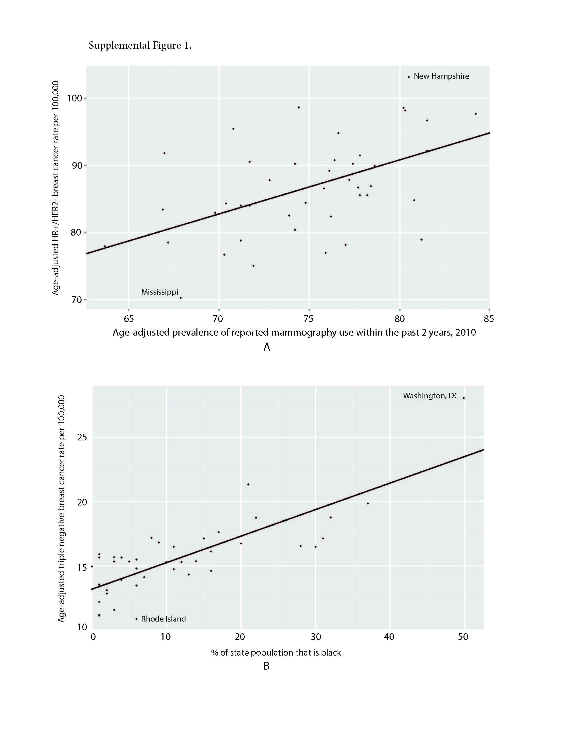Supplementary Figure 1. Scatterplot of state-level breast cancer rates versus correlated state-level risk factors. A. Scatterplot of state-level, age-adjusted invasive HR+/HER2- breast cancer rates for non-Hispanic white women plotted against state-level, reported mammography use which shows increasing rates of HR+/HER2- cancers correlated with increasing mammography use (Pearson <.001). B. Scatterplot of state-level, age adjusted invasive triple negative breast cancer rates plotted against the percent of state-level black population which shows increasing rates of triple negative cancers correlated with increasing percent black population (Pearson <.001). All statistical tests were two-sided.

