S1. The tenofovir (TFV) and emtricitabine (FTC) drug concentration patterns by pill count and self-report geometric mean at 90% and at 100%, BotswanaTDF2 PrEP trial, 2007-2010
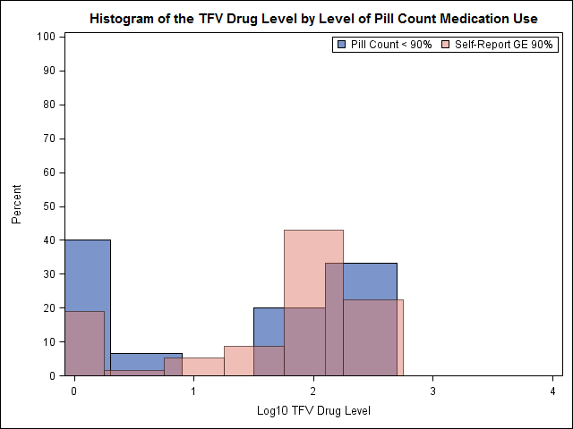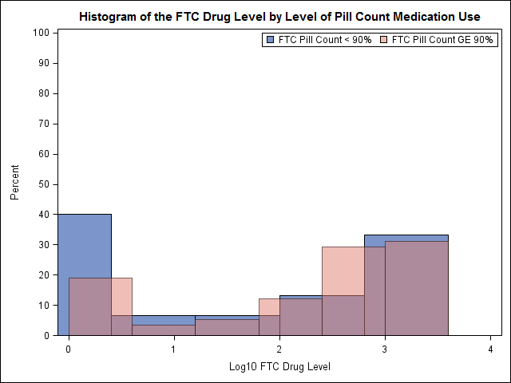
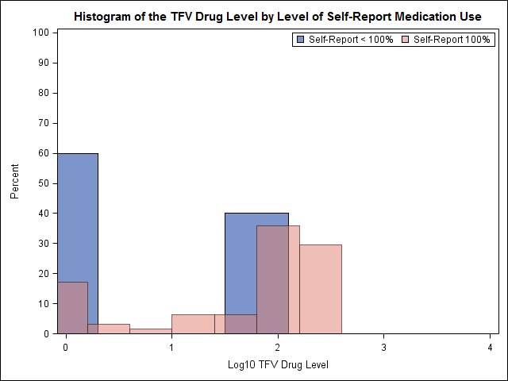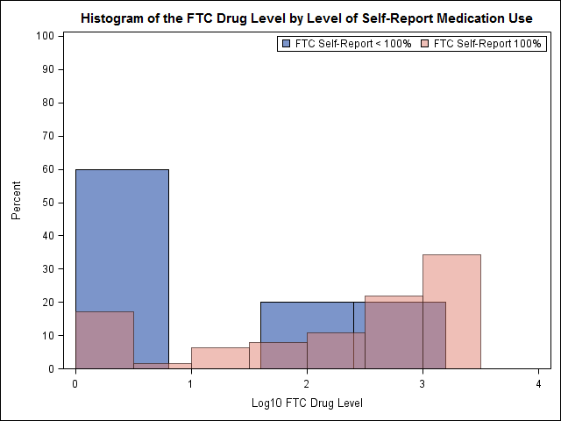
Drug concentration samples for seroconvertors were collected before or near the estimated date of infection; samples for non-seroconvertors were selected around the same study visit
Sample size was the same for TFV (n=73) and FTC (n=73)
Sample size for pill count data was: GE 90% and <90% (58 and 15 for n=73); 100% and <100% (43 and 30 for n=73)
Sample size for self-report: GE 90% and <90% (64 and 5 for n=69 (there are 4 missing values for self-report); 100% and <100% (64 and 5 for n= 69)

