Figure 8. Splines for PCE cumulative exposure (µg/L-year) and male breast cancer using RCS with 3 knots (25th, 50th, and 75th percentiles among those with exposure)
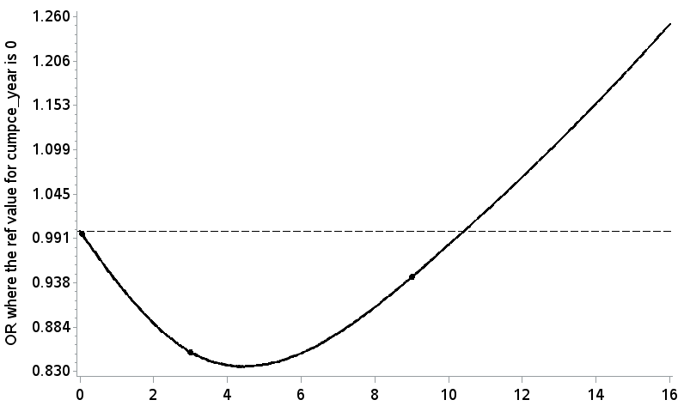
. . . ^{Knots}

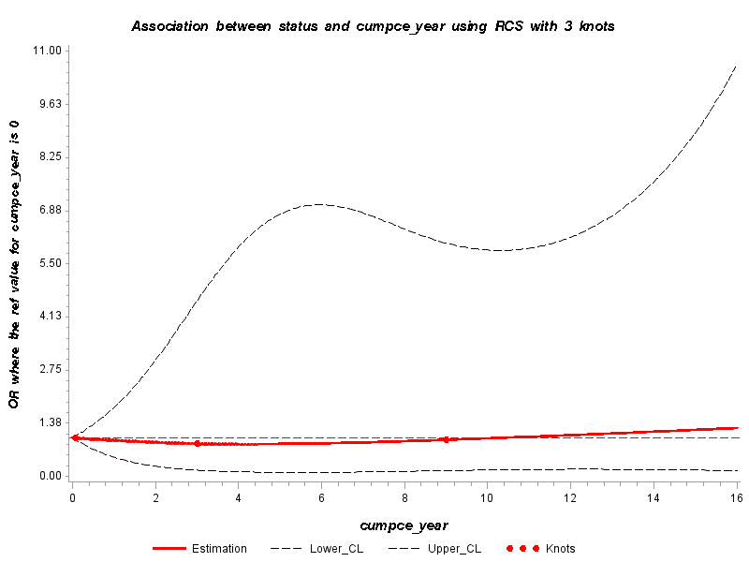

Figure 9. Splines for TCE cumulative exposure (µg/L-year) and male breast cancer using RCS with 3 knots (10th, 50th, and 90th percentiles among those with exposure)
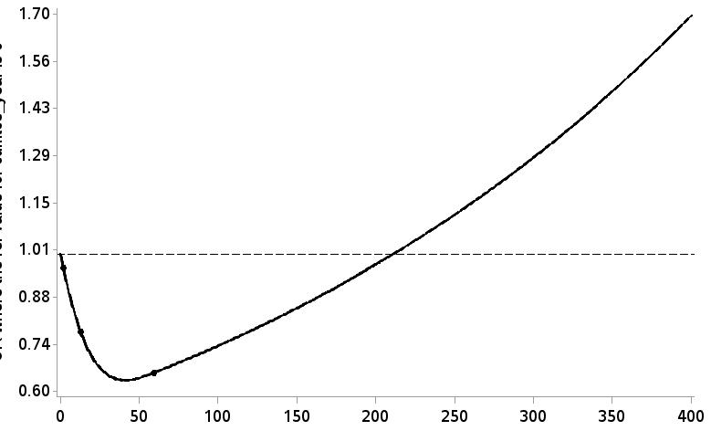
. . . ^{Knots}

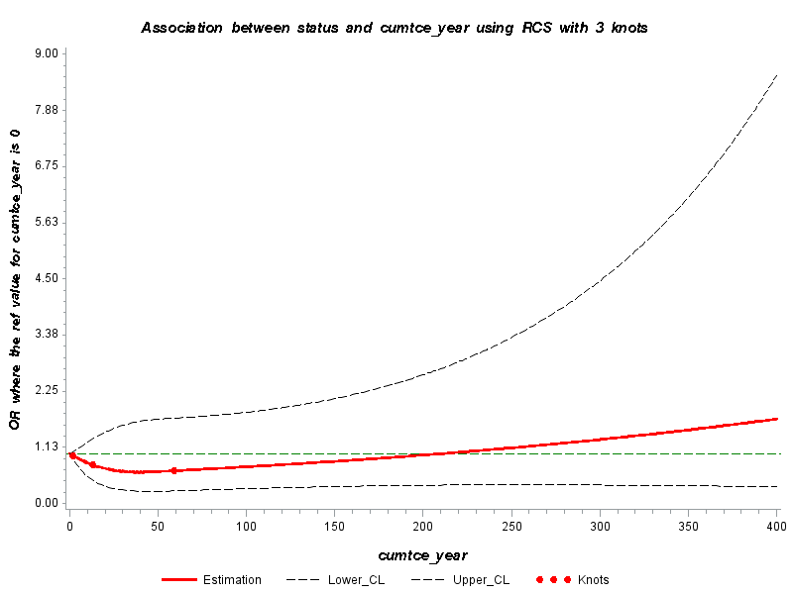

Figure 10. Splines for DCE cumulative exposure (µg/L-year) and male breast cancer using RCS with 3 knots (10th, 50th, and 90th percentiles among those with exposure)
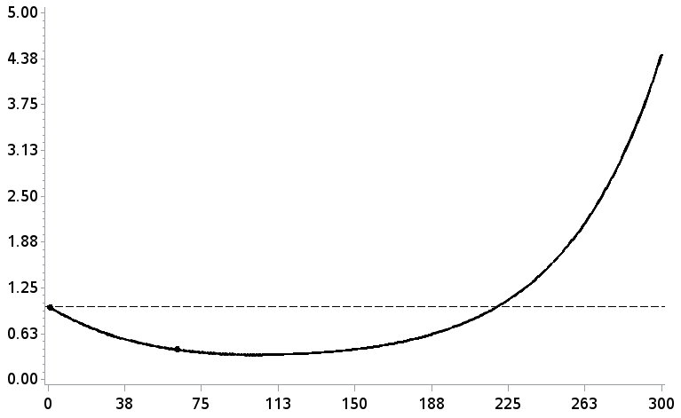
. . . ^{Knots}

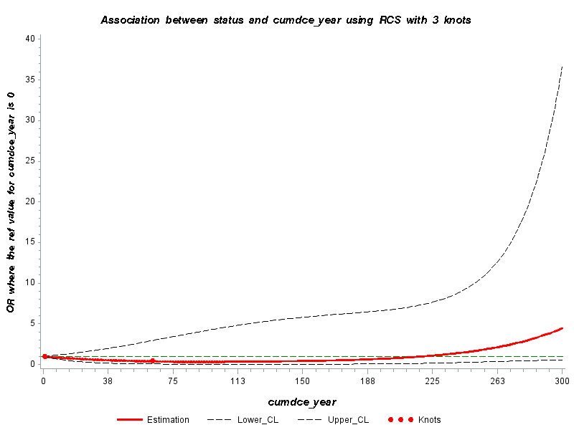

Figure 11. Splines for vinyl chloride cumulative exposure (µg/L-year) and male breast cancer using RCS with 3 knots (20th, 50th, and 80th percentiles among those with exposure)
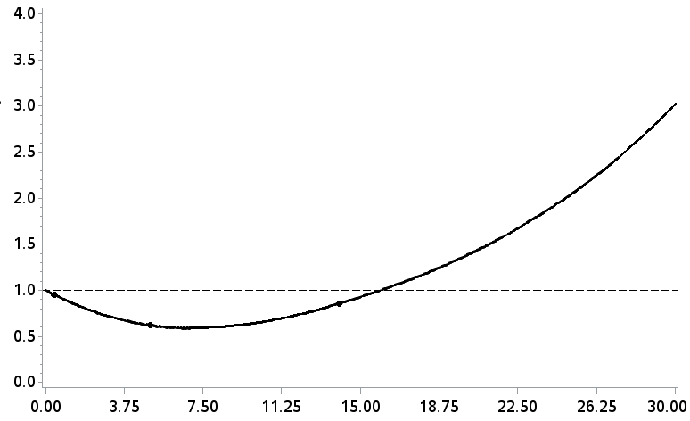
. . . ^{Knots}
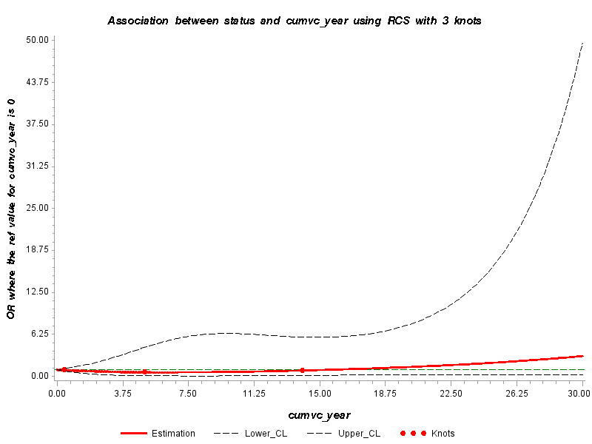

Figure 12. Splines for benzene cumulative exposure (µg/L-year) and male breast cancer using RCS with 3 knots (10th, 50th, and 90th percentiles among those with exposure) 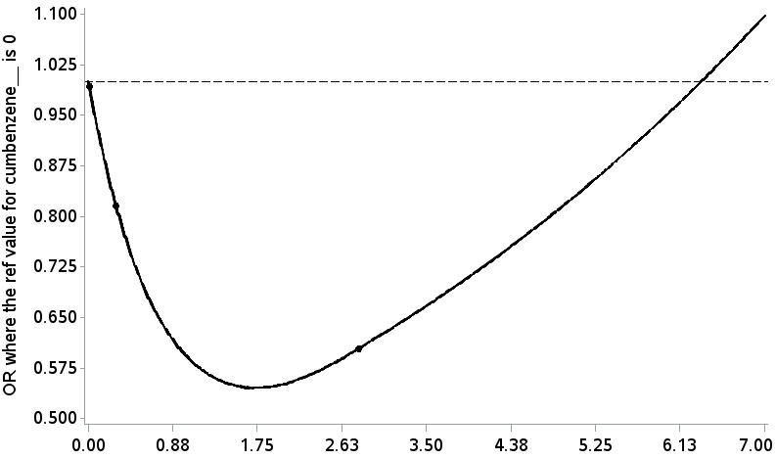
. . . ^{Knots}
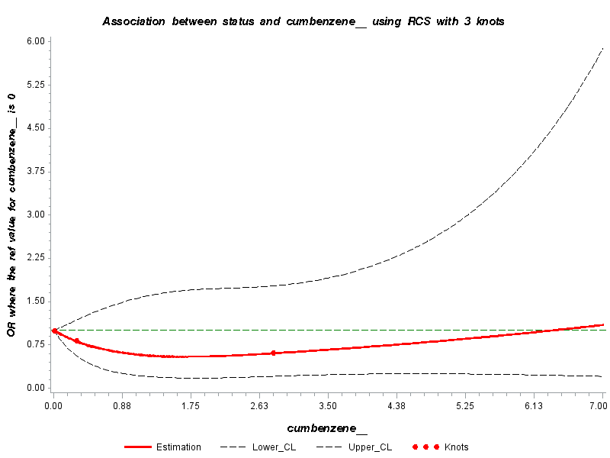
Figure 13. Splines for TVOC cumulative exposure (µg/L-year) and male breast cancer using RCS with 3 knots (5th, 50th, and 95th percentiles among those with exposure)
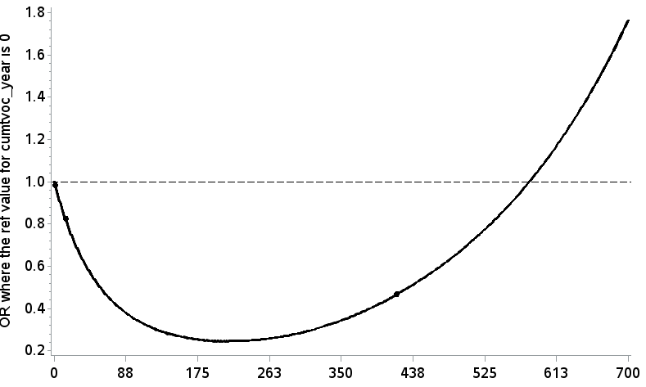
. . . ^{Knots}
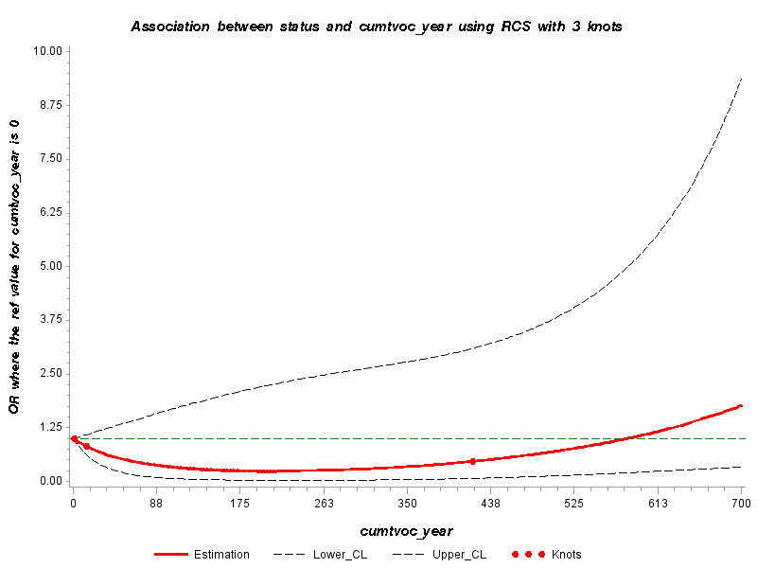

Figure 14. Splines for PCE average exposure (ppb) and male breast cancer using RCS with 3 knots (25th, 50th and 75th percentiles among those with exposure)
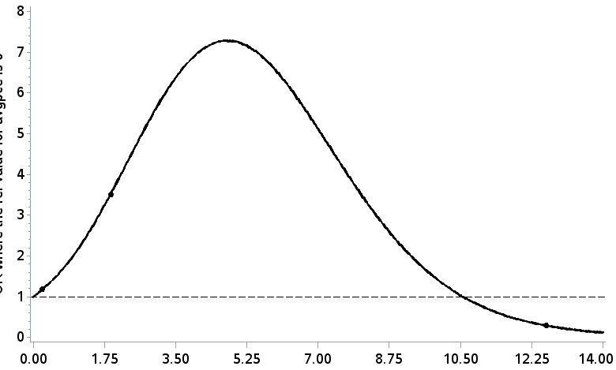
. . . ^{Knots}
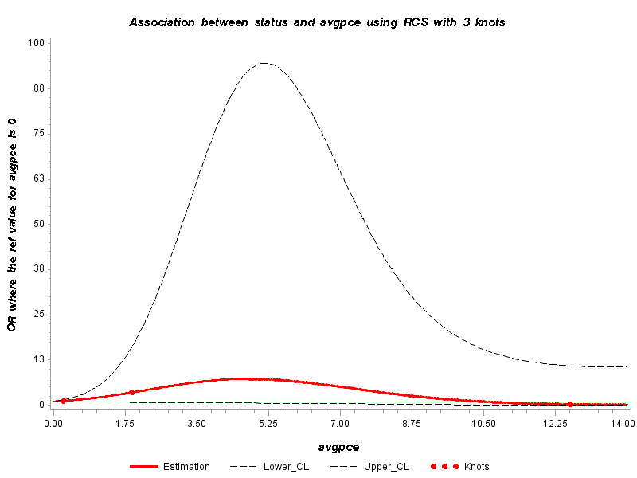

Figure 15. Splines for DCE average exposure (ppb) and male breast cancer using RCS with 3 knots (20th, 50th, and 80th percentiles among those with exposure)
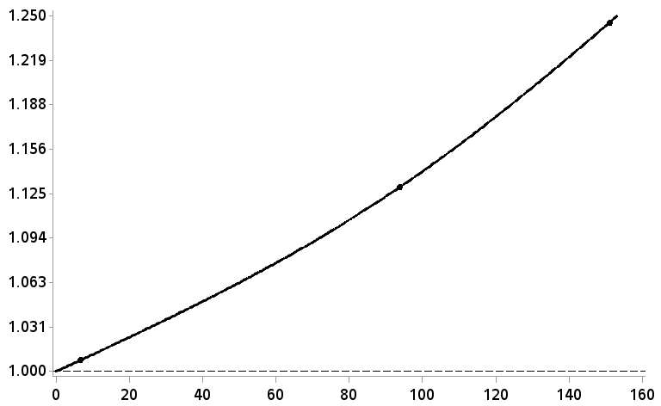

. . . ^{Knots}
