The impact of UVB exposure and differentiation state of primary keratinocytes on their interaction with quantum dots

Luke J. Mortensen¹, Supriya Ravichandran¹, Lisa A. DeLouise^{1,2}

¹Department of Biomedical Engineering and ²Department of Dermatology, University of Rochester

Supplementary Information

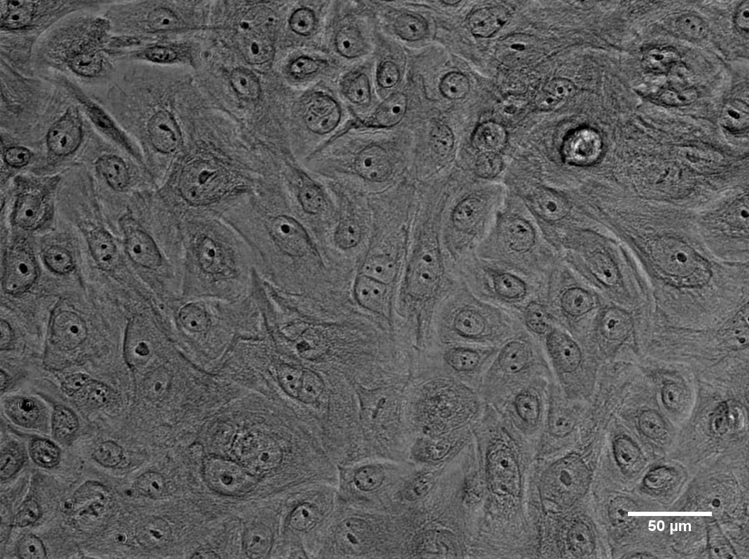
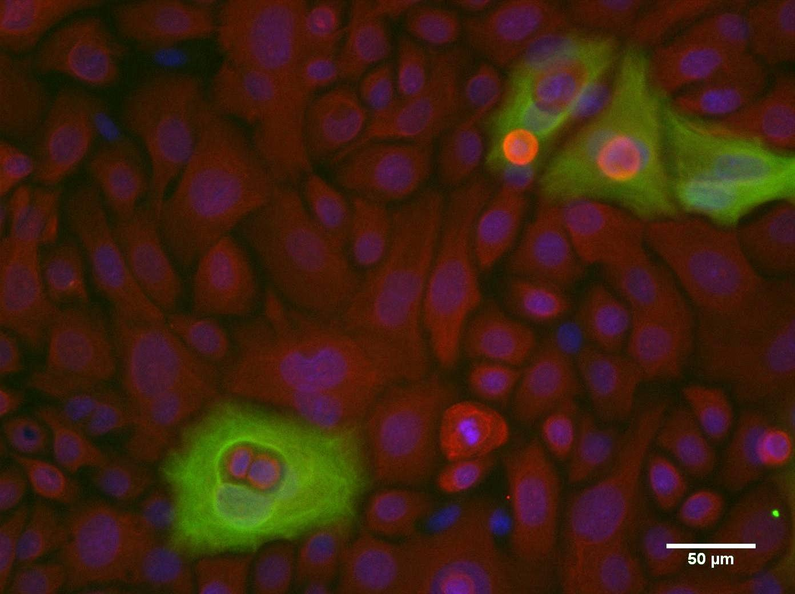
Figure 1S Fluorescent co-stained (left) and bright field (right) images of primary keratinocytes cultured in low calcium media. Keratin 5 staining red (Texas Red). Keratin 10 staining green (FITC). Blue represents DAPI nuclear stain. The presence of cells expressing K10 is a rare in low calcium media and is only observed under high confluent conditions. Images taken at 20x.

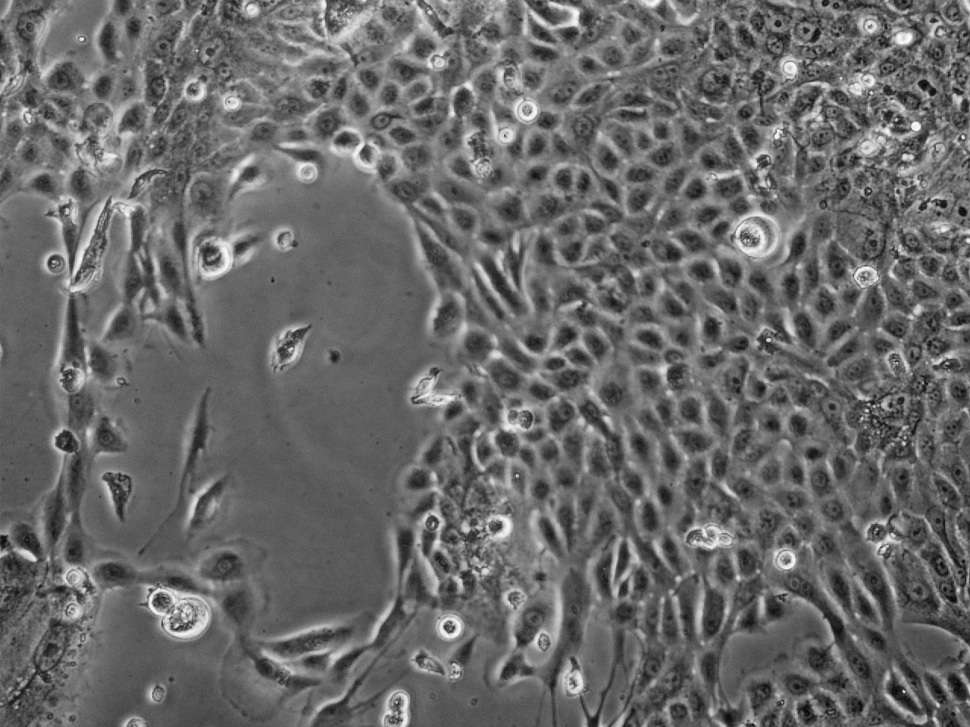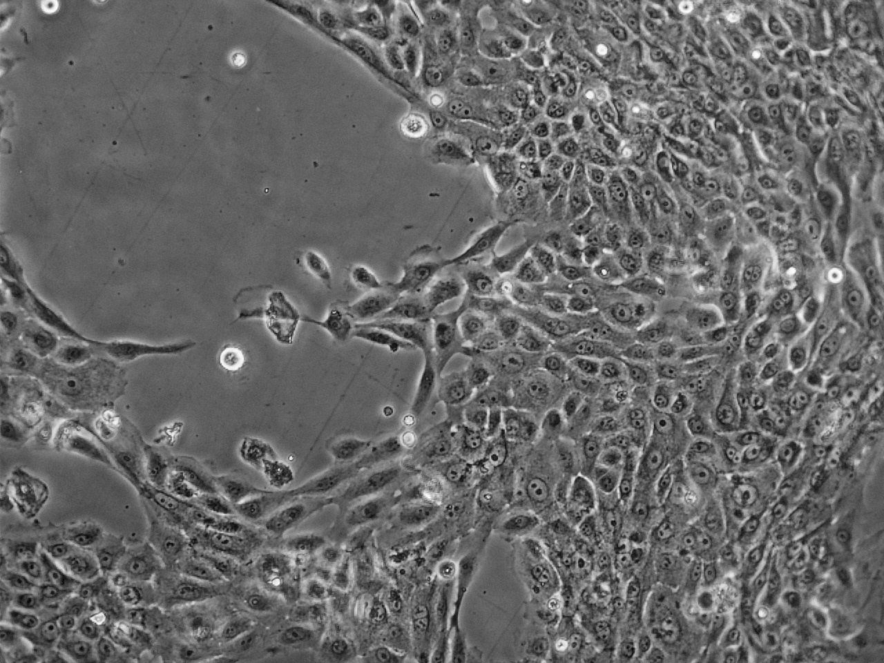
pKC in High Ca- 24 hours
A
B

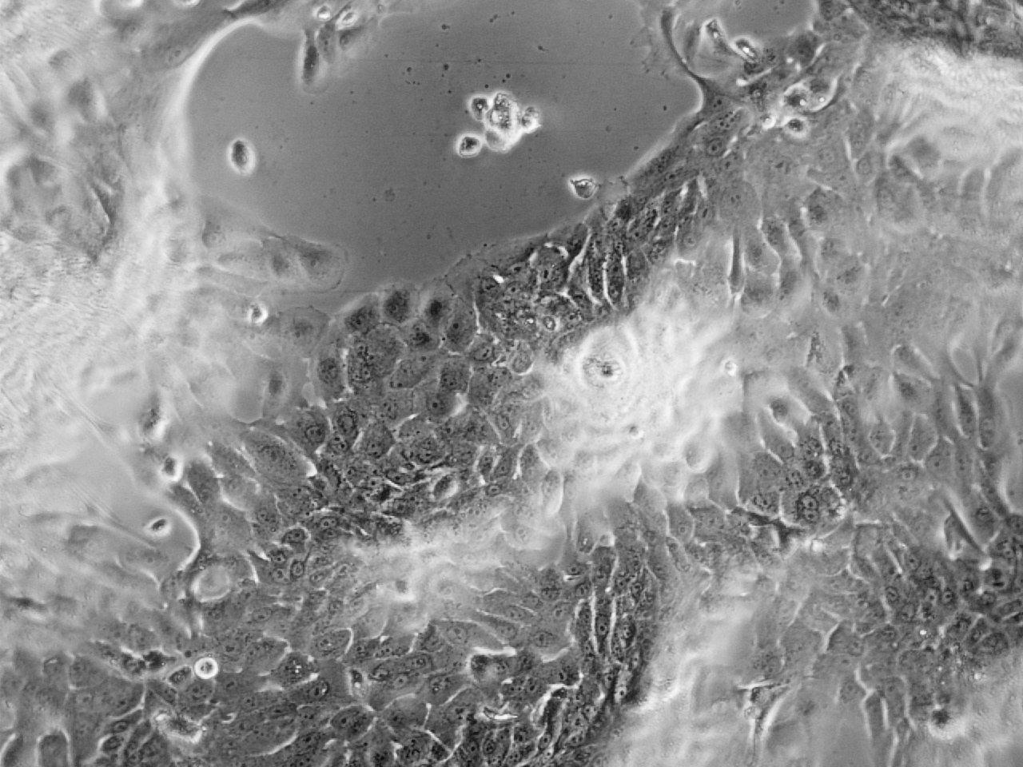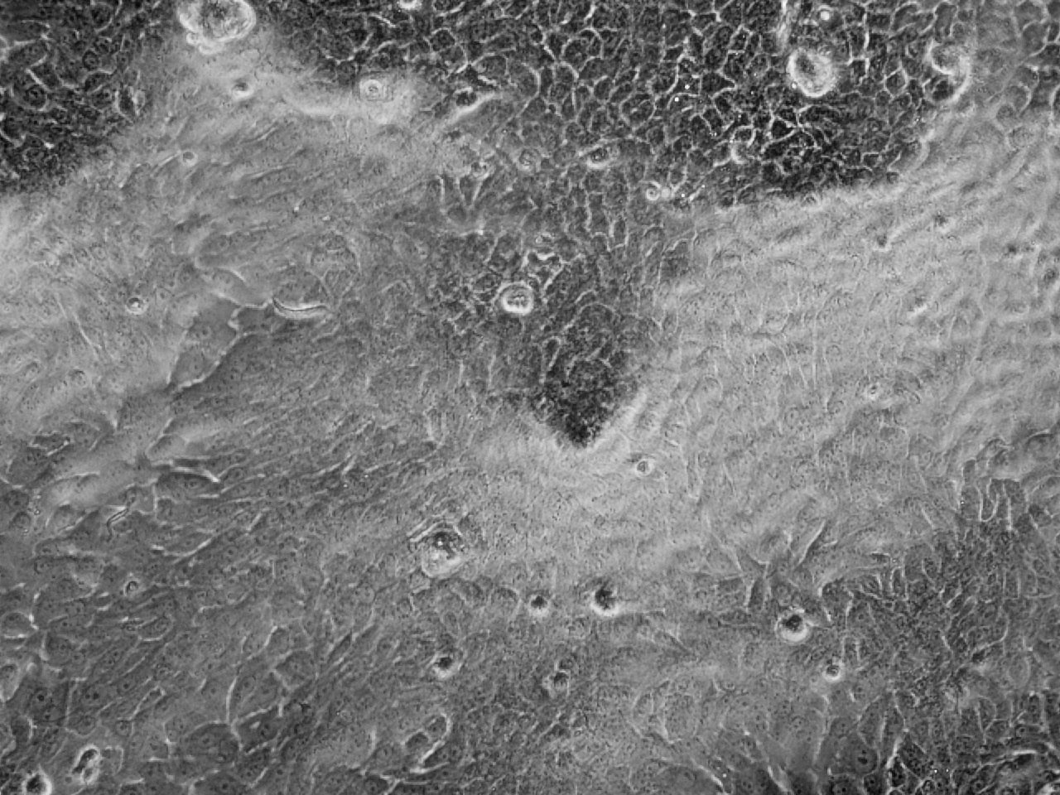
pKC in high Ca- 72 hours
C
D
Figure 2S Bright field images of primary keratinocyte cultured in high calcium media at 24 hours (A and B) and after 72 hours (C and D). After 24 hours cell migration and distinct changes in cell morphology are evident but islands of differentiated cells are not present. After 72 hours large regions of differentiated cells are evident. All images taken at 20x

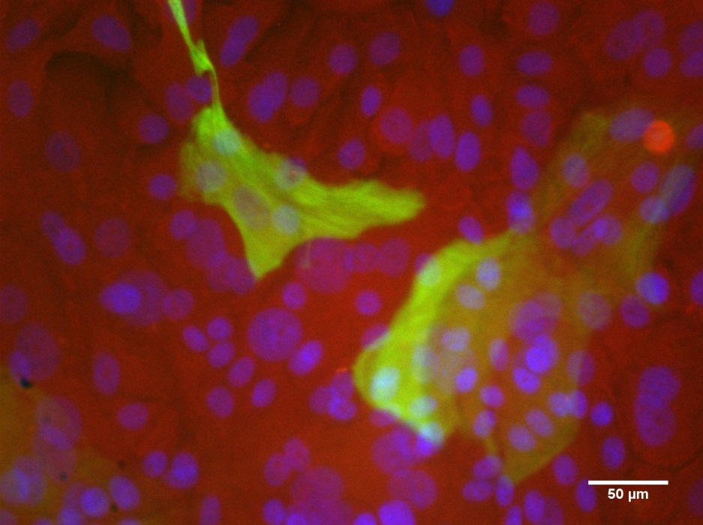
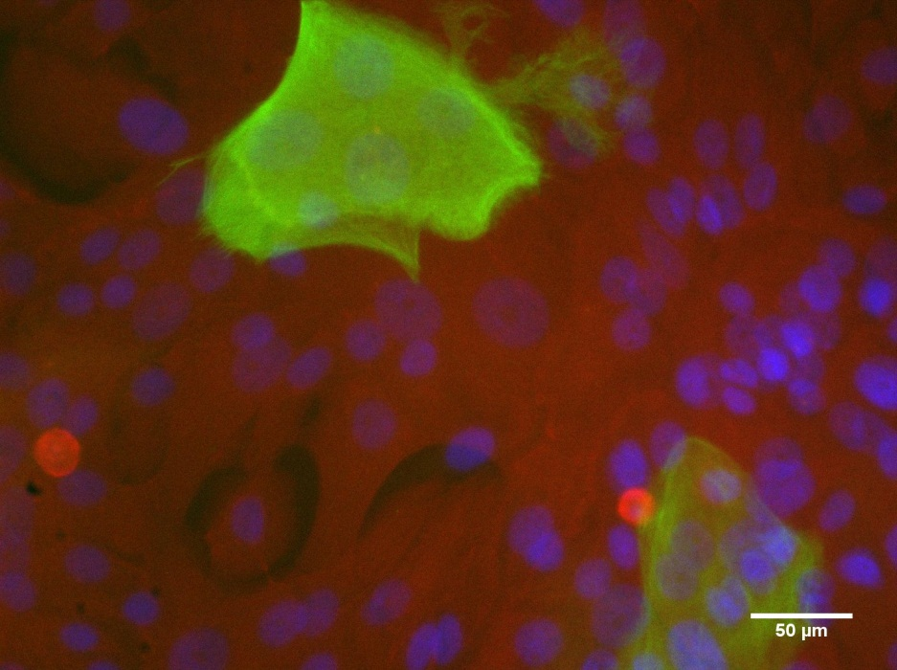
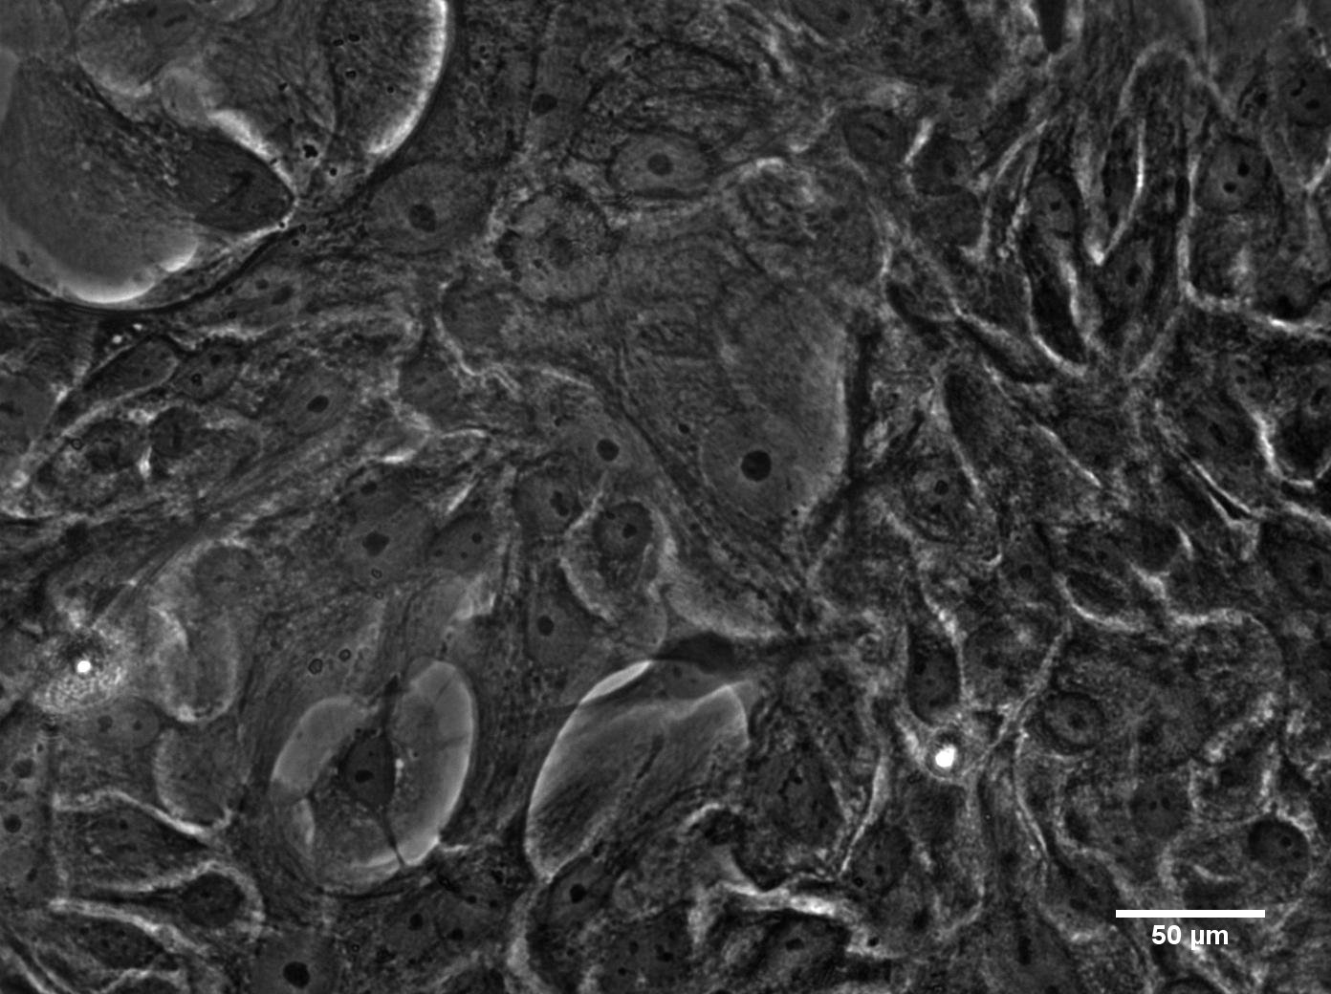
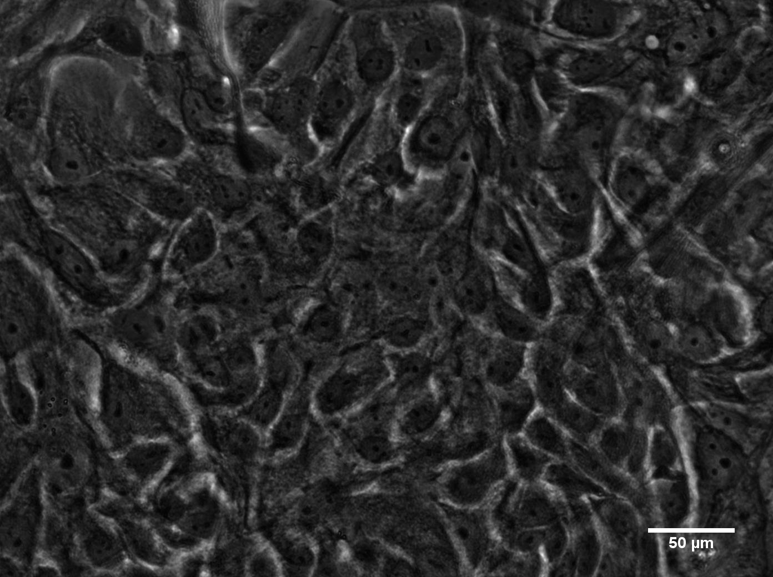
Figure 3S Fluorescent co-stained (left) and bright field (right) images of primary keratinocytes cultured in high calcium media. Keratin 5 staining red (Texas Red). Keratin 10 staining green (FITC). Blue represents DAPI nuclear stain. Large patches of keratin 10 expression is observed over many cell nuclei. Cells neighboring differentiated regions continue to express a keratin 5 basal cell phenotype. Images taken at 20x.

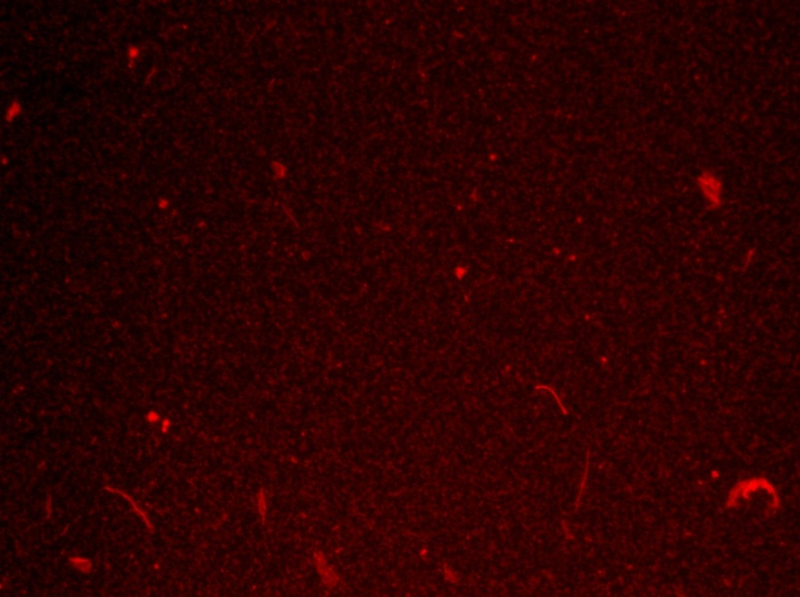
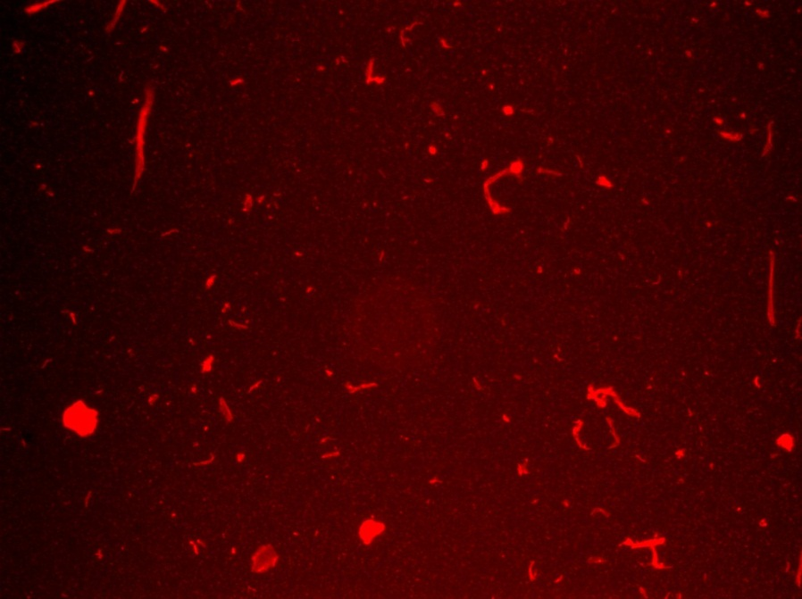
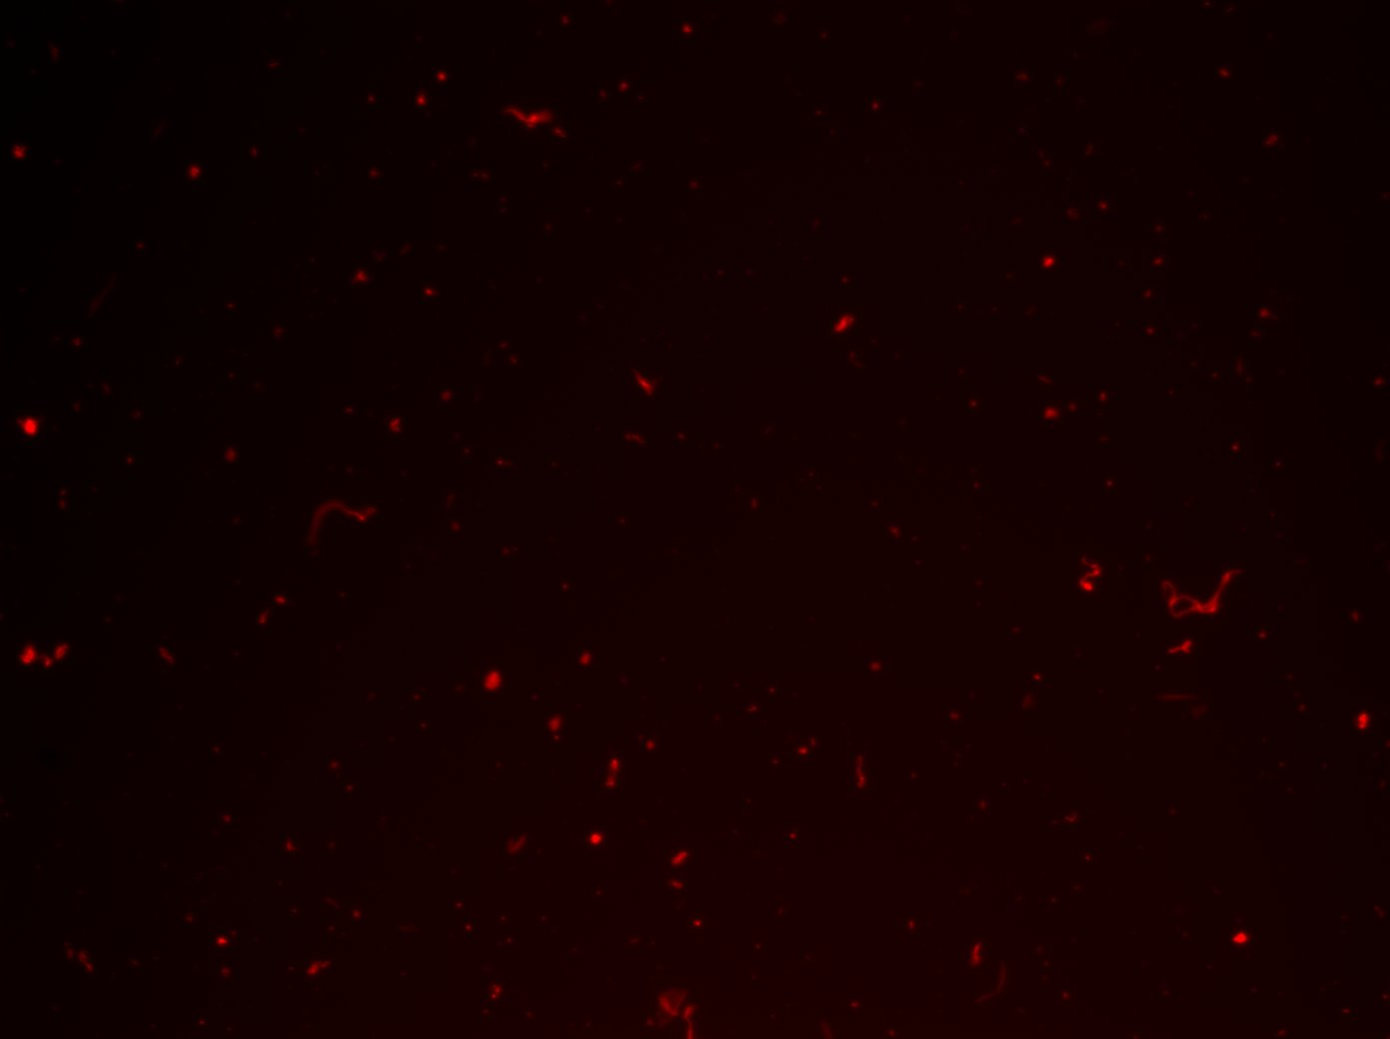
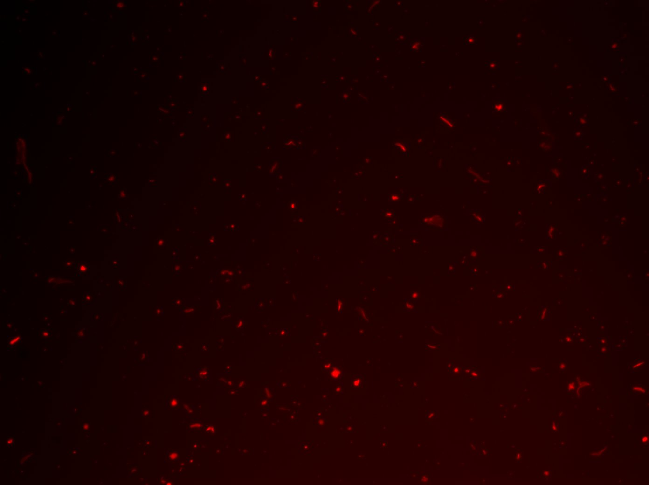
DLHA QDs in media incubated 24 hrs at 37°C
50 nM KGM high Ca
50 nM KGM low Ca
5 nM KGM low Ca

5 nM KGM high Ca

Figure 4S QD precipitation onto tissue culture plate following 24 hrs incubation in high and low calcium media for 24 hours. (A, B) 5 nM QD shows considerable less precipitation than (C, D) 50 nM QD but there does not appear to be an effect of calcium level on precipitation.

