Supplemental Information

Efferocytosis is an innate antibacterial mechanism
Constance J. Martin, Matthew G. Booty, Tracy R. Rosebrock, Cláudio Nunes-Alves, Danielle M. Desjardins, Iris Keren, Sarah M. Fortune, Heinz G. Remold and Samuel M. Behar

Inventory

Supplemental Information:

- Figure S1 – (related to figure 2) Efferocytosis of Mtb in vitro and in vivo
- Figure S2 – (related to figure 4) PGE₂ impairs efferocytosis
- Figure S3 – (related to figure 5) Efferocytosis of apoptotic cells results in digestion of that material
- Figure S4 – (related to figure 6) Efferocytosis delivers Mtb to the lysosome
- Figure S5 – (related to figure 7) Pro-apoptotic Mtb-infected macrophages are efferocytosed at a higher rate and uptake can be blocked in vivo

Supplemental Methods:
- Flow cytometric assay for efferocytosis and phagocytosis
- Live/Dead-H37Rv reporter construction and validation
- Flow cytometric in vivo efferocytosis blockade

Supplemental Information

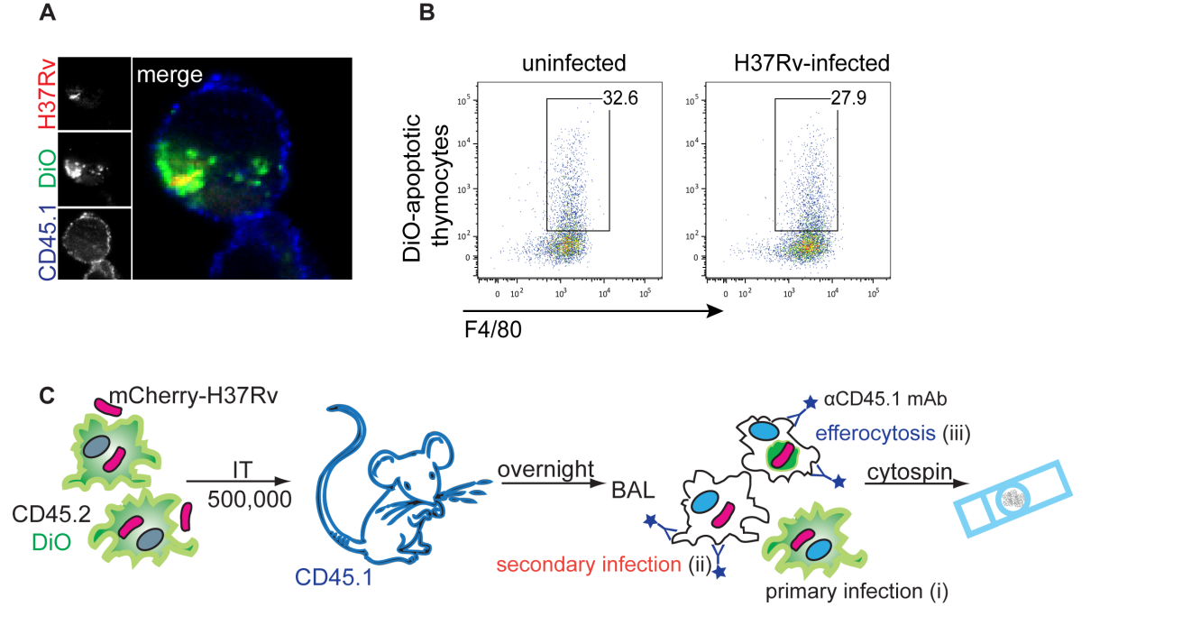
Supplemental Figure 1. Efferocytosis of Mtb in vitro and in vivo.
A. Confocal microscopy images of CD45.2⁺ resident peritoneal macrophages dyed with DiO, infected with mCherry-H37Rv and co-cultured with uninfected undyed CD45.1⁺ resident peritoneal macrophages for 16 hours before fixation and visualization. B. pMφs were left uninfected as a control (left) or infected with H37Rv (MOI 10) for 4 hours, washed, and cultured overnight before the addition of DiO-dyed apoptotic thymocytes for 1 hour. Uninternalized thymocytes were washed away and the remaining cells were analyzed by flow cytometry. Data is representative of 2 experiments. C. Scheme for the study of efferocytosis of Mtb-infected macrophages in vivo.

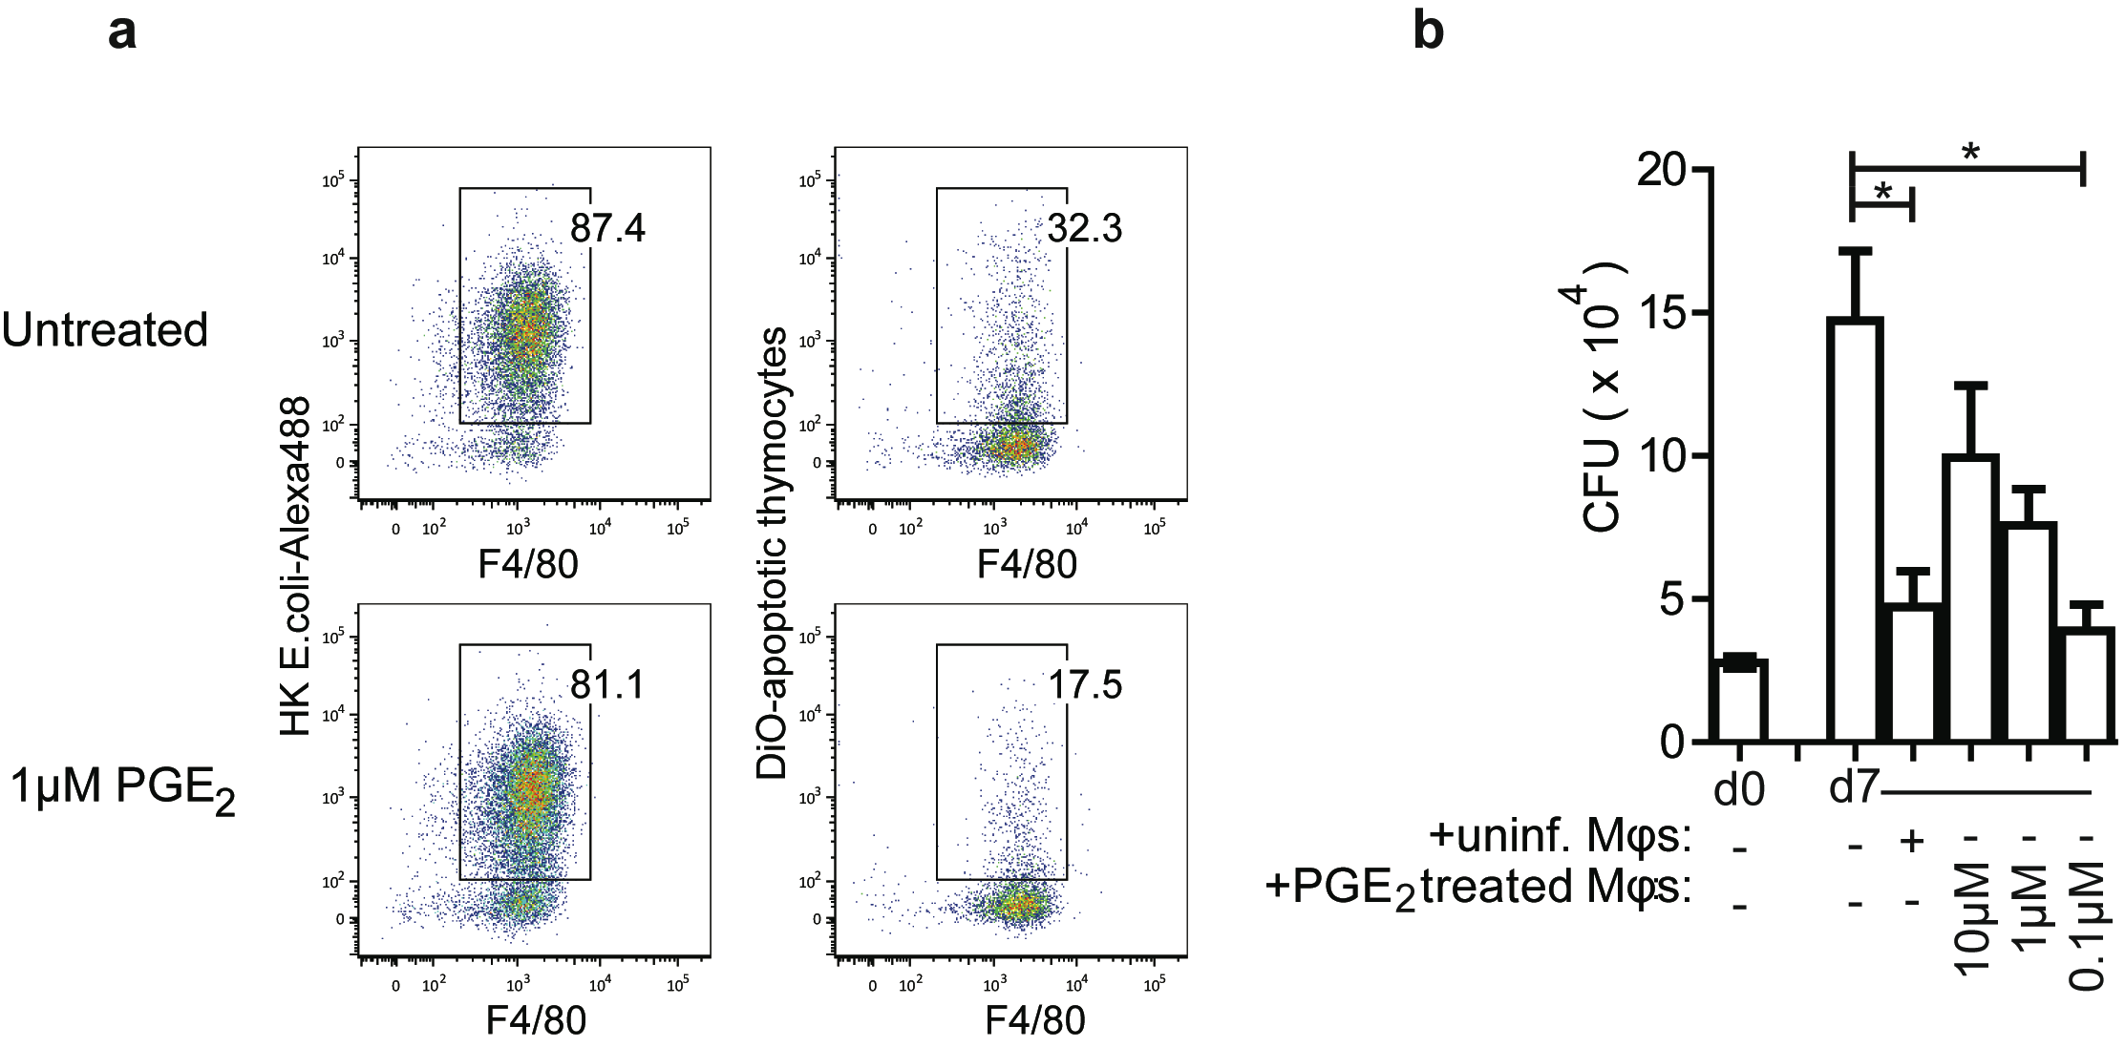
Supplemental Figure 2. PGE₂ inhibits efferocytosis and efferocytosis-mediated CFU control with little impact on phagocytosis.
A. pMφs were incubated with 1µM PGE₂ for 4 hours or left untreated, washed and then cultured with fluorescent heat-killed Escherichia coli (HK E.coli-Alexa488) particles or DiO-dyed apoptotic thymocytes for 1 hour. pMφs were then washed and identified by their staining for Mφ marker F4/80, fixed and analyzed by flow cytometry. Panels shown are gated on live cells, single cells and F4/80. Results are representative of 2 experiments. B. Uninfected pMφs were treated with indicated doses of PGE₂, washed and added to H37Rv-infected pMφs. CFU were determined at time 0 (“d0”) and day 7 (“d7”). Statistical analysis was performed by comparing the growth by d7 (2nd column) to different conditions. Data is representative of 3 experiments. Bars, mean ± SEM. *, p≤0.05 was determined using one-way ANOVA with Dunnet’s post-test.

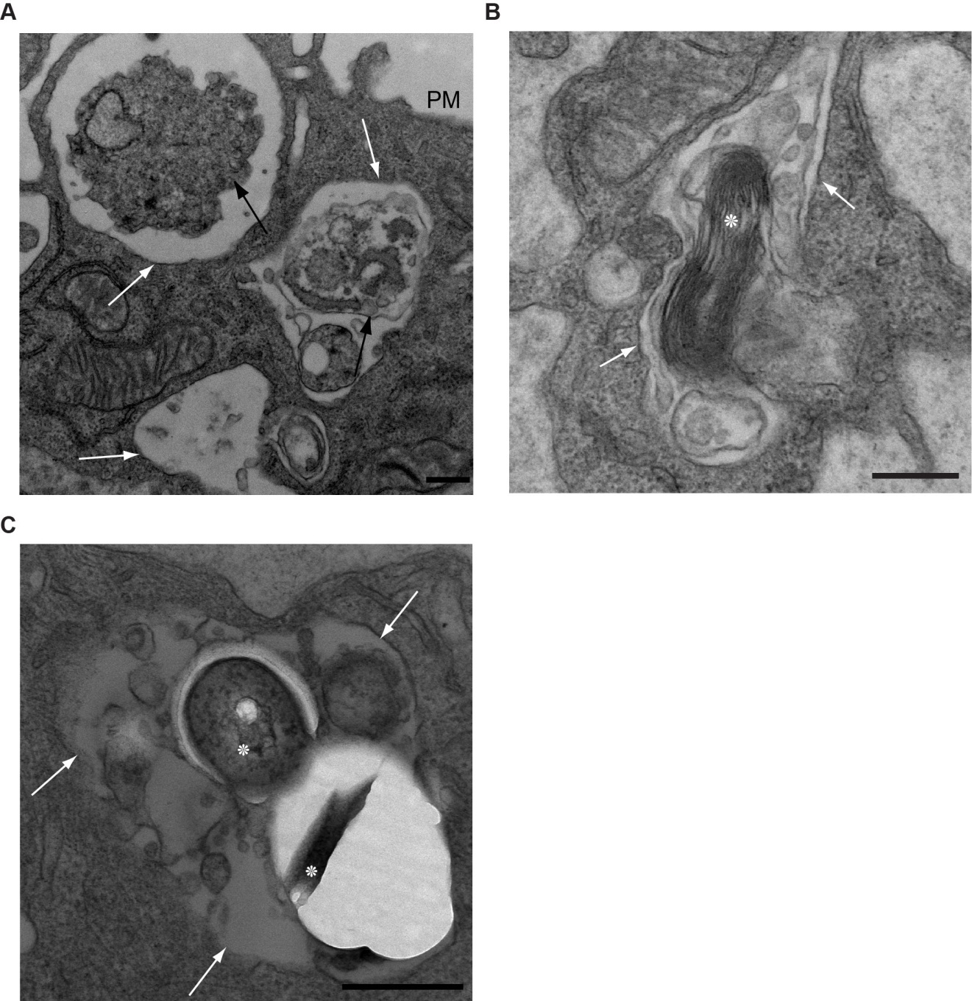

Supplemental Figure 3. Efferocytosis of apoptotic macrophages and Mtb results in digestion.

A, B & C. Transmission electron micrographs of Mtb-infected pMφs were co-cultured for 16 hours with uninfected pMφs before fixation and staining with lead citrate. A. Blebs from an apoptotic Mφ in three stages of digestion within vacuous phagosomes. White arrows: efferocytic phagosome membrane; apoptotic bleb membrane black arrows: apoptotic bleb membrane; PM: plasma membrane. B. Compromised Mtb (asterisk) among cell debris within a vacuous phagosome, defined by white arrows, amongst cell debris. C. Mtb within efferocytic phagosome amongst cell debris. Scale bar, 500nM. Images are representative from 2 experiments with >1000 Mφs examined on multiple non-serial 60nM sections.

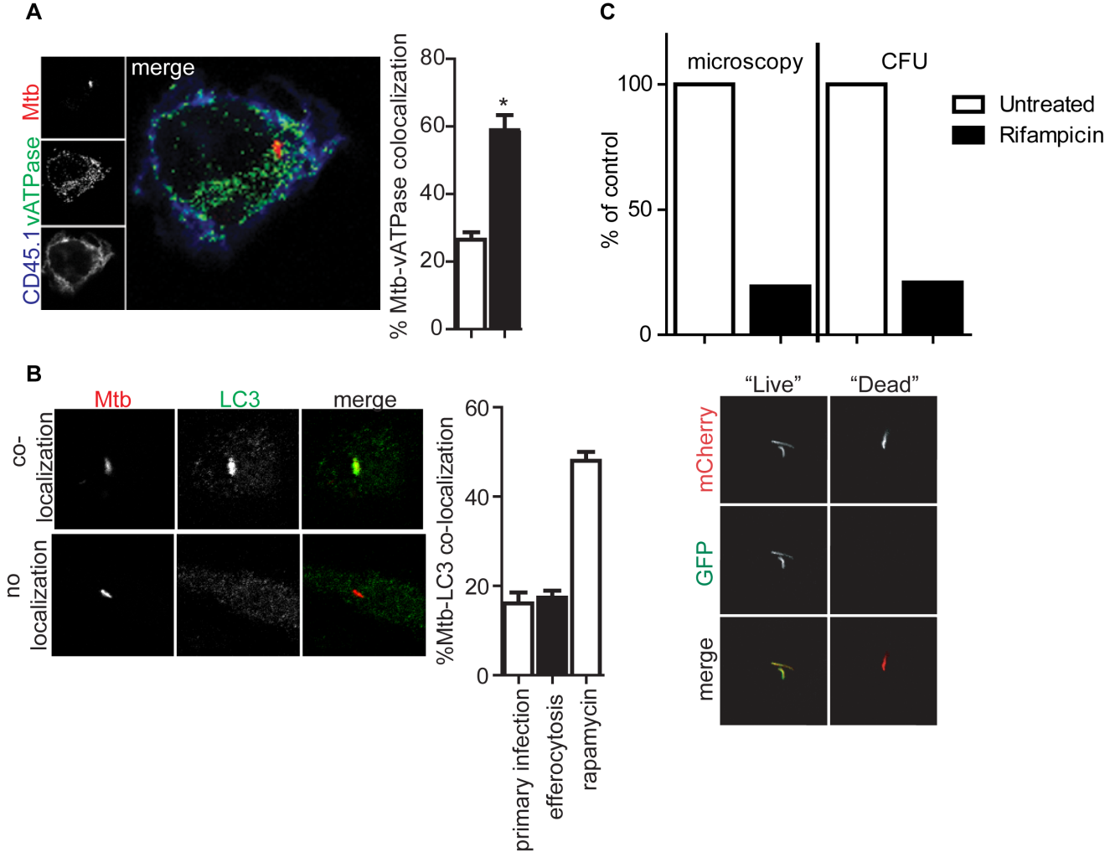
Supplemental Figure 4. Efferocytosis delivers Mtb to the lysosome
A. Mtb co-staining with ATP6v1B2 subunit of the vATPase in BMDMφs. Percent Mtb-vATPase colocalization of total Mtb within either primary infected BMDMφs (clear bar) or CD45.1⁺ BMDMφs (black bar). Data is representative of 2 experiments. Error bars ±SEM. Student’s T-test. B. A. Confocal microscopy images of co-localization (top) and no co-localization (bottom) of Mtb (red) with LC3 (green) and merge within pMφs infected for 16 hours. B. Percent Mtb-LC3 co-localization out of total Mtb counted in either primary infected Mφs or CD45.1⁺ Mφs following co-culture with infected CD45.2⁺ Mφs or after treatment for 6 hours with rapamycin (50µM). 50 Mtb were counted in triplicate per condition. Data is representative of 2 experiments. Error bars, mean ± SEM. C. (top) Primary human monocyte-derived Mφs were infected with Live/Dead H37Rv and were infected with MOI 1 for three days before treatment with rifampicin for one day. Bacterial burden was then ascertained by microscopy or serial dilution and CFU. The ratio red:green (live:dead) pixels were averaged in untreated verses rifampicin treated wells and plotted as percent ‘live’ of control untreated wells. (bottom) Live/Dead Mtb following overnight incubation with 200ng/mL tetracycline. “Live” Mtb are mCherry+ (red) and GFP+ (green) while “Dead” Mtb are mCherry+.

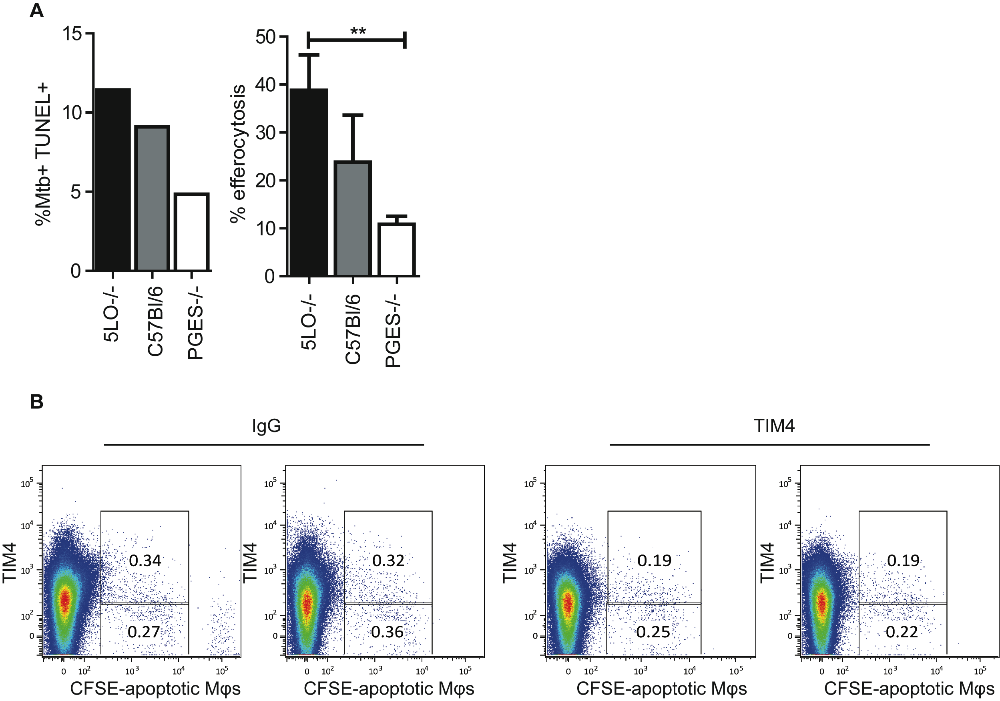
Supplemental Figure 5. Pro-apoptotic Mtb infected macrophages are efferocytosed at a higher rate and uptake can be blocked in vivo.
A (left) pMφs from 5-lipoxigenase deficient, prostaglandin E synthase deficient of wildtype mice were infected with mCherry-H37Rv for two days and apoptotic nuclei were stained by TUNEL. (right) CD45.1 macrophages were added to infected macrophages of indicated genotypes and efferocytosis was assessed as previously described. Data is representative of 3 experiments. Error bars, SEM. One way ANOVA with Student’s T-test. B. FACS plots of CD45.1 splenocytes 2.5 hours after intravenous injection of CFSE-labled apoptototic CD45.2 macrophages and 8 hours post intraperitoneal administration of IgG control or αTIM4 antibody. FACS plots are gated on live cells, singlets, CD45.1⁺ F4/80⁺.

Supplemental Experimental Procedures

Flow Cytometry

pMφs were treated for 4 hours with 0.1-10µM PGE₂ before incubation with Alexa488 E.coli BioParticles (Invitrogen) or staurosporine-treated DiO-dyed thymocytes for 1 hour. Cells were washed, stained with antibodies against F4/80 (BioLegend) and analyzed by flow cytometry on a BD FACS Canto II and using FlowJo software.

Live/Dead Mtb construction
The Live-Dead reporter plasmid contains a mCherry fluorescent protein constitutively expressed by the hsp60 promoter and green florescent protein (GFP) under the control of a tetracycline-inducible promoter. Briefly, we have replaced GFP in the pBEN (Zafer et al, 2001) plasmid with the mCherry fluorescent protein using the BamHI and ClaI sites. This resulted in the plasmid pBen mCherry, which constitutively expresses mCherry driven by the mycobacterial hsp60 promoter. A fragment containing both the hsp60 promoter and mCherry was PCR amplified and inserted into the SwaI and EcoRV sites in the pTetOR plasmid (Ehrt et al, 2005). This plasmid contains an E. coli and a mycobacterial origin of replications, a hygromycin resistance gene and GFP controlled by a tetracycline-inducible promoter. The resulting plasmid, the Live-Dead reporter, constitutively expresses mCherry and conditionally expresses GFP.

Live/Dead Mtb reporter validation
Primary human monocyte-derived Mφs, differentiated by adherence for one week, were infected with Live/Dead-H37Rv at an MOI of 1. Rifampicin (0.25μg/mL) was added three days post infection and bacterial burden was assessed by CFU and imaging. PFA fixed cells were imaged on a Deltavision Epifluorescence microscopy. Z stacks were taken at 0.5 micron intervals for 40 sections. Images were deconvuluted and z stacks were summed with Softworx (Applied Precision). Using Matlab (Mathworks) single cells were identified and total green and red pixels per Mφ were summed for 45 cells. The total number of green pixels was divided by the total number of red pixels to determine the average percentage of living intracellular Mtb.

In vivo efferocytosis blockade
400ug aTIM4 blocking antibody or IgG control (BioXCell) were injected intraperitoneally 4 hours prior to intravenous injection of CFSE-labeled UV-irradiated congenic macrophages. Spleens were isolated 1-3 hours later and engulfment of apoptotic cells were measured by flow cytometry

References
Ehrt, S., X. V. Guo, C. M. Hickey, M. Ryou, M. Monteleone, L. W. Riley, and D. Schnappinger. 2005. Controlling gene expression in mycobacteria with anhydrotetracycline and Tet repressor. Nucleic Acids Res 33:e21.

Zafer, A. A., Y. E. Taylor, and S. A. Sattar. 2001. Rapid screening method for Mycobactericidal activity of chemical germicides that uses Mycobacterium terrae expressing a green fluorescent protein gene. Appl Environ Microbiol 67:1239-45.

