Table A. Comparison of suicide decedents in long-term care versus community settings: Virginia 2003 – 2011
 | Nursing home or Assisted living | Community | p-value
 | N (%) | N (%)
Number of suicides | 51 | 3,402
Location of death
NH | 21 (41.2)
AL | 25 (49.0)
Unknown type but matched to a facility* | 5 (9.8)
Age (mean, SD) | 78.6 (11.4) | 63.3 (10.9) | <0.001
Female | 14 (27.5) | 736 (21.6) | 0.307
White race | 48 (94.1) | 3121 (91.7) | 0.796
Manner of injury
Firearm | 13 (25.5) | 2261 (66.5) | <0.001
Hanging/suffocation | 13 (25.5) | 404 (11.9)
Poisoning | 5 (9.8) | 525 (15.4)
Cutting | 6 (11.8) | 61 (1.8)
Fall | 10 (19.6) | 44 (1.3)
Other/unknown | <5 | 107 (3.2)
Mental and physical health
Depressed mood | 20 (39.2) | 1358 (39.9) | 0.999
Mental health problem | 31 (61.8) | 1812 (53.3) | 0.323
Receiving psychiatric treatment | 29 (56.9) | 1289 (37.9) | 0.008
Alcohol or substance use problem | <5 | 668 (19.6) | 0.002
Physical health problem | 17 (33.3) | 1166 (34.3) | 0.999
History of suicide attempts | 13 (25.5) | 471 (13.8) | 0.024
Disclosed suicidal ideation | 16 (31.4) | 1207 (35.5) | 0.658
Social context
Problems with family, finances, or spouse | 7 (13.7) | 1033 (30.4) | 0.009
Crisis in past 2 weeks | 6 (11.8) | 901 (26.5) | 0.016
P-value from Fisher’s exact test for categorical variables and Wilcoxon rank sum test for continuous variables.
*Unknown type facilities represent address matches to facilities that were no longer operational at the time of the data merger, but through record searches were determined to be long-term care facilities in the past.

Table B. Comparison of suicide decedents in nursing homes versus assisted living facilities: Virginia 2003 – 2011
 | Nursing home | Assisted Living | p-value
 | N (%) | N (%)
Number of suicide deaths | 21 | 25
Age (mean, SD) | 82.3 (9.2) | 76.0 (12.5) | 0.067
Female | 7 (33.3) | 6 (24.0) | 0.527
White race | 20 (95.2) | 25 (100.0) | 0.457
Manner of injury
Firearm | 7 (33.3) | 5 (20.0) | 0.574
Hanging/suffocation | 5 (23.8) | 7 (28.0)
Poisoning | <5 | <5
Cutting | <5 | <5
Fall | 5 (23.8) | <5
Other/unknown | <5 | <5
Mental and physical health
Depressed mood | 8 (38.1) | 9 (36.0) | 1.0
Mental health problem | 11 (52.4) | 16 (64.0) | 0.550
Receiving psychiatric treatment | 10 (47.6) | 15 (60.0) | 0.553
Alcohol or substance use problem | <5 | <5 | 1.0
Physical health problem | 7 (33.3) | 7 (28.0) | 0.755
History of suicide attempts | <5 | 8 (32.0) | 0.188
Disclosed suicidal ideation | 7 (33.3) | 7 (28.0) | 0.755
Social context
Problems with family, finances, or spouse | <5 | 6 (24.0) | 0.106
Crisis in past 2 weeks | <5 | <5 | 1.0
P-value from Fisher’s exact test for categorical variables and Wilcoxon rank sum test for continuous variables.

Table C. Individual-level correlates of suicide in long-term care vs. community settings: Virginia 2003 – 2011
 | Crude | Adjusted
 | Odds Ratio  (95% Confidence Interval) | Odds Ratio  (95% Confidence Interval)
Age | 1.12 (1.09 – 1.15) | --
Female gender (ref. Male) | 1.37 (0.74 – 2.55) | --
Non-white race (ref. White) | 0.69 (0.21 – 2.24) | --
Currently receiving psychiatric treatment (ref. No) | 2.16 (1.24 – 3.78) | 3.81 (2.06 – 7.02)
Current mental health problem (ref. No) | 1.36 (0.77 – 2.40) | 2.21 (1.21 – 4.05)
Current depressed mood (ref. No) | 0.97 (0.55 – 1.71) | 0.95 (0.53 – 1.69)
Contributing physical health problem (ref. No) | 0.96 (0.53 – 1.72) | 0.41 (0.22 – 0.77)
History of suicide attempts (ref. No) | 2.13 (1.13 – 4.03) | 4.02 (1.92 – 8.40)
Disclosed ideation (ref. No) | 0.83 (0.46 – 1.51) | 0.83 (0.45 – 1.52)
Recent crisis (ref. No) | 0.37 (0.16 – 0.87) | 0.48 (0.20 – 1.14)
Problems with family, finances, or spouse (ref. No) | 0.36 (0.16 – 0.81) | 0.92 (0.40 – 2.14)
N | 3,453 | 3,453
Models adjusted for age, gender, and race.

Table D. Characteristics of long-term care facilities with and without a suicide decedent: Virginia 2003 - 2011
 | Facility with decedent | Facility without decedent | p-value
Nursing homes
N facilities | 16 | 268
N suicides | 21
Number of beds (M, SD) | 103.9 (85.5) | 113 (57.1) | 0.266
Ownership (N, %)
For-profit | 7 (43.8) | 188 (70.2) | 0.055
Non-profit | 7 (43.8) | 61 (22.8)
Religious | 0 | 9 (3.4)
Government | 2 (12.5) | 10 (3.7)
Part of a CCRC (N, %) | 8 (50.0) | 26 (9.7) | 0.001
Family/residents council (N, %)
None | 1 (6.3) | 9 (3.4) | 0.515
Resident or family council | 10 (62.5) | 181 (67.8)
Both family & resident council | 5 (31.3) | 77 (28.8)
General quality ratings (range 1 – 5)
Overall rating (M, SD) | 4.1 (1.1) | 3.1 (1.4) | 0.006
Health rating (M, SD) | 3.5 (1.2) | 2.8 (1.3) | 0.024
Staff rating (M, SD) | 4.0 (1.1) | 3.0 (1.2) | 0.002
Quality rating (M, SD) | 4.1 (1.1) | 3.8 (1.1) | 0.097
Specific quality measures for long-stay residents (M, SD)
Proportion in moderate/severe pain | 8.6 (5.6) | 10.7 (7.8) | 0.491
Proportion receiving anti-psychotic medication | 22.9 (12.4) | 22.6 (8.9) | 0.627
Proportion physically restrained | 0.5 (1.5) | 1.3 (5.5) | 0.137
Proportion with depressed mood | 8.6 (2.6) | 4.6 (5.9) | 0.093
Proportion experienced ≥1 falls | 3.2 (2.3) | 3.2 (2.2) | 0.872
Assisted living facilities
N facilities | 24 | 524
N suicides | 25
Bed size (M, SD) | 105.4 (62.8) | 57.1 (53.8) | <0.001
Type of care provided
Non-ambulatory | 20 (83.3) | 367 (70.7) | 0.133
Ambulatory | 4 (16.7) | 152 (29.3)
License type (N, %)
Provisional | 1 (5.9) | 21 (5.0) | 0.923
1 year | 8 (47.1) | 200 (47.7)
2 – 3 years | 8 (47.1) | 198 (47.3)
Number of inspection violations (M, SD) | 43.5 (39.0) | 62.3 (52.4) | 0.090
Inspection prompted by complaint-related (N, %) | 14 (82.4) | 272 (64.9) | 0.107
P-value from Fisher’s exact test for categorical variables and Wilcoxon rank sum test for continuous variables.
Note on missing data: General quality ratings (N_{NH}=284); Quality measures for long-stay residents (N_{NH} =278); Inspections promoted by complaint and number of inspection violations (N_{AL}=437); Type of care (N_{AL} =544); License type (N_{AL} =437).

Table E. Select characteristics of nursing homes with zero, one, and more than one suicide decedent
 | No suicide decedents | One suicide decedent | More than one suicide decedent
N facilities | 269 | 12 | 4
N suicides | -- | 12 | 9
Bed size (M, SD) | 113.4 (57.0) | 86.8 (51.5) | 155.5 (148.6)
Ownership  For-profit  Non-profit  Religious/Government | 188 (69.9)  61 (22.7)  20 (7.4) | 5 (41.7)  5 (41.7)  2 (16.7) | 2 (50.0)  2 (50.0)  --
Overall facility rating | 3.1 (1.4) | 4.0 (1.2) | 4.3 (1.0)
Health rating | 2.8 (1.3) | 3.5 (1.2) | 3.5 (1.3)
Staffing rating | 3.0 (1.2) | 4.1 (1.0) | 3.8 (1.3)
Quality rating | 3.8 (1.0) | 4.0 (1.3) | 4.5 (0.6)

Table F. Cumulative incidence of suicide in nursing homes under different scenarios of population at risk: 2006 - 2011
Year | 2011 | 2010 | 2009 | 2008 | 2007 | 2006
Total NH census | 29,606 | 50,801 | 48,248 | 47,870 | 45,375 | 44,865
85% age 65+ | 25165 | 43181 | 41011 | 40690 | 38569 | 38135
80% age 65+ | 23685 | 40641 | 38598 | 38296 | 36300 | 35892
90% age 65+ | 26645 | 45721 | 43,423 | 43083 | 40838 | 40379
Number of suicides in NH aged 65+ | 4 | 8 | 5 | 5 | 5 | 5
Incidence in NH (85% age 65+) | 15.90 per 100,000 | 18.53 per 100,000 | 12.19 per 100,000 | 12.29 per 100,000 | 12.96 per 100,000 | 13.11 per 100,000
Incidence in NH (80% age 65+) | 16.89 per 100,000 | 19.68 per 100,000 | 12.95 per 100,000 | 13.06 per 100,000 | 13.77 per 100,000 | 13.93 per 100,000
Incidence in NH (90% aged 65+) | 15.01 per 100,000 | 17.50 per 100,000 | 11.51 per 100,000 | 11.61 per 100,000 | 12.24 per 100,000 | 12.38 per 100,000
Note: Total NH census derived from the Nursing Home Compendium for each year.

Figure A. Illustration of location matching for quantitative analysis
Deaths that occurred in the community
Number of suicides=3,402
Number of undetermined deaths=221
Deaths that occurred in long-term care
Number of suicides=51
Number of undetermined deaths=8
*Unknown type facilities represent address matches to a long-term care facility that was no longer operational at the time of the Virginia Department of Social Services or Nursing Home Compare data download, but through public record searches was determined to be a long-term care facility in the past.
Decedent residence or place of death did not match to an AL or NH
Number of deaths=3,623
Decedent residence or place of death matched to an AL or NH
Number of deaths=59
Number of deaths matched to a long-term care facility in either database=52
Number of deaths matched to an unknown* long-term care facility=7
Number of unique facilities in which a death (suicide or undetermined) occurred=46
Fine-grained Record Integration Linkage
Nursing Home Compare
Addresses of Medicare/Medicaid Certified Nursing Homes (NH)
Number of facilities=285
Virginia Department of Social Services
Addresses of Assisted Living (AL) Facilities
Number of facilities=548
VA VDRS 2003 – 2011
Addresses of suicides and undetermined deaths among adults aged 50+
Number of decedents=3,682

Figure B. Number of suicides in long-term care and community settings among adults aged 50 and older: Virginia 2003 – 2011
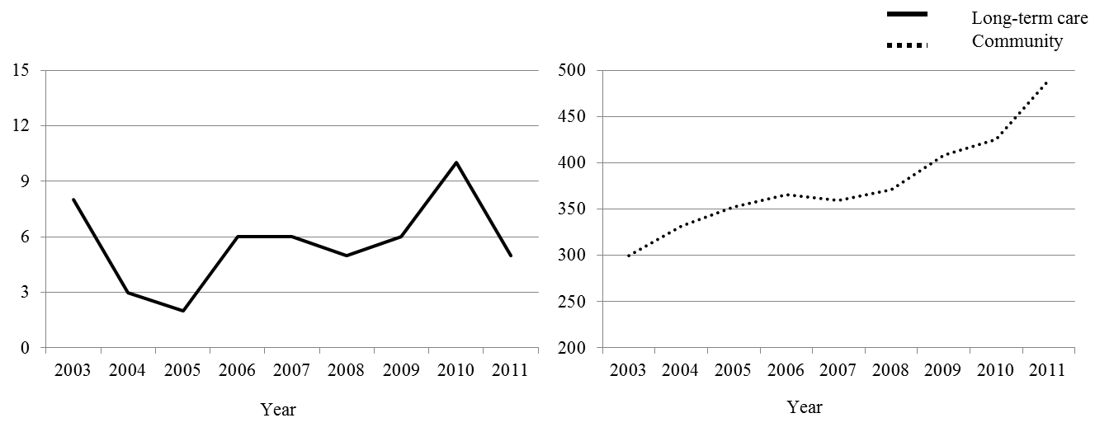
Number of suicides
Caption for Supplemental Figure 2. Number of suicides that matched to a nursing home or assisted-living facility (see Figure A) by year. Virginia Violent Death Reporting System 2003 – 2011. Decedents identified by narratives only are not included in these plots.

Figure C. Cumulative incidence of suicide in nursing homes among adults aged 65 and older: Virginia 2006 – 2011
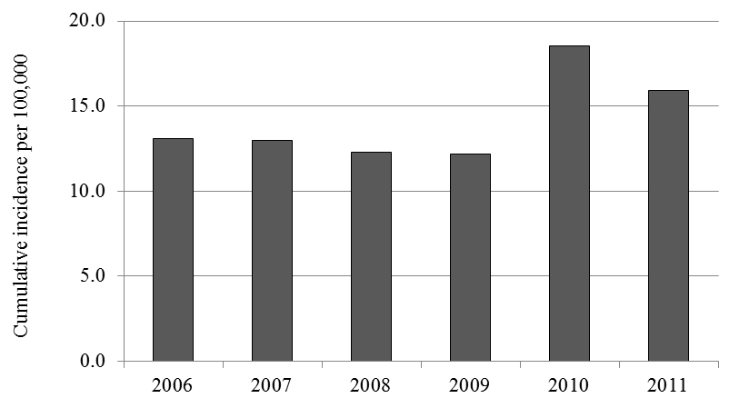

Figure 1 Legend. Cumulative incidence estimated assuming 85% of nursing home residents are aged 65 and older, consistent with Nursing Home Compendium estimates. See Table F for additional estimates under other scenarios of age composition of residents.

