**Supplementary Material**

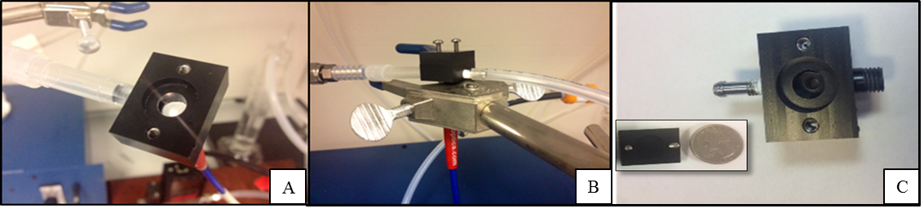

**Figure S1**: Depiction of sensor holder. A. Looking down on filter paper inserted into the holder. B. View of flow-through sensor holder with lid on top. C. Looking down at sensor holder, inset is sensor lid.

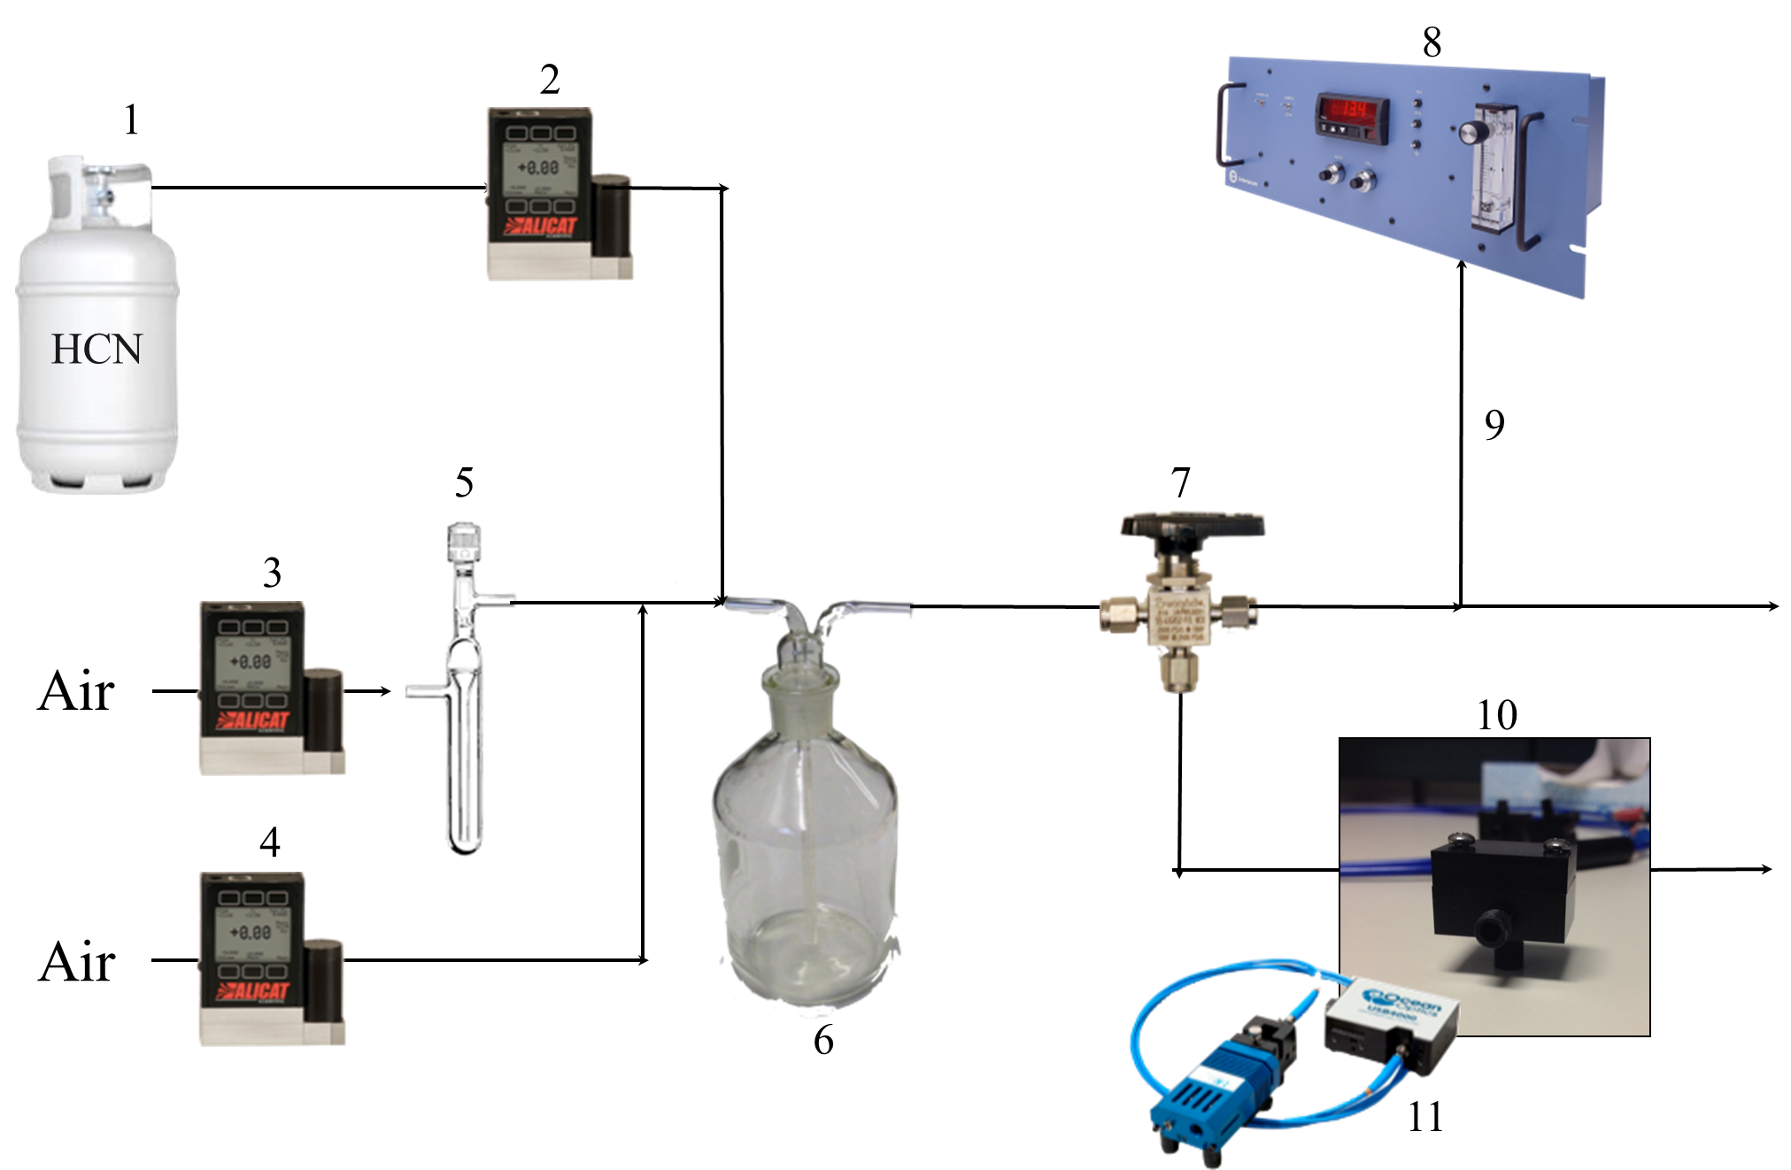

**Figure S2**: Schematic illustration of the experimental setup for HCN gas exposure. Individual items are explained in the text. 1. Stock HCN (495 ± 2% ppm). 2. MFC 1 (0-1 LPM). 3. MFC 2 (0-10 LPM). 4. MFC 3 (0-10 LPM). 5. Water bubbler for % RH control. 6. Gas blender. 7. 3-way valve. 8. Interscan®: HCN electrochemical detector. 9. Interscan® draws air at 0.5 LPM. 10. Sensor holder. 11. Ocean Optics® miniature USB spectrometer and light source.

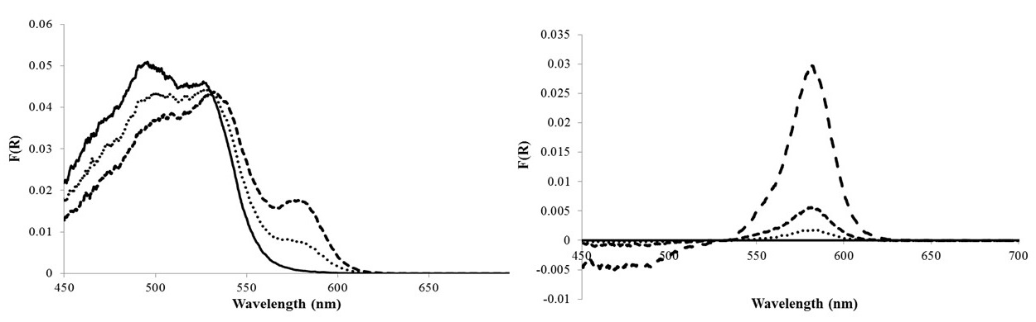

**Figure S3:** A: Monocyanocobinamide response to 5.0 ppm HCN exposure on cellulose filter paper. CN(H2O)Cbi before HCN (solid line), after 1 min of exposure (dotted line) and after 5 min of exposure (dashed line). B: Diffuse reflectance spectra when the reflectance spectrum of monocyanocobinamide on cellulose filter paper was designated as the “blank” (solid line), 1 min exposure (dotted line), 5 min exposure (short dashed line) and 60 min exposure (long dashed line).

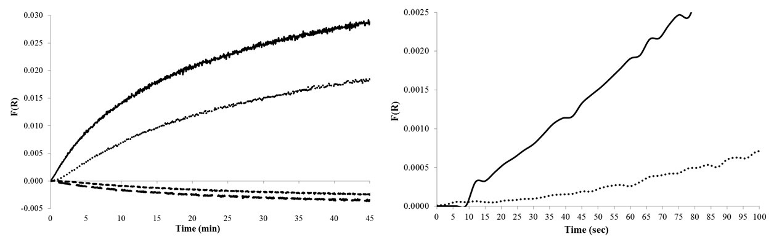

**Figure S4** A. CN(H2O)Cbi on cellulose paper response to 1.0 and 5.0 ppm HCN. 5.0 ppm HCN response at 583 nm (dotted line), 1.0 ppm HCN response at 583 nm (solid line), 5.0 ppm HCN response to the average of signal over 400-450 nm (long dashed line), 1.0 ppm HCN response to the average of 400-450 nm (short dashed line line). B: Expanded version of the initial response (in seconds) to 5.0 ppm HCN at 583 nm (solid line) and 1.0 ppm HCN (dotted line).

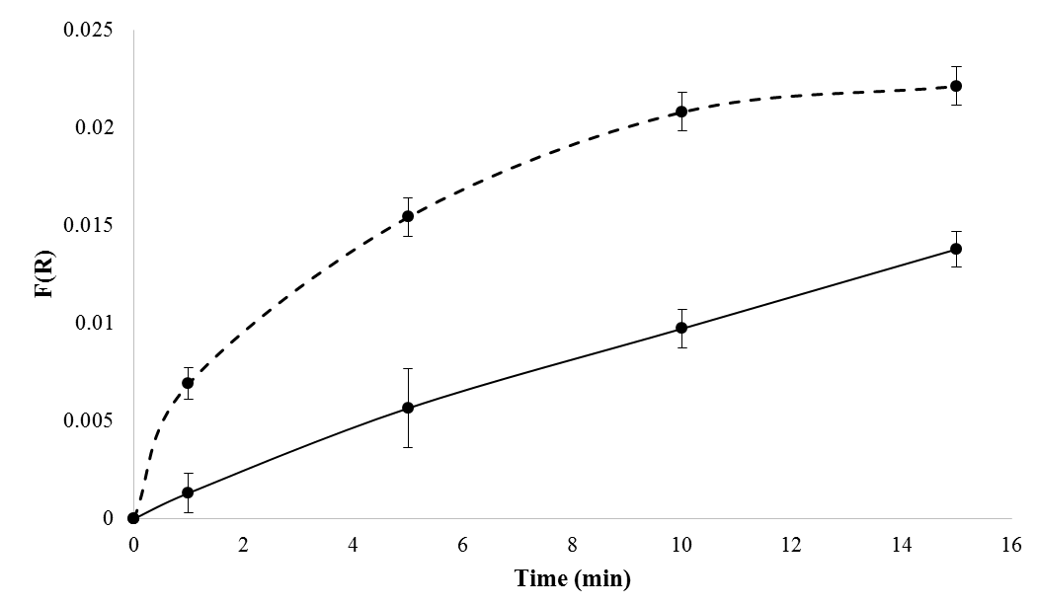

**Figure S5**: Comparison of the average response of on cellulose filter paper (solid line) and glass fiber filter paper (dashed line) to 5.0 ppm HCN at various exposure times. Error bars are represented by 95% C.I. using n=3 for cellulose paper and n=6 for glass fiber filter paper.

|  |  |  |  |  |
| --- | --- | --- | --- | --- |
| **Time (min)** | F(R) at 583 nm Cellulose F.P. | 95% C.I.  n=3 | F(R) at 583 nm Glass Fiber F.P. | 95% C.I.  n=6 |
| **0** | 7.E-07 | 7.E-07 | 1.00E-06 | 1. E-08 |
| **1** | 0.001 | 0.001 | 0.0069 | 0.0008 |
| **5** | 0.006 | 0.002 | 0.016 | 0.001 |
| **10** | 0.010 | 0.001 | 0.021 | 0.001 |
| **15** | 0.0138 | 0.0009 | 0.022 | 0.001 |

**Table S1**: Data for Figure S5.

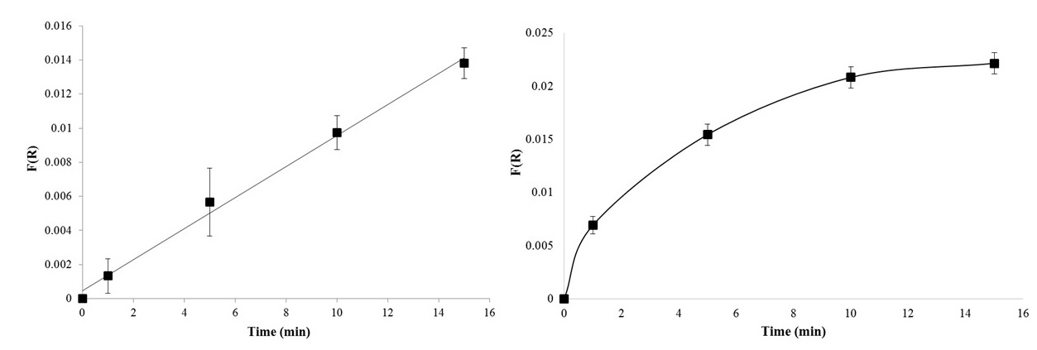

**Figure S6:** Comparison of the average response of CN(H2O)Cbi on cellulose filter paper (A) and glass fiber filter paper (B) to 5.0 ppm HCN (583 nm) at various exposure times. Error bars are represented by 95% C.I. using n=3 for cellulose filter paper and n=6 for glass fiber filter paper.

**Table S2**: Data for Figure S6

|  |  |  |
| --- | --- | --- |
| **Cellulose Filter Paper** | | |
| **Time (min)** | **F(R)** | **F(R) 95% C.I.** |
| 0 | 3.E-06 | 8.E-06 |
| 1 | 0.001 | 0.001 |
| 5 | 0.006 | 0.002 |
| 10 | 0.010 | 0.001 |
| 15 | 0.0138 | 0.0009 |
| **Glass Fiber Filter Paper** | | |
| **Time (min)** | **F(R)** | **F(R) 95% C.I.** |
| 0 | 1.E-06 | 1.E-06 |
| 1 | 0.0069 | 0.0008 |
| 5 | 0.015 | 0.001 |
| 10 | 0.021 | 0.001 |
| 15 | 0.022 | 0.001 |

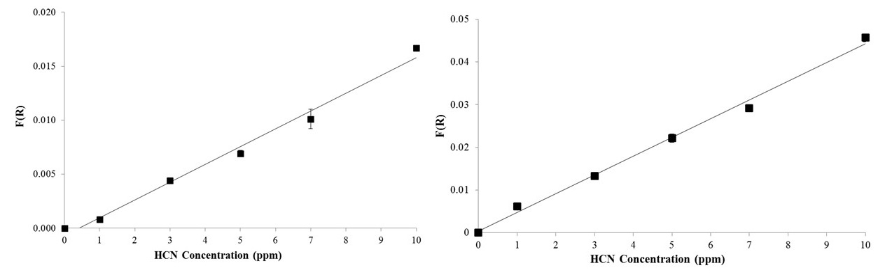

**Figure S7:** Average response of CN(H2O)Cbi on glass fiber filter paper as a function of concentration for 1 minute exposure time (A) and after 15 minutes exposure time at 583 nm (B). Error bars are represented by 95% C.I. for n=3.

**Table S3**: Data for Figure S7

|  |  |  |
| --- | --- | --- |
| **1 Minute HCN Exposure** | | |
| **HCN Concentration (ppm)** | **F(R)** | **F(R) 95% C.I.** |
| 0.0 | 1.E-06 | 1.E-06 |
| 1.0 | 0.0008 | 0.0001 |
| 3.0 | 0.0044 | 0.0001 |
| 5.0 | 0.0069 | 0.0008 |
| 7.0 | 0.0101 | 0.0009 |
| 10.0 | 0.0167 | 0.0002 |
| **15 Minute HCN Exposure** | | |
| **HCN Concentration (ppm)** | **F(R)** | **F(R) 95% C.I.** |
| 0.0 | 1.E-06 | 1.E-06 |
| 1.0 | 0.0062 | 0.0002 |
| 3.0 | 0.0133 | 0.0002 |
| 5.0 | 0.022 | 0.001 |
| 7.0 | 0.0292 | 0.0003 |
| 10.0 | 0.0456 | 0.0009 |

|  |  |  |  |  |  |  |
| --- | --- | --- | --- | --- | --- | --- |
| **Average F(R) Cbi Response on Cellulose Filter Paper for 25, 50 and 85 %RH** | | | | | | |
| **Time (min)** | **F(R) at 583 nm for 25% RH** | **95% C.I.**  **N=3** | **F(R) at 583 nm for 50% RH** | **95% C.I.**  **N=3** | **F(R) at 583 nm for 85% RH** | **95% C.I.**  **N=3** |
| **0** | 4.E-07 | 9.E-07 | 7.E-06 | 7.E-06 | 9.E-06 | 2.E-06 |
| **1** | 0.001 | 0.001 | 0.005 | 0.001 | 0.0115 | 0.0009 |
| **5** | 0.006 | 0.002 | 0.0248 | 0.0009 | 0.0309 | 0.0009 |
| **10** | 0.010 | 0.001 | 0.0330 | 0.0009 | 0.035 | 0.001 |
| **15** | 0.0138 | 0.0009 | 0.035 | 0.001 | 0.036 | 0.001 |
| **60** | 0.030 | 0.001 |

**Table S4:** Data for Figure 6a in text.

**Table S5**: Data for Figure 6b in text.

|  |  |  |  |  |  |  |
| --- | --- | --- | --- | --- | --- | --- |
| **Average F(R) Cbi Response on Glass Fiber Filter Paper for 25, 50 and 85 %RH** | | | | | | |
| **Time (min)** | **F(R) at 583 nm for 25% RH** | **95% C.I. N=6** | **F(R) at 583 nm for 50% RH** | **95% C.I. N=3** | **F(R) at 583 nm for 85% RH** | **95% C.I. N=3** |
| **0** | 1.E-06 | 3.E-06 | 1.E-06 | 7.E-06 | 1.E-06 | 7.E-06 |
| **1** | 0.0069 | 0.0008 | 0.026 | 0.002 | 0.060 | 0.004 |
| **5** | 0.015 | 0.001 | 0.0395 | 0.001 | 0.062 | 0.003 |
| **10** | 0.021 | 0.001 | 0.0413 | 0.001 | 0.062 | 0.003 |
| **15** | 0.022 | 0.001 | 0.0421 | 0.001 | 0.063 | 0.003 |

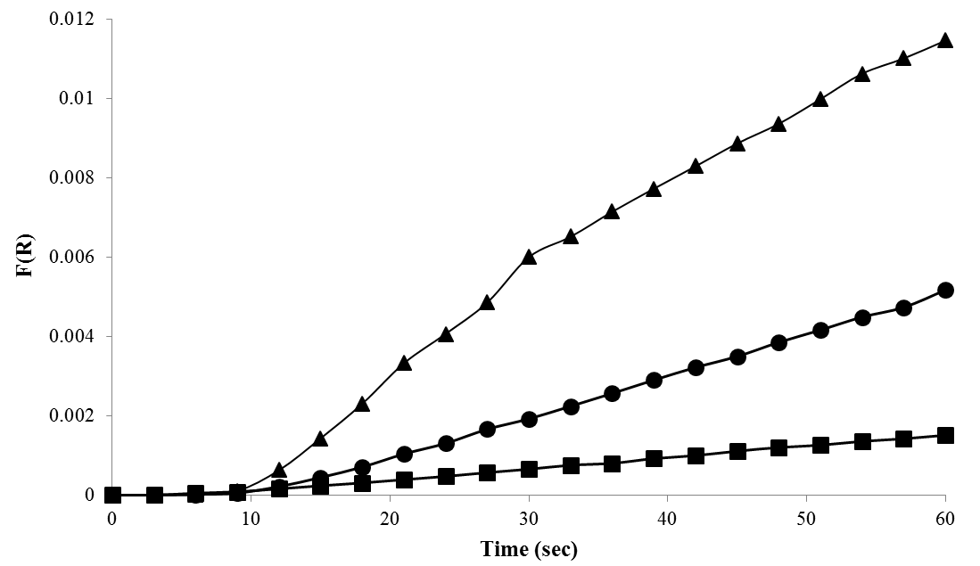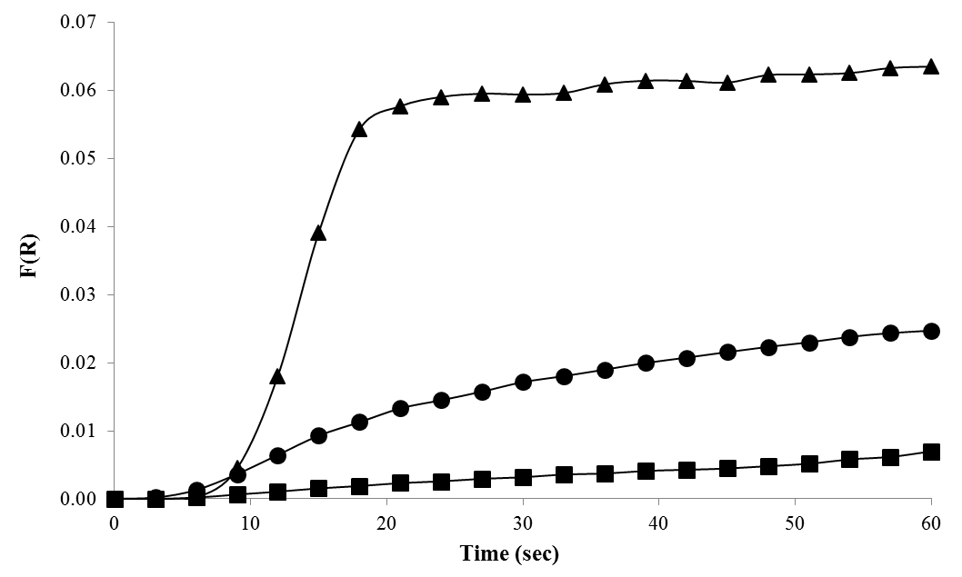

A

B

**Figure S8**: A. Average initial response of CN(H2O)Cbi on cellulose filter paper to 5.0 ppm HCN at various relative humidity: 25 %RH (square), 50 %RH (circle), and 85 %RH (triangle). N=3. B. Average initial response of CN(H2O)Cbi on glass fiber filter paper to 5.0 ppm HCN at various relative humidity: 25 %RH (square), 50 %RH (circle), and 85 %RH (triangle). n=3.

**Table S6:** Data for Figure S4a.

|  |  |  |  |
| --- | --- | --- | --- |
| **Time (s)** | **F(R) at 583 nm for 25% RH** | **F(R) at 583 nm for 50% RH** | **F(R) at 583 nm for 85% RH** |
| **0** | 4.E-06 | 9.E-06 | 8.E-06 |
| **3** | 4.E-06 | 5.E-06 | 1.E-05 |
| **6** | 5.E-05 | 2.E-05 | 1.E-05 |
| **9** | 9.E-05 | 6.E-05 | 0.0001 |
| **12** | 0.0002 | 0.0002 | 0.0006 |
| **15** | 0.0002 | 0.0005 | 0.0014 |
| **18** | 0.0003 | 0.0007 | 0.0023 |
| **21** | 0.0004 | 0.0010 | 0.0033 |
| **24** | 0.0005 | 0.0013 | 0.0041 |
| **27** | 0.0006 | 0.0017 | 0.0049 |
| **30** | 0.0007 | 0.0019 | 0.0060 |
| **33** | 0.0008 | 0.0022 | 0.0065 |
| **36** | 0.0008 | 0.0026 | 0.0071 |
| **39** | 0.0009 | 0.0029 | 0.0077 |
| **42** | 0.0010 | 0.0032 | 0.0083 |
| **45** | 0.0011 | 0.0035 | 0.0089 |
| **48** | 0.0012 | 0.0039 | 0.0094 |
| **51** | 0.0013 | 0.0042 | 0.010 |
| **54** | 0.0014 | 0.0045 | 0.0106 |
| **57** | 0.0014 | 0.0047 | 0.0110 |
| **60** | 0.0015 | 0.0052 | 0.0115 |

**Table S7**: Data for Figure S4b.

|  |  |  |  |
| --- | --- | --- | --- |
| **Time (s)** | **F(R) at 583 nm for 25% RH** | **F(R) at 583 nm for 50% RH** | **F(R) at 583 nm for 85% RH** |
| **0** | 5.E-07 | 3.E-05 | 2.E-05 |
| **3** | 2.E-06 | 0.0002 | 4.E-05 |
| **6** | 0.0002 | 0.0013 | 0.0002 |
| **9** | 0.0006 | 0.0037 | 0.0045 |
| **12** | 0.0011 | 0.0065 | 0.0181 |
| **15** | 0.0016 | 0.0093 | 0.0391 |
| **18** | 0.0019 | 0.0113 | 0.0543 |
| **21** | 0.0023 | 0.0133 | 0.0577 |
| **24** | 0.0026 | 0.0145 | 0.0591 |
| **27** | 0.0030 | 0.0158 | 0.0596 |
| **30** | 0.0032 | 0.0172 | 0.0594 |
| **33** | 0.0036 | 0.0180 | 0.0596 |
| **36** | 0.0037 | 0.0190 | 0.0609 |
| **39** | 0.0041 | 0.0200 | 0.0615 |
| **42** | 0.0043 | 0.0208 | 0.0614 |
| **45** | 0.0045 | 0.0216 | 0.0612 |
| **48** | 0.0048 | 0.0223 | 0.0623 |
| **51** | 0.0052 | 0.0230 | 0.0624 |
| **54** | 0.0058 | 0.0238 | 0.0626 |
| **57** | 0.0062 | 0.0244 | 0.0633 |
| **60** | 0.0070 | 0.0247 | 0.0635 |