Tittle: Comparative Transcriptomic Analysis of Multiple Cardiovascular Fates from Embryonic Stem Cells Predicts Novel Regulators in Human Cardiogenesis

Authors and Affiliations: Yang Li ¹, Bo Lin ¹, Lei Yang ^{1, *}

¹ Department of Developmental Biology, University of Pittsburgh School of Medicine, 530 45th Street, Rangos Research Center, Pittsburgh, PA 15201

*Correspondence information:
Lei Yang, PhD
Department of Developmental Biology
University of Pittsburgh School of Medicine
530 45th Street, 8117 Rangos Research Center
Pittsburgh, PA 15201
Phone: 01-412-692-9842
Fax: 01-412-692-6184
Email: lyang@pitt.edu

Supplementary Information

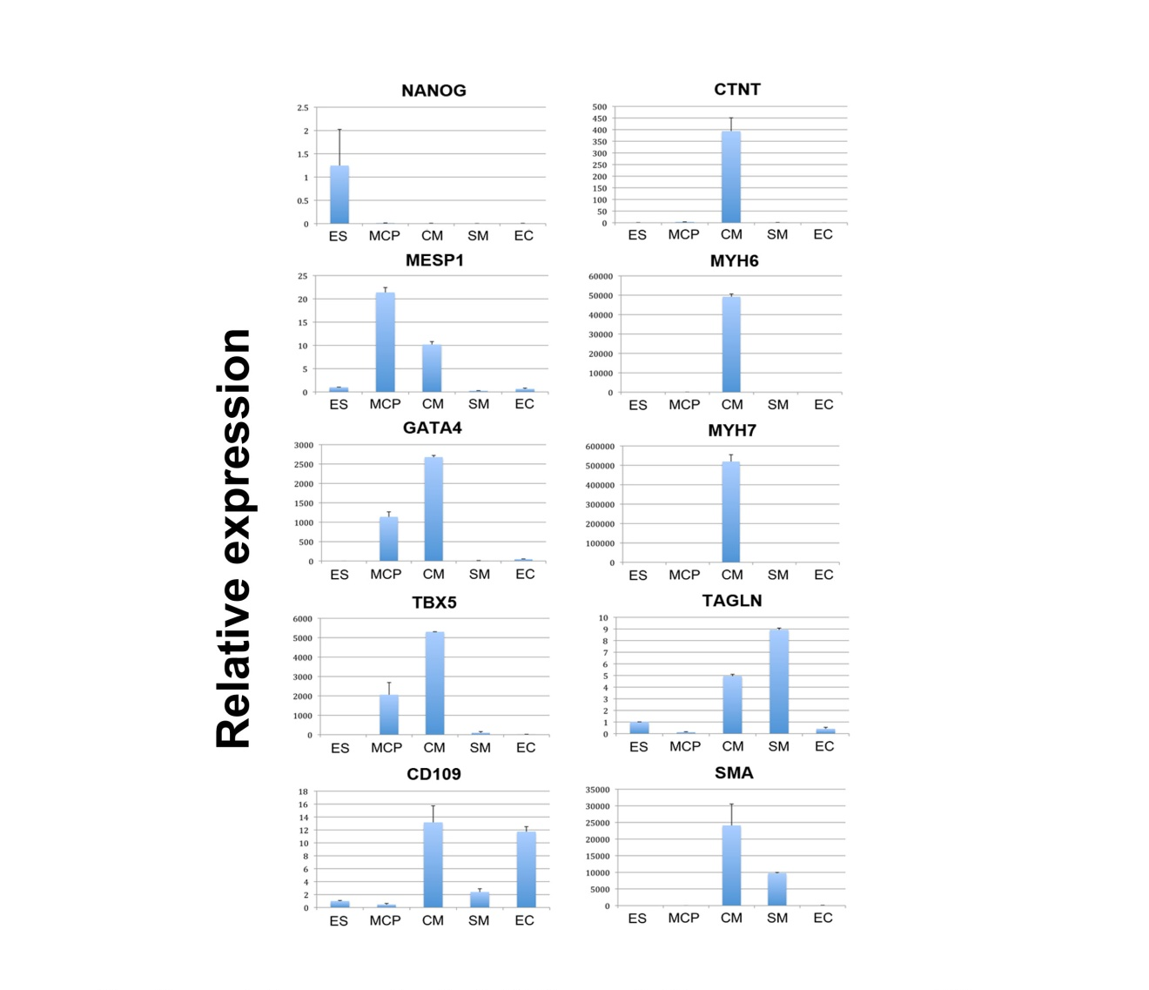
Supplementary Figure. 1: Additional lineage-specific markers validated by qRT-PCR. Related to Fig. 1d.
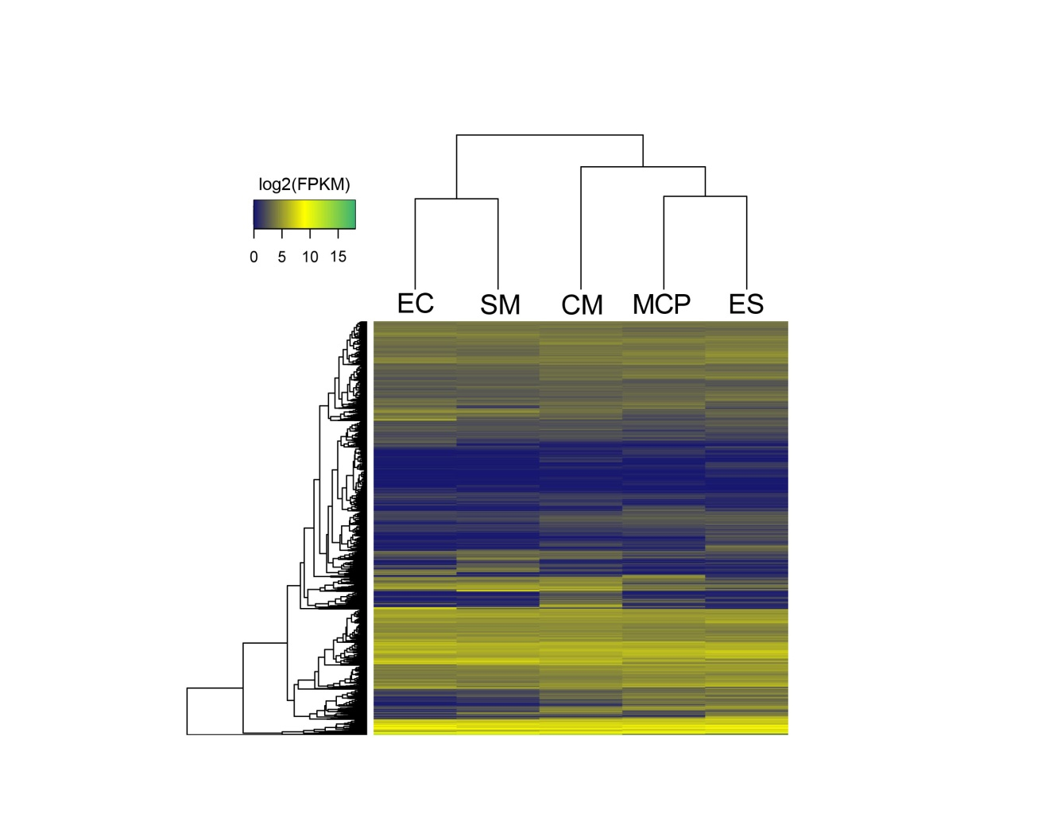
Supplementary Figure. 2: Hierarchical clustering of the five cell types during cardiovascular differentiation using all the detected genes. Related to Figure 1e.

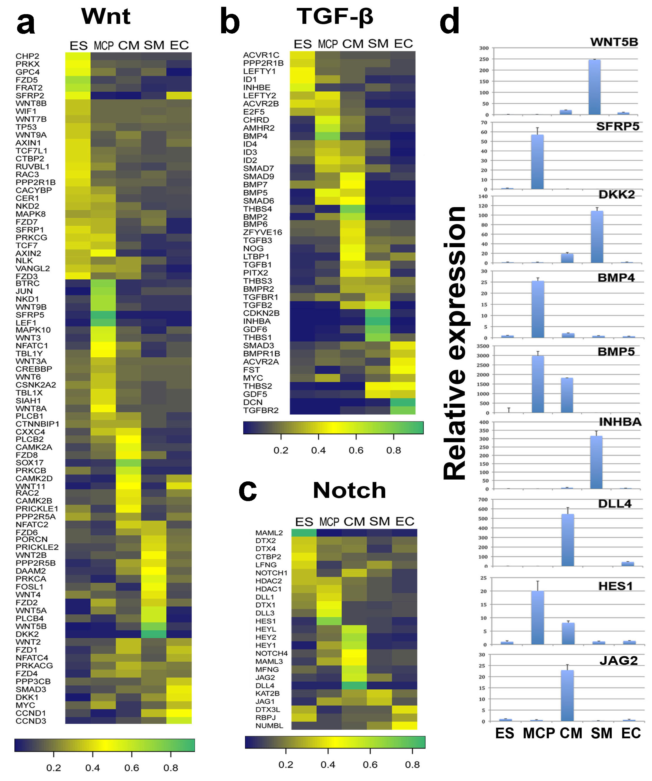
Supplementary Figure. 3: Dynamic expressions of pathway components during the cardiovascular differentiation. To indicate the lineage-specificity, the relative gene expression percent in the sum of all the cell types was shown in the heatmap. (a) Genes in Wnt signaling pathway. (b) Genes in TGF-β signaling pathway. (c) Genes in Notch signaling pathway. (d) qRT-PCR validation of the expression pattern of above signaling pathway component genes in the five cell types.

Supplementary Video 1. Day 20 embryoid bodies differentiated from hiPSC with DMSO in medium from day 4 to day 20.

Supplementary Video 2. Day 20 embryoid bodies differentiated from hiPSC with 200 μM lithocholic acid in medium from day 4 to day 20.

Supplementary Table 1. Positive control sets used to estimate false negative rates of GEPA predictions
Gene | Cell type
ACTN2 | cardiomyocytes
NPPA | cardiomyocytes
NPPB | cardiomyocytes
SGCA | cardiomyocytes
GJA4 | cardiomyocytes
GJA5 | cardiomyocytes
FABP3 | cardiomyocytes
GATA4 | cardiomyocytes
GATA6 | cardiomyocytes
HCN4 | cardiomyocytes
MEF2C | cardiomyocytes
MYH7 | cardiomyocytes
MYH6 | cardiomyocytes
MYH11 | cardiomyocytes
TNNT2 | cardiomyocytes
TNNI3 | cardiomyocytes
TNNI1 | cardiomyocytes
TBX2 | cardiomyocytes
TBX3 | cardiomyocytes
TBX5 | cardiomyocytes
PLN | cardiomyocytes
MYL7 | cardiomyocytes
MYL2 | cardiomyocytes
HAND2 | cardiomyocytes
NKX2-5 | cardiomyocytes
ISL1 | cardiomyocytes
MYOCD | cardiomyocytes
TBX20 | cardiomyocytes
MYBPC3 | cardiomyocytes
ATP2A2 | cardiomyocytes
NANOG | embryonic stem cell
SOX2 | embryonic stem cell
POU5F1 | embryonic stem cell
GDF3 | embryonic stem cell
ZFP42 | embryonic stem cell
DNMT3B | embryonic stem cell
KLF4 | embryonic stem cell
TERT | embryonic stem cell
FGF4 | embryonic stem cell
DPPA5 | embryonic stem cell
DPPA2 | embryonic stem cell
DPPA4 | embryonic stem cell
TDGF1 | embryonic stem cell
LEFTY1 | embryonic stem cell
UTF1 | embryonic stem cell
LEFTY2 | embryonic stem cell
GRB7 | embryonic stem cell
PODXL | embryonic stem cell
CD9 | embryonic stem cell
GAL | embryonic stem cell

Supplementary Table 2. Distribution of genes in lineage-specific categories classified by GEPA and comparison to random shuffle
 | Original |  |  | Shuffle
Pattern | 1.5 | 2.5 | 3 | 2.5 | 2.5 | 2.5
ES | 1683 | 472 | 346 | 1457 | 1437 | 1441
MCP | 693 | 211 | 167 | 1280 | 1285 | 1296
CM | 996 | 368 | 291 | 1396 | 1361 | 1382
SM | 675 | 263 | 201 | 1270 | 1299 | 1241
EC | 902 | 366 | 286 | 1373 | 1378 | 1352
ES MCP | 769 | 228 | 118 | 288 | 278 | 303
ES CM | 137 | 40 | 27 | 315 | 355 | 338
ES SM | 71 | 21 | 11 | 240 | 253 | 279
ES EC | 87 | 17 | 12 | 258 | 238 | 289
MCP CM | 209 | 92 | 77 | 327 | 327 | 284
MCP SM | 24 | 8 | 3 | 244 | 236 | 257
MCP EC | 19 | 12 | 8 | 260 | 253 | 234
CM SM | 143 | 61 | 48 | 287 | 269 | 301
CM EC | 104 | 46 | 30 | 282 | 267 | 289
SM EC | 375 | 136 | 108 | 223 | 221 | 224
ES MCP CM | 508 | 242 | 176 | 284 | 276 | 266
ES MCP SM | 17 | 3 | 3 | 175 | 201 | 171
ES MCP EC | 131 | 9 | 4 | 172 | 181 | 161
ES CM SM | 44 | 17 | 16 | 228 | 216 | 260
ES CM EC | 27 | 2 | 1 | 219 | 218 | 226
ES SM EC | 65 | 17 | 9 | 177 | 161 | 166
MCP SM EC | 15 | 1 | 1 | 154 | 153 | 148
MCP CM SM | 58 | 26 | 23 | 224 | 210 | 217
MCP CM EC | 47 | 12 | 9 | 183 | 213 | 224
CM SM EC | 358 | 139 | 100 | 182 | 171 | 185
ES MCP CM SM | 199 | 125 | 102 | 412 | 438 | 453
ES MCP CM EC | 173 | 50 | 35 | 411 | 404 | 407
ES MCP SM EC | 25 | 4 | 2 | 273 | 274 | 238
ES CM SM EC | 164 | 69 | 47 | 322 | 352 | 319
MCP CM SM EC | 244 | 129 | 96 | 292 | 311 | 297
Gradient | 4500 | 4683 | 3898 | 1795 | 1780 | 1751
Even | 1670 | 7263 | 8877 | 129 | 116 | 133

Supplementary Table 3. Primers for qRT-PCR
gene | sequence
NANOG-F | CAGAAGGCCTCAGCACCTAC
NANOG-R | GTCACTGGCAGGAGAATTTGG
POU5F1-F | AACCTGGAGTTTGTGCCAGGGTTT
POU5F1-R | TGAACTTCACCTTCCCTCCAACCA
MESP1-F | GATGGAGCCAAGCCCAC
MESP1-R | TCAGTTGTCCCTTGTCACTTG
MSX1-F | TCCAGTTTCACCTCTTTGCTCCCT
MSX1-R | TTAACCTCTCTGCCCTCAGTTTCCC
ISL1-F | TTGTACGGGATCAAATGCGCCAAG
ISL1-R | AGGCCACACAGCGGAAACA
HAND2-F | CGCCGACACCAAACTCTCCAAA
HAND2-R | GCTCCTTCTTCCTCTTCTCCTCTTTCAC
GATA4-F | GGAAGCCCAAGAACCTGAAT
GATA4-R | GTTGCTGGAGTTGCTGGAA
TBX20-F | GTCTCTCAGCTCCTGGGTATCATCTT
TBX20-R | TGTTGCTATGGATGCTGTGCTGGT
TBX5-F | AAATGAAACCCAGCATAGGAGCTGGC
TBX5-R | ACACTCAGCCTCACATCTTACCCT
NKX2.5-F | ACCTCAACAGCTCCCTGACTCT
NKX2.5-F | ATAATCGCCGCCACAAACTCTCC
CTNT-F | AAAGCCCAGGTCGTTCATGCCC
CTNT-R | CATTCCGGATGCGCTGCTGC
MYH6-F | GGGATAACCAGGGGAAGCACCAAGA
MYH6-R | TGCCTCCCTCCCGGGACAAAT
MYH7-F | TTGAGTAGCCCAGGCACAGCCAT
MYH7-R | TGCCACCCTCTCGAGACACGAT
SMA-F | AATACTCTGTCTGGATCGGTGGCT
SMA-R | ACGAGTCAGAGCTTTGGCTAGGAA
CNN1-F | ACAACCACCACGCACACAACTAC
CNN1-R | GTCTGCTCTCTCCAAACTCTAACCCT
TAGLN-F | CTGACATGTTCCAGACTGTTGACCTCTT
TAGLN-R | CCTCTTATGCTCCTGCGCTTTCTT
CD109-F | TGCCCAGTGTATTGAATTGGTGGTAGA
CD109-R | ACCATACAGGCTTGAAGGACCAGAAC
LAMA4-F | CTCCTAGCCTGGGCAACATAATGAGA
LAMA4-R | AGTGCAGGTACAGTCAGCAGTCATAG
LIN28A-F | GTGAGGCAGTGGAGTTCACCTTT
LIN28A-R | TCTGCGCTTCTGCATGCTCTTT
FOXH1-F | ACTCCATTCGCCACAACCTTTCCT
FOXH1-R | CGCCCAGAAGTTGCCCTTG
DNAH2-F | TAGAGAAAGGCATCCAGGGTCTCATC
DNAH2-R | CCACAGCTCAAACTGCTCCACA
LIX1-F | CCCGACAGGAAGTCATCTCCTACTATTC
LIX1-R | TTCTTGTCCTGCTTTCCTGGCTTC
PDLIM3-F | AAGTGTTCTCCTCCCATAAGGTCCCA
PDLIM3-R | ACAGGTCAGGGTCAGAGTCAGTT
HDAC9-F | TGAACGGATCGTAATTCCACCCAGA
HDAC9-R | GCCTCATGCTAGTTCCTCCATCTTGAAC
GREM1-F | CCTCCTCCTCACAATCCATCTCTTCT
GREM1-R | ACCCTCCCTTTCTCACTCCACTATC
CDKN2A-F | CATGGAGCCTTCGGCTGACT
CDKN2A-R | CCGTAACTATTCGGTGCGTTGGG
RUNX1-F | GAGAAATGCTACCGCAGCCATGAA
RUNX1-R | ACTTGCGGTGGGTTTGTGAAGA
SIX2-F | GCCAAGGAAAGGGAGAACAACGAGAA
SIX2-R | TCATCCTCCGAGCTGCCTAACA
BICC1-F | AGAACGCCCACAAATACCTGGAGTG
BICC1-R | TTGGACCGTGAAAGGGACATGGA
HHIP-F | TGTCGTCATGGAGGTGTCTGTGTTAG
HHIP-R | TGGTCACTCTGCGGATGTTTCTGT
MEIS2-F | GCCACCGATACATTAGCTGTTTGAAGGG
MEIS2-R | GGTTATGGTCAGCGAGATTTGTGGAG
SNAI2-F | CAACAGAGCATTTGCAGACAGGTCAA
SNAI2-R | GCTACACAGCAGCCAGATTCCTC
FZD5-F | ATCATCTTCCTGTCAGCCTGCTACCT
FZD5-R | TGGTCTCGTAGTGGATGTGGTTGTG
SFRP5-F | ACCGCTGGGACAAGAAGAATAAGGAG
SFRP5-R | CGTAGAAGAAAGGGTAGTAGAGGGAGCA
WNT5B-F | TACCGCTTCGCCAAGGAGTTTGT
WNT5B-R | TTTGCAGGCTACGTCTGCCATCTT
DKK2-F | GCCAAACTCAACTCCATCAAGTCCTCTC
DKK2-R | TGTGGCAATACCTCCCAACTTCAC
WNT11-F | CTGTGAAGGACTCGGAACTCGTCTATCT
WNT11-R | TGTCTTGTTGCACTGCCTGTCTTG
BMP4-F | ATCAGGAGATGGTAGTAGAGGGATGTGG
BMP4-R | GTGGTGTATGTGGTGTGTGTGTGT
BMP7-F | TGTGCCTTCCCTCTGAACTCCTAC
BMP7-R | CCCGGACCACCATGTTTCTGTATTTCT
BMP5-F | CGTGAGAGCAGCCAACAAACGAAA
BMP5-R | TGGTGCTATAATCCAGTCCTGCCATC
TGFB2-F | GCTTTGGATGCGGCCTATTGCTTT
TGFB2-R | GGCATTGTACCCTTTGGGTTCGTGTATC
TGFBR2-F | CCTGTGTCGAAAGCATGAAGGACAAC
TGFBR2-R | CTCAGTCAACGTCTCACACACCATCT
INHBA-F | CAGTTTCAAGGACATCGGCTGGAATG
INHBA-R | TGTTGAGTGGAAGGACAGTGAGGA
HES1-F | GCCAGTTTGCTTTCCTCATTCCCA
HES1-R | TCCACATGGAGTCCGCCGTAA
JAG2-F | GGAGGATGAGGAGGACGAGGA
JAG2-R | CGGCCAGGATCTTTGGTGAATTTGTG
DLL4-F | CAGCAGGGAAGCCATGAACAACT
DLL4-R | AGTCCACTTCCAGCTCCTTCTTCT
MFNG-F | GGGAAACTCAACGTCATTAAGCTACAGGG
MFNG-R | TGGATAGAGCAGACAATGGAGGGAG
CYCLOPHININ-F | GAAGAGTGCGATCAAGAACCCATGAC
CYCLOPHININ-R | GTCTCTCCTCCTTCTCCTCCTATCTTTACTT
FGFR1-primer1-F | CCTTGTCACCAACCTCTAAC
FGFR1-primer1-R | GATGTCCAATATGGAGCTACG
FGFR1-primer2-F | GATGTGCAGAGCATCAACTG
FGFR1-primer2-R | CTGGTTACGCAAGCATAGAG
NR_034008-F | CAGGGCCTTTGAAGAAGTAA
NR_034008-R | TGTGCATCTGTGTCCTAATC
NR_028406-F | GAAGAGGCCTCCTATCTACTC
NR_028406-R | CACTCCTGAAGCAGAGAAAC
NR_021490-F | CGAGGATCTTGGGATCATTTC
NR_021490-R | CTGGCCCTCATTAGGATTTAC

