Light Sensitization of DNA Nanostructures via Incorporation of Photo-Cleavable Spacers

Richie E. Kohman & Xue Han
Biomedical Engineering Department, Boston University, Boston, MA, USA.

Experimental Methods

Design and assembly of DNA nanostructures. Nanostructures were designed using caDNAno.¹ The sphere’s northern hemisphere was unaltered from that in reference 2 while its southern hemisphere and equator contained a different set of staples strands. Single stranded M13mp18 bacteriophage DNA was prepared as described previously.³ All oligonucleotides were purchased from Integrated DNA Technologies (IDT) and used with no additional purification. Creation of nanostructures was performed by first heating a solution containing a final concentration of 20 nM m13 scaffold DNA and 200 nM of each staple in a folding buffer containing 5 mM Tris, 1 mM EDTA, and 16 mM MgCl₂ to 80°C, followed by cooling from 80°C to 60°C over 80 minutes, and then from 60°C to 24°C over 48 hours.

Gel electrophoresis. Reaction solutions were electrophoresed on 1.5 or 1.8% agarose gels containing 0.5x TBE, supplemented with 10 mM MgCl₂. DNA dyes ethidium bromide or SybrSafe were mixed with reaction solutions before loading onto the gel. The more sensitive dye Ethidium bromide was used when visualizing faint bands as in Figure S1 lane 1. The gel box was submerged in an ice water bath to prevent excessive heating.

Purification of DNA nanostructures. o-nb containing product was purified by first running the reaction mixture through a 1.5% agarose gel. The product band containing the correct nanostructures was excised from the gel and centrifuged at 13,000 rcf for 3 minutes at room temperature in a Freeze ‘N Squeeze DNA gel extraction spin column (Bio-Rad). Samples were then concentrated by diluting with folding buffer containing 5 mM Tris, 1 mM EDTA, and 16 mM MgCl₂, and then centrifuged in Amicon Ultra 0.5 centrifugal filter devices (Millipore) at 14,000 rcf for 5 minutes at room temperature.

TEM sample preparation and imaging. TEM samples were prepared by placing 3 µL of sample solution onto a carbon coated grid (FCF400-Cu, Electron Microscopy Sciences). After 2 minutes, the solution was wicked away from the grid with filter paper (Whatman 50 hardened). The grid was immediately treated with 2% uranyl acetate (diluted with ddH₂O from 4%, Electron Microscopy Sciences) for 30 seconds and excess solution was wicked away. Finally the grid was washed with ddH₂O for 30 seconds and excess solution was wicked away. The remaining solution on the grid was evaporated at room temperate prior to imaging. TEM images were acquired with an FEI Tecnai Spirit Transmission Electron Microscope operated at 80 kV. Images were used directly without any additional manipulation.

UV light irradiation. Approximately 10 µL of a 1 nM solution of purified nanostructures in a closed PCR tube was irradiated with handheld UV lamps from UVP LCC for a given period of time and then directly characterized by gel electrophoresis or TEM. For irradiation with 302 nm light, we used lamp model UVM-57 at 6W. For irradtiation with 365 nm light, we used lamp model UVGL-58 at 6W at the long wavelength setting.

TEM Particle counting. For each condition, several hundred structures were counted from TEM images (at a magnification of 18500x). The entirety of each TEM image was analyzed to avoid bias. Particles were only counted if they unambiguously resembled a spherical DNA nanostructure and the location of the unpaired scaffold was used to help determine this. Aggregates of structures and structures that were located at the edge of the image were not counted. Particles were only considered “open” if spherical objects were seen separated by the scaffold spacer. Partially open structures were not counted as “open” therefore a percent opening of 100% is unlikely because many open structures adhere to the TEM grid in an orientation where the hemispheres lay next to each other. An example of the counting process is shown in Figure S8.

References:
(1) Douglas, S. M.; Marblestone, A. H.; Teerapittayanon, S.; Vazquez, A.; Church, G. M.; Shih, W. M. Nucleic Acids Research 2009, 37, 5001.
(2) Han, D.; Pal, S.; Nangreave, J.; Deng, Z.; Liu, Y.; Yan, H. Science 2011, 332, 342.
(3) Sambrook, J. Molecular Cloning : A Laboratory Manual; 3rd ed. ed.; Cold Spring Harbor Laboratory Press: Cold Spring Harbor, N.Y. :, 2001.

Supplemental Figures
Figure S1. Fluorescent image of a 1.5% agarose gel containing crude DNA folding mixtures stained with Ethidium bromide. From left to right, L = 1 kb ladder, m13 = m13 DNA scaffold, 1 = Closed sphere containing all 9 equator crossovers, 2 = Sphere with no equator crossovers, 3 = Sphere with 3 equator crossovers, 4 = Sphere with 3 photo-crossovers. Loop staple strands included for all samples. The bright bands at the bottom of the gel are the excess staple strands. The desired product lies in the fasted migrating band (not including the staple band).

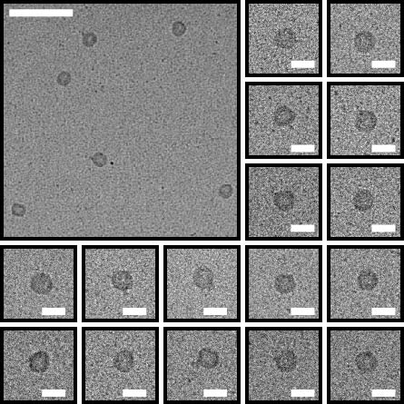

Figure S2. TEM images of closed spheres. Top left scale bar = 200 nm. All other scale bars = 50 nm.

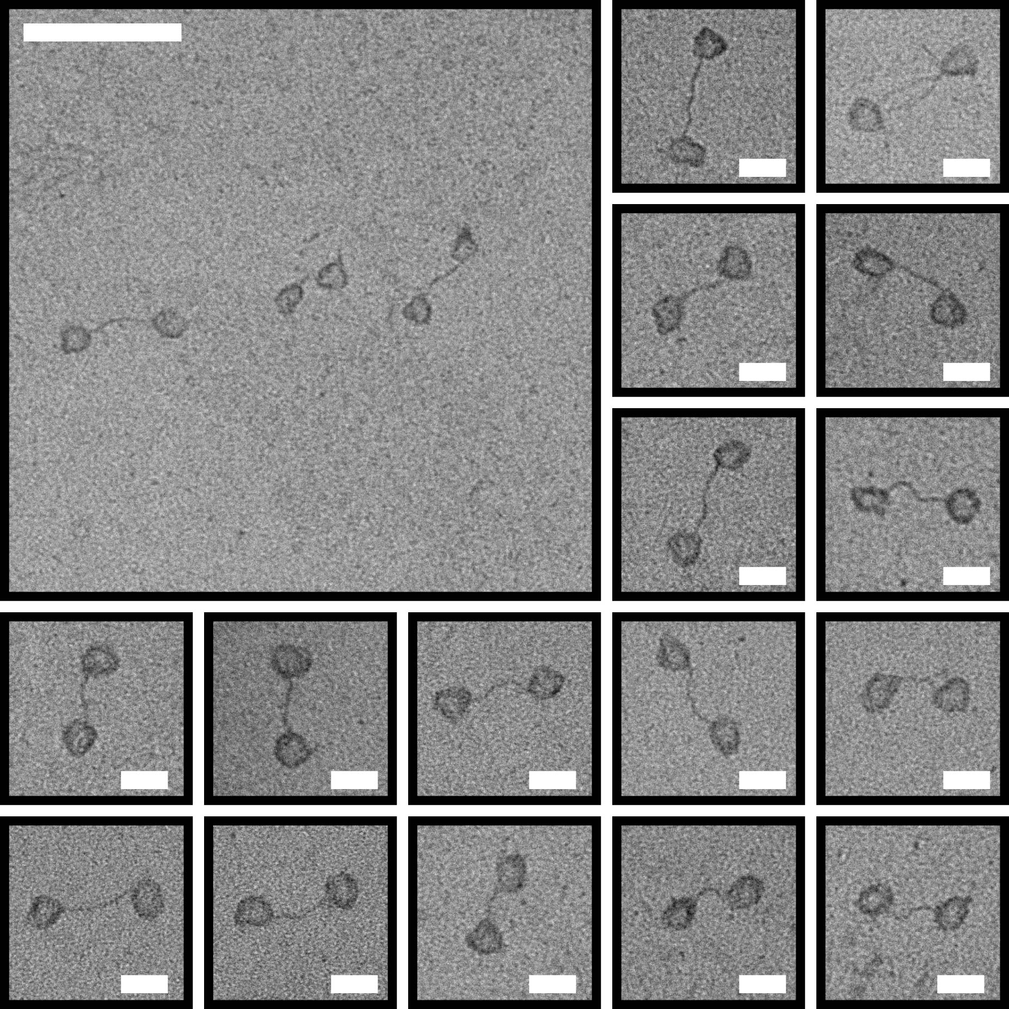

Figure S3. TEM images of structures created without the equator crossovers. Top left scale bar = 200 nm. All other scale bars = 50 nm.
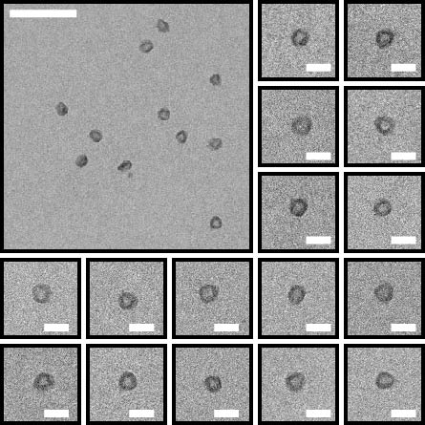

Figure S4. TEM images of closed spheres created with 3 equator crossovers. Top left scale bar = 200 nm. All other scale bars = 50 nm.

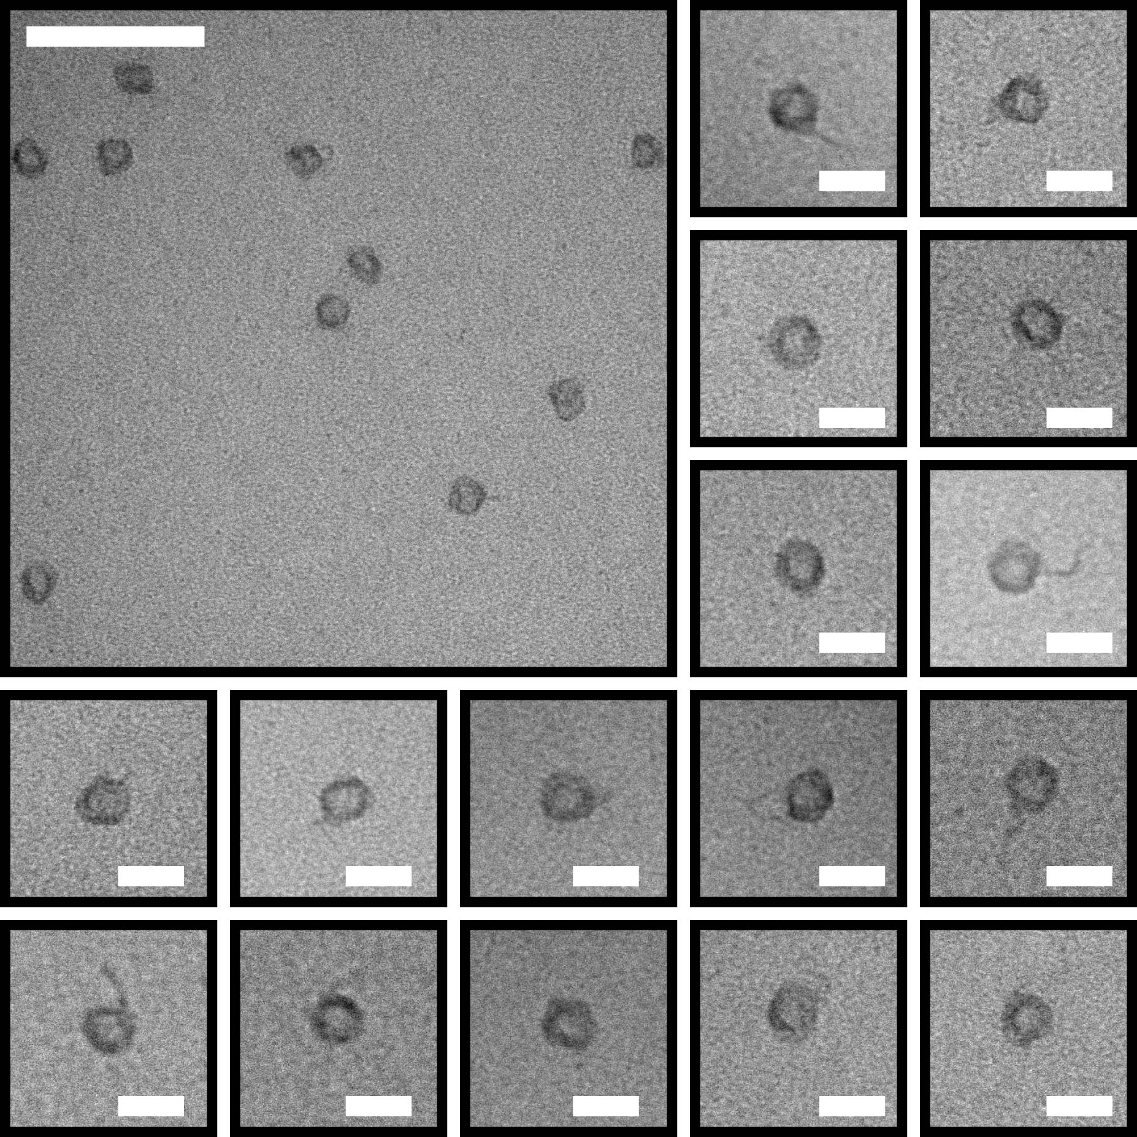
Figure S5. TEM images of closed spheres created with o-NB photo-crossovers before light illumination. Top left scale bar = 200 nm. All other scale bars = 50 nm.

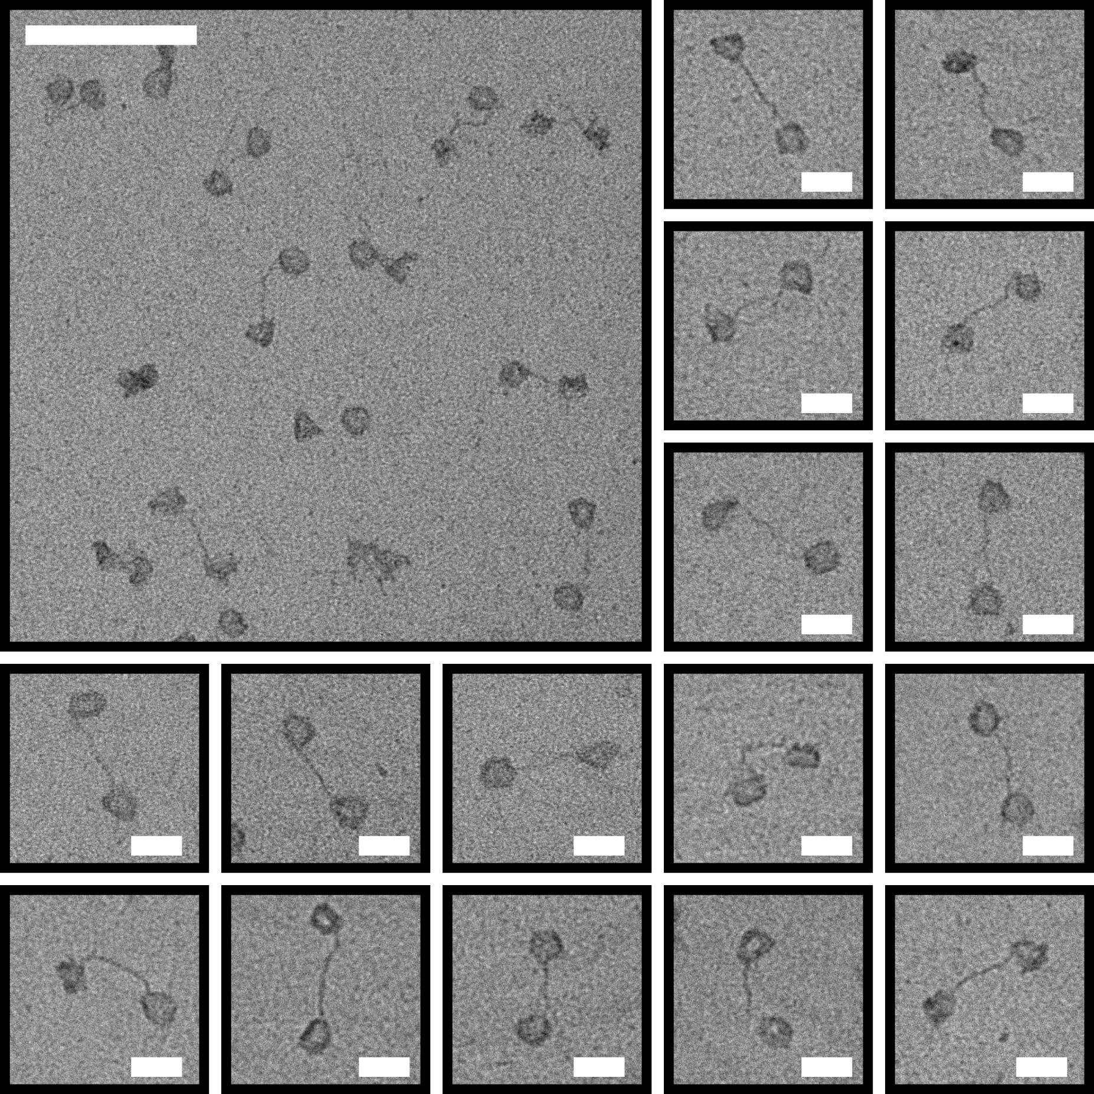

Figure S6. TEM images of well separated hemispheres created by light irradiation (10 minutes, 302 nm) of closed spheres containing 0-NB photo-crossovers. Top left scale bar = 200 nm. All other scale bars = 50 nm.

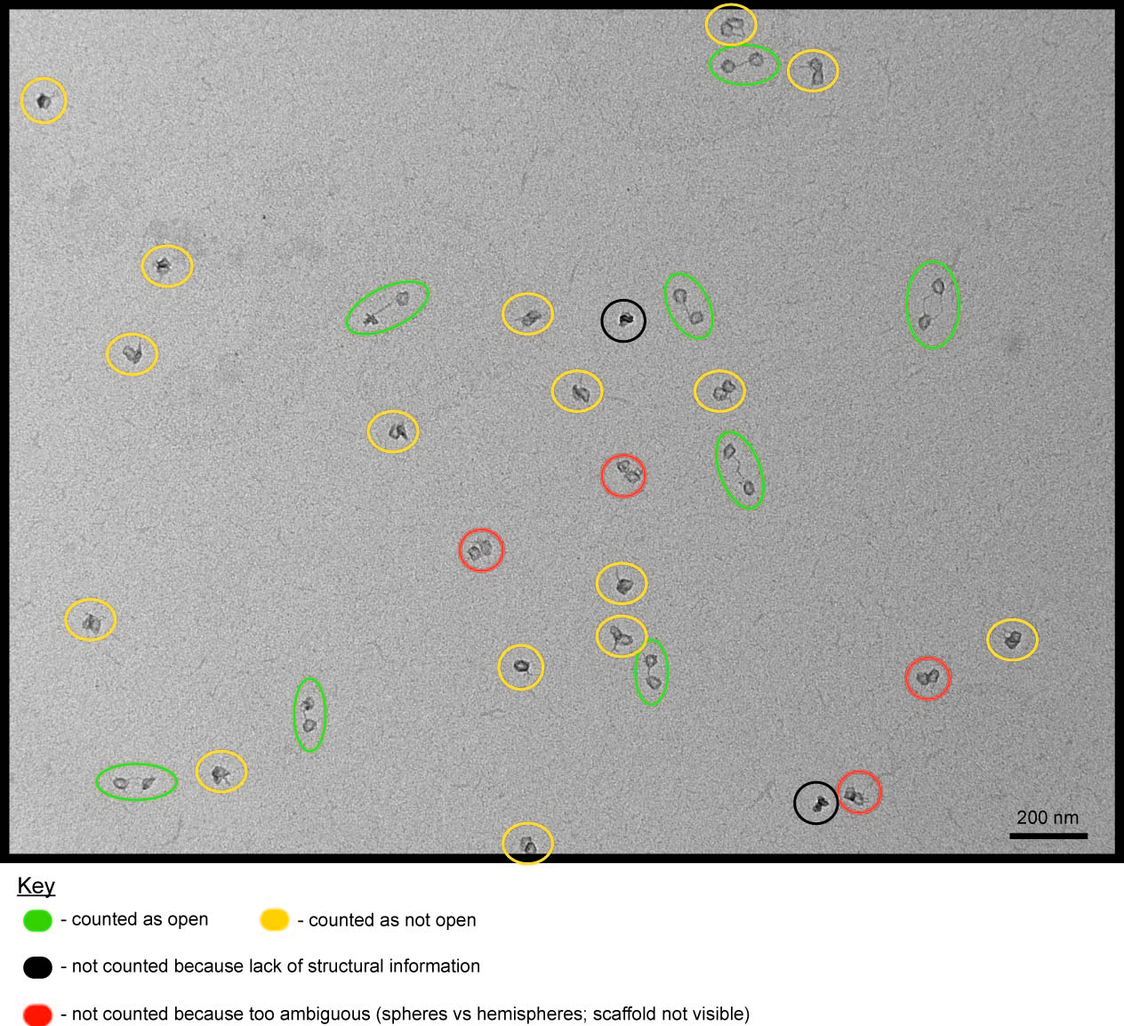

Figure S7. Illustration of the open sphere quantification process. Image of light sensitized spheres irradiated for 4 minutes with 302 nm light. Percent of opened structures is determined by number of open structures (green) compared to the total number of identified structures (green + orange). Particles are not counted if they lack convincing structural information (black) or if their orientation relative to other structures makes identification ambiguous (red).

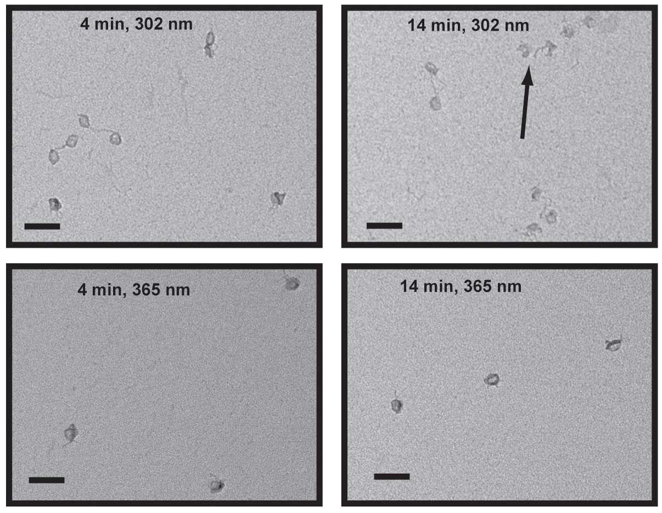Figure S8. Photo damage accumulation over time. TEM images of light-sensitized spheres irradiated at 4 or 14 minutes with 302 or 365 nm light. 302 nm light irradiation effectively opened spheres over time (top left, top right) however photo damage became apparent at long irradiation durations (top right, arrows). Photo damage does not appear when 365 nm light is used however this wavelength is ineffective at opening spheres (bottom left, bottom right). Scale bar =100 nm.

Staple oligonucleotide list

Designs were obtained using caDNAno (high resolution images and .json files separately attached). Staple oligonucleotide lists were obtained directly from caDNAno software.

Northern Hemisphere (70 staples):

GTGAATTACCTTAATGTTTAGA
ACCGCCACCCTCCTATTATTCTGAAA
CGTACTCAGGAGGGATTAGCGGGGTTT
CTAAAACACTCATCCGCTTTTGCGGGA
AGCCAGAATGGAACGGATAAGTGCCGT
AACGAAAGAGGCACCATGTTACTTAGCC
AGATGAACGGTGTACAGAATGCCCCCTGC
CGAGAGGGTAACAAAGTACAACGGAGATT
TTAATTTCAACACAAATAAATCCTCATTAA
ATCAAGAGTAATCTTGTGAGATTTAGGAATA
CAAGCCCAATTTTTCTGTATGTGAATTTCTT
TCAGTGAATAAGGCTTGGAAGAAAAATCTAC
ATTGCGTGCTTTCGAGGGGATTTTGCTAAGGA
GTCAGTGCCTTGAGTAGAACCGCCTCCCTCAG
GTTTCCATTAAACGGGCAACTTTGAAAGAGGAC
TTCCAGTAAGCGTCATCAGAACCACCACCAGAGC
CTAAAGTAAACTACAACGCCTGATAGGTGTATCAC
ACAACAACCAGCGAAAGACAGCAGCACCAACCTAA
AAATGAAAGGAACCCATGTACCCGCCACCCTCAGA
AAACAGTTACCAGGCGCATCATAATCAAAATCACCG
TGCTCAGTACCAGGAGCGCAGAGGTTGAGGCAGGTC
TCGTCACCCTCAGCATCGCCCACGCATATCCAAAAG
CATGAAAGTATTAAACTGGTGCCACCCTCAGAGCCA
GGAACGAGGCGCAGTCAACGGAACAACATTATTACAG
CCACATTCAATGCCATCTTTTAGGCTGGCTGACCTTC
TGTATCATCGCCTGAGTAAATTTAAGAACTGGCTCATT
TACATAACGAGGAAGCCCGAAAGACTTCACATGATTAAG
ACTCCTTATTTAGCCCCCTTATTAGCGTTCTAATGCAGA
CATTAAAGGTTCCAATACTGCGGAATCGTATGTTTTAAA
TATGCAACTAAGAATTAACTGAACACCCTGGGAAATTATT
AAAGAACTGGAATATCGCGTTTTAATTCGACTACTAATAG
AAACAGCTTGGAGGCTTTGAGGACTAAAGATCAGGGATAG
TAGTAGCATTAGCCTTAAATCAAGATTAGTGGAATACCCA
TACATAAAGTCAGACTGTAGCGCCACCGACAGTGCCCGTAT
ATATGGTGCCGGAAACGTCACCGCCACACATGGCTTTTGATGA
GAGCCTTTTTTTCACGTTGAAAATATAGAAGCGGAGTAACGAT
CAGACAGCCCGGCTTGCAGGGAGTTAAAGGCTTTGACCCCCAG
AGATTAAGCCAAAAGGAATTACATCAGTACAAGAACCGGATATT
CAACCGATCCAGCAAAATCACCTGACAGGTCTCTGAATTTACCG
TGACTATTTCATAACCCTCGTTCTAACGTAACAAAGCTGCTCAT
AACGAGAAAATAGCGAGAGGCTACGTTGGCCCTGACGAGAAACA
CACGGAATCGTAATCAGTAGCGAGAACCAATAAGTTTTAACGGG
ATTCATTGGGGGTAATAGTAAATGCGATTTGGGCTTGAGATGGT
CTATTTCGGAACAGAGCCACCACCCTCATTTCTTTTTCATGAGGAA
AGTTGCGCTATCGGTTTATCAGCTAATAATAATTAATTGCGACAATG
GCCACCCTCAGAACGTAACACTGAGTTTCGTCACCAGTACTTTGTCGT
GTAGAAAGATTCGAGGCATAGTAAGAGCAACACTAATAGTCAGAAGCA
CGATTATACCAAGCGCGATGATATAAGTATAGCCCGGATAGCATTCCA
GAACCAGAGCCACGTTTTCATCGGCATTTTCGGTCAACGCAGTATGTT
CTTTCCAGACTTTCAACAGTTTCAAGGAACAACTAAAACAACGTTAGT
CGCCGCCAGCATAGTAGCACCATTACCATTAGCAAGTTACCAGCGCCA
AATGCCACTACGAAGTCGGAACGAGGGTAGCAACGGCTACAATACCGAT
CCACCCTCAGAGCCAATGAAACCATCGATAGCAGCACAAGTTTATTTTG
GTTAATAAAACGAATACCAGACGACGATAAAAACCAATGACCATAAATC
AAGACAAAAGGGAACCCACAAGAATTGAGTTAAGCCCGAAACGATTTTTT
AGCCGCCACCCTCACAGAATCAAGTTTGCCTTTAGCGGTGGCAACATATA
AAGCGGATTGCAGACCGGAAGCAAACTCCAACAGGTCTATTTTCATTTGG
AAAGAAACGCATTAAGAAAAGTAAGCAGATAGCCGAACAACGCTAACGAG
TACAGGAGTGTGAGGCTGAGACTCCTCAAGAGAAGGATTAGTTTAGTACC
AGCAAACGTAGAGAAACCGAGGAAACGCAATAATAACTGCTATTTTGCAC
TAAATATTGACAACAAAGTCAGAGGGTAATTGAGCGCCTTTACAGAGAGA
GCTTTAAACAGGGCTTAGAGCTTAATTGCTGAATATAGTTGATTCCCAAT
ATACCAGTCAGGTTTGCAAAAGAAGTTTTGCCAGAGAATCCCCCTCAAAT
CATTACCCAAAACGGTCAATCATAAGGGAACCGAACTGACTAAAATACGT
TCACAATCAATAAAACAATGAAATAGCAATAGCTATCACAAAATAAACAG
CCAGAACGAGTATAAATTGTGTCGAAATCCGCGACCTGCTAAAGAATACA
AGACGATTGGCCTCTTGAGCCATTTGGGAATTAGAGTGAGGGAGGGAAGG
AAAAATCAGGTCCTTTAATTGCTCCTTTTGATAAGAGATTAGATACATTT
CTGGATAGCGGAATTATCACCGTCACCGATGATATTCACAATTTAATCATT
CGGTCGCTGATCATAGTTAGCGTGAGACTCCAAAAAAAAGGCACCGATATATT

Southern Hemisphere (70 staples):

TATCAAAATTATTGTGAATAAC
ATGGTTGCTTTGTAAAGCACTAAATC
GAATAGCCCGAGAAGAAAGCGAAAGGA
CTGAACCTCAAATATTGAATGGCTATT
GTAACCACCACAGCCGGCGAACGTGGC
GAAAAATCTAAAGCTAATAGATTAGAGC
GCGGGCGCTGCAAATCAACAGTTGAAAGG
CTCGTATTAAATCCTTTAAGTTTTTTGGG
TGGAAGGGTTAAATCCCTTATAAATCAAAA
AGAATCAGAGCAATACTTCTATTGGCAGATT
TGAGTAACATTATCATTGCTTTGAATACCAA
CTGATTATCAGATGATTTTAACGTCAGATGA
CCAGAAGATTATTTACTTGATTAGTAAAATAT
AGGGCGATGGCCCACTCCAGGGTGGTTTTTCT
GGTCAGTATTAACACCTACAAACAATTCGACAA
TTGGAACAAGAGTCCAGAGTTGCAGCAAGCGGTC
TAAAAGAGAACGGTACGCCAGAGGTCACGCTGCGC
CTGGCCAACGAACTGATAGCCCTCCAGCAGCAAAT
GTTGTAGCGGGAGCTAAACAGGCAGGGCGCGTACT
AGTCTTTAATGCGCAGAGATAGAACCCTGAAATACC
GGAACCCTAAAGGGAAAGGGAACAGCTGATTGCCCT
GAGAAAGGAAGGGATAGGGTCAGGCGAAAATCCTGT
CCCAAATCGCCCGAACGTTCAACGCGCGGGGAGAGG
CGTCAATAGATAATGAGCGGTTACATCGGGAGAAACA
GTTACAAAATAATGAATCGGCATTAATTTTAAAAGTT
AATTGAGGAAGGTTTTTGGATAAAACAGAAATAAAGAA
CGAATTATTAACTATATGTAAATGCTGATGGCACCGCTT
GGTCGACTCTTAAATCGTCGCTATTAATTAAGCCTGTTT
CTGGTGCCGGCTGTCGTGCCAGCTGCATTCGCGCAGAGG
CACCAGTCACCGAACCACCAGCAGAAGATATTTCCTCGTT
AGTATCATATCGCCATCAAAAATAATTCGCCATGCCTGCA
CCAGCTTTCCGCAAATCCAATCGCAAGACAGTCCAGACGA
CGACAATAAAATCTACAAAGGCTATCAGGTCGCACTCCAG
CTGCGCAATTGCGTTGCGCTCATGGGCGACGTGAACCATCA
GCGATTATTCCACACAACATACTGAGACTATTAAAGAACGTGG
TACATTTTGCCAGCCATTGCAACACTATCGAAGAACCACCGAG
GTGTTTTTATTACGTGGCACAGACAATATTTTCAAACCCTCAA
ACGCTGAGTCATTTGAATTACCTTCAGGGGCAATTCATCAATAT
GGTTATATCATTTCAATTACCTCCTGATTTTGCGGAACAAAGAA
CGCTATTAGCCTGGGGTGCCTAACGGGCCGAAAAACCGTCTATC
GACGTTGTATAGCTGTTTCCTGCCCCAGTGAGTGTTGTTCCAGT
GGTCTGAGAACATCAAGAAAACTACCTTAATTATCATCATATTC
CCTTAGAAATCAATATATGTGATGCACGTTATACTTCTGAATAA
GTCGAGGTGCCGACGAGCACGTATAACGTGCAAACAGAGGTGAGGC
TAATAAAATCAATCGTCTGAAATGCAATATTACCGACGCGGGACATT
TCAATATCTGGTCAGTTGAGGGCGCTGGCAAGTGTAGCATCCTGAGAA
TTAATGCGCCGCTAAGGCCGATTAAAGGGATTTTAGACAGGTCTGTCC
CACGCTGGTTTGTGTGAAATTGTTATCCGCTCACAAAGTTGGGTAACG
CGGTTTGCGTATCTGCCCGCTTTCCAGTCGGGAAACAAACCAGGCAAA
ATAACGGATTCGGAGCAAAAGAAGATGATGAAACAAGACTACCTTTTT
ATCACGCATCACTTGCCTGAGTAGGCCTTGCTGGTTAACAAATTAACC
TCACCGCCTGGCCCGAGCCGGAAGCATAAAGTGTAAACGCCAGCTGGCG
ATATACAGTAACAGAAAATTAATTACATTTAACAATTAAGAGTCAATAG
GTGCCACGCTGAGAGAAAACATCGCCATTAAAAATACCGAAACGACCAG
GATCGGTGCGGTGGGCGCATCGTAACCGTGCATCTGCGGTAATCGTAAAA
AATCCTGATTGATCTAAAATATCTTTAGGAGCACTAACAACATCACCTTG
AAAGGGGGATGTGGCGGATTGACCGTAATGGGATAGGTGATAATCAGAAA
ACTCCAACGTCAGCCCCCGATTTAGAGCTTGACGGGGAAACCCGCCGCGC
TGAATTTATCAAAATTTAATGGTTTGAAATACCGACCCGCCAACATGTAA
ACCACCAGAAGACATTTGAGGATTTAGAAGTATTAGACTTGCCTGCAACA
TTTCACCAGTGAGATGAGTGAGCTAACTCACATTAACTGTTGGGAAGGGC
ATTGCGTAGATTTTTTTTAATGGAAACAGTACATAATCCTTGAAAACATA
TGCCAAGCTTGGTCTGGCCTTCCTGTAGCCAGCTTTCCGCATTAAATTTT
TTGATGGTGGTTCAGCTCGAATTCGTAATCATGGTCAAAACGACGGCCAG
GCGATAGCTTACGTTAAATAAGAATAAACACCGGAATCTCAACAGTAGGG
GCGCCATTCGCCACGACAGTATCGGCCTCAGGAAGATCATTGCCTGAGAG
AACCTCCGGCTCTTTTTCAAATATATTTTAGTTAATTATAAGAGAATATA
CCAGGGTTTTCCGAGCGAGTAACAACCCGTCGGATTCGCAAATATTTAAA
CTTGCTTCTGAGAGGATCCCCGGGTACCGCGAAATCGGCAAGAACCTACCA
AGCGTAAGAAAATCAGTGAGGCTCAAAGGAAAAACGCTCATGTCTGACCTGAA

Equator Crossovers (18 staples):

ATAACATAAAAATCATTTTTTAACCAATAGGAAGCGTTATA
TGTTAAATCAGCCAGGGAAGCGCATTAGACGGGAAGTACGG
TGTCTGGAAGTTTATTTTGTTAAAATTATCAACATTAAATGTCAGTCAC
AAGTACCGACAATATCCTGAATCTTACCAAAGTTACCAGAAGAAATACA
CAAATTCTTACCAATGAAAATAGCAGCTAATATCAGAGAGATCGACATT
CGTCTTTCCAGAATTTTCGAGCCAGTATCATCTTCTGACCTAAATCATA
GGCGCGAGCTGAAGAGAATCGATGAACCAGTTTGAGGGGACGATTCAGG
CTAGCATGTCAATAACCTGTTTAGCTAAGGATTAGAGAGTACTTTACCC
CTTAATTGAGAATCCCAATCCAAATAAAATAATAAGAGCAAGGAAAATTC
TCTGCGAACGAGAGGAAGATTGTATAATCCGTGGGAACAAACGCTGCAAG
TTGTAAACGTTAATCATTCCATATAACAATGCTGTAGCTCAACCATAAAT
GTTTAACGTCAAAAGTATAAAGCCAACGCATAATTACTAGAAAAATTTTC
CCATATTATTTATCGCCATATTTAACAAGTGTGATAAATAAGGGATTAAG
AGCCCCAAAAACTAGATTTAGTTTGACCGTCATTTTTGCGGATTTCAGAA
TTTAGGCAGAGGCGCCTAATTTGCCAGTTTTACCGAAGCCCTTTAAGACAC
CGCAAATGGTCAATCATATGTACCCCGGTTCACGTTGGTGTAGAGCCTCTT
TCTGGAGCAAACAAAAGGTGGCATCAATTGCTTCAAAGCGAACCATCAAAA
CCAGCTACAATTTAAGGTAAAGTAATTCTAAGAACGCGAGAAAATAGGTTG

Photo-Crossovers (6 staples)
o-nb = ortho-nitrobenzyl

ATAACATAAAAA o-nb TCATTTTTTAACCAATAGGAAGCGTTATA
TGTTAAATCAGC o-nb CAGGGAAGCGCATTAGACGGGAAGTACGG
CGTCTTTCCAGA o-nb ATTTTCGAGCCAGTATCATCTTCTGACCTAAATCATA
CTAGCATGTCAA o-nb TAACCTGTTTAGCTAAGGATTAGAGAGTACTTTACCC
TTTAGGCAGAGGC o-nb GCCTAATTTGCCAGTTTTACCGAAGCCCTTTAAGA CAC
CGCAAATGGTCAA o-nb TCATATGTACCCCGGTTCACGTTGGTGTAGAGCCT CTT

Loop (12 staples):

CCAATAAATCATACAGGCAAGGCAAAGAATTAGCAAAATTAAGCAATAAA
GCCTCAGAGCATAAAGCTAAATCGGTTGTACCAAAAACATTATGACCCTG
TAATACTTTTGCGGGAGAAGCCTTTATTTCAACGCAAGGATAAAAATTTT
TAGAACCCTCATATATTTTAAATGCAATGCCTGAGTAATGTGTAGGTAAA
GATTCAAAAGGGTGAGAAAGGCCGGAGACAGTCAAATCACCATCAATATGA
TATTCAACCGTTCTAGCTGATAAATTAATGCCGGAGAGGGTAGCTATTTTT
TGTTCAGCTAATGCAGAACGCGCCTGTTTATCAACAATAGATAAGTCCTG
AACAAGAAAAATAATATCCCATCCTAATTTACGAGCATGTAGAAACCAAT
CAATAATCGGCTGTCTTTCCTTATCATTCCAAGAACGGGTATTAAACCAA
GTACCGCACTCATCGAGAACAAGCAAGCCGTTTTTATTTTCATCGTAGGA
ATCATTACCGCGCCCAATAGCAAGCAAATCAGATATAGAAGGCTTATCCG
GTATTCTAAGAACGCGAGGCGTTTTAGCGAACCTCCCGACTTGCGGGAGGT

