**Supplementary Appendix**

Protocolized fluid therapy in brain-dead donors:

The multi-center randomized MOnIToR trial

Ali Al-Khafaji MD, MPH; Michele Elder RN; Daniel J Lebovitz MD; Raghavan Murugan MD, MS; Michael Souter MB, ChB, FRCA; Susan Stuart RN, MPM; Abdus S. Wahed PhD; Ben Keebler EMT-P, CPTC; Dorrie Dils RN; Stephanie Mitchell RN; Kurt Shutterly; Dawn Wilkerson RN; Rupert Pearse MD; John A Kellum MD on behalf of the Monitoring Organ Donors to Improve Transplantation Results (MOnIToR) Study Investigators

Contents

**MOnIToR Study Sites and Personnel2**

**MOnIToR Protocol Deviations (Table S1)4**

**Mean Arterial Pressure (Figure S1)5**

**Reasons for Aborted Cases (Table S2)5**

**Provider Survey (Table S3)6**

**Recipient Survival (Figure S2)7**

**Recipient Length of Hospitalization (Table S4)8**

**MOnIToR Study Personnel and Study Sites**

Principal Investigator: John A Kellum, MD

Co-Principal Investigator: Ali Al-Khafaji, MD, MPH

Statistician: Abdus S. Wahed, PhD

Coordinating Center Faculty: John A. Kellum, MD; Ali Al-Khafaji, MD, MPH; Raghavan Murugan, MD; Abdus S Wahed, PhD

Coordinating Center Staff: Michele Elder, RN, BSN; Ali Smith, BA; Melinda Carter, BS; Michael Willochell; Kyle Landis, BS, Qian Hao, MS

Planning Committee members:

Ali Al-Khafaji, MD, MPH; *University of Pittsburgh, Pittsburgh, PA*

Michelle Berens, RN; *Gift of Hope, Elmhurst, IL*

Christine Cottingham, RN, MS; *University of Washington, Seattle, WA*

Michele Elder, RN, BSN; *University of Pittsburgh, Pittsburgh, PA*

Michael Harmon, RN; *Gift of Hope, Elmhurst, IL*

J. Steven Hata, MD; *University of Iowa, Iowa City, IA*

Ibtesam Hilmi, MD; *University of Pittsburgh, Pittsburgh, PA*

John A Kellum, MD; *University of Pittsburgh, Pittsburgh, PA*

Dan Lebovitz, MD; *Akron Children’s Hospital, Akron, OH*

Kenneth McCurry, MD; *University of Pittsburgh, Pittsburgh, PA*

Martin Mozes, MD; *Gift of Hope, Elmhurst, IL*

Raghavan Murugan, MD; *University of Pittsburgh, Pittsburgh, PA*

C. Lee Parmley, MD, JD; *Vanderbilt University, Nashville, TN*

Ali Salim, MD; *Cedars-Sinai Hospital, West Hollywood, CA*

Alan Spriggs, *Tennessee Donor Services, Knoxville, TN*

Michael Souter, MD; *University of Washington, Harborview, Seattle, WA*

Susan Stuart, RN, MPM; *CORE, Pittsburgh, PA*

Kenneth Wood, MD; *University of Wisconsin, Madison, WI*

Steering Committee members:

Ali Al-Khafaji, MD, MPH; *University of Pittsburgh, Pittsburgh, PA*

John A Kellum, MD; *University of Pittsburgh, Pittsburgh, PA*

Dan Lebovitz, MD; *Lifebanc, Cleveland, OH*

Raghavan Murugan, MD; *University of Pittsburgh, Pittsburgh, PA*

Michael Souter, MD; *University of Washington, Harborview, Seattle, WA*

Susan Stuart, RN, MPM; *CORE; Pittsburgh, PA*

Abdus S Wahed, PhD; *University of Pittsburgh, Pittsburgh, PA*

External Advisory Committee members:

Rupert Pearse, MD (Chair); *Barts and London School of Medicine and Dentistry, London, UK*

Luis Angel, MD; *University of Texas, Austin, TX*

Howard Rockette, PhD; *University of Pittsburgh, Pittsburgh, PA*

MOnIToR Study Enrolling Sites and Investigators:

CORE- *Pittsburgh, PA*- Susan Stuart RN, MPM; Kurt Shutterly; Dawn Wilkerson RN

Lifebanc- *Cleveland, OH-* Dan Lebovitz MD;Beverly Alt RN, CPTC

LifeCenter Northwest- *Bellevue, WA-* Michael Souter MD;Angela Brooks RN, CPTC; Bill Goe

Lifeline of Ohio- *Columbus, OH-* Dorrie Dils RN, CPTC;Kelly Simonton CPTC; Jennifer Heisler RN; Mindy Zoll RN, CPTC

Lifelink of Georgia- *Norcross, GA-* Shri Bharadwaj; Jennifer Dennis RN, CPTC

LifeShare of Oklahoma- *Oklahoma City, OK*- Stephanie Mitchell RN; Chad Muse RN, BSN, CPTC; Misty Nicholson RN, CPTC

Southwest Transplant Alliance- *Dallas, TX*- Ben Keebler, EMT-P, CPTC; James Hill CPTC

Tennessee Donor Services- *Knoxville, TN*- Deirdre McAdams RN; Deena Clapper RN, MSN

**Table S1. Protocol Deviations**

|  |  |
| --- | --- |
| **Protocol Deviation reasons**  **(as reported by Organ Procurement Coordinator via study website)** | **n=60** |
| Unavailability or faulty cables | 16 |
| No time to set-up LiDCO due to OR time | 6 |
| Operator error; unable to calibrate/chose not to set-up/ did not know how to set-up LiDCOplus | 6 |
| LiDCO unavailable | 5 |
| Reason not specified; only "LiDCO not used" | 5 |
| Difficult arterial-line placement | 5 |
| Mechanical Problems w/LiDCOplus monitor | 4 |
| Expired or faulty sensors | 4 |
| No arterial-line module | 4 |
| Donor too unstable | 2 |
| Not eligible for study; should not have been randomized | 1 |
| Donor had atrial-fibrillation | 1 |
| Hospital monitor malfunction | 1 |

**Figure S1. Mean Arterial Pressure**

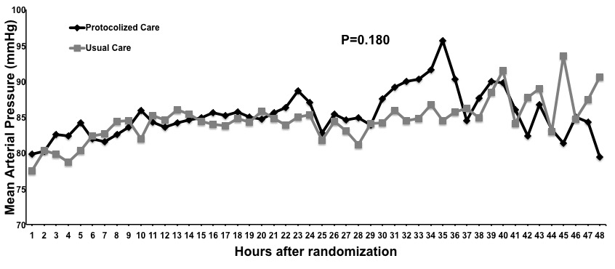

**Table S2. Reasons for Aborted Cases**

|  |  |
| --- | --- |
| **Reasons for Aborted Cases** | **n=48** |
| Infectious disease (includes High Risk donors) | 16 |
| OR visualization, Biopsy positive/Malignancy or Other contraindication | 9 |
| Medical examiner decline | 2 |
| Donor arrest prior to intervention | 4 |
| Other (list exhausted; no recipient located; unknown) | 15 |

**Table S3. Study Close-out survey to Organ Procurement Coordinators**

|  |  |  |  |  |
| --- | --- | --- | --- | --- |
| **Question** | **Answer** | | | |
| Are you a Registered Nurse? | Yes (48.1%) | No (51.9%) |  |  |
| If you are a Registered Nurse, how many years? | 0-5yrs (7.7%) | 5-10yrs (46.2%) | 10yrs or more (46.2%) |  |
| How many years have you worked as an Organ Procurement Coordinator? | 0-5yrs (63%) | 5-10yrs (22.2%) | 10yrs or more (14.8%) |  |
| Did you enroll or care for a donor in the MOnIToR study? | Yes (100%) | No (0%) |  |  |
| If yes, was the donor in the Protocolized Care arm? | Yes (92.6%) | No (7.4%) |  |  |
| If you enrolled a donor into the Protocolized Care arm, how do you rate the process of connecting the donor to the LiDCO monitor? | Easy (0%) | Moderate (53.8%) | Hard (46.2%) |  |
| How easy was following the algorithm protocol? | Easy (55.6%) | Moderate (25.9%) | Hard (3.7%) | N/A; Did not enroll/care for a donor in the Protocolized Care arm (14.8%) |
| How often did you follow the protocol? | Strictly (34.6%) | Intermittently  (50%) | Did not follow protocol algorithm (3.8%) | N/A; Did not enroll or care for a donor in the Protocolized Care arm (11.5%) |
| Did you run into any difficulties while following protocol? | Yes (44%) | No (56%) |  |  |
| Do you think a bedside nurse would have trouble following the algorithm? | Yes (23.1%) | No (76.9%) |  |  |
| In the donors you cared for or enrolled in the Protocolized Care arm, do you think the protocol algorithm resulted in increased procurement of organs for transplantation? | Yes (19.2%) | No (65.4%) | N/A; Did not enroll or care for a donor in Protocolized Care arm (15.4%) |  |
| Would you use a non-invasive hemodynamic monitoring device and a protocol algorithm in the future while caring for donors? | Yes (84%) | No (16%) |  |  |
| How easy was it to transport the LiDCOplus monitors to different hospitals? | Easy (11.5%) | Difficulty (50%) | Very difficult (38.5%) |  |
| Do you think that this protocol algorithm would be feasible to use in every hospital that cares for donors (i.e., both community and academic hospitals)? | Yes (38.5%) | No (61.5%) |  |  |

**Figure S2. Recipient Survival**

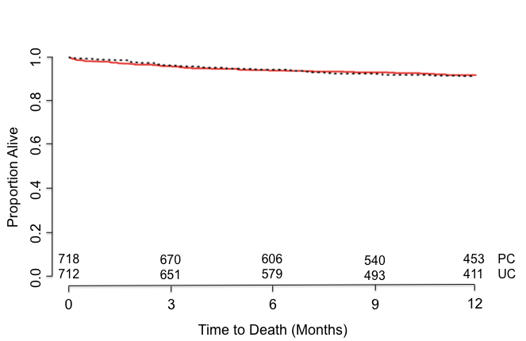

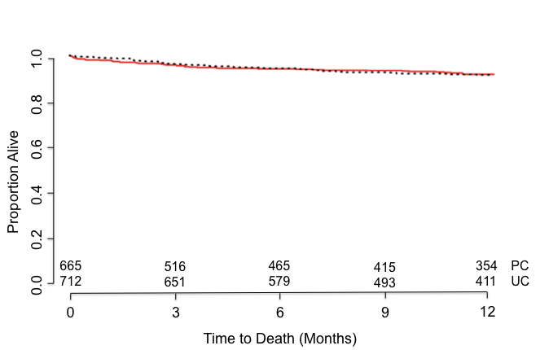

Kaplan-Meier curves for Overall Survival (PC=Protocolized Care, UC=Usual Care) restricted to 365 days. Top Panel: Intention-to-treat cohort; Bottom Panel: Modified intention-to-treat cohort

**Table S4. Recipient Length of Hospitalization**

**A**

Length of stay (in days)

| **Arm** | **N** | **Mean** | **Median** | **Minimum** | **Maximum** |
| --- | --- | --- | --- | --- | --- |
| **Protocolized Care** | 736 | 14.21 | 9.00 | 0.00 | 205.00 |
| **Usual Care** | 731 | 14.60 | 9.00 | 0.00 | 151.00 |

**B**

Length of stay (in days) among those who were discharged alive

| **Arm** | **N** | **Mean** | **Median** | **Minimum** | **Maximum** |
| --- | --- | --- | --- | --- | --- |
| **Protocolized Care** | 695 | 13.81 | 9.00 | 1.00 | 205.00 |
| **Usual Care** | 695 | 14.26 | 9.00 | 0.00 | 151.00 |

**C**

Length of stay (in days)

| **Arm** | **N** | **Mean** | **Median** | **Minimum** | **Maximum** |
| --- | --- | --- | --- | --- | --- |
| **Protocolized Care** | 573 | 14.08 | 9.00 | 0.00 | 205.00 |
| **Usual Care** | 731 | 14.60 | 9.00 | 0.00 | 151.00 |

**D**

Length of stay (in days) among those who were discharged alive

| **Arm** | **N** | **Mean** | **Median** | **Minimum** | **Maximum** |
| --- | --- | --- | --- | --- | --- |
| **Protocolized Care** | 537 | 13.57 | 9.00 | 1.00 | 205.00 |
| **Usual Care** | 695 | 14.26 | 9.00 | 0.00 | 151.00 |

Panels A and B: Results from 1476 recipients receiving organs from enrolled donors (n=740 for protocolized arm, and n=736 for usual care arm) included in the ITT analysis.

Panels C and D: Results from 1304 recipients receiving organs from enrolled donors (n=573 for protocolized arm, and n=731 for usual care arm) included in the mITT analysis.

The differing N’s in each analysis reflects missing data on the outcomes being analyzed.