Table S1. Results of Single-variant Analysis by Using Conventional Logistic Regression Approach
Block | Gene | Genetic  Model¹ | SNP in Block | Allele | MAF_M² | MAF_B³ | SNP  p-value⁴ | Block  p-value⁵
Block 1 | GSTM4 | Maternal | rs542338 | A/G | 0.41 | 0.40 | 0.060 | 0.038
 |  | Effect | rs668413 | A/C | 0.41 | 0.40 | 0.103
 |  |  | rs560018 | A/G | 0.32 | 0.31 | 0.029
 |  |  | rs535537 | A/G | 0.12 | 0.12 | 0.286
 |  |  | rs670439 | A/G | 0.13 | 0.13 | 0.818
Block 2 | DNMT3A | MFG | rs7578575 | A/T | 0.27 | 0.27 | 0.561 | 0.028
 |  | Interaction | rs7590760 | C/G | 0.49 | 0.49 | 0.037
Block 3 | PGDS | Fetal | rs8336 | A/G | 0.41 | 0.43 | 0.654 | 0.017
 |  | Effect | rs11097411 | A/G | 0.42 | 0.42 | 0.056
 |  |  | rs2016483 | A/T | 0.43 | 0.45 | 0.569
 |  |  | rs11932130 | A/G | 0.16 | 0.15 | 0.414
 |  |  | rs10033662 | A/G | 0.40 | 0.39 | 0.004
 |  |  | rs11097413 | A/G | 0.42 | 0.45 | 0.827
 |  |  | rs2865352 | A/G | 0.42 | 0.45 | 0.496
 |  |  | rs10084984 | A/G | 0.16 | 0.16 | 0.257
 |  |  | rs10516950 | A/G | 0.41 | 0.43 | 0.425
 |  |  | rs2059605 | A/G | 0.41 | 0.40 | 0.003
 |  |  | rs2289186 | A/C | 0.39 | 0.38 | 0.002
 |  |  | rs724260 | A/G | 0.44 | 0.43 | 0.005
 |  |  | rs11727030 | A/G | 0.46 | 0.45 | 0.017
 |  |  | rs1991316 | A/C | 0.46 | 0.46 | 0.038
 |  |  | rs10856909 | C/G | 0.39 | 0.41 | 0.942
 |  |  | rs4282187 | A/G | 0.4 | 0.39 | 0.004
Block 4 | MGMT | Fetal | rs11813363 | A/G | 0.20 | 0.18 | 0.514 | 0.0082
 |  | Effect | rs7068306 | C/G | 0.34 | 0.32 | 0.385
 |  |  | rs10829615 | A/G | 0.20 | 0.18 | 0.501
 |  |  | rs10764896 | A/G | 0.48 | 0.48 | 0.104
 |  |  | rs11016866 | A/G | 0.13 | 0.14 | 0.009
 |  |  | rs7910123 | A/C | 0.33 | 0.34 | 0.161
Block 5 | MGMT | Fetal | rs10829616 | A/G | 0.4 | 0.39 | 0.074 | 0.0015
 |  | Effect | rs2039374 | A/G | 0.28 | 0.28 | 0.004
 |  |  | rs11016875 | A/G | 0.07 | 0.07 | 0.716
Block 6 | MTHFS | Fetal | rs7175723 | C/G | 0.26 | 0.25 | 0.146 | 0.031
 |  | Effect | rs685487 | A/G | 0.39 | 0.38 | 0.189
 |  |  | rs11854561 | A/G | 0.29 | 0.28 | 0.629
 |  |  | rs2733103 | A/G | 0.18 | 0.16 | 0.405
 |  |  | rs622506 | A/C | 0.37 | 0.36 | 0.078
 |  |  | rs2054287 | A/G | 0.16 | 0.15 | 0.006
 |  |  | rs17284990 | A/G | 0.21 | 0.21 | 0.098
 |  |  | rs7164897 | A/T | 0.13 | 0.13 | 0.058
 |  |  | rs12912711 | A/G | 0.08 | 0.08 | 0.094
 |  |  | rs16971449 | A/G | 0.10 | 0.10 | 0.176
 |  |  | rs6495446 | A/G | 0.29 | 0.28 | 0.554
Block 7 | MTHFS | Fetal | rs12440609 | A/G | 0.20 | 0.22 | 0.342 | 0.0043
 |  | Effect | rs8039272 | A/G | 0.32 | 0.31 | 0.670
 |  |  | rs8030396 | A/G | 0.34 | 0.33 | 0.150
Block 8 | CBS | MFG | rs4920037 | A/G | 0.2 | 0.22 | 0.155 | 0.0040
 |  | Interaction | rs12329764 | A/G | 0.11 | 0.11 | 0.862
 |  |  | rs234705 | A/G | 0.32 | 0.33 | 0.002
 |  |  | rs9974224 | A/G | 0.10 | 0.10 | 0.128
 |  |  | rs2851391 | A/G | 0.43 | 0.43 | 0.356
 |  |  | rs11701048 | A/G | 0.10 | 0.10 | 0.624
Block 9 | DNMT3L | MFG | rs2838540 | A/G | 0.26 | 0.27 | 0.070 | 0.0032
 |  | Interaction | rs2838541 | A/G | 0.10 | 0.10 | 0.250
¹ Genetic model is determined by the penalized logistic regression model as described in the main text.
² Minor Allele Frequency among mothers
³ Minor Allele Frequency among babies
⁴ p-values by using conventional single-variant logistic regression
⁵ p-values by using haplotype-based penalized logistic regression

Figure S1. MGMT (Block 4) – Fetal Main Effect Only

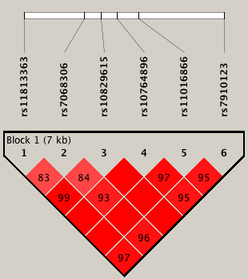

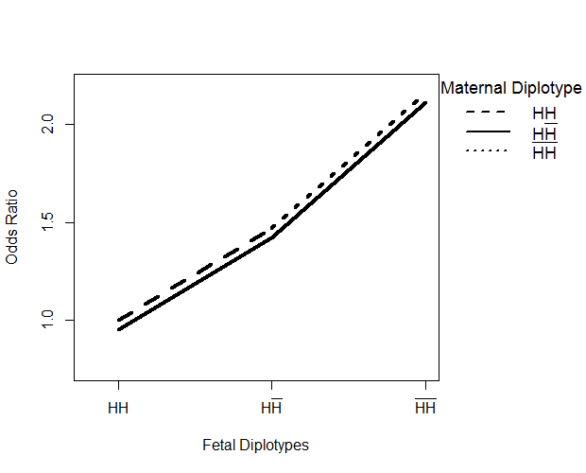

Figure S2. MTHFS (Block 7) – Fetal Main Effect Only

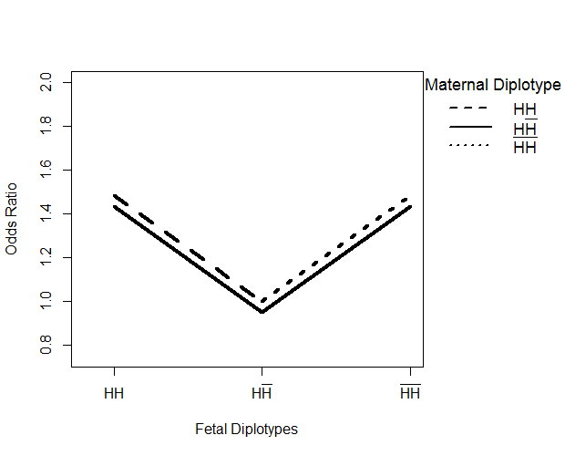
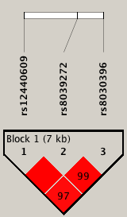

Figure S3. PGDS (Block 3) - Fetal Main Effect Only

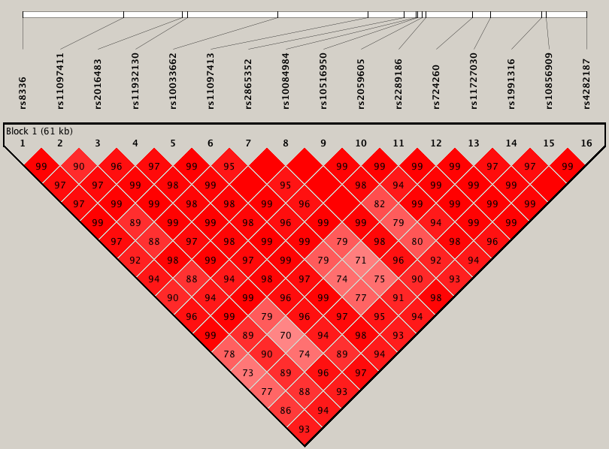

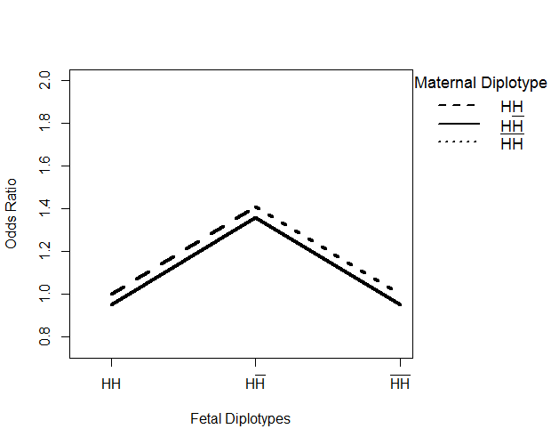

Figure S4. MGMT (Block 5) - Fetal Main Effect Only

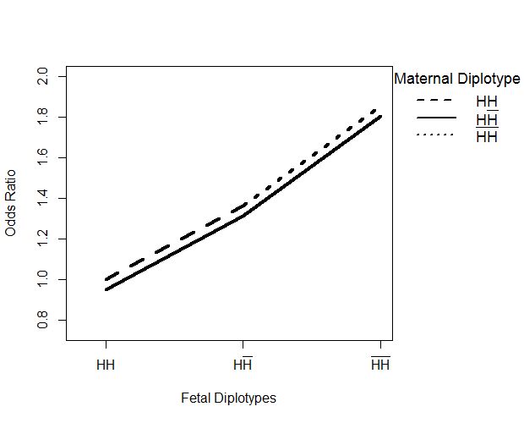
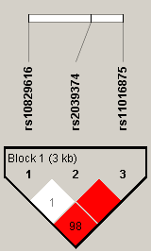

Figure S5. MTHFS (Block 6) – Fetal Main Effect Only

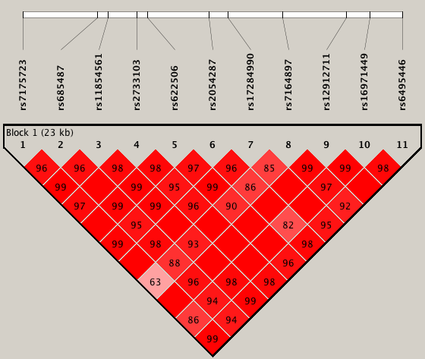

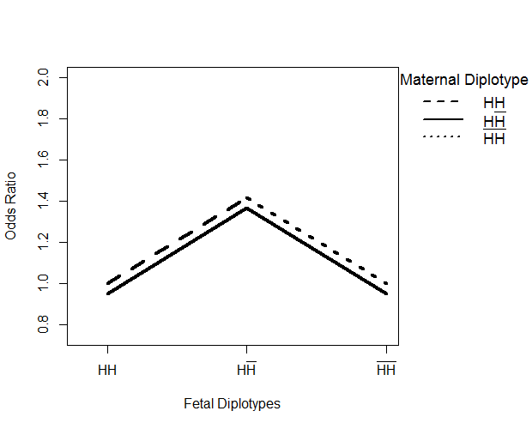

Figure S6. GSTM4 (Block 1) - Maternal Main Effect Only

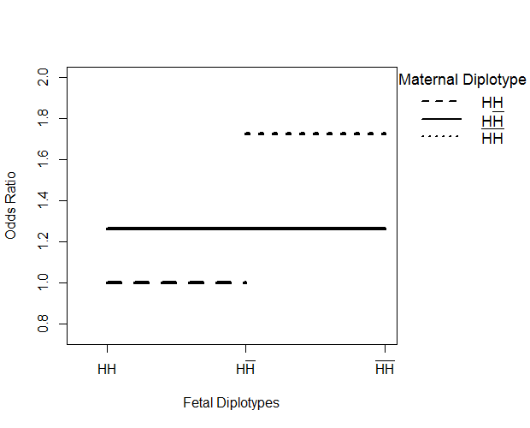
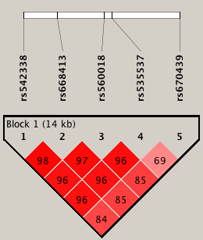

Figure S7. CBS (Block 8) - MFG Interaction Effect

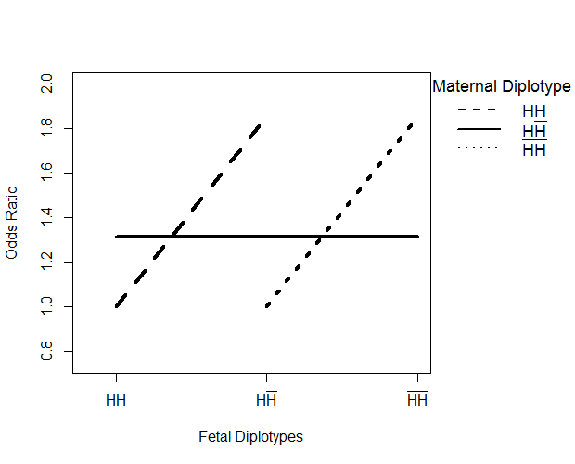
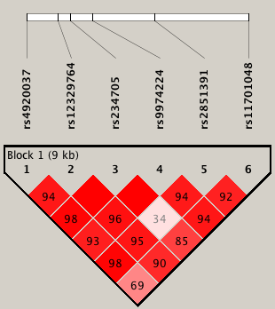

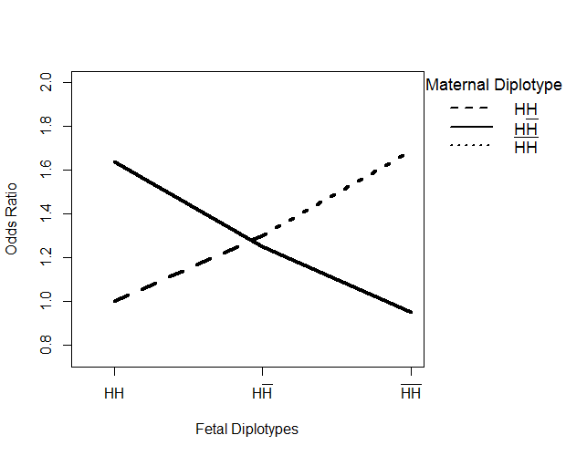
Figure S8. DNMT3L (Block 9) - MFG Interaction Effect

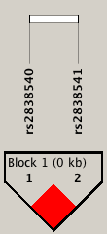

Figure S9. DNMT3A ((Block 2) – MFG Interaction Effect

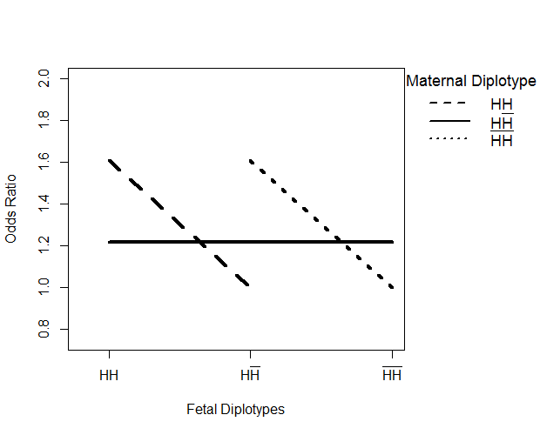
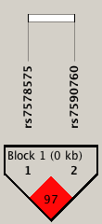

Figure S10. Pairwise R² values for SNPs within Block 1
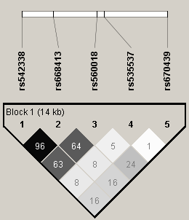

Figure S11. Pairwise R² values for SNPs within Block 2
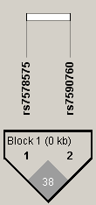

Figure S12. Pairwise R² values for SNPs within Block 3
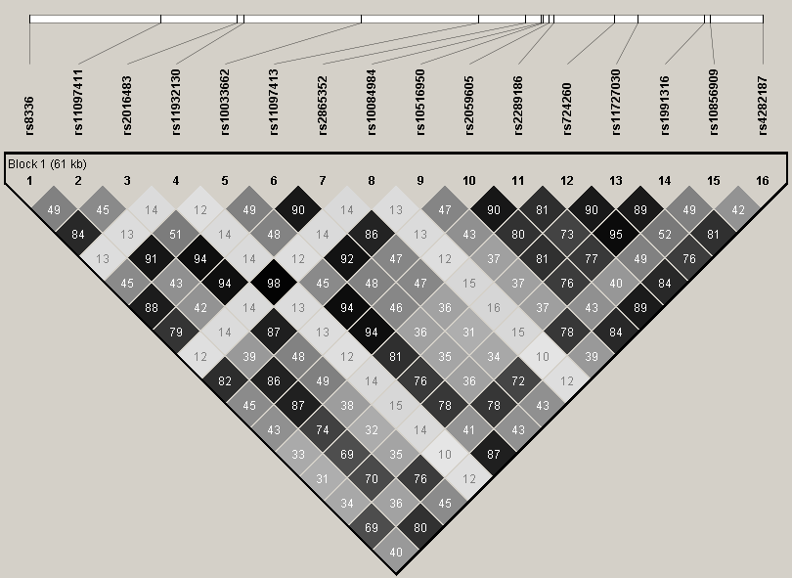

Figure S13. Pairwise R² values for SNPs within Block 4
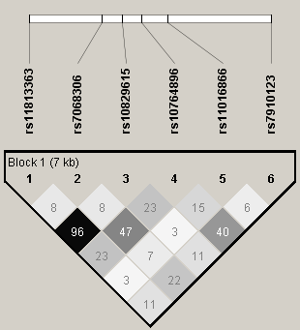

Figure S14. Pairwise R² values for SNPs within Block 5
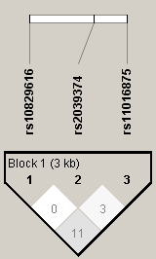

Figure S15. Pairwise R² values for SNPs within Block 6
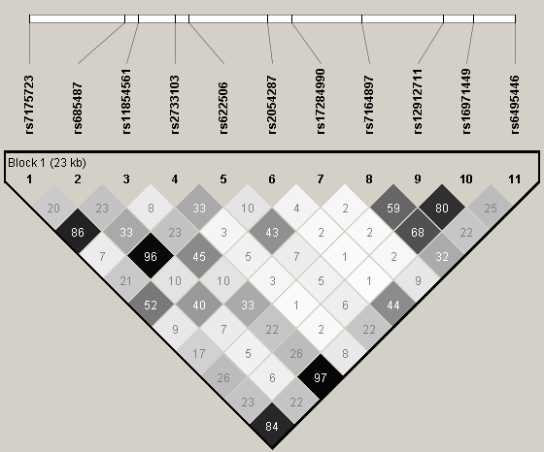

Figure S16. Pairwise R² values for SNPs within Block 7
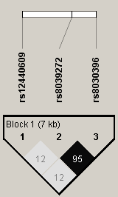

Figure S17. Pairwise R² values for SNPs within Block 8
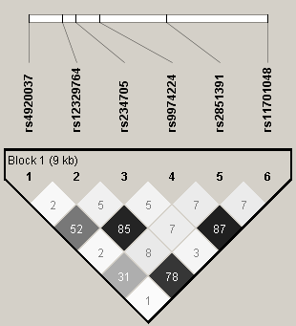

Figure S18. Pairwise R² values for SNPs within Block 9
