Supplemental Materials

Spatial analysis of gastroschisis in Massachusetts and Texas

Mahsa M. Yazdy, Martha M. Werler, Marlene Anderka,
Peter H. Langlois, and Veronica M. Vieira

Table of Contents

I. Effect measure modification by maternal age 2
II. Controlling for maternal age using a loess smoother 4
III. Sensitivity analysis: imputing missing geocodes 5
IV. Summary of GAM specifications and results for Texas space-time analysis 8
V. Adjusting for maternal race/ethnicity in Texas space-time analysis 9

- Effect measure modification by maternal age
Due to the strong association between gastroschisis and young maternal age, we conducted a stratified analysis by restricting the data to the two maternal age groups and ran the models for younger women (<25 years of age) and older women (≥25 years of age) separately. For race/ethnicity we included all the women in the stratum and chose only to predict for non-Hispanic white women; predicting for other race/ethnicities would not change the risk pattern observed on the map because changing the value of one variable in the prediction model would change all the values in the prediction grid by the same amount. Typically to obtain the odds ratios (ORs) for the maps, the log odds at each grid point is divided by the value from the aspatial model resulting in ORs that fall above and below one. To allow for comparisons between the stratified maps, we chose to use the same referent model for both strata which could result in maps having ORs that are no longer centered around one. Choosing a different reference group (e.g., the overall aspatial model) would shift the magnitude of the ORs, but the observed spatial pattern would not be altered.

  - Massachusetts
When the data were stratified by maternal age, a pattern was detected among the older women but the surface of the map was relatively flat for younger women; due to the observed pattern in older women, we opted to use the aspatial model for older women as the reference group for computing the ORs for both strata. When calculating the ORs among younger women, the use of the aspatial model for the older women as the reference resulted in much higher ORs due to the to the lower baseline risk of gastroschisis in older women. Of note, the referent odds for older women were 10 times lower than for younger women (data not shown). Location was statistically significant for older women (≥25 years of age) but not younger women (<25 years of age), among whom the local test identified areas of increased odds in the south-central area of the state (global p-value=0.03; span size=0.90) with maximum ORs at 1.9 (Figure S1A). Among younger women, ORs were elevated throughout the entire state and a pattern of increasing ORs from east to west was observed (Figure SB); however, the global test was not statistically significant (global p-value=0.37; span size=0.95).

Figure S1. Map of predicted odds ratio for non-Hispanic White women among older mothers only (≥25 years) (A), and predicted odds ratio for non-Hispanic White women among younger mothers only (<25 years) (B), Massachusetts Birth Defects Registry, 2000—2007.
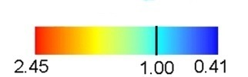  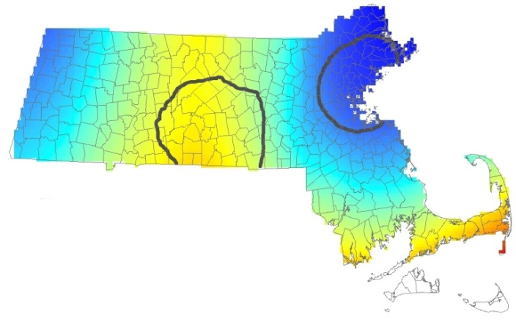  Odds Ratios | B)  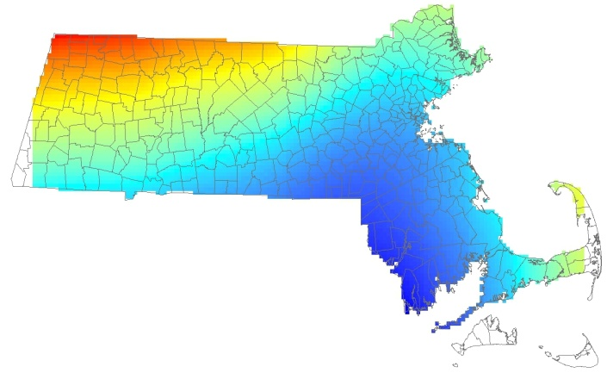  Odds Ratios
  - Texas
Similar to Massachusetts, when the data were stratified by maternal age a pattern was detected among the older women; therefore, we chose to use the aspatial model for older women as the reference group to further explore the pattern detected. The use of the aspatial model for the older women as the reference resulted in much higher ORs that were not centered on 1 for the stratum of younger women. The maximum adjusted OR for older women was 2.3 for non-Hispanic white women (global p-value <0.01; span size=0.35). The significance bands identified the central and Corpus Christi regions as statistically significant (Figure S2A). When the data were restricted to only younger women, we did not identify a pattern of elevated risk and the global test was not significant (global p-value=0.52; span size=0.95) (Figure S2B).

Figure S2. Map of odds ratio predicted for non-Hispanic White women among older mothers only (≥25 years) (A), and odds ratio predicted for non-Hispanic White women among younger mothers only (<25 years) (B), Texas Birth Defects Registry, 1999—2008.

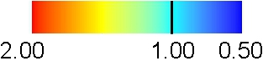  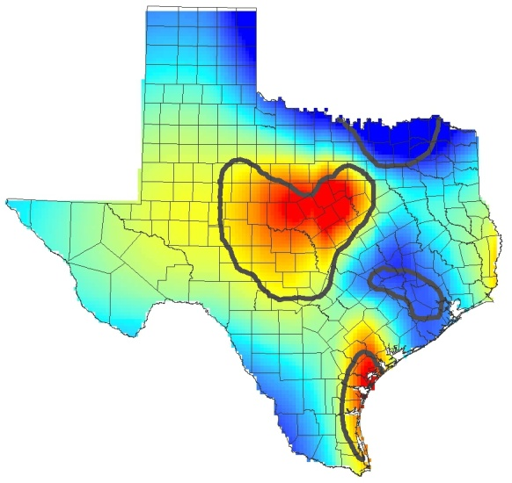  Odds Ratios | B)  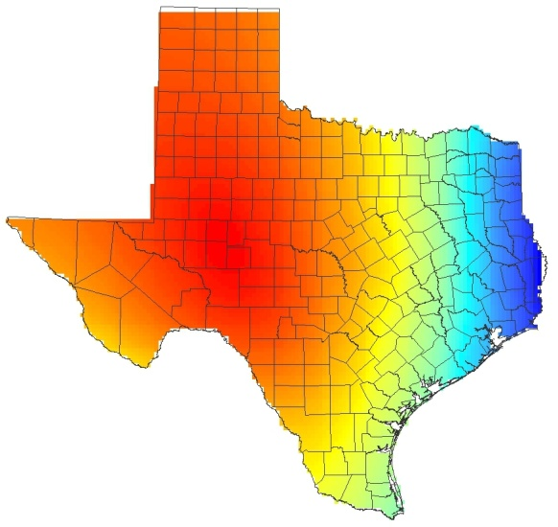  Odds Ratios

- Controlling for maternal age using a loess smoother

A loess smoother was used to model maternal age. The results were similar to the main analysis, which model age categorically.

Figure S3. Map of odds ratio using a loess smooth for maternal age, Massachusetts Birth Defects Registry, 2000—2007.
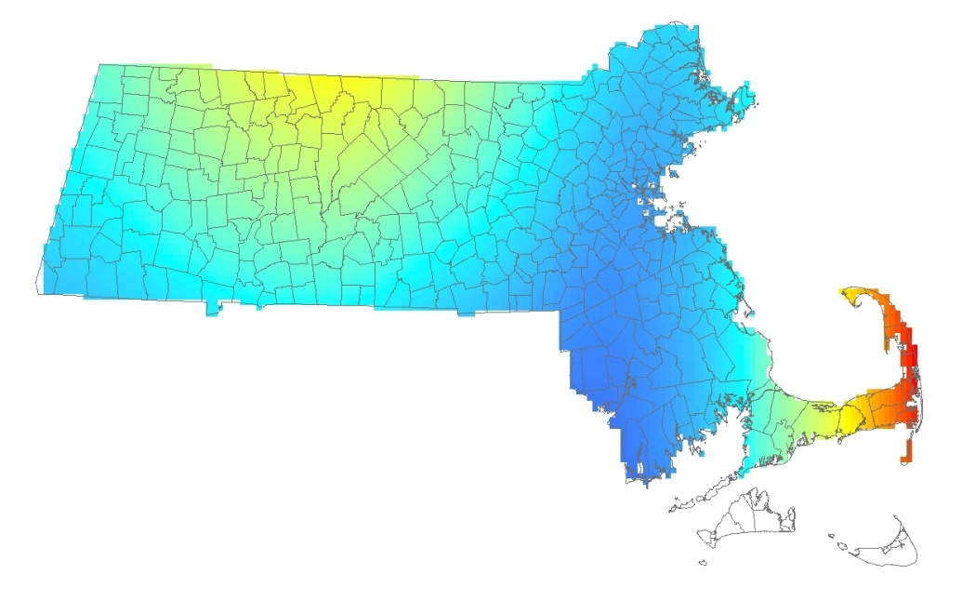
p-value: 0.137
Odds Ratios
Figure S4. Map of odds ratio using a loess smooth for maternal age, Texas Birth Defects Registry, 1999—2008.
Odds Ratios
p-value: 0.009
- Sensitivity analysis: imputing missing geocodes

A sensitivity analysis was conducted to assess if the results changed when mothers with missing geocodes were included in the analysis. In Massachusetts, the ORs were slightly larger when the missing geocodes were added, though the pattern of disease odds remained the same. The results did not change for the Texas data.

Figure S5: Distribution of mothers with imputed geocodes from the first imputation sample, Massachusetts Birth Defects Registry (81 cases) and Massachusetts Birth Registry (1 control), 2000—2007. Locations have been altered to preserve confidentiality.
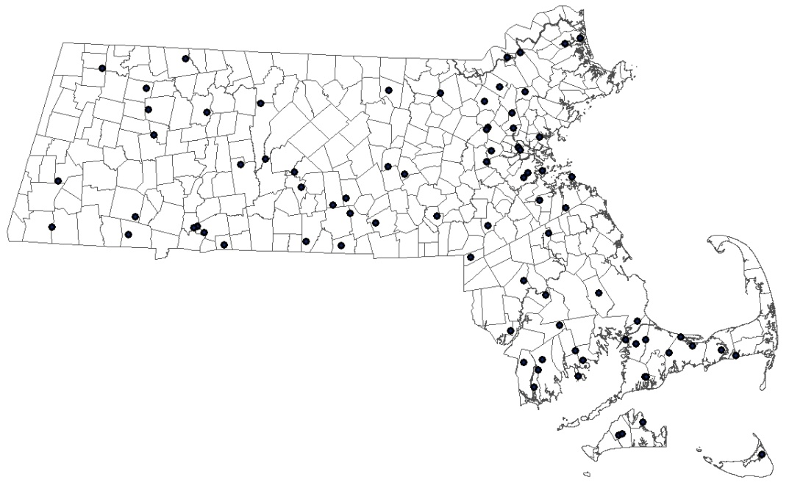

Figure S6: Map of predicted odds ratios for non-Hispanic White women ≥25 years of age for the first (A), second (B), and third (C) iteration of the sensitivity analysis including mothers with imputed geocodes Massachusetts Birth Defects Registry (81 cases) and Massachusetts Birth Registry (1 control), 2000—2007

A)  P-value: 0.04  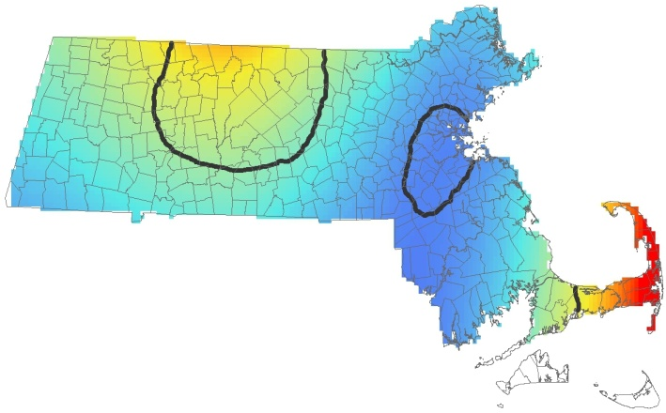  Odds Ratio | B)  P-value: 0.04  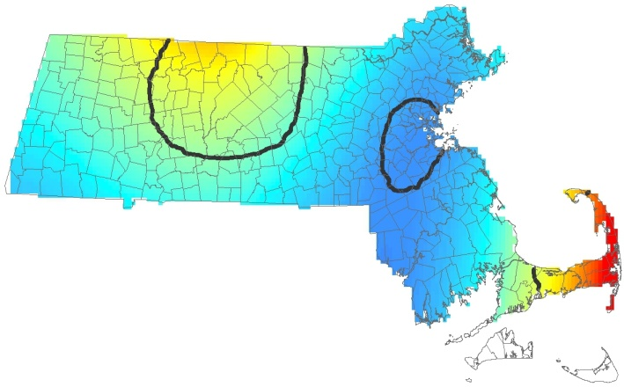  Odds Ratio
C)
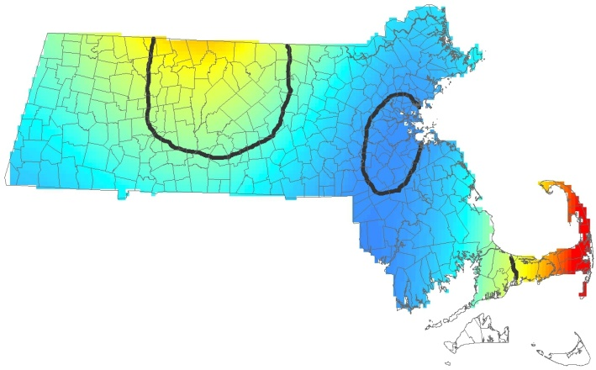
P-value: 0.04
Odds Ratio

Figure S7. Distribution of mothers with imputed geocodes from the first imputation sample, Texas Birth Defects Registry (68 cases) and Texas Birth Registry (291 controls), 1999—2008. Locations have been altered to preserve confidentiality.
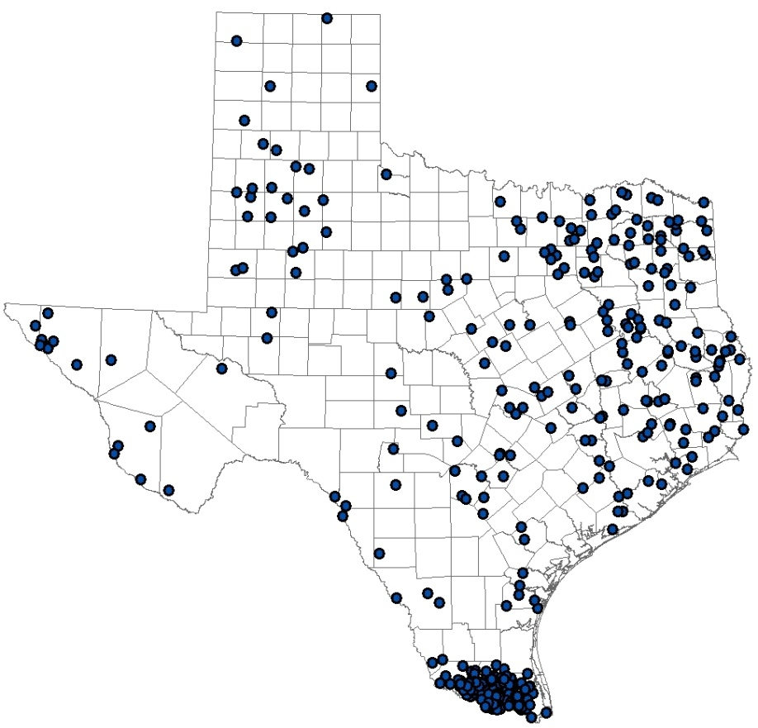

Figure S8. Map of predicted odds ratios for non-Hispanic White women ≥25 years of age for the first (A), second (B), and third (C) iteration of the sensitivity analysis including mothers with imputed geocodes, Texas Birth Defects Registry (68 cases) and Texas Birth Registry (291 controls), 1999—2008.

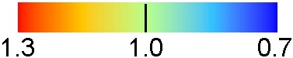  A)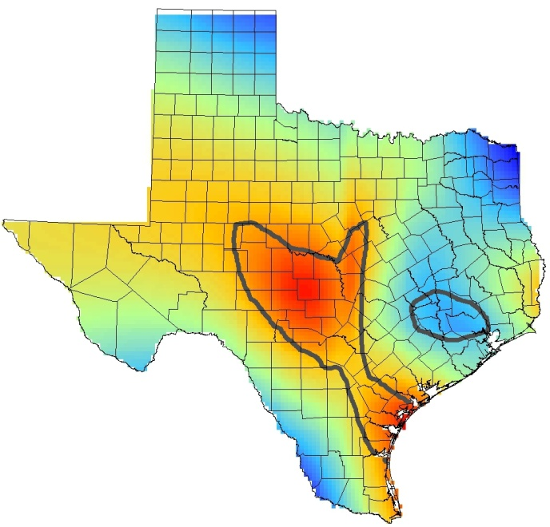  P-value <0.001  Odds Ratio | B)  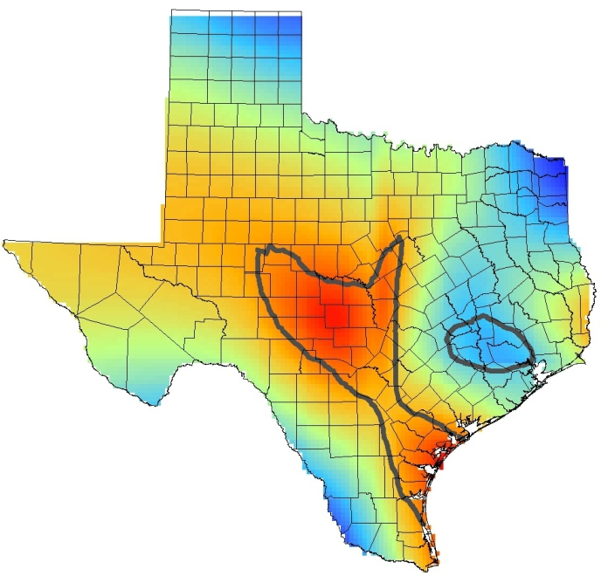  P-value <0.001  Odds Ratio
C)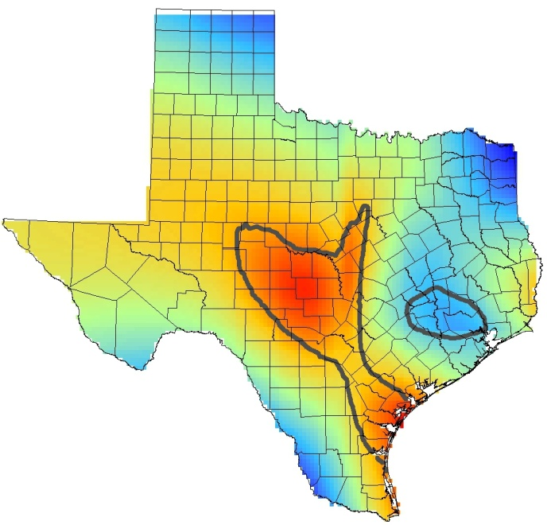
P-value <0.001
Odds Ratio

- Summary of GAM specifications and results for Texas space-time analysis

In Texas, the data were partitioned into calendar years (January 1st – December 31st) and maps were generated for each year. Below are the ranges of ORs for each map, as well as the span size used, the referent odds value, and the global p-value for each map.

Table S1. Summary of GAM specifications and results for Texas space-time analysis

Calendar Year | OR  Range | Span  Size | Referent odds | Global  p-value
1999 | 0.2 – 1.8 | 0.45 | 0.10 | 0.39
2000 | 0.4 – 1.8 | 0.45 | 0.08 | 0.79
2001 | 0.3 – 2.4 | 0.45 | 0.09 | 0.09
2002 | 0.5 – 2.6 | 0.45 | 0.10 | 0.42
2003 | 0.5 – 2.1 | 0.45 | 0.10 | 0.03
2004 | 0.1 – 2.6 | 0.45 | 0.11 | <0.01
2005 | 0.4 – 1.4 | 0.45 | 0.13 | 0.24
2006 | 0.5 – 1.7 | 0.45 | 0.15 | 0.67
2007 | 0.5 – 1.8 | 0.45 | 0.16 | 0.25
2008 | 0.6 – 2.0 | 0.45 | 0.14 | 0.34

- Adjusting for maternal race/ethnicity in Texas space-time analysis

The appearance of the maps did not change substantially when race/ethnicity was added to the model; therefore, we elected to remove the variable from the main model. Below are the results when race/ethnicity is included in the model for the two years where we identified statistically significant results.

Figure S9. Map of age and race adjusted odds ratios for Texas, Texas Birth Defects Registry, 2003.
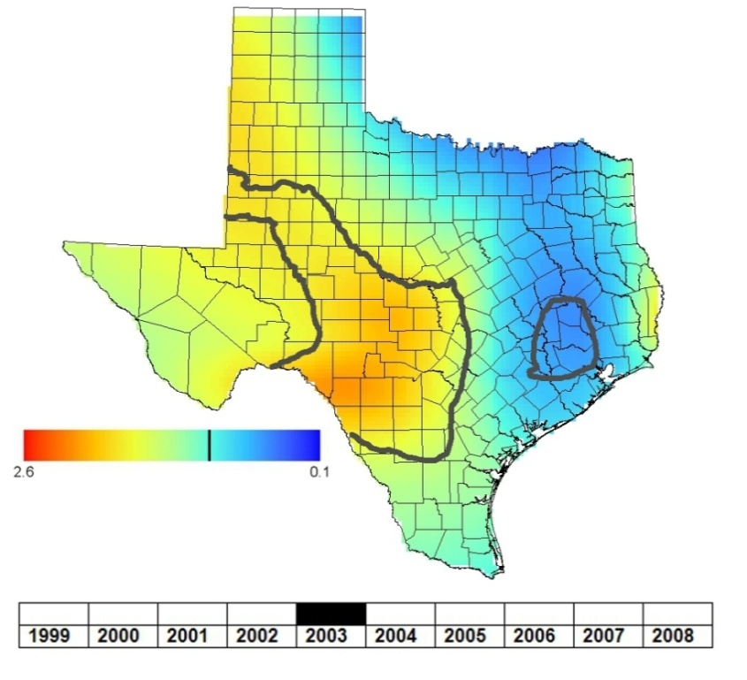
p-value: 0.045
Figure S10. Map of age and race adjusted odds ratios for Texas, Texas Birth Defects Registry, 2004.
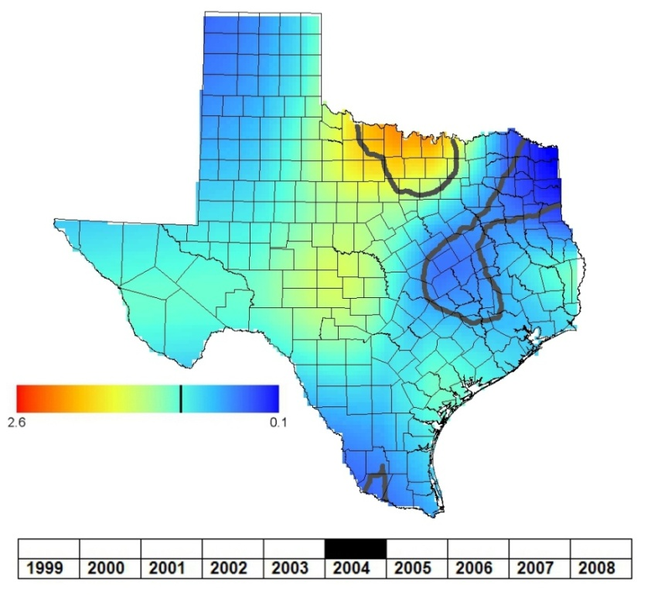
p-value: 0.026

