Supplemental Figure I. Mn levels in rat brain regions after oral chronic Mn exposure
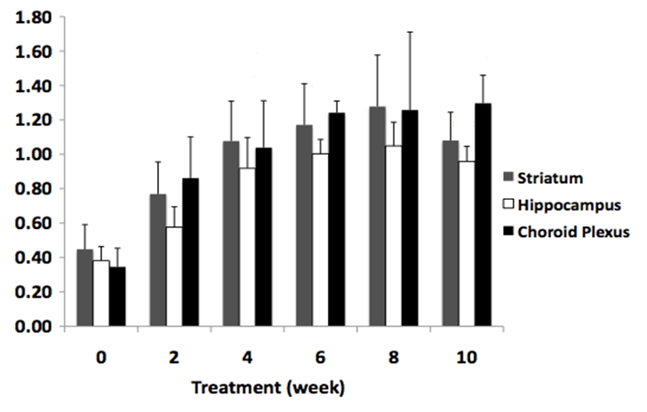
Mn Concentration (µg/g)
*
*
**
**
**
**
**
**
**
**
**
**
**
**
**

