Inventory of Supplemental Information:

- Figure S1. Related to Figure 2. Providing information on the generation of the α_{1E}-null mice with verification of gene deletion at the DNA and protein levels.
- Figure S2. Related to Figure 3. Providing analysis and quantification of additional stimulants of Ca²⁺ responses and AE.
- Figure S3. Related to Figure 4. Providing further information and verification of Ca²⁺/AE simultaneous measurements.
- Figure S4. Related to Figure 5. Providing further details on membrane potential measurements, as well as control experiments for α₂δ₁ immunolabeling.
- Movie S1. Related to Figure 4.
- Legends Figures S1-4.
- Legend Movie S1.
- Supplemental Experimental Procedures
- Supplemental References

Figure S1

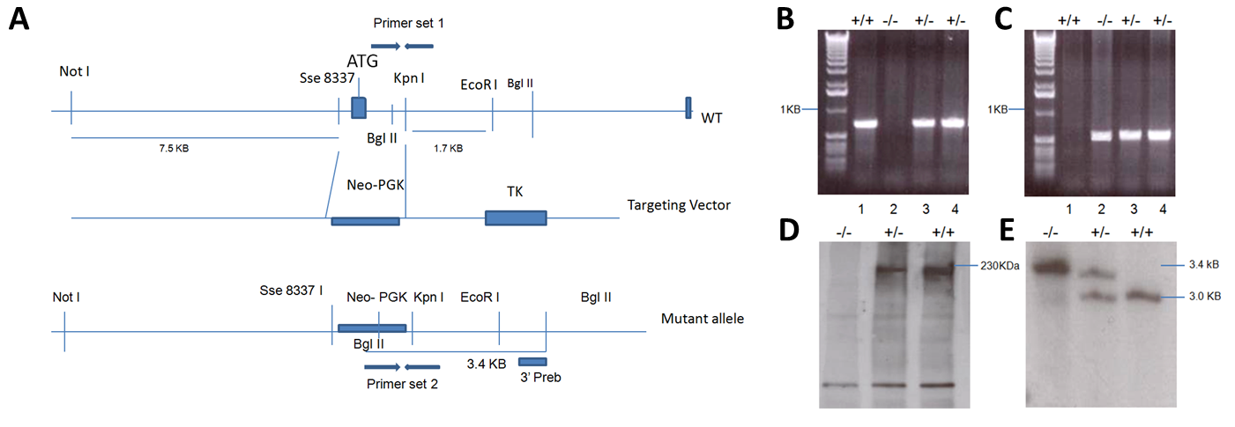

Figure S2

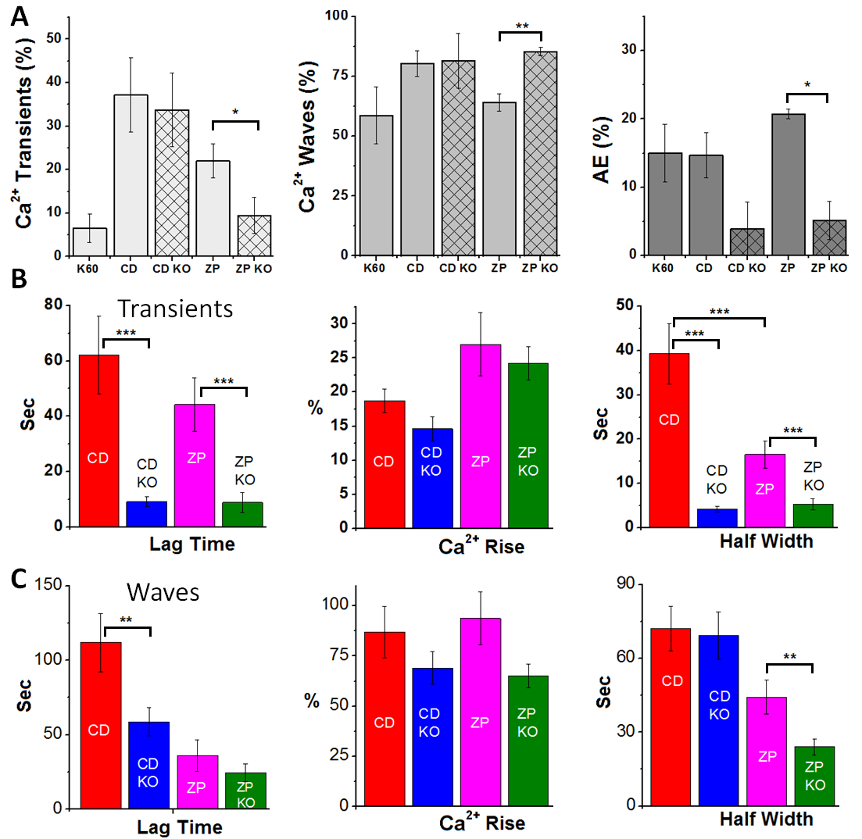

Figure S3

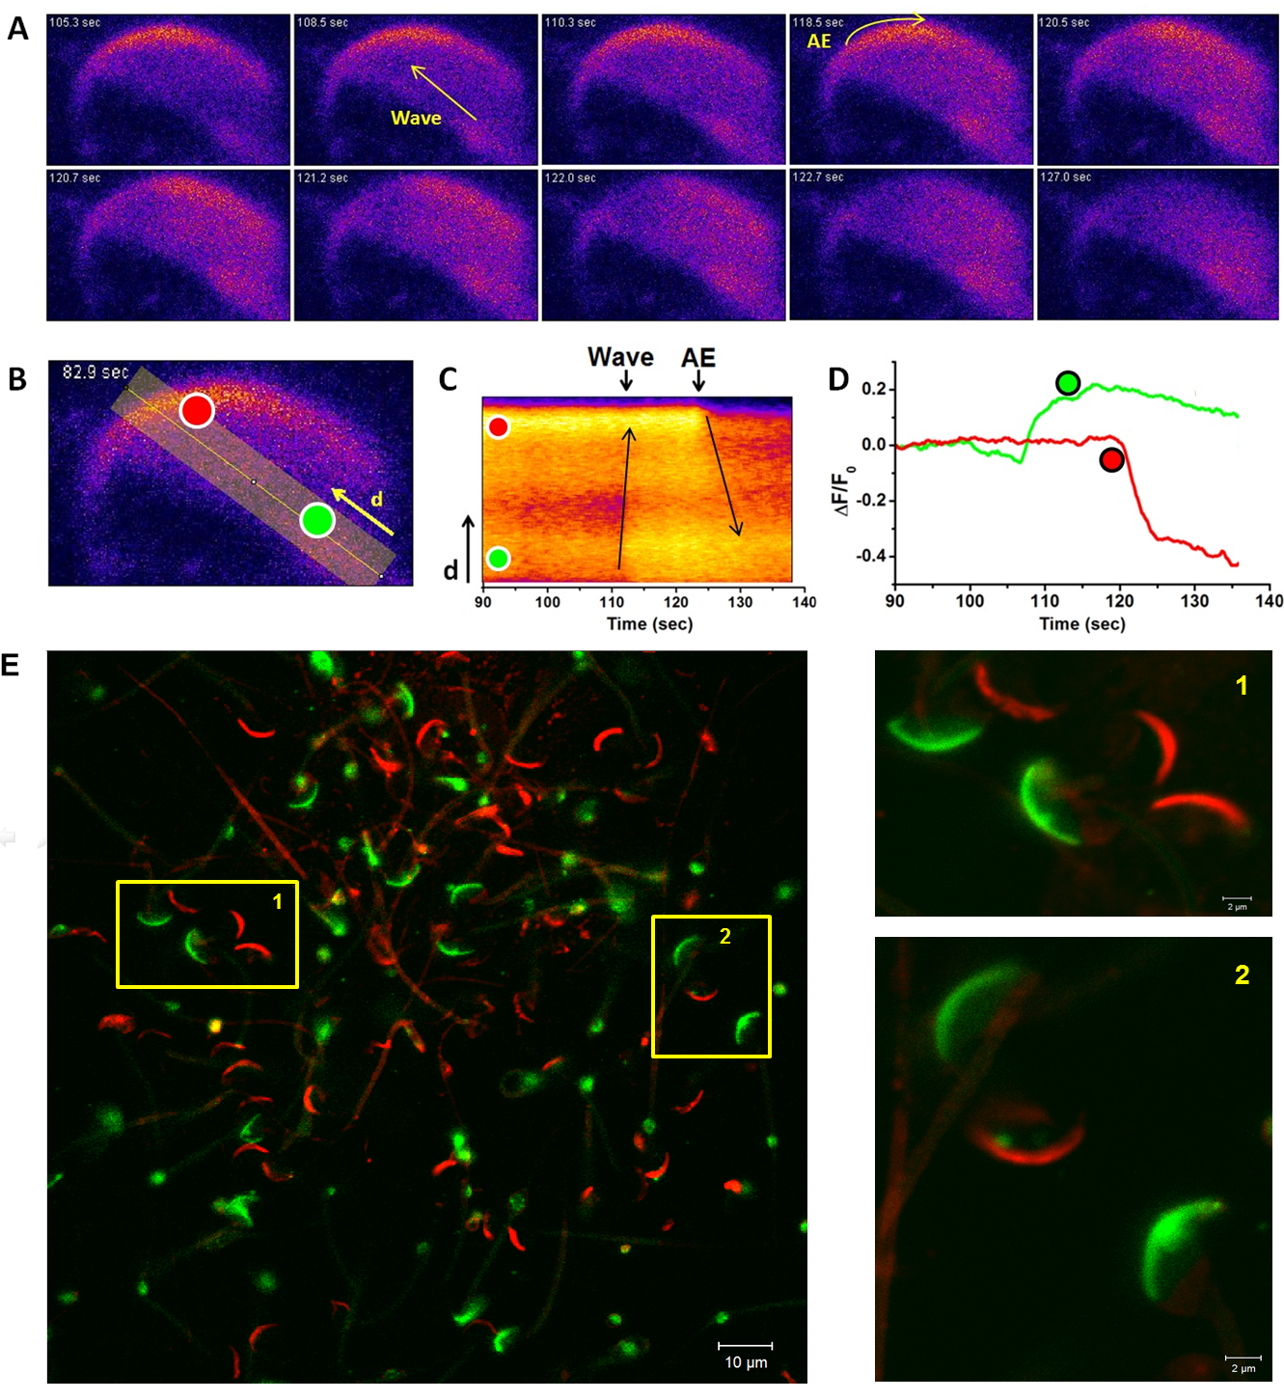

Figure S4
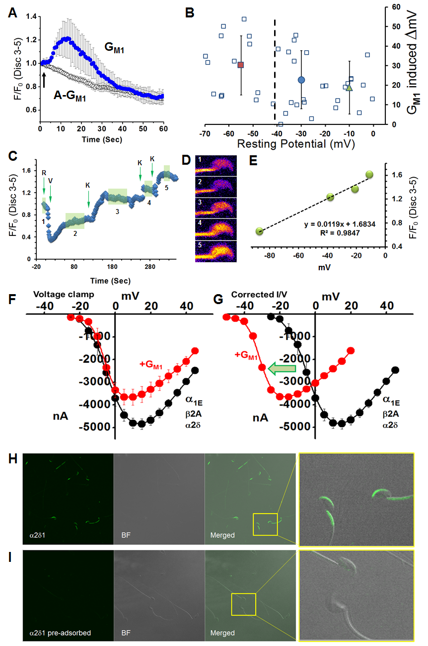
Figure S1 (related to Figure 2). Generation and verification of α_{1E} KO mice. A) Recombination strategy used to generate mice null for α_{1E}, showing the targeting vector and resulting mutant allele, as well as primer sets used for PCR analysis of genomic DNA from mice derived from ES cell clones. B) An 800-bp PCR fragment amplified by primer set 1 could be found in wild-type and heterozygous mice. Absence of product in lane 2 indicates recombination occurred, creating a homozygous null. C) A 600bp PCR fragment amplified by primer set 2 could be found in heterozygous and homozygous null mice, with no product in the wild-type mice, lane 1. D) Immunoblots of proteins from mouse brain, showing expression of the 230 kDa α_{1E} protein, in the wild-type and heterozygous tissue. Immunoreactivity was clearly absent in the null. Immunoblots were performed twice, with similar results showing a lack of expressed protein from tissues from the null mice. E) Southern blot analyses of genomic DNA digested by BgI II. Two bands of the expected sizes were detected, with the homozygous null having a single band of 3.4 kb, the heterozygous having two bands at 3.4 and 3.0 kb, and wild-type having a single band at 3.0 kb.

Figure S2 (related to Figure 3). Ca²⁺ transients, waves and AE in response to various stimuli. A) Summary representation of the percentage of sperm having transients (left panel) or waves (middle panel) or undergoing AE (right panel), in response to depolarization by high potassium (K60; 60 mM K⁺), sterol efflux mediated by 5 mM 2-OHCD (CD), or interaction with solubilized zona pellucida proteins (ZP) in CD1 or α_{1E}-null (KO) mice. These results show that sterol efflux can induce both transients and waves, but that similar to addition of exogenous G_{M1}, loss of α_{1E} significantly retarded AE. They also show that depolarization of non-capacitated sperm did not induce a transient, but could induce a wave, consistent with lipid regulation of Ca_{V}2.3. B) Comparison of Ca²⁺ transient dynamics in CD1 versus α_{1E}-null mice in response to stimuli as in A. The left panel summarizes lag time from stimulation initiation to the onset of Ca²⁺ response. The middle panel represents the relative Ca²⁺ elevation relative to resting and right panel summarizes the half width of the Ca²⁺ transients in response to the various stimuli. C) Statistical summary as in B of the Ca²⁺ waves imaged in sperm from CD1 or α_{1E}-null mice in response to stimuli as indicated in A. For all panels, statistical comparisons were performed using a Student’s t-test with significance defined at 0.05, and asterisks denoting p values of *<0.05, **<0.01, ***<0.005.

Figure S3 (related to Figure 4). Live cell imaging of AE. A). To investigate a potential role for α_{1E} and Ca_{V}2.3 in regulation of AE, we loaded sperm with Fluo4 to image changes in Ca²⁺ with high spatial and temporal resolution and take advantage of loss of fluorescence from the apical acrosome as a marker for AE. Selected sequential frames of a single sperm stimulated with CTB, first showing a Ca²⁺ wave (propagating rostrally, as indicated by arrow in 2nd panel), then AE (progressing caudally along the apical acrosome as indicated by yellow arrow in 4th panel; see Movie S1). B) Fluorescence intensity was integrated in selected regions of interest (red and green circles) and a line scan time analysis was performed in the area shown. C) Line scan analysis shows changes in fluorescence intensity over time, allowing characterization of the Ca²⁺ wave and subsequent AE. The red and green regions of interest are indicated on the scan to provide orientation (i.e. the apical acrosome is near the top of the scan on the Y axis, and the posterior ring of the sperm is at the bottom of the Y axis. Black arrows show the directionality of the movements of the wave and subsequent loss of fluorescence. D) Fluorescence intensity in the regions of interest over time relative to the initial fluorescence intensity. Note that the green region of interest is localized at the site of origin of propagation in the sperm head, and is not over the apical acrosome. It therefore does not experience the sudden loss of fluorescence intensity as would be consistent with AE. E) To validate that AE occurred in sperm showing loss of Fluo4 signal from the AA, sperm were stimulated with G_{M1} to induce exocytosis, fixed and labeled with PNA-A647. Sperm were imaged using a Zeiss 510 LSM. We observed no overlap between sperm that retained Fluo4 signal (acrosome intact, green) and sperm that had undergone membrane fusion and were labeled by PNA (acrosome fused, red). Selected areas indicated by yellow rectangles (1 and 2), are shown in magnification on right.

Figure S4 (related to Figure 5). Addition of G_{M1} induced membrane depolarization in live sperm. Sperm cells incubated in the presence of 3mM 2-OHCD were loaded with the membrane potential sensitive dye, 3’- dipropylthiadicarbocyanineiodide (Disc-3(5), 1μM final) and monitored for fluorescence changes indicating changes in membrane potential (positive change reflects depolarization). A) Averaged changes in Disc-3(5) fluorescence intensity in response to addition of 25μM G_{M1} (blue) or A-G_{M1} (open circles), demonstrating a significant depolarizing effect following G_{M1} addition. In contrast, the addition of A-G_{M1}, lacking the negatively charged sialic acid residue, failed to induce any change in potential. The time of addition of G_{M1} and A-G_{M1} is indicated by the arrow. B) Data from individual sperm following the addition of G_{M1} (25μM) showing the range of Vm changes as a function of the membrane potential prior to G_{M1} addition. Note that even in the presence of a sterol acceptor, sperm represent a highly heterogeneous population with widely differing membrane potentials at the time of addition of G_{M1}. Typically, sperm having more hyperpolarized potentials (more negative), are believed to be those that have responded to stimuli for capacitation such as a sterol acceptor. The dashed vertical line represents the approximate cut-off that distinguishes the more hyperpolarized capacitated sperm from non-capacitated sperm (mV<-40mV; (De La Vega-Beltran et al., 2012)). When analyzed as a single population, G_{M1} induced potential changes that corresponded on average to +23.1mV±15 mV, as indicated by the blue circle (error bars represent STDEV). When analyzed as sub-populations, the capacitated sperm (to the left of the dashed line) exhibited a larger depolarization (+30.3mV±15 mV, red rectangle) compared to the non-capacitated sperm to the right of the line (+18.9mV±14 mV, green triangle). C) The changes in resting (indicated by R) membrane potential were calibrated using valinomycin (indicated by V) and KCl (indicated by K) (Demarco et al., 2003) to calculate mV from Disc-3(5) intensity changes. Highlighted areas on the trace indicate the range of time points averaged as the Vm for the calibration according to calculated Vm based on K⁺ concentration. D) Representative images of valinomycin or KCl mediated fluorescence intensity changes in sperm loaded with Disc-3(5) used to generate the curve shown in C. E) F/Vm calibration curve generated from data in C. F and G) Because the oocyte voltage clamp technique is basically insensitive to changes of Vm induced by addition of G_{M1}, we used the data presented in B to extrapolate the modulation of Ca_{V}2.3 I/V relationship. Thus, we generated a theoretical, conservatively corrected I/V curve for Ca_{V}2.3 channels in the presence of G_{M1} using the average depolarization induced by G_{M1} G). This plot demonstrates the increased channel current density in the presence of G_{M1} at negative potentials. H and I) Peptide competition assay (antibody pre-adsorption) for α₂δ₁ immunofluorescent labeling was conducted to control for non-specific binding of the antibody. For these experiments the α₂δ₁ antibody and blocking peptide (AbGent, SD) were mixed in a 1:100 molar ratio and incubated overnight at 4˚C with rotational mixing, followed by centrifugation at 20,000 x g, also at 4˚C. Wild-type sperm were immunolabeled with either the untreated or with the pre-adsorbed antibody. Panels H and I contain representative images of sperm labeled with either the untreated antibody against α₂δ₁ (H) or with the same antibody after pre-adsorption (I; 3 separate trials were performed with >100 sperm assessed for each group in each trial). In each panel, fluorescence labeling is shown using identical exposures, followed by a bright-field (BF) image to show the number and location of sperm, followed by a merged image and then a magnified view of the inset box.

Movie S1 (related to Figure 4). A sperm loaded with Fluo4 and stimulated with a puff of CTB as described above. Movie images were collected every 250ms, for 5 minutes at 37˚C. This movie shows the response of a representative single sperm to that puff, including both a transient response and wave that results in AE, as determined from loss of Fluo-4 fluorescence in the apical acrosome. (For more details, see Figure S2).

Supplemental Experimental Procedures
Preparation of mice lacking the α_{1E} Ca_{V}2.3 subunit.
A mouse Ca²⁺ channel α_{1E} cDNA probe (Williams et al., 1994) was used to screen a mouse lambda genomic library (Stratagene, Palo Alto, CA). An EcoRI restriction fragment of α_{1E} was subcloned into bluescript KS+ vector and partially sequenced. The clone was subjected to extensive restriction map analyses and segments were subsequently selected for preparation of the targeting vector. The positioning of the exon–intron structure was determined by partial sequencing and is shown in Figure S1. Southern blot analysis detected only a single band, indicative of a single allele of the α_{1E} gene. We designed a targeting vector to delete exon 1 including the start codon of the α_{1E} gene by homologous recombination. The 7.5-kb and 1.7-kb flanking genomic fragments were used as 5′ and 3′ arms respectively (Fig S1). The phosphoglycerate kinase 1 (PGK) promoter-driven neomycin-resistance gene was used for positive selection with G418, and the PGK promoter-driven herpes thymidine kinase (tk) gene was used for negative selection with Gancyclovir. The 90 ES cell clones that survived in the presence of G418 and Gancyclovir were subjected to Southern blot analysis, yielding 15 positive clones with evidence of homologous recombination. Four of these clones were used to generate α_{1E} ^{−/−} mice, by means of injecting the ES cells into mouse 129/sv blastocysts, which were then bred to C57BL/6 females.
Heterozygous mice were identified by Southern blot and PCR analysis of genomic DNA (Fig S1B). PCR primer set 1 (5’-GGC TGC TCT CCC AGT ATA CT-3’, and 5’-CAG GAA GCA TCA CTG CTT AG-3’) yielded an 800-bp product in wild-type (+/+) and heterozygous (+/−) mice. Primer set 2 (5’-ATT GCA GTG AGC CAA GAT TGT GCC-3’, and 5’-CAG GAA GCA TCA CTG CTT AG-3’) yielded a 600bp product in homozygous null (−/−) and heterozygous (+/−) mice. We also designed a targeting probe for Southern blot analysis. The primer pair 5’-GGC TGT GAC CAC ACT TTG CC-3’, and 5’-CTA AGC AGT GAT GCT TCC TG’-3 yielded a 500-bp product.
We used immunoblots to look for the expression of α_{1E} at the protein level. Proteins from the brains of wild-type and α_{1E}-deficient mice were collected. The brains were removed on ice in the presence of protease inhibitors and homogenized in lysis buffer [150 mM NaCl, 50 mM Tris-HCl (pH 7.4), 1 mM EDTA, 1 mM NaN₃, 0.1% SDS, 1% Triton X-100, and 0.5 mM DTE]. Multiple protease inhibitors were freshly added, including pepstatin A, leupeptin, and aprotinin (all at final concentrations of 1 g/mL), with 8 g/mL each of calpain inhibitors I and II and 0.2 mM AEBSF. The lysates were incubated on ice for 10 min before centrifugation at 4°C to remove cell debris. The supernatants were frozen at -80°C.
Prior to electrophoresis, samples were diluted in SDS-sample buffer containing 5% ß-mercaptoethanol and heated at 100˚C for 5 min. Proteins (20μg/lane) were loaded in 6% SDS-PAGE on polyacrylamide gels (Mini-Protean 3, Bio-Rad) with SDS-PAGE prestained standards (Bio-Rad) and were run at 150 V for 3 hs. The proteins were transferred to PVDF membranes (Amersham) in 25 mM Tris, 192 mM glycine, and 20% methanol and were then blocked in 5% skimmed milk in PBS. Immunoreactivity was detected with anti-human α_{1E} (Eli Lilly) (Vajna et al., 1998), at a 1:20 dilution overnight at 4˚C. After washing, blots were incubated with HRP-conjugated secondary antibody (Santa Cruz, CA) at 1:2000 for 1 h at room temperature, prior to detection with chemiluminescence.

Sperm capacitation and tyrosine phosphorylation.
For murine sperm, incubation with different stimuli for capacitation was carried out with 2x10⁶ sperm in 300μl of medium with 5.5mM glucose under one of two conditions: (a) MW base medium, termed non-capacitating conditions, (b) MW with both 10mM NaHCO₃ and 3mM 2-OHCD, termed capacitating conditions, for 45 minutes. The pH of medium for all incubation conditions was adjusted to 7.35 with HCl. Immunoblotting to detect phosphotyrosine residues as a marker for capacitation associated changes was conducted as described previously (Visconti et al., 1999). Sperm from α_{1E}-null mice were grossly normal in terms of morphology and motility, and were able to capacitate based on their patterns of tyrosine phosphorylation in response to capacitating conditions (Visconti et al., 1995), which were indistinguishable from those in wild-type sperm (data not shown).

Collection and preparation of heat-solubilized zona pellucida.
Zona pellucidae were collected via ovarian homogenization as described previously (Buffone et al., 2009). All glass and plasticware was siliconized to reduce the loss of ZP by adherence to surfaces. Homogenization buffer (HB) contained 150mM NaCl, 25mM triethanolamine (TEA), 1mM MgCl₂, 1mM CaCl₂, pH 8.5, with 10mg DNase, and 1 tablet Complete Protease Inhibitor added to 50ml HB just prior to ovary collection. Ovaries from thirty-five 6-to-12 week-old female mice were homogenized using 7-12 strokes in a Wheaten-Boroek tissue grinder on ice in 2ml of HB. Ten % Nonidet P40 (w/v) and 10 % sodium deoxycholate (w/v) were added to the homogenate which was briefly homogenized again. The homogenate was layered atop a discontinuous percoll gradient containing 3ml of 22% percoll in HB, 2 ml of 10% percoll in HB, and 2 ml of 2% percoll in HB. The gradient was centrifuged for 2 hours at 400 x g in a swinging bucket centrifuge at 4 °C. The 10 % percoll fraction was collected and diluted with 45ml of HB. The diluted zonae were split into 24 2-ml conical centrifuge tubes and centrifuged for 10 minutes at 16,000 x g at 4 °C. The top 1.7ml of supernatant was removed and discarded, and the zonae were pooled into six tubes and washed again via centrifugation at 16,000 x g for 10 minutes as previously in HB, followed by two additional washes in MW. The final pellets were collected and combined. Three 1μl aliquots were visually inspected under a dissecting microscope to determine the concentration of ZP per μl pellet. The ZP solution was heated at 60 °C for 2 hours to solubilize the ZP and 12μl aliquots were snap frozen and stored at -80 °C until use.

Ca²⁺ imaging in live sperm.
We chose Fluo4 as the Ca²⁺ indicator because of its moderate Kd (∼345 nM), large dynamic range, rapidly reversible kinetics and bright fluorescence (Gee et al., 2000). Images of individual sperm are representative of results from multiple experiments. Offline image analysis was conducted using Zeiss LSM image analysis software and ImageJ (National Institutes of Health). Changes in fluorescence (F) were normalized by the initial fluorescence (F0) and are expressed as ΔF. Localization of center of mass of Ca²⁺ transients was achieved by running a 5X5 pixel region of interest (ROI) on the image series, using the Z Profiler plugin for ImageJ. Then, intensity over time (ΔF/t) traces were plotted and the ROI with highest intensity change was designated as the transient center of mass. Time line analysis of sperm Ca²⁺ mobilization was performed using the Virtual Line Scan plugin for Image J. Ca²⁺ transient incidence was calculated as the percentage of cells with a detectable transient, compared with the total number of cells imaged in a given experimental condition. The lag time before Ca²⁺ response initiation was measured from the initiation of the stimulus pulse to the onset of the transient signal. AE in live sperm was determined from the loss of Fluo-4 fluorescence over the apical acrosome region (see Figure S2 and Movie S1) (Tesarik et al., 1996).

In Vitro Fertilization.
All steps of in vitro fertilization (IVF) were carried out in a modified Kreb’s bicarbonate (TYH) medium. Sperm were obtained from the cauda epididymides, and introduced into a droplet of TYH medium and incubated for 1 hour prior to IVF. Ovulation was induced in six-week-old B6129SF/J mice by intraperitoneal injections of 5 IU pregnant mare serum gonadotropin followed 48 hours later by 5 IU of human chorionic gonadotropin. Cumulus oocyte complexes were collected from the oviducts 13 hours later using 20 gauge needles. Cumulus-oocyte complexes were either used directly for IVF or treated with 0.015% hyaluronidase for 1 minute and pipetted up and down to remove cumulus cells. Cumulus-free oocytes were utilized for IVF with the ZP intact or after freed from ZP by exposure to acid tyrode’s solution (Irvine Scientific, Santa Ana, CA). They were allowed to rest for 20 minutes prior to sperm addition at a concentration of 500,000 sperm/ml and incubation at 37°C in 5% CO₂, 5% O₂ and 90% N₂. Oocytes were transferred to sperm-free droplets after 6 hours and returned to an incubator. The percentage of eggs fertilized was calculated by assessing 2-cell embryos after 24 hours. Embryos and unfertilized oocytes were fixed with 4 % paraformaldehyde and stained with 1:100 Hoechst to evaluate the occurrence of sperm binding and polyspermy.

Two-electrode voltage-clamp recordings in Xenopus oocytes.
Stage V and VI oocytes were surgically removed from female Xenopus laevis performed as described (Cohen et al., 2004). Capped polyA cRNA from linearized cDNA templates encoding human α_{1E}(1.5 ng/oocyte), α₂δ (1.5 ng/oocyte), β_{2A} (5 ng/oocyte) subunits were co-injected into oocytes and whole-cell currents were recorded using the standard two-electrode voltage-clamp configuration as described previously (Cohen et al., 2004). Briefly voltage and current 1% agar cushioned electrodes (0.3–0.6-megohm tip resistance) were filled with 3 mM KCl. A reference electrode was placed in a reference chamber filled with 3 mM KCl and connected to the assay chamber by two glass bridges filled with 1% agarose dissolved in 3 mM KCl. Prior to recording for 15–60 min, oocytes were injected with 40 nl of solution containing 5 mm HEPES, pH 7.0, and the Ca²⁺ chelator 1,2-bis (2-aminophenoxy) ethane-N, N, N′, N′-tetraacetic acid (potassium salt) at a final concentration of 5 mM in oocyte.
Activation parameters were estimated from the mean G-V curves obtained for each channel combination. G/Gmax was calculated according to the equation:
G/Gmax=(I/V−Vrev)/(Imax/Vmax−Vrev), where all Gmax values were normalized to Gmax of α_{1E} + α₂δ + β₂.
The G-V relationships were normalized to the maximum amplitude and were fitted according to the Boltzmann relationship in which V_{1/2} is the potential for 50% activation, z is the slope parameter, and V_{m} is the test potential:
G/Gmax=1/1+{exp−zF/RT(V_{m}−V_{1/2})}

Supplemental References

Buffone, M.G., Rodriguez-Miranda, E., Storey, B.T., and Gerton, G.L. (2009). Acrosomal exocytosis of mouse sperm progresses in a consistent direction in response to zona pellucida. J Cell Physiol 220, 611-620.

Cohen, R., and Atlas, D. (2004). R-type voltage-gated Ca(2+) channel interacts with synaptic proteins and recruits synaptotagmin to the plasma membrane of Xenopus oocytes. Neuroscience 128, 831-841.

De La Vega-Beltran, J.L., Sanchez-Cardenas, C., Krapf, D., Hernandez-Gonzalez, E.O., Wertheimer, E., Trevino, C.L., Visconti, P.E., and Darszon, A. (2012). Mouse sperm membrane potential hyperpolarization is necessary and sufficient to prepare sperm for the acrosome reaction. J Biol Chem 287, 44384-44393.

Demarco, I.A., Espinosa, F., Edwards, J., Sosnik, J., De La Vega-Beltran, J.L., Hockensmith, J.W., Kopf, G.S., Darszon, A., and Visconti, P.E. (2003). Involvement of a Na+/HCO-3 cotransporter in mouse sperm capacitation. J Biol Chem 278, 7001-7009.

Gee, K.R., Brown, K.A., Chen, W.N., Bishop-Stewart, J., Gray, D., and Johnson, I. (2000). Chemical and physiological characterization of fluo-4 Ca(2+)-indicator dyes. Cell Calcium 27, 97-106.

Tesarik, J., Carreras, A., and Mendoza, C. (1996). Single cell analysis of tyrosine kinase dependent and independent Ca2+ fluxes in progesterone induced acrosome reaction. Mol Hum Reprod 2, 225-232.

Vajna, R., Schramm, M., Pereverzev, A., Arnhold, S., Grabsch, H., Klockner, U., Perez-Reyes, E., Hescheler, J., and Schneider, T. (1998). New isoform of the neuronal Ca2+ channel alpha1E subunit in islets of Langerhans and kidney--distribution of voltage-gated Ca2+ channel alpha1 subunits in cell lines and tissues. Eur J Biochem 257, 274-285.

Visconti, P.E., Bailey, J.L., Moore, G.D., Pan, D., Olds-Clarke, P., and Kopf, G.S. (1995). Capacitation of mouse spermatozoa. I. Correlation between the capacitation state and protein tyrosine phosphorylation. Development 121, 1129-1137.

Visconti, P.E., Stewart-Savage, J., Blasco, A., Battaglia, L., Miranda, P., Kopf, G.S., and Tezon, J.G. (1999). Roles of bicarbonate, cAMP, and protein tyrosine phosphorylation on capacitation and the spontaneous acrosome reaction of hamster sperm. Biol Reprod 61, 76-84.

Williams, M.E., Marubio, L.M., Deal, C.R., Hans, M., Brust, P.F., Philipson, L.H., Miller, R.J., Johnson, E.C., Harpold, M.M., and Ellis, S.B. (1994). Structure and functional characterization of neuronal alpha 1E calcium channel subtypes. J Biol Chem 269, 22347-22357.

