

**Materials:** Starting materials, reagents, and solvents were purchased from commercial suppliers (Sigma-Aldrich, Acros, and Fisher) and used as received unless otherwise noted. All reactions were conducted in flame-dried glassware with magnetic stirring under an atmosphere of dry nitrogen

**Methods**

**Synthesis of core-shell nanoparticles**

*Synthesis of Zn doped iron oxide nanoparticles:* In a typical experiment for synthesis of the nanoparticles[1], 300 mg ZnCl2, 400 mg FeCl2 and 3.5 g Fe(acac)3 were mixed in 50 mL of tri-octylamine. To this, 1.2 mL oleic acid was added and refluxed at 300 degrees for an hour in a 250 mL three necked round bottom flask. After one hour, the reaction mixture was cooled down to room temperature and the magnetic nanoparticles were precipitated using ethanol. They were purified by repeated centrifugation and sonication. The as obtained nanoparticles were then dried overnight under vacuum.

*Synthesis of Au coated magnetic nanoparticles:* In a typical coating experiment[2], 243 mg of HAuCl4 in 5 mL chloroform was added to a solution of 10 mg zinc doped iron oxide nanoparticles in chloroform. The HAuCl4 solution was added slowly dropwise to the reaction vial in the presence of oleylamine. The reaction was carried out for 12 hrs. The Au coated nanoparticles were precipitated using ethanol. They were purified by repeated centrifugation and sonication. The core shell nanoparticles were dried under vacuum overnight.

*Synthesis of water soluble core shell nanoparticles:* For converting the hydrophobic core shell nanoparticles into hydrophilic ones, a ligand exchange reaction was carried out using 11- mercaptoundecanoic acid (MUA).[3] In a typical experiment, 5 g of MUA was dissolved in chloroform and added to a solution containing 40 mg of oleic acid/ oleyl amine coated coreshell nanoparticles. The reaction was carried out at room temperature for 24 hours. The nanoparticles were collected by centrifugation and dried completely. Once dried, they were transferred to water, thereby obtaining an aqueous solution of core shell nanoparticles with desirable concentration.

**Synthesis of polyamine dendrimer [4]**

A solution of tris(aminoethyl)amine (4.3872g, 30 mmol) in methanol (25 mL) was added dropwise to a stirred solution of methyl acrylate (19.37 g, 225 mmol) in methanol (25 mL) for 1 h in an ice-water bath. The resulting solution was stirred for 1 h in an ice-water bath and then allowed to warm to room temperature and stirred for further 48 h. The solvent and excess acrylate were removed under reduced pressure using a rotary evaporator. The residue was purified by column chromatography to afford the product (1, hexamethyl-3,3',3'',3''',3'''',3'''''-(2,2',2''-nitrilotris(ethane-2,1-diyl)tris(azanetriyl)) hexapropanoate as a colorless oil. A solution of the above product (2.17 g, 3.3 mmol) in methanol (20 mL) was added dropwise to solution of tris(aminoethyl)amine (7, 5.8 g, 39.6 mol) in methanol (20 mL) and stirred over a period of 1 h in an ice bath. The resulting solution was allowed to warm to room temperature and stirred for 7 days at room temperature at which time no methyl ester was detectable by NMR spectroscopy. The solvent was removed under reduced pressure using a rotary evaporator and then the excess tris(aminoethyl)amine was removed using an azeotropic mixture of toluene and methanol (90:10 v/v). The remaining toluene was removed by azeotropic distillation using methanol. Finally, the remaining methanol was removed under vacuum. The residue was purified by dialysis and centrifugal filtration to afford the desired product. Finally the product was kept under vacuum to obtain the amino-terminated product (2)

*Synthesis of methyl ester of 2:* A solution of 2 (1.48g, 1.1 mmol) in methanol (5 mL) was added dropwise to a stirred solution of methyl acrylate (2.84 g, 33.0 mmol) in methanol (5 mL) for 1 h in an ice bath. The resulting solution was stirred for 30 min in an ice bath and then for 60 h at room temperature. The volatiles were removed under reduced pressure. The residue was purified by column chromatography using DCM:MeOH (10:1 v/v) to afford the desired product (3) as a yellow oil.

*Synthesis of polyamine:* A solution of ester (3.41g, 1 mmol) in methanol (20 mL) was added dropwise to a stirred solution of tris(aminoethyl)amine (7, 7.02 g, 48 mmol) in methanol (20 mL) over a period of 1 h in an ice bath. The resulting solution was allowed to warm to room temperature and stirred for 7 days at room temperature at which time no methyl ester was detectable by NMR spectroscopy. The solvent was removed under reduced pressure the excess tris(aminoethyl)amine was removed using an azeotropic mixture of toluene:MeOH (90:10 v/v). The product was further purified by washing with anhydrous ether twice, yielding a highly viscous liquid. Finally the product was kept under vacuum to provide the amino-terminated final product (4) as a light yellow liquid.



**Scheme 1. Synthesis of polyamine dendrimer. a) MeOH, 0°C, 1h/ RT, 48h, b) MeOH, 0°C, 1 h, RT, 7 days**

**Quantification of siRNA loading efficiency**

The complexes were prepared at various charge ratios by mixing equal volumes of polyamine-coated with siRNA in PBS. Charge ratios (N/P) were calculated as a ratio of the number of primary amines in the polymer, determined from 1H NMR spectra, to the number of anionic phosphate groups in the siRNA. The samples were then incubated at room temperature for 30 minutes to ensure complex formation. The complexes were prepared at a final siRNA concentration of 0.2 μg of siRNA/100 μL of solution. 100 μL of each complex were transferred to a 96-well (black-walled, clear-bottom, non-adsorbing) plate (Corning, NY, USA). A total of 100 μL of diluted PicoGreen dye (1:200 dilution in Tris- EDTA (TE) buffer) was added to each sample. Fluorescence measurements were made after 10 minutes of incubation at room temperature using a M200 Pro Multimode Detector (Tecan USA Inc, NC, USA), at excitation and emission wavelengths of 485 and 535 nm, respectively. All measurements were corrected for background fluorescence from a solution containing only buffer and PicoGreen dye.

**Particle size and Zeta potential analysis:**

Dynamic light scattering (DLS) and Zeta Potential analyses were performed using a Malvern Instruments Zetasizer Nano ZS-90 instrument (Southboro, MA) with reproducibility being verified by collection and comparison of sequential measurements. Nanoparticle/siRNA complexes (siRNA concentration = 330 nM), were prepared using purified water (resistivity = 18.5 MΩ-cm). DLS measurements were performed at a 90° scattering angle at 25°C. Z-average sizes of three sequential measurements were collected and analyzed. Zeta potential measurements were collected at 25°C, and the Z-average potentials following three sequential measurements were collected and analyzed.

**Cell culture**

Rat neural stem cells (Millipore) were purchased and routinely expanded according to the manufacture’s protocol. The NSCs were maintained in laminin (Sigma, 20 μg/ml) coated culture dishes pre-coated with poly-L-ornithine (10 μg/ml) in DMEM/F-12 media (Invitrogen) supplemented with B-27 (Gibco) and containing L-Glutamine (2 mM, Sigma), and antibiotics penicillin and streptomycin (Invitrogen) in the presence of basic fibroblast growth factor (bFGF-2, 20 ng/ml, Millipore). All the cells were maintained at 37°C in a humidified atmosphere of 5% CO2.

**Magnetically-facilitated delivery of MCNPs**

24 h before the magnetically-facilitated delivery of MCNPs, 50,000 NSCs in a volume of 500 uL were seeded into each well of a 24-well plate, so as to attain 80-90% confluency at the time of transfection. For the preparation of MCNP-siRNA constructs, the varying amounts of MCNPs and siRNA solution were gently mixed with DMEM to attain the desired siRNA and MCNP concentration and then incubated at room temperature for 15-30 min. Thereafter the MCNP-siRNA complexes were added to each well to attain the desired final concentration of siRNA/well. Subsequently, the cell culture plates were placed on the Nd-Fe-B magnetic plates (OZ Biosciences, France) for different time periods. After each time period of incubation, the cell were washed with DPBS and the transfection medium was replaced with fresh growth medium.

**Cytotoxicity assays**

The percentage of viable cells was determined by MTS assay following standard protocols described by the manufacturer. All experiments were conducted in triplicate and averaged. The quantification of nanoparticle-mediated toxicity was done using MTS assay after incubating the neural stem cells in the presence of varying concentrations (2-20 ug/mL) of only nanoparticles for 48-96 h. The data is represented as formazan absorbance at 490 nm, considering the control (untreated) cells as 100% viable.

**Quantification of knockdown of EGFP expression (Image J)**

Following siRNA treatment, cells were washed with DPBS and fixed with 2-4% paraformaldehyde solution prior to imaging. The fluorescent and phase contrast images were obtained using the Nikon T2500 inverted epifluorescence microscope. Each image was captured with different channels and focus. Images were processed and overlapped using Image-Pro (Media Cybernetics) and ImageJ (NIH).

**Immunocytochemistry**

To investigate the extent of differentiation, at Day 6, the basal medium was removed and the cells fixed for 15 minutes in Formalin solution (Sigma) followed by two PBS washes. Cells were permeabilized with 0.1% Triton X-100 in PBS for 10 minutes and non- specific binding was blocked with 5% normal goat serum (NGS, Invitrogen) in PBS for 1 hour at room temperature. To study the extent of neuronal differentiation the primary mouse antibody against TuJ1 (1:500, Covance) was used, for glial differentiation the primary rabbit antibody against GFAP (1:500, Dako) was used and for oligodendrocyte differentiation, the primary mouse antibody against MBP (1:300, Abcam) was used. The fixed samples were incubated overnight at 4°C in solutions of primary antibodies in PBS containing 10% NGS. After washing three times with PBS, the samples were incubated for 1 h at room temperature in solution of anti-mouse secondary antibody labeled with Alexa-Fluor® 546 and anti-rabbit secondary antibody labeled with Alexa-Fluor® 647 (1:400, Jackson ImmunoResearch), Hoechst (1:500, Invitrogen) in PBS containing 10% NGS to observe neuronal, glial and oligodendral differentiation. The stained samples were imaged using Nikon T2500 epifluorescent microscope.

**Quantification of mechanism of uptake of MCNPs**

Our methods included low temperature (4°C, an inhibitory condition for internalization through endocytosis), indomethacin (a specific inhibitor of caveolae-mediated endocytosis), phenylarsine oxide (a specific inhibitor of clathrin-mediated endocytosis) and sodium azide/ 2-deoxy glucose (an inhibitor of all types of energy-dependent transport inside cells).[5] The GFP knockdown efficiency was quantified 72 h post transfection using fluorescence microscopy as described previously.

**In vitro Magnetic Resonance Imaging:** For MRI studies, 3% (w/v) agar solution containing different amounts of magnetic nanoparticles formulations was prepared by heating agar solution at 80 °C for about 20 min and stirring thoroughly to obtain uniform solution, then allowed to cool down to room temperature. These phantom gels were employed to test the *in vitro* MRI properties. MR images were acquired using 1 Tesla M2‐High Performance MRI System (Aspect Magnet Technologies Ltd, Netanya, Israel).

**References:**

[1] J. T. Jang, H. Nah, J. H. Lee, S. H. Moon, M. G. Kim, J. Cheon, Angewandte Chemie- International Edition 2009, 48, 1234.

[2] Z. Xu, Y. Hou, S. Sun, Journal of the American Chemical Society 2007, 129, 8698.

[3] S. Guo, Y. Huang, Q. Jiang, Y. Sun, L. Deng, Z. Liang, Q. Du, J. Xing, Y. Zhao, P. C. Wang, A. Dong, X.-J. Liang, Acs Nano 2010, 4, 5505.

[4] C. Kim, B. P. Shah, P. Subramaniam, K.-B. Lee, Molecular pharmaceutics 2011, 8, 1955.

**Supporting Figures**

|  |  |  |
| --- | --- | --- |
| Figure S1 | TEM images of core ZnFe2O4 nanoparticles | S-9 |
| Figure S2 | Chemical structure of polyamine dendrimer | S-10 |
| Figure S3 | Comparison of particle diameters and zeta potentials of core-shell nanoparticles | S-11 |
| Figure S4 | siRNA complexation ability of polyamine-coated nanoparticles using Picogreen assay | S-12 |
| Figure S5 | Quantification of the expression of proliferation and differentiation markers after exposing the NSCs to different concentrations of MCNPs | S-13 |
| Figure S6 | Effect of different magnetic field exposure times on the viability of NSCs | S-14 |
| Figure S7 | Effect of different incubation times on the uptake of Cy-3 labeled siRNA into NSCs | S-15 |
| Figure S8 | Concentration-dependent GFP knockdown in neural stem cells | S-16 |
| Figure S9 | Effect of different incubation times on the viability of NSCs. | S-17 |
| Figure S10 | (a) Comparison of transfection efficiencies after multifection and single transfection of MCNP/siGFP and X-tremeGENE/siGFP constructs. (b) Comparison of cytotoxicity after multifection and single transfection of MCNP/siGFP and X-tremeGENE/siGFP constructs. | S-18 |
| Figure S11 | Magnetically-facilitated delivery of MCNP/DsRED constructs | S-19 |
| Figure S12 | Comparison of mechanism of uptake of MCNPs and X-tremeGENE constructs | S-20 |

**Figure S1:** TEM image of ZnFe2O4 core nanoparticles.



**Figure S2:** Chemical structure of the polyamine-dendrimer. The dendrimer has 48 primary amines. For detailed information regarding synthesis, see the methods section.



**Figure S3:** Particle size (a) and zeta potentials (b) of core-shell nanoparticles.

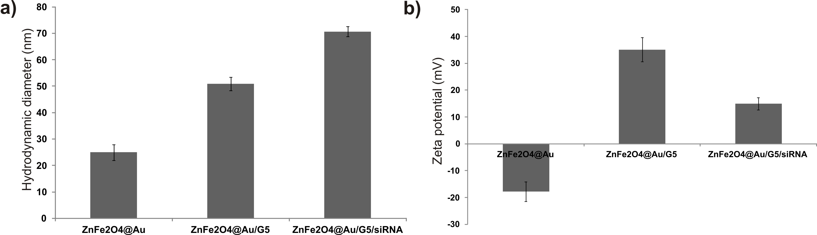

**Figure S4:** Quantification of siRNA complexation ability of polyamine-coated MCNPs (4, 5 and 8 μg/mL) using Picogreen assay.

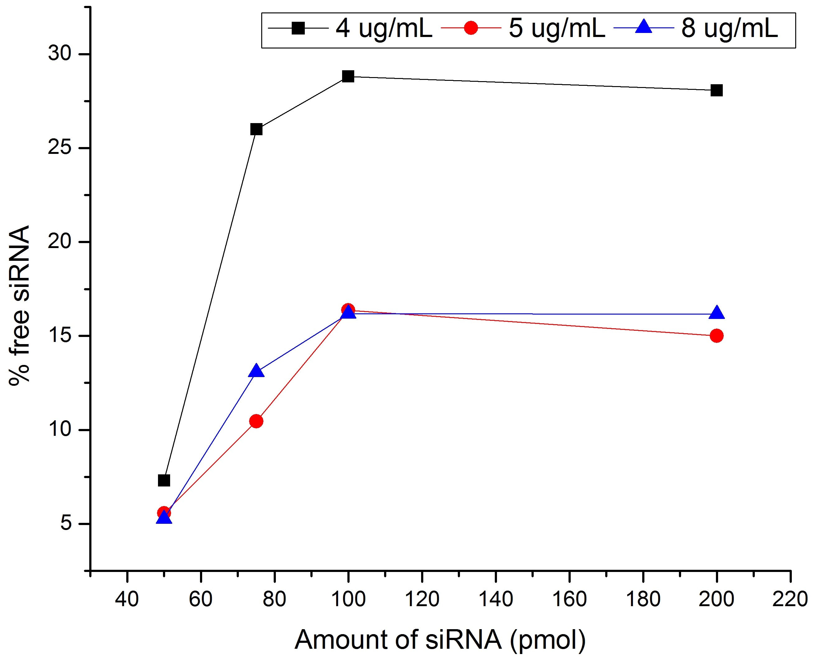

**Figure S5:** Quantification of the expression of proliferation (Ki67) and differentiation (TUJ1-neurons; GFAP- astrocytes) markers following the treatment of NSCs with different concentrations of MCNPs. The MCNPs were complexed with control siRNA (200 nM) before treating the NSCs

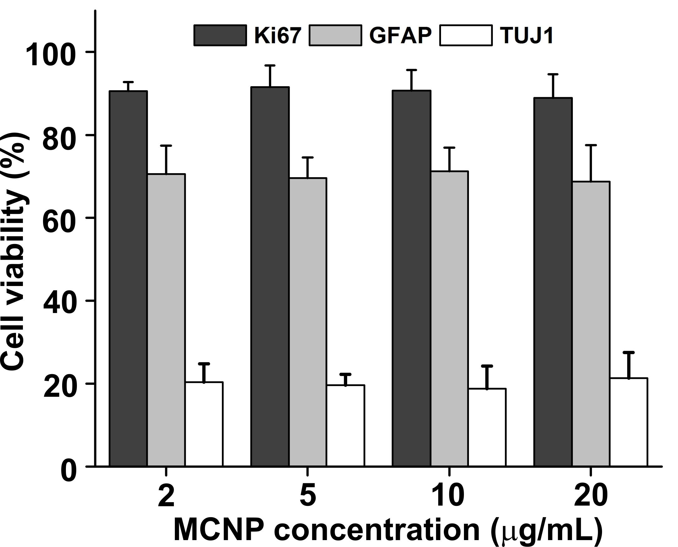

**Figure S6:** Effect of different incubation times on the viability of the NSCs. The neural stem cells were exposed to the magnetic field for different periods of time ranging from 5 min to 4 h, after which the magnetic field was removed. The cells were then incubated for an additional 24 h and their viability was assessed using MTS cell proliferation assay. No nanoparticles were used for this experiment.

**Figure S7.** Comparison of the uptake of Cy-3 labeled siRNA using MCNP and Fe3O4 NPs into NSCs following exposure to magnetic field (MF) for varying periods of time. The NSCs were incubated with Cy3-labeled siRNA/MCNP (MCNP = 5 μg/mL; Cy-3 siRNA = 200 nM) or Cy3-labeled siRNA/Fe3O4 (Fe3O4 = 5 μg/mL; Cy-3 siRNA = 200 nM) complexes in the presence of MF for varying periods of time. Thereafter, the NSCs were washed and the uptake of siRNA was measured using fluorescence microscopy

.

**Figure S8.** Concentration-dependent GFP knockdown in neural stem cells. The rNSCs were incubated with different concentrations of MCNPs (2 and 5 ug/mL) and siRNA (50, 75, 100 and 200 pmol/mL). All the results are the mean and standard error of three independent experiments.

**Figure S9.** Effect of incubation times on the viability of NSCs. The MCNPs complexes were incubated with the NSCs for different time periods ranging from 15 min to 6 h in the presence or absence of the magnet. The X-Gene/siGFP complexes were also incubated with NSCs for the above mentioned period. After each incubation period, the cells were washed thrice with DPBS. The cell viability was assessed using MTS cell proliferation assay kit after incubating the cells for an additional 48 h. The concentrations of MCNPs and siGFP were 5 μg/mL and 200 nM respectively, while X-tremeGENE/siRNA ratio was 3:1 in accordance with the manufacturer's recommendation.



**Figure S10.** Quantification of (a) GFP-knockdown efficiency and (b) cell viability of NSCs treated with MCNP/siGFP or X-TremeGENE/siGFP complexes, either with single transfection or multifection. In case of single transfection, the NSCs were treated with MCNP/siGFP for 30 mins in the presence of MF, and X-TremeGENE/siGFP for 6 hours. The media was changed at the end of treatment. In case of multifection, the same NSCs were treated with MCNP/siGFP or X-TremeGENE/siGFP twice within a 24 h period.

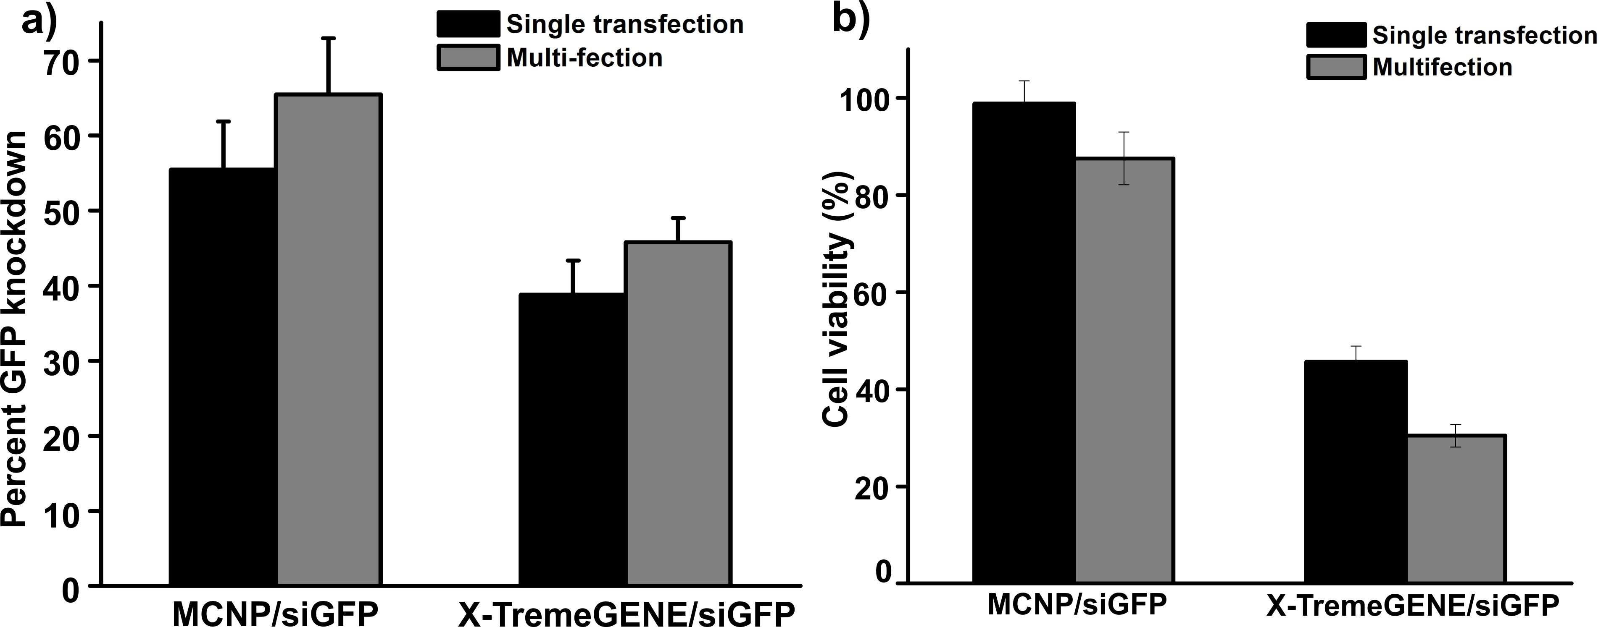

**Figure S11:** Magnetically-facilitated delivery of plasmid DNA (DsRED) using MCNPs to neural stem cells. The MCNPs (8 μg/mL) were complexed with DsRED (1 μg) and incubated with NSCs in the presence (t = 30 mins) and absence of MF. The expression levels of DsRED were monitored 72h post transfection using fluorescence microscopy.

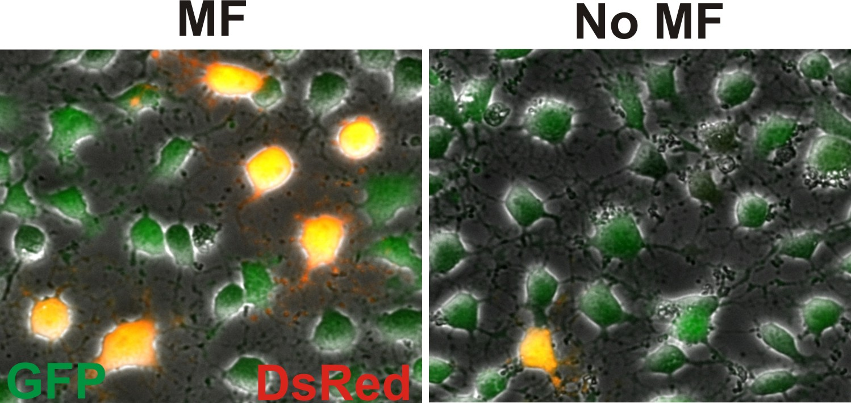

**Figure S12:** Effect of endocytosis inhibitors on the gene silencing efficiency of MCNPs. The cells were treated with the inhibitors 10 min prior to treatment with the siGFP/MCNP complexes. The quantification of GFP expression levels following the inhibitor treatment was done 72h post transfection.

