**Figure S1**. Spline of kidney cancer and cumulative exposure to all the drinking water contaminants combined (“TVOC”).

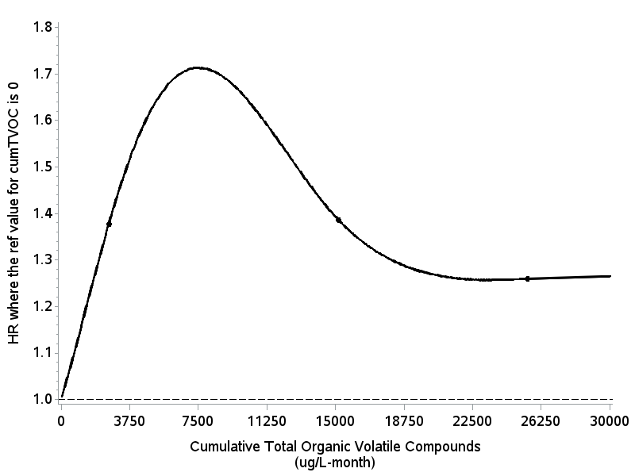

Knots: µg/L-month

5%: 30

25%: 2,612

75% 15,166

95% 25,499

**Figure S2**. Spline of Hodgkin lymphoma and cumulative exposure to trichloroethylene (TCE).

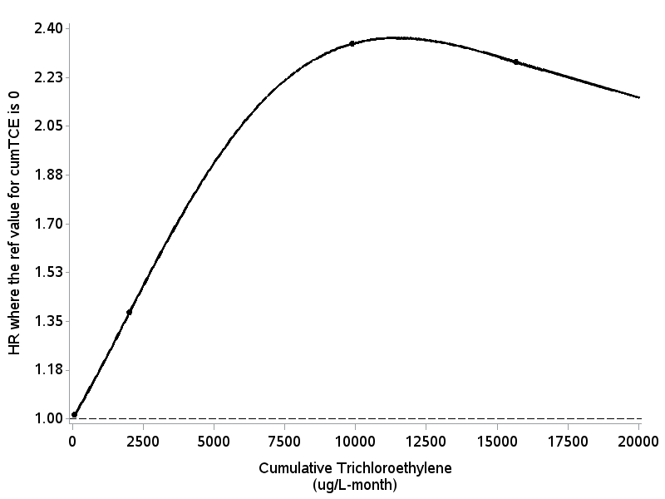

Knots: µg/L-month

5%: 85

25%: 2,017

75% 9.880

95% 15,667

**Figure S3a**. Spline of ALS and cumulative exposure to vinyl chloride.

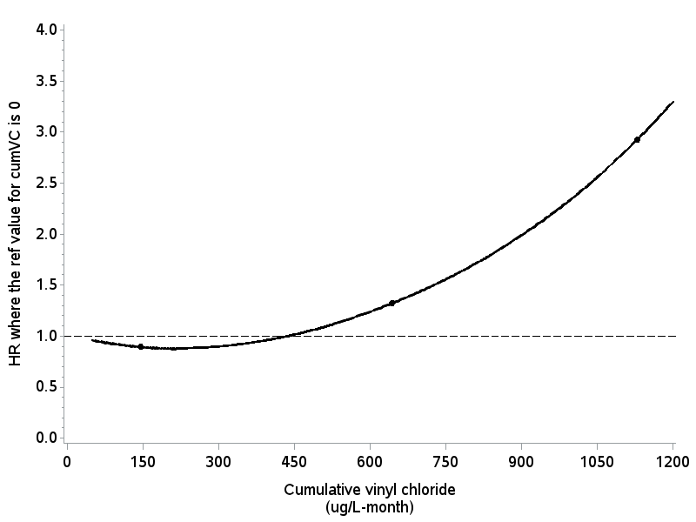

Knots: µg/L-month

5%: 39

25%: 147

75% 645

95% 1,130

**Figure S3b**. Spline of ALS and cumulative exposure to tetrachloroethylene (PCE).

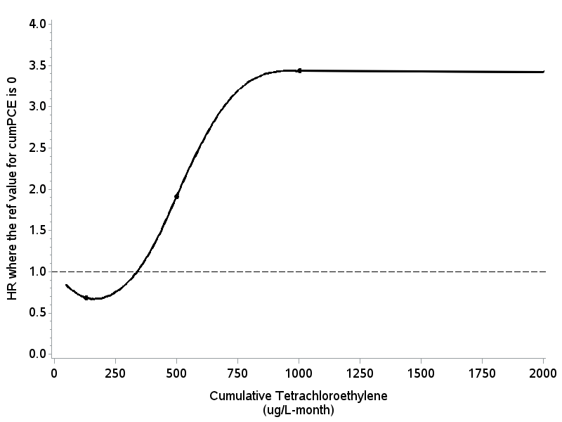

Knots: µg/L-month

5%: 21

25%: 130

75% 501

95% 1,005