Supplementary Figures and Tables

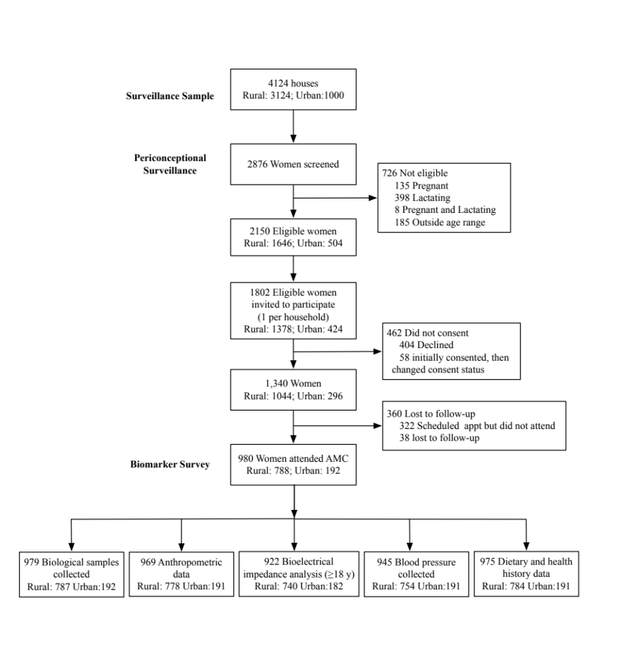

Supplemental Figure 1. Participant Flow Chart

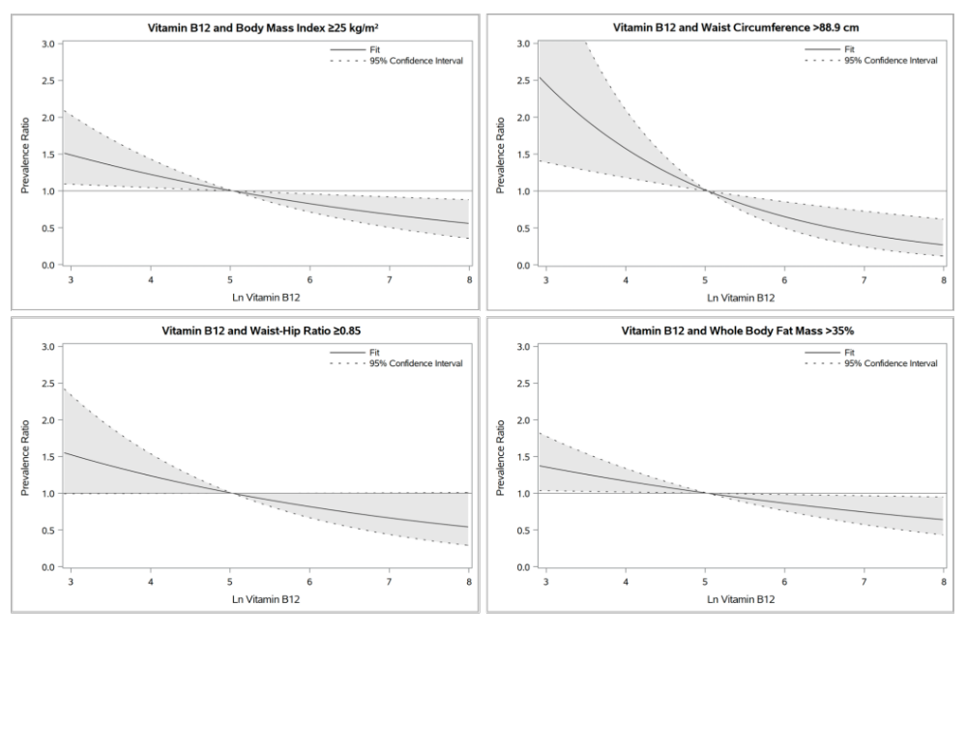
Supplemental Figure 2. Vitamin B₁₂ concentrations and metabolic characteristics among adult women (≥18 y): Restricted cubic splines
Potential nonlinear associations of vitamin B₁₂ status (natural logarithmically transformed vitamin B₁₂) with metabolic characteristics were examined using restricted cubic splines and assessed using the likelihood ratio test, comparing models with only the linear term to models with both the linear and cubic spline terms (74). Nonlinear associations were not detected; multivariable models with only the linear term are presented, with a reference value of 5.03, corresponding to the median value of 152.9 pmol/L. Vitamin B₁₂ results outside assay limits of detection (LOD) were set to half the LOD (if below LOD, n=4) or 2-times LOD (if above LOD, n=6). Multivariable models adjusted for: body mass index ≥25 kg/m²: currently married, employment; waist circumference >88.9 cm: No variables met criteria to be included as covariates; waist-hip ratio ≥0.85: education, employment; whole body fat mass >35%: education, currently married, employment. Observations with missing data for covariates (<3%, i.e., education, n=5; marital status, n= 5; gravidity, n= 5; employment status, n=28) were retained in analyses using the missing indicator method, in which a dummy variable to indicate missing and a variable with missing values set to the reference value were included in the model (75).
Supplemental Table 1. Nutritional characteristics of the study population¹
 | Total |  | Rural (n=787) | Urban (n=192)
 | n | n (%) or  GM (95% CI) | n (%) or  GM (95% CI) | n (%) or  GM (95% CI)
Hemoglobin, g/dL² | 979 | 11.9 (11.7, 12.0) | 11.8 (11.7, 11.9) | 12.1 (11.8, 12.4)
<12.0 |  | 406 (41.5) | 332 (42.2) | 74 (38.5)
Total vitamin B₁₂, pmol/L | 978 | 156.0 (150.3, 162.0) | 155.0 (148.7, 161.6) | 160.2 (147.3, 174.4)
<148 |  | 472 (48.3) | 386 (49.1) | 86 (44.8)
<221 |  | 727 (74.3) | 583 (74.2) | 144 (75.0)
<148 |  | 472 (48.3) | 386 (49.1) | 86 (44.8)
148 to <221 |  | 255 (26.1) | 197 (25.1) | 58 (30.2)
≥221 |  | 251 (25.7) | 203 (25.8) | 48 (25.0)
Holotranscobalamin, pmol/L | 966 | 35.6 (34.5, 36.6) | 36.0 (34.9, 37.2) | 33.8 (31.6, 36.1)
<35 |  | 579 (59.9) | 447 (57.6) | 132 (69.5)
<40 |  | 684 (70.8) | 535 (68.9) | 149 (78.4)
Methylmalonic acid (MMA), mmol/L | 979 | 0.33 (0.32, 0.35) | 0.34 (0.33, 0.36) | 0.30 (0.27, 0.33)
>0.37 |  | 433 (44.2) | 362 (46.0) | 71 (37.0)
>0.26 |  | 593 (60.6) | 487 (61.9) | 106 (55.2)
Homocysteine, mmol/L | 979 | 6.6 (6.4, 6.8) | 6.7 (6.4, 6.9) | 6.5 (6.0, 6.9)
>10.0 |  | 157 (16.0) | 134 (17.0) | 23 (12.0)
>15.0 |  | 65 (6.6) | 53 (6.7) | 12 (6.3)
Impaired vitamin B₁₂ status
Vitamin B₁₂ <148 and MMA >0.26 | 978 | 370 (37.8) | 303 (38.5) | 67 (34.9)
Vitamin B₁₂ <148 and MMA >0.37 | 978 | 286 (29.2) | 237 (30.2) | 49 (25.5)
cB₁₂^{3,4} | 965 | -0.37 (-0.41, -0.33) | -0.38 (-0.43, -0.33) | -0.32 (-0.41, -0.22)
Elevated vitamin B₁₂ (≥1.5) |  | 7 (0.7) | 7 (0.9) | 0 (0.0)
Adequate vitamin B₁₂ (-0.5 to <1.5) |  | 549 (56.9) | 432 (55.7) | 117 (61.6)
Decreased vitamin B₁₂ (-1.5 to <-0.5) |  | 369 (38.2) | 305 (39.4) | 64 (33.7)
Possibly deficient (-2.5 to <-1.5) |  | 39 (4.0) | 30 (3.9) | 9 (4.7)
Probably deficient (<-2.5) |  | 1 (0.1) | 1 (0.1) | 0 (0.0)
c3B₁₂^{3,4} | 978 | -0.35 (-0.41, -0.30) | -0.38 (-0.44, -0.32) | -0.25 (-0.37, -0.12)
Elevated vitamin B₁₂ (³1.5) |  | 20 (2.0) | 15 (1.9) | 5 (2.6)
Adequate vitamin B₁₂ (-0.5 to <1.5) |  | 518 (53.0) | 412 (52.4) | 106 (55.2)
Decreased vitamin B₁₂ (-1.5 to <-0.5) |  | 333 (34.0) | 267 (34.0) | 66 (34.4)
Possibly deficient (-2.5 to <-1.5) |  | 100 (10.2) | 86 (10.9) | 14 (7.3)
Probably deficient (<-2.5) |  | 7 (0.7) | 6 (0.8) | 1 (0.5)
Vitamin B₁₂ status and RBC folate sufficiency
Vitamin B₁₂ <221 and RBC folate ³748 | 977 | 105 (10.8) | 73 (9.3) | 32 (16.7)
Vitamin B₁₂ <148 and RBC folate ³748 | 977 | 52 (5.3) | 36 (4.6) | 16 (8.3)
Red blood cell folate, nmol/L | 977 | 540.5 (526.2, 555.1) | 528.5 (513.0, 544.4) | 592.3 (557.8, 628.9)
<305 |  | 74 (7.6) | 62 (7.9) | 12 (6.3)
<748 |  | 775 (79.3) | 635 (80.9) | 140 (72.9)
Serum folate, nmol/L | 977 | 16.5 (16.0, 17.0) | 17.0 (16.4, 17.6) | 14.8 (13.8, 15.9)
<7 |  | 34 (3.5) | 28 (3.6) | 6 (3.1)
¹Values reported are geometric means (95% Confidence Interval) and n (%). Biomarker results outside assay limits of detection (LOD) were set to half the LOD (if below LOD) or 2-times LOD (if above LOD); results outside assay LODs: serum folate (n=1 below LOD), vitamin B₁₂ (n=4 below LOD, n=6 above LOD), holotranscobalamin (n=1 above LOD)
²Hemoglobin values from complete blood count; adjusted for smoking
³Values are arithmetic mean (95% CI)
⁴A combined indicator of vitamin B₁₂ status (cB₁₂) was calculated using the method and classification developed by Fedesov et al: [i.e., cB12=log10 [(holoTC x B₁₂)/(MMA x Hcy)] – (age factor)] (59); a c3B₁₂ indicator (i.e., total vitamin B₁₂, MMA, Hcy) was also considered using methods described by Fedesov et al (59)
Abbreviations: GM: geometric mean, INR: Indian rupees, RBC: red blood cell, USD: United States Dollar, 95% CI: 95% confidence interval

Supplemental Table 2. Metabolic characteristics of the study population by vitamin B₁₂ strata (vitamin B₁₂ <148 vs. ≥148 pmol/L)²
 | Total |  | Vitamin B₁₂ <148 pmol/L |  | Vitamin B₁₂ ≥148 pmol/L |  | p-value⁵
 | n | n (%) or GM (95% CI) | n | n (%) or GM (95% CI) | n | n (%) or GM (95% CI) | p-value⁵
Weight, kg | 967 | 53.0 (52.2, 53.8) | 469 | 54.2 (53.1, 55.4) | 498 | 51.8 (50.8, 52.9) | 0.002
Height, cm | 967 | 153.2 (152.9, 153.6) | 469 | 153.4 (152.9, 153.9) | 498 | 153.1 (152.6, 153.6) | 0.446
Body mass index, kg/m² | 967 | 22.6 (22.3, 22.9) | 469 | 23.0 (22.6, 23.5) | 498 | 22.1 (21.7, 22.5) | 0.004
<18.5^{1, 3} | 918 | 176 (19.2) | 436 | 70 (16.1) | 482 | 106 (22.0) | 0.003
18.5 to <25.0^{1, 3} |  | 440 (47.9) |  | 202 (46.3) |  | 238 (49.4)
25.0 to <30.0^{1, 3} |  | 214 (23.3) |  | 109 (25.0) |  | 105 (21.8)
≥30.0^{1, 3} |  | 88 (9.6) |  | 55 (12.6) |  | 33 (6.8)
Waist circumference, cm | 967 | 74.6 (73.9, 75.4) | 469 | 75.6 (74.6, 76.6) | 498 | 73.8 (72.8, 74.8) | 0.010
>88.9¹ | 918 | 123 (13.4) | 436 | 77 (17.7) | 482 | 46 (9.5) | <0.001
Hip circumference, cm | 967 | 93.6 (93.0, 94.3) | 469 | 94.6 (93.7, 95.6) | 498 | 92.7 (91.8, 93.6) | 0.003
Waist-hip ratio | 967 | 0.80 (0.79, 0.80) | 469 | 0.80 (0.79, 0.80) | 498 | 0.80 (0.79, 0.80) | 0.400
≥0.85¹ | 918 | 191 (20.8) | 436 | 106 (24.3) | 482 | 85 (17.6) | 0.013
Mid-upper arm circumference, cm | 967 | 26.7 (26.5, 27.0) | 469 | 27.1 (26.7, 27.5) | 498 | 26.4 (26.0, 26.8) | 0.009
Triceps skinfold thickness, mm | 966 | 18.9 (18.4, 19.3) | 468 | 19.2 (18.6, 19.8) | 498 | 18.5 (18.0, 19.1) | 0.132
Whole body, % fat mass¹ | 920 | 30.6 (30.0, 31.3) | 437 | 31.5 (30.6, 32.4) | 483 | 29.9 (29.0, 30.7) | 0.004
>35%¹ |  | 361 (39.2) |  | 192 (43.9) |  | 169 (35.0) | 0.006
Trunk, % fat mass¹ | 920 | 27.8 (27.0, 28.7) | 437 | 28.8 (27.5, 30.1) | 483 | 27.0 (25.9, 28.2) | 0.007
>35%¹ |  | 333 (36.2) |  | 177 (40.5) |  | 156 (32.3) | 0.010
HbA1c, % | 978 | 5.4 (5.4, 5.5) | 472 | 5.4 (5.4, 5.5) | 506 | 5.4 (5.4, 5.5) | 0.676
<5.7 |  | 733 (74.9) |  | 361 (76.5) |  | 372 (73.5) | 0.478
≥5.7 to <6.5 |  | 196 (20.0) |  | 87 (18.4) |  | 109 (21.5)
≥6.5 |  | 49 (5.0) |  | 24 (5.1) |  | 25 (4.9)
≥5.7 |  | 245 (25.1) |  | 111 (23.5) |  | 134 (26.5) | 0.285
SBP, mmHg | 944 | 104.9 (104.3, 105.6) | 458 | 105.2 (104.3, 106.2) | 486 | 104.7 (103.8, 105.6) | 0.438
DBP, mmHg | 944 | 67.7 (67.3, 68.2) | 458 | 67.8 (67.1, 68.6) | 486 | 67.6 (67.0, 68.3) | 0.662
Blood pressure⁴ | 944 |  | 458 |  | 486 |  | 0.809
Normal |  | 740 (78.4) |  | 359 (78.4) |  | 381 (78.4)
Elevated |  | 28 (3.0) |  | 16 (3.5) |  | 12 (2.5)
Stage 1 HTN |  | 155 (16.4) |  | 73 (15.9) |  | 82 (16.9)
Stage 2 HTN |  | 21 (2.2) |  | 10 (2.2) |  | 11 (2.3)
Stage 1 or 2 HTN |  | 176 (18.6) |  | 83 (18.1) |  | 93 (19.1) | 0.689
¹Among women ≥18 years old
²Values reported are geometric means (GM) and 95% Confidence Interval and n (%). Vitamin B₁₂ results outside assay limits of detection (LOD) were set to half the LOD (if below LOD, n=4) or 2-times LOD (if above LOD, n=6)
³BMI categories as defined by the WHO (62)
⁴Blood pressure was categorized as normal (SBP <120 and DBP <80 mmHg), elevated blood pressure (SBP 120-129 and DBP <80 mmHg), stage 1 hypertension (SBP 130-139 or DBP 80-89 mmHg), and stage 2 hypertension (SBP ≥140 or DBP ≥90 mmHg) (70)
⁵Chi-square statistics and one-way ANOVA were used to evaluate differences in categorical and continuous variables, respectively; HbA1c was natural logarithmically transformed prior to analyses
Abbreviations: BMI, body mass index, DBP: diastolic blood pressure, GM: geometric mean, HbA1c: glycosylated hemoglobin, HTN: hypertension, SBP: systolic blood pressure, 95% CI: 95% confidence interval

Supplemental Table 3. Metabolic characteristics of the study population by vitamin B₁₂ status (vitamin B₁₂ <148, ≥148-<221, ≥221 pmol/L)²
 | Vitamin B₁₂ <148 pmol/L |  | Vitamin B₁₂ ≥148-<221 pmol/L |  | Vitamin B₁₂ ≥221 pmol/L |  | p-value⁵
 | n | n (%) or GM (95% CI) | n | n (%) or GM (95% CI) | n | n (%) or GM (95% CI) | p-value⁵
Weight, kg | 469 | 54.2 (53.1, 55.4) | 244 | 52.7 (51.2, 54.2) | 247 | 51.0 (49.5, 52.5) | 0.004
Height, cm | 469 | 153.4 (152.9, 153.9) | 244 | 153.7 (153, 154.4) | 247 | 152.5 (151.8, 153.2) | 0.038
Body mass index, kg/m² | 469 | 23.0 (22.6, 23.5) | 244 | 22.3 (21.7, 22.9) | 247 | 21.9 (21.3, 22.5) | 0.012
<18.5^{1, 3} | 436 | 70 (16.1) | 242 | 50 (20.7) | 240 | 56 (23.3) | 0.021
18.5 to <25.0^{1, 3} |  | 202 (46.3) |  | 125 (51.7) |  | 113 (47.1)
25.0 to <30.0^{1, 3} |  | 109 (25.0) |  | 50 (20.7) |  | 55 (22.9)
≥30.0^{1, 3} |  | 55 (12.6) |  | 17 (7) |  | 16 (6.7)
Waist circumference, cm | 469 | 75.6 (74.6, 76.6) | 244 | 74.1 (72.7, 75.5) | 247 | 73.4 (72.1, 74.8) | 0.032
>88.9¹ | 436 | 77 (17.7) | 242 | 23 (9.5) | 240 | 23 (9.6) | 0.002
Hip circumference, cm | 469 | 94.6 (93.7, 95.6) | 244 | 93.3 (92.1, 94.6) | 247 | 92.1 (90.9, 93.3) | 0.006
Waist-hip ratio | 469 | 0.80 (0.79, 0.80) | 244 | 0.79 (0.79, 0.80) | 247 | 0.80 (0.79, 0.81) | 0.550
≥0.85¹ | 436 | 106 (24.3) | 242 | 40 (16.5) | 240 | 45 (18.8) | 0.038
Mid-upper arm circumference, cm | 469 | 27.1 (26.7, 27.5) | 244 | 26.6 (26.1, 27.2) | 247 | 26.1 (25.6, 26.7) | 0.017
Triceps skinfold thickness, mm | 468 | 19.2 (18.6, 19.8) | 244 | 18.9 (18.1, 19.8) | 247 | 18.1 (17.4, 19) | 0.150
Whole body, % fat mass¹ | 437 | 31.5 (30.6, 32.4) | 244 | 30.2 (29, 31.4) | 239 | 29.5 (28.4, 30.7) | 0.014
>35%¹ |  | 192 (43.9) |  | 83 (34.0) |  | 86 (36.0) | 0.019
Trunk, % fat mass¹ | 437 | 28.8 (27.5, 30.1) | 244 | 27.5 (25.9, 29.2) | 239 | 26.5 (24.9, 28.1) | 0.023
>35%¹ |  | 177 (40.5) |  | 75 (30.7) |  | 81 (33.9) | 0.027
HbA1c, % | 472 | 5.4 (5.4, 5.5) | 255 | 5.4 (5.3, 5.5) | 251 | 5.5 (5.4, 5.6) | 0.404
<5.7 |  | 361 (76.5) |  | 192 (75.3) |  | 180 (71.7) | 0.670
≥5.7 to <6.5 |  | 87 (18.4) |  | 51 (20) |  | 58 (23.1)
≥6.5 |  | 24 (5.1) |  | 12 (4.7) |  | 13 (5.2)
≥5.7 |  | 111 (23.5) |  | 63 (24.7) |  | 71 (28.3) | 0.366
SBP, mmHg | 458 | 105.2 (104.3, 106.2) | 244 | 104.2 (102.9, 105.5) | 242 | 105.2 (103.9, 106.5) | 0.429
DBP, mmHg | 458 | 67.8 (67.1, 68.6) | 244 | 67.8 (66.9, 68.8) | 242 | 67.4 (66.5, 68.4) | 0.774
Blood pressure⁴ | 458 |  | 244 |  | 242 |  | 0.969
Normal |  | 359 (78.4) |  | 192 (78.7) |  | 189 (78.1)
Elevated |  | 16 (3.5) |  | 5 (2.0) |  | 7 (2.9)
Stage 1 HTN |  | 73 (15.9) |  | 41 (16.8) |  | 41 (16.9)
Stage 2 HTN |  | 10 (2.2) |  | 6 (2.5) |  | 5 (2.1)
Stage 1 or 2 HTN |  | 83 (18.1) |  | 47 (19.3) |  | 46 (19.0) | 0.921
¹Among women ≥18 years old
²Values reported are geometric means (GM) and 95% Confidence Interval and n (%). Vitamin B₁₂ results outside assay limits of detection (LOD) were set to half the LOD (if below LOD, n=4) or 2-times LOD (if above LOD, n=6)
³BMI categories as defined by the WHO (62)
⁴Blood pressure was categorized as normal (SBP <120 and DBP <80 mmHg), elevated blood pressure (SBP 120-129 and DBP <80 mmHg), stage 1 hypertension (SBP 130-139 or DBP 80-89 mmHg), and stage 2 hypertension (SBP ≥140 or DBP ≥90 mmHg) (70)
⁵Chi-square statistics and one-way ANOVA were used to evaluate differences in categorical and continuous variables, respectively; HbA1c was natural logarithmically transformed prior to analyses
Abbreviations: BMI, body mass index, DBP: diastolic blood pressure, GM: geometric mean, HbA1c: glycosylated hemoglobin, HTN: hypertension, SBP: systolic blood pressure, 95% CI: 95% confidence interval

Supplemental Table 4. Associations between vitamin B₁₂ <221 pmol/L and metabolic characteristics in women of reproductive age
 |  | Univariate |  | Multivariable
Characteristics | n | β (SE) or PR (95% CI) | p-value² | β (SE) or PR (95% CI) | p-value²
Body mass index, kg/m² | 967 | 0.84 (0.39) | 0.032 | 1.04 (0.37)³ | 0.006
≥25.0¹ | 918 | 1.15 (0.92, 1.44) | 0.201 | 1.18 (0.95, 1.47)⁴ | 0.120
Waist circumference, cm | 967 | 1.62 (0.87) | 0.063 | 2.09 (0.83)³ | 0.012
>88.9¹ | 918 | 1.54 (1.00, 2.36) | 0.037 | 1.54 (1.00, 2.36)⁵ | 0.037
Waist-hip ratio | 967 | -0.0005 (0.005) | 0.922 | 0.002 (0.005)³ | 0.606
≥0.85¹ | 918 | 1.15 (0.85, 1.55) | 0.357 | 1.21 (0.90, 1.64)⁶ | 0.194
Whole body, % fat mass¹ | 920 | 1.39 (0.68) | 0.040 | 1.59 (0.67)⁷ | 0.018
>35%¹ | 920 | 1.12 (0.93, 1.36) | 0.229 | 1.14 (0.95, 1.38)⁸ | 0.150
Trunk, % fat mass¹ | 920 | 1.65 (0.84) | 0.050 | 1.88 (0.83)⁷ | 0.024
>35%¹ | 920 | 1.09 (0.89, 1.34) | 0.387 | 1.12 (0.92, 1.36)⁹ | 0.263
HbA1c, % | 978 | -0.01 (0.01) | 0.197 | -0.01 (0.01)¹⁰ | 0.428
≥5.7 | 978 | 0.85 (0.67, 1.07) | 0.174 | 0.90 (0.71, 1.14)¹⁰ | 0.388
SBP, mmHg | 944 | -0.32 (0.78) | 0.678 | 0.03 (0.76)³ | 0.965
DBP, mmHg | 944 | 0.42 (0.59) | 0.475 | 0.71 (0.58)³ | 0.218
Stage 1 or 2 HTN | 944 | 0.97 (0.72, 1.32) | 0.866 | 1.02 (0.76, 1.38)¹¹ | 0.894
¹Among women ≥18 years old
²Linear and binomial regression models; HbA1c was natural logarithmically transformed prior to analyses. Vitamin B₁₂ results outside assay limits of detection (LOD) were set to half the LOD (if below LOD, n=4) or 2-times LOD (if above LOD, n=6). In multivariable models, observations with missing data for covariates (<3%, i.e., education, n=5; marital status, n= 5; gravidity, n= 5; employment status, n=28) were retained in analyses using the missing indicator method, in which a dummy variable to indicate missing and a variable with missing values set to the reference value were included in the model (75)
Multivariable models adjusted for:
³age, education, currently married, gravidity, employment
⁴age, currently married
⁵No variables met criteria to be included as covariates in multivariable models
⁶education
⁷gravidity
⁸age, education, currently married
⁹age, education, currently married, gravidity
¹⁰education, currently married, gravidity, employment
¹¹age, currently married, gravidity, employment
Abbreviations: DBP: diastolic blood pressure, HbA1c: glycated hemoglobin, HTN: hypertension, PR: prevalence ratio, SBP: systolic blood pressure, SE: standard error, 95% CI: 95% confidence interval

Supplemental Table 5. Associations between vitamin B₁₂ status (exposure) and metabolic characteristics in adult (≥18 years) women of reproductive age¹
 |  | Total vitamin B₁₂ |  | Vitamin B₁₂ <148 pmol/L |  | Impaired vitamin B₁₂ status²
Characteristics | n | β (SE) or PR (95% CI) | p-value³ | β (SE) or PR (95% CI) | p-value³ | β (SE) or PR (95% CI) | p-value³
Body mass index, kg/m² | 918 | -0.95 (0.28)⁴ | 0.001 | 1.35 (0.34)¹² | <0.001 | 0.77 (0.35)⁶ | 0.029
³25.0 | 918 | 0.82 (0.71, 0.96)⁵ | 0.013 | 1.31 (1.09, 1.58)⁷ | 0.004 | 1.22 (1.02, 1.46)¹² | 0.032
Waist circumference, cm | 918 | -1.74 (0.63)⁶ | 0.006 | 2.81 (0.75)⁴ | <0.001 | 1.38 (0.78)⁶ | 0.077
>88.9 | 918 | 0.64 (0.49, 0.85)⁷ | 0.002 | 1.85 (1.32, 2.60)⁷ | <0.001 | 1.48 (1.07, 2.06)¹⁴ | 0.020
Waist-hip ratio | 918 | -0.002 (0.003)⁶ | 0.620 | 0.01 (0.004)⁶ | 0.157 | -0.0004 (0.004)⁶ | 0.917
³0.85 | 918 | 0.81 (0.66, 1.00)⁸ | 0.049 | 1.38 (1.07, 1.78)⁷ | 0.013 | 1.18 (0.92, 1.52)¹⁵ | 0.196
Whole body, % fat mass | 920 | -1.34 (0.49)⁹ | 0.007 | 1.72 (0.60)⁷ | 0.004 | 1.28 (0.61)⁵ | 0.036
>35% | 920 | 0.86 (0.76, 0.98)¹⁰ | 0.028 | 1.29 (1.10, 1.51)¹³ | 0.001 | 1.17 (1.00, 1.37)¹⁶ | 0.055
Trunk, % fat mass | 920 | -1.51 (0.61)⁹ | 0.013 | 1.99 (0.73)⁷ | 0.007 | 1.51 (0.76)¹⁴ | 0.046
>35% | 920 | 0.88 (0.77, 1.01)⁶ | 0.065 | 1.25 (1.06, 1.49)⁷ | 0.010 | 1.20 (1.02, 1.42)¹⁶ | 0.033
HbA1c, % | 929 | 0.005 (0.01)¹¹ | 0.539 | 0.001 (0.01)⁶ | 0.899 | -0.002 (0.01)⁶ | 0.835
³5.7 | 929 | 1.11 (0.94, 1.32)¹¹ | 0.239 | 0.95 (0.77, 1.19)⁴ | 0.666 | 1.05 (0.84, 1.32)⁶ | 0.654
SBP, mmHg | 896 | -0.44 (0.57)⁶ | 0.440 | 1.14 (0.68)⁶ | 0.0.93 | 0.75 (0.71)⁶ | 0.293
DBP, mmHg | 896 | -0.14 (0.43)⁶ | 0.740 | 0.61 (0.52)⁶ | 0.243 | 0.51 (0.54)⁶ | 0.345
Stage 1 or 2 HTN | 896 | 1.00 (0.81, 1.23)⁴ | 0.988 | 1.01 (0.78, 1.32)⁴ | 0.930 | 0.98 (0.75, 1.29)¹⁴ | 0.909
¹Among women ≥18 years old
²Impaired vitamin B₁₂ status defined as total vitamin B₁₂ <148 pmol/L and methylmalonic acid >0.26 mmol/L
³Linear and binomial regression models; total vitamin B₁₂ and HbA1c were natural logarithmically transformed prior to analyses. Vitamin B₁₂ results outside assay limits of detection (LOD) were set to half the LOD (if below LOD, n=4) or 2-times LOD (if above LOD, n=6). In multivariable models, observations with missing data for covariates (<3%, i.e., education, n=5; marital status, n= 5; gravidity, n= 5; employment status, n=28) were retained in analyses using the missing indicator method, in which a dummy variable to indicate missing and a variable with missing values set to the reference value were included in the model (75)
Multivariable models adjusted for:
⁴age, currently married, gravidity, employment
⁵currently married, employment
⁶age, education, currently married, gravidity, employment
⁷ No variables met criteria to be included as covariates
⁸education, employment
⁹currently married, gravidity, employment
¹⁰education, currently married, employment
¹¹education, currently married, gravidity, employment
¹²age, currently married, employment
¹³age
¹⁴employment
¹⁵age, education, employment
¹⁶age, education, currently married, employment
Abbreviations: DBP: diastolic blood pressure, HbA1c: glycated hemoglobin, HTN: hypertension, PR: prevalence ratio, SBP: systolic blood pressure, SE: standard error, 95% CI: 95% confidence interval

