Supplemental text: Imputation of smoking information for current cigarette smokers and creation of time-dependent smoking data
A smoking history file was created for all the miners, in which the last smoking date was imputed for each current smoker individually, so that analyses based on pack-years could be conducted. Imputation was based on single-year age- and 5-year birth cohort-specific cessation probabilities for U.S. men, obtained from the literature (Holford et al. 2013), conditional on the age last known to be smoking.
Creation of the smoking history file
General overview: The purpose was to create a smoking file with multiple smoking records per miner, in which the last smoking level extends to actual or imputed date at which each miner last stopped smoking. For miners who were current smokers at the time of their last survey (either 6/30/1973 or 6/30/1986), an imputed quit date was calculated, based on each miner’s age at last survey and the birth cohort- and age-specific models from Holford et al. (2013).
  - Format and examples. Each single-line record per miner was separated into up to five records per miner. The cigarettes smoked per day (1-5) and pack-years per day (1-5) were aligned with begin and end dates numbered 1-5. The resulting file (before any quit date imputation) had the format shown in Supplemental Table 1. Notes: pkyrate=cigday/7305 (one pack-year is the equivalent of 365.24 packs of cigarettes or 7,305 cigarettes). Cigday was rounded to no more than 1 decimal place.

Supplemental Table 1. Example of smoking history file before imputation of quit date
Miner_ID | Date1 | Date2 | Daily pack-year rate (pkyrate) | Cigarettes per day (Cigday) | Imputed quit date (Impquitdate) | Final smoking category (FinalSmk)
0001 | 07/15/1942 | (Impute) | 0.0027378508 | 20 |  | 4
0002 | 07/15/1945 | (Impute) | 0.0027378508 | 20 |  | 4
0003 | 07/15/1950 | 04/14/1957 | 0.0027378508 | 20 |  | 4
0003 | 04/15/1957 | 11/14/1971 | 0.0054757016 | 40 |  | 4
0003 | 11/15/1971 | (Impute) | 0.0027378508 | 20 |  | 4
0004 | 07/01/1957 | 07/01/1978 | 0 | 0 |  | 1
0005 | 07/15/1929 | 07/14/1937 | 0.0013689254 | 10 |  | 5
0005 | 07/15/1937 | 08/29/1969 | 0.0032854204 | 24 |  | 5
  - For most miners who were current smokers at the time of last smoking survey (FinalSmk=3-5), a variable called “Impquitdate” was created and added to each record in the smoking file: This was based on their last known smoking age (from the smoking questionnaire) and their birth cohort, using the single-year age- and 5-year birth cohort-specific annual smoking cessation probabilities obtained from Holford et al. (2013)
  - To impute smoking quit dates for each worker who is a current smoker (FinalSmk=3-5) and who is alive or who died after 12/31/1973, the following steps were followed:
    - Calculate an age at last interview: For every miner included in the 1986 questionnaire, date of last interview was set to 6/30/1986 and age at last interview was calculated as date of last interview minus date of birth. For all other miners, date of last interview was set to 6/30/1973 and age at last interview was similarly calculated. Age at last interview was used as the last known smoking age.
    - Calculate imputed quit date (Impquitdate): each miner’s birth year and age at last interview (last known smoking age) were used to create a “life table”, starting with 100 current smokers and applying the annual (birth cohort-specific) smoking cessation probabilities, as in the example below. The last known smoking age plus one year was used as the first age in the life table. The earliest age at which <50% of the initial 100 smokers would be expected to be still smoking was used as the imputed quit age. The date that corresponds to the midpoint of the person’s quit age was used as a candidate Impquitdate (cImpquitdate). Final Impquitdate was the earlier of cImpquitdate and DOD. An example is given in Supplemental Table 2.
Supplemental Table 2. Example of imputation of smoking quit age.
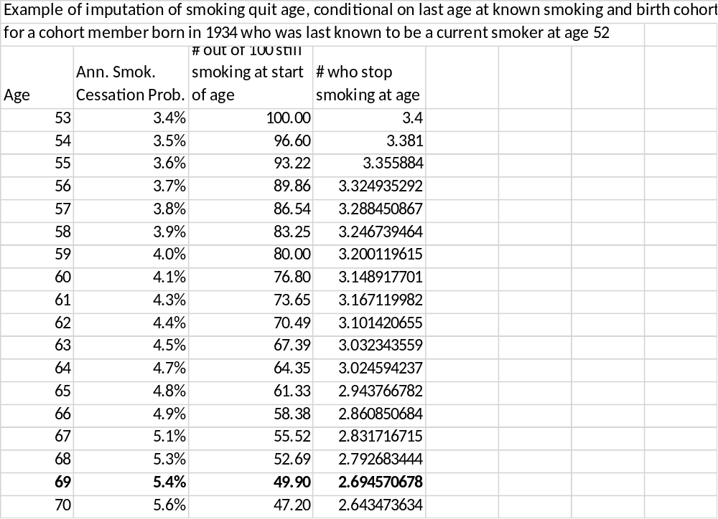

  - Examples from Supplemental Table 1, with the imputed quit date filled in, are shown in Supplemental Table 3 below.
Supplemental Table 3. Example of smoking file after imputation of quit date
Miner_ID | Date1 | Date2 | pkyrate | Cigday | cImpquitdate | Impquitdate | FinalSmk
0001 | 07/15/1942 | 04/10/1976 | 0.0027378508 | 20 | 09/20/1990 | 04/10/1976 | 4
0002 | 07/15/1945 | 07/15/1992 | 0.0027378508 | 20 | 11/10/1997 | 07/15/1992 | 4
0003 | 07/15/1950 | 04/14/1957 | 0.0027378508 | 20 | --ª | -- | 4
0003 | 04/15/1957 | 11/14/1971 | 0.0054757016 | 40 | -- | -- | 4
0003 | 11/15/1971 | 02/07/1992 | 0.0027378508 | 20 | 10/09/2002 | 02/07/1992 | 4
0004 | 07/01/1957 | 07/01/1978 | 0 | 0 | -- | -- | 1
0005 | 07/15/1929 | 07/14/1937 | 0.0013689254 | 10 | -- | -- | 5
0005 | 07/15/1937 | 08/29/1969 | 0.0032854204 | 24 | -- | -- | 5
ª--: not calculated

Supplemental Table 4. Person-year distribution across age and time since last exposure (TSLE) within Colorado Plateau cohort.
Age category | 0-<5 yrs TSLE | 5-<15 yrs TSLE | 15-<25 yrs TSLE | 25-<35 yrs TSLE | 35+ yrs TSLE
<55 | 36382 | 18927 | 8304 | 1118 | 0
55-<65 | 5582 | 7455 | 8537 | 6203 | 974
65-<75 | 1478 | 3415 | 5268 | 6183 | 5609
75+ | 122 | 747 | 2020 | 3153 | 7100

Supplemental Table 5. (a) Standardized mortality ratios (SMRs) compared to that of general regional population by decades and (b) SMRs, internally standardized rate ratios (SRRs), and excess absolute rates (EARs) by smoking pack-year categories, across 5-year lagged radon decay product exposure categories for lung cancer mortalityª in Colorado Plateau cohort (n=4021).
(a)
 | SMR (95% CI), number of lung cancer deaths
Decade | 0-< 60 WLM | 60-<120 WLM | 120-<260 WLM | 260-<400 WLM | 400-<1000 WLM | 1000+ WLM | Total
1960-69 | 0.56 (0.01, 3.2), -^{b} | 0.95 (0.02, 5.30), - ^{b} | 6.57 (3.28, 11.8), 11 | 2.25 (0.46, 6.59), - ^{b} | 6.00 (3.55, 9.48), 18 | 12.9 (9.31, 17.5), 42 | 6.29 (4.96, 7.87), 76
1970-79 | 1.11 (0.23, 3.23), - ^{b} | 0.54 (0.01, 3.01), - ^{b} | 2.23 (0.96, 4.39), 8 | 3.22 (1.54, 5.91), 10 | 5.81 (4.13, 7.94), 39 | 13.0 (10.4, 16.0), 85 | 5.95 (5.03, 7.00), 146
1980-89 | 1.18 (0.38, 2.75), 5 | 0.91 (0.19, 2.67), - ^{b} | 2.49 (1.36, 4.17), 14 | 2.48 (1.28, 4.34), 12 | 6.09 (4.62, 7.87), 58 | 8.58 (6.71, 10.8), 72 | 4.57 (3.89, 5.32), 164
1990-99 | 2.23 (1.15, 3.90), 12 | 1.30 (0.42, 3.03), 5 | 2.18 (1.22, 3.60), 15 | 3.63 (2.22, 5.61), 20 | 5.34 (4.01, 6.97), 54 | 7.03 (5.27, 9.20), 53 | 4.05 (3.44, 4.73), 159
2000-09 | 0.88 (0.24, 2.26), -^{b} | 1.55 (0.50, 3.62), 5 | 1.72 (0.82, 3.16), 10 | 2.92 (1.51, 5.10), 12 | 4.74 (3.30, 6.59), 35 | 10.4 (7.36, 14.2), 39 | 3.64 (2.98, 4.40), 105
2010-16 | 1.42 (0.29, 4.14), - ^{b} | 1.86 (0.38, 5.44), - ^{b} | 2.63 (1.06, 5.43), 7 | 6.42 (3.20, 11.5), 11 | 6.03 (3.57, 9.53), 18 | 2.54 (0.52, 7.42), - ^{b} | 3.67 (2.68, 4.91), 45
Total | 1.35 (0.90, 1.95), 28 | 1.21 (0.72, 1.91), 18 | 2.48 (1.91, 3.16), 65 | 3.30 (2.56, 4.18), 68 | 5.59 (4.88, 6.37), 222 | 9.58 (8.52, 10.7), 294 | 4.55 (4.21, 4.90), 695

(b)
 | SMR (95% CI), number of lung cancer deaths  SRR (95% CI) |  |  |  |  |  |  |  | EAR/100 WLM, per 10,000 person-years, (SE)^{c}
Smoking category | 0-< 60 WLM | 60-<120 WLM | 120-<260 WLM | 260-<400 WLM | 400-<1000 WLM | 1000+ WLM | Total (60+ WLM)
0 to <10 pack-yrs | 0.35 (0.07, 1.02), - ^{b}  1 | 0.29 (0.04, 1.04), - ^{b}  0.94 (0.15, 5.94) | 0.57 (0.21, 1.25), 6  1.79 (0.44, 7.31) | 1.52 (0.83, 2.56), 14  5.22 (1.46, 18.61) | 3.75 (2.81, 4.90), 53  12.1 (3.73, 39.4) | 5.65 (4.38, 7.16), 68  22.7 (6.97, 73.8) | 2.38 (2.01, 2.80), 146  8.88 (2.79, 28.3) | 5.00 (0.560)
10 to <30 pack-yrs | 1.08 (0.35, 2.52), 5  1 | 0.94 (0.19, 2.76), - ^{b}  1.00 (0.21, 4.65) | 2.21 (1.14, 3.86), 12  2.50 (0.83, 7.51) | 3.81 (2.18, 6.19), 16  5.37 (1.80, 16.0) | 4.43 (3.10, 6.14), 36  5.01 (1.85, 13.6) | 10.9 (8.54, 13.7), 73  12.2 (4.62, 32.2) | 4.50 (3.79, 5.29), 145  5.46 (2.11, 14.2) | 6.25 (0.771)
30-<50 pack-yrs | 1.47 (0.54, 3.21), 6  1 | 2.63 (1.06, 5.41), 7  1.64 (0.50, 5.33) | 4.08 (2.66, 5.97), 26  3.30 (1.18, 9.21) | 5.46 (3.46, 8.20), 23  3.32 (1.24, 8.88) | 5.90 (4.52, 7.57), 62  3.50 (1.40, 8.73) | 13.2 (10.7, 16.1), 97  8.30 (3.31, 20.8) | 6.28 (5.48, 7.17), 221  4.15 (1.70, 10.1) | 9.78 (1.93)
50+ pack-yrs | 4.06 (2.22, 6.81), 14  1 | 2.83 (1.04, 6.15), 6  0.55 (0.20, 1.51) | 5.26 (3.25, 8.04), 21  1.40 (0.63, 3.10) | 4.98 (2.78, 8.21), 15  1.23 (0.55, 2.75) | 10.2 (7.97, 12.9), 71  2.44 (1.28, 4.65) | 12.2 (9.24, 15.9), 56  2.95 (1.52, 5.72) | 7.59 (6.53, 8.77), 183  1.89 (1.02, 3.50) | 15.4 (3.49)
Abbreviations: CI, confidence interval; EAR, excess absolute rate; pk-yrs, pack-years of cigarette smoking; SE, standard error; SMR, standardized mortality ratio [compared to combined Arizona, Colorado, New Mexico, Utah rates (whites) or combined Arizona and New Mexico rates (American Indians)]; SRR, standardized rate ratio; WLM, working level month
ª One miner’s date of death was reduced by one day, to avoid creating a stratum with one event and one person-day
^{b} Cell size <5 suppressed
^{c} Overall EAR/100 WLM for all smoking categories combined is 7.85 (SE=0.611) lung cancer deaths per 10,000 PY.

Supplemental Fig. 1. Excess absolute risk of lung cancer, by decade (number of cases per 10⁴ person-years per 100 working level months; error bars indicate 95% confidence intervals).

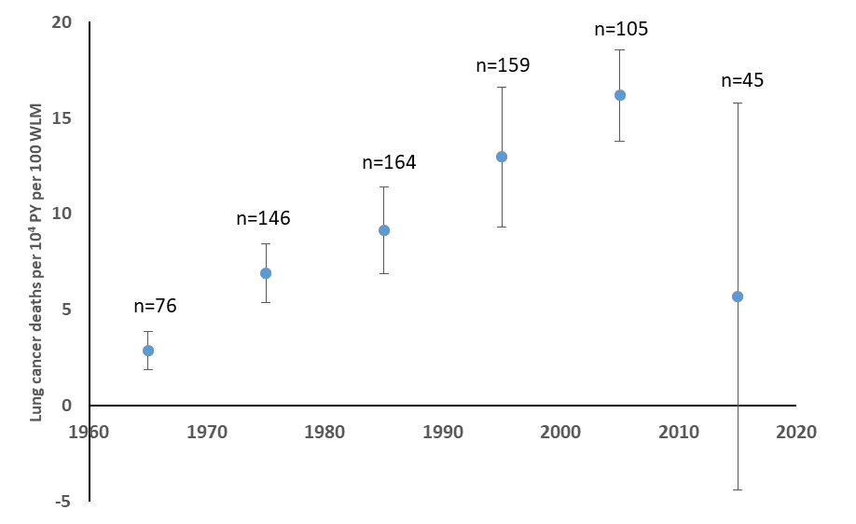

Supplemental Fig. 2. Spline models illustrating shape of overall radon progeny dose-response patterns for lung cancer (a) overall and (b) across smoking pack-year categories (0-<10 pack-yrs, 10-<30 pack-yrs, 30-<50 pack-yrs, 50+ pack-yrs). Solid line shows restricted cubic spline-fitted curve, dotted line shows linear excess relative rate (ERR) fitted curve, and shaded area indicates 95% confidence limits on linear ERR model.

Supplemental Fig. 3. Temporal patterns in ERR per WLM/100 by smoking category.

Supplemental Table 6. Evaluation of fit of observed to expected joint effects under an additive model.
Standardized rates (observed incidence rates/1000)
Pack-years | 0-<120 | 120-<260 | 260-<400 | 400-<1000 | 1000+
0-<10 | 0.36 | 0.58 | 1.70 | 3.94 | 7.37
10-<30 | 0.86 | 2.17 | 4.65 | 4.34 | 10.57
30-<50 | 2.61 | 7.84 | 7.90 | 8.31 | 19.75
50+ | 6.91 | 12.36 | 10.84 | 21.62 | 26.17
NOTE: the above derived from the SRR report from LTAS, by multiplying the rate in the baseline category by the SRR for each higher category to obtain the standardized rate
Observed attributable risk/1000
Pack-years | 0-<120 | 120-<260 | 260-<400 | 400-<1000 | 1000+
0-<10 | 0.00 | 0.22 | 1.34 | 3.58 | 7.01
10-<30 | 0.50 | 1.81 | 4.29 | 3.98 | 10.21
30-<50 | 2.24 | 7.48 | 7.54 | 7.95 | 19.39
50+ | 6.54 | 12.00 | 10.48 | 21.25 | 25.81
Expected joint AR/1000 under an additive model
Pack-years | 0-<120 | 120-<260 | 260-<400 | 400-<1000 | 1000+
0-<10 | -- | -- | -- | -- | --
10-<30 | -- | 0.72 | 1.84 | 4.08 | 7.51
30-<50 | -- | 2.47 | 3.58 | 5.83 | 9.26
50+ | -- | 6.77 | 7.88 | 10.13 | 13.56
Observed/Expected joint AR/1000
Pack-years | 0-<120 | 120-<260 | 260-<400 | 400-<1000 | 1000+
0-<10 | Mean Obs/Exp: | 2.44 | 1.92 | 1.48 | 1.79
10-<30 | 1.79 | 2.51 | 2.33 | 0.97 | 1.36
30-<50 | 2.15 | 3.04 | 2.10 | 1.36 | 2.09
50+ | 1.78 | 1.77 | 1.33 | 2.10 | 1.90

Supplemental Table 7. Evaluation of fit of observed to expected joint effects under a multiplicative model.
Standardized rates (observed incidence rates/1000)
WLM
Pack-years | 0-<120 | 120-<260 | 260-<400 | 400-<1000 | 1000+
0-<10 | 0.36 | 0.58 | 1.70 | 3.94 | 7.37
10-<30 | 0.86 | 2.17 | 4.65 | 4.34 | 10.57
30-<50 | 2.61 | 7.84 | 7.90 | 8.31 | 19.75
50+ | 6.91 | 12.36 | 10.84 | 21.62 | 26.17
Observed relative risks (compared to lowest-exposed to radon and cigarettes)

Pack-years | 0-<120 | 120-<260 | 260-<400 | 400-<1000 | 1000+
0-<10 | 1.00 | 1.61 | 4.70 | 10.92 | 20.42
10-<30 | 2.38 | 6.01 | 12.87 | 12.01 | 29.26
30-<50 | 7.22 | 21.72 | 21.87 | 23.02 | 54.70
50+ | 19.12 | 34.23 | 30.03 | 59.86 | 72.48
Expected joint RR under a multiplicative model
Pack-years | 0-<120 | 120-<260 | 260-<400 | 400-<1000 | 1000+
0-<10 | -- | -- | -- | -- | --
10-<30 | -- | 3.84 | 11.20 | 26.02 | 48.66
30-<50 | -- | 11.62 | 33.92 | 78.81 | 147.37
50+ | -- | 30.79 | 89.89 | 208.84 | 390.53
Observed/Expected joint RR
Pack-years | 0-<120 | 120-<260 | 260-<400 | 400-<1000 | 1000+
0-<10 | Mean Obs/Exp: | 1.52 | 0.71 | 0.35 | 0.39
10-<30 | 0.94 | 1.57 | 1.15 | 0.46 | 0.60
30-<50 | 0.79 | 1.87 | 0.64 | 0.29 | 0.37
50+ | 0.48 | 1.11 | 0.33 | 0.29 | 0.19

Supplemental Table 8. Externally standardized mortality ratios by radon progeny exposure category for cancers other than lung.

Cumulative exposure to radon progeny from uranium mining^{a,b}
 | 0 to <60 WLM |  |  | 60-<120 WLM |  |  | 120-<260 WLM |  |  | 260-<400 WLM |  |  | 400-1000 WLM |  |  | 1000+ WLM
 | N | SMR | 95% CI | N | SMR | 95% CI | N | SMR | 95% CI | N | SMR | 95% CI | N | SMR | 95% CI | N | SMR | 95% CI
All cancers other than lung | 51 | 0.96 | 0.71, 1.3 | 45 | 1.2 | 0.87, 1.6 | 82 | 1.3 | 1.0, 1.6 | 59 | 1.1 | 0.87, 1.5 | 106 | 1.1 | 0.90, 1.3 | 95 | 1.3 | 1.0, 1.5
Extrathoracic airways | -^{c} | 1.5 | 0.31, 4.3 | -^{c} | 2.1 | 0.43, 6.1 | -^{c} | 1.6 | 1.44, 4.1 | -^{c} | 0.51 | 0.01, 2.8 | -^{c} | 0.79 | 0.16, 2.3 | -^{c} | 0.66 | 0.08, 2.4
Esophagus | -^{c} | 1.4 | 0.29, 4.1 | -^{c} | 1.3 | 0.16, 4.8 | -^{c} | 0.74 | 0.09, 2.7 | 5 | 2.5 | 0.80, 5.8 | -^{c} | 0.52 | 0.06, 1.9 | -^{c} | 0.36 | 0.01, 2.0
Stomach | -^{c} | 1.3 | 0.36, 3.4 | 0 | 0 | 0, 1.8 | 9 | 2.4 | 1.1, 4.7 | -^{c} | 1.3 | 0.36, 3.4 | 10 | 1.8 | 0.87, 3.3 | 6 | 1.2 | 0.45, 2.7
Intestine | 5 | 0.86 | 0.28, 2.0 | 5 | 1.2 | 0.39, 2.8 | 10 | 1.4 | 0.66, 2.5 | -^{c} | 0.69 | 0.19, 1.8 | 9 | 0.82 | 0.37, 1.6 | 12 | 1.4 | 0.71, 2.4
Liver & gall bladder | 0 | 0 | 0, 1.39 | 0 | 0 | 0, 2.0 | -^{c} | 1.2 | 0.33, 3.1 | 5 | 1.9 | 0.62, 4.4 | -^{c} | 0.87 | 0.24, 2.2 | 5 | 1.4 | 0.44, 3.2
Pancreas | -^{c} | 0.48 | 0.06, 1.7 | -^{c} | 1.0 | 0.21, 2.9 | -^{c} | 0.39 | 0.05, 1.4 | -^{c} | 0.74 | 0.15, 2.2 | 9 | 1.2 | 0.53, 2.2 | 12 | 2.0 | 1.04, 3.5
Prostate | 9 | 1.0 | 0.47, 2.0 | -^{c} | 0.62 | 0.17, 1.6 | 14 | 1.3 | 0.73, 2.2 | 12 | 1.3 | 0.69, 2.3 | 11 | 0.69 | 0.34, 1.2 | 17 | 1.3 | 0.74, 2.0
Skin | 5 | 2.9 | 0.94, 6.7 | -^{c} | 1.6 | 0.20, 5.9 | -^{c} | 0.98 | 0.12, 3.5 | -^{c} | 0.65 | 0.02, 3.6 | 5 | 1.7 | 0.55, 3.9 | 5 | 2.4 | 0.78, 5.6
Brain/CNS | -^{c} | 1.1 | 0.13, 3.9 | 0 | 0 | N/A | 0 | 0 | N/A | -^{c} | 1.8 | 0.37, 5.3 | -^{c} | 0.31 | 0.01, 1.7 | -^{c} | 0.83 | 0.10, 3.0
Lymphatic & hematopoietic | 8 | 1.0 | 0.43, 2.0 | 15 | 2.7 | 1.5, 4.4 | 10 | 1.0 | 0.50, 1.9 | 6 | 0.81 | 0.30, 1.8 | 15 | 1.1 | 0.60, 1.8 | 9 | 0.84 | 0.38, 1.6
Other & unspecified | -^{c} | 0.52 | 0.11, 1.5 | 7 | 1.7 | 0.68, 3.5 | 14 | 2.0 | 1.1, 3.3 | 6 | 1.1 | 0.39, 2.3 | 27 | 2.6 | 1.7, 3.8 | 16 | 1.9 | 1.1, 3.1
Abbreviations: WLM, working level months; SMR, standardized mortality ratio [compared to combined Arizona, Colorado, New Mexico, Utah rates (Whites) or combined Arizona, New Mexico rates (American Indians)]; CI, confidence interval; N/A, not available. SMRs are standardized on race, age and calendar year.
ª One miner’s date of death was reduced by one day, to avoid creating a stratum with one event and one person-day
^{b} WLM lagged five years for lung cancer, silicosis and pulmonary fibrosis and ten years for non-Hodgkin lymphoma and multiple myeloma
^{c} Cell size <5 suppressed

No Impquitdate was calculated for current smokers (FinalSmk=3-5) who died before 12/31/1973.
https://resources.cisnet.cancer.gov/projects/#shg/tce/smoking-cessation/opts/mode=age-cohort;interval=5;show_all_series=true;current_series=1890;show_reference=false;reference_series=1890;sex=1;render_method=table;advanced=true;show_reference=false, date last accessed 16/04/2026

