TITLE: SARS-CoV-2 incidence, seroprevalence, and antibody dynamics in a rural, population-based cohort: March 2020 – July 2022.
AUTHORS: Joshua G. Petrie¹; David Pattinson²; Jennifer P. King¹; Gabriele Neumann²; Lizheng Guan²; Peter Jester²; Melissa A. Rolfes³; Jennifer K. Meece¹; Burney A. Kieke¹; Edward A. Belongia¹; Yoshihiro Kawaoka²; Huong Q. Nguyen¹
AFFILIATIONS: ¹Marshfield Clinic Research Institute, Marshfield, Wisconsin, USA; ²Department of Pathobiological Sciences, School of Veterinary Medicine, University of Wisconsin-Madison, Wisconsin, USA; ³Influenza Division, Centers for Disease Control and Prevention, Atlanta, Georgia, USA.
TABLE OF CONTENTS:
 | Pages
Appendix S1 | 1-2
Table S1 | 3
Figure S1 | 4
Table S2 | 5
Figure S2 | 6
Figure S3 | 7
Figure S4 | 8
Figure S5 | 9
Figure S6 | 10
Figure S7 | 11
Figure S8 | 12

Appendix S1
Calculating ELISA Optical Density Change Thresholds for Identifying SARS-CoV-2 Infection among Seropositive Individuals
An individual’s first SARS-CoV-2 infection may be identified by 1) a seropositive result from an ELISA assay targeting the spike protein if they have not yet received any COVID-19 vaccine doses; or 2) a seropositive result from an ELISA assay targeting the nucleocapsid protein regardless of COVID-19 vaccination status. We assessed whether SARS-CoV-2 infection correlated with an increase in spike or nucleocapsid ELISA optical density (OD) values measured in paired serum specimens collected pre- and post-infection from individuals who were already spike or nucleocapsid seropositive prior to infection.
To accomplish this, we identified infected persons who 1) had SARS-CoV-2 infection identified by research RT-PCR testing, a positive result in the electronic health record, or self-report of a positive test; 2) had paired serum specimens collected no more than 180 days pre-infection and no more than 180 days post-infection; 3) were not vaccinated, or infected more than once in the interval between the collection of the pre- and post-infection serum specimens; and 4) had a seropositive result from ELISA assays targeting spike or nucleocapsid proteins, respectively for ELISA end-point specific analyses, from their pre-infection serum specimen (Figure S4). We similarly identified uninfected persons who 1) had paired specimens collected 21 to 308 days apart (the specimen collection interval range observed among cases); 2) did not have vaccination or infection identified in the interval between the collection of the pre- and post-serum specimens; and 3) had a seropositive result from ELISA assays targeting spike or nucleocapsid proteins, respectively, from their pre-infection serum specimen (Figure S4). A total of 66 serum pairs bracketing infection and 902 serum pairs not bracketing infection were included in the nucleocapsid analysis; 214 serum pairs bracketing infection and 1,935 serum pairs not bracketing infection were included in the spike analysis.
Separately for each protein target, we calculated the change in ELISA OD (Δ_{OD}) as the difference in OD values measured in the pre and post specimens. An algorithm was then applied using the cutpointr package in R (cutpointr(method = maximize_metric, metric = sens_constrain, min_constrain = 0.95)) to identify the optimal Δ_{OD} threshold to distinguish SARS-CoV-2 cases from controls. The algorithm maximized the sensitivity (Equation 1) of the proposed threshold while maintaining ≥95% specificity (Equation 2).
Equation 1. Sensitivity of proposed ELISA OD change (Δ_{OD}) threshold.
$\frac{No. Cases ∆_{OD }≥ threshold}{Total No. Cases}$
Equation 2. Specificity of proposed ELISA OD change (Δ_{OD}) threshold.
$\frac{No. Controls ∆_{OD }< threshold}{Total No. Controls }$
For nucleocapsid protein, the Δ_{OD} threshold to identify infection in a previously seropositive individual was estimated to be 0.256 OD units (Figure S5A). This threshold had a sensitivity of 70% and specificity of 95% in identifying infection among individuals already nucleocapsid seropositive (Figure S5B). The spike protein Δ_{OD} threshold to identify infection in a previously seropositive individual was estimated to be 0.545 OD units (Figure S5C). The sensitivity of this threshold was only 1% with a specificity of 95% in identifying infection among individuals already spike seropositive (Figure S5D). In sensitivity analyses restricting the paired specimen collection window to 90 days pre and post-infection, the nucleocapsid Δ_{OD} threshold was nearly identical (0.253 OD units; 71% sensitivity; 96% specificity), and the spike threshold was very similar (0.463 OD units; 1% sensitivity; 95% specificity).
Estimating the Durability of SARS-CoV-2 Spike and Nucleocapsid Protein Binding Antibodies
The durability of SARS-CoV-2 spike and nucleocapsid binding antibodies was assessed separately for each protein by plotting the trajectories of ELISA OD values by time since SARS-CoV-2 infection to serum specimen collection. For each protein, we considered the series of serum specimens collected from participants at least 14 days after SARS-CoV-2 infection identified by research testing, a positive result in the electronic health record, or self-report. Individuals could contribute time after multiple SARS-CoV-2 infections to the analysis with the timescale resetting to 0 on the date of the first positive test for each infection and subsequent ELISA measurements only linked to the most recent infection.
For nucleocapsid, post-infection serum specimens were excluded if 1) the first specimen collected post-infection did not have a nucleocapsid seropositive result; 2) a nucleocapsid seropositive result was obtained after a seronegative result in a previously collected specimen; or 3) the change in nucleocapsid ELISA OD relative to the most recently collected previous specimen surpassed the Δ_{OD} threshold of 0.256 derived above (Figure S6). For spike, post-infection serum specimens were excluded if 1) the first specimen collected post-infection did not have a spike seropositive result; 2) documented COVID-19 vaccination occurred post-infection, but prior to serum collection; 3) a spike seropositive result was obtained after a seronegative result in a previously collected specimen; 4) the change in spike ELISA OD relative to the most recently collected previous specimen surpassed the Δ_{OD} threshold of 0.545 derived above; or 5) the change in nuclecapsid ELISA OD relative to the most recently collected previous specimen surpassed the Δ_{OD} threshold of 0.256 derived above (Figure S7).
Follow-up time was limited to ≤350 days in primary analyses of the durability of SARS-CoV-2 spike and nucleocapsid binding antibodies because there were relatively observations >350 days post-vaccination available for the spike-specific analysis. Full data were used in a sensitivity analysis (Figure S8).
The proportion of individuals still seropositive by number of days from positive test was estimated by interval-censored Kaplan-Meier analysis using the “survival” package in R. This analysis included individuals with self-reported or RT-PCR identified infection who had nucleocapsid ELISA results for at least 1 specimen collected after infection, and whose first collected serum specimen after infection was seropositive. Person-time began on the date of positive SARS-CoV-2 test and ended at the collection date of 1) the last serum specimen if all were seropositive, 2) the first seronegative serum specimen, 3) the last serum specimen prior to evidence of re-infection (self-report, RT-PCR, or seroconversion).

TABLE S1. Characteristics of participants in the Prospective Assessment of COVID-19 in a Community (PACC) Cohort and of residents of the Marshfield Epidemiologic Study Area (MESA) source population from which they were recruited, and participation in each scheduled PACC blood draw.
 | No. Residents  in MESA  No. (%) | No. Enrolled  in PACC  No. (%) | No. PACC Draw 1  No. (%) | No. PACC Draw 2  No. (%) | No. PACC Draw 3  No. (%) | No. PACC Draw 4  No. (%) | No. PACC Draw 5  No. (%)
Age Group
<5 years | 2,165 (4) | 44 (3) | 42 (3) | 41 (3) | 39 (3) | 23 (2) | 16 (2)
5-11 years | 4,452 (8) | 206 (14) | 206 (14) | 194 (13) | 180 (12) | 125 (11) | 95 (9)
12-17 years | 4,319 (8) | 132 (9) | 132 (9) | 130 (9) | 130 (9) | 103 (9) | 87 (9)
18-29 years | 7,212 (14) | 150 (10) | 150 (10) | 143 (10) | 131 (9) | 84 (7) | 68 (7)
30-59 years | 19,893 (37) | 482 (32) | 482 (32) | 475 (32) | 464 (32) | 398 (34) | 347 (35)
60-79 years | 12,330 (23) | 376 (25) | 376 (25) | 372 (25) | 371 (26) | 316 (27) | 288 (29)
80+ years | 2,708 (5) | 130 (9) | 130 (9) | 126 (9) | 128 (9) | 107 (9) | 103 (10)
Sex
Female | 26,671 (50) | 874 (57) | 872 (57) | 850 (57) | 830 (58) | 669 (58) | 585 (58)
Male | 26,408 (50) | 646 (43) | 646 (43) | 631 (43) | 613 (42) | 487 (42) | 419 (42)
Race
American Indian or Alaska Native | 157 (0) | <5 (0) | <5 (0) | <5 (0) | <5 (0) | <5 (0) | <5 (0)
Asian | 529 (1) | 6 (0) | 6 (0) | 6 (0) | 6 (0) | <5 (0) | <5 (0)
Black or African American | 380 (1) | 10 (1) | 10 (1) | 10 (1) | 10 (1) | 7 (1) | 7 (1)
Native Hawaiian or Other Pacific Islander | 51 (0) | <5 (0) | <5 (0) | <5 (0) | <5 (0) | <5 (0) | <5 (0)
White | 47,602 (90) | 1,460 (96) | 1,458 (96) | 1,424 (96) | 1,386 (96) | 1,114 (96) | 968 (96)
More than 1 race | 405 (1) | 12 (1) | 12 (1) | 12 (1) | 11 (1) | 10 (1) | 7 (1)
Unknown | 3,955 (7) | 28 (2) | 28 (2) | 26 (2) | 27 (2) | 19 (2) | 16 (2)
Ethnicity
Hispanic or Latino | 2,743 (5) | 53 (3) | 53 (3) | 50 (3) | 49 (3) | 25 (2) | 21 (2)
Not Hispanic or Latino | 47,189 (89) | 1459 (96) | 1457 (96) | 1423 (96) | 1386 (96) | 1124 (97) | 976 (97)
Unknown | 3,147 (6) | 8 (1) | 8 (1) | 8 (1) | 8 (1) | 7 (1) | 7 (1)
Zip Code
54449 | 26,309 (50) | 856 (56) | 855 (56) | 835 (56) | 817 (57) | 680 (59) | 597 (59)
Other | 26,770 (50) | 664 (44) | 663 (44) | 646 (44) | 626 (43) | 476 (41) | 407 (41)

Figure S1. Recruitment of Prospective Assessment of COVID-19 in a Community (PACC) participants from the Marshfield Epidemiologic Study Area (MESA) source population. Individuals living in institutional or group settings, those not planning to reside in the MESA study area for the following year, and those participating in a clinical trial evaluating investigational COVID-19 vaccines or drugs were ineligible for participation.

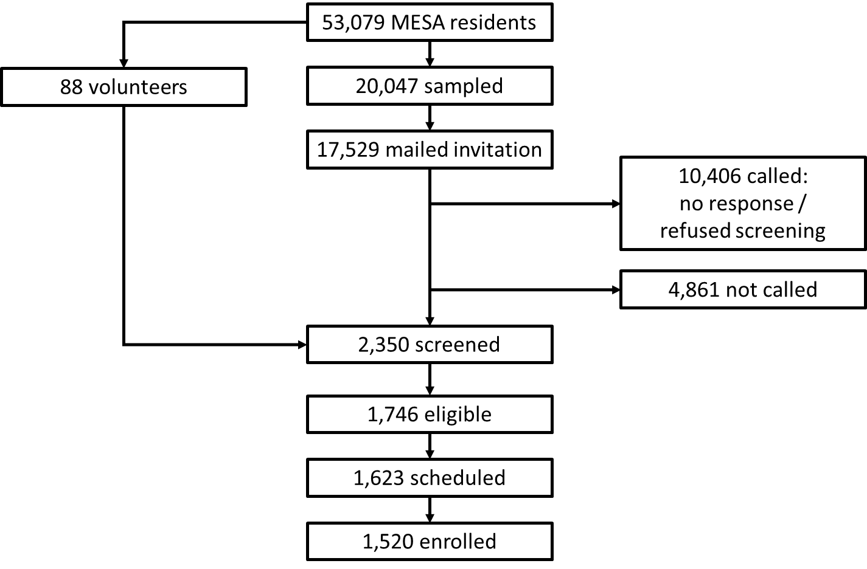
TABLE S2. Participant characteristics by loss to follow-up. Prospective Assessment of COVID-19 in a Community November 2020 – July 2022.

 |  |  | Lost to Follow-up
 | Total  No. = 1,520 | P-value ª | No  No. = 1,159 | Yes  No. = 361 | P-value ^{b}
Age Group, No. (%)
<5 years | 44 (3) | Ref. | 30 (3) | 14 (4) | Ref.
5-11 years | 206 (14) | 0.83 | 146 (13) | 60 (17) | 0.59
12-17 years | 132 (9) | 0.78 | 99 (9) | 33 (9) | 0.45
18-29 years | 150 (10) | 0.10 | 78 (7) | 72 (19) | <0.001
30-59 years | 482 (32) | 0.79 | 386 (33) | 96 (27) | 0.52
60-79 years | 376 (25) | 0.76 | 314 (27) | 62 (17) | 0.51
≥80 years | 130 (9) | 0.67 | 106 (9) | 24 (6) | 0.25
Sex, No. (%)
Female | 874 (57) | Ref. | 665 (57) | 209 (58) | Ref.
Male | 646 (42) | 0.84 | 494 (43) | 152 (42) | 0.57
Race Ethnicity, No. (%)
Other/Unknown/Refused | 87 (6) | Ref. | 51 (4) | 36 (10) | Ref.
Non-Hispanic White | 1,433 (94) | 0.21 | 1,108 (96) | 325 (90) | 0.003
Chronic Conditions ^{c}, No. (%)
No | 821 (54) | Ref. | 580 (50) | 241 (67) | Ref.
Yes | 699 (46) | 0.19 | 579 (50) | 120 (33) | <0.001
COVID-19 Vaccine Doses
Unvaccinated | 381 (25) | 0.04 | 241 (21) | 140 (39) | <0.001
≥1 vaccine dose | 1,139 (75) | Ref. | 918 (79) | 221 (61) | Ref.
ª P-value from multivariable generalized estimating equations logistic regression model comparing the total enrolled population (N=1,520) to the population not lost to follow-up (N=1,159) across all participant characteristic in the table. The model clustered on individual participant assuming an exchangeable correlation structure.
^{b} P-value from multivariable logistic regression model estimating loss to follow-up from all participant characteristic in the table.

FIGURE S2. Timeline of enrollment, collection of self- or guardian-collected nasal swabs for SARS-CoV-2 identification, and collection of blood specimens for serologic studies in the Prospective Assessment of COVID-19 in a Community (PACC) Cohort: November 2020 – July 2022.

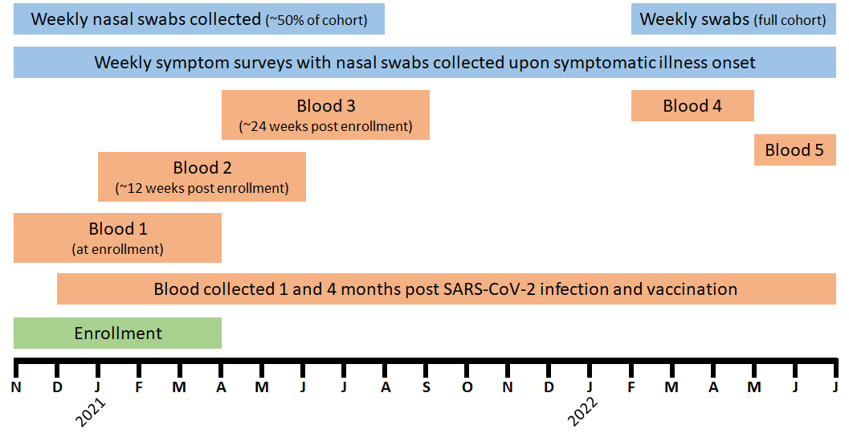
FIGURE S3. Number of participants enrolled during study period by SARS-CoV-2 surveillance type (A), and weekly number of serum specimens collected (B). At enrollment participants were assigned to standard or enhanced surveillance. Both groups completed weekly symptom surveys. Participants in enhanced surveillance collected weekly nasal swabs regardless of symptoms; the standard surveillance group only collected a nasal swab if they had new onset of illness in the past 7 days with symptoms of cough, fever or chills, sore throat, muscle or body aches, loss of smell or taste, shortness of breath, or diarrhea. Participants in enhanced surveillance transitioned to standard surveillance six months after enrollment. SARS-CoV-2 infections were identified only by retrospective EHR documentation or self-report (passive surveillance) during periods of lapsed consent between study waves.

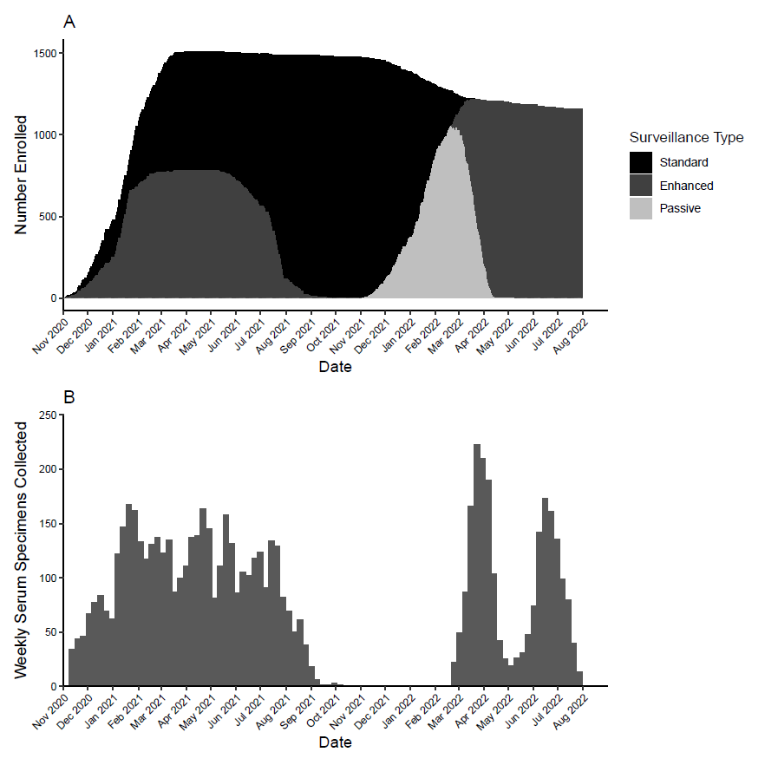
FIGURE S4. Flow chart of selection of SARS-CoV-2 infected and uninfected persons for calculating ELISA optical density change thresholds used to identify SARS-CoV-2 infection among seropositive individuals. Blue boxes represent the analysis population for nucleocapsid threshold analyses; green boxes represent the analysis population for spike threshold analyses. The same individuals could have been included in both analyses if seropositive for both nucleocapsid and spike proteins.

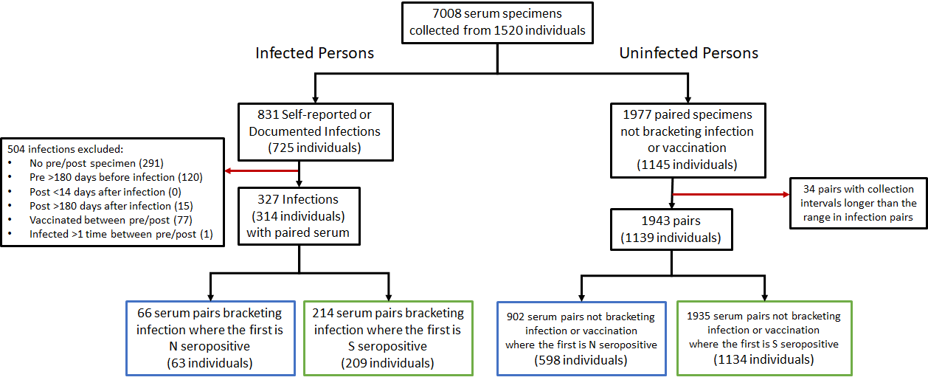

FIGURE S5. Distribution of SARS-CoV-2 nucleocapsid (A) and spike (B) protein ELISA optical density changes in paired serum collected from SARS-CoV-2 infected and uninfected persons, and receiver operating characteristics curves classifying SARS-CoV-2 case status by change in nucleocapsid (C) and spike (D) protein ELISA optical density. Vertical lines (A and B) and dots (C and D) represent optimal threshold values (nucleocapsid [A and C]: 0.256; spike [B and D]: 0.545) maximizing sensitivity with specificity ≥95%.
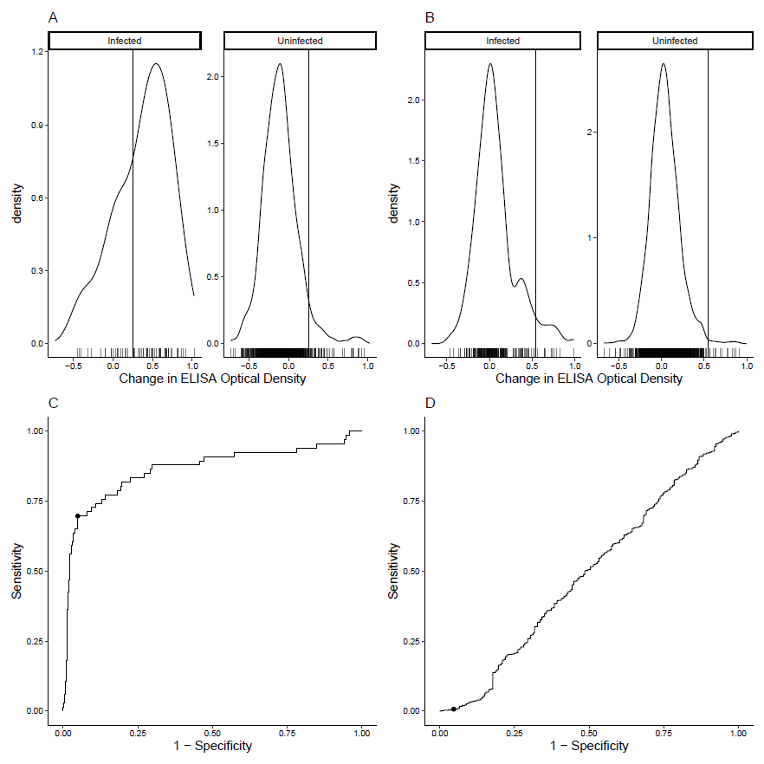
FIGURE S6. Flow chart of serum specimen selection for analysis of durability of SARS-CoV-2 nucleocapsid protein binding antibodies after infection.

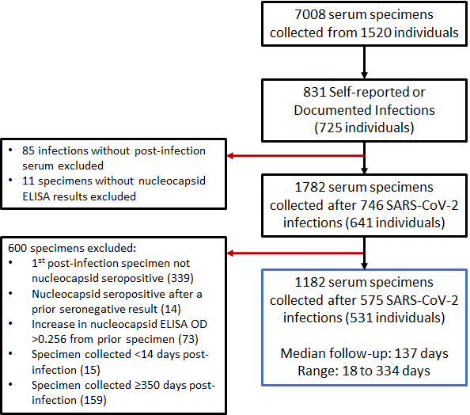
FIGURE S7. Flow chart of serum specimen selection for analysis of durability of SARS-CoV-2 spike protein binding antibodies after infection.

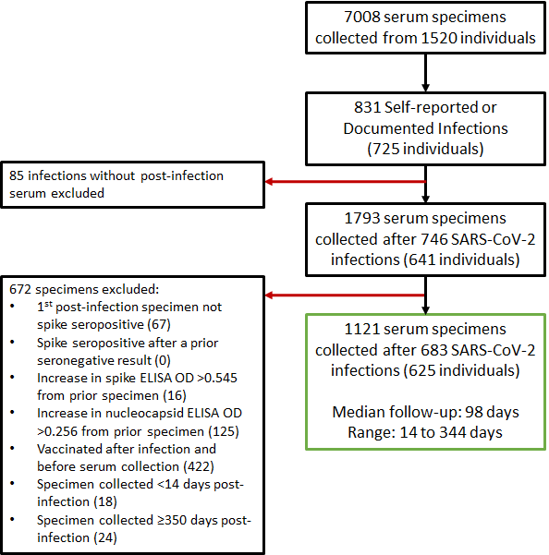

FIGURE S8. Persistence of anti-nucleocapsid antibody. Scatterplot of (A) spike and (B) nucleocapsid ELISA Optical Density values by time since SARS-CoV-2 infection among individuals who were seropositive after infection with linear trend (dark black line). Observations from the same individual are connected by lines. C) Kaplan Meier curve of time to nucleocapsid ELISA seronegativity among SARS-CoV-2 infected individuals who were seropositive after infection.
