Supplemental File

Estimating the Prevalence of Injection Drug Use among Acute Hepatitis C Cases from a National Surveillance System: Application of Random Forest-based Multiple Imputation

Shaoman Yin;¹ Kathleen N. Ly;¹ Laurie K. Barker;¹ Danae Bixler;¹ Nicola D. Thompson;¹ Neil Gupta¹
¹Division of Viral Hepatitis, Centers for Disease Control and Prevention, Atlanta, GA, USA

Contents

Supplemental Table 1. List of variables and data sources used for Multiple Imputation by Chain Equations (MICE) imputations……………………………………………………………………2
Supplemental Figure 1. Impact of varying numbers of Multiple Imputation by Chain Equations (MICE) imputation on prevalence estimation of injection drug use (IDU)………………………6
Supplemental Appendix 1. Procedures for evaluation and sensitivity studies for Multiple Imputation by Chain Equations (MICE) imputation…………………………………………...…7
Supplemental Figure 2. Flow-chart for sensitivity studies for Multiple Imputation by Chain Equations (MICE) imputation with fast implementation of Random Forest (fRF)………………………………………………………………………………………….……9
Supplemental Figure 3. Relationship between Prevalence of Injection Drug Use (IDU) and IDU Data Completeness by State among Reported Acute Hepatitis C Cases, National Notifiable Diseases Surveillance System (NNDSS) 2019–2021……………………………………………………………………………………….……...10
Supplemental Figure 4. Comparison of age distribution by injection drug use (IDU) before and after Multiple Imputation by Chain Equations (MICE) imputation with fast implementation of Random Forest (fRF)………………………………………………………………………………...……………11
Supplemental Figure 5. List of top 50 important variables used by Multiple Imputation by Chain Equations (MICE) imputation with fast implementation of Random Forest (fRF)……………………………………………………………………………………..……….12

 | Supplemental Table 1. List of variables and data sources used for Multiple Imputation by Chain Equations (MICE) imputations
No. | Variable Labels | Data Source
1 | Injection Drug Use (IDU) | NNDSS
2 | Age | NNDSS
3 | Sex | NNDSS
4 | Race/ethnicity | NNDSS
5 | Urbanicity | NNDSS
6 | SVI quartile | CDC SVI Data
7 | Uninsured in the total civilian noninstitutionalized population estimate, 2014-2018 ACS | CDC SVI Data
8 | Civilian (age 16+) unemployed estimate | CDC SVI Data
9 | Persons below poverty estimate, 2014-2018 ACS | CDC SVI Data
10 | Households with no vehicle available estimate, 2014-2018 ACS | CDC SVI Data
11 | Mobile homes estimate, 2014-2018 ACS | CDC SVI Data
12 | Persons in group quarters estimate, 2014-2018 ACS | CDC SVI Data
13 | Transfusion | NNDSS
14 | % non-Hispanic white raw value | County Health Rankings & Roadmap
15 | Uninsured raw value | County Health Rankings & Roadmap
16 | % Hispanic raw value | County Health Rankings & Roadmap
17 | Uninsured adults raw value | County Health Rankings & Roadmap
18 | Tattoo | NNDSS
19 | Surgery | NNDSS
20 | Needlestick Injury | NNDSS
21 | Ever had STD treatment | NNDSS
22 | Occupational | NNDSS
23 | Non-injection drug use | NNDSS
24 | Men who have sex with men | NNDSS
25 | Incarcerated | NNDSS
26 | Household contact | NNDSS
27 | Dialysis | NNDSS
28 | Death | NNDSS
29 | NNDSS data transmission type | NNDSS
30 | SVI overall ranking score | CDC SVI Data
31 | SVI housing type and transportation ranking score | CDC SVI Data
32 | SVI minority status and language ranking score | CDC SVI Data
33 | SVI household composition and disability ranking score | CDC SVI Data
34 | SVI socioeconomic ranking score | CDC SVI Data
35 | Single parent household with children under 18 estimate, 2014-2018 ACS | CDC SVI Data
36 | Per capita income estimate, 2014-2018 ACS | CDC SVI Data
37 | Persons (age 25+) with no high school diploma estimate, 2014-2018 ACS | CDC SVI Data
38 | Housing in structures with 10 or more units estimate, 2014-2018 ACS | CDC SVI Data
39 | Minority (all persons except non-Hispanic White) estimate, 2014-2018 ACS | CDC SVI Data
40 | Persons (age 5+) who speak English "less than well" estimate, 2014-2018 ACS | CDC SVI Data
41 | Civilian noninstitutionalized population with a disability estimate | CDC SVI Data
42 | At household level (occupied housing units), more people than rooms estimate | CDC SVI Data
43 | Persons aged 65 and older estimate, 2014-2018 ACS | CDC SVI Data
44 | Persons aged 17 and younger estimate, 2014-2018 ACS | CDC SVI Data
45 | COVID-19 age-adjusted mortality raw value | County Health Rankings & Roadmap
46 | Childcare centers raw value | County Health Rankings & Roadmap
47 | Childcare cost burden raw value | County Health Rankings & Roadmap
48 | School funding adequacy raw value | County Health Rankings & Roadmap
49 | High school completion raw value | County Health Rankings & Roadmap
50 | School segregation raw value | County Health Rankings & Roadmap
51 | Broadband access raw value | County Health Rankings & Roadmap
52 | Suicides raw value | County Health Rankings & Roadmap
53 | Math scores raw value | County Health Rankings & Roadmap
54 | Reading scores raw value | County Health Rankings & Roadmap
55 | Juvenile arrests raw value | County Health Rankings & Roadmap
56 | Traffic volume raw value | County Health Rankings & Roadmap
57 | Flu vaccinations raw value | County Health Rankings & Roadmap
58 | Severe housing cost burden raw value | County Health Rankings & Roadmap
59 | Homeownership raw value | County Health Rankings & Roadmap
60 | Gender pay gap raw value | County Health Rankings & Roadmap
61 | Disconnected youth raw value | County Health Rankings & Roadmap
62 | Firearm fatalities raw value | County Health Rankings & Roadmap
63 | Life expectancy raw value | County Health Rankings & Roadmap
64 | Frequent mental distress raw value | County Health Rankings & Roadmap
65 | Frequent physical distress raw value | County Health Rankings & Roadmap
66 | Insufficient sleep raw value | County Health Rankings & Roadmap
67 | Residential segregation - non-white/white raw value | County Health Rankings & Roadmap
68 | Residential segregation - Black/white raw value | County Health Rankings & Roadmap
69 | Social associations raw value | County Health Rankings & Roadmap
70 | Food insecurity raw value | County Health Rankings & Roadmap
71 | Drug overdose deaths raw value | County Health Rankings & Roadmap
72 | Long commute - driving alone raw value | County Health Rankings & Roadmap
73 | Severe housing problems raw value | County Health Rankings & Roadmap
74 | Injury deaths raw value | County Health Rankings & Roadmap
75 | Alcohol-impaired driving deaths raw value | County Health Rankings & Roadmap
76 | Food environment index raw value | County Health Rankings & Roadmap
77 | Access to exercise opportunities raw value | County Health Rankings & Roadmap
78 | Other primary care providers raw value, 2014-2018 ACS | County Health Rankings & Roadmap
79 | Infant mortality raw value | County Health Rankings & Roadmap
80 | Child mortality raw value | County Health Rankings & Roadmap
81 | Premature age-adjusted mortality raw value | County Health Rankings & Roadmap
82 | Air pollution - particulate matter raw value | County Health Rankings & Roadmap
83 | Drinking water violations raw value | County Health Rankings & Roadmap
84 | Uninsured children raw value | County Health Rankings & Roadmap
85 | Dentists raw value | County Health Rankings & Roadmap
86 | Limited access to healthy foods raw value | County Health Rankings & Roadmap
87 | Children in single-parent households raw value | County Health Rankings & Roadmap
88 | % Asian raw value | County Health Rankings & Roadmap
89 | % Native Hawaiian/Other Pacific Islander raw value | County Health Rankings & Roadmap
90 | Physical inactivity raw value | County Health Rankings & Roadmap
91 | Some college raw value | County Health Rankings & Roadmap
92 | Driving alone to work raw value | County Health Rankings & Roadmap
93 | Children eligible for free or reduced price lunch raw value | County Health Rankings & Roadmap
94 | Median household income raw value | County Health Rankings & Roadmap
95 | Mental health providers raw value | County Health Rankings & Roadmap
96 | HIV prevalence raw value | County Health Rankings & Roadmap
97 | Diabetes prevalence raw value | County Health Rankings & Roadmap
98 | % not proficient in English raw value | County Health Rankings & Roadmap
99 | % rural raw value | County Health Rankings & Roadmap
100 | % female raw value | County Health Rankings & Roadmap
101 | % American Indian & Alaska Native raw value | County Health Rankings & Roadmap
102 | % non-Hispanic Black raw value | County Health Rankings & Roadmap
103 | % 65 and older raw value | County Health Rankings & Roadmap
104 | % below 18 years of age raw value | County Health Rankings & Roadmap
105 | Population raw value | County Health Rankings & Roadmap
106 | Mammography screening raw value | County Health Rankings & Roadmap
107 | Excessive drinking raw value | County Health Rankings & Roadmap
108 | Sexually transmitted infections raw value | County Health Rankings & Roadmap
109 | Income inequality raw value | County Health Rankings & Roadmap
110 | Violent crime raw value | County Health Rankings & Roadmap
111 | Poor mental health days raw value | County Health Rankings & Roadmap
112 | Motor vehicle crash deaths raw value | County Health Rankings & Roadmap
113 | Low birthweight raw value | County Health Rankings & Roadmap
114 | Poor physical health days raw value | County Health Rankings & Roadmap
115 | Children in poverty raw value | County Health Rankings & Roadmap
116 | Unemployment raw value | County Health Rankings & Roadmap
117 | High school graduation raw value | County Health Rankings & Roadmap
118 | Homicides raw value | County Health Rankings & Roadmap
119 | Teen births raw value | County Health Rankings & Roadmap
120 | Adult obesity raw value | County Health Rankings & Roadmap
121 | Adult smoking raw value | County Health Rankings & Roadmap
122 | Preventable hospital stays raw value | County Health Rankings & Roadmap
123 | Primary care physicians raw value | County Health Rankings & Roadmap
124 | Poor or fair health raw value | County Health Rankings & Roadmap
125 | Premature death raw value | County Health Rankings & Roadmap
126 | MMWR year | NNDSS
127 | State | NNDSS
128 | Sexual contact | NNDSS
129 | Multiple sex partners | NNDSS
130 | MMWR week | NNDSS
131 | Hospitalization | NNDSS
132 | County of Residence | NNDSS
133 | Symptomatic | NNDSS
134 | Jaundiced | NNDSS
Abbreviations: SVI, Social Vulnerability Index; ACS, American Community Survey; NNDSS, National Notifiable Diseases Surveillance System.
Data source: County Health Rankings & Roadmaps: 2020 data, https://www.countyhealthrankings.org; CDC SVI Data: 2018 data, https://www.atsdr.cdc.gov/placeandhealth/svi.html; NNDSS: viral hepatitis case surveillance data, 2019–2021.
Variables No. 1–29 were selected for Multiple Imputation by Chain Equations (MICE) models including parametric logistic regression (LR), semi-parametric Predictive Mean Matching (PMM), and non-parametric standard Random Forest (sRF) based on their higher correlation with IDU missingness (absolute Pearson correlation ≥0.2). For fast implementation of Random Forest (fRF), variables 1–134 were used as inputs for model selection.
For this analysis, the IDU information was obtained from two questions, one about whether the person injected drugs in the 2 weeks to 6 months prior to onset of symptoms, and a second about ever having injected drugs. If the response was yes to either question, then IDU was coded yes. Both unknown and blank values were treated as missing.

Supplemental Figure 1. Impact of varying numbers of Multiple Imputation by Chain Equations (MICE) imputation on prevalence estimation of injection drug use (IDU)
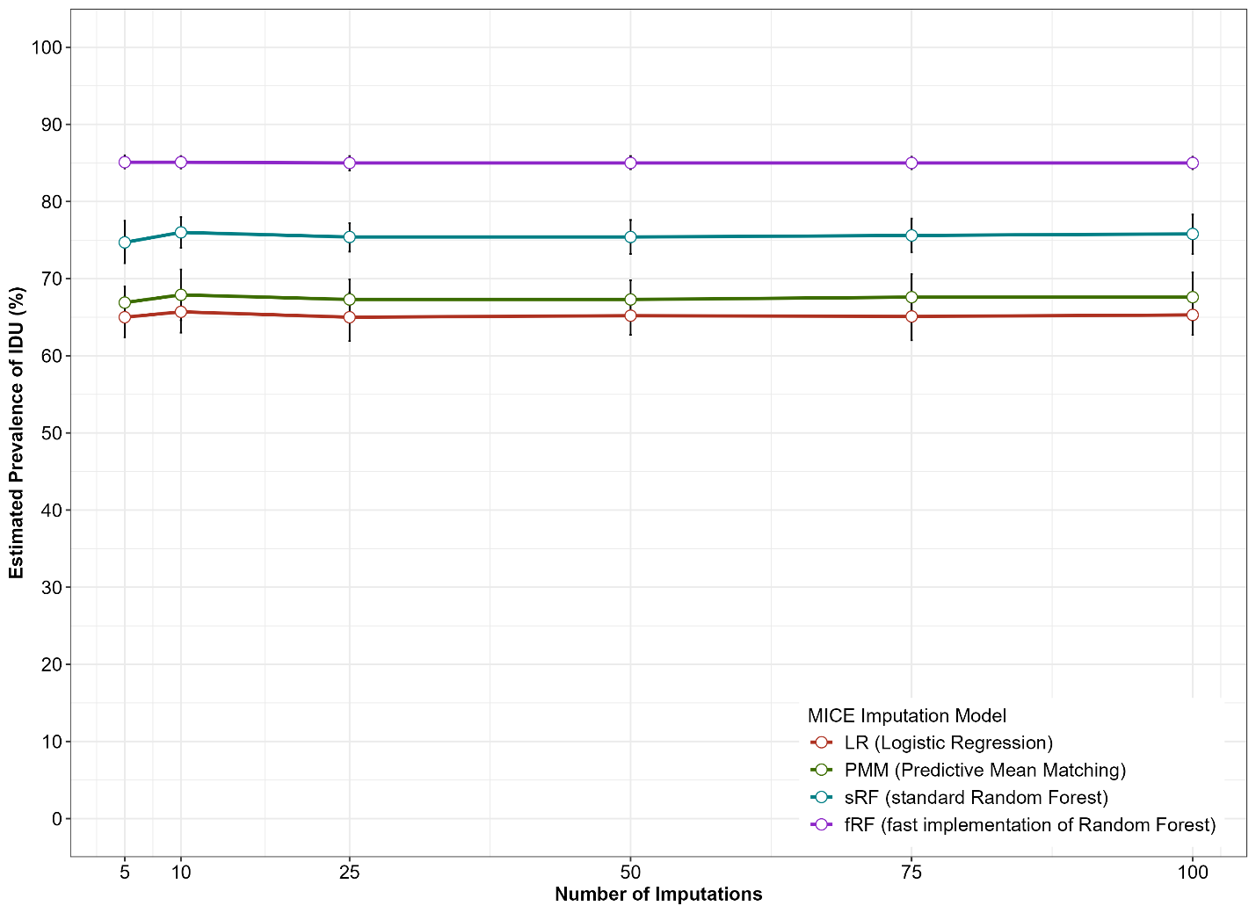

We conducted four types of MICE imputations including parametric logistic regression (LR), semi-parametric Predictive Mean Matching (PMM), and non-parametric standard Random Forest (sRF) and fast implementation of Random Forest (fRF), with 5, 10, 25, 50, 75 and 100 imputations each, to assess how many imputations were sufficient. The final estimate of injection drug use (IDU) prevalence and its 95% confidence interval were derived based on Rubin’s rule. Results suggest that setting the number of imputations at 10 (as used in the manuscript) is sufficient to achieve the stability of estimation.

Supplemental Appendix 1. Procedures for evaluation and sensitivity studies of Multiple Imputation by Chain Equations (MICE) imputation

This section provides detailed information about procedures used in the manuscript for the evaluation and sensitivity studies. The steps of the evaluation study are described below.
- Step 1: Choose the raw data with variables 1-29 (including IDU) as listed in the Web Table 1 as the initial data set, where the dummy variable for IDU missingness was created (IDU missing as 1, otherwise as 0). Develop a propensity model for IDU missingness using a logistic regression model.
Logit (P (IDU is missing)) =beta0+X1*beta1+ X2*beta2 +…+ X28*beta28
Covariates X1 to X28 include age, sex, …, NNDSS data transmission type as described in Web Table 1.
- Step 2: Use the “predict” function to derive the probability of IDU missing by applying the above model to the “true” data (one copy of an imputed data from fast implementation of Random Forest-based MICE), where all IDU data were completed. Generate a testing variable IDU from the completed IDU variable based on the probability of IDU missing (when the probability is larger than its mean value, set as missing; otherwise use the value from the original value in the raw data).
- Step 3: Generate 50 random datasets from the dataset created by Step 2 through bootstrap sampling with replacement.
- Step 4: For each of the 50 random data sets from Step 3, repeat the different methods of handling missing IDU data including listwise deletion, parametric logistic regression (LR) MICE, semi-parametric Predictive Mean Matching (PMM) MICE, non-parametric standard Random Forest (sRF) MICE and fast implementation of RF (fRF) MICE. For MICE imputation, 10 imputations were conducted. The final estimation of IDU prevalence and 95% confidence interval (CI) was derived based on the Rubin’s rule for each of the 50 datasets.
- Step 5: Calculate evaluation measures from 50 data sets in Step 4 as below:
Raw bias=average of IDU prevalence from the 50 replicates – the IDU prevalence from the “true” data
Percent bias= Raw bias / the IDU prevalence from the “true” data
95% CI width=the average of 95% CI width from the 50 replicates
RMSE (root mean square error) = the square root of the sum of the squared difference between the average IDU prevalence from 50 replicates and the IDU prevalence from the “true” data.

The steps of the sensitivity study (also see Web figure 1) are described below.
- Step 1: Choose the raw data with variables 1-29 (including IDU) as listed in the Web Table 1 as the initial data set, where the dummy variable for IDU missingness was created (IDU missing as 1, otherwise as 0). Develop a propensity model for IDU missingness using a logistic regression model.
Logit (P (IDU is missing)) =beta0+X1*beta1+ X2*beta2 +…+ X28*beta28
Covariates X1 to X28 include age, sex, …, NNDSS data transmission type as described in Web Table 1.
Different from the evaluation procedure, we continue by adding a predictor IDU*beta29
setting the beta29 as 0, 0.1, 0.2, 0.5, 0.8, 1.0 to generate six models of predicting IDU missingness increasingly not at random.
Logit (P (IDU is missing)) =beta0+X1*beta1+ X2*beta2 +…+ X28*beta28+IDU*beta29
- Step 2: Use the “predict” function to derive the probability of IDU missing by applying the above six models to the “true” data (one copy of an imputed data from fast implementation of Random Forest-based MICE), where all IDU data were completed. Generate a testing variable IDU from the completed IDU variable based on the probability of IDU missing (when the probability is larger than its mean value, set as missing; otherwise use the value from the original or imputed value in the “true” data).
- Step 3: Generate 50 random datasets from the dataset created by Step 2 through bootstrap sampling with replacement for each of the six models.
- Step 4: For each of the 50 random data sets from Step 3, conduct the fast implementation of RF (fRF) MICE to impute IDU missing data and repeat for each of the six models with beta29 set to 0, 0.1, 0.2, 0.5, 0.8, and 1.0. For each fRF MICE imputation, 10 imputations were conducted. The final estimation of IDU prevalence and 95% confidence interval (CI) was derived based on the Rubin’s rule for each of the 50 datasets.
- Step 5: Calculate evaluation measures from 50 replicates in Step 4 as below:
Raw bias=average of IDU prevalence from the 150 replicates – the IDU prevalence from the “true” data
Percent bias=Raw bias / the IDU prevalence from the “true” data
95% CI width=the average of 95% CI width from the 50 replicates
RMSE (root mean square error) = the square root of the sum of the squared difference between the average IDU prevalence from 50 replicates and the IDU prevalence from the “true” data.

Supplemental Figure 2. Flow-chart for sensitivity studies for Multiple Imputation by Chain Equations (MICE) imputation with fast implementation of Random Forest (fRF)
“true” data (with completed IDU data)

Predict and assign IDU missingness
Logistic model for IDU missingness
Original raw data
MAR (Missing at Random)
…
Bootstrap sampling
Average estimates from 50 multiple imputation analyses
Evaluation Measures
- Raw Bias = estimate – “true”
- Percent Bias = (raw bias / “true”) *100
- 95%CI Width = 95%CI up –95%IC low
- RMSE = root mean square error
IDU missing data 1
rRF-MICE
IDU Prevalence and 95% CI (Rubin’s Rule)
…
True IDU Prevalence
Evaluation Measures
MNAR (Missing Not at Random)
Add IDU as one predictor with different coefficients of 0, 0.1, 0.2, 0.5, 0.8, and 1.0
IDU missing data 25
IDU Prevalence and 95% CI (Rubin’s Rule)
IDU missing data 50
IDU Prevalence and 95% CI (Rubin’s Rule)
rRF-MICE
rRF-MICE
Supplemental Figure 3. Relationship between Prevalence of Injection Drug Use (IDU) and IDU Data Completeness by State among Reported Acute Hepatitis C Cases, National Notifiable Diseases Surveillance System (NNDSS) 2019–2021

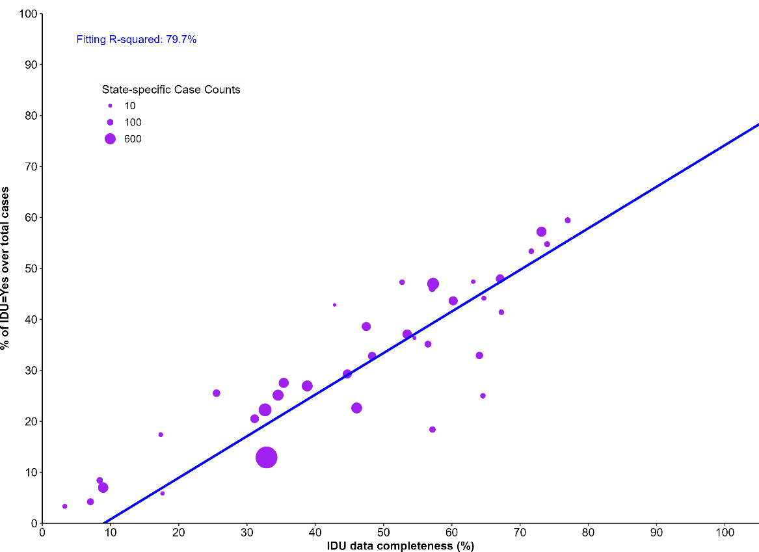

In the manuscript, we showed the evaluation measures of raw bias, percent bias, 95% CI width, and RMSE across the five estimation approaches (LD, LR, PMM, sRF, and fRF). In this figure, we also examined the associations between IDU data completeness and prevalence of IDU among all cases (including missing IDU data) at the state level using 2019-2021 NNDSS acute hepatitis C data. Each dot in the figure represents one state’s data. There was a strong linear relationship between both measures (R-squared=79.7%), suggesting that for a hypothetical state with 100% complete IDU data, the estimated prevalence of IDU extrapolates to approximately 80%. This number was close to our estimate (85.1%) based on the fRF MICE imputation in the manuscript.

Supplemental Figure 4. Comparison of age distribution by injection drug use (IDU) before and after Multiple Imputation by Chain Equations (MICE) imputation with fast implementation of Random Forest (fRF)

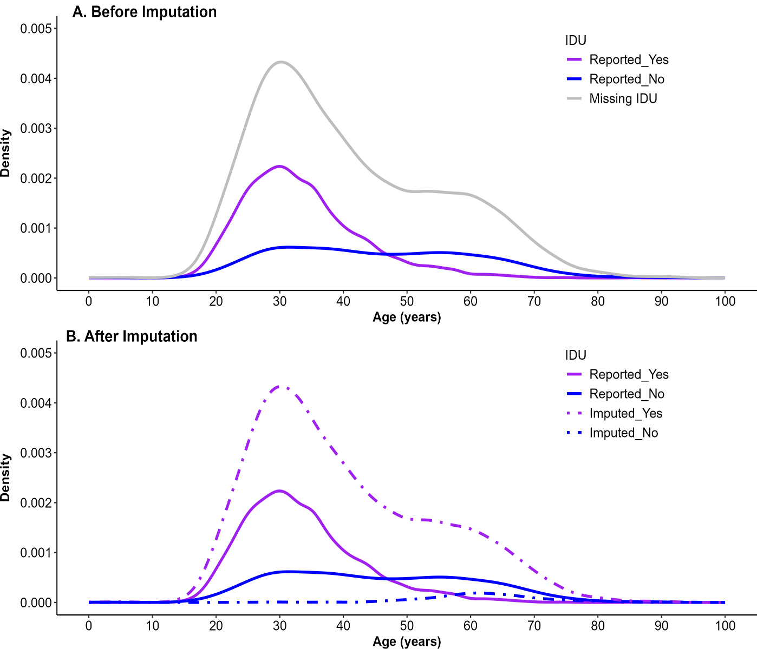

We compared the age distribution by IDU before imputation (A) (using the raw completed data that excluded missing IDU data) and after imputation (B) (using one imputed data set from rRF MICE). Results suggested that most cases with missing IDU data had been imputed as “yes” for IDU through fRF MICE with a peak around age 30 years. Fewer cases were imputed as “no” for IDU with the peak around age 60 years.

Supplemental Figure 5. List of the top 50 important variables for injection drug use (IDU) missing data imputation selected by Multiple Imputation by Chain Equations (MICE) imputation with fast implementation of Random Forest (fRF). Among these 50 variables, 19 variables overlapped with the variable No. 2-29 list in Web Table 1 are in black font; all other variables are in grey font.

