SUPPLEMENTAL TABLES

Supplemental Table 1. Single nucleotide polymorphisms (SNPs) included in the amyotrophic lateral sclerosis-polygenic risk score (ALS-PGS).
Table contains the identifier, alleles, weight, and p-value for each SNP included in the ALS-PGS. This table is provided as a separate file labeled “Supplemental Table 1 – ALS-PGS SNPs.xlsx.”

Supplemental Table 2. Single nucleotide polymorphisms (SNPs) included in the metal-polygenic risk score (metal-PGS).
Table contains the identifier, alleles, chromosome, base pair, and reference for each SNP included in the metal-PGS. The SNPs are based on a literature search. This table is provided as a separate file labeled “Supplemental Table 2 – Metal-PGS SNPs.xlsx.”

Supplemental Table 3. Standard occupational classification (SOC) codes
SOC Code | Occupation
11-0000 | Management Occupations
13-0000 | Business and Financial Operations Occupations
15-0000 | Computer and Mathematical Occupations
17-0000 | Architecture and Engineering Occupations
19-0000 | Life, Physical, and Social Science Occupations
21-0000 | Community and Social Services Occupations
23-0000 | Legal Occupations
25-0000 | Education, Training, and Library Occupations
27-0000 | Arts, Design, Entertainment, Sports, and Media Occupations
29-0000 | Healthcare Practitioners and Technical Occupations
31-0000 | Healthcare Support Occupations
33-0000 | Protective Service Occupations
35-0000 | Food Preparation and Serving Related Occupations
37-0000 | Building and Grounds Cleaning and Maintenance Occupations
39-0000 | Personal Care and Service Occupations
41-0000 | Sales and Related Occupations
43-0000 | Office and Administrative Support Occupations
45-0000 | Farming, Fishing, and Forestry Occupations
47-0000 | Construction and Extraction Occupations
49-0000 | Installation, Maintenance, and Repair Occupations
52-0000 | Production Occupations
53-0000 | Transportation and Material Moving Occupations
55-0000 | Military Occupations

Supplemental Table 4. ALS and control participant demographics: Plasma and urine
Covariate | ALS, N = 255¹ | Control, N = 181¹ | p-value²
Age at Urine Sample Collection | 65 (58-72) | 61 (55-68) | <0.001
Age at Plasma Sample Collection | 66 (58-72) | 61 (55-68) | <0.001
Sex |  |  | <0.001
Female | 99 (39%) | 101 (56%)
Male | 156 (61%) | 80 (44%)
Ethnicity |  |  | 0.018
Hispanic or Latino | 2 (0.8%) | 8 (4.6%)
Not Hispanic or Latino | 251 (99%) | 166 (95%)
Missing | 2 | 7
Race |  |  | 0.2
Asian | 0 (0%) | 2 (1.1%)
Black or African American | 8 (3.1%) | 9 (5.0%)
Other | 1 (0.4%) | 0 (0%)
White or Caucasian | 245 (96%) | 170 (94%)
Missing | 1 | 0
Military Service |  |  | 0.5
Yes | 30 (12%) | 16 (10%)
No | 217 (88%) | 142 (90%)
Missing | 8 | 23
Education |  |  | <0.001
High school or less | 62 (25%) | 8 (5.0%)
Bachelor’s degree | 56 (23%) | 64 (40%)
Some postsecondary | 88 (35%) | 29 (18%)
Graduate degree | 42 (17%) | 58 (36%)
Missing | 7 | 22
Family History of ALS | 26 (10%) | 0 (0%) | <0.001
Missing | 6
Age at Diagnosis | 65 (58-71)
Missing | 2
Diagnosis
ALS | 233 (91%)
ALS/Frontotemporal dementia | 13 (5.1%)
Brachial amyotrophic diplegia | 5 (2.0%)
Flail leg | 1 (0.4%)
Progressive muscular atrophy | 3 (1.2%)
El Escorial Criteria
Definite | 72 (28%)
Probable | 73 (29%)
Probable, lab supported | 70 (28%)
Possible | 26 (10%)
Suspected | 12 (4.7%)
Missing | 2
Onset Segment
Bulbar | 68 (27%)
Cervical | 90 (36%)
Lumbar | 90 (36%)
Respiratory | 3 (1.2%)
Thoracic | 2 (0.8%)
Missing | 2
ALSFRS-R | 38 (34-41)
Missing | 1
Time Between Symptom Onset and Diagnosis | 1.05 (0.61-1.79)
Missing | 4
Time Between Diagnosis and Urine Sample (Years) | 0.45 (0.21-0.82)
Missing | 2
Time Between Diagnosis and Plasma Sample (Years) | 0.50 (0.21-0.96)
Missing | 2
¹Median (25%-75%); n (%)
²Wilcoxon rank sum test; Pearson’s Chi-squared test; Fisher’s exact test
Abbreviations: ALS, amyotrophic lateral sclerosis; ALSFRS-R, Revised ALS Functional Rating Scale

Supplemental Table 5. Gene mutation status in familiar ALS for plasma and urine cohorts

Plasma
Mutation Status | N = 42¹
C9orf72 | 9 (21%)
FUS | 1 (2.4%)
SOD1 | 2 (4.8%)
SQSTM1 | 2 (4.8%)
TARDBP | 1 (2.4%)
VCP | 1 (2.4%)
No mutation identified | 15 (36%)
No test results | 11 (26%)
¹n (%)

Urine
Mutation Status | N = 30¹
C9orf72 | 7 (23%)
FUS | 1 (3.3%)
SOD1 | 2 (6.7%)
SQSTM1 | 1 (3.3%)
VCP | 1 (3.3%)
No mutation identified | 12 (40%)
No test results | 6 (20%)
¹n (%)

Supplemental Table 6. Metal levels in plasma samples
Abbreviations: ALS, amyotrophic lateral sclerosis; N, the number of subjects in the group; SD, standard deviation; Q10, 10th Percentile; Q25, 25th Percentile; Q50, median; Q75, 75th Percentile; Q90, 90th Percentile. P-value, the p-value from the Wilcoxon rank sum test compares metal levels between the case and control groups; BH, Benjamini-Hochberg; %BDL, the percentage of samples below the detection limit. Red, median value is higher in ALS group; Blue, median value is higher in control group; Significance based on q-value.

 |  | ALS, N=387  (μg/ℓ) |  |  |  |  |  |  |  |  | Control, N=281  (μg/ℓ)
Metal | %BDL | Mean | SD | Min | Q10 | Q25 | Q50 | Q75 | Q90 | Max | Mean | SD | Min | Q10 | Q25 | Q50 | Q75 | Q90 | Max | P-value | Q-value (BH)
Aluminum | 84.0% | 49.56 | 320.11 | 14.14 | 14.14 | 14.14 | 14.14 | 14.14 | 25.75 | 4,612.83 | 64.43 | 587.46 | 14.14 | 14.14 | 14.14 | 14.14 | 14.14 | 23.04 | 9,595.32 | 0.864 | >0.999
Antimony | 3.5% | 3.16 | 2.02 | 0.08 | 1.76 | 2.43 | 3.09 | 3.73 | 4.45 | 23.36 | 3.67 | 1.94 | 1.68 | 2.30 | 2.68 | 3.24 | 4.07 | 5.62 | 28.02 | <0.001 | 0.003
Arsenic | 0.1% | 0.52 | 0.92 | 0.09 | 0.15 | 0.18 | 0.25 | 0.42 | 1.08 | 8.11 | 0.70 | 1.90 | 0.12 | 0.19 | 0.23 | 0.31 | 0.57 | 1.27 | 29.29 | <0.001 | <0.001
Barium | 0.1% | 1.62 | 1.32 | 0.22 | 0.58 | 0.82 | 1.33 | 2.05 | 2.89 | 15.42 | 2.46 | 6.09 | 0.22 | 0.51 | 0.94 | 1.64 | 2.51 | 4.08 | 95.58 | 0.001 | 0.018
Beryllium | 99.6% | 0.07 | 0.00 | 0.07 | 0.07 | 0.07 | 0.07 | 0.07 | 0.07 | 0.11 | 0.07 | 0.02 | 0.07 | 0.07 | 0.07 | 0.07 | 0.07 | 0.07 | 0.34 | 0.763 | >0.999
Cadmium | 36.3% | 0.01 | 0.02 | 0.00 | 0.00 | 0.00 | 0.01 | 0.02 | 0.03 | 0.09 | 0.01 | 0.02 | 0.00 | 0.00 | 0.00 | 0.01 | 0.01 | 0.02 | 0.25 | <0.001 | 0.016
Chromium | 0.4% | 0.65 | 2.15 | 0.06 | 0.23 | 0.28 | 0.37 | 0.49 | 0.82 | 39.08 | 0.53 | 1.00 | 0.09 | 0.24 | 0.29 | 0.35 | 0.47 | 0.62 | 11.65 | 0.543 | >0.999
Cobalt | 0.1% | 0.36 | 1.04 | 0.09 | 0.14 | 0.16 | 0.19 | 0.26 | 0.37 | 13.40 | 0.29 | 0.33 | 0.09 | 0.14 | 0.17 | 0.20 | 0.28 | 0.45 | 3.89 | 0.135 | >0.999
Copper | 0.1% | 1,112.83 | 205.24 | 587.71 | 878.43 | 968.38 | 1,088.97 | 1,231.59 | 1,384.44 | 1,894.29 | 1,065.57 | 226.63 | 671.57 | 822.01 | 921.63 | 1,038.48 | 1,181.87 | 1,326.67 | 2,432.46 | 0.001 | 0.018
Iron | 0.1% | 1,307.97 | 819.60 | 237.89 | 751.77 | 923.79 | 1,149.08 | 1,439.91 | 1,866.88 | 9,084.29 | 1,335.07 | 635.83 | 448.96 | 744.54 | 932.36 | 1,234.62 | 1,569.71 | 2,061.99 | 6,207.42 | 0.130 | >0.999
Lead | 0.8% | 0.46 | 0.57 | 0.03 | 0.10 | 0.18 | 0.29 | 0.49 | 0.94 | 4.09 | 0.37 | 1.12 | 0.02 | 0.06 | 0.11 | 0.16 | 0.26 | 0.55 | 16.40 | <0.001 | <0.001
Manganese | 0.1% | 1.45 | 4.15 | 0.24 | 0.38 | 0.47 | 0.55 | 0.72 | 3.27 | 70.17 | 1.19 | 2.21 | 0.29 | 0.42 | 0.51 | 0.60 | 0.74 | 1.27 | 21.91 | 0.010 | 0.119
Mercury | 85.2% | 1.20 | 1.19 | 0.88 | 0.88 | 0.88 | 0.88 | 0.88 | 1.53 | 11.46 | 1.25 | 1.43 | 0.88 | 0.88 | 0.88 | 0.88 | 0.88 | 2.07 | 16.50 | 0.299 | >0.999
Molybdenum | 85.0% | 2.15 | 1.04 | 1.75 | 1.75 | 1.75 | 1.75 | 1.75 | 3.17 | 8.11 | 2.01 | 0.99 | 1.75 | 1.75 | 1.75 | 1.75 | 1.75 | 2.61 | 12.01 | 0.019 | 0.211
Nickel | 7.7% | 0.82 | 0.63 | 0.20 | 0.33 | 0.51 | 0.76 | 0.97 | 1.24 | 8.56 | 0.97 | 1.23 | 0.20 | 0.37 | 0.59 | 0.85 | 1.06 | 1.30 | 17.28 | 0.006 | 0.080
Selenium | 0.1% | 142.50 | 29.51 | 70.80 | 116.59 | 126.96 | 139.18 | 150.39 | 171.80 | 361.30 | 132.82 | 15.61 | 90.07 | 114.41 | 122.38 | 132.27 | 141.86 | 150.45 | 225.49 | <0.001 | <0.001
Silver | 17.9% | 0.15 | 0.32 | 0.02 | 0.02 | 0.04 | 0.08 | 0.16 | 0.30 | 5.37 | 0.12 | 0.16 | 0.02 | 0.02 | 0.04 | 0.07 | 0.14 | 0.26 | 1.59 | 0.830 | >0.999
Strontium | 0.1% | 25.03 | 13.71 | 8.14 | 14.41 | 17.71 | 22.54 | 28.67 | 36.77 | 203.01 | 30.17 | 18.71 | 11.79 | 17.11 | 22.45 | 26.85 | 34.37 | 42.19 | 254.24 | <0.001 | <0.001
Thallium | 2.8% | 0.03 | 0.01 | 0.01 | 0.01 | 0.02 | 0.03 | 0.04 | 0.05 | 0.11 | 0.03 | 0.01 | 0.01 | 0.02 | 0.02 | 0.03 | 0.04 | 0.05 | 0.09 | 0.031 | 0.309
Tin | 19.3% | 0.39 | 0.97 | 0.07 | 0.07 | 0.12 | 0.19 | 0.35 | 0.66 | 15.05 | 0.27 | 0.32 | 0.07 | 0.07 | 0.11 | 0.18 | 0.30 | 0.53 | 3.72 | 0.166 | >0.999
Uranium | 98.6% | 0.02 | 0.01 | 0.02 | 0.02 | 0.02 | 0.02 | 0.02 | 0.02 | 0.18 | 0.02 | 0.02 | 0.02 | 0.02 | 0.02 | 0.02 | 0.02 | 0.02 | 0.42 | 0.618 | >0.999
Vanadium | 0.3% | 0.12 | 0.48 | 0.01 | 0.03 | 0.04 | 0.05 | 0.07 | 0.14 | 8.14 | 0.10 | 0.54 | 0.02 | 0.03 | 0.03 | 0.04 | 0.06 | 0.08 | 8.36 | <0.001 | <0.001
Zinc | 0.1% | 829.76 | 198.28 | 429.59 | 635.10 | 704.72 | 790.08 | 916.18 | 1,067.51 | 1,738.72 | 771.77 | 181.35 | 507.28 | 612.23 | 661.45 | 740.94 | 837.65 | 943.61 | 2,217.53 | <0.001 | <0.001

Supplemental Table 7. Metal levels in urine samples
Abbreviations: ALS, amyotrophic lateral sclerosis; N, the number of subjects in the group; SD, standard deviation; Q10, 10th Percentile; Q25, 25th Percentile; Q50, median; Q75, 75th Percentile; Q90, 90th Percentile. P-value, the p-value from the Wilcoxon rank sum test compares metal levels between the case and control groups.; BH, Benjamini-Hochberg; %BDL, the percentage of samples below the detection limit. Red, median value is higher in ALS group; Significance based on q-value.

 |  | ALS, N=322  (μg/ℓ) |  |  |  |  |  |  |  |  | Control, N=194  (μg/ℓ)
Metal | %BDL | Mean | SD | Min | Q10 | Q25 | Q50 | Q75 | Q90 | Max | Mean | SD | Min | Q10 | Q25 | Q50 | Q75 | Q90 | Max | P-value | Q-value (BH)
Aluminum | 35.0% | 14.58 | 36.52 | 2.84 | 2.84 | 2.84 | 5.96 | 10.91 | 22.65 | 364.19 | 12.87 | 33.96 | 2.84 | 2.84 | 2.84 | 4.51 | 9.20 | 19.13 | 306.75 | 0.003 | 0.031
Antimony | 37.8% | 0.08 | 0.49 | 0.01 | 0.01 | 0.01 | 0.03 | 0.06 | 0.11 | 8.73 | 0.04 | 0.05 | 0.01 | 0.01 | 0.01 | 0.02 | 0.05 | 0.08 | 0.43 | 0.015 | 0.150
Arsenic | 0.2% | 16.92 | 30.56 | 0.22 | 2.38 | 3.77 | 7.64 | 15.17 | 33.85 | 239.70 | 24.16 | 159.09 | 1.15 | 2.13 | 3.86 | 6.82 | 12.92 | 29.81 | 2,212.14 | 0.240 | >0.999
Barium | 0.0% | 3.49 | 13.68 | 0.11 | 0.46 | 0.90 | 1.83 | 3.12 | 6.65 | 242.05 | 1.93 | 3.05 | 0.04 | 0.29 | 0.56 | 1.10 | 2.22 | 3.81 | 32.75 | <0.001 | <0.001
Beryllium | 92.3% | 0.02 | 0.00 | 0.02 | 0.02 | 0.02 | 0.02 | 0.02 | 0.02 | 0.06 | 0.02 | 0.01 | 0.02 | 0.02 | 0.02 | 0.02 | 0.02 | 0.03 | 0.07 | 0.063 | 0.507
Cadmium | 0.0% | 0.49 | 0.53 | 0.02 | 0.11 | 0.18 | 0.33 | 0.58 | 0.98 | 3.77 | 0.31 | 0.32 | 0.01 | 0.05 | 0.12 | 0.22 | 0.38 | 0.65 | 1.76 | <0.001 | <0.001
Chromium | 79.9% | 0.94 | 1.62 | 0.53 | 0.53 | 0.53 | 0.53 | 0.53 | 1.26 | 18.40 | 0.77 | 1.37 | 0.53 | 0.53 | 0.53 | 0.53 | 0.53 | 0.98 | 17.91 | 0.056 | 0.507
Cobalt | 0.2% | 0.63 | 2.68 | 0.01 | 0.07 | 0.11 | 0.18 | 0.30 | 0.55 | 36.65 | 0.43 | 0.80 | 0.01 | 0.06 | 0.09 | 0.20 | 0.38 | 0.91 | 8.41 | 0.314 | >0.999
Copper | 0.2% | 13.56 | 22.40 | 0.33 | 3.69 | 6.40 | 9.90 | 15.18 | 22.25 | 277.36 | 8.49 | 9.97 | 0.68 | 1.79 | 3.50 | 6.55 | 10.82 | 15.91 | 96.77 | <0.001 | <0.001
Iron | 26.3% | 17.79 | 31.09 | 3.07 | 3.07 | 6.09 | 10.19 | 17.38 | 34.14 | 382.91 | 8.14 | 16.77 | 3.07 | 3.07 | 3.07 | 4.99 | 8.53 | 13.37 | 179.67 | <0.001 | <0.001
Lead | 14.5% | 0.19 | 0.12 | 0.04 | 0.04 | 0.10 | 0.17 | 0.24 | 0.34 | 0.85 | 0.20 | 0.16 | 0.04 | 0.04 | 0.08 | 0.17 | 0.27 | 0.38 | 1.08 | 0.899 | >0.999
Manganese | 49.9% | 0.21 | 0.42 | 0.06 | 0.06 | 0.06 | 0.09 | 0.16 | 0.38 | 3.89 | 0.16 | 0.31 | 0.06 | 0.06 | 0.06 | 0.06 | 0.13 | 0.24 | 3.15 | 0.006 | 0.068
Mercury | 77.0% | 0.39 | 0.27 | 0.28 | 0.28 | 0.28 | 0.28 | 0.28 | 0.68 | 2.76 | 0.39 | 0.26 | 0.28 | 0.28 | 0.28 | 0.28 | 0.28 | 0.73 | 1.93 | 0.959 | >0.999
Molybdenum | 0.0% | 59.32 | 54.17 | 1.97 | 13.84 | 25.58 | 43.68 | 74.14 | 123.62 | 423.66 | 47.32 | 53.18 | 1.96 | 8.05 | 13.87 | 30.17 | 56.09 | 109.45 | 331.18 | <0.001 | <0.001
Nickel | 17.7% | 1.47 | 1.59 | 0.18 | 0.18 | 0.47 | 1.12 | 1.93 | 3.05 | 15.04 | 1.84 | 2.39 | 0.18 | 0.18 | 0.37 | 1.03 | 2.05 | 4.35 | 14.75 | 0.809 | >0.999
Selenium | 0.0% | 54.91 | 45.33 | 2.95 | 15.02 | 26.97 | 42.29 | 69.09 | 104.98 | 353.37 | 35.03 | 30.67 | 2.52 | 7.45 | 13.26 | 28.98 | 46.81 | 69.93 | 259.40 | <0.001 | <0.001
Silver | 98.0% | 0.02 | 0.08 | 0.02 | 0.02 | 0.02 | 0.02 | 0.02 | 0.02 | 1.51 | 0.02 | 0.00 | 0.02 | 0.02 | 0.02 | 0.02 | 0.02 | 0.02 | 0.04 | 0.178 | >0.999
Strontium | 0.0% | 158.38 | 134.84 | 8.70 | 48.48 | 78.58 | 126.17 | 195.99 | 283.23 | 1,351.11 | 110.18 | 102.53 | 5.48 | 25.49 | 43.12 | 88.00 | 148.27 | 217.34 | 922.83 | <0.001 | <0.001
Thallium | 32.2% | 0.27 | 0.32 | 0.04 | 0.04 | 0.04 | 0.16 | 0.34 | 0.64 | 2.65 | 0.26 | 0.32 | 0.04 | 0.04 | 0.04 | 0.14 | 0.33 | 0.71 | 1.98 | 0.403 | >0.999
Tin | 6.4% | 1.81 | 9.03 | 0.02 | 0.10 | 0.20 | 0.42 | 1.16 | 2.59 | 149.69 | 0.60 | 1.06 | 0.02 | 0.02 | 0.10 | 0.28 | 0.64 | 1.28 | 9.68 | <0.001 | <0.001
Uranium | 0.0% | 1.30 | 8.86 | 0.04 | 0.17 | 0.30 | 0.52 | 0.88 | 1.34 | 152.48 | 0.38 | 0.35 | 0.02 | 0.09 | 0.15 | 0.31 | 0.49 | 0.75 | 2.81 | <0.001 | <0.001
Vanadium | 35.2% | 0.16 | 0.96 | 0.02 | 0.02 | 0.02 | 0.06 | 0.12 | 0.20 | 16.88 | 0.07 | 0.14 | 0.02 | 0.02 | 0.02 | 0.02 | 0.07 | 0.11 | 1.61 | <0.001 | <0.001
Zinc | 0.2% | 655.58 | 756.37 | 5.94 | 135.59 | 250.62 | 470.49 | 812.11 | 1,213.73 | 6,717.82 | 323.94 | 324.62 | 10.83 | 42.47 | 80.20 | 249.77 | 447.39 | 626.58 | 2,464.99 | <0.001 | <0.001

Supplemental Table 8. Metals included in environmental risk scores (ERS)

Metal | Weights
Metal | ERS^{PR} | ERS^{PS} | ERS^{UR} | ERS^{US}
Aluminum |  |  | 0.000 | 0.014
Antimony | -0.352 | 0.029 | 0.000 | 0.004
Arsenic |  | -0.028 | -0.103 | -0.007
Barium | -0.251 | 0.002 | 0.188 | 0.003
Cadmium |  | 0.030 | 0.144 | 0.022
Chromium | 0.192 | -0.019
Cobalt | 0.056 | -0.008 | -0.023 | 0.003
Copper | 0.300 | 0.015 | 0.232 | 0.021
Iron | 0.048 | -0.000
Lead | 0.308 | 0.015 | -0.421 | 0.004
Manganese | -0.267 | 0.000
Molybdenum |  |  | 0.000 | 0.014
Nickel | -0.249 | -0.030 | -0.522 | 0.015
Selenium | 0.384 | -0.024 | 0.343 | 0.008
Silver |  | -0.016
Strontium | -0.491 | -0.027 |  | 0.002
Thallium | -0.127 | -0.012 | -0.198 | 0.012
Tin | 0.121 | 0.049 | 0.116 | 0.025
Uranium |  |  | 0.477 | 0.007
Vanadium | 0.185 | -0.024 | 0.000 | -0.002
Zinc | 0.252 | -0.011 | 0.439 | 0.017
ERS^{PR}, ERS plasma risk; ERS^{PS}, ERS plasma survival; ERS^{UR}, ERS urine risk; ERS^{US}, ERS urine survival.

Supplemental Table 9. ALS and control participant demographics: Plasma and urine with and without genetics

A. Plasma + ALS-PGS
Covariate | ALS, N = 266¹ | Control, N = 179¹ | p-value²
Age at Sample Collection | 66 (58-73) | 62 (54-67) | <0.001
Sex |  |  | <0.001
Female | 115 (43%) | 106 (59%)
Male | 151 (57%) | 73 (41%)
Ethnicity |  |  | 0.023
Hispanic or Latino | 0 (0%) | 4 (2.4%)
Not Hispanic or Latino | 263 (100%) | 164 (98%)
Missing | 3 | 11
Race |  |  | >0.9
American Indian and Alaska native | 1 (0.4%) | 0 (0%)
White or Caucasian | 264 (100%) | 179 (100%)
Missing | 1 | 0
Military Service | 31 (12%) | 10 (6.6%) | 0.080
Missing | 6 | 27
Education |  |  | <0.001
High school or less | 82 (32%) | 10 (6.6%)
Bachelor’s degree | 57 (22%) | 55 (36%)
Some postsecondary | 79 (30%) | 35 (23%)
Graduate degree | 42 (16%) | 52 (34%)
Missing | 6 | 27
Family History of ALS | 28 (11%) | 0 (0%) | <0.001
Missing | 8
C9orf72 Expansion |  |  | 0.003
Positive | 15 (8.5%) | 0 (0%)
Negative | 162 (92%) | 86 (100%)
Missing | 89 | 93
Age at Diagnosis | 65 (57-72)
Diagnosis
ALS | 246 (92%)
ALS/Frontotemporal dementia | 13 (4.9%)
Brachial amyotrophic diplegia | 3 (1.1%)
Flail leg | 1 (0.4%)
Progressive muscular atrophy | 3 (1.1%)
El Escorial Criteria
Definite | 74 (29%)
Probable | 81 (32%)
Probable, lab supported | 65 (26%)
Possible | 33 (13%)
Suspected | 0 (0%)
Missing | 13
Onset Segment
Bulbar | 69 (26%)
Cervical | 84 (32%)
Lumbar | 108 (41%)
Respiratory | 1 (0.4%)
Thoracic | 3 (1.1%)
Missing | 1
ALSFRS-R | 38 (33-41)
Missing | 2
Time Between Symptom Onset and Diagnosis (Years) | 1.05 (0.62-1.72)
Missing | 1
Time Between Diagnosis and Sample (Years) | 0.59 (0.30-1.06)
¹Median (25%-75%); n (%)
²Wilcoxon rank sum test; Pearson's Chi-squared test; Fisher's exact test
Abbreviations: ALS, amyotrophic lateral sclerosis; ALSFRS-R, Revised ALS Functional Rating Scale

B. Plasma + Metal-PGS

Covariate | ALS, N = 297¹ | Control, N = 179¹ | p-value²
Age at Sample Collection | 65 (57-73) | 62 (54-67) | <0.001
Sex |  |  | <0.001
Female | 129 (43%) | 106 (59%)
Male | 168 (57%) | 73 (41%)
Ethnicity |  |  | 0.017
Hispanic or Latino | 0 (0%) | 4 (2.4%)
Not Hispanic or Latino | 292 (100%) | 164 (98%)
Missing | 5 | 11
Race |  |  | >0.9
American Indian and Alaska native | 1 (0.3%) | 0 (0%)
White or Caucasian | 295 (100%) | 179 (100%)
Missing | 1 | 0
Military Service | 36 (12%) | 10 (6.6%) | 0.058
Missing | 6 | 27
Education |  |  | <0.001
High school or less | 91 (31%) | 10 (6.6%)
Bachelor’s degree | 65 (22%) | 55 (36%)
Some postsecondary | 89 (31%) | 35 (23%)
Graduate degree | 46 (16%) | 52 (34%)
Missing | 6 | 27
Family History of ALS | 31 (11%) | 0 (0%) | <0.001
Missing | 9
C9orf72 Expansion |  |  | 0.004
Positive | 17 (8.2%) | 0 (0%)
Negative | 190 (92%) | 86 (100%)
Missing | 90 | 93
Age at Diagnosis | 64 (56-72)
Diagnosis
ALS | 276 (93%)
ALS/Frontotemporal dementia | 13 (4.4%)
Brachial amyotrophic diplegia | 4 (1.3%)
Flail leg | 1 (0.3%)
Progressive muscular atrophy | 3 (1.0%)
El Escorial Criteria
Definite | 81 (29%)
Probable | 89 (31%)
Probable, lab supported | 76 (27%)
Possible | 37 (13%)
Suspected | 0 (0%)
Missing | 14
Onset Segment
Bulbar | 75 (25%)
Cervical | 101 (34%)
Lumbar | 116 (39%)
Respiratory | 1 (0.3%)
Thoracic | 3 (1.0%)
Missing | 1
ALSFRS-R | 38 (33-41)
Missing | 2
Time Between Symptom Onset and Diagnosis (Years) | 1.07 (0.66-1.84)
Missing | 1
Time Between Diagnosis and Sample (Years) | 0.65 (0.32-1.27)
¹Median (25%-75%); n (%)
²Wilcoxon rank sum test; Pearson's Chi-squared test; Fisher's exact test
Abbreviations: ALS, amyotrophic lateral sclerosis; ALSFRS-R, Revised ALS Functional Rating Scale

C. Urine + ALS-PGS
Covariate | ALS, N = 243¹ | Control, N = 135¹ | p-value²
Age at Sample Collection | 66 (58-72) | 62 (55-67) | <0.001
Sex |  |  | <0.001
Female | 94 (39%) | 81 (60%)
Male | 149 (61%) | 54 (40%)
Ethnicity |  |  | 0.042
Hispanic or Latino | 0 (0%) | 3 (2.3%)
Not Hispanic or Latino | 241 (100%) | 126 (98%)
Missing | 2 | 6
Race |  |  | >0.9
American Indian and Alaska native | 1 (0.4%) | 0 (0%)
White or Caucasian | 241 (100%) | 135 (100%)
Missing | 1 | 0
Military Service | 28 (12%) | 8 (7.0%) | 0.2
Missing | 4 | 20
Education |  |  | <0.001
High school or less | 64 (27%) | 6 (5.2%)
Bachelor’s degree | 56 (23%) | 42 (37%)
Some postsecondary | 77 (32%) | 22 (19%)
Graduate degree | 42 (18%) | 45 (39%)
Missing | 4 | 20
Family History of ALS | 23 (9.7%) | 0 (0%) | 0.002
Missing | 5
C9orf72 Expansion |  |  | 0.008
Positive | 16 (9.2%) | 0 (0%)
Negative | 158 (91%) | 63 (100%)
Missing | 69 | 72
Age at Diagnosis | 65 (57-72)
Diagnosis
ALS | 220 (91%)
ALS/Frontotemporal dementia | 12 (4.9%)
Brachial amyotrophic diplegia | 8 (3.3%)
Progressive muscular atrophy | 3 (1.2%)
El Escorial Criteria
Definite | 60 (27%)
Probable | 72 (32%)
Probable, lab supported | 62 (27%)
Possible | 32 (14%)
Suspected | 0 (0%)
Missing | 17
Onset Segment
Bulbar | 66 (27%)
Cervical | 86 (36%)
Lumbar | 87 (36%)
Respiratory | 1 (0.4%)
Thoracic | 2 (0.8%)
Missing | 1
ALSFRS-R | 38.0 (34.0-41.0)
Missing | 1
Time Between Symptom Onset and Diagnosis (Years) | 1.06 (0.67-1.72)
Missing | 1
Time Between Diagnosis and Sample (Years) | 0.52 (0.30-0.86)
¹Median (25%-75%); n (%)
²Wilcoxon rank sum test; Pearson's Chi-squared test; Fisher's exact test
Abbreviations: ALS, amyotrophic lateral sclerosis; ALSFRS-R, Revised ALS Functional Rating Scale

D. Urine + Metal-PGS

Covariate | ALS, N = 248¹ | Control, N = 135¹ | p-value²
Age at Sample Collection | 65 (57-72) | 62 (55-67) | <0.001
Sex |  |  | <0.001
Female | 94 (38%) | 81 (60%)
Male | 154 (62%) | 54 (40%)
Ethnicity |  |  | 0.040
Hispanic or Latino | 0 (0%) | 3 (2.3%)
Not Hispanic or Latino | 246 (100%) | 126 (98%)
Missing | 2 | 6
Race |  |  | >0.9
American Indian and Alaska native | 1 (0.4%) | 0 (0%)
White or Caucasian | 246 (100%) | 135 (100%)
Missing | 1 | 0
Military Service | 29 (12%) | 8 (7.0%) | 0.15
Missing | 6 | 20
Education |  |  | <0.001
High school or less | 65 (27%) | 6 (5.2%)
Bachelor’s degree | 58 (24%) | 42 (37%)
Some postsecondary | 77 (32%) | 22 (19%)
Graduate degree | 42 (17%) | 45 (39%)
Missing | 6 | 20
Family History of ALS | 23 (9.5%) | 0 (0%) | 0.002
Missing | 5
C9orf72 Expansion |  |  | 0.014
Positive | 16 (8.9%) | 0 (0%)
Negative | 163 (91%) | 63 (100%)
Missing | 69 | 72
Age at Diagnosis | 65 (56-72)
Diagnosis
ALS | 225 (91%)
ALS/Frontotemporal dementia | 12 (4.8%)
Brachial amyotrophic diplegia | 8 (3.2%)
Progressive muscular atrophy | 3 (1.2%)
El Escorial Criteria
Definite | 62 (27%)
Probable | 73 (32%)
Probable, lab supported | 64 (28%)
Possible | 32 (14%)
Suspected | 0 (0%)
Missing | 17
Onset Segment
Bulbar | 66 (27%)
Cervical | 89 (36%)
Lumbar | 89 (36%)
Respiratory | 1 (0.4%)
Thoracic | 2 (0.8%)
Missing | 1
ALSFRS-R | 38.0 (34.0-41.0)
Missing | 1
Time Between Symptom Onset and Diagnosis (Years) | 1.06 (0.67-1.74)
Missing | 1
Time Between Diagnosis and Sample (Years) | 0.53 (0.31-0.89)
¹Median (25%-75%); n (%)
²Wilcoxon rank sum test; Pearson's Chi-squared test; Fisher's exact test
Abbreviations: ALS, amyotrophic lateral sclerosis; ALSFRS-R, Revised ALS Functional Rating Scale

Supplemental Table 10. The associations between the metal polygenic score with plasma and urine metals concentrations.
For one standard deviation increase in metal polygenic score, the estimates and 95% confidence intervals (CI) show the difference in log metal concentration, adjusted for sex and two genetic ancestry principal components. P-value<0.05 are shown in bold.

 | Urine |  | Plasma
Metal | Estimate  (95% CI) | P-value | Estimate  (95% CI) | P-value
Aluminum | -0.12  (-0.23, -0.015) | 0.0253 | -0.054  (-0.16, 0.051) | 0.316
Antimony | -0.083  (-0.2, 0.034) | 0.165 | 0.00099  (-0.086, 0.088) | 0.982
Arsenic | -0.041  (-0.15, 0.064) | 0.441 | - | -
Barium | -0.013  (-0.12, 0.092) | 0.814 | -0.023  (-0.1, 0.058) | 0.581
Beryllium | -0.026  (-0.13, 0.078) | 0.624 | 0.14  (0.032, 0.24) | 0.0109
Cadmium | -0.045  (-0.15, 0.057) | 0.385 | - | -
Chromium | -0.068  (-0.17, 0.034) | 0.191 | -0.028  (-0.13, 0.075) | 0.595
Cobalt | -0.061  (-0.17, 0.046) | 0.265 | -0.032  (-0.14, 0.072) | 0.542
Copper | -0.031  (-0.14, 0.073) | 0.56 | 0.0078  (-0.072, 0.088) | 0.848
Iron | - | - | 0.049  (-0.038, 0.14) | 0.27
Lead | -0.039  (-0.14, 0.061) | 0.447 | -0.061  (-0.16, 0.038) | 0.228
Manganese | - | - | -0.015  (-0.12, 0.087) | 0.779
Mercury | -0.12  (-0.21, -0.021) | 0.0172 | -0.052  (-0.14, 0.036) | 0.244
Molybdenum | 0.031  (-0.07, 0.13) | 0.549 | -0.031  (-0.13, 0.068) | 0.534
Nickel | -0.061  (-0.17, 0.042) | 0.246 | -0.065  (-0.16, 0.027) | 0.166
Selenium | -0.025  (-0.12, 0.075) | 0.624 | 0.0062  ( -0.086, 0.099) | 0.896
Strontium | - | - | 0.0067  (-0.082, 0.095) | 0.882
Thallium | -0.11  (-0.2, -0.0087) | 0.0332 | -0.03  (-0.12, 0.058) | 0.506
Tin | -0.098  (-0.21, 0.0096) | 0.0751 | -0.075  (-0.17, 0.015) | 0.104
Uranium | -0.12  (-0.23, -0.0092) | 0.0344 | 0.1  (-0.0027, 0.21) | 0.0566
Vanadium | -0.064  (-0.17, 0.04) | 0.228 | -0.002  (-0.11, 0.1) | 0.97
Zinc | -0.062  (-0.16, 0.036) | 0.214 | 0.02  (-0.074, 0.11) | 0.676

Supplemental Table 11. Supplement and/or vitamin usage: Plasma
Abbreviations: N, the number of subjects in the group; SD, standard deviation; Q10, 10th Percentile; Q25, 25th Percentile; Q50, median; Q75, 75th Percentile; Q90, 90th Percentile. P-value, the p-value from the Wilcoxon rank sum test compares metal levels between the case and control groups; BH, Benjamini-Hochberg; %BDL, the percentage of samples below the detection limit. Red, median value is higher in supplement and/or vitamin use group; significance based on q-value.

 |  | Supplement / Vitamin Use Positive, N=349  (μg/ℓ) |  |  |  |  |  |  |  |  | Supplement / Vitamin Use Negative, N=319  (μg/ℓ)
Metal | %BDL | Mean | SD | Min | Q10 | Q25 | Q50 | Q75 | Q90 | Max | Mean | SD | Min | Q10 | Q25 | Q50 | Q75 | Q90 | Max | P-value | Q-value (BH)
Aluminum | 84.0% | 42.18 | 284.91 | 14.14 | 14.14 | 14.14 | 14.14 | 14.14 | 22.37 | 4,612.83 | 70.73 | 582.33 | 14.14 | 14.14 | 14.14 | 14.14 | 14.14 | 25.63 | 9,595.32 | 0.673 | >0.999
Antimony | 3.5% | 3.26 | 2.19 | 0.08 | 1.91 | 2.45 | 3.15 | 3.77 | 4.56 | 28.02 | 3.50 | 1.77 | 0.08 | 2.22 | 2.63 | 3.20 | 3.96 | 5.20 | 23.36 | 0.032 | 0.574
Arsenic | 0.1% | 0.62 | 1.75 | 0.09 | 0.15 | 0.20 | 0.27 | 0.43 | 1.19 | 29.29 | 0.58 | 0.93 | 0.09 | 0.17 | 0.20 | 0.28 | 0.53 | 1.20 | 8.48 | 0.142 | >0.999
Barium | 0.1% | 1.72 | 1.53 | 0.22 | 0.57 | 0.81 | 1.37 | 2.07 | 3.13 | 15.42 | 2.26 | 5.69 | 0.22 | 0.54 | 0.91 | 1.53 | 2.30 | 3.44 | 95.58 | 0.049 | 0.826
Beryllium | 99.6% | 0.07 | 0.00 | 0.07 | 0.07 | 0.07 | 0.07 | 0.07 | 0.07 | 0.11 | 0.07 | 0.02 | 0.07 | 0.07 | 0.07 | 0.07 | 0.07 | 0.07 | 0.34 | 0.512 | >0.999
Cadmium | 36.3% | 0.01 | 0.01 | 0.00 | 0.00 | 0.00 | 0.01 | 0.02 | 0.03 | 0.09 | 0.01 | 0.02 | 0.00 | 0.00 | 0.00 | 0.01 | 0.02 | 0.03 | 0.25 | 0.400 | >0.999
Chromium | 0.4% | 0.67 | 2.25 | 0.06 | 0.23 | 0.29 | 0.37 | 0.51 | 0.83 | 39.08 | 0.52 | 0.97 | 0.09 | 0.24 | 0.29 | 0.35 | 0.46 | 0.58 | 11.65 | 0.279 | >0.999
Cobalt | 0.1% | 0.38 | 1.09 | 0.11 | 0.14 | 0.16 | 0.20 | 0.27 | 0.40 | 13.40 | 0.28 | 0.35 | 0.09 | 0.14 | 0.17 | 0.19 | 0.26 | 0.40 | 3.89 | 0.818 | >0.999
Copper | 0.1% | 1,096.36 | 222.91 | 587.71 | 848.56 | 948.78 | 1,065.06 | 1,209.92 | 1,353.82 | 2,432.46 | 1,089.22 | 207.60 | 610.65 | 854.84 | 940.34 | 1,059.09 | 1,205.86 | 1,359.38 | 1,894.29 | 0.731 | >0.999
Iron | 0.1% | 1,322.66 | 831.47 | 237.89 | 732.10 | 912.50 | 1,189.09 | 1,434.84 | 1,935.70 | 9,084.29 | 1,315.77 | 644.33 | 386.48 | 775.08 | 938.31 | 1,189.46 | 1,554.31 | 1,916.29 | 7,109.31 | 0.341 | >0.999
Lead | 0.8% | 0.43 | 0.63 | 0.03 | 0.08 | 0.14 | 0.24 | 0.43 | 0.91 | 6.36 | 0.42 | 1.04 | 0.02 | 0.08 | 0.13 | 0.21 | 0.35 | 0.72 | 16.40 | 0.025 | 0.473
Manganese | 0.1% | 1.51 | 4.33 | 0.24 | 0.40 | 0.47 | 0.55 | 0.71 | 4.24 | 70.17 | 1.16 | 2.15 | 0.29 | 0.40 | 0.49 | 0.59 | 0.75 | 1.57 | 21.91 | 0.134 | >0.999
Mercury | 85.2% | 1.16 | 0.90 | 0.88 | 0.88 | 0.88 | 0.88 | 0.88 | 1.65 | 8.02 | 1.29 | 1.62 | 0.88 | 0.88 | 0.88 | 0.88 | 0.88 | 1.84 | 16.50 | 0.666 | >0.999
Molybdenum | 85.0% | 2.12 | 1.02 | 1.75 | 1.75 | 1.75 | 1.75 | 1.75 | 2.98 | 7.66 | 2.06 | 1.03 | 1.75 | 1.75 | 1.75 | 1.75 | 1.75 | 2.98 | 12.01 | 0.279 | >0.999
Nickel | 7.7% | 0.80 | 0.55 | 0.20 | 0.32 | 0.51 | 0.77 | 0.96 | 1.21 | 8.56 | 0.97 | 1.21 | 0.20 | 0.38 | 0.57 | 0.85 | 1.06 | 1.30 | 17.28 | 0.006 | 0.119
Selenium | 0.1% | 141.47 | 29.00 | 70.80 | 117.92 | 125.96 | 137.90 | 149.58 | 168.09 | 361.30 | 135.09 | 19.44 | 86.32 | 114.18 | 123.23 | 134.63 | 143.74 | 153.92 | 266.83 | 0.002 | 0.041
Silver | 17.9% | 0.14 | 0.33 | 0.02 | 0.02 | 0.04 | 0.07 | 0.13 | 0.27 | 5.37 | 0.13 | 0.17 | 0.02 | 0.02 | 0.04 | 0.08 | 0.16 | 0.27 | 2.15 | 0.136 | >0.999
Strontium | 0.1% | 26.99 | 18.87 | 9.07 | 15.26 | 18.82 | 23.63 | 29.62 | 39.29 | 254.24 | 27.42 | 12.65 | 8.14 | 15.71 | 19.38 | 25.04 | 31.96 | 40.55 | 152.55 | 0.067 | >0.999
Thallium | 2.8% | 0.03 | 0.01 | 0.01 | 0.01 | 0.02 | 0.03 | 0.04 | 0.05 | 0.11 | 0.03 | 0.01 | 0.01 | 0.01 | 0.02 | 0.03 | 0.04 | 0.05 | 0.09 | 0.211 | >0.999
Tin | 19.3% | 0.35 | 0.89 | 0.07 | 0.07 | 0.12 | 0.20 | 0.34 | 0.58 | 15.05 | 0.32 | 0.60 | 0.07 | 0.07 | 0.11 | 0.18 | 0.32 | 0.55 | 6.88 | 0.383 | >0.999
Uranium | 98.6% | 0.02 | 0.01 | 0.02 | 0.02 | 0.02 | 0.02 | 0.02 | 0.02 | 0.18 | 0.02 | 0.02 | 0.02 | 0.02 | 0.02 | 0.02 | 0.02 | 0.02 | 0.42 | 0.160 | >0.999
Vanadium | 0.3% | 0.11 | 0.49 | 0.02 | 0.03 | 0.04 | 0.05 | 0.07 | 0.12 | 8.14 | 0.11 | 0.53 | 0.01 | 0.03 | 0.04 | 0.04 | 0.06 | 0.10 | 8.36 | <0.001 | 0.017
Zinc | 0.1% | 819.19 | 191.05 | 429.59 | 636.19 | 696.36 | 776.72 | 902.62 | 1,052.09 | 1,724.57 | 790.23 | 194.98 | 456.70 | 612.69 | 676.35 | 756.36 | 857.12 | 960.27 | 2,217.53 | 0.017 | 0.344

Supplemental Table 12. Supplement and/or vitamin usage: Urine
Abbreviations: N, the number of subjects in the group; SD, standard deviation; Q10, 10th Percentile; Q25, 25th Percentile; Q50, median; Q75, 75th Percentile; Q90, 90th Percentile. P-value, the p-value from the Wilcoxon rank sum test compares metal levels between the case and control groups.; BH, Benjamini-Hochberg; %BDL, the percentage of samples below the detection limit.

 |  | Supplement / Vitamin Use Positive, N=294  (μg/ℓ) |  |  |  |  |  |  |  |  | Supplement / Vitamin Use Negative, N=222  (μg/ℓ)
Metal | %BDL | Mean | SD | Min | Q10 | Q25 | Q50 | Q75 | Q90 | Max | Mean | SD | Min | Q10 | Q25 | Q50 | Q75 | Q90 | Max | P-value | Q-value (BH)
Aluminum | 35.0% | 13.89 | 35.09 | 2.84 | 2.84 | 2.84 | 5.68 | 10.10 | 20.88 | 364.19 | 13.99 | 36.25 | 2.84 | 2.84 | 2.84 | 5.13 | 10.12 | 20.31 | 279.19 | 0.397 | >0.999
Antimony | 37.8% | 0.07 | 0.51 | 0.01 | 0.01 | 0.01 | 0.02 | 0.05 | 0.10 | 8.73 | 0.04 | 0.05 | 0.01 | 0.01 | 0.01 | 0.02 | 0.06 | 0.10 | 0.45 | 0.664 | >0.999
Arsenic | 0.2% | 23.14 | 131.11 | 0.22 | 2.28 | 3.81 | 6.99 | 14.60 | 32.72 | 2,212.14 | 15.01 | 25.72 | 1.19 | 2.12 | 3.79 | 7.51 | 14.56 | 32.47 | 239.70 | 0.878 | >0.999
Barium | 0.0% | 3.34 | 14.28 | 0.11 | 0.41 | 0.81 | 1.73 | 2.97 | 5.91 | 242.05 | 2.32 | 3.21 | 0.04 | 0.31 | 0.64 | 1.41 | 2.67 | 4.99 | 32.75 | 0.085 | >0.999
Beryllium | 92.3% | 0.02 | 0.00 | 0.02 | 0.02 | 0.02 | 0.02 | 0.02 | 0.02 | 0.05 | 0.02 | 0.01 | 0.02 | 0.02 | 0.02 | 0.02 | 0.02 | 0.03 | 0.07 | 0.039 | 0.679
Cadmium | 0.0% | 0.43 | 0.46 | 0.02 | 0.08 | 0.16 | 0.28 | 0.51 | 0.90 | 3.45 | 0.41 | 0.47 | 0.01 | 0.08 | 0.14 | 0.27 | 0.52 | 0.85 | 3.77 | 0.427 | >0.999
Chromium | 79.9% | 0.88 | 1.31 | 0.53 | 0.53 | 0.53 | 0.53 | 0.53 | 1.19 | 16.13 | 0.86 | 1.79 | 0.53 | 0.53 | 0.53 | 0.53 | 0.53 | 1.03 | 18.40 | 0.377 | >0.999
Cobalt | 0.2% | 0.65 | 2.63 | 0.01 | 0.07 | 0.11 | 0.18 | 0.30 | 0.66 | 36.65 | 0.43 | 1.33 | 0.01 | 0.06 | 0.10 | 0.20 | 0.35 | 0.77 | 18.74 | 0.340 | >0.999
Copper | 0.2% | 10.41 | 7.27 | 0.33 | 3.06 | 5.07 | 8.69 | 14.02 | 18.69 | 57.21 | 13.31 | 27.47 | 0.68 | 2.17 | 4.32 | 8.30 | 13.02 | 21.39 | 277.36 | 0.263 | >0.999
Iron | 26.3% | 12.26 | 11.61 | 3.07 | 3.07 | 4.77 | 8.70 | 15.81 | 24.88 | 78.12 | 16.68 | 38.87 | 3.07 | 3.07 | 3.07 | 7.24 | 13.12 | 28.84 | 382.91 | 0.025 | 0.510
Lead | 14.5% | 0.19 | 0.12 | 0.04 | 0.04 | 0.10 | 0.16 | 0.24 | 0.35 | 0.85 | 0.20 | 0.15 | 0.04 | 0.04 | 0.09 | 0.18 | 0.26 | 0.35 | 1.08 | 0.443 | >0.999
Manganese | 49.9% | 0.21 | 0.44 | 0.06 | 0.06 | 0.06 | 0.09 | 0.16 | 0.39 | 3.89 | 0.16 | 0.30 | 0.06 | 0.06 | 0.06 | 0.06 | 0.14 | 0.29 | 3.15 | 0.010 | 0.237
Mercury | 77.0% | 0.39 | 0.27 | 0.28 | 0.28 | 0.28 | 0.28 | 0.28 | 0.67 | 2.76 | 0.40 | 0.26 | 0.28 | 0.28 | 0.28 | 0.28 | 0.28 | 0.71 | 1.93 | 0.472 | >0.999
Molybdenum | 0.0% | 58.67 | 57.10 | 2.47 | 10.64 | 22.86 | 39.68 | 72.86 | 126.73 | 423.66 | 49.69 | 49.41 | 1.96 | 9.43 | 16.51 | 34.91 | 63.13 | 105.81 | 331.18 | 0.032 | 0.608
Nickel | 17.7% | 1.51 | 1.61 | 0.18 | 0.18 | 0.47 | 1.13 | 1.95 | 3.23 | 12.23 | 1.74 | 2.28 | 0.18 | 0.18 | 0.38 | 1.05 | 1.97 | 4.14 | 15.04 | 0.836 | >0.999
Selenium | 0.0% | 51.87 | 47.39 | 2.95 | 11.06 | 22.25 | 37.28 | 64.04 | 100.67 | 353.37 | 41.57 | 31.38 | 2.52 | 10.14 | 17.50 | 33.28 | 55.35 | 79.25 | 199.74 | 0.038 | 0.679
Silver | 98.0% | 0.02 | 0.09 | 0.02 | 0.02 | 0.02 | 0.02 | 0.02 | 0.02 | 1.51 | 0.02 | 0.00 | 0.02 | 0.02 | 0.02 | 0.02 | 0.02 | 0.02 | 0.05 | 0.045 | 0.722
Strontium | 0.0% | 147.16 | 142.81 | 10.74 | 36.68 | 67.63 | 111.91 | 174.59 | 277.71 | 1,351.11 | 131.12 | 98.38 | 5.48 | 32.32 | 57.36 | 114.16 | 180.96 | 240.38 | 700.56 | 0.540 | >0.999
Thallium | 32.2% | 0.25 | 0.33 | 0.04 | 0.04 | 0.04 | 0.14 | 0.31 | 0.64 | 2.65 | 0.28 | 0.32 | 0.04 | 0.04 | 0.04 | 0.17 | 0.38 | 0.70 | 1.98 | 0.301 | >0.999
Tin | 6.4% | 1.55 | 9.17 | 0.02 | 0.07 | 0.16 | 0.38 | 0.91 | 1.78 | 149.69 | 1.10 | 2.95 | 0.02 | 0.06 | 0.16 | 0.35 | 0.89 | 2.03 | 29.13 | 0.858 | >0.999
Uranium | 0.0% | 1.25 | 9.27 | 0.03 | 0.14 | 0.24 | 0.40 | 0.78 | 1.08 | 152.48 | 0.57 | 0.57 | 0.02 | 0.10 | 0.21 | 0.40 | 0.70 | 1.20 | 4.13 | 0.490 | >0.999
Vanadium | 35.2% | 0.14 | 0.98 | 0.02 | 0.02 | 0.02 | 0.05 | 0.10 | 0.18 | 16.88 | 0.10 | 0.25 | 0.02 | 0.02 | 0.02 | 0.04 | 0.09 | 0.16 | 2.97 | 0.013 | 0.282
Zinc | 0.2% | 538.48 | 523.61 | 5.94 | 82.48 | 197.11 | 391.16 | 718.75 | 1,082.71 | 4,502.51 | 520.85 | 787.13 | 12.12 | 54.15 | 148.79 | 345.95 | 582.89 | 956.46 | 6,717.82 | 0.020 | 0.420

Supplemental Table 13. Sensitivity analysis: original logistic regression models vs education as an additional covariate in plasma samples
Single metal logistic regression models based on plasma samples with case/control status as the outcome and individual metal levels as predictors. The original model was adjusted for continuous age at sample, sex, and military service. The sensitivity analysis included all the covariates in the original model plus education. OR 95% CI, odds ratio and its 95% confidence interval; P-value, the p-value of the metal; BH, Benjamini-Hochberg; ERS^{PR}, plasma risk environmental risk score. P-value<0.05 are shown in bold. Q-value (BH)<0.05 are presented in bold and red.

 | Original Model |  |  | Sensitivity Analysis Adjusted for Education
Metal | OR 95% CI | P-value | Q-value (BH) | OR 95% CI | P-value | Q-value (BH)
Aluminum | 1.04 (0.89, 1.23) | 0.608 | 0.652 | 1.13 (0.94, 1.35) | 0.191 | 0.345
Antimony | 0.58 (0.47, 0.71) | <0.001 | <0.001 | 0.60 (0.48, 0.74) | <0.001 | <0.001
Barium | 0.72 (0.61, 0.86) | <0.001 | <0.001 | 0.77 (0.64, 0.92) | 0.005 | 0.016
Beryllium | 0.92 (0.76, 1.12) | 0.427 | 0.502 | 0.96 (0.80, 1.16) | 0.681 | 0.786
Chromium | 1.09 (0.92, 1.28) | 0.330 | 0.472 | 1.12 (0.93, 1.35) | 0.244 | 0.376
Cobalt | 1.00 (0.86, 1.18) | 0.959 | 0.959 | 1.04 (0.85, 1.26) | 0.708 | 0.786
Copper | 1.52 (1.26, 1.83) | <0.001 | <0.001 | 1.49 (1.22, 1.82) | <0.001 | <0.001
Iron | 0.88 (0.75, 1.04) | 0.133 | 0.222 | 0.91 (0.76, 1.08) | 0.282 | 0.403
Lead | 1.44 (1.18, 1.76) | <0.001 | <0.001 | 1.28 (1.05, 1.56) | 0.013 | 0.037
Manganese | 1.07 (0.91, 1.25) | 0.423 | 0.502 | 1.02 (0.86, 1.22) | 0.801 | 0.843
Mercury | 0.94 (0.80, 1.09) | 0.411 | 0.502 | 0.95 (0.80, 1.12) | 0.523 | 0.653
Molybdenum | 1.15 (0.97, 1.36) | 0.115 | 0.210 | 1.13 (0.94, 1.35) | 0.207 | 0.345
Nickel | 0.81 (0.69, 0.96) | 0.015 | 0.038 | 0.84 (0.70, 1.01) | 0.065 | 0.162
Selenium | 1.58 (1.31, 1.90) | <0.001 | <0.001 | 1.47 (1.21, 1.79) | <0.001 | <0.001
Strontium | 0.58 (0.49, 0.70) | <0.001 | <0.001 | 0.59 (0.49, 0.72) | <0.001 | <0.001
Thallium | 0.85 (0.72, 1.00) | 0.048 | 0.107 | 0.91 (0.77, 1.09) | 0.322 | 0.429
Tin | 1.16 (0.97, 1.40) | 0.105 | 0.210 | 1.14 (0.93, 1.40) | 0.206 | 0.345
Uranium | 0.96 (0.82, 1.12) | 0.619 | 0.652 | 1.00 (0.85, 1.17) | 0.956 | 0.956
Vanadium | 1.16 (0.94, 1.42) | 0.162 | 0.249 | 1.18 (0.95, 1.47) | 0.124 | 0.277
Zinc | 1.50 (1.25, 1.78) | <0.001 | <0.001 | 1.35 (1.12, 1.64) | 0.002 | 0.009
ERS^{PR} | 2.95 (2.38, 3.65) | <0.001 |  | 2.75 (2.19, 3.44) | <0.001

Supplemental Table 14. Sensitivity analysis: origianl logistic regression models vs education as an additional covariate in urine samples
Single metal logistic regression models based on urine samples with case/control status as the outcome and individual metal levels as predictors. The original model was adjusted for continuous age at sample, sex, and military service. The sensitivity analysis included all the covariates in the original model plus education. OR 95% CI, odds ratio and its 95% confidence interval; P-value, the p-value of the metal; BH, Benjamini-Hochberg; ERS^{UR}, urine risk environmental risk score. P-value<0.05 are shown in bold. Q-value (BH)<0.05 are presented in bold and red.

 | Original Model |  |  | Sensitivity Analysis Adjusted for Education
Metal | OR 95% CI | P-value | Q-value (BH) | OR 95% CI | P-value | Q-value (BH)
Aluminum | 1.24 (1.01, 1.52) | 0.036 | 0.063 | 1.21 (0.98, 1.50) | 0.084 | 0.159
Antimony | 1.67 (1.05, 2.65) | 0.031 | 0.060 | 1.43 (0.84, 2.43) | 0.184 | 0.268
Arsenic | 1.08 (0.90, 1.30) | 0.426 | 0.506 | 1.12 (0.91, 1.39) | 0.289 | 0.392
Barium | 1.63 (1.31, 2.02) | <0.001 | <0.001 | 1.72 (1.35, 2.19) | <0.001 | <0.001
Beryllium | 0.89 (0.74, 1.07) | 0.202 | 0.295 | 0.86 (0.69, 1.07) | 0.177 | 0.268
Cadmium | 1.62 (1.29, 2.03) | <0.001 | <0.001 | 1.50 (1.17, 1.92) | 0.001 | 0.003
Chromium | 1.14 (0.92, 1.42) | 0.232 | 0.315 | 1.11 (0.89, 1.38) | 0.371 | 0.470
Cobalt | 0.95 (0.79, 1.14) | 0.599 | 0.670 | 0.96 (0.79, 1.18) | 0.712 | 0.785
Copper | 1.79 (1.45, 2.21) | <0.001 | <0.001 | 1.75 (1.39, 2.21) | <0.001 | <0.001
Lead | 0.92 (0.77, 1.11) | 0.387 | 0.490 | 0.97 (0.79, 1.18) | 0.744 | 0.785
Mercury | 0.97 (0.81, 1.17) | 0.764 | 0.807 | 1.03 (0.83, 1.27) | 0.809 | 0.809
Molybdenum | 1.39 (1.15, 1.69) | <0.001 | 0.002 | 1.46 (1.18, 1.81) | <0.001 | 0.002
Nickel | 0.84 (0.70, 1.01) | 0.067 | 0.106 | 0.84 (0.69, 1.03) | 0.102 | 0.176
Selenium | 1.82 (1.47, 2.24) | <0.001 | <0.001 | 1.85 (1.47, 2.32) | <0.001 | <0.001
Thallium | 0.99 (0.82, 1.19) | 0.896 | 0.896 | 1.06 (0.86, 1.30) | 0.599 | 0.712
Tin | 1.66 (1.27, 2.15) | <0.001 | <0.001 | 1.63 (1.23, 2.15) | <0.001 | 0.002
Uranium | 2.76 (1.94, 3.93) | <0.001 | <0.001 | 2.67 (1.82, 3.91) | <0.001 | <0.001
Vanadium | 1.73 (1.09, 2.74) | 0.020 | 0.041 | 1.57 (1.00, 2.47) | 0.052 | 0.110
Zinc | 2.11 (1.69, 2.62) | <0.001 | <0.001 | 2.03 (1.60, 2.58) | <0.001 | <0.001
ERS^{UR} | 3.10 (2.43, 3.97) | <0.001 |  | 2.79 (2.16, 3.59) | <0.001

Supplemental Table 15. Sensitivity analysis: original logistic regression models vs smoking as an additional covariate in plasma samples
Single metal logistic regression models based on plasma samples with case/control status as the outcome and individual metal levels as predictors. The original model was adjusted for continuous age at sample, sex, and military service. The sensitivity analysis included all the covariates in the original model plus smoking. OR 95% CI, odds ratio and its 95% confidence interval; P-value, the p-value of the metal; BH, Benjamini-Hochberg; ERS^{PR}, plasma risk environmental risk score. P-value<0.05 are shown in bold. Q-value (BH)<0.05 are presented in bold and red.

 | Original Model |  |  | Sensitivity Analysis Adjusted for Smoking
Metal | OR 95% CI | P-value | Q-value (BH) | OR 95% CI | P-value | Q-value (BH)
Aluminum | 1.04 (0.89, 1.23) | 0.608 | 0.652 | 1.04 (0.88, 1.22) | 0.644 | 0.698
Antimony | 0.58 (0.47, 0.71) | <0.001 | <0.001 | 0.58 (0.47, 0.71) | <0.001 | <0.001
Barium | 0.72 (0.61, 0.86) | <0.001 | <0.001 | 0.73 (0.61, 0.86) | <0.001 | <0.001
Beryllium | 0.92 (0.76, 1.12) | 0.427 | 0.502 | 0.93 (0.76, 1.13) | 0.466 | 0.582
Chromium | 1.09 (0.92, 1.28) | 0.330 | 0.472 | 1.07 (0.91, 1.26) | 0.426 | 0.582
Cobalt | 1.00 (0.86, 1.18) | 0.959 | 0.959 | 1.01 (0.86, 1.19) | 0.894 | 0.894
Copper | 1.52 (1.26, 1.83) | <0.001 | <0.001 | 1.49 (1.23, 1.80) | <0.001 | <0.001
Iron | 0.88 (0.75, 1.04) | 0.133 | 0.222 | 0.87 (0.74, 1.03) | 0.104 | 0.179
Lead | 1.44 (1.18, 1.76) | <0.001 | <0.001 | 1.41 (1.15, 1.71) | <0.001 | 0.002
Manganese | 1.07 (0.91, 1.25) | 0.423 | 0.502 | 1.05 (0.89, 1.23) | 0.557 | 0.656
Mercury | 0.94 (0.80, 1.09) | 0.411 | 0.502 | 0.94 (0.80, 1.10) | 0.453 | 0.582
Molybdenum | 1.15 (0.97, 1.36) | 0.115 | 0.210 | 1.15 (0.97, 1.36) | 0.107 | 0.179
Nickel | 0.81 (0.69, 0.96) | 0.015 | 0.038 | 0.80 (0.68, 0.95) | 0.010 | 0.026
Selenium | 1.58 (1.31, 1.90) | <0.001 | <0.001 | 1.59 (1.32, 1.93) | <0.001 | <0.001
Strontium | 0.58 (0.49, 0.70) | <0.001 | <0.001 | 0.57 (0.47, 0.68) | <0.001 | <0.001
Thallium | 0.85 (0.72, 1.00) | 0.048 | 0.107 | 0.85 (0.72, 1.00) | 0.053 | 0.118
Tin | 1.16 (0.97, 1.40) | 0.105 | 0.210 | 1.17 (0.97, 1.41) | 0.105 | 0.179
Uranium | 0.96 (0.82, 1.12) | 0.619 | 0.652 | 0.97 (0.83, 1.13) | 0.664 | 0.698
Vanadium | 1.16 (0.94, 1.42) | 0.162 | 0.249 | 1.16 (0.95, 1.42) | 0.154 | 0.236
Zinc | 1.50 (1.25, 1.78) | <0.001 | <0.001 | 1.46 (1.22, 1.74) | <0.001 | <0.001
ERS^{PR} | 2.95 (2.38, 3.65) | <0.001 |  | 2.93 (2.37, 3.63) | <0.001

Supplemental Table 16. Sensitivity analysis: original cox survival models vs smoking as an additional covariate in plasma samples
Cox survival models based on plasma samples with survival time since diagnosis as the outcome and individual metal levels as predictors. The original model was adjusted for continuous age at diagnosis, sex, family history of ALS, onset segment, El Escorial criteria, initial ALSFRS-R, and time between symptom onset and diagnosis. The sensitivity analysis included all the covariates in the original model plus smoking. HR 95% CI, hazard ratio and its 95% confidence interval; P-value, the p-value of the metal; BH, Benjamini-Hochberg; ERS^{PS}, plasma survival environmental risk score. P-value<0.05 are shown in bold. No metals with Q-value (BH)<0.05 were found.

 | Original Model |  |  | Sensitivity Analysis Adjusted for Smoking
Metal | HR 95% CI | P-value | Q-value (BH) | HR 95% CI | P-value | Q-value (BH)
Aluminum | 0.87 (0.77, 0.98) | 0.025 | 0.144 | 0.88 (0.78, 0.99) | 0.039 | 0.225
Antimony | 1.04 (0.93, 1.17) | 0.523 | 0.707 | 1.02 (0.91, 1.15) | 0.701 | 0.796
Arsenic | 0.91 (0.80, 1.02) | 0.119 | 0.249 | 0.90 (0.80, 1.02) | 0.100 | 0.289
Barium | 1.02 (0.90, 1.17) | 0.710 | 0.810 | 1.03 (0.90, 1.17) | 0.705 | 0.796
Beryllium | 1.02 (0.92, 1.13) | 0.656 | 0.794 | 1.02 (0.92, 1.13) | 0.704 | 0.796
Cadmium | 1.19 (1.04, 1.35) | 0.009 | 0.104 | 1.16 (1.01, 1.33) | 0.034 | 0.225
Chromium | 0.97 (0.85, 1.11) | 0.634 | 0.794 | 0.97 (0.85, 1.11) | 0.676 | 0.796
Cobalt | 0.93 (0.81, 1.06) | 0.289 | 0.511 | 0.93 (0.81, 1.06) | 0.293 | 0.518
Copper | 1.04 (0.92, 1.19) | 0.523 | 0.707 | 1.04 (0.91, 1.18) | 0.598 | 0.796
Iron | 1.01 (0.90, 1.15) | 0.811 | 0.817 | 1.00 (0.88, 1.13) | 0.967 | 0.967
Lead | 1.02 (0.89, 1.17) | 0.740 | 0.810 | 1.01 (0.88, 1.16) | 0.899 | 0.940
Manganese | 1.06 (0.94, 1.18) | 0.365 | 0.600 | 1.05 (0.93, 1.18) | 0.455 | 0.698
Mercury | 1.10 (0.96, 1.25) | 0.160 | 0.307 | 1.09 (0.95, 1.24) | 0.226 | 0.433
Molybdenum | 0.88 (0.78, 1.00) | 0.056 | 0.202 | 0.89 (0.78, 1.01) | 0.078 | 0.257
Nickel | 0.89 (0.79, 1.01) | 0.061 | 0.202 | 0.89 (0.79, 1.01) | 0.069 | 0.257
Selenium | 0.91 (0.82, 1.02) | 0.103 | 0.238 | 0.92 (0.82, 1.02) | 0.118 | 0.294
Silver | 0.86 (0.75, 0.98) | 0.022 | 0.144 | 0.85 (0.75, 0.97) | 0.017 | 0.200
Strontium | 0.88 (0.77, 1.01) | 0.061 | 0.202 | 0.88 (0.77, 1.01) | 0.068 | 0.257
Thallium | 1.01 (0.90, 1.14) | 0.817 | 0.817 | 1.02 (0.91, 1.15) | 0.727 | 0.796
Tin | 1.18 (1.06, 1.33) | 0.004 | 0.087 | 1.17 (1.05, 1.32) | 0.006 | 0.143
Uranium | 0.94 (0.82, 1.08) | 0.410 | 0.629 | 0.95 (0.83, 1.09) | 0.452 | 0.698
Vanadium | 0.87 (0.73, 1.03) | 0.102 | 0.238 | 0.87 (0.74, 1.04) | 0.128 | 0.294
Zinc | 1.11 (0.98, 1.26) | 0.098 | 0.238 | 1.10 (0.97, 1.24) | 0.154 | 0.321
ERS | 1.37 (1.20, 1.58) | <0.001 |  | 1.44 (1.25, 1.65) | <0.001

Supplemental Table 17. Sensitivity analysis: original logistic regression models vs smoking as an additional covariate in urine samples
Single metal logistic regression models based on urine samples with case/control status as the outcome and individual metal levels as predictors. The original model was adjusted for continuous age at sample, sex, and military service. The sensitivity analysis included all the covariates in the original model plus smoking. OR 95% CI, odds ratio and its 95% confidence interval; P-value, the p-value of the metal; BH, Benjamini-Hochberg; ERS^{UR}, urine risk environmental risk score. P-value<0.05 are shown in bold. Q-value (BH)<0.05 are presented in bold and red.

 | Original Model |  |  | Sensitivity Analysis Adjusted for Smoking
Metal | OR 95% CI | P-value | Q-value (BH) | OR 95% CI | P-value | Q-value (BH)
Aluminum | 1.24 (1.01, 1.52) | 0.036 | 0.063 | 1.32 (1.07, 1.63) | 0.011 | 0.023
Antimony | 1.67 (1.05, 2.65) | 0.031 | 0.060 | 1.76 (1.09, 2.83) | 0.021 | 0.036
Arsenic | 1.08 (0.90, 1.30) | 0.426 | 0.506 | 1.09 (0.90, 1.31) | 0.375 | 0.475
Barium | 1.63 (1.31, 2.02) | <0.001 | <0.001 | 1.65 (1.32, 2.05) | <0.001 | <0.001
Beryllium | 0.89 (0.74, 1.07) | 0.202 | 0.295 | 0.87 (0.72, 1.05) | 0.145 | 0.213
Cadmium | 1.62 (1.29, 2.03) | <0.001 | <0.001 | 1.58 (1.26, 1.98) | <0.001 | <0.001
Chromium | 1.14 (0.92, 1.42) | 0.232 | 0.315 | 1.14 (0.92, 1.42) | 0.239 | 0.325
Cobalt | 0.95 (0.79, 1.14) | 0.599 | 0.670 | 0.95 (0.79, 1.15) | 0.624 | 0.697
Copper | 1.79 (1.45, 2.21) | <0.001 | <0.001 | 1.84 (1.48, 2.28) | <0.001 | <0.001
Lead | 0.92 (0.77, 1.11) | 0.387 | 0.490 | 0.94 (0.78, 1.13) | 0.483 | 0.574
Mercury | 0.97 (0.81, 1.17) | 0.764 | 0.807 | 0.97 (0.80, 1.17) | 0.765 | 0.807
Molybdenum | 1.39 (1.15, 1.69) | <0.001 | 0.002 | 1.44 (1.19, 1.76) | <0.001 | <0.001
Nickel | 0.84 (0.70, 1.01) | 0.067 | 0.106 | 0.86 (0.71, 1.04) | 0.112 | 0.177
Selenium | 1.82 (1.47, 2.24) | <0.001 | <0.001 | 1.88 (1.52, 2.33) | <0.001 | <0.001
Thallium | 0.99 (0.82, 1.19) | 0.896 | 0.896 | 1.00 (0.82, 1.20) | 0.962 | 0.962
Tin | 1.66 (1.27, 2.15) | <0.001 | <0.001 | 1.72 (1.31, 2.24) | <0.001 | <0.001
Uranium | 2.76 (1.94, 3.93) | <0.001 | <0.001 | 2.71 (1.90, 3.87) | <0.001 | <0.001
Vanadium | 1.73 (1.09, 2.74) | 0.020 | 0.041 | 1.81 (1.12, 2.94) | 0.016 | 0.030
Zinc | 2.11 (1.69, 2.62) | <0.001 | <0.001 | 2.12 (1.70, 2.65) | <0.001 | <0.001
ERS^{UR} | 3.10 (2.43, 3.97) | <0.001 |  | 2.93 (2.37, 3.63) | <0.001

Supplemental Table 18. Sensitivity analysis: original cox survival models vs smoking as an additional covariate in urine samples
Cox survival models based on urine samples with survival time since diagnosis as the outcome and individual metal levels as predictors. The original model was adjusted for continuous age at diagnosis, sex, family history of ALS, onset segment, El Escorial criteria, initial ALSFRS-R, and time between symptom onset and diagnosis. The sensitivity analysis included all the covariates in the original model plus smoking. HR 95% CI, hazard ratio and its 95% confidence interval; P-value, the p-value of the metal; BH, Benjamini-Hochberg; ERS^{US}, urine survival environmental risk score. P-value<0.05 are shown in bold. Q-value (BH)<0.05 are presented in bold and red.

 | Original Model |  |  | Sensitivity Analysis Adjusted for Smoking
Metal | HR 95% CI | P-value | Q-value (BH) | HR 95% CI | P-value | Q-value (BH)
Aluminum | 1.14 (1.01, 1.28) | 0.032 | 0.071 | 1.14 (1.01, 1.28) | 0.032 | 0.077
Antimony | 1.15 (0.97, 1.37) | 0.114 | 0.192 | 1.18 (0.99, 1.39) | 0.060 | 0.109
Arsenic | 0.95 (0.84, 1.08) | 0.466 | 0.592 | 0.93 (0.82, 1.05) | 0.256 | 0.376
Barium | 1.04 (0.93, 1.15) | 0.485 | 0.592 | 1.03 (0.92, 1.14) | 0.616 | 0.714
Beryllium | 0.95 (0.84, 1.07) | 0.397 | 0.550 | 0.94 (0.83, 1.07) | 0.337 | 0.463
Cadmium | 1.28 (1.13, 1.46) | <0.001 | 0.004 | 1.24 (1.09, 1.41) | 0.001 | 0.008
Chromium | 0.97 (0.84, 1.11) | 0.654 | 0.720 | 0.99 (0.86, 1.13) | 0.837 | 0.877
Cobalt | 1.05 (0.90, 1.22) | 0.560 | 0.648 | 1.03 (0.88, 1.20) | 0.723 | 0.795
Copper | 1.29 (1.12, 1.49) | <0.001 | 0.004 | 1.31 (1.14, 1.51) | <0.001 | 0.002
Lead | 1.14 (1.00, 1.30) | 0.060 | 0.110 | 1.10 (0.97, 1.26) | 0.137 | 0.232
Manganese | 0.99 (0.88, 1.11) | 0.830 | 0.870 | 1.00 (0.89, 1.12) | 0.981 | 0.981
Mercury | 1.15 (1.02, 1.29) | 0.021 | 0.066 | 1.15 (1.02, 1.30) | 0.026 | 0.072
Molybdenum | 1.15 (1.01, 1.31) | 0.038 | 0.076 | 1.17 (1.03, 1.34) | 0.016 | 0.051
Nickel | 1.23 (1.07, 1.41) | 0.004 | 0.016 | 1.22 (1.06, 1.40) | 0.005 | 0.020
Selenium | 1.18 (1.03, 1.34) | 0.016 | 0.058 | 1.21 (1.06, 1.38) | 0.005 | 0.020
Silver | 1.05 (0.94, 1.18) | 0.400 | 0.550 | 1.04 (0.93, 1.17) | 0.480 | 0.622
Strontium | 1.17 (1.02, 1.33) | 0.026 | 0.071 | 1.14 (1.00, 1.31) | 0.050 | 0.100
Thallium | 1.15 (1.01, 1.30) | 0.032 | 0.071 | 1.15 (1.01, 1.31) | 0.035 | 0.077
Tin | 1.24 (1.09, 1.41) | 0.001 | 0.006 | 1.29 (1.14, 1.46) | <0.001 | 0.002
Uranium | 1.06 (0.97, 1.17) | 0.210 | 0.330 | 1.06 (0.96, 1.17) | 0.234 | 0.368
Vanadium | 1.01 (0.84, 1.21) | 0.937 | 0.937 | 1.05 (0.89, 1.23) | 0.588 | 0.714
Zinc | 1.31 (1.13, 1.52) | <0.001 | 0.004 | 1.32 (1.13, 1.53) | <0.001 | 0.003
ERS | 1.44 (1.23, 1.67) | <0.001 |  | 1.51 (1.30, 1.75) | <0.001

Supplemental Table 19. Sensitivity analysis: original cox survival models vs survival time defined as the time since sample collection in plasma samples
Cox survival models based on plasma samples adjusted for age at diagnosis, sex, family history of ALS, onset segment, El Escorial criteria, initial ALSFRS-R, and time between symptom onset and diagnosis. The original model defined survival time as the time since diagnosis. The sensitivity analysis redefined survival time as the time since sample collection. HR 95% CI, hazard ratio and its 95% confidence interval; P-value, the p-value of the metal; BH, Benjamini-Hochberg; ERS^{PS}, plasma survival environmental risk score. P-value<0.05 are shown in bold. Q-value (BH)<0.05 are presented in bold and red.

 | Original Model |  |  | Sensitivity Analysis with Time Since Sample Collection as Survival Time
Metal | HR 95% CI | P-value | Q-value (BH) | HR 95% CI | P-value | Q-value (BH)
Aluminum | 0.87 (0.77, 0.98) | 0.025 | 0.144 | 0.94 (0.83, 1.07) | 0.382 | 0.586
Antimony | 1.04 (0.93, 1.17) | 0.523 | 0.707 | 1.03 (0.92, 1.16) | 0.582 | 0.767
Arsenic | 0.91 (0.80, 1.02) | 0.119 | 0.249 | 0.85 (0.75, 0.96) | 0.010 | 0.079
Barium | 1.02 (0.90, 1.17) | 0.710 | 0.810 | 0.99 (0.88, 1.13) | 0.918 | 0.918
Beryllium | 1.02 (0.92, 1.13) | 0.656 | 0.794 | 1.08 (0.97, 1.19) | 0.149 | 0.380
Cadmium | 1.19 (1.04, 1.35) | 0.009 | 0.104 | 1.22 (1.08, 1.38) | 0.001 | 0.013
Chromium | 0.97 (0.85, 1.11) | 0.634 | 0.794 | 1.04 (0.92, 1.17) | 0.544 | 0.767
Cobalt | 0.93 (0.81, 1.06) | 0.289 | 0.511 | 0.97 (0.86, 1.10) | 0.667 | 0.767
Copper | 1.04 (0.92, 1.19) | 0.523 | 0.707 | 1.16 (1.01, 1.32) | 0.031 | 0.142
Iron | 1.01 (0.90, 1.15) | 0.811 | 0.817 | 0.97 (0.86, 1.09) | 0.620 | 0.767
Lead | 1.02 (0.89, 1.17) | 0.740 | 0.810 | 1.07 (0.95, 1.21) | 0.280 | 0.537
Manganese | 1.06 (0.94, 1.18) | 0.365 | 0.600 | 1.12 (1.00, 1.24) | 0.050 | 0.189
Mercury | 1.10 (0.96, 1.25) | 0.160 | 0.307 | 1.02 (0.90, 1.15) | 0.809 | 0.845
Molybdenum | 0.88 (0.78, 1.00) | 0.056 | 0.202 | 1.06 (0.93, 1.20) | 0.381 | 0.586
Nickel | 0.89 (0.79, 1.01) | 0.061 | 0.202 | 0.94 (0.83, 1.06) | 0.308 | 0.545
Selenium | 0.91 (0.82, 1.02) | 0.103 | 0.238 | 0.90 (0.80, 1.00) | 0.057 | 0.189
Silver | 0.86 (0.75, 0.98) | 0.022 | 0.144 | 0.92 (0.79, 1.06) | 0.236 | 0.494
Strontium | 0.88 (0.77, 1.01) | 0.061 | 0.202 | 0.85 (0.74, 0.97) | 0.015 | 0.086
Thallium | 1.01 (0.90, 1.14) | 0.817 | 0.817 | 0.92 (0.80, 1.05) | 0.210 | 0.482
Tin | 1.18 (1.06, 1.33) | 0.004 | 0.087 | 1.26 (1.13, 1.40) | <0.001 | 0.001
Uranium | 0.94 (0.82, 1.08) | 0.410 | 0.629 | 1.02 (0.91, 1.15) | 0.742 | 0.813
Vanadium | 0.87 (0.73, 1.03) | 0.102 | 0.238 | 1.03 (0.90, 1.18) | 0.642 | 0.767
Zinc | 1.11 (0.98, 1.26) | 0.098 | 0.238 | 1.10 (0.97, 1.24) | 0.139 | 0.380
ERS^{PS} | 1.37 (1.20, 1.58) | <0.001 |  | 1.44 (1.25, 1.66) | <0.001

Supplemental Table 20. Sensitivity analysis: original cox survival models vs survival time defined as the time since sample collection in urine samples
Cox survival models based on urine samples adjusted for age at diagnosis, sex, family history of ALS, onset segment, El Escorial criteria, initial ALSFRS-R, and time between symptom onset and diagnosis. The original model defined survival time as the time since diagnosis. The sensitivity analysis redefined survival time as the time since sample collection. HR 95% CI, hazard ratio and its 95% confidence interval; P-value, the p-value of the metal; BH, Benjamini-Hochberg; ERS^{US}, urine survival environmental risk score. P-value<0.05 are shown in bold. Q-value (BH)<0.05 are presented in bold and red.

 | Original Model |  |  | Sensitivity Analysis with Time Since Sample Collection as Survival Time
Metal | HR 95% CI | P-value | Q-value (BH) | HR 95% CI | P-value | Q-value (BH)
Aluminum | 1.14 (1.01, 1.28) | 0.032 | 0.071 | 1.16 (1.03, 1.31) | 0.019 | 0.060
Antimony | 1.15 (0.97, 1.37) | 0.114 | 0.192 | 1.07 (0.90, 1.26) | 0.464 | 0.568
Arsenic | 0.95 (0.84, 1.08) | 0.466 | 0.592 | 0.91 (0.80, 1.03) | 0.128 | 0.252
Barium | 1.04 (0.93, 1.15) | 0.485 | 0.592 | 1.06 (0.95, 1.19) | 0.285 | 0.448
Beryllium | 0.95 (0.84, 1.07) | 0.397 | 0.550 | 0.93 (0.82, 1.05) | 0.249 | 0.421
Cadmium | 1.28 (1.13, 1.46) | <0.001 | 0.004 | 1.31 (1.15, 1.49) | <0.001 | 0.001
Chromium | 0.97 (0.84, 1.11) | 0.654 | 0.720 | 0.97 (0.85, 1.12) | 0.687 | 0.720
Cobalt | 1.05 (0.90, 1.22) | 0.560 | 0.648 | 1.01 (0.86, 1.18) | 0.900 | 0.900
Copper | 1.29 (1.12, 1.49) | <0.001 | 0.004 | 1.27 (1.11, 1.45) | <0.001 | 0.004
Lead | 1.14 (1.00, 1.30) | 0.060 | 0.110 | 1.05 (0.92, 1.20) | 0.465 | 0.568
Manganese | 0.99 (0.88, 1.11) | 0.830 | 0.870 | 1.03 (0.91, 1.16) | 0.662 | 0.720
Mercury | 1.15 (1.02, 1.29) | 0.021 | 0.066 | 1.09 (0.97, 1.23) | 0.137 | 0.252
Molybdenum | 1.15 (1.01, 1.31) | 0.038 | 0.076 | 1.20 (1.06, 1.37) | 0.006 | 0.028
Nickel | 1.23 (1.07, 1.41) | 0.004 | 0.016 | 1.19 (1.04, 1.37) | 0.011 | 0.042
Selenium | 1.18 (1.03, 1.34) | 0.016 | 0.058 | 1.11 (0.97, 1.27) | 0.117 | 0.252
Silver | 1.05 (0.94, 1.18) | 0.400 | 0.550 | 1.06 (0.94, 1.19) | 0.347 | 0.508
Strontium | 1.17 (1.02, 1.33) | 0.026 | 0.071 | 1.16 (1.02, 1.33) | 0.024 | 0.066
Thallium | 1.15 (1.01, 1.30) | 0.032 | 0.071 | 1.10 (0.97, 1.25) | 0.136 | 0.252
Tin | 1.24 (1.09, 1.41) | 0.001 | 0.006 | 1.29 (1.14, 1.47) | <0.001 | 0.001
Uranium | 1.06 (0.97, 1.17) | 0.210 | 0.330 | 1.03 (0.94, 1.13) | 0.550 | 0.637
Vanadium | 1.01 (0.84, 1.21) | 0.937 | 0.937 | 1.06 (0.91, 1.24) | 0.455 | 0.568
Zinc | 1.31 (1.13, 1.52) | <0.001 | 0.004 | 1.24 (1.06, 1.44) | 0.006 | 0.028
ERS^{US} | 1.44 (1.23, 1.67) | <0.001 |  | 1.44 (1.23, 1.68) | <0.001

SUPPLEMENTAL FIGURES

Supplemental Figure 1. Single nucleotide polymorphism (SNP) filtering based on quality control assessments and post imputation SNP filtering.
HWE, Hardy-Weinberg equilibrium; MAF, minor allele frequency.
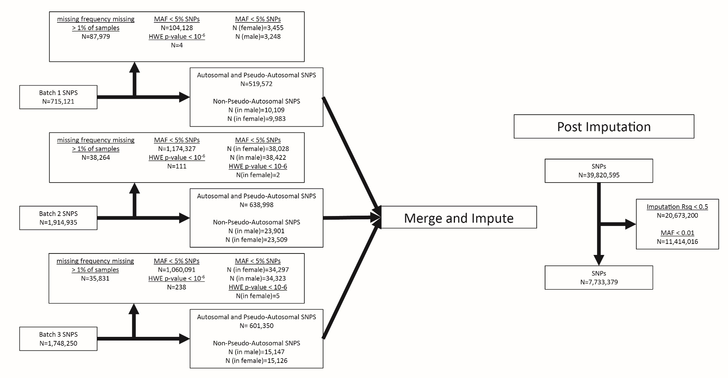

Supplemental Figure 2. Genetic sample filtering based on quality control assessments.
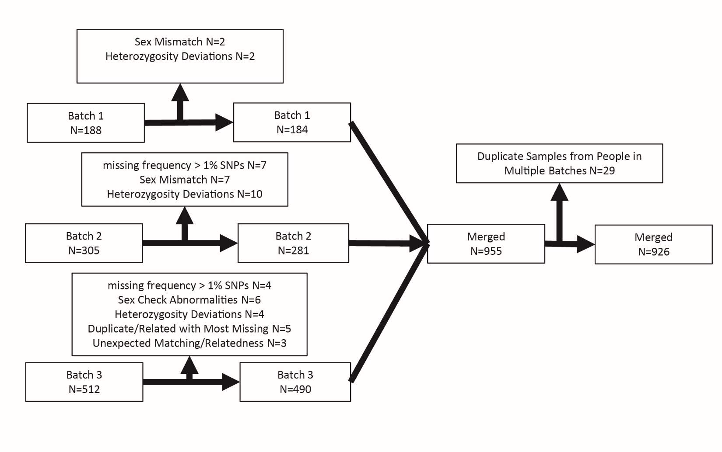

Supplemental Figure 3. Metal correlations for plasma and urine samples.
Spearman correlations of log-transformed metal levels in (A) plasma, (B) urine, and (C) between biofluids. *p-value < 0.05; **p-value < 0.01; ***p-value < 0.001; ****p-value < 0.0001. Red, positive correlation; Blue, negative correlation.

A. Plasma
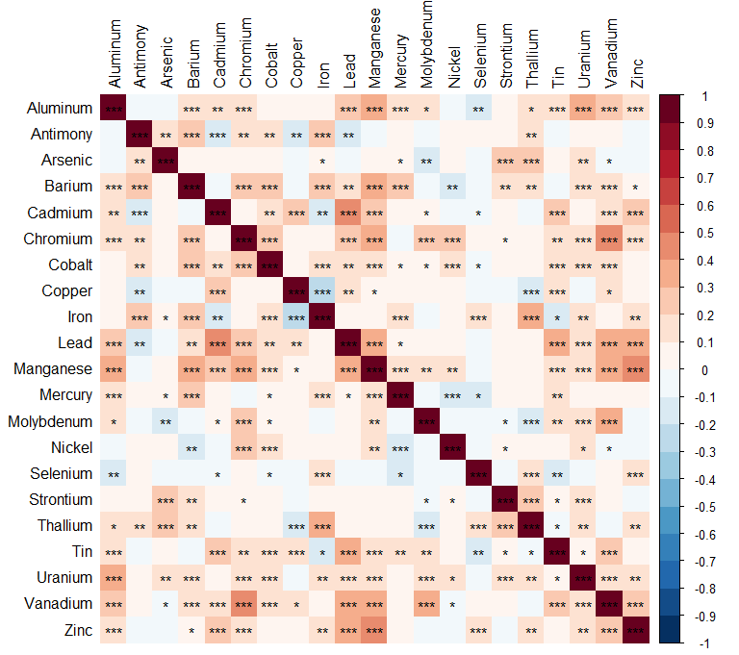

B. Urine

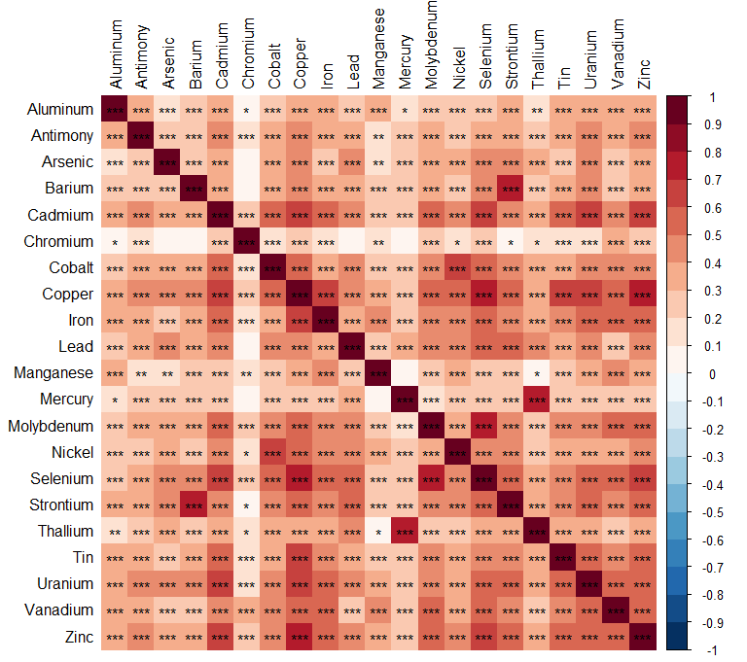

C. Plasma and Urine

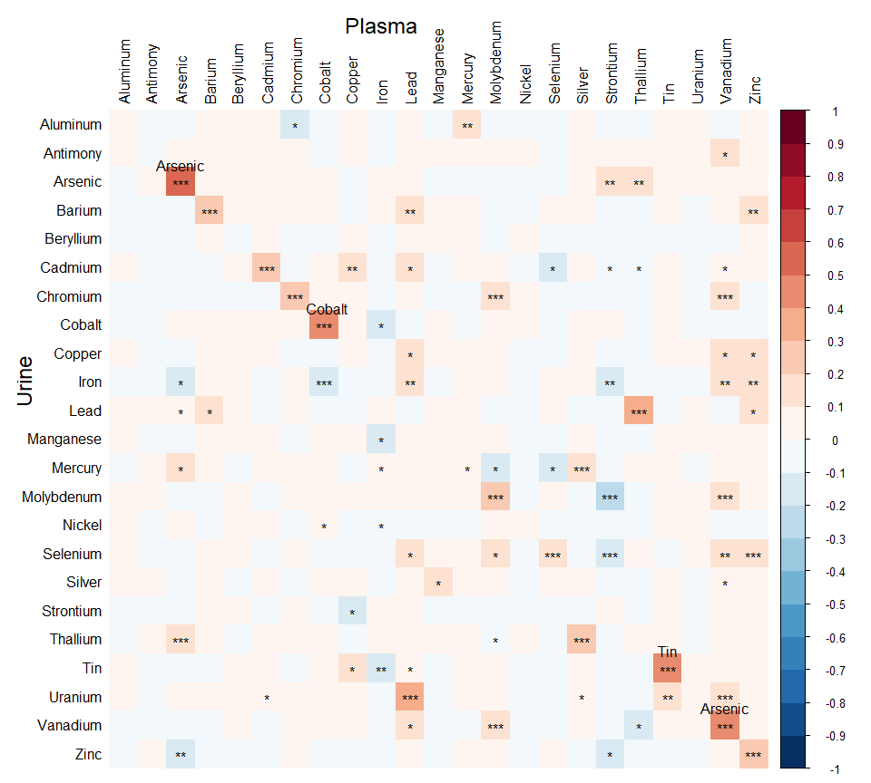

Supplemental Figure 4. Environmental risk score (ERS) risk heatmaps.
Heatmaps of (A) plasma and (B) urine metal levels. Rows represent standardized log-transformed metal levels, while columns represent subjects categorized by sex (F, female; M, male) and amyotrophic lateral sclerosis (ALS) cases/controls. Within each category, the arrangement is based on environmental risk scores (plasma, ERS^{PR}; urine, ERS^{UR}) derived from ALS case/control logistic regression analysis and standardized by the mean and standard deviation of the control distribution. Z-score, log-transformed and standardized metal levels.

A. Plasma
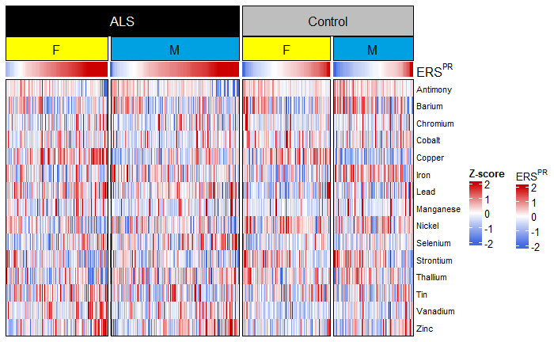

B. Urine
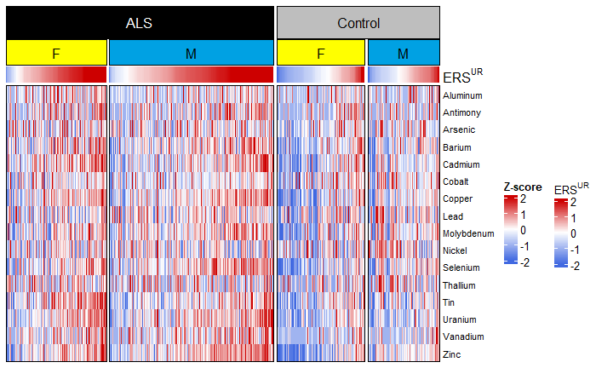

Supplemental Figure 5. Plasma single metal and mixture association with amyotrophic lateral sclerosis (ALS) risk and ALS polygenic risk score (ALS-PGS) forest plot.
Single metal logistic regression models based on plasma samples from ALS (n=266) and control (n=179). The outcome is the case/control status, the predictors are metal levels, ALS-PGS, and the interaction between metal levels and ALS-PGS, and the covariates are continuous age at diagnosis, sex, military service, and the first five genetic principal components. OR 95% CI, odds ratio and its 95% confidence interval of the metal main effect; P-value, the p-value of metal main effect; BH, Benjamini-Hochberg; OR 95% CI (int), odds ratio and its 95% confidence interval of the interaction effect; P-value (int), the p-value of the interaction effect, red for significant interactions; %BDL, the percentage of samples below detection limit; ERS^{PR}, plasma risk environmental risk score.

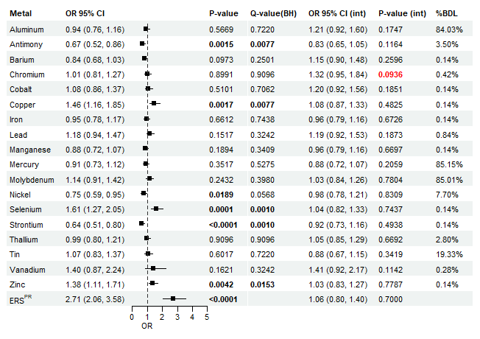

Supplemental Figure 6. Plasma single metal and mixture associations with amyotrophic lateral sclerosis (ALS) risk and metal polygenic risk score (metal-PGS) forest plot.
Singel metal logistic regression models based on plasma samples from ALS (n=297) and control (n=179). The outcome is the case/control status, the predictors are metal levels, metal-PGS, and the interaction between metal levels and metal-PGS, and the covariates are continuous age at diagnosis, sex, military service, and the first five genetic principal components. OR 95% CI, odds ratio and its 95% confidence interval of the metal main effect; P-value, the p-value of metal main effect; BH, Benjamini-Hochberg; OR 95% CI (int), odds ratio and its 95% confidence interval of the interaction effect; P-value (int), the p-value of the interaction effect, red for significant interactions; %BDL, the percentage of samples below detection limit; ERS^{PR}, plasma risk environmental risk score.
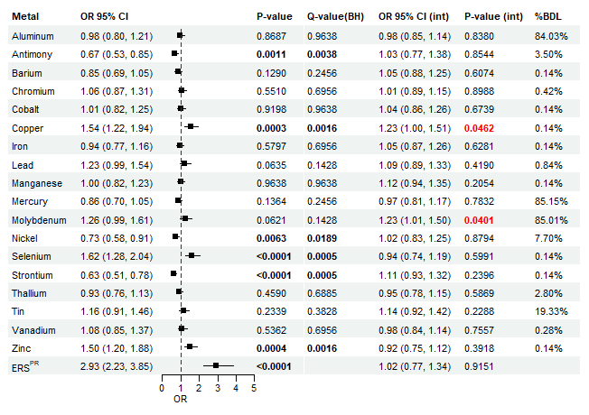

Supplemental Figure 7. Urine single metal and mixture associations with amyotrophic lateral sclerosis (ALS) risk and ALS polygenic risk score (ALS-PGS) forest plot.
Single metal logistic regression models based on urine samples from ALS (n=243) and control (n=135). The outcome is the case/control status, the predictors are metal levels, ALS-PGS, and the interaction between metal levels and ALS-PGS, and the covariates are continuous age at diagnosis, sex, military service, and the first five genetic principal components. OR 95% CI, odds ratio and its 95% confidence interval of the metal main effect; P-value, the p-value of metal main effect; BH, Benjamini-Hochberg; OR 95% CI (int), odds ratio and its 95% confidence interval of the interaction effect; P-value (int), the p-value of the interaction effect, red for significant interactions; %BDL, the percentage of samples below detection limit; ERS^{UR}, urine risk environmental risk score.
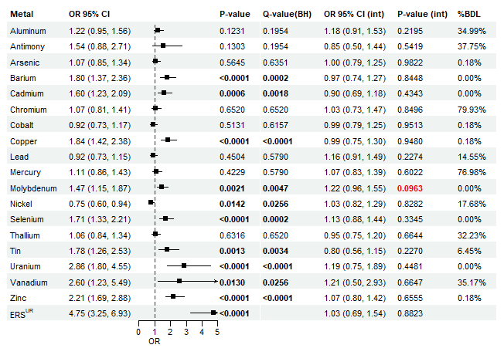

Supplemental Figure 8. Urine single metal and mixture associations with amyotrophic (ALS) risk and metal polygenic risk score (metal-PGS) forest plot.
Single metal logistic regression models based on urine samples from ALS (n=248) and control (n=135). where the outcome is the case/control status, the predictors are metal levels, metal-PGS, and the interaction between metal levels and metal-PGS, and the covariates are continuous age at diagnosis, sex, military service, and the first five genetic principal components. OR 95% CI, odds ratio and its 95% confidence interval of the metal main effect; P-value, the p-value of metal main effect; BH, Benjamini-Hochberg; OR 95% CI (int), odds ratio and its 95% confidence interval of the interaction effect; P-value (int), the p-value of the interaction effect, red for significant interactions; %BDL, the percentage of samples below detection limit; ERS^{UR}, urine risk environmental risk score.
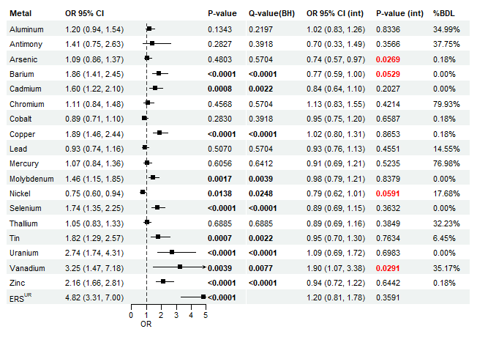

Supplemental Figure 9. Environmental risk score (ERS) survival heatmaps.
Heatmaps of (A) plasma and (B) urine metal levels. Rows represent standardized log-transformed metal levels, while columns represent subjects categorized by sex (F, female; M, male). Within each category, the arrangement is based on standardized environmental risk scores (plasma, ERS^{PS}; urine, ERS^{US}) from survival analysis. Z-score, log-transformed and standardized metal levels.

A. Plasma

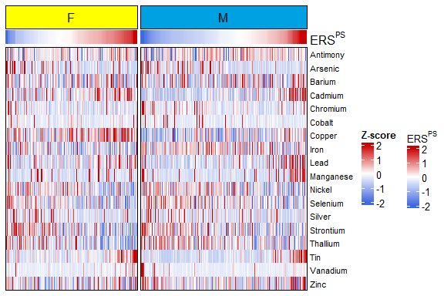

B. Urine

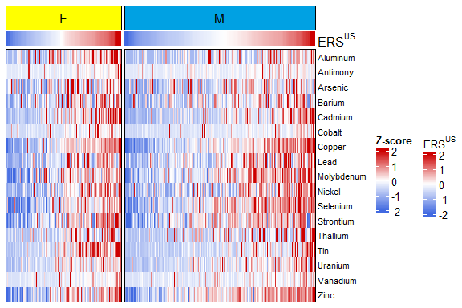

Supplemental Figure 10. Cohort survival analysis with amyotrophic lateral sclerosis polygenic risk score (ALS-PGS) forest plot based on plasma samples.
Cox proportional hazards survival models from plasma samples from ALS cases (n=266). The outcome is survival time since diagnosis (in years), the predictors are metal levels, ALS-PGS, and the interaction between metal and ALS-PGS, and adjustment covariates are age at diagnosis, sex, family history of ALS, onset segment, El-Escorial criteria, initial ALSFRS-R, time between symptom onset and diagnosis, the first five genetic principal components, and C9orf72 gene status (positive, negative, missing). HR 95% CI, hazard ratio and its 95% confidence interval of the metal main effect; P-value, the p-value of metal main effect; BH, Benjamini-Hochberg; HR 95% CI (int), hazard ratio and its 95% confidence interval of the interaction effect; P-value (int), the p-value of the interaction effect, red for significant interactions; %BDL, the percentage of samples below detection limit; ERS^{PS}, plasma survival environmental risk score.
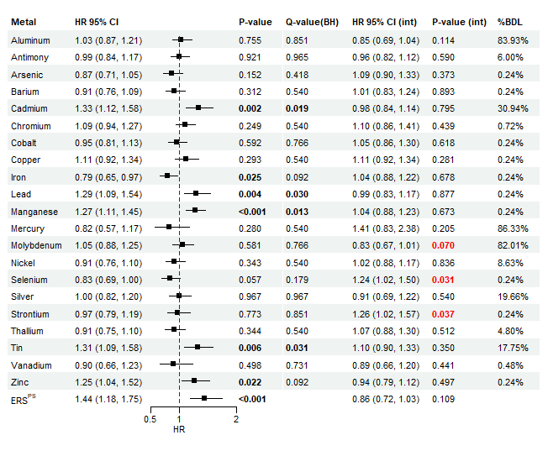

Supplemental Figure 11. Cohort survival analysis with metal polygenic risk score (metal-PGS) forest plot based on plasma samples.
Cox proportional hazards survival models from plasma samples from ALS cases (n=297). The outcome is survival time since diagnosis (in years), the predictors are metal levels, metal-PGS, and the interaction between metal and metal-PGS, and adjustment covariates are age at diagnosis, sex, family history of ALS, onset segment, El-Escorial criteria, initial ALSFRS-R, time between symptom onset and diagnosis, the first five genetic principal components, and C9orf72 gene status (positive, negative, missing). HR 95% CI, hazard ratio and its 95% confidence interval of the metal main effect; P-value, the p-value of metal main effect; BH, Benjamini-Hochberg; HR 95% CI (int), hazard ratio and its 95% confidence interval of the interaction effect; P-value (int), the p-value of the interaction effect, red for significant interactions; %BDL, the percentage of samples below detection limit; ERS^{PS}, plasma survival environmental risk score.

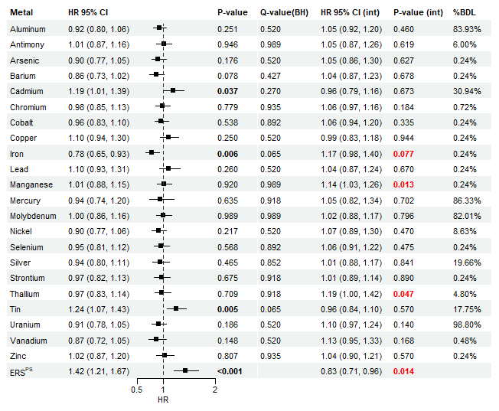

Supplemental Figure 12. Cohort survival analysis with amyotrophic lateral sclerosis polygenic risk score (ALS-PGS) forest plot based on urine samples.
Cox proportional hazards survival models from urine samples from ALS cases (n=243). The outcome is survival time since diagnosis (in years), the predictors are metal levels, ALS-PGS, and the interaction between metal and ALS-PGS, and adjustment covariates are age at diagnosis, sex, family history of ALS, onset segment, El-Escorial criteria, initial ALSFRS-R, time between symptom onset and diagnosis, the first five genetic principal components, and C9orf72 gene status (positive, negative, missing). HR 95% CI, hazard ratio and its 95% confidence interval of the metal main effect; P-value, the p-value of metal main effect; BH, Benjamini-Hochberg; HR 95% CI (int), hazard ratio and its 95% confidence interval of the interaction effect; P-value (int), the p-value of the interaction effect, red for significant interactions; %BDL, the percentage of samples below detection limit; ERS^{US}, urine survival environmental risk score.
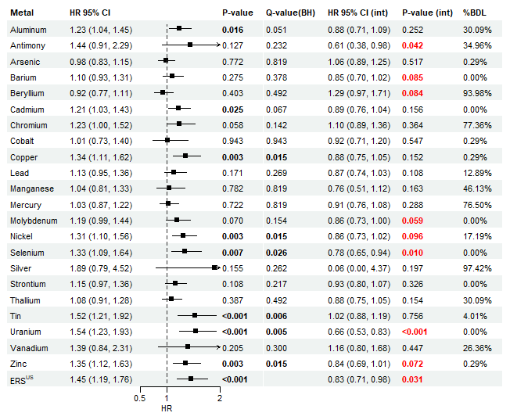

Supplemental Figure 13. Cohort survival analysis with metal polygenic risk score (metal-PGS) forest plot based on urine samples.
Cox proportional hazards survival models from urine samples from ALS cases (n=248). The outcome is survival time since diagnosis (in years), the predictors are metal levels, metal-PGS, and the interaction between metal and metal-PGS, and adjustment covariates are age at diagnosis, sex, family history of ALS, onset segment, El-Escorial criteria, initial ALSFRS-R, time between symptom onset and diagnosis, the first five genetic principal components, and C9orf72 gene status (positive, negative, missing). HR 95% CI, hazard ratio and its 95% confidence interval of the metal main effect; P-value, the p-value of metal main effect; BH, Benjamini-Hochberg; HR 95% CI (int), hazard ratio and its 95% confidence interval of the interaction effect; P-value (int), the p-value of the interaction effect, red for significant interactions; %BDL, the percentage of samples below detection limit; ERS^{US}, urine survival environmental risk score.
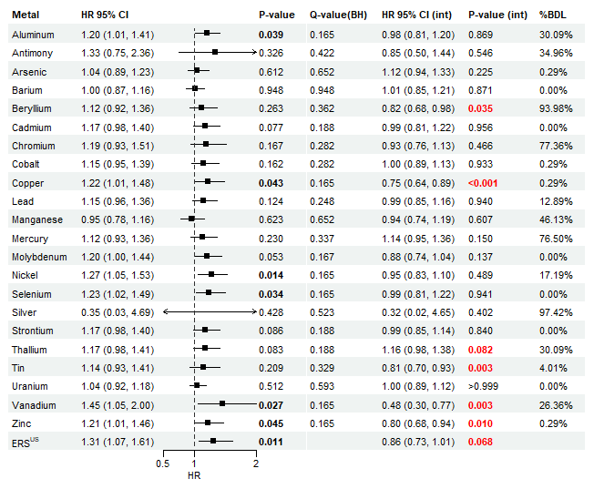

Supplemental Figure 14. Distribution of environmental risk scores (ERS) by high and low occupational metal exposure.
Distribution of the environmental risk scores (ERS) for (A) plasma (ERS^{PR}) and (B) urine (ERS^{UR}) by high (plasma, n=99; urine, n=51) and low (plasma, n=292; urine, n=265) occupational metal exposure groups. The high metal exposure group is defined by Standard Occupational Classification (SOC) codes “Building and Grounds Cleaning and Maintenance” (SOC 37), “Construction and Extraction” (SOC 47), “Installation, Maintenance, and Repair” (SOC 49), and “Production Occupations” (SOC 51). All other occupations are included in the low metal exposure group. P<0.05 by Wilcoxon test.

A. Plasma
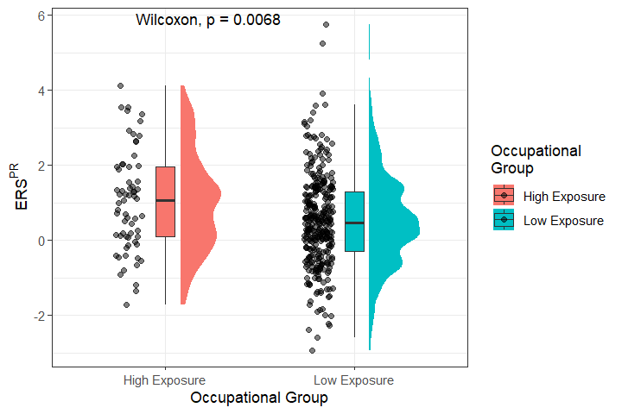

B. Urine
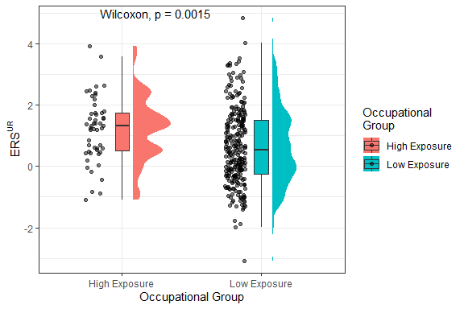

Supplemental Figure 15. Plasma and occupational exposure network analysis.
Associations between self-reported occupational metal exposures from participants’ most recent job and plasma metals estimated by the partial least squares method. Red, positive association; Blue, negative association.

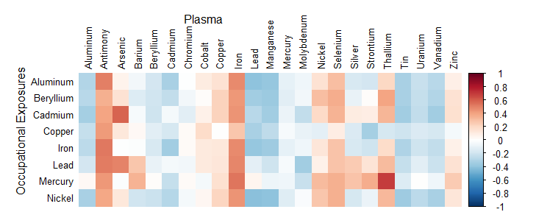

Supplemental Figure 16. Plasma and non-occupational exposure network analysis.
Associations between self-reported non-occupational metal exposures and plasma metals estimated by the partial least squares method. Red, positive association; Blue, negative association.

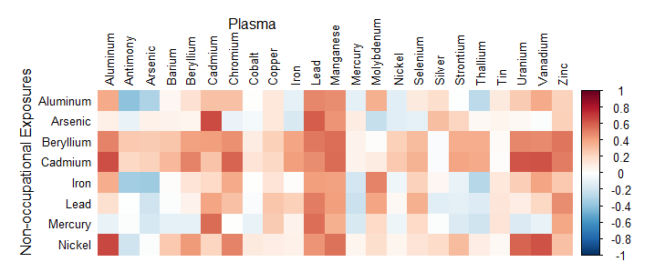

Supplemental Figure 17. Urine and occupational exposure network analysis.
Associations between self-reported occupational metal exposures from participants’ most recent job and urine metals estimated by partial least squares method. Red, positive association; Blue, negative association.
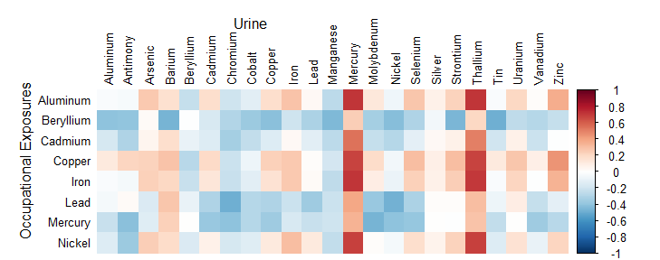

Supplemental Figure 18. Urine and non-occupational exposure network analysis.
Associations between self-reported non-occupational metal exposures and urine metals estimated by partial least squares method. Red, positive correlation; Blue, negative correlation.

