Supplementary Table 1. International Classification of Disease, 9th Revision (ICD-9) and 10th Revision (ICD-10) for pneumonia.
Description | ICD-9 | ICD-10 | Frequency, No. (%) with ICD-9 / ICD-10 code ª
Viral pneumonia | 480* | J12.* | 1107 (4.0)
Pneumococcal pneumonia, Pneumonia due to Streptococcus pneumoniae | 481, 481.0, 481.00 | J13 | 669 (2.5)
Other bacterial pneumonia | 482* | J14 | 1522 (5.3)
Pneumonia due to other infectious organisms, not elsewhere classified |  | J16.* | 52 (0.2)
Pneumonia due to other specified organism | 483* | J15.* | 2910 (11.8)
Pneumonia infectious diseases classified elsewhere | 484* | J17 | 30 (0.1)
Pneumonia, organism unspecified | 485, 485.0, 485.00, 486, 486.0, 486.00 | J18.* | 5069 (19.1)
Influenza | 487, 487.0 | J09.X1, J10.0, J10.00, J10.01, J10.08, J11.0, J11.00, J11.08 | 18743 (71.7)
Empyema | 510, 510.9 | J86.9 | 103 (0.4)
Abscess of lung and mediastinum | 513, 513.1 | J85.1 | 43 (0.2)
Ventilator associated pneumonia | 997.31 | J95.851 | 50 (0.2)
ª A patient could have a discharge diagnosis in ≥1 of above pneumonia groups. A patient could also have a diagnosis of pneumonia in the discharge summary without a pneumonia-related ICD-9/ICD-10 discharge diagnosis. Overall, 2996/26,233 (11.7%) of patients had a pneumonia diagnosis on discharge summary only, without a pneumonia-related ICD-9/ICD-10 code.

Supplementary Table 2. Sensitivity analysis of the association between timing of influenza antiviral therapy and 30-day mortality with patients who started antiviral treatment before hospital admission as the reference group.
30-day mortality
 | n/N (%) | Unadjusted OR | 95% CI | Adjusted OR | 95% CI
Alternative reference group of patients started on treatment before admission
Initiated antiviral pre-admissionª | 1,146/27,379 (4.2) | Ref |  | Ref
Treatment day 0 | 15,806/27,379 (58.3) | 1 | (0.79, 1.27) | 0.95 | (0.74, 1.21)
Treatment day 1 | 7,810/27,379 (28.2) | 1.16 | (0.90, 1.49) | 1.08 | (0.84, 1.39)
Treatment day 2-5 | 2,617/27,379 (9.3) | 1.41 | (1.08, 1.84) | 1.33 | (1.00, 1.76)
Abbreviations: CI = confidence interval; OR = odds ratio
ª1338 patients were started on treatment within 14 days before hospital admission; of these, 192 were excluded for this analysis because they were discharged from the hospital or died on hospital day 0 or 1.

Supplementary Table 3. Baseline demographic and clinical characteristics of patients excluded because they received antiviral treatment before admission, were discharged on hospital day 0-1, or died on day 0-1.
Characteristic, unweighted count (weighted %) | Treated up to 14 days prior to admission (n=1338) | Discharged day 0 or day 1 (n=1576) | Died on day 0 or day 1 (n=180)
Median (IQR) age, years | 69.0 (56.0, 83.0) | 63.0 (49.0, 75.0) | 75.0 (59.5, 84.5)
Male sex | 626 (47.7) | 839 (53.0) | 83 (46.1)
Race and ethnicity
Hispanic | 100 (7.2) | 171 (10.9) | 9 (5.0)
White, NH | 836 (62.5) | 896 (56.0) | 120 (66.7)
Black, NH | 241 (17.6) | 280 (17.8) | 20 (11.1)
Other, NH | 107 (8.6) | 128 (9.1) | 15 (8.3)
Unknown | 54 (4.0) | 101 (6.2) | 16 (8.9)
Influenza season
2012-2013 | 112 (7.4) | 129 (7.3) | 14 (7.8)
2013-2014 | 80 (5.3) | 157 (8.9) | 9 (5.0)
2014-2015 | 199 (13.2) | 183 (10.4) | 26 (14.4)
2015-2016 | 97 (6.4) | 175 (9.9) | 10 (5.6)
2016-2017 | 254 (16.8) | 276 (15.7) | 36 (20.0)
2017-2018 | 353 (33.3) | 362 (29.3) | 51 (28.3)
2018-2019 | 243 (17.6) | 294 (18.3) | 34 (18.9)
Social vulnerability index (SVI)ª
Low | 436 (36.6) | 446 (30.8) | 55 (32.9)
Medium | 406 (30.2) | 470 (32.6) | 51 (30.5)
High | 433 (33.2) | 553 (36.7) | 61 (36.5)
Smoking status
Current | 214 (15.5) | 399 (24.3) | 33 (18.3)
Former | 397 (31.0) | 379(24.9) | 54 (30.0)
Never / unknown | 727 (53.8) | 798 (50.7) | 93 (51.7)
Place of discharge
Private residence | 910 (69.3) | 1427 (90.5) | 0 (0.0)
Facility | 274 (20.6) | 66 (4.5) | 0 (0.0)
Hospice | 34 (2.3) | 15 (0.9) | 1 (0.61)
Other / unknown | 120 (7.9) | 68 (4.2) | 179 (99.4)
Immunocompromising condition | 239 (17.7) | 242 (14.7) | 27 (15.0)
≥1 of conditions in categories below | 1219 (91.6) | 1310 (83.2) | 160 (88.9)
Asthma | 267 (19.4) | 327 (20.0) | 17 (9.4)
Blood disorder | 64 (4.5) | 47 (3.0) | 7 (3.9)
Cardiovascular disease | 655 (50.9) | 533 (36.1) | 108 (60.0)
Chronic lung disease other than asthma | 349 (26.8) | 310 (19.7) | 50 (27.8)
Chronic metabolic disease | 574 (44.1) | 526 (33.5) | 83 (46.1)
Liver disease | 43 (3.3) | 67 (4.0) | 10 (5.6)
Neurological or neuromuscular disease | 385 (27.8) | 250 (15.5) | 58 (32.2)
Obesity | 482 (35.7) | 595 (37.8) | 41 (22.8)
Renal disease | 294 (22.4) | 218 (15.8) | 46 (25.6)
Number of medical condition categories (excluding immunocompromising conditions), of those with ≥1 condition
1 | 255 (20.6) | 396 (25.1) | 30 (16.7)
2 | 333 (26.8) | 416 (25.7) | 45 (25.0)
3 | 296 (24.4) | 257 (16.3) | 31 (17.2)
≥4 | 335 (28.2) | 241 (16.2) | 54 (30.0)
Influenza vaccination status
Yes | 675 (52.2) | 604 (39.5) | 78 (43.3)
No | 505 (36.4) | 750 (46.5) | 52 (28.9)
Unknown | 158 (11.4) | 222 (14.1) | 50 (27.8)
Antiviral treatment administered
Oseltamivir | 1332 (99.6) | 1574 (99.7) | 179 (99.4)
Other or unknown | 6 (0.4) | 2 (0.3) | 1 (0.6)
Median (IQR) days from illness onset to hospital admission^{b} | 4.0 (3.0, 7.0) | 3.0 (2.0, 5.0) | 3.0 (1.0, 5.0)
Median (IQR) days from first positive test to hospital admission | -1.0 (-1.0, 0.0) | 0.0 (0.0, 0.0) | 0.0 (0.0, 0.0)
Influenza type
Influenza A | 1095 (80.9) | 1315 (83.0) | 152 (84.5)
Influenza B | 229 (18.0) | 253 (16.5) | 26 (14.4)
Influenza A & B | 3 (0.4) | 4 (0.3) | 2 (1.1)
Other | 11 (0.8) | 4 (0.2) | 0 (0.0)

Abbreviations: IQR = interquartile range; NH = non-Hispanic
ª Of patients who initiated treatment prior to admission, 1275/1338 (95.3%) had geocoded data available to calculate SVI. Of patients who were discharged or died on day 0 or 1, 1636/1756 (93.2%) had geocoded data available.
^{b} Illness onset date abstracted where available from medical charts and documented for 2,786/3,094 (90.0%) of patients.
Supplementary Table 4. Clinical outcomes of patients excluded because the received antiviral treatment before admission, were discharged on hospital day 0-1, or died on day 0-1.
Characteristic, unweighted count (weighted %) | Treated up to 14 days prior to admission (n=1338) | Discharged day 0 or day 1 (n=1576) | Died on day 0 or day 1 (n=180)
ICU admission | 221 (15.4) | 56 (3.4) | 144 (80.0)
Invasive mechanical ventilation | 93 (6.4) | 12 (0.7) | 112 (62.2)
Death within 30 days | 107 (7.1) | 23 (1.3) | 180 (100)
Days to death among those who died during 30-day follow-up, median (IQR) | 6.5 (2.5, 14.0) | 6.0 (4.0, 16.0) | 1.0 (1.0, 1.0)

Supplementary Figure 1. Exclusion flow diagram.ª
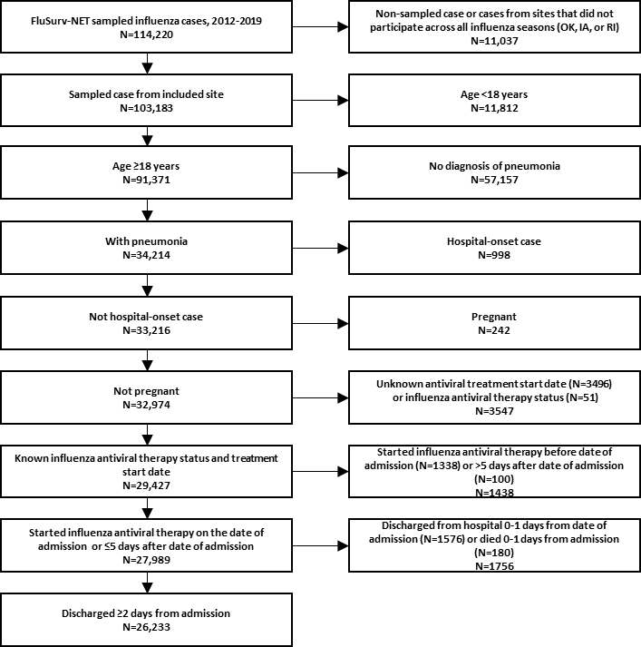

ª Unweighted counts are presented in the figure.

