Supplemental Materials

Cure models, survival probabilities, and solid organ transplantation
for patients with colorectal cancer

Eric A. Engels, Soutrik Mandal, Douglas A. Corley, Christopher D. Blosser, Allyson Hart, Charles F. Lynch, Baozhen Qiao, Karen S. Pawlish, Gregory Haber, Kelly J. Yu, Ruth M. Pfeiffer

Supplemental Methods
Colorectal cancer patients
We identified colorectal cancer patients from the US general population using data from 17 cancer registries in the Surveillance, Epidemiology, and End Results program (SEER, (https://seer.cancer.gov/). We included adults (ages 20-79 years) who were diagnosed with colorectal cancer as a first primary malignancy, restricted to diagnosis years 2004-2015 to allow assessment of American Joint Committee on Cancer staging, version 6 (AJCC6). Colorectal cancers were identified as arising in the proximal colon (International Classification of Diseases for Oncology, version 3 [ICD-O3] sites C18.0-18.4), distal colon (C18.5-18.7), or rectosigmoid/rectum (i.e., “rectum,” C19.9-20.9), with ICD-O3 histology codes of 8000-8049, 8140-8239, 8250-8389, or 8440-8499. We excluded patients from the Alaska Native Tumor Registry (because of its small size and unique population base), individuals diagnosed with colorectal cancer on autopsy or identified by death certificate only, and patients with AJCC6 stage that was missing or outside the major categories (I, IIA, IIB, IIIA, IIIB, IIIC, or IV).
We separately identified colorectal cancer patients who received a solid organ transplant after their cancer diagnosis using data from the Transplant Cancer Match Study, a linkage of the US national solid organ transplant registry with 32 cancer registries. The inclusion criteria based on cancer site, histology, and age at diagnosis were the same as for SEER cases, but the year of colorectal cancer diagnosis range was broader (1976-2017) to capture more cases, so AJCC6 stage was allowed to be missing. For transplanted patients, we therefore relied primarily on SEER historic stage (which categorizes stage as localized, regional, or distant and is available across calendar periods) and excluded N=48 patients with missing SEER historic stage. We also excluded patients identified in cancer registries or calendar years where cancer treatment information or cause of death was missing (N=87 and N=16 exclusions, respectively).

Cure model specification and fitting
We used statistical cure models to describe the cancer-specific survival distribution of patients with colorectal cancer. Cure models assume that there are two groups of patients: 1) those who will eventually die from their cancer (non-cured group), and 2) those who will not (the “cured” group). Cure models are fitted to simultaneously estimate the probability that a patient belongs to the cured group and the survival function over time for those in the non-cured group.
To be specific, let $z$ denote baseline covariates, $U=1$ if a patient is in the cured group, and $0$ otherwise, and let $T$ denote the time from colorectal cancer diagnosis to death from colorectal cancer. The survival function for patients in the non-cured group is $S(t|U = 0, z) = P(T > t| U = 0, z)$ and the probability of belonging to the cured group is $π\left(z\right)=P\left(U=1 \right|z)$. As $U$ is unobserved, the survival probability at a given time as a function of $z$ is modeled as a mixture of both groups, as
$S\left(t, z\right)=(1 -π\left(z\right)) S\left(t\right|U=0, z)+π(z)$. (1)

We fit the cure probability component of the model $π(z)$ using logistic regression,
$π\left(z\right)=1/(1+\exp\left(z^{T}β\right)),$ and the survival component S$\left(t\right|U=0, z)$ using a semiparametric proportional hazards model, with the smcure function (with options model="ph" and link="logit) from the smcure package in R software (Cai C, Zou Y, Peng Y, Zhang J. smcure: an R-package for estimating semiparametric mixture cure models. Comput Methods Programs Biomed. 2012 Dec;108(3):1255-60. doi: 10.1016/j.cmpb.2012.08.013. Epub 2012 Sep 25. PMID: 23017250; PMCID: PMC3494798). We used the option emmax=500 for the maximum number of iterations to ensure convergence.
Once $π\left(z\right)$ and S$\left(t\right|U=0, z)$are estimated, the probability of a patient not dying from colorectal cancer in the next t* years, i.e., by time $t+t*$ after diagnosis, given that the patient has survived up to time t, is computed from (1) as
$P\left(T>t+t* \right|T>t, z)= \frac{π\left(z\right)+\left(1-π\left(z\right)\right)S\left(t+t*\right|U=0, z)}{π\left(z\right)+\left(1 -π\left(z\right)\right)S\left(t\right|U=0, z)}$. (2)
In the calculations that we present in this paper, we focus on $t* =5$ years, i.e., 5-year cancer-specific survival at time t, as current clinical guidelines for transplant candidate selection consider 5 years to be the clinically relevant time horizon. Finally, for t > 10 years, we used the value of (2) for t = 10 years, because SEER follow-up data did not have a sufficient number of events to allow longer-term estimates.
We divided colorectal cancer patients in the SEER dataset into subgroups based anatomic subsite (distal, proximal, rectum), stage (localized, regional, or distant for SEER historic stages, or I, IIA, IIB, IIIA, IIIB, IIIC, IV, for AJCC6 stages), and sex (male, female). We fit the above cure models separately for each of these subgroups. We considered the following covariates in the models, for both the logistic and survival components: age at cancer diagnosis, radiation treatment (yes vs. no/unknown), surgery (yes vs. no/unknown), and chemotherapy (yes vs. no/unknown). Age at cancer diagnosis was modeled with linear and quadratic terms for 5-year categories (coded numerically as 1-12, for ages 20-24, 25-29, 30-34, 35-39, 40-44, 45-49, 50-54, 55-59, 60-64, 65-69, 70-74, 75-79 years), because several subgroups did not have enough patients to fit models with more age parameters. We dropped treatment variables when almost all patients received or did not receive that form of treatment to insure model convergence. The list of variables in each model according to patient subgroup is shown in Supplemental Table 4.

Internal cross-validation in SEER
To internally validate the cure models, we used leave-one-registry-out cross-validation as follows. First, we removed one specified SEER registry. We then fit the cure model to a selected subgroup of colorectal cancer patients defined based on subsite, stage, and sex using data from the remaining SEER registries. We did not perform variable selection but fit the model using the corresponding subgroup variables that had been selected for the main analysis as specified in Supplemental Table 4. In the second step, we used this cure model to calculate the cure probabilities for patients from the left-out registry. These steps were repeated for all SEER registries and subgroups defined by subsite, stage, and sex and thus yield unbiased predictions for all patients in SEER, as the patients for whom we predicted the cure probability were not used in the model building.
Because the cross-validation method leaves one cancer registry out at a time, the results of the cross-validation indicate how the cure models would perform in other US regions outside the catchment areas of the SEER cancer registries. The resulting estimates of the cure probabilities at cancer diagnosis were similarly distributed compared to those estimated in our main analysis (Supplemental Figure 4). To assess the calibration of our models, we plotted the cure probabilities from the cross-validation against the cure probabilities from the main analysis (Supplemental Figure 5). These estimates were almost perfectly correlated (Spearman R 0.998 for SEER historic stage models, 0.997 for AJCC6 stage models).
To assess the discriminatory ability of our models, we defined a patient outcome COD (“colorectal cancer cause of death”), which was 1 if the patient was reported to have died from colorectal cancer (N=74,190) and 0 otherwise (N=156,275). We computed the area under the operator characteristics curve (AUC) of our models in identifying people with COD=1 using the pROC package in R, overall and separately for each cancer registry. For the SEER historic stage classification, the overall AUC was 0.822 (95% confidence interval [CI] 0.820-0.824) and using the AJCC6 stage classification, the overall AUC was 0.842 (95%CI 0.840-0.843) (see also Supplemental Figure 6). AUC results stratified by tumor and patient characteristics are given in Supplemental Tables 5-10. They were generally similar to the AUCs for the overall population, except when stratifying by stage, where the AUC values are noticeably lower. This decreases in the AUCs for stage-stratified analyses arise because stage is a very strong predictor in the cure models, and this predictive contribution is not available when all the patients have the same stage.

Supplemental Table 1. Causes of death among colorectal cancer patients who received a solid organ transplant
Cause of death | Number of patients (percentage of deaths)
Cancer | 101 (25.9)
Colorectal cancer | 28 (7.2)
Other cancer | 73 (18.7)
Heart disease | 57 (14.6)
Kidney disease | 36 (9.2)
Diabetes mellitus | 30 (7.7)
Infection | 21 (5.4)
Cerebrovascular disease | 11 (2.8)
Other/unknown | 134 (34.4)

Supplemental Table 2A. Comparison of transplanted colorectal cancer patients according to five-year cancer-specific survival probability (5yCSS) < 0.90 vs. ≥ 0.90 at transplantation
 | 5yCSS < 0.90  N (%) | 5yCSS ≥ 0.90  N (%)
Total | 118 (100) | 838 (100)
Subsite
Proximal colon | 38 (32.2) | 329 (39.3)
Distal colon | 46 (39.0) | 319 (38.1)
Rectum | 34 (28.8) | 190 (22.7)
Male sex | 91 (77.1) | 549 (65.5)
Age at diagnosis, years
20-49 | 53 (44.9) | 212 (25.3)
50-59 | 36 (30.5) | 398 (47.5)
60-69 | 26 (22.0) | 215 (25.7)
70-79 | 3 (2.5) | 13 (1.6)
Calendar year of diagnosis
1976-2000 | 56 (47.5) | 338 (40.3)
2001-2005 | 25 (21.2) | 240 (28.6)
2006-2010 | 21 (17.8) | 188 (22.4)
2011-2017 | 16 (13.6) | 72 (8.6)
SEER historic stage
Localized | 28 (23.7) | 592 (70.6)
Regional | 74 (62.7) | 243 (29)
Distant | 16 (13.6) | 3 (0.4)
Surgery
Yes | 91 (77.1) | 779 (93)
No/unknown | 27 (22.9) | 59 (7)
Radiation
Yes | 34 (28.8) | 43 (5.1)
No/unknown | 84 (71.2) | 795 (94.9)
Chemotherapy
Yes | 65 (55.1) | 133 (15.9)
No/unknown | 53 (44.9) | 705 (84.1)
Transplanted organ
Kidney | 59 (50.0) | 510 (60.9)
Liver | 42 (35.6) | 207 (24.7)
Heart or lung | 10 (8.5) | 103 (12.3)
Other/multiple | 7 (5.9) | 18 (2.1)
Time from diagnosis to transplant, years
0 - 4.99 | 79 (66.9) | 278 (33.2)
5 - 9.99 | 23 (19.5) | 335 (40)
10+ | 16 (13.6) | 225 (26.8)

Supplemental Table 2B. Comparison of transplanted colorectal cancer patients according to five-year cancer-specific survival probability (5yCSS) < 0.80 vs. ≥ 0.80 at transplantation

 | 5yCSS < 0.80  N (%) | 5yCSS ≥ 0.80  N (%)
Total | 29 (100) | 927 (100)
Subsite
Proximal colon | 12 (41.4) | 355 (38.3)
Distal colon | 7 (24.1) | 358 (38.6)
Rectum | 10 (34.5) | 214 (23.1)
Male sex | 23 (79.3) | 617 (66.6)
Age at diagnosis, years
20-49 | 12 (41.4) | 253 (27.3)
50-59 | 9 (31.0) | 425 (45.8)
60-69 | 7 (24.1) | 234 (25.2)
70-79 | 1 (3.4) | 15 (1.6)
Calendar year of diagnosis
1976-2000 | 16 (55.2) | 378 (40.8)
2001-2005 | 7 (24.1) | 258 (27.8)
2006-2010 | 4 (13.8) | 205 (22.1)
2011-2017 | 2 (6.9) | 86 (9.3)
SEER historic stage
Localized | 11 (37.9) | 609 (65.7)
Regional | 8 (27.6) | 309 (33.3)
Distant | 10 (34.5) | 9 (1)
Surgery
Yes | 17 (58.6) | 853 (92)
No/unknown | 12 (41.4) | 74 (8)
Radiation
Yes | 9 (31.0) | 68 (7.3)
No/unknown | 20 (69.0) | 859 (92.7)
Chemotherapy
Yes | 16 (55.2) | 182 (19.6)
No/unknown | 13 (44.8) | 745 (80.4)
Transplanted organ
Kidney | 11 (37.9) | 558 (60.2)
Liver | 11 (37.9) | 238 (25.7)
Heart or lung | 3 (10.3) | 110 (11.9)
Other/multiple | 4 (13.8) | 21 (2.3)
Time from diagnosis to transplant, years
0 - 4.99 | 23 (79.3) | 334 (36)
5 - 9.99 | 2 (6.9) | 356 (38.4)
10+ | 4 (13.8) | 237 (25.6)

Supplemental Table 3. Time from colorectal cancer diagnosis to transplantation, by cancer stage
Cancer stage | Number of patients | Years from cancer diagnosis to transplantation,  median (interquartile range)
SEER historic stage
Localized | 620 | 5.4 (2.8-8.5)
Regional | 317 | 8.3 (5.7-12.2)
Distant | 19 | 6.6 (4.6-14.1)
AJCC6 stage
I | 166 | 3.8 (2.2-5.9)
IIA | 62 | 5.7 (3.4-7.1)
IIB | 5 | 6.9 (5.7-7.3)
IIIA | 11 | 6.1 (2.8-7.4)
IIIB | 30 | 6.9 (5.1-9.2)
IIIC | 10 | 7.3 (4.8-7.7)
IV | 4 | 7.0 (4.4-10.9)

Supplemental Table 4. List of variables used in the cure models, according to colorectal cancer subsite, stage, and sex

Cancer subsite | Cancer stage | Sex | Variables in the logistic regression component of the model | Variables in the proportional hazards component of the model
Proximal colon, distal colon, rectum | SEER historic stage: localized, regional, distant | Male, female | dxage, dxage2, surgery, radiation, chemotherapy | dxage, surgery, radiation, chemotherapy
Proximal colon, distal colon, rectum | AJCC6 stage: I, IIB, IIIB, IV | Male, female | dxage, dxage2, surgery, radiation, chemotherapy | dxage, surgery, radiation, chemotherapy
Proximal colon, distal colon, rectum | AJCC6 stage: IIIA, IIIC | Male, female | dxage, dxage2, chemotherapy | dxage, chemotherapy
Distal colon | AJCC6 stage: IIA | Male | dxage, dxage2, surgery, radiation, chemotherapy | dxage, surgery, radiation, chemotherapy
Distal colon | AJCC6 stage: IIA | Female | dxage, dxage2, radiation, and chemotherapy | dxage, radiation, chemotherapy

Notes
The variables dxage and dxage2 correspond to the age at cancer diagnosis and that age squared, where age was coded in 5-year intervals and the categories treated as a numeric variable in the range 1-12. Surgery, radiation, and chemotherapy were coded as yes vs. no/unknown.

Supplemental Table 5. AUC values based on cross-validated cure probabilities, by registry
Registry | Patients, N | Cancer deaths, N | SEER historic stage models |  | AJCC6 stage models
 |  |  | AUC | 95%CI | AUC | 95%CI
California | 94091 | 30237 | 0.8234 | 0.8205, 0.8263 | 0.8416 | 0.8389, 0.8443
Connecticut | 10320 | 2972 | 0.8362 | 0.8275, 0.8450 | 0.8543 | 0.8461, 0.8625
Hawaii | 4678 | 1441 | 0.8345 | 0.8218, 0.8471 | 0.8557 | 0.8440, 0.8674
Iowa | 10260 | 3208 | 0.8360 | 0.8274, 0.8446 | 0.8585 | 0.8505, 0.8665
New Mexico | 5469 | 1889 | 0.8113 | 0.7991, 0.8234 | 0.8318 | 0.8203, 0.8432
Seattle (Puget Sound) | 12477 | 3827 | 0.8417 | 0.8340, 0.8494 | 0.8636 | 0.8564, 0.8707
Utah | 4799 | 1533 | 0.8471 | 0.8350, 0.8592 | 0.8739 | 0.8630, 0.8848
Georgia | 28593 | 9586 | 0.8135 | 0.8081, 0.8188 | 0.8349 | 0.8299, 0.8399
Kentucky | 16523 | 5405 | 0.8178 | 0.8108, 0.8248 | 0.8371 | 0.8306, 0.8437
Louisiana | 16638 | 5635 | 0.8132 | 0.8063, 0.8201 | 0.8325 | 0.8260, 0.8390
New Jersey | 26617 | 8457 | 0.8116 | 0.806, 0.8172 | 0.8315 | 0.8263, 0.8367

Supplemental Table 6. AUC values based on cross validated cure probabilities, by cancer stage
Stage | Patients, N | Cancer deaths, N | AUC | 95%CI
SEER historic stage
Localized | 88810 | 8777 | 0.6579 | 0.6516, 0.6643
Regional | 88308 | 24267 | 0.5659 | 0.5616, 0.5702
Distant | 53347 | 41146 | 0.5866 | 0.5810, 0.5922
AJCC6 stage
I | 56844 | 4164 | 0.6995 | 0.6905, 0.7085
IIA | 48985 | 7083 | 0.6082 | 0.6009, 0.6154
IIB | 8699 | 2850 | 0.6217 | 0.6089, 0.6345
IIIA | 8347 | 1087 | 0.6065 | 0.5888, 0.6243
IIIB | 35632 | 10031 | 0.5783 | 0.5717, 0.585
IIIC | 21712 | 9218 | 0.5487 | 0.541, 0.5565
IV | 50246 | 39757 | 0.5705 | 0.5644, 0.5766

Supplemental Table 7. AUC values based on cross validated cure probabilities, by sex
Sex | Patients, N | Cancer deaths, N | SEER historic stage models |  | AJCC6 stage models
 |  |  | AUC | 95%CI | AUC | 95%CI
Male | 127669 | 42331 | 0.8173 | 0.8148, 0.8198 | 0.8371 | 0.8347, 0.8394
Female | 102796 | 31859 | 0.8268 | 0.8241, 0.8296 | 0.8468 | 0.8442, 0.8494

Supplemental Table 8. AUC values based on cross validated cure probabilities, by cancer subsite

Subsite | Patients, N | Cancer deaths, N | SEER historic stage models |  | AJCC6 stage models
 |  |  | AUC | 95%CI | AUC | 95%CI
Proximal colon | 89691 | 28558 | 0.8272 | 0.8242, 0.8301 | 0.8517 | 0.849, 0.8544
Distal colon | 69247 | 21011 | 0.8319 | 0.8286, 0.8353 | 0.8535 | 0.8504, 0.8566
Rectum | 71527 | 24621 | 0.7995 | 0.796, 0.8029 | 0.8123 | 0.8089, 0.8156

Supplemental Table 9. AUC values based on cross validated cure probabilities, by age at cancer diagnosis (divided at the median)

Diagnosis age | Patients, N | Cancer deaths, N | SEER historic stage models |  | AJCC6 stage models
 |  |  | AUC | 95%CI | AUC | 95%CI
20-59 years | 93571 | 30642 | 0. 8303 | 0.8275, 0.8331 | 0.8495 | 0.8469, 0.8522
60-79 years | 136894 | 43548 | 0.8145 | 0.8120, 0.8170 | 0.8357 | 0.8334, 0.838

Supplemental Table 10. AUC values based on cross validated cure probabilities, by race/ethnicity

Race | Patients, N | Cancer deaths, N | SEER historic stage models |  | AJCC6 stage models
 |  |  | AUC | 95%CI | AUC | 95%CI
Non-Hispanic White | 153001 | 47962 | 0.8271 | 0.8249, 0.8294 | 0.8470 | 0.8449, 0.8492
Non-Hispanic Black | 27411 | 10626 | 0.814 | 0.8087, 0.8192 | 0.8332 | 0.8283, 0.8381
Hispanic (All Races) | 27512 | 8973 | 0.8052 | 0.7997, 0.8108 | 0.8247 | 0.8195, 0.8299
Non-Hispanic Asian or Pacific Islander | 20435 | 6101 | 0.8158 | 0.8094, 0.8222 | 0.8348 | 0.8287, 0.8408

Supplemental Figure 1. Scatterplot comparing five-year cancer-specific survival probability (5yCSS) at transplantation using SEER historic stage and AJCC6 stage cure probabilities, for patients who received a solid organ transplant after diagnosis. Results are shown for N=288 patients with a known AJCC6 stage.

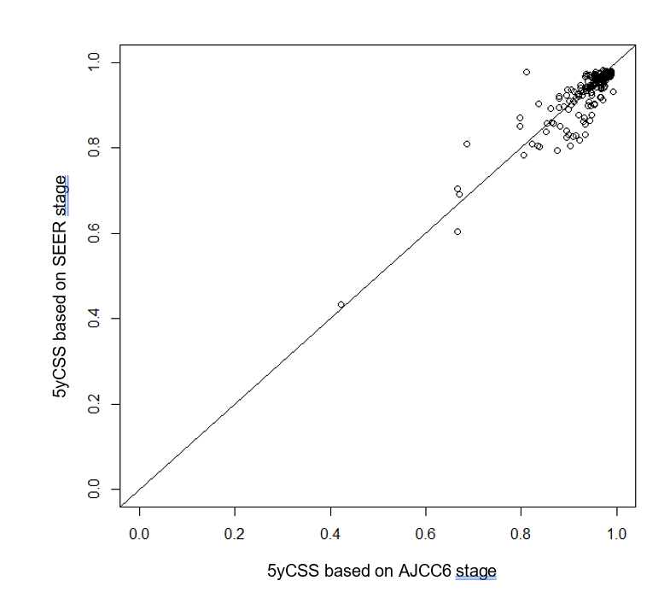

Supplemental Figure 2. Five-year cancer-specific survival probabilities (5yCSS) at cancer diagnosis for patients who received a solid organ transplant after diagnosis. Results are shown for N=288 patients with a known AJCC6 stage as overlapping histograms using SEER historic stage and AJCC6 stage cure models.
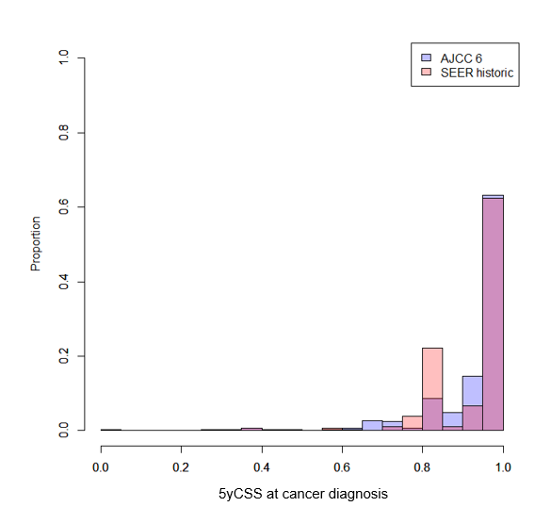

Supplemental Figure 3. Five-year cancer-specific survival probabilities for colorectal cancer patients in the US general population, according to cancer subsite, stage at diagnosis, and time since cancer diagnosis. Estimates at each timepoint after cancer diagnosis reflect the probability of cancer-specific survival for the next five years, conditioned on surviving to that timepoint. The figure has one panel for each combination of cancer subsite and stage (24 in total, with one panel on each page).

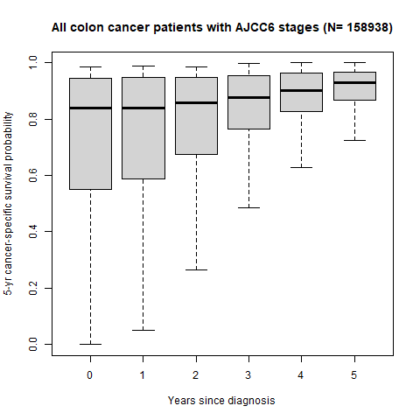
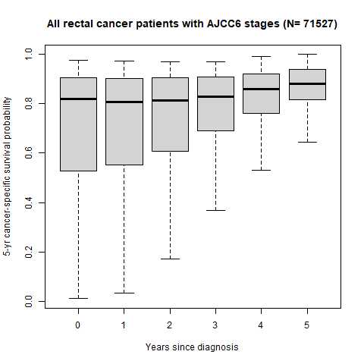
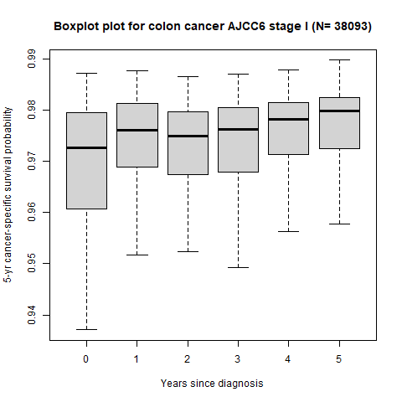
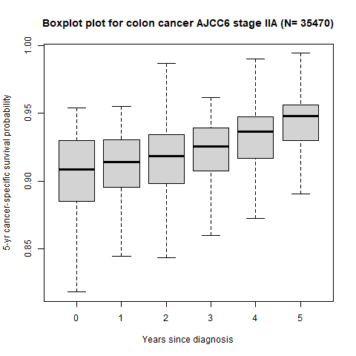
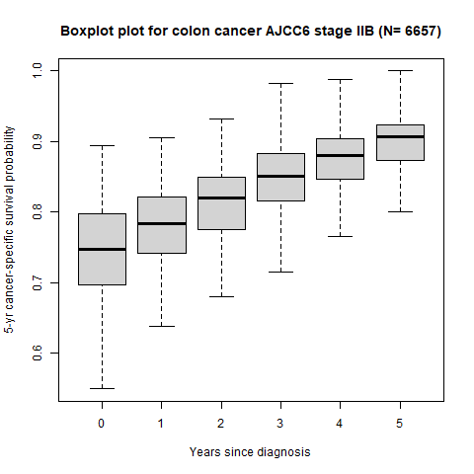
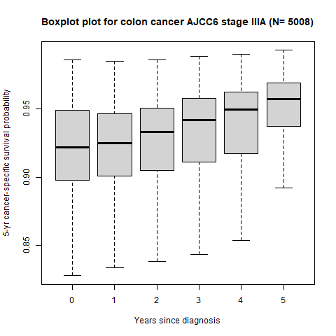
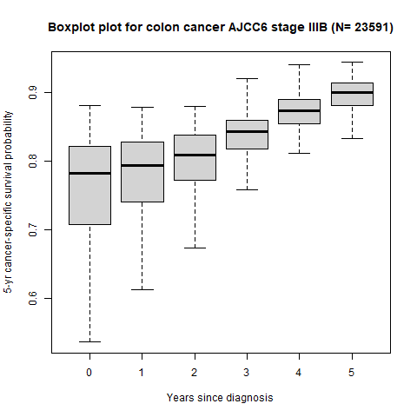
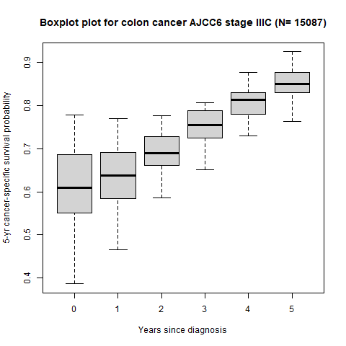
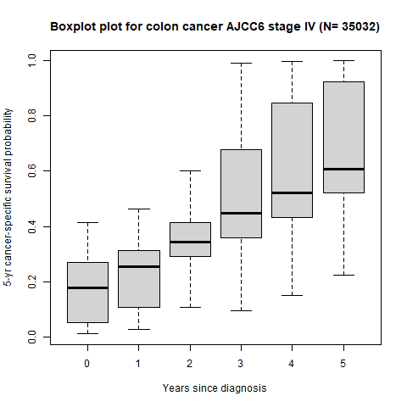
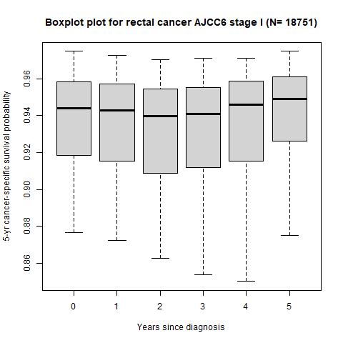
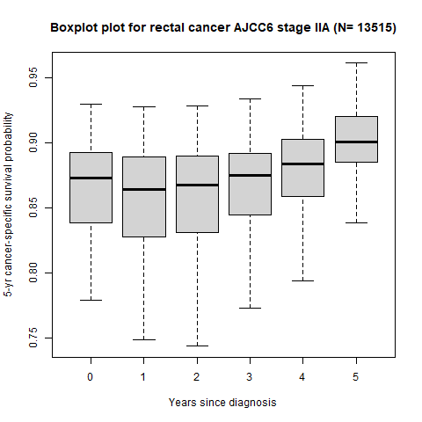
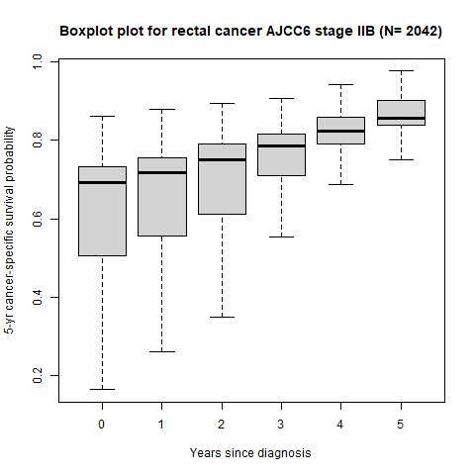
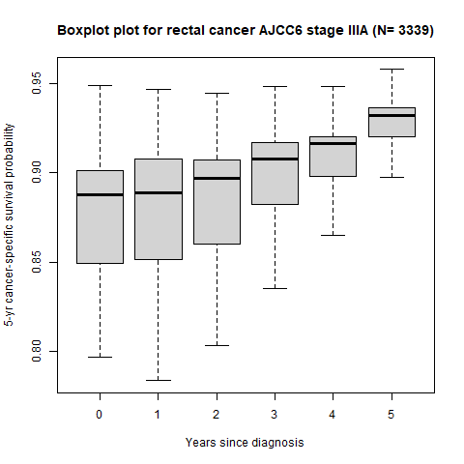
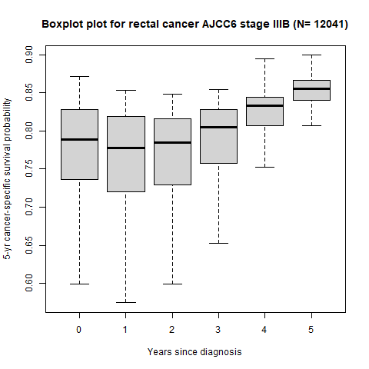
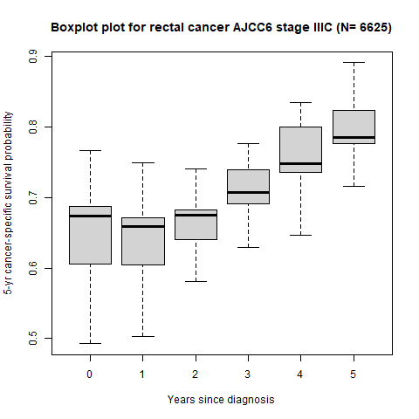
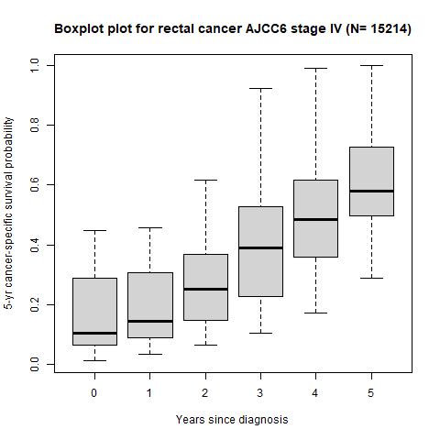
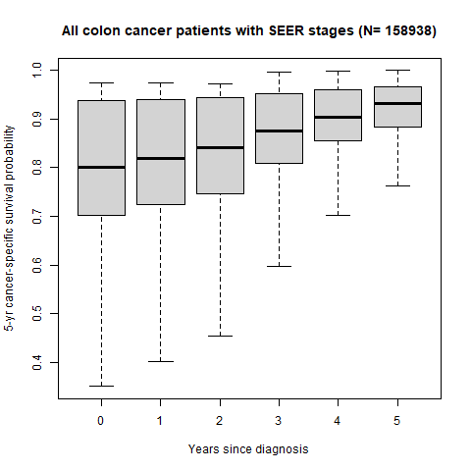
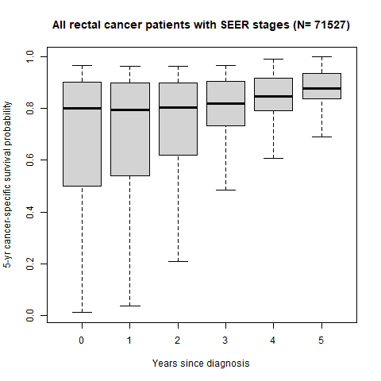

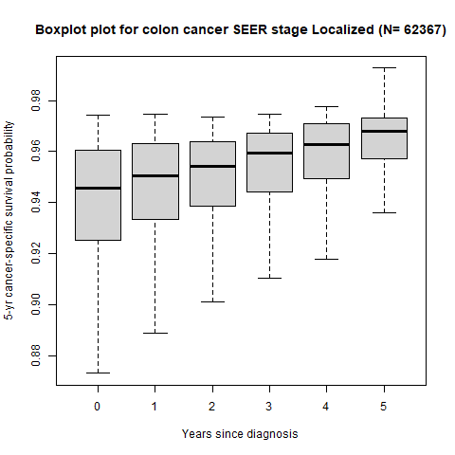
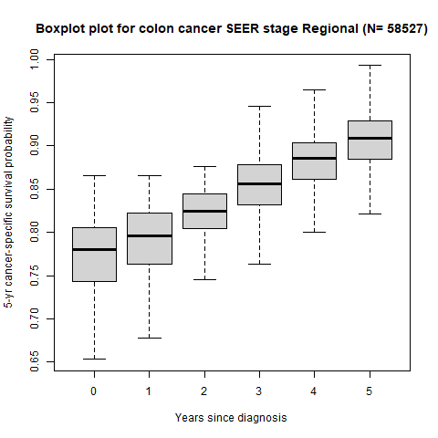

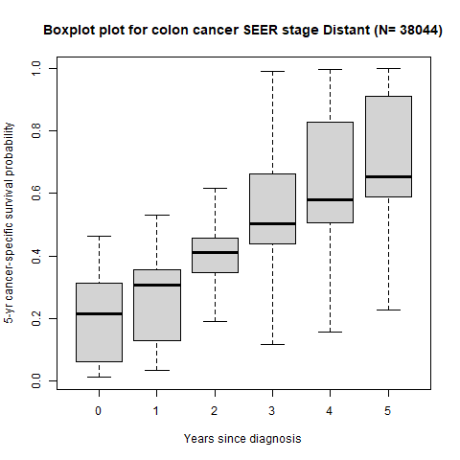

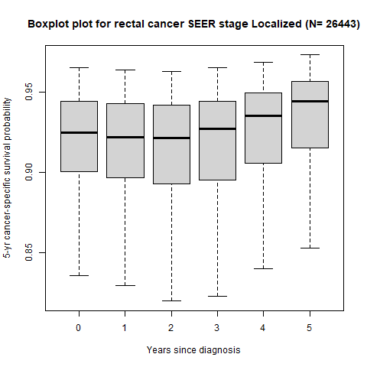

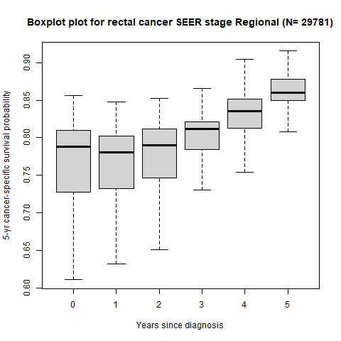
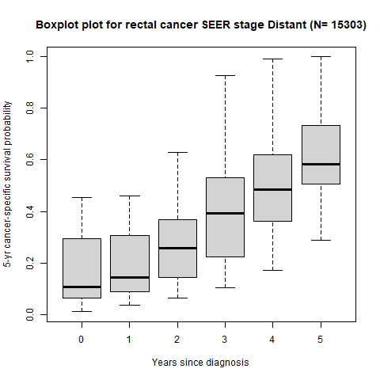

Supplemental Figure 4. Distributions of cure probabilities for colorectal cancer patients in the general population based on the cross-validation (models using either AJCC6 or SEER historic stage)

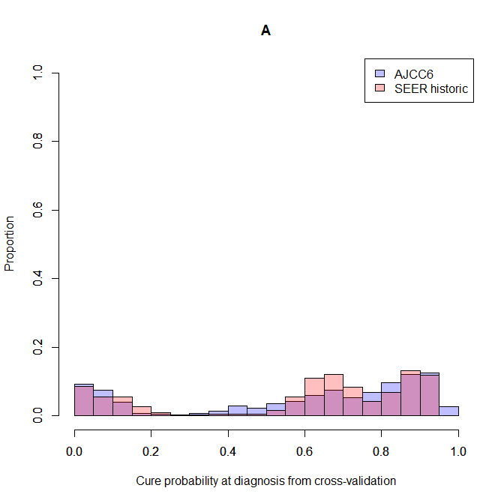

Supplemental Figure 5. Comparison of cure probabilities from the main analysis and those calculated in the cross-validation (models using either AJCC6 or SEER historic stage). Results for a random 1% sample of patients are shown.
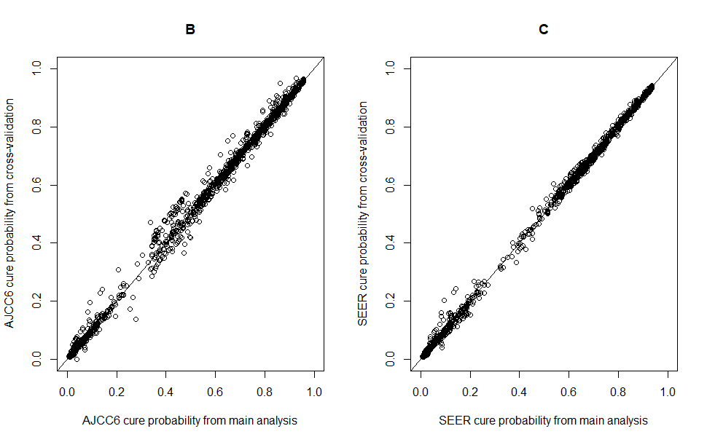
Supplemental Figure 6. Receiver operator characteristic curves for cure probabilities based on cross-validation

