Supplementary Material
Public Health Surveillance of Outpatient Antibiotic Prescription Trends, United States, 2011–2019
Christine Kim, Monina Bartoces, Katryna A. Gouin, Emily McDonald, Lauri A. Hicks, Sarah Kabbani

Table of Contents
Table S1. Outpatient oral antibiotic prescriptions by patient characteristics, United States, 2011–2019, IQVIA® Xponent data
Figure S1. Outpatient oral antibiotic prescription rates per 1,000 persons by antibiotic category, United States, 2011–2019, IQVIA® Xponent data, for A) ages 0–20 years, B) ages 20–64 years, and C) ages ≥65 years.

Table S1. Outpatient oral antibiotic prescriptions by patient characteristics, United States, 2011–2019, IQVIA® Xponent data
Characteristics | 2011 |  | 2012 |  | 2013 |  | 2014 |  | 2015 |  | 2016 |  | 2017ª |  | 2018 |  | 2019
Characteristics | n in millions (%) | Rate per 1000 persons | n in millions (%) | Rate per 1000 persons | n in millions (%) | Rate per 1000 persons | n in millions (%) | Rate per 1000 persons | n in millions (%) | Rate per 1000 persons | n in millions (%) | Rate per 1000 persons | n in millions (%) | Rate per 1000 persons | n in millions (%) | Rate per 1000 persons | n in millions (%) | Rate per 1000 persons
Overall (with methodology change) | - | - | - | - | - | - | - | - | - | - | - | - | 258.2 (100) | 794 | 249.8 (100) | 765 | 251.1 (100) | 765
Overall (no methodology change) | 273.3 (100) | 877 | 272.3 (100) | 868 | 268.6 (100) | 850 | 266.1 (100) | 836 | 269.4 (100) | 840 | 270.2 (100) | 837 | 267.5 | 823 | 258.9 | 793 | - | -
Age group (years)
<20 | 75.2 (28) | 908 | 70.8 (26) | 858 | 66.8 (25) | 813 | 63.9 (24) | 779 | 64.7 (24) | 789 | 64.9 (24) | 790 | 60.4 (23) | 736 | 56.2 (23) | 687 | 55.8 (22) | 684
20–64 | 145.8 (53) | 778 | 147.7 (54) | 785 | 146.5 (55) | 775 | 146.7 (55) | 772 | 149.4 (55) | 783 | 149.7 (55) | 781 | 141.3 (55) | 735 | 136.3 (55) | 708 | 135.5 (54) | 703
≥65 | 46.0 (17) | 1113 | 49.3 (18) | 1142 | 51.0 (19) | 1143 | 51.6 (19) | 1117 | 53.9 (20) | 1130 | 55.7 (21) | 1131 | 56.4 (22) | 1112 | 56.8 (23) | 1085 | 59.4 (24) | 1099
Unknown | 6.2 (2) | - | 4.5 (2) | - | 4.3 (2) |  | 4.0 (1) |  | 1.3 (0) |  | - |  | - |  | 0.4 (0) |  | 0.3 (0)
Sex
Male | 106.5 (39) | 695 | 106.5 (39) | 690 | 104.8 (39) | 674 | 103.4 (39) | 660 | 104.9 (39) | 665 | 105.5 (39) | 663 | 100.9 (39) | 631 | 97.4 (39) | 605 | 98.0 (39) | 606
Female | 164.2 (60) | 1037 | 164.7 (60) | 1033 | 162.8 (61) | 1014 | 161.7 (61) | 1001 | 164.0 (61) | 1007 | 164.6 (61) | 1004 | 157.1 (61) | 953 | 152.1 (61) | 918 | 152.9 (61) | 918
Unknown | 2.6 (1) | - | 1.1 (0) |  | 1.1 (0) |  | 1.0 (0) |  | 0.4 (0) |  | 0.1 (0) |  | 0.1 (0) |  | 0.2 (0) |  | 0.2 (0)
Region
Northeast | 49.6 (18) | 893 | 49.5 (18) | 887 | 49.0 (18) | 876 | 48.6 (18) | 868 | 48.8 (18) | 871 | 48.8 (15) | 871 | 46.9 (18) | 837 | 45.3 (18) | 809 | 45.1 (18) | 806
Midwest | 63.4 (23) | 944 | 61.3 (23) | 910 | 61.0 (23) | 903 | 60.8 (23) | 897 | 61.0 (23) | 899 | 60.2 (18) | 886 | 56.7 (22) | 832 | 53.8 (22) | 789 | 53.8 (21) | 788
South | 111.4 (41) | 961 | 114.4 (42) | 976 | 111.7 (42) | 944 | 110.5 (42) | 924 | 111.5 (41) | 921 | 114.7 (35) | 937 | 110.0 (43) | 891 | 107.7 (43) | 864 | 108.9 (43) | 867
West | 48.9 (18) | 671 | 47.1 (17) | 641 | 47.0 (17) | 633 | 46.3 (17) | 618 | 48.1 (18) | 635 | 46.5 (14) | 608 | 44.6 (17) | 577 | 42.9 (17) | 552 | 43.0 (17) | 549
Antibiotic classes
Tetracyclines | 21.2 (8) | 68 | 21.8 (8) | 69 | 20.6 (8) | 65 | 20.4 (8) | 64 | 20.7 (8) | 65 | 21.7 (7) | 67 | 21.9 (8) | 67 | 23.0 (9) | 70 | 24.9 (10) | 76
Cephalosporins | 36.6 (13) | 117 | 36.2 (13) | 115 | 36.3 (14) | 115 | 35.7 (13) | 112 | 36.3 (13) | 113 | 36.9 (11) | 114 | 36.1 (14) | 111 | 35.9 (14) | 110 | 37.1 (15) | 113
Lincosamides | 8.2 (3) | 26 | 8.6 (3) | 28 | 9.0 (3) | 28 | 9.5 (4) | 30 | 9.9 (4) | 31 | 10.1 (3) | 31 | 9.7 (4) | 30 | 9.6 (4) | 29 | 9.5 (4) | 29
Macrolides | 59.2 (22) | 190 | 57.1 (21) | 182 | 51.0 (19) | 161 | 49.0 (18) | 154 | 49.4 (18) | 154 | 47.7 (15) | 148 | 44.6 (17) | 137 | 40.5 (16) | 124 | 39.8 (16) | 121
Penicillins | 61.1 (22) | 196 | 59.6 (22) | 190 | 60.8 (23) | 192 | 60.7 (23) | 191 | 61.6 (23) | 192 | 63.2 (19) | 196 | 61.3 (24) | 189 | 59.0 (24) | 180 | 58.8 (23) | 179
Fluoroquinolones | 31.6 (12) | 101 | 32.7 (12) | 104 | 33.2 (12) | 105 | 32.8 (12) | 103 | 32.5 (12) | 101 | 29.7 (9) | 92 | 24.6 (10) | 76 | 22.1 (9) | 68 | 19.1 (8) | 58
Trimethoprim-sulfamethoxazole | 20.8 (8) | 67 | 21.3 (8) | 68 | 21.7 (8) | 69 | 21.0 (8) | 66 | 20.3 (8) | 63 | 20.4 (6) | 63 | 19.1 (7) | 59 | 18.1 (7) | 55 | 17.5 (7) | 53
Beta-lactams, increased activity | 22.1 (8) | 71 | 21.8 (8) | 69 | 23.1 (9) | 73 | 23.5 (9) | 74 | 25.3 (9) | 79 | 26.4 (8) | 82 | 26.7 (10) | 82 | 26.6 (11) | 81 | 28.4 (11) | 87
Other antibiotics | 0.5 (0) | 2 | 0.5 (0) | 2 | 0.5 (0) | 2 | 0.5 (0) | 2 | 0.5 (0) | 1 | 0.5 (0) | 2 | 0.5 (0) | 2 | 0.6 (0) | 2 | 0.7 (0) | 2
Urinary anti-infectives | 12.1 (4) | 39 | 12.5 (5) | 40 | 12.4 (5) | 39 | 12.9 (5) | 40 | 12.9 (5) | 40 | 13.6 (4) | 42 | 13.7 (5) | 42 | 14.4 (6) | 44 | 15.3 (6) | 46
ªMethodology change occurred in 2017.
Note: Antibiotic classes used are as defined by the IQVIA database. Examples of antibiotic agents in each class include: tetracyclines (e.g., doxycycline, tetracycline), cephalosporins (e.g., cephalexin, cefdinir), lincosamides (e.g., clindamycin, fidaxomicin), macrolides (e.g., azithromycin, erythromycin), penicillins (e.g., penicillin, amoxicillin), fluoroquinolones (e.g., ciprofloxacin, levofloxacin), trimethoprim-sulfamethoxazole (e.g., sulfadiazine, trimethoprim), beta-lactams, increased activity (e.g., amoxicillin clavulanic acid), other antibiotics (e.g., benznidazole, linezolid), and urinary anti-infectives (e.g., nitrofurantoin, fosfomycin).

Figure S1. Outpatient oral antibiotic prescription rates per 1,000 persons by antibiotic category,ª United States, 2011–2019, IQVIA® Xponent data, for A) ages 0–20 years, B) ages 20–64 years, and C) ages ≥65 years.
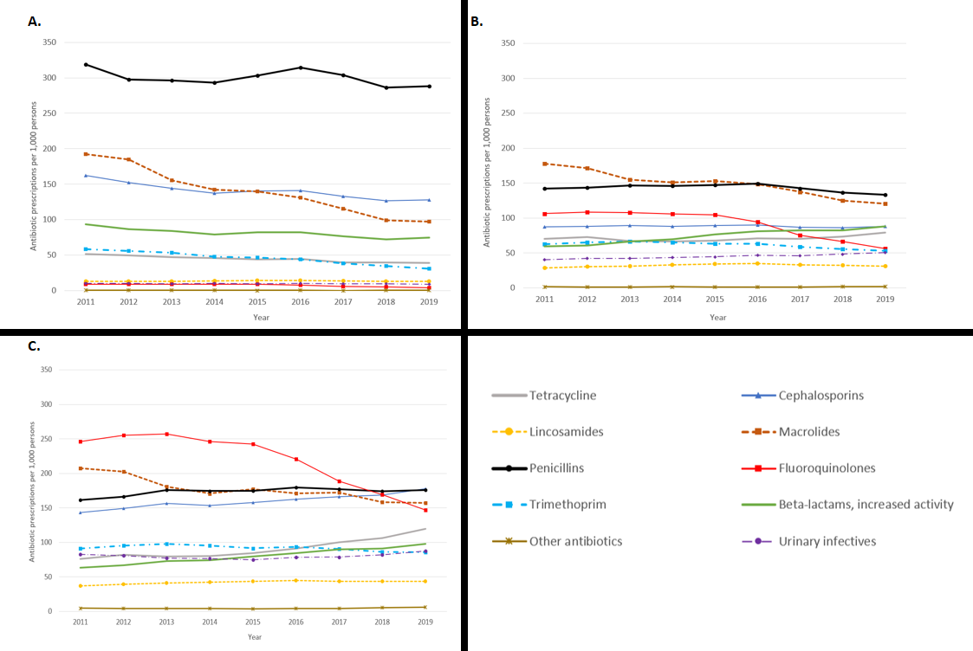
ªPrescribing rates use the rates calculated from the data captured using the new methodology in the Joinpoint-jump model.

