Supplemental information
Dynamics of residential indoor gas- and particle-phase water-soluble organic carbon: measurements during the CASA Experiment
Marc Webb,ª Glenn Morrison,ª Karsten Baumann,^{a,b}, Jienan Li,^{c} Jenna C. Ditto,^{d} Han N. Huynh,^{d} Jie Yu,^{d} Kathryn Mayer,^{c} Liora Mael,^{e} Marina Vance,^{e} Delphine Farmer,^{c} Jonathan Abbatt,^{d} Dustin Poppendieck,^{f} and Barbara J. Turpin^{a*}
*Corresponding Author:
Barbara J. Turpin- Department of Environmental Sciences and Engineering, Gillings School of Global Public Health, University of North Carolina at Chapel Hill, Chapel Hill, North Carolina, 27514; Email: bjturpin@email.unc.edu
a. Department of Environmental Sciences and Engineering, Gillings School of Global Public Health, University of North Carolina at Chapel Hill, Chapel Hill, NC, United States.
b. Picarro Inc., Santa Clara, CA, United States.
c. Department of Chemistry, Colorado State University, Fort Collins, CO, United States.
d. Department of Chemistry, University of Toronto, Toronto, ON, Canada.
e. Department of Mechanical Engineering, Environmental Engineering Program, University of Colorado Boulder, Boulder, CO, United States.
f. National Institute of Standards and Technology, Gaithersburg, MD, United States

No. of Pages: 18
No. of Figures: 11
No. of Tables: 3

S1. Perturbations
Cooking without vinegar
Green peppers, bacon and tater tots were prepared in the National Institute of Standards and Technology (NIST) Net-Zero Energy Residential Test Facility (NZERTF) kitchen for cooking perturbations. These meals were prepared during 3 consecutive days of the campaign (March 13th to 15th). The food items were sequentially pan-fried in heated canola oil for about 10 min on an electric hot plate (pan temperature was approximately 150 ◦C to 200 ◦C), removing each food item from pan before starting the next. Cooking day 1 consisted of 3 rounds of cooking under high relative humidity (RH) conditions (74 % RH). Cooking on days 2 and 3 provided a comparison of pan-fry and air-fry cooking emissions where the same food items were sequentially pan-fried in the morning and sequentially air-fried (about 10 min with air fryer temperature set to 190 ◦C) in the afternoon under normal RH conditions (30 % to 33 % RH). All cooking perturbations were performed by University of Colorado Boulder researchers.
Cooking with vinegar
Two perturbations with vinegar were performed to specifically observe acetic acid dynamics under normal house conditions. First, 30 ml (2 Tbsp) of balsamic vinegar were boiled until fully evaporated in a heated pan (burner set to high heat). Then later on the same day, 30 ml (2 Tbsp) of balsamic vinegar were incorporated into a balsamic glaze for cooking with vinegar perturbations. Chopped onions, green peppers, zucchinis, and sliced mushrooms were sautéed in heated pan soiled with bacon grease (under high heat burner setting) until onions were caramelized and other vegetables were browned. Then, balsamic vinegar was added to the pan until visibly turning into a glaze. All cooking with vinegar perturbations were performed by University of Colorado Boulder researchers.
Product addition (i.e., pesticide)
Approximately 30 g of commercial insecticide was sprayed on the first floor of the NZERTF. A box fan was operated to promote mixing of the sprayed pesticide which was 0.15% permethrin, 0.15% tetramethrin, and 99.70% other ingredients (i.e., organic solvents such as isobutane and propane and petroleum distillates). The Henry’s Law constants (K_{H}) of isobutane and propane are on the order of 10⁻⁴ M atm⁻¹ and 10⁻³ M atm⁻¹, respectively.⁷ The Henry’s law constants form aromatic naphtha from petroleum can be on the order of 10⁰ M atm⁻¹ and pyrethroids are typically on the order of 10² M atm⁻¹.⁷ Product additions were performed by NIST researchers.
Acid/base addition
Mass-flow controlled additions of 500 mg min⁻¹ and 40 mg min⁻¹ of carbon dioxide (CO₂) and ammonia (NH₃), respectively, were injected into the supply flow of the Heat Recovery Ventilator (HRV) system and delivered peak mixing ratios of approximately 5000 ppm_{v} CO₂ and 500 ppb_{v} NH₃. Note: we define mixing ratio as the ratio of the number density of a gaseous compound to the dry air number density (approximately 2.43 x 10¹⁹ molecules cm⁻³ at standard ambient temperature and pressure) expressed as parts-per-million by volume (ppm_{v}), parts-per-billion by volume (ppb_{v}) or parts-per-trillion by volume (ppt_{v}). Mixing ratios of CO₂ and NH₃ were allowed to decay for at least 3 h before repeated injections. In all, 2 to 3 injections of each species were performed under elevated RH conditions on a single day, then under lower, background RH conditions the following day.
CASA cocktail injection
A volatile organic compound (VOC) cocktail (i.e., acetone, toluene-d8, o-xylene, chlorobenzene, 2-pentanone, 2-heptanone, alpha-pinene, 1-hexene, isoprene, 1-octene and furfural) was injected into the NZERTF for a VOC addition perturbation (aka CASA cocktail injection) under normal house conditions. A volume of 0.5 mL of each compound was combined in a flask that was submerged in an 89 ◦C water bath until the solution was evaporated (approximately 10 min). During heating and evaporation, a 10.2 L min⁻¹ zero air carrier gas flow was passed over the flask headspace and into 1.14 m long Teflon tube that protruded through the porch door into the dining room of the NZERTF. The CASA cocktail perturbations were performed by University of Toronto researchers.
Wood smoke injection
A portable cocktail smoker was used to generate small amounts of smoke from combusting Ponderosa pine woodchips. There were 23 wood smoke injections between March 21st and April 6th performed by Colorado State University researchers.¹ Approximately 0.2 g to 0.5 g of woodchips were either burned in a cocktail smoker directly inside the test house or burned outside the house where the smoke was collected in a ~1 m³ Teflon chamber and indirectly injected into the house; Teflon chamber-contained smoke was then injected into the house using a zero-air flow that diluted/pushed smoke in the chamber through a copper tube outlet that extended into the first floor of the house through a side door. For some experiments, smoke was injected under high (74 % RH; March 29th and March 30th) and compared to repeat experiments under low RH conditions (32 % to 36 % RH; April 5th and April 6th). Furthermore, for some experiments, wood smoke (typically obtained burning a total of ~6 g of woodchips in the cocktail smoke) was aged in the Teflon bag with 10 ppm_{v} to 20 ppm_{v} of ozone (O₃) before injection. Also, O₃ injections occurred in both the smoke-free and smoke-exposed house.
Ozone addition
An O₃ generator was used to deliver a 0.001 L min⁻¹ flow of approximately 100 ppm_{v} O₃ into the HRV (245 m³ h⁻¹) that supplied air to the main house; O₃ injections were typically 30 min to 90 min in duration and were performed by NIST personnel throughout the campaign. A total of 17 ozone experiments (1 to 4 O₃ injections each experiment) was performed by NIST personnel throughout the campaign.
Cleaning
Surface cleaning (dusting, vacuuming, and mopping) and air cleaning (i.e., portable commercial air cleaners and custom-built Corsi-Rosenthal boxes constructed of air conditioning filters and a fan) were performed. Two surface cleaning days were implemented during the campaign under normal temperature and RH conditions aimed at cleaning the NZERTF before smoke additions began (March 21st) and then again in the smoke-exposed house after smoke injections were completed (April 7th). Main house floors were vacuumed, and other surface were dusted (approximately 1 h), followed by floor mopping and surface wiping (approximately 30 min); the total floor area of the house 1st and 2nd floor in the main house was about 252 m². Floors were mopped and surfaces were wiped with 110 ml (7.5 Tbsp) tri-sodium phosphate (TSP) and 90 ml (3/8 cups) of a commercial multiple purpose cleaner diluted in 5.7 L (1.5 gallons) of water, which was a recommended cleaning solutions for removal of smoke odor by the Red Cross.² Air cleaners were located on the first floor and operated after some smoke additions and represented a broad spectrum of cleaning mechanisms (e.g., HEPA filters, UV, photocatalytic oxidation, activated carbon, and electrostatic charge). The air and surface cleaning experiment was led by University of California, San Diego researchers.
Window opening
All windows on the first and second floors and the front door of the NZERTF were opened during a high occupancy day (April 7th; 10 occupants inside the house for most of the afternoon) for about 5 h in which visitors were given tours of the house. At the end of the day, all windows were closed. Water soluble organic carbon (WSOC) measurements during window opening and closing were captured.

S2. Experimental set-up details
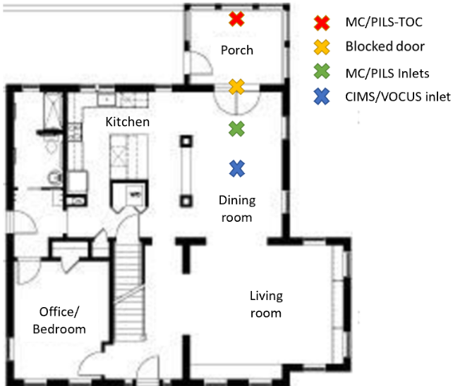
Figure S1. NZERTF 1st floor plan with sampling system (red) and sampling inlet position (green and blue) marked (x).
The blocked porch door is also marked (gold).

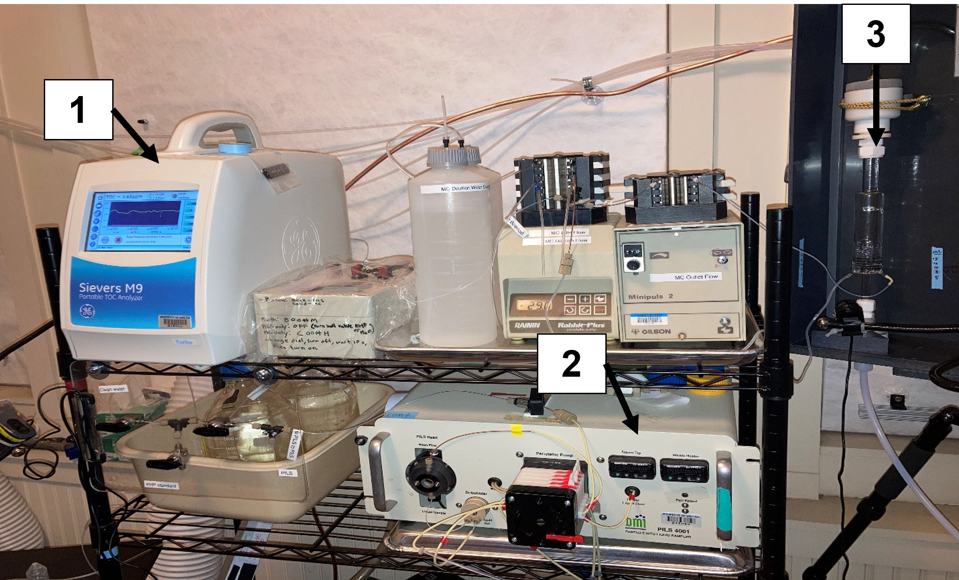
Figure S2. Instruments for WSOC_{g} and WSOC_{p} on NZERTF porch.
1. Total organic carbon analyzer (TOC) 2. Particle-into-liquid sampler (PILS) 3. Mist Chamber (MC).

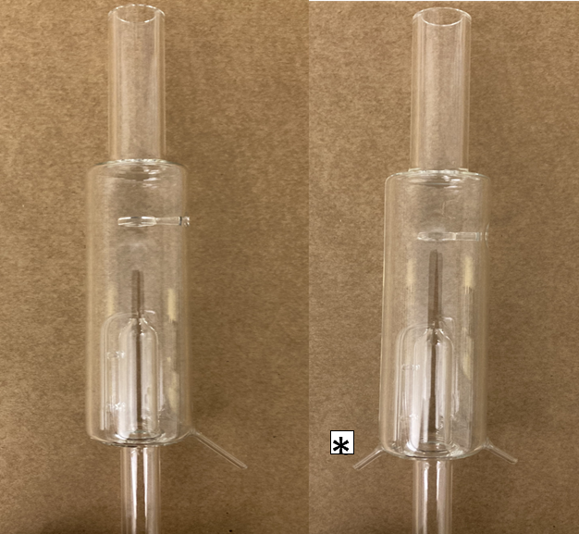
Figure S4. Traditional mist chamber (left) and real-time mist chamber (right).
The new inlet that enabled continuous bulk water flow and real-time analysis is denoted (*). The new inlet nozzle was added to the same side of MC as the capillary tube that draws water for mist generation. The real-time MC was operated with a water reservoir and droplet residence time of 8.3 min (10 mL of water/1.2 mL min⁻¹ of water flow) and 0.43 sec ((0.190 L MC volume - 0.010 L bulk water volume)/0.42 L sec⁻¹ air flow), respectively.

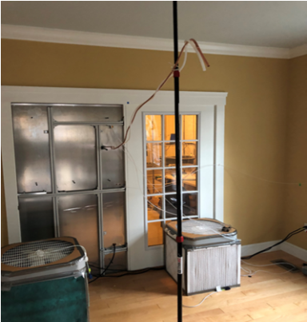
Figure S3. WSOC sampling inlet locations.
Room air was drawn to the MC (WSOC_{g}) and PILS (WSOC_{p}) through the Teflon tube and copper tube, respectively.

S3. Quality control
Determination of MC collection efficiency
Traditionally, MCs have been used as integrated samplers to measure individual compounds³ and characterization of MC performance in collecting total gas phase WSOC (WSOC_{g}) mixtures is limited but improving.^{4–6} Collection efficiency was measured using two real-time MCs operated in series (MC1 = upstream MC, MC2 = downstream MC) and MC water from each was analyzed for WSOC in real-time, alternating between MC1 and MC2 every 6 min for total collection. A dynamic blank was performed before sampling air and MC water was analyzed with the vacuum pump off (no air flow through MC1 or MC2) and subtracted from sample TOC concentrations. Here, for MCs operated as a continuous real-time sampler, the collection efficiency was constant and a steady-state WSOC concentration was maintained (Figure S5B). Collection efficiency (CE) was calculated using the Equation S1.
$CE=1-\frac{Concentration in MC2}{Concentration in MC1}$ Eqn S1
A
B
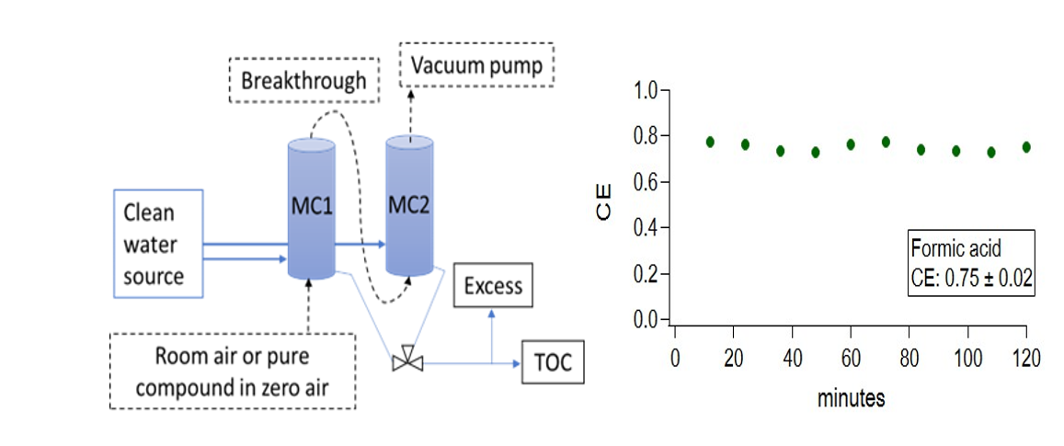
Figure S5. Collection efficiency (CE) experimental set-up (A) and a representative CE vs time for formic acid in the real-time mist chamber (B).

Summary and discussion of MC collection efficiency results
Mean (n = 10) measured collection efficiencies and K_{H} values for glyoxal, formic acid, acetic acid, acetone and WSOC_{g} in room air are listed in Table S1 and compared to reported values for integrated MCs in literature. The collection efficiency for compounds with K_{H} > 10³ (formic acid, acetic acid, and glyoxal) were in the range of 63 % to 75 % whereas collection efficiency for acetone (K_{H} < 10² M atm⁻¹) was 41 %. Reversing the order of the MCs in series yielded the same result. The minimum collection efficiency observed for acetone was roughly 4 times higher than observed by Hennigan et al.⁷

Table S1. Measured mist chamber collection efficiencies for individual water-soluble organic gases and mixtures from this work and reported in literature.
Compound | Henry’s law constant (mol L⁻¹ atm⁻¹)⁸ | MC collection efficiency (%) (Henningan et al. 2018)⁵* | MC collection efficiency (%) (Duncan et al. 2019)^{9ⴕ} | MC collection efficiency (%) (this work) ‡
Glyoxal | 4,000,000 | 109 ± 4 |  | 63 ± 2
Formic acid | 8,000 | 104 ± 5 | 76 ± 5 | 75 ± 2
Acetic acid | 4,000 | 94 ± 4 | 55 ± 4 | 74 ± 8
Acetone | 31 | 11 ± 8 |  | 41 ± 3
WSOC_{g} in room air | 10¹ to 10⁶** |  | 43 ± 10 | 57 ± 4
*Mist chamber parameters: 10 mL water (initial), approximately 8 mL water (final), 28 L min⁻¹ air flow, room temperature (21 °C), 5 min collection time, 0.6 sec droplet residence time. Collection efficiency > 100 % were reported when the downstream MC was measured to have TOC levels below the dynamic blank and were reported as such to demonstrate method uncertainty.
^{ⴕ}Mist chamber parameters: 25 mL water topped off as needed (due to evaporation), 25 L min⁻¹ air flow, room temperature (20 °C to 22 °C), 2 h collection time, 0.4 sec droplet residence time. Measured in a NC home.
‡Mist chamber parameters: 10 mL water (initial), approximately 10 mL water (final; constant water flow in and out while maintaining the meniscus height), 25 L min⁻¹ air flow, room temperature (20 °C to 22 °C), 2 h collection time, 0.43 sec droplet residence time and 8.3 min bulk water residence time. WSOC_{g} in room air was measured in a kitchen used as a teaching lab in the Department of Nutrition at UNC.
**General range of K_{H} for water-soluble organic gases in indoor air.^{4,10}
Note: MCs experience evaporative loss of bulk water due to air flow

Calibrant check, clean water check, and dynamic blanks

Figure S6. TOC data (aqueous concentrations; ppb_{m}) from measurements of a potassium hydrogen phthalate (KHP) calibrant check, clean water, PILS dynamic blank, MC dynamic blank and semicontinuous dynamic blanks of both the MC and PILS in 6 min intervals. DAT is date and time.

MC and PILS dynamic blank concentrations were 2.6 and 4.9 times higher than the TOC concentration measured in the clean water supply, respectively. After correcting for the clean water background (63 ppb_{m}), the PILS dynamic blank WSOC signal was 11 % of the house background WSOC_{g} concentration measured by MC-TOC. This indicates that there was 11 % breakthrough of WSOC_{g} through the PILS upstream carbon denuder. Reported particulate WSOC (WSOC_{p}) concentrations are corrected for WSOC_{g} breakthrough. Note: ppb_{m} is defined as the grams of compound (or in this case the grams of carbon) per billion grams of solution.

S4. Indoor vs. outdoor WSOC measurements
Indoor-outdoor (I/O) ratios
Figure S7 shows blank corrected indoor and outdoor WSOC concentrations on April 11. Indoor WSOC_{g} was at least factor of 19 greater indoors (95 µg-C m⁻³ ± 18 µg-C m⁻³) than outdoors (5 µg-C m⁻³ ± 1 µg-C m⁻³), suggesting that there are substantial indoor WSOC_{g} sources. Indoor and outdoor WSOC_{p} concentrations were below the limit of detection (LOD) on average. On this day, people were freely entering and exiting the house and the front door was sometimes propped open which should explain the larger indoor WSOC_{g} variability and lower indoor WSOC_{g} concentrations compared to unperturbed time periods on other days. This also suggests that the WSOC_{g} indoor to outdoor ratio may be even larger when the house’s doors and windows are closed. The WSOC_{g} outdoor measurements were near, but still above the LOD. WSOC_{p} measurements were near LOD indoors and below LOD outdoors. The I/O ratio was approximately 20 for the WSOC_{g} and greater than or equal to 1 for WSOC_{p} (using the LOD as the upper bound outdoor WSOC_{p} concentration).
Figure S7. Indoor and outdoor WSOC_{g} and WSOC_{p} concentrations (blank corrected). The LOD for the WSOC_{g} (LOD: 0.5 µg-C m⁻³) and WSOC_{p} (LOD: 2.0 µg-C m⁻³) are also shown.

S5. Additional measurements
Aldehydes, ketones, and alcohols
Gas-phase mixing ratios of C2 to C4 water-soluble aldehydes, ketones, and alcohols were measured using a Vocus proton-transfer-reaction (PTR-MS) mass spectrometer¹¹ by University of Toronto researchers. The instrument was in the garage of the NZERTF. The sample inlet was in the dining room and located approximately 1.6 m from the floor. The instrument exhibited an average mass resolution of approximately 10,000 (m/Δm) to 11,000 (m/Δm). Gases were sampled through a 30 m long, 12.7 mm OD, 9.5 mm ID Teflon line that was heated to 50 ◦C, through which 4 L min⁻¹ of room air was flowing. A PTFE particulate filter in the inlet line removed particles so that only the gas phase was measured. The PTR-MS detects protonated molecular ions. Instrument backgrounds were performed frequently using a heated catalyst system. Calibrations for ethanol and acetaldehyde were conducted onsite every 3 h to 6 h for 5 min using flow from a cylinder containing 99.4 and 101.9 ppb_{v} of these species, respectively. Acetone, butanone, and hydroxyacetone were all calibrated post-campaign. Acetone was calibrated using a standard cylinder with 992 ppb_{v} of acetone. Butanone and hydroxyacetone were calibrated from liquid standards by injecting a set flow rate of each liquid standard solution from a syringe pump into a pre-determined zero air carrier gas flow (a detailed procedure has been published previously).¹² Since these three calibrations were performed after the measurement period, their signals were ratioed to toluene’s post-campaign signal from toluene calibrations with the same cylinder mixture (1000 ppb_{v} toluene in cylinder VOC mix). These ratios were compared to the toluene calibrations during the campaign (103.1 ppb_{v} toluene in field cylinder) to infer acetone, butanone, and hydroxyacetone mixing ratios during the measurement period.
In addition to structural isomers, PTR ionization can lead to ion fragmentation so that multiple species may contribute intensity to any specific ion signal. To assess interferences at the protonated molecular ions for each species, a fast-scanning gas chromatograph¹⁵ was periodically interfaced to the inlet of the PTR-MS which provided chromatographic separation for each sampled ion. Using 19 chromatograms measured throughout the campaign, it was determined that a large portion of the signal of the protonated VOC ions was due to the targeted analyte, with 11 % interference for ethanol, 17 % for acetone, 11 % for acetaldehyde, 48 % for butanone, and 55 % for hydroxyacetone. The reported mixing ratios account for these interferences. Given the onsite nature of the calibrations for acetaldehyde and ethanol, we estimate the uncertainties in the mixing ratios for these compounds to be on the order of 20 %. For the species calibrated post-campaign, the potential uncertainties are harder to estimate but are likely larger, perhaps up to a factor of two. Data processing, including mass calibration and high-resolution peak fitting, was performed using Tofware software (v 3.2.5).
Organic Acids
The gas-phase mixing ratios of C1 to C5 water-soluble carboxylic acids (i.e., formic, acetic, propanoic, butanoic, and pentanoic acids) were measured using a Time-of-Flight Chemical Ionization Mass Spectrometer (ToF-CIMS) equipped with iodide (I–) reagent ions. The ToF-CIMS was operated by Colorado State University researchers. The instrument exhibited an average mass resolution of approximately 4000 (m/Δm). Detailed information regarding the ion chemistry and operational procedures can be found elsewhere.^{13,14} Air samples from the dining room were drawn into the instrument, which was located in the garage of the NZERTF, via a 30.5 m heated 6.1 mm PFA (perfluoroalkoxy alkane) line, maintaining a flow rate of 5 L min⁻¹ to 12 L min⁻¹. Hourly zero measurements and calibrations were conducted using ultra-high purity (UHP) nitrogen (N₂) and certified standards of the C₁ to C₅ carboxylic acids. To maintain equivalent RH levels as ambient air, the zeroing N₂ flow consisted of a combination of dry N₂ and wet N₂. Throughout each sampling day, the sensitivities of these acids exhibited variations of less than 20 %. All data processing, including mass calibration and high-resolution peak fitting, was performed using Tofware software (v 2.5.7).
Ozone
O₃ mixing ratios in the main house were measured using an O₃ analyzer (LOD: 0.5 ppb_{v}, precision: ± 1 ppb_{v}) by NIST personnel on the first floor and outside the NZERTF using separate, but identical, sampling lines. The sample line was 9.1 m long PFA tube with a 6.3 mm OD and 0.45 µm in-line particle filter. The O₃ sampling system was designed to switch between the first floor and a sampling location outside the NZERTF. The combined flow rate through the sampling lines was 8 L min⁻¹. The instrument itself was located in the attic of the NZERTF.

Formaldehyde
Formaldehyde and formic acid mixing ratios in the main house were measured by NIST personnel using a quantum cascade tunable infrared direct absorption spectrometer (QC-TILDAS) which sampled at 1 L min⁻¹ with an LOD of 0.1 ppb_{v} and a precision of 20 ppt_{v} to 100 ppt_{v}. The spectrometer measured formaldehyde on the first floor and outside the NZERTF; the instrument itself was located in the attic of the NZERTF and formaldehyde was measured using the same sampling system as O₃.

S6. WSOC in house background
Table S2. WSOC_{g} and WSOC_{p} (mean ± σ) of 4 s measurements (n = 30) during 6 min sampling intervals) during unperturbed conditions (house background).
WSOC_{g} concentrations were corrected using the measured effective collection efficiency of 57 %. Also shown are the fraction of airborne WSOC in the particle phase (F_{p} = WSOC_{p}/[WSOC_{g} +WSOC_{p}]), temperature (T), relative humidity (RH) and air change rate with outdoor air (ACR; h⁻¹). “House background periods” refer to time periods immediately before conditions were perturbed by scripted activities (typically 1 h to 2 h before the perturbation), 12 h to 16 h after the last perturbation, and sometimes shortly (1 h to 2 h) after perturbations that did not induce an observable change in WSOC in our system. σ: standard deviation
Date | Time | $\overline{{WSOC}_{g}}$ ± σ (µg-C m⁻³) | $\overline{{WSOC}_{p}}$ ± σ (µg-C m⁻³) | F_{p} | T (°C) | RH (%) | ACR
8-Mar | 11 AM- 12 PM | 213 ± 5 | 10 ± 4 | 0.05 | 24 | 27 | 0.24
11-Mar | 10 AM-11 AM | 228 ± 14 | 4 ± 2 | 0.02 | 24 | 28 | 0.24
16-Mar | 10:30 AM-11:30 AM | 258 ± 9 | 3 ± 1 | 0.01 | 24 | 32 | 0.24
21-Mar | 11 AM-12 PM | 196 ± 6 | 3 ± 1 | 0.02 | 24 | 37 | 0.24
1-Apr | 10:30 AM-11:30 AM | 182 ± 6 | 8 ± 1 | 0.04 | 23 | 34 | 0.24
Avg: |  | 215 ± 29 | 6 ± 3 | 0.03  ± 0.02 | 24.0  ± 0.3 | 31.5  ± 0.0 | 0.24

Table S3. Ranges of compound class contributions to the WSOC_{g} and concentrations of selected individual water soluble organic gases in the house background across March 11, March 21, and April 1.
Compound class | Contribution  (%) | Species | Concentration (µg-C m⁻³)
Alcohol | 33 - 45 | Ethanol | 46 - 82
Organic Acid | 12 - 16 | Acetic | 12 - 24
Organic Acid | 12 - 16 | Formic | 7 - 9
Organic Acid | 12 - 16 | Propanoic | 3
Organic Acid | 12 - 16 | Butanoic | 0.5 - 1
Organic Acid | 12 - 16 | Pentanoic | 1 - 1.5
Aldehyde | 4 - 7 | Acetaldehyde | 7 - 9
Aldehyde | 4 - 7 | Formaldehyde | 5 - 6
Ketone | 8 - 9 | Acetone | 11 - 16
Ketone | 8 - 9 | Butanone | 1 - 3
Ketone | 8 - 9 | Hydroxyacetone | 0.8 - 1.2
Sum of Known Compounds | 51 – 72 | Ethanol, acetic acid, formic acid, propanoic acid, butanoic acid, pentanoic acid, acetaldehyde, formaldehyde, acetone, butanone, and hydroxyacetone | 101 - 144
Sum of Unknown Compounds | 28 - 49 | -- | 51 - 95

S7. WSOC response to air cleaner operation
There was no clear change in WSOC induced by use of the air cleaners after wood smoke additions in our system (Figure S8). WSOC_{g} concentration may have decreased during operation of air cleaners 1 and 2 but is difficult to differentiate from the wood smoke peak decay due to ventilation and normal surface removal. More experiments are needed to verify these effects.
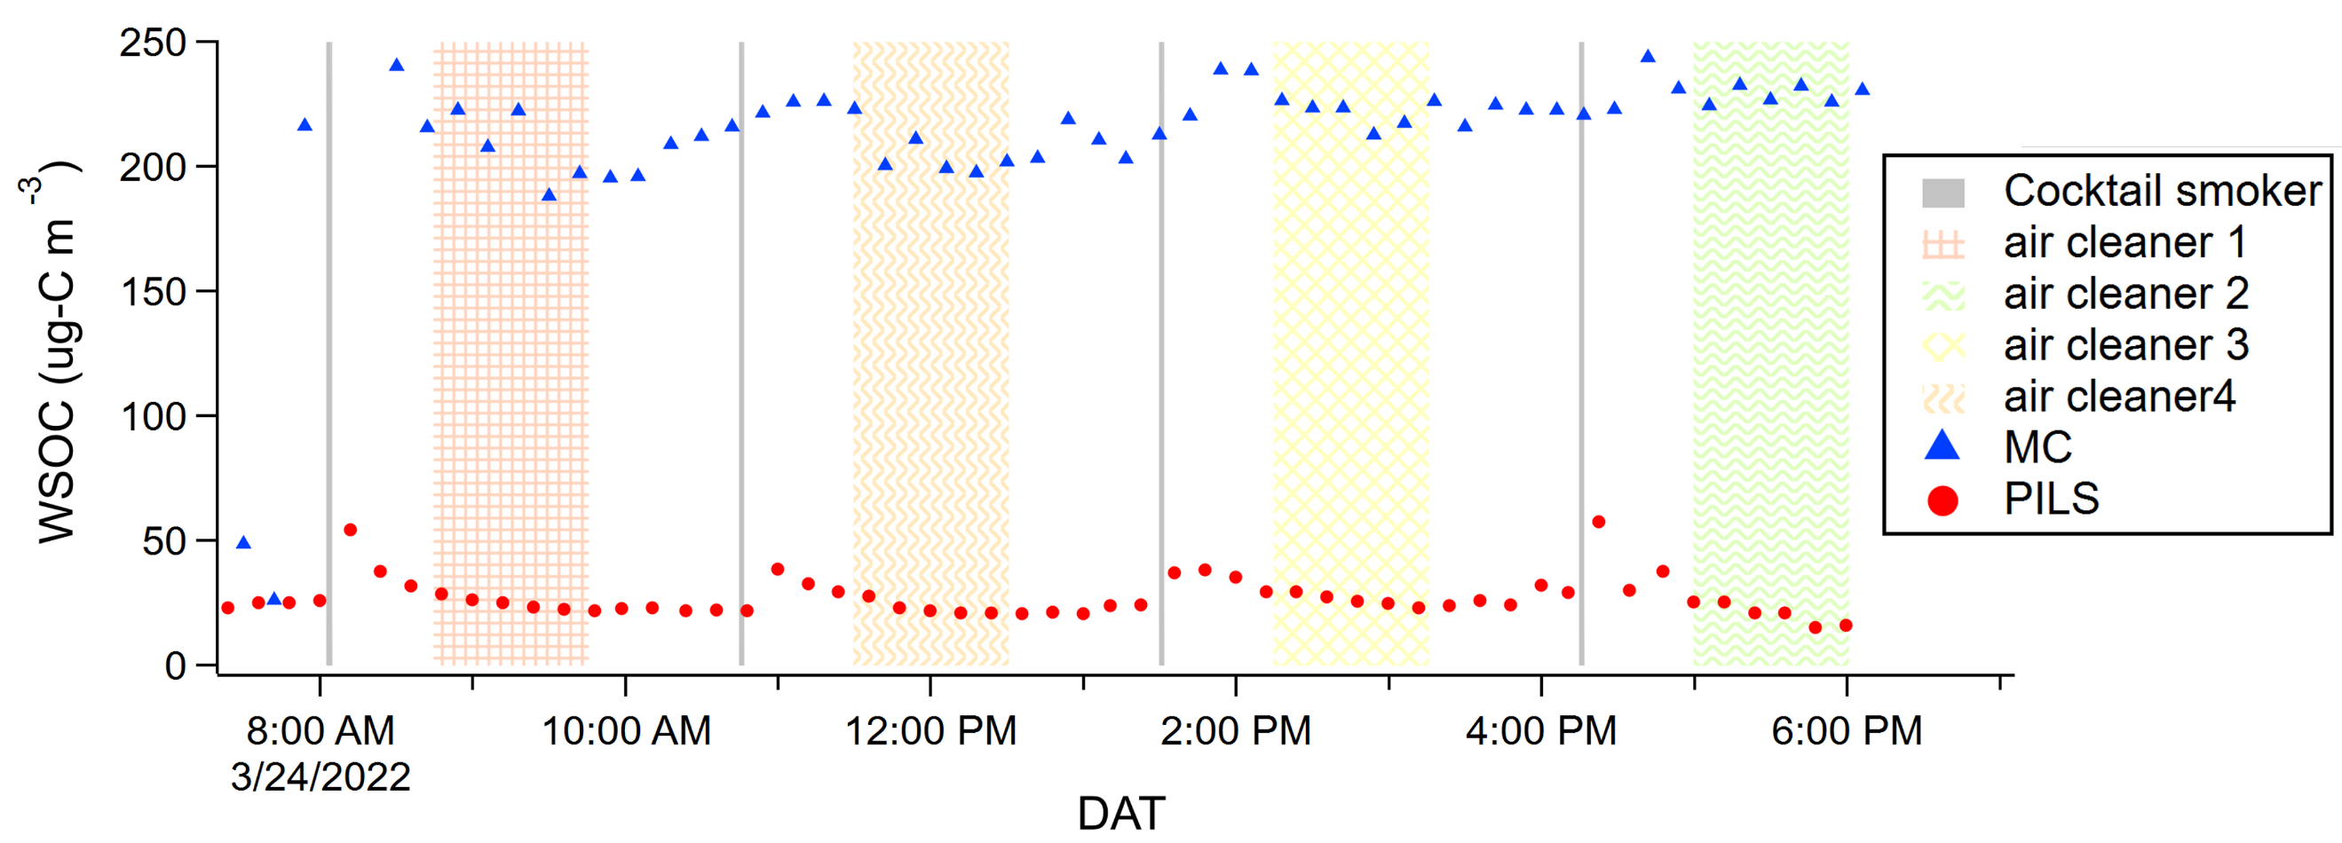Figure S8. WSOC_{g} and WSOC_{p} concentrations during direct wood smoke injections (i.e., woodchips burned inside house) and operation of 4 different air cleaners—electrostatic (1), carbon filter (2), Corsi-Rosenthal box for gases (3; built with activated carbon filters), and Corsi-Rosenthal box for particles (4; built with traditional air filters for particle filtration). Error bars represent measurement uncertainties (± 1 σ) and are mostly smaller than the data point markers. (DAT = date and time).

S8. Air change rate with open windows
Determination of the elevated ventilation rate with windows open
There was a second co-located time-of-flight mass spectrometer equipped with hydronium ion proton-transfer ionization (PTR-MS) at the Chemical Assessment of Surfaces and Air (CASA) experiment operated by NIST personnel. A 5 L min⁻¹ sample flow was sampled through 30.5 m, 6.3 mm OD PFA lines. Sample lines were Teflon filtered and heated to 50 °C. The instrument was zeroed and calibrated on an hourly basis. SF₆ was measured using the PTR-MS via product ions SF₃O⁺ ion (mass-to-charge ratio: 104.962) with 10 s measurement resolution. The sensitivity, LOD, and signal-to-noise ratio of SF₃O⁺ was 8 cps ppb_{v}⁻¹, 350 ppt_{v}, and 3, respectively. Additional product ions were SF₃⁺, SF₂⁺, and SF⁺, which were measured with less sensitivity. Tracer gas decay was used to determine the outdoor ventilation rate, or air change rate with outdoor air (ACR) (Figure S9).
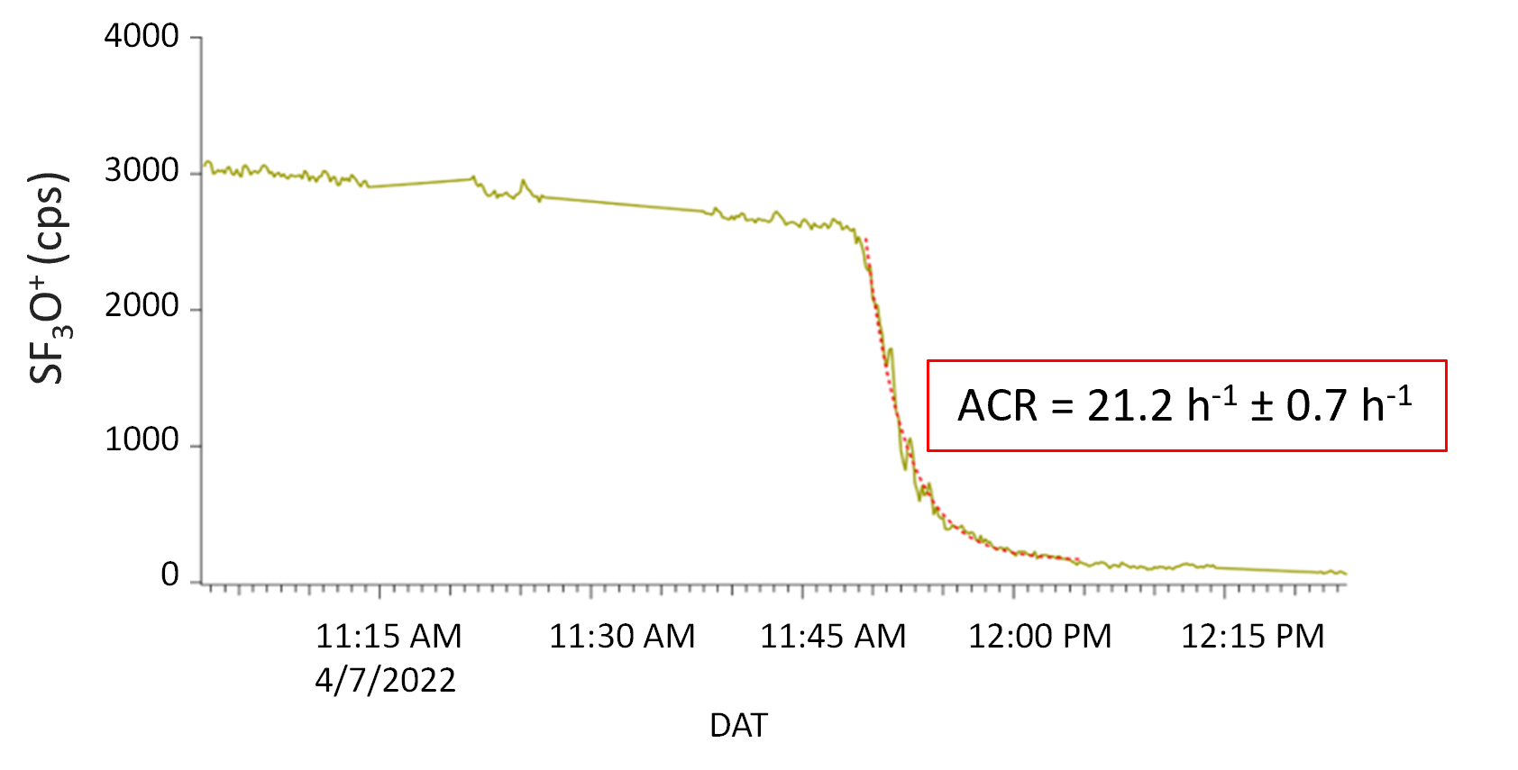
Figure S9. Tracer gas decay (sulfur hexafluoride, SF₆) during a window opening experiment on April 8th.
The outdoor air change rate (ACR) during the natural ventilation event (at about 9:45 AM) was determined by fitting an exponential function to the decay of the measured SF6 signal. Date and time (DAT) is in eastern daylight time (EDT).

The extremely high ACR with windows open (21 h⁻¹) occurred because all windows and doors were opened nearly simultaneously at a time when that resulted in substantial thermal and wind pressure gradients. The outside temperature was 9 °C and the initial inside temperature was 24 °C. Figure XX demonstrates the impact on house temperatures when the house was opened (just prior to 12:00). This strong thermal gradient contributed to the high air change rate. In addition, thunderstorms were moving through the area resulting in local wind gusts.
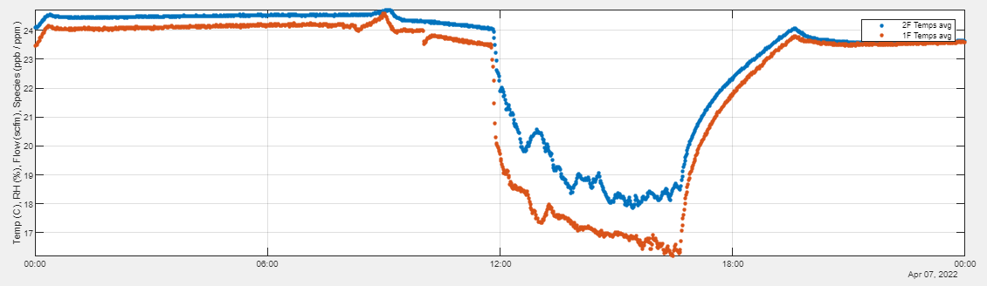
Figure S10. NZERTF average 1st and 2nd floor temperatures during open house event 04-07-22.

S9. WSOC response to acid/base addition
No observable change occurred in TOC but did for total inorganic carbon (TIC) upon addition of NH₃ and CO₂ (Figure S10). TIC increased upon NH₃ injection for only the MC likely due to increase in MC water pH resulting in increased collection efficiency for acidic CO₂. During CO₂ injections, TIC increased due to CO₂ uptake into MC water and PILS aqueous sample flow (i.e., the carbon denuders upstream of PILS inlet does not remove CO₂). Incorporation of NH₃ and CO₂ into MC water suggests Henry’s law driven uptake of NH₃ and CO₂ to aqueous surface reservoirs inside the NZERTF likely also occurred and may have influenced surface pH conditions.

S10. Change in decay rates with time
Figure S11. TOC (green markers) and TIC (blue markers) in ppb_{m} (grams carbon per billion grams of water) during semi-continuously monitoring of total carbon, alternating between the MC (blue asterisk; peaks) and PILS (red asterisk; valleys), during NH₃ and CO₂ injections.

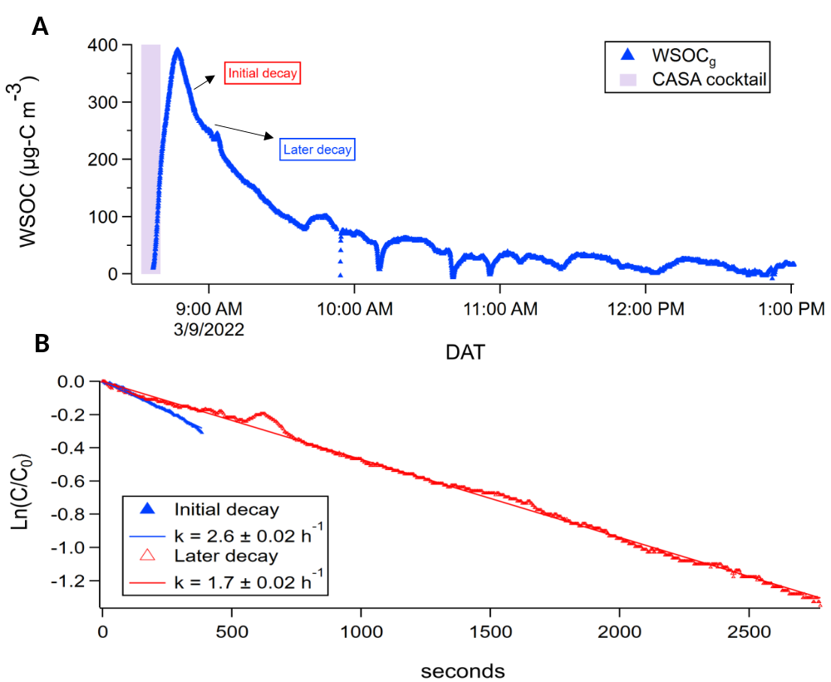
Figure S12. Room background corrected WSOC_{g} from volatile organic compound (VOC) “CASA cocktail” injection.
A. WSOC_{g} peak from VOC injection. Initial and later decay periods denoted. B. Log decay of WSOC_{g} from VOC injection. Initial (k = 2.6 ± 0.02 h⁻¹) and later (k = 1.7 ± 0.02 h⁻¹) decay.
S11. Disclaimer
Any equipment, instruments, software, or materials mentioned in this paper are solely for the purpose of accurately describing the experimental procedure. Mentioning these items does not constitute an endorsement or recommendation by NIST, nor does it imply that they are the best available options.

References
1 J. Li, M. F. Link, S. Pandit, M. H. Webb, K. J. Mayer, L. A. Garofalo, K. L. Rediger, D. G. Poppendieck, S. M. Zimmerman, M. E. Vance, V. H. Grassian, G. C. Morrison, B. J. Turpin and D. K. Farmer, The persistence of smoke VOCs indoors: Partitioning, surface cleaning, and air cleaning in a smoke-contaminated house., Sci. Adv., 2023, 9, eadh8263.
2 Cleaning Up After A Fire | American Red Cross, https://www.redcross.org/get-help/how-to-prepare-for-emergencies/types-of-emergencies/fire/cleaning-up-after-fire.html, (accessed May 30, 2023).
3 R. S. Spaulding, R. W. Talbot and M. J. Charles, Optimization of a mist chamber (Cofer scrubber) for sampling water-soluble organics in air., Environ. Sci. Technol., 2002, 36, 1798–1808.
4 S. M. Duncan, S. Tomaz, G. Morrison, M. Webb, J. Atkin, J. D. Surratt and B. J. Turpin, Dynamics of Residential Water-Soluble Organic Gases: Insights into Sources and Sinks., Environ. Sci. Technol., 2019, 53, 1812–1821.
5 C. J. Hennigan, M. M. H. El-Sayed and A. Hodzic, Detailed characterization of a mist chamber for the collection of water-soluble organic gases, Atmos. Environ., 2018, 188, 12–17.
6 C. H. Anderson, J. E. Dibb, R. J. Griffin, G. S. W. Hagler and M. H. Bergin, Atmospheric water-soluble organic carbon measurements at Summit, Greenland, Atmos. Environ., 2008, 42, 5612–5621.
7 C. J. Hennigan, M. H. Bergin, A. G. Russell, A. Nenes and R. J. Weber, Gas/particle partitioning of water-soluble organic aerosol in Atlanta, Atmospheric Chemistry and Physics, 2009, 9, 3613–3628.
8 R. Sander, Compilation of Henry’s law constants (version 4.0) for water as solvent, Atmospheric Chemistry and Physics, 2015, 15, 4399–4981.
9 S. M. Duncan, K. Sexton, L. Collins and B. J. Turpin, Residential water-soluble organic gases: chemical characterization of a substantial contributor to indoor exposures., Environ. Sci. Process. Impacts, 2019, 21, 1364–1373.
10 S. M. Duncan, K. G. Sexton and B. J. Turpin, Oxygenated VOCs, aqueous chemistry, and potential impacts on residential indoor air composition., Indoor Air, 2018, 28, 198–212.
11 J. Krechmer, F. Lopez-Hilfiker, A. Koss, M. Hutterli, C. Stoermer, B. Deming, J. Kimmel, C. Warneke, R. Holzinger, J. Jayne, D. Worsnop, K. Fuhrer, M. Gonin and J. de Gouw, Evaluation of a New Reagent-Ion Source and Focusing Ion-Molecule Reactor for Use in Proton-Transfer-Reaction Mass Spectrometry., Anal. Chem., 2018, 90, 12011–12018.
12 Q. Liu and J. P. D. Abbatt, Liquid crystal display screens as a source for indoor volatile organic compounds., Proc Natl Acad Sci USA, , DOI:10.1073/pnas.2105067118.
13 B. H. Lee, F. D. Lopez-Hilfiker, C. Mohr, T. Kurtén, D. R. Worsnop and J. A. Thornton, An iodide-adduct high-resolution time-of-flight chemical-ionization mass spectrometer: application to atmospheric inorganic and organic compounds., Environ. Sci. Technol., 2014, 48, 6309–6317.
14 P. Brophy and D. K. Farmer, A switchable reagent ion high resolution time-of-flight chemical ionization mass spectrometer for real-time measurement of gas phase oxidized species: characterization from the 2013 southern oxidant and aerosol study, Atmos. Meas. Tech., 2015, 8, 2945–2959.
15 M. S. Claflin, D. Pagonis, Z. Finewax, A. V. Handschy, D. A. Day, W. L. Brown, J. T. Jayne, D. R. Worsnop, J. L. Jimenez, P. J. Ziemann, J. de Gouw, B. Learner, An in situ gas chromatograph with automatic detector switching between PTR-and EI-TOF-MS: isomer-resolved measurements of indoor air, Atmos. Meas. Techn., 2021, 14, 133-152.

