SUPPLEMENTARY APPENDIX

Comparative Efficacy of Advanced Therapies for Management of Moderate-to-Severe Ulcerative Colitis: 2024 AGA Evidence Synthesis

Ashwin N. Ananthakrishnan^{1,2}, M. Hassan Murad^{3,} Frank I. Scott⁴, Manasi Agrawal^{5,6}, John P. Haydek^{7,8}, Berkeley N. Limketkai⁹, Edward V Loftus¹⁰, Siddharth Singh^{11,12}

¹Division of Gastroenterology, Massachusetts General Hospital, Boston, MA; ²Harvard Medical School, Boston, MA; ³Robert D and Patricia E Kern Center for the Science of Health Care Delivery, Mayo Clinic, Rochester, MN; ⁴Crohn’s and Colitis Center, Division of Gastroenterology and Hepatology, University of Colorado Anschutz Medical Campus, Denver, CO; ⁵The Dr. Henry D. Janowitz Division of Gastroenterology, Icahn School of Medicine at Mount Sinai, New York, NY; ⁶Center for Molecular Prediction of Inflammatory Bowel Disease (PREDICT), Department of Clinical Medicine, Aalborg University, Copenhagen, Denmark; ⁷Division of Gastroenterology and Hepatology, University of North Carolina at Chapel Hill, Chapel Hill, NC; ⁸Multidisciplinary Center for Inflammatory Bowel Diseases, University of North Carolina at Chapel Hill, Chapel Hill, NC; ⁹Vatche & Tamar Manoukian Division of Digestive Diseases, UCLA School of Medicine, Los Angeles, CA; ¹⁰Division of Gastroenterology and Hepatology, Mayo Clinic College of Medicine and Science, Rochester, MN; ¹¹Division of Gastroenterology, Department of Medicine, University of California San Diego, La Jolla, CA; ¹²Division of Biomedical Informatics, Department of Medicine, University of California San Diego, La Jolla, CA

SEARCH STRATEGY
We used the following search strategy to identify relevant trials for the treatment of moderate-to-severe ulcerative colitis.
Ulcerative Colitis Search
Medline via Ovid
- exp Colitis, Ulcerative/
- ((ulcerative adj2 colitis) or (colitis adj2 gravis)).tw,kw
- 1 or 2
- exp Mercaptopurine/
- exp Azathioprine/
- (6-Mercaptopurine or 6-MP or me?captopurin# Puri#ethol or Purixan or azothioprine or Azathioprine or Azasan or Im?uran or imurel).tw,kw
- exp METHOTREXATE/
- (Methotrexate or Otrexup or Rasuvo or Rheumatrex or Trexall or MTX or Amethopterin or mexate).tw,kw.
- exp Antibodies, Monoclonal/
- exp Infliximab/
- exp Adalimumab/
- exp Sphingosine 1 Phosphate Receptor Modulators/
- exp Janus Kinase Inhibitors/
- exp Ustekinumab/
- exp Interleukin-12/
- exp Interleukin-23/
- (infliximab* or renflexis or "monoclonal antibody cA2" or "MAb CA2" or inflectra or remicade).tw,kw.
- (adalimumab* or humira or cyltezo or (D2E7 adj2 antibody)).tw,kw.
- (golimumab or CNTO-148 or "CNTO 148" or simponi).tw,kw.
- (vedolizumab or entyvio or MLN0002 or MLN02 or "MLN-0002" or "MLN-02").tw,kw.
- (ozanimod or RPC1063 or zeposia or estrasimod).tw,kw.
- (tofacitinib or xeljanz or jakvinus or "CP 690,550" or CP690550 or "CP-690550" or "CP 690550" or "CP-690,550").tw,kw.
- (upadacitinib or "(3S,4R)-3-ethyl-4-(3H-imidazo(1,2-a)pyrrolo(2,3-e)pyrazin-8-yl)-N-(2,2,2-trifluoroethyl)-1-pyrrolidinecarboxamide" or "ABT-494" or rinvoq).tw,kw.
- (GLPG0634 or filgotinib).tw,kw.
- (ustekinumab or stelara or "CNTO 1275" or "CNTO-1275").tw,kw.
- ("Interleukin-12" or "Natural Killer Cell Stimulatory Factor" or "IL-12" or "IL 12" or "Cytotoxic Lymphocyte Maturation Factor" or "interleukin 12" or IL12 or "edodekin alfa").tw,kw.
- ("Interleukin-23" or "Interleukin 23" or "IL-23").tw,kw.
- (mirikizumab or "LY-3074828" or LY3074828).tw,kw
- (risankizumab* or "ABBV-066" or skyrizi or "BI 655066" or "BI-655066").tw,kw.
- (guselkumab or tremfya or "CNTO 1959" or "CNTO-1959").tw,kw.
- exp Immunologic Factors/
- ((immunologic* adj1 factor*) or (immune adj1 factor*) or biomodulator* or immunomodulator* or (biological adj2 modifier*)).tw,kw
- exp Mesalamine/
- (5-ASA or "5-aminosalicylic acid" or asacol* or mesalamine or mesalazine or mesasal or "5 aminosalicylate" or fivasa or canasa or delzicol or lialda or pentasa or rowasa or octasa or apriso or sfrowasa or dipentum or colazal or mezavant).tw,kw
- or/4-34
- 3 and 35
- (exp Child/ or exp Infant/ or exp Adolescent/) not exp Adult/
- 36 not 37
- exp animals/ not exp humans/
- 38 not 39
- limit 40 to english language
- (systematic review or meta-analysis).pt.
- meta-analysis/ or systematic review/ or meta-analysis as topic/ or systematic review as topic/ or "meta analysis (topic)"/ or "systematic review (topic)"/ or exp technology assessment, biomedical/ or network meta-analysis/
- ((systematic* adj3 (review* or overview*)) or (methodologic* adj3 (review* or overview*))).ti,ab,kf,kw.
- (met analy* or metanaly* or "technology assessment*" or HTA or HTAs or "technology overview*" or "technology appraisal*").ti,ab,kf,kw.
- ("meta regression*" or metaregression*).ti,ab,kf,kw.
- (meta-analy* or metaanaly* or "systematic review* " or "biomedical technology assessment* " or "bio-medical technology assessment*").mp,hw.
- Randomized Controlled Trial.pt.
- controlled clinical trial.pt
- exp Randomized Controlled Trials as Topic/
- Randomized Controlled Trial/ or Randomization/ or Random Allocation/ or Double-Blind Method/ or Double Blind Procedure/ or Double-Blind Studies/ or Single-Blind Method/ or Single Blind Procedure/ or Single-Blind Studies/ or Placebos/ or Placebo/
- (placebo or randomly or randomi#ed).ab
- trial.ti,ab
- ((singl* or doubl* or tripl* or trebl*) adj (blind* or dumm* or mask*)).ti,ab,hw,kf,kw.
- or/42-54
- 41 and 55
- Case reports.pt
- Comment.pt
- Editorial.pt
- or/57-59
- 56 not 60
- ..dedup 61
- epidemiologic studies/
- cohort studies/
- longitudinal studies/
- follow-up studies/
- prospective studies/
- retrospective studies/
- (cohorts or longitudinal or prospective or retrospective).ti,ab,kf
- (observational adj (study or studies)).ti,ab,kf
- (cohort adj (study or studies or analy*)).ti,ab,kf
- or/63-71
- 41 and 72
- Case reports.pt
- Comment.pt
- Editorial.pt
- or/74-76
- 73 not 77
- ..dedup 78
- 62 or 79
Embase via Ovid
- exp ulcerative colitis/
- ((ulcerative adj2 colitis) or (colitis adj2 gravis)).tw,kw
- 1 or 2
- exp mercaptopurine/
- exp azathioprine/
- (6-Mercaptopurine or 6-MP or me?captopurin# Puri#ethol or Purixan or azothioprine or Azathioprine or Azasan or Im?uran or imurel).tw,kw
- exp methotrexate/
- (Methotrexate or Otrexup or Rasuvo or Rheumatrex or Trexall or MTX or Amethopterin or mexate).tw,kw.
- exp monoclonal antibody/
- exp infliximab/
- exp adalimumab/
- exp sphingosine 1 phosphate receptor modulator/
- exp Janus kinase inhibitor/
- exp ustekinumab/
- exp interleukin 12/
- exp interleukin 23/
- (infliximab* or renflexis or "monoclonal antibody cA2" or "MAb CA2" or inflectra or remicade).tw,kw.
- (adalimumab* or humira or cyltezo or (D2E7 adj2 antibody)).tw,kw.
- (golimumab or CNTO-148 or "CNTO 148" or simponi).tw,kw.
- (vedolizumab or entyvio or MLN0002 or MLN02 or "MLN-0002" or "MLN-02").tw,kw.
- (ozanimod or RPC1063 or zeposia or estrasimod).tw,kw.
- (tofacitinib or xeljanz or jakvinus or "CP 690,550" or CP690550 or "CP-690550" or "CP 690550" or "CP-690,550").tw,kw.
- (upadacitinib or "(3S,4R)-3-ethyl-4-(3H-imidazo(1,2-a)pyrrolo(2,3-e)pyrazin-8-yl)-N-(2,2,2-trifluoroethyl)-1-pyrrolidinecarboxamide" or "ABT-494" or rinvoq).tw,kw.
- (GLPG0634 or filgotinib).tw,kw.
- (ustekinumab or stelara or "CNTO 1275" or "CNTO-1275").tw,kw.
- ("Interleukin-12" or "Natural Killer Cell Stimulatory Factor" or "IL-12" or "IL 12" or "Cytotoxic Lymphocyte Maturation Factor" or "interleukin 12" or IL12 or "edodekin alfa").tw,kw.
- ("Interleukin-23" or "Interleukin 23" or "IL-23").tw,kw.
- (mirikizumab or "LY-3074828" or LY3074828).tw,kw
- (risankizumab* or "ABBV-066" or skyrizi or "BI 655066" or "BI-655066").tw,kw.
- (guselkumab or tremfya or "CNTO 1959" or "CNTO-1959").tw,kw.
- exp immunologic factor/
- ((immunologic* adj1 factor*) or (immune adj1 factor*) or biomodulator* or immunomodulator* or (biological adj2 modifier*)).tw,kw
- exp mesalazine/
- (5-ASA or "5-aminosalicylic acid" or asacol* or mesalamine or mesalazine or mesasal or "5 aminosalicylate" or fivasa or canasa or delzicol or lialda or pentasa or rowasa or octasa or apriso or sfrowasa or dipentum or colazal or mezavant).tw,kw
- or/4-34
- 3 and 35
- (exp child/ or exp adolescent/ or exp infant/) not exp adult/
- 36 not 37
- exp animals/ not exp humans/
- 38 not 39
- limit 40 to english language
- exp "systematic review"/
- exp meta analysis/
- exp network meta-analysis/
- (systematic* adj3 (review* or overview*)).ti,ab,kf,kw.
- ("met analy*" or metanaly*).ti,ab,kf,kw.
- ("meta regression*" or metaregression*).ti,ab,kf,kw.
- (meta-analy* or metaanaly* or "systematic review*").mp,hw.
- exp randomized controlled trial/
- exp controlled clinical trial/
- exp randomization/
- exp double blind procedure/
- exp single blind procedure/
- exp placebo/
- (placebo or randomly or randomi#ed).ab
- trial.ti,ab
- ((singl* or doubl* or tripl* or trebl*) adj1 (blind* or dumm* or mask*)).ti,ab,hw,kf,kw.
- or/42-57
- 41 and 58
- article.pt
- review.pt
- 60 or 61
- 59 and 62
- ..dedup 63
- exp cohort analysis/
- longitudinal study/
- clinical study/
- retrospective study/
- prospective study/
- exp Randomized controlled trials/
- 69 not 70
- or/65-68,71
- (cohorts or longitudinal or prospective or retrospective).ti,ab,kf.
- (observational adj (study or studies)).ti,ab,kf.
- (cohort adj (study or studies or analy*)).ti,ab,kf.
- Or/72-75
- 41 and 76
- Article.pt
- 77 and 78
- “case report”.ti
- 79 not 80
- ..dedup 81
- 64 or 82
Cochrane Library via Wiley
- MeSH descriptor: [Colitis, Ulcerative] explode all trees
- ((ulcerative NEAR/2 colitis) OR (colitis NEAR/2 gravis)):ti,ab,kw
- #1 OR #2
- MeSH descriptor: [Mercaptopurine] explode all trees
- MeSH descriptor: [Azathioprine] explode all trees
- ("6-Mercaptopurine" OR "6-MP" OR mercaptopurine OR Purinethol OR Purixan OR azothioprine OR Azathioprine OR Azasan OR Imuran OR imurel):ti,ab,kw
- MeSH descriptor: [Methotrexate] explode all trees
- (Methotrexate OR Otrexup OR Rasuvo OR Rheumatrex OR Trexall OR MTX OR Amethopterin OR mexate):ti,ab,kw
- MeSH descriptor: [Antibodies, Monoclonal] explode all trees
- MeSH descriptor: [Infliximab] explode all trees
- MeSH descriptor: [Adalimumab] explode all trees
- MeSH descriptor: [Sphingosine 1 Phosphate Receptor Modulators] explode all trees
- MeSH descriptor: [Janus Kinase Inhibitors] explode all trees
- MeSH descriptor: [Ustekinumab] explode all trees
- MeSH descriptor: [Interleukin-12] explode all trees
- MeSH descriptor: [Interleukin-23] explode all trees
- (infliximab* OR renflexis OR "monoclonal antibody cA2" OR "MAb CA2" OR inflectra OR remicade):ti,ab,kw
- (adalimumab* OR humira OR cyltezo OR (D2E7 NEAR/2 antibody)):ti,ab,kw
- (golimumab OR CNTO-148 OR "CNTO 148" OR simponi):ti,ab,kw
- (vedolizumab OR entyvio OR MLN0002 OR MLN02 OR "MLN-0002" OR "MLN-02"):ti,ab,kw
- (ozanimod OR RPC1063 OR zeposia OR estrasimod):ti,ab,kw
- (tofacitinib OR xeljanz OR jakvinus OR "CP 690,550" OR CP690550 OR "CP-690550" OR "CP 690550" OR "CP-690,550"):ti,ab,kw
- (upadacitinib OR "(3S,4R)-3-ethyl-4-(3H-imidazo(1,2-a)pyrrolo(2,3-e)pyrazin-8-yl)-N-(2,2,2-trifluoroethyl)-1-pyrrolidinecarboxamide" OR "ABT-494" OR rinvoq):ti,ab,kw
- (GLPG0634 OR filgotinib):ti,ab,kw
- (ustekinumab OR stelara OR "CNTO 1275" OR "CNTO-1275"):ti,ab,kw
- ("Interleukin-12" OR "Natural Killer Cell Stimulatory Factor" OR "IL-12" OR "IL 12" OR "Cytotoxic Lymphocyte Maturation Factor" OR "interleukin 12" OR IL12 OR "edodekin alfa"):ti,ab,kw
- ("Interleukin-23" OR "Interleukin 23" OR "IL-23"):ti,ab,kw
- (mirikizumab OR "LY-3074828" OR LY3074828):ti,ab,kw
- (risankizumab* OR "ABBV-066" OR skyrizi OR "BI 655066" OR "BI-655066"):ti,ab,kw
- (guselkumab OR tremfya OR "CNTO 1959" OR "CNTO-1959"):ti,ab,kw
- MeSH descriptor: [Immunologic Factors] explode all trees
- ((immunologic* NEAR/1 factor*) OR (immune NEAR/1 factor*) OR biomodulator* OR immunomodulator* OR (biological NEAR/2 modifier*)):ti,ab,kw
- MeSH descriptor: [Mesalamine] explode all trees
- ("5-ASA" OR "5-aminosalicylic acid" OR mesalamine OR mesalazine OR mesasal OR "5 aminosalicylate" OR fivasa OR canasa OR delzicol OR lialda OR pentasa OR rowasa OR octasa OR apriso OR sfrowasa OR dipentum OR colazal OR mezavant OR asacol*):ti,ab,kw
- {OR #4-#34}
- #3 AND #35
- MeSH descriptor: [Child] explode all trees
- MeSH descriptor: [Infant] explode all trees
- MeSH descriptor: [Adolescent] explode all trees
- {OR #37-#39}
- MeSH descriptor: [Adult] explode all trees
- #40 NOT #41
- #36 NOT #42
- MeSH descriptor: [Animals] explode all trees
- MeSH descriptor: [Humans] explode all trees
- #44 NOT #45
- #43 NOT #46

SUPPLEMENTARY FIGURE LEGENDS
eFigure 1a: Forest plot for induction of endoscopic improvement in patients with moderate-to-severely active ulcerative colitis, excluding janus kinase inhibitors (p-score is the probability of being ranking best in the network) [Abbreviations: IFX – infliximab; ADA – adalimumab; GLM – golimumab; VDZ – vedolizumab; UST – ustekinumab; RISA – risankizumab; GUS – guselkumab; MIRI – mirikizumab; OZA – ozanimod; ETR – etrasimod; PBO – placebo]
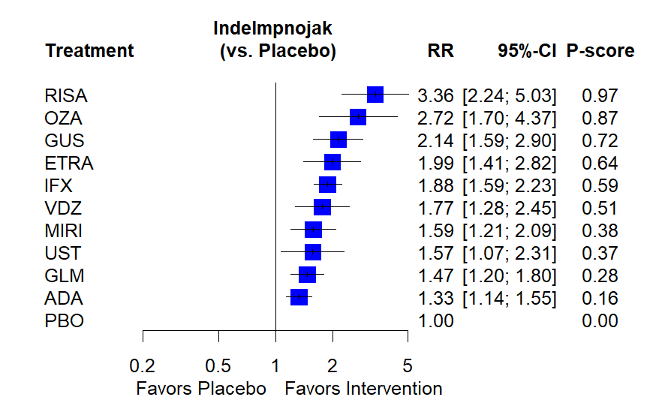

eFigure 1b: Forest plot for induction of endoscopic improvement in patients with moderate-to-severely active ulcerative colitis, including janus kinase inhibitors (p-score is the probability of being ranking best in the network) [Abbreviations: IFX – infliximab; ADA – adalimumab; GLM – golimumab; VDZ – vedolizumab; UST – ustekinumab; RISA – risankizumab; GUS – guselkumab; MIRI – mirikizumab; OZA – ozanimod; ETR – etrasimod; TOFA – tofacitinib; UPA- upadacitinib; FILG – filgotinib; PBO – placebo]

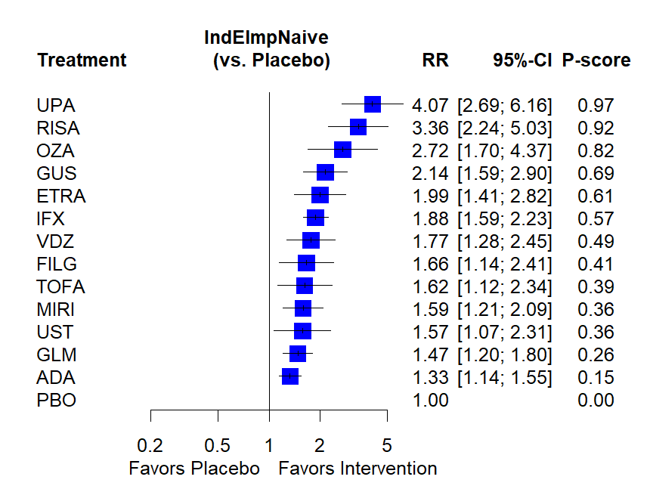

eFigure 2a: Network of included studies examining treatments for maintenance of clinical remission in patients with moderate-to-severely active ulcerative colitis among trials with a treat-straight through design [Abbreviations: IFX – infliximab; ADA – adalimumab; VDZ – vedolizumab; ETR – etrasimod; PBO – placebo]
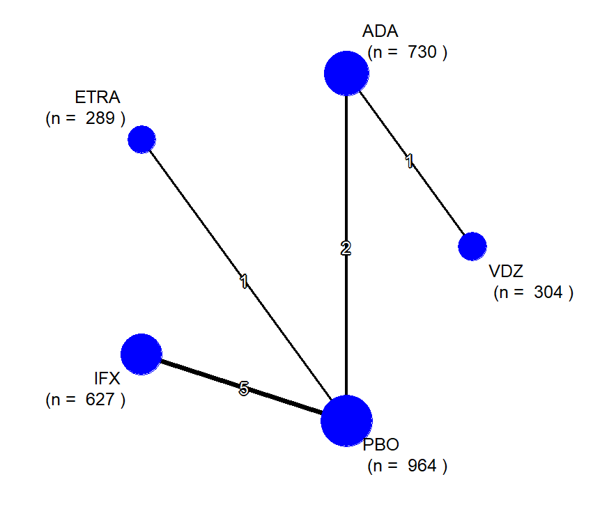

eFigure 2b: Forest plot for maintenance of clinical remission in patients with moderate-to-severely active ulcerative colitis among trials using a treat-straight through design (p-score is the probability of being ranking best in the network) [Abbreviations: IFX – infliximab; ADA – adalimumab; VDZ – vedolizumab; ETR – etrasimod; PBO – placebo]
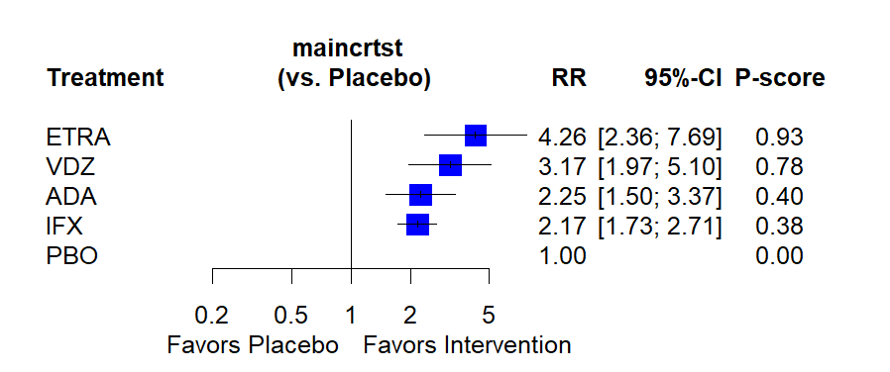

eFigure 3a: Network of included studies examining treatments for maintenance of clinical remission in patients with moderate-to-severely active ulcerative colitis among trials with a responder re-randomization design [Abbreviations: IFX – infliximab; ADA – adalimumab; GLM – golimumab; VDZ – vedolizumab; UST – ustekinumab; RISA – risankizumab; GUS – guselkumab; MIRI – mirikizumab; OZA – ozanimod; ETR – etrasimod; TOFA – tofacitinib; UPA- upadacitinib; FILG – filgotinib; PBO – placebo]
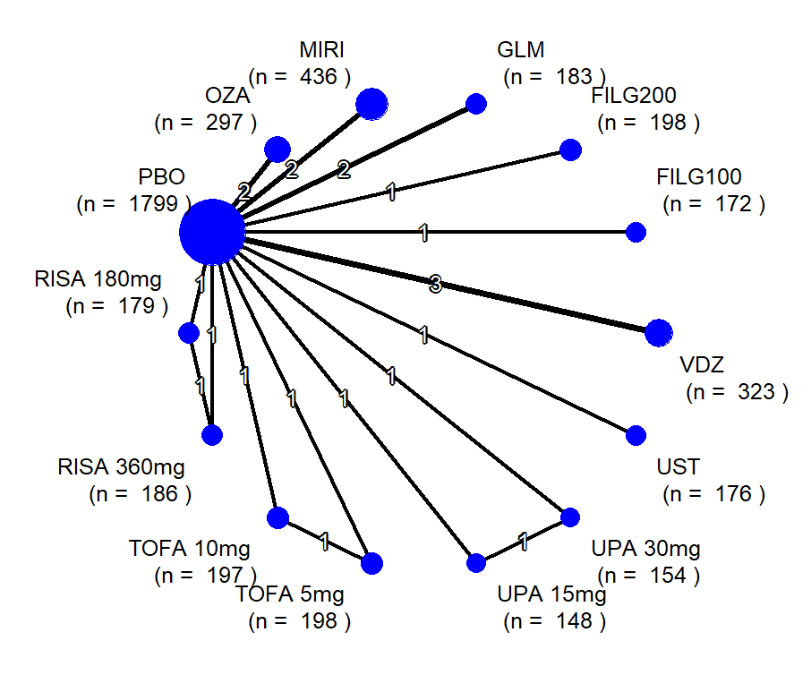

eFigure 3b: Forest plot for maintenance of clinical remission in patients with moderate-to-severely active ulcerative colitis among trials using a responder re-randomization design (p-score is the probability of being ranking best in the network) [Abbreviations: IFX – infliximab; ADA – adalimumab; GLM – golimumab; VDZ – vedolizumab; UST – ustekinumab; RISA – risankizumab; GUS – guselkumab; MIRI – mirikizumab; OZA – ozanimod; ETR – etrasimod; TOFA – tofacitinib; UPA- upadacitinib; FILG – filgotinib; PBO – placebo]

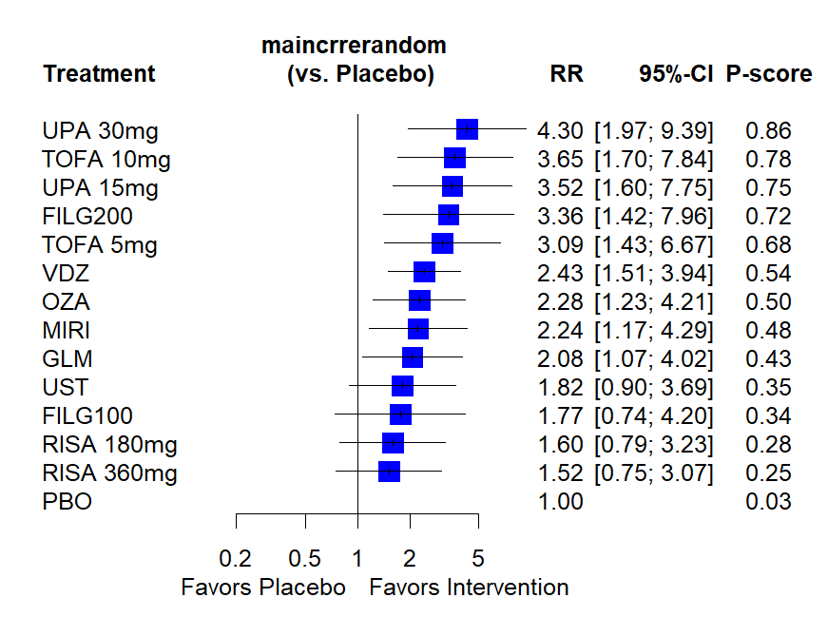

eFigure 4a: Forest plot for induction of clinical remission in biologic-naïve patients with moderate-to-severely active ulcerative colitis (p-score is the probability of being ranking best in the network) [Abbreviations: IFX – infliximab; ADA – adalimumab; GLM – golimumab; VDZ – vedolizumab; UST – ustekinumab; RISA – risankizumab; GUS – guselkumab; MIRI – mirikizumab; OZA – ozanimod; ETR – etrasimod; Etro – etrolizumab; UPA – upadacitinib; Tofa – Tofacitinib; Filg – filgotinib; PBO – placebo]
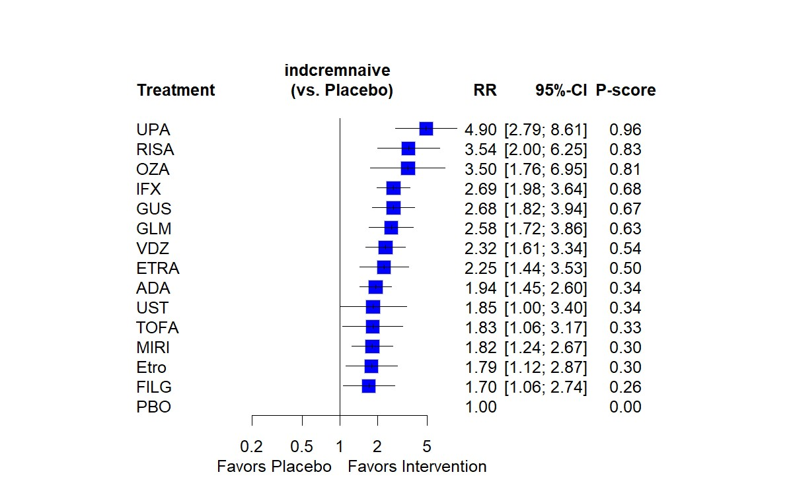

eFigure 4b: Forest plot for induction of clinical remission in biologic-exposed patients with moderate-to-severely active ulcerative colitis (p-score is the probability of being ranking best in the network) [Abbreviations: IFX – infliximab; ADA – adalimumab; GLM – golimumab; VDZ – vedolizumab; UST – ustekinumab; RISA – risankizumab; GUS – guselkumab; MIRI – mirikizumab; OZA – ozanimod; ETR – etrasimod; Etro – etrolizumab; UPA – upadacitinib; Tofa – Tofacitinib; Filg – filgotinib; PBO – placebo]
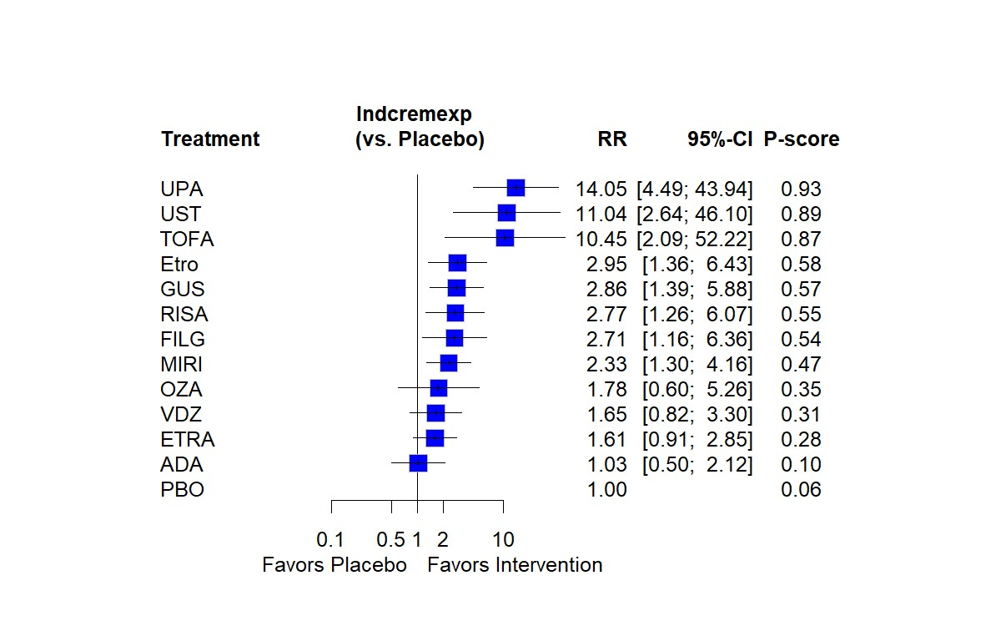

eFigure 4c: Forest plot for maintenance of clinical remission in patients with moderate-to-severely active ulcerative colitis among trials using a treat-straight through design (p-score is the probability of being ranking best in the network) [Abbreviations: IFX – infliximab; ADA – adalimumab; VDZ – vedolizumab; ETR – etrasimod; Etro – etrolizumab; PBO – placebo]
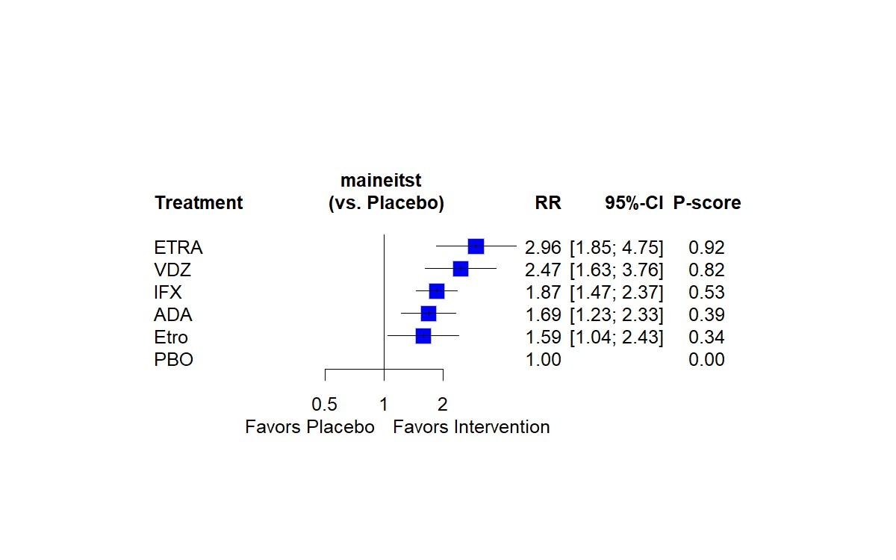

eFigure 4d: Forest plot for maintenance of clinical remission in patients with moderate-to-severely active ulcerative colitis among trials using a responder re-randomization design (p-score is the probability of being ranking best in the network) [Abbreviations: GLM – golimumab; VDZ – vedolizumab; UST – ustekinumab; RISA – risankizumab; GUS – guselkumab; MIRI – mirikizumab; OZA – ozanimod; ETR – etrasimod; Etro – etrolizumab; UPA – upadacitinib; Tofa – Tofacitinib; Fil – filgotinib; PBO – placebo]

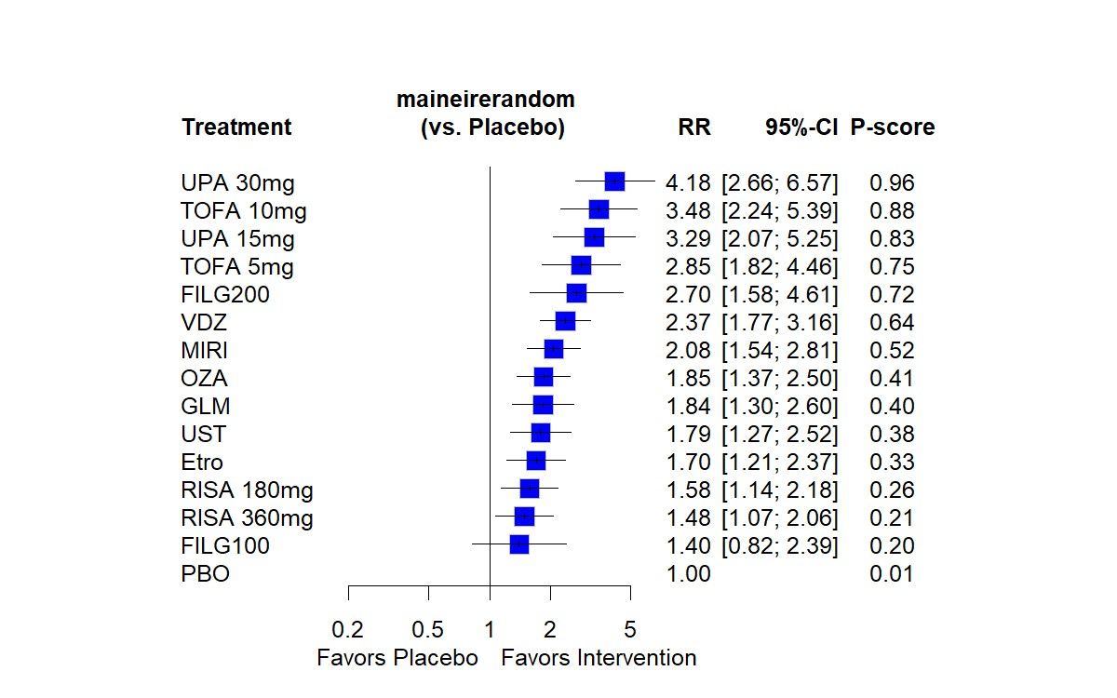

 | Trial and Intervention Characteristics | Definition and Timing of Outcome (CRem) | Mean age (y)  (SD);  Sex  (% male) |  | Mean Disease duration (y)  (SD); Disease extent (% extensive colitis) | Concomitant medications |  | Mean CRP (mg/L)  (SD) | Prior anti-TNF therapy (%), Prior vedolizumab therapy (%), Prior tofacitinib therapy (%)
 |  |  |  |  |  | Immunomodulators (%) | Corticosteroids (%) | Mean CRP (mg/L)  (SD)
INFLIXIMAB
ACT 1²⁰ | 62 sites, 2002-05; treat-through  P: 121;  I: IFX 5mg/kg, w0,2,6 and q8w – 121 | MCS≤2 with no score >1; W54 | P: 41 (14); 60  I: 42 (14); 65 |  | 6.2 (5.9); 45  5.9 (5.4); 47 | 43.8  54.5 | 65.3  57.9 | 17 (27)  14 (19) | 0/0/0  0/0/0
ACT 2²⁰ | 55 sites, 2002-05;  Treat-through  P: 123;  I: IFX 5mg/kg, w0,2,6 and q8w – 121 | MCS≤2 with no score >1; W30 | P: 39 (14); 58  I: 41 (13); 63 |  | 6.5 (6.7); 42  6.7 (5.3); 41 | 43.9  43.0 | 48.8  49.6 | 16 (29)  13 (23) | 0/0/0  0/0/0
Jiang et al²¹ | 1 site (China), 2008-13; treat-through  P: 41;  I: IFX 5mg/kg, w0,2,6 and q8w – 41 | MCS≤2 with no score >1; W30 | P: 35 (15); 61  I: 34 (14); 63 |  | 4.4 (2.6); 61  4.4 (2.8); 59 | 31.7  29.3 | 51.2  53.7 | NR | 0/0/0  0/0/0
NCT01551290²² | 12 sites (China), 2012-14; treat-through  P: 49;  I: IFX 5mg/kg, w0,2,6 and q8w – 50 | MCS≤2 with no score >1; W26 | Entire group: 37; NR |  | 3.7; NR | NR | 80  60 | NR | 0/0/0  0/0/0
LIBERTY-UC⁴³ | NR, NR; re-randomized responders to IV IFX induction at W10  P: 144  I: SC IFX (CT-P13) 120mg q2w after IV induction – 294 | Mayo score ≤2, SFS≤1, RBS=0, MES ≤1 without friability; W54 | P: 40 (13); 58  I: 38 (13); 55 |  | NR | NR | NR | NR | NR
ADALIMUMAB
ULTRA 2²⁷ | 103 sites, 2006-10; treat-through  P: 246;  I: ADA 160/80/40, w0,2 and q2w – 248 | MCS≤2 with no score >1; W52 |  | P: 41 (13); 62  I: 40 (12); 57 | 8.5 (7.4); 49  8.1 (7.1); 48 | 50.8  57.7 | 75.2  80.7 | 13.1 (36.7)  14.5 (32.1) | 41/0/0  39/0/0
Suzuki et al²⁵ | 65 sites, 2009-11; treat-through  P: 96;  I: ADA 160/80/40, w0,2 and q2w – 90 | MCS≤2 with no score >1; W52 |  | P: 41 (14); 73  I: 43 (15); 68 | 7.8 (7.1); 62  7.8 (6.6); 70 | 54.2  45.6 | 60.4  63.3 | 3.4 (0.5-87.2)  2.2 (0.5-62.8) | 0/0/0  0/0/0
GOLIMUMAB
PURSUIT-M²⁹ | 251 sites, 2007-11; re-randomized responders to induction GLM at w6  P: 156;  I: GLM 100mg q4w  - 154 | MCS≤2 with no score >1; W54 |  | P: 40 (14); 48  I: 39 (13); 58 | 6.9 (7.0); NR  7.2 (7.0); NR | 33.3  31.2 | 53.2  51.2 | 9.6 (15.5)  8.9 (14.7) | 0/0/0  0/0/0
PURSUIT-J⁶⁶ | 49 sites (Japan), 2013-16; re-randomized responders to induction GLM at w6  P: 31  I: GLM 100mg q4w – 32 | MCS≤2 with no score >1; W54 |  | P: 43 (14); 61  I: 39 (12); 69 | 5.7 (5.3); 39  5.4 (6.1); 38 | 41.9  50.0 | 29.0  28.1 | 4.1 (7.7)  5.3 (14.8) | 0/0/0  0/0/0
VEDOLIZUMAB
GEMINI I³⁰ | 211 sites, 2008-12;  re-randomized responders to induction VDZ at w6  P(m): 126  I(m): 122 | MCS≤2 with no score >1;  W52 |  | P: 40 (14); 55  I: 41 (13); 57 | 7.8 (7.0); 50  6.2 (5.0); 43 | 40  36 | 57  57 | NR | Any prior advanced therapy:  P: 37  I: 42
Motoya et al³¹ | 100 sites, 2014-18; re-randomized responders to induction VDZ at w10  P: 42  I: VDZ 300mg q8w; 41 | MCS≤2 with no score >1;  W60 |  | P: 43 (14); 55  I: 43 (14); 51 | 8.7 (7.0); 55  8.6 (7.8); 68 | 50.0  53.8 | 35.7  31.8 | NR | Any prior advanced therapy:  P: 33  I: 4
VARSITY⁷ | 245 sites, 2015-19;  ADA 160/80/40, w0,2 then q2w; 386  VDZ 300mg, w0,2,6, then q8w - 383 | MCS≤2 with no score >1; W52 |  | ADA: 41 (13); 56  VDZ: 41 (14); 61 | 6.4 (6.0); NR  7.3 (7.2); NR | 25.9  26.2 | 36.3  36.1 | NR | 21/0/0  21/0/0
VISIBLE 1¹⁶ | 141 sites, 2015-18; re-randomized responders to induction VDZ at w6  P: 56  SQ: VDZ 108mg q2w – 106  IV: VDZ 300mg q8w – 54 | MCS≤2 with no score >1;  W52 |  | P: 39 (12); 61  SQ: 38 (13); 61  IV: 42 (14); 57 | 7.4 (7.1); 45  8.0 (6.2); 42  8.2 (5.9); 48 | NR | 42.9  42.5  38.9 | NR | 35.7/0/0  37.7/0/0  44.4/0/0
TOFACITINIB
OCTAVE-Sustain⁴⁰ | 297 sites; 2012-16; re-randomized responders to induction regimen at w8  P: 198  I1: Tofacitinib 5 mg BID – 198  I2: Tofacitinib 10 mg BID – 197 | MCS≤2, with rectal bleeding score 0; W52 | P: 43 (14); 59  I1: 42 (14); 52  I2: 43 (14); 56 |  | 7.2 (0.6-42.7); 55  6.5 (0.6-40.3); 52  6.8 (0.6-35.7); 53 | 0  0  0 | 50.5  51.0  44.2 | 1.0 (0.1-45.0)  0.7 (0.1-33.7)  0.9 (0.1- 74.3) | 44.9/0/0  41.9/0/0  47.2/0/0
UPADACITINIB
U-ACHIEVE Maintenance³⁸ | 195 sites; 2018-20; re-randomized responders to induction upadacitinib at w8  P: 149  I1: Upadacitinib 15 mg daily – 148  I2: Upadacitinib 30 mg daily – 154 | Adapted Mayo score ≤2, SFS≤1 and not greater than baseline, RBS=0, MES ≤1 without friability; W52 | P: 40 (21); 57  I1: 40 (22); 36  I2: 41 (7); 44 |  | 6.2 (8.6); 47  6.4 (10.6); 55  6.0 (9.7); 56 | 0  <1  <1 | 40  37  37 | 4.3 (8.0)  3.8 (10.0)  4.1 (7.1) | Any prior advanced therapy:  P: 54  I1: 48  I2: 47
FILGOTINIB
SELECTION⁴² | 341 sites, 2016-20; re-randomized responders to induction filgotinib at w11  I1: Filgotinib 100 mg induction then Placebo – 91  I2: Filgotinib 100 mg induction and maintenance – 179  I3: Filgotinib 200 mg induction then Placebo – 99  I4: Filgotinib 200 mg induction and maintenance – 202 | Adapted Mayo score ≤2, SFS≤1 and at least 1 point decrease from baseline, RBS=0, MES ≤1 without friability; W58 | I1: 43 (15); 54  I2: 42 (13); 56  I3: 42 (13); 51  I4: 43 (14); 47 |  | I1: 7.5 (7.5); NR  I2: 8.9 (8.4): NR  I3: 8.9 (7.6); NR  I4: 8.4 (7.4); NR | I1: 16.5  I2: 15.1  I3: 18.2  I4: 17.3 | I1: 30.8  I2: 34.6  I3: 31.3  I4: 30.2 | I1: 3.5 (5.4)  I2: 3.0 (5.7)  I3: 2.7 (4.4)  I4: 3.7 (10.1) | I1: 35.2/17.6/0  I2: 38/17.9/0  I3: 43.4/24.2/0  I4: 41.6/24.3/0
OZANIMOD
TOUCHSTONE³⁶ | 57 sites; 2012-2015; patients with clinical response at w8 continued their blinded induction regimen  P: 23  I: Ozanimod 1mg qday – 42 | MCS ≤2 with no subscore >1; W32 | NR |  | NR | NR | NR | NR | NR
TRUE NORTH³⁵ | 285 sites; 2015-20; re-randomized responders to induction regimen at w10  P: 227;  I: Ozanimod 1 mg qday – 230 | Adapted Mayo score ≤2, SFS≤1 and at least 1 point decrease from baseline, RBS=0, MES ≤1 without friability; W52 | NR |  | NR | NR | NR | NR | NR
ETRASIMOD
ELEVATE 52¹⁵ | 315 sites; 2019-2021; treat-through  P: 144  I: Etrasimod 2mg qday – 289 | Adapted Mayo score ≤2, SFS≤1 and at least 1 point decrease from baseline, RBS=0, MES ≤1 without friability; W52 | P: 39 (14); 61  I: 41 (14); 53 |  | 5.9 (5.5); 33  7.5 (8.0); 32 | 0  0 | 32  33 | 10.8 (18.1)  9.6 (15.5) | 22/13/6  21/10/7
USTEKINUMAB
UNIFI³² | 244 sites, 2015-18; re-randomized responders to induction ustekinumab at w8  P: 175  I: UST q8w – 176 | MCS ≤2 with no subscore >1; W48 | P: 42 (14); 61  I: 40 (13); 53 |  | 7.5 (6.8); 49  8.1 (6.6); 46 | 28.0  26.1 | 54.3  53.9 | 3.4 (1.39-9.72)  4.0 (1.37-12.7) | 34.3/16.0/0  39.2/12.5/0
MIRIKIZUMAB
AMAC Ph2³³ | 75 sites, 2016-2017; re-randomized responders to induction mirikizumab to either q4w or q12w mirikizumab; responders to induction placebo continued on placebo  P: 13  I: MIR 200mg q4w, 47 | Adapted Mayo score ≤2, SFS≤1 and at least 1 point decrease from baseline, RBS=0, MES ≤1 without friability; W52 | NR |  | NR | NR | NR | NR | NR
LUCENT-2¹⁴ | 383 sites, 2018-2021; re-randomized responders to induction mirikizumab at w12  P: 192  I: MIR 200mg q4w: 389 | Adapted Mayo score ≤2, SFS≤1 and at least 1 point decrease from baseline, RBS=0, MES ≤1 without friability; W52 | P: 43 (14); 59  I: 43 (14); 59 |  | 6.7 (5.6); 34  6.9 (7.1); 36 | 21.8  21.4 | 38.0  37.0 | 3.0 (1.0-7.7)  3.8 (1.4-8.7) | 32.4/12.8/4.5  30.7/12.9/2.2
RISANKIZUMAB
COMMAND⁶⁷ | Site NR; 2018-22; re-randomized responders to Risankizumab induction at W8  P: 179  I1: RIS 180mg q4w, 186  I2: RIS 360mg q4w, 183 | Adapted Mayo score ≤2, SFS≤1 and at least 1 point decrease from baseline, RBS=0, MES ≤1 without friability; W52 | NR |  | NR | NR | NR | NR | NR
Median (range)
[Abbreviations: ADA-Adalimumab, CRP-C-reactive protein, GLM-Golimumab, IFX-Infliximab, i-induction, LOR-Loss of response; MCS-Mayo Clinic Score; m-maintenance; NR-Not reported; P-Placebo; PNR-Primary non-response, TNF-tumor necrosis factor; VDZ-Vedolizumab, W-Week]

Supplementary Table 1. Trial and patient characteristics in included trials of MAINTENANCE therapy for moderate-severe ulcerative colitis

 | Any Adverse Event (%) | Any Adverse Event leading to drug discontinuation (%) | Serious Adverse Events (%) | Any Infections (%) | Serious Infections (%) | Infusion/Injection-site Reaction (%)
INFLIXIMAB
ACT 1¹ | NR (reported only for full trial at end of maintenance)
ACT 2¹ | NR (reported only for full trial at end of maintenance)
Jiang et al² | P: 39.0  I: 41.5 | P: 4.9  I: 2.4 | P: 9.8  I: 7.3 | P: 12.2  I: 14.6 | P: 0  I: 2.4 | P: 4.9  I: 7.3
NCT01551290³ | NR | NR | NR | NR | NR | NR
Kobayashi 2016⁴ | P: 82.7  I: 81.7 | P: 7.7  I: 4.8 | P: 12.5  I: 8.7 | P: 33.7  I: 31.7 | P: 1.9  I: 1.0 | P: 8.7  I: 10.6
ADALIMUMAB
ULTRA 1⁵ | P: 48.4  I: 50.2 | P: 5.4  I: 5.4 | P: 7.6  I: 4.0 | P: 15.7  I: 14.3 | P: 1.3  I: 0 | P: 3.1  I: 5.8
ULTRA 2⁶ | NR | NR | NR | NR | NR | NR
Suzuki et al⁷ | P: 46.9  I: 44.4 | P: 4.2  I: 6.7 | P: 7.3  I: 4.4 |  | P: 0  I: 3.3
HIBISCUS I⁸ | P: 36  I: 43 | P: 0  I: 1 | P: 2  I: 3 | P: 10  I: 12 | P: 3  I: 0 | NR
HIBISCUS II⁸ | P: 43  I: 46 | P: 1  I: 1 | P: 7  I: 2 | P: 18  I: 13 | P: 0  I: 1 | NR
GOLIMUMAB
PURSUIT Phase 2 and Phase 3^{9, 10} | P: 38.2  I: 37.5 | P: 0.9  I: 0.3 | P: 6.1  I: 2.7 | P: 12.1  I: 11.8 | P: 1.8  I: 0.3 | P: 1.5  I: 3.3
VEGA¹¹ | I1 (GLM): 53  I2 (GUS): 44 | I1: 4  I2: 1 | I1: 1  I2: 3 | I1: 22  I2: 14 | I1: 0  I2: 0 | I1: 3  I2: 4
VEDOLIZUMAB
GEMINI I¹² | P: 46.3  I: 45.2 | NR | P: 6.7  I: 3.4 | P: 15  I: 14 | P: 2.0  I: 0.5 | P: 0.6  I: 0.4
Motoya et al¹³ | P: 52.4  I: 50.0 | P: 2.4  I: 4.9 | P: 4.9  I: 6.1 | NR | P: 0.6  I: 2.4 | P: 2.4  I: 3.0
VARSITY¹⁴ | NR (reported only for full trial at end of maintenance)
TOFACITINIB
OCTAVE 1¹⁵ | P: 59.8  I: 56.5 | P: 1.6  I: 3.8 | P: 4.1  I: 3.4 | P: 15.6  I: 23.3 | P: 0  I: 1.3 | NA
OCTAVE 2¹⁵ | P: 52.7  I: 54.1 | P: 7.1  I: 4.0 | P: 8.0  I: 4.2 | P: 15.2  I: 18.2 | P: 0  I: 0.2 | NA
A3921063 Ph2¹⁶ | P: 48  I: 42 | P: 8  I: 3 | P: 8  I: 6 | P: 15  I: 27 | P: 0  I: 6 | NA
UPADACITINIB
U-ACHIEVE¹⁷ | P: 62  I: 56 | P: 9  I: 2 | P: 6  I: 3 | NR | P: 1  I: 2 | NA
U-ACCOMPLISH¹⁷ | P: 40  I: 53 | P: 5  I: 2 | P: 5  I: 3 | NR | P: 1  I: 1 | NA
Sandborn Ph2¹⁸ | P: 71.7  I: 62.5 | P: 8.7  I: 7.1 | P: 10.9  I: 7.1 | P: 34.8  I: 23.2 | P: 4.3  I: 3.6 | NA
FILGOTINIB
SELECTION A+B¹⁹ | P: 56.3  I: 53.6 | P: 5.0  I: 4.5 | P: 4.7  I: 4.3 | P: 14.0  I: 18.1 | P: 1.1  I: 0.6 | NA
OZANIMOD
TOUCHSTONE²⁰ | P: 59  I: 51 | P: 6  I: 1 | P: 9  I: 4 | NR | NR | NA
TRUE NORTH²¹ | P: 38  I: 40 | P: 3.2  I: 3.3 | P: 3.2  I: 4.0 | P: 11.6  I: 10.7 | P: 0.5  I: 0.9 | N/A
ETRASIMOD
OASIS²² | P: 50  I: 56 | P: 0  I: 8.0 | P: 11.1  I: 0 | NR | P: 0  I: 0 | NA
ELEVATE 12²³ | P: 47  I: 47 | P: 1  I: 5 | P: 2  I: 3 | P: 54  I: 50 | P: 0  I: 0 | NA
ELEVATE 52²³ | NR (reported only for full trial at end of maintenance)
USTEKINUMAB
UNIFI32 | P: 48.0  I: 50.6 | P: NR  I: NR | P:6.9  I: 3.4 | P: 15.4  I: 15.9 | P: 1.6  I: 0.3 | P: 1.9  I: 0.9
MIRIKIZUMAB
AMAC Ph2²⁴ | P: 50.8  I: 51.6 | P: 4.8  I: 1.6 | P: 3.2  I: 3.2 | NR | NR | NR
LUCENT²⁵ | P: 46.1  I: 44.5 | P: 7.2  I: 1.6 | P: 5.3  I: 2.8 | P: 14.0  I: 15.1 | P: 0.6  I: 0.7 | P: 0.3  I: 0.4
RISANKIZUMAB
INSPIRE²⁶ | P: 49.7  I: 42.1 | P: 3.7  I: 0.6 | P: 10.2  I: 2.3 | P: NR  I: NR | P: 1.2  I: 0.6 | P: 1.2  I: 0.6
GUSELKUMAB
QUASAR 2B²⁷ | P: 56.2  I: 44.6 | P: 2.9  I: 1.0 | P: 5.7  I: 1.0 | P: 12.4  I: 13.9 | P: 1.9  I: 0.0 | NR
QUASAR 3²⁸ | P: 49.3  I: 49.4 | P: 3.9  I: 1.7 | P: 7.1  I: 2.9 | P: 15.4  I: 15.7 | P: 0.4  I: 0.7 | NR
[Abbreviations: I-Intervention, NR-Not reported; P-Placebo]

Supplementary Table 2. Rate of adverse events in included trials of INDUCTION THERAPY for moderate-severe ulcerative colitis. Only data on randomized patients are included.

 | Any Adverse Event (%) | Any Adverse Event leading to drug discontinuation (%) | Serious Adverse Events (%) | Any Infections (%) | Serious Infections (%) | Infusion/Injection-site Reaction (%)
INFLIXIMAB
ACT 1²⁹ | P: 85.1  I: 87.6 | 9.1  8.3 | 25.6  21.5 | 38.8  43.8 | 4.1  2.5 | 10.7  9.9
ACT 2²⁹ | P: 73.2  I: 81.8 | 9.8  1.7 | 19.5  10.7 | 23.6  27.3 | 0.8  1.7 | 8.1  11.6
Jiang et al² | P: 39.0  I: 41.5 | 4.9  2.4 | 9.8  7.3 | 12.2  14.6 | 0  2.4 | 4.9  7.3
NCT01551290^{3√} | P: 63.3  I: 66.0 | 4.1  8.0 | 8.2  14.0 | 16.3  28.0 | 0  0 | NR
LIBERTY-UC³⁰ | P: 59.3  I: 67.6 | NR | 2.9  6.4 | 25.7  28.0 | NR | 5.0  7.5
ADALIMUMAB
ULTRA 2³¹ | P: 83.8  I: 82.9 | 13.1  8.9 | 12.3  12.1 | 39.6  45.1 | 1.9  1.6 | 3.8  12.1
Suzuki et al⁷ | P: 35.4*  I: 44.4* | 6.3  12.4 | 14.6  18.6 | 72.9  75.7 | 2.1  4.5 | 4.2  11.3
GOLIMUMAB
PURSUIT-M¹⁰ | P: 66.0  I: 73.4 | 6.4  9.1 | 7.7  14.3 | 28.2  39.0 | 1.9  3.2 | 1.9  7.1
PURSUIT-J³² | P: 71.0  I: 96.9 | NR | 12.9  3.1 | 35.5  65.6 | NR | 0  18.8
VEDOLIZUMAB
GEMINI I^{12¶} | P: 84.1  I: 82.0 | NR | 15.9  8.2 | 70.6  71.3 | 3.2  2.5 | 1.6  2.5
Motoya et al¹³ | P: 78.6  I: 87.8 | 14.3  4.9 | 7.1  9.8 | NR | 2.4  2.4 | 0  0
VARSITY¹⁴ | ADA: 69.2  VDZ: 62.7 | 6.5  4.4 | 11.0  13.7 | 32.1  26.8 | 2.1  1.8 | NR
VISIBLE 1³³ | P: 76.8  SQ VDZ: 65.1  IV VDZ: 75.9 | 8.9  4.7  3.7 | 10.7  9.4  13.0 | 25.0  19.8  27.8 | 0  1.9  0 | 0  10.4  1.9
TOFACITINIB
OCTAVE-Sustain¹⁵ | P: 75.3  I: 72.2 | 18.7  9.1 | 6.6  5.1 | 24.2  35.9 | 1.0  1.0 | NA
UPADACITINIB
U-ACHIEVE Maintenance¹⁷ | P: 76  I1: 78  I2: 79 | 11  4  6 | 13  7  6 | NR | 4  3  3 | NA
FILGOTINIB
SELECTION¹⁹ | P: 61.3  I1: 65.9  I2: 60.3  I3: 59.6  I4: 66.8 | 3.2  4.4  5.6  2.0  3.5 | 4.3  7.7  4.5  0  4.5 | 22.6  29.7  25.7  25.3  35.1 | 1.1  2.2  1.7  0  1.0 | NA
OZANIMOD
TOUCHSTONE²⁰ | P: 59  I: 51 | 6  1 | 9  4 | NR | NR | NA
TRUENORTH²¹ | P: 36.6  I: 49.1 | 2.6  1.3 | 7.9  5.2 | 11.9  23.0 | 1.8  0.9 | NA
ETRASIMOD
ELEVATE UC 52²³ | P: 56  I: 71 | 5  4 | 6  7 | NR | 3  1 | NA
USTEKINUMAB
UNIFI³⁴ | P: 78.9  I: 77.3 | 11.4  2.8 | 9.7  8.5 | 46.3  48.9 | 2.3  1.7 | 2.3  2.8
MIRIKIZUMAB
AMAC Ph2²⁴ | P: 76.9  I:76.6 | 0  0 | 15.4  4.3 | NR | NR | NR
LUCENT 1²⁵ | P: 68.8  I: 64.5 | 8.3  1.5 | 7.8  3.3 | 22.9  23.9 | 1.6  0.8 | 4.2  8.7
RISANKIZUMAB
COMMAND³⁵ | NR | NR | P: 8.2  I (RIS 180mg): 5.2  I (RIS 360mg): 5.1 | NR | NR | NR
[Abbreviations: ADA-Adalimumab, I-Intervention, NR-Not reported, P-Placebo, RIS-Risankizumab, VDZ-Vedolizumab]

Supplementary Table 3. Rate of adverse events in included trials of MAINTENANCE THERAPY for moderate-severe ulcerative colitis. Only data on randomized patients are included.

 | Comparison of therapies | Clinical remission, RR (95% CI) | Absolute risk difference (95% CI), per 1000 patients treated | GRADE | INTERPRETATION
 | VS. INFLIXIMAB (reference, risk of maintaining remission = 43%)
 | Adalimumab | 1.04 (0.65-1.65) | 17 (-151 to 280) | Very low¹ | Uncertain trivial benefit
 | Vedolizumab | 1.46 (0.86-2.48) | 198 (-60 to 636) | Very low¹ | Uncertain important benefit
 | Etrasimod | 1.97 (1.04-3.71) | 417 (17 to 1000) | MODERATE² | Likely important benefit
VS. ADALIMUMAB (reference, risk of maintaining remission = 45%)
Vedolizumab |  | 1.41 (1.10-1.81) | 185 (45 to 365) | MODERATE² | Likely important benefit
Etrasimod |  | 1.90 (0.93-3.88) | 405 (-32 to 1000) | LOW³ | Possibly important benefit
VS. VEDOLIZUMAB (reference, risk of maintaining remission = 63%)
 | Etrasimod | 1.34 (0.63-2.88) | 214 (-233 to 1000) | Very low¹ | Uncertain important benefit
¹Rated down thrice for imprecision since the MCID of 50 per 1000 was crossed on both sides with the 95% CI
²Rated down once for imprecision due to failure to meet optimal information size since the ratio of upper limit of 95% CI and lower limit of 95% CI of the relative risk was >3
³Rated down twice for very serious imprecision since the lower limit of 95% CI for a comparison crossed the MCID of 50 per 1000 and the line of unity (no difference in efficacy)

Supplementary Table 4. Comparative efficacy of pharmacologic therapies for MAINTENANCE of clinical remission in patients with moderate-to-severely active ulcerative colitis among trials with a TREAT-THROUGH DESIGN [Rows in bold represent at least low certainty of evidence supporting clinically meaningful benefit or harm between intervention vs. reference; benefit refers to higher likelihood of maintaining remission and harm refers to lower likelihood of maintaining clinical remission]

Comparison of therapies | Clinical remission, RR (95% CI) | Endoscopic improvement, RR (95% CI)
VS. GOLIMUMAB (reference)
Vedolizumab | 1.17 (0.52-2.65) | 1.23 (0.72-2.10)
Ozanimod | 1.10 (0.45-2.71) | 0.99 (0.56-1.74)
Ustekinumab | 0.88 (0.33-2.31) | 0.93 (0.51-1.71)
Mirikizumab | 1.08 (0.43-2.72) | 1.11 (0.62-1.97)
Risankizumab 360mg | 0.73 (0.28-1.92) | 0.77 (0.43-1.40)
Risankizumab 180mg | 0.77 (0.29-2.02) | 0.82 (0.45-1.49)
Tofacitinib 10mg | 1.76 (0.64-4.83) | 1.82 (0.93-3.53)
Tofacitinib 5mg | 1.49 (0.54-4.10) | 1.49 (0.76-2.90)
Filgotinib 200mg | 1.62 (0.55-4.80) | 1.41 (0.68-2.93)
Filgotinib 100mg | 0.85 (0.29-2.53) | 0.73 (0.35-1.52)
Upadacitinib 30mg | 2.07 (0.74-5.76) | 2.18 (1.11-4.28)
Upadacitinib 15mg | 1.70 (0.61-4.75) | 1.72 (0.87-3.40)
VS. VEDOLIZUMAB (reference)
Ozanimod | 0.94 (0.43-2.04) | 0.80 (0.49-1.33)
Ustekinumab | 0.75 (0.32-1.76) | 0.76 (0.44-1.31)
Mirikizumab | 0.92 (0.41-2.06) | 0.90 (0.54-1.50)
Risankizumab 360mg | 0.62 (0.27-1.46) | 0.63 (0.37-1.08)
Risankizumab 180mg | 0.66 (0.28-1.54) | 0.67 (0.39-1.14)
Tofacitinib 10mg | 1.50 (0.61-3.70) | 1.47 (0.80-2.72)
Tofacitinib 5mg | 1.27 (0.51-3.15) | 1.21 (0.65-2.24)
Filgotinib 200mg | 1.38 (0.52-3.71) | 1.14 (0.58-2.27)
Filgotinib 100mg | 0.73 (0.27-1.95) | 0.59 (0.30-1.18)
Upadacitinib 30mg | 1.77 (0.71-4.42) | 1.77 (0.95-3.30)
Upadacitinib 15mg | 1.45 (0.57-3.65) | 1.40 (0.74-2.63)
VS. OZANIMOD (reference)
Ustekinumab | 0.80 (0.31-2.04) | 0.94 (0.53-1.68)
Mirikizumab | 0.98 (0.48-2.40) | 1.12 (0.65-1.93)
Risankizumab 360mg | 0.67 (0.26-1.70) | 0.78 (0.44-1.38)
Risankizumab 180mg | 0.70 (0.28-1.79) | 0.83 (0.47-1.47)
Tofacitinib 10mg | 1.60 (0.60-4.27) | 1.83 (0.97-3.48)
Tofacitinib 5mg | 1.36 (0.51-3.63) | 1.50 (0.78-2.86)
Filgotinib 200mg | 1.48 (0.51-4.25) | 1.42 (0.70-2.89)
Filgotinib 100mg | 0.78 (0.27-2.24) | 0.74 (0.36-1.50)
Upadacitinib 30mg | 1.89 (0.70-5.10) | 2.20 (1.15-4.21)
Upadacitinib 15mg | 1.55 (0.57-4.20) | 1.73 (0.90-3.35)
VS. USTEKINUMAB (reference)
Mirikizumab | 1.23 (0.47-3.20) | 1.18 (0.68-2.14)
Risankizumab 360mg | 0.83 (0.31-2.26) | 0.83 (0.45-1.53)
Risankizumab 180mg | 0.88 (0.32-2.38) | 0.88 (0.48-1.62)
Tofacitinib 10mg | 2.00 (0.71-5.67) | 1.94 (0.99-3.82)
Tofacitinib 5mg | 1.70 (0.60-4.81) | 1.59 (0.80-3.15)
Filgotinib 200mg | 1.85 (0.61-5.62) | 1.51 (0.71-3.17)
Filgotinib 100mg | 0.97 (0.32-2.96) | 0.78 (0.37-1.64)
Upadacitinib 30mg | 2.36 (0.82-6.76) | 2.33 (1.17-4.64)
Upadacitinib 15mg | 1.93 (0.67-5.57) | 1.84 (0.92-3.69)
VS. MIRIKIZUMAB (reference)
Risankizumab 360mg | 0.68 (0.26-1.76) | 0.70 (0.39-1.25)
Risankizumab 180mg | 0.71 (0.27-1.86) | 0.74 (0.42-1.33)
Tofacitinib 10mg | 1.63 (0.60-4.44) | 1.64 (0.86-3.15)
Tofacitinib 5mg | 1.38 (0.50-3.77) | 1.34 (0.70-2.59)
Filgotinib 200mg | 1.50 (0.51-4.41) | 1.27 (0.62-2.61)
Filgotinib 100mg | 0.79 (0.27-2.33) | 0.66 (0.32-1.35)
Upadacitinib 30mg | 1.92 (0.70-5.76) | 1.97 (1.02-3.81)
Upadacitinib 15mg | 1.57 (0.57-4.75) | 1.55 (0.80-3.04)
VS. RISANKIZUMAB 360MG (reference)
Risankizumab 180mg | 1.05 (0.53-2.08) | 1.06 (0.71-1.58)
Tofacitinib 10mg | 2.41 (0.85-6.80) | 2.34 (1.20-4.58)
Tofacitinib 5mg | 2.04 (0.72-5.78) | 1.92 (0.97-3.78)
Filgotinib 200mg | 2.22 (0.73-6.74) | 1.82 (0.87-3.80)
Filgotinib 100mg | 1.16 (0.32-3.55) | 0.94 (0.45-1.97)
Upadacitinib 30mg | 2.83 (0.99-8.10) | 2.82 (1.43-5.56)
Upadacitinib 15mg | 2.32 (0.81-6.68) | 2.22 (1.12-4.42)
Tofacitinib 10mg | 2.28 (0.81-6.45) | 2.21 (1.13-4.31)
Tofacitinib 5mg | 1.93 (0.68-5.48) | 1.81 (0.92-3.55)
Filgotinib 200mg | 2.10 (0.69-6.39) | 1.71 (0.82-3.57)
Filgotinib 100mg | 1.10 (0.36-3.37) | 0.89 (0.43-1.85)
Upadacitinib 30mg | 2.69 (0.94-7.68) | 2.65 (1.34-5.22)
Upadacitinib 15mg | 2.20 (0.77-6.33) | 2.09 (1.05-4.15)
VS. TOFACITINIB 10MG (reference)
Tofacitinib 5mg | 0.85 (0.43-1.67) | 0.82 (0.55-1.24)
Filgotinib 200mg | 0.92 (0.29-2.91) | 0.78 (0.35-1.71)
Filgotinib 100mg | 0.48 (0.15-1.53) | 0.40 (0.18-0.89)
Upadacitinib 30mg | 1.18 (0.39-3.51) | 1.20 (0.57-2.52)
Upadacitinib 15mg | 0.96 (0.32-2.89) | 0.95 (0.45-2.00)
VS. TOFACITINIB 5MG (reference)
Filgotinib 200mg | 1.09 (0.34-3.45) | 0.95 (0.42-2.11)
Filgotinib 100mg | 0.57 (0.18-1.82) | 0.49 (0.22-1.09)
Upadacitinib 30mg | 1.39 (0.39-4.16) | 1.47 (0.70-3.10)
Upadacitinib 15mg | 1.14 (0.32-3.43) | 1.16 (0.54-2.46)
VS. FILGOTINIB 200MG (reference)
Filgotinib 100mg | 0.53 (0.16-1.78) | 0.52 (0.22-1.21)
Upadacitinib 30mg | 1.28 (0.40-4.09) | 1.55 (0.69-3.45)
Upadacitinib 15mg | 1.05 (0.33-3.37) | 1.22 (0.54-2.74)
VS. FILGOTINIB 100MG (reference)
Upadacitinib 30mg | 2.43 (0.76-7.80) | 2.98 (1.34-6.64)
Upadacitinib 15mg | 1.99 (0.62-6.42) | 2.35 (1.05-5.28)
VS. UPADACITINIB 30MG (reference)
Upadacitinib 15mg | 0.82 (0.42-1.61) | 0.79 (0.53-1.17)

Supplementary Table 5. Comparative efficacy of pharmacologic therapies for MAINTENANCE of clinical remission and endoscopic improvement in patients with moderate-to-severely active ulcerative colitis among trials with a RESPONDER RE-RANDOMIZATION DESIGN.

REFERENCES

1. Rutgeerts P, Sandborn WJ, Feagan BG, et al. Infliximab for induction and maintenance therapy for ulcerative colitis. N Engl J Med 2005;353:2462-76.
2. Jiang XL, Cui HF, Gao J, et al. Low-dose Infliximab for Induction and Maintenance Treatment in Chinese Patients With Moderate to Severe Active Ulcerative Colitis. J Clin Gastroenterol 2015;49:582-8.
3. Ltd. X-JP. A Study to Evaluate the Effectiveness and Safety of Infliximab in Chinese Patients With Active Ulcerative Colitis. Volume 2017. clinicaltrials.gov, 2015.
4. Kobayashi T, Suzuki Y, Motoya S, et al. First trough level of infliximab at week 2 predicts future outcomes of induction therapy in ulcerative colitis-results from a multicenter prospective randomized controlled trial and its post hoc analysis. J Gastroenterol 2016;51:241-51.
5. Reinisch W, Sandborn WJ, Hommes DW, et al. Adalimumab for induction of clinical remission in moderately to severely active ulcerative colitis: results of a randomised controlled trial. Gut 2011;60:780-7.
6. Sandborn WJ, van Assche G, Reinisch W, et al. Adalimumab induces and maintains clinical remission in patients with moderate-to-severe ulcerative colitis. Gastroenterology 2012;142:257-65 e1-3.
7. Suzuki Y, Motoya S, Hanai H, et al. Efficacy and safety of adalimumab in Japanese patients with moderately to severely active ulcerative colitis. J Gastroenterol 2014;49:283-94.
8. Rubin DT, Dotan I, DuVall A, et al. Etrolizumab versus adalimumab or placebo as induction therapy for moderately to severely active ulcerative colitis (HIBISCUS): two phase 3 randomised, controlled trials. Lancet Gastroenterol Hepatol 2022;7:17-27.
9. Sandborn WJ, Feagan BG, Marano C, et al. Subcutaneous golimumab induces clinical response and remission in patients with moderate-to-severe ulcerative colitis. Gastroenterology 2014;146:85-95; quiz e14-5.
10. Sandborn WJ, Feagan BG, Marano C, et al. Subcutaneous golimumab maintains clinical response in patients with moderate-to-severe ulcerative colitis. Gastroenterology 2014;146:96-109 e1.
11. Feagan BG, Sands BE, Sandborn WJ, et al. Guselkumab plus golimumab combination therapy versus guselkumab or golimumab monotherapy in patients with ulcerative colitis (VEGA): a randomised, double-blind, controlled, phase 2, proof-of-concept trial. Lancet Gastroenterol Hepatol 2023;8:307-320.
12. Feagan BG, Rutgeerts P, Sands BE, et al. Vedolizumab as induction and maintenance therapy for ulcerative colitis. New England Journal of Medicine 2013;369:699-710.
13. Motoya S, Watanabe K, Ogata H, et al. Vedolizumab in Japanese patients with ulcerative colitis: A Phase 3, randomized, double-blind, placebo-controlled study. PLoS One 2019;14:e0212989.
14. Sands BE, Peyrin-Biroulet L, Loftus EV, Jr., et al. Vedolizumab versus Adalimumab for Moderate-to-Severe Ulcerative Colitis. N Engl J Med 2019;381:1215-1226.
15. Sandborn WJ, Su C, Sands BE, et al. Tofacitinib as Induction and Maintenance Therapy for Ulcerative Colitis. N Engl J Med 2017;376:1723-1736.
16. Sandborn WJ, Ghosh S, Panes J, et al. Tofacitinib, an oral Janus kinase inhibitor, in active ulcerative colitis. N Engl J Med 2012;367:616-24.
17. Danese S, Vermeire S, Zhou W, et al. Upadacitinib as induction and maintenance therapy for moderately to severely active ulcerative colitis: results from three phase 3, multicentre, double-blind, randomised trials. Lancet 2022;399:2113-2128.
18. Sandborn WJ, Ghosh S, Panes J, et al. Efficacy of Upadacitinib in a Randomized Trial of Patients With Active Ulcerative Colitis. Gastroenterology 2020;158:2139-2149 e14.
19. Feagan BG, Danese S, Loftus EV, Jr., et al. Filgotinib as induction and maintenance therapy for ulcerative colitis (SELECTION): a phase 2b/3 double-blind, randomised, placebo-controlled trial. Lancet 2021;397:2372-2384.
20. Sandborn WJ, Feagan BG, Wolf DC, et al. Ozanimod Induction and Maintenance Treatment for Ulcerative Colitis. N Engl J Med 2016;374:1754-62.
21. Sandborn WJ, Feagan BG, D'Haens G, et al. Ozanimod as Induction and Maintenance Therapy for Ulcerative Colitis. N Engl J Med 2021;385:1280-1291.
22. Sandborn WJ, Peyrin-Biroulet L, Zhang J, et al. Efficacy and Safety of Etrasimod in a Phase 2 Randomized Trial of Patients With Ulcerative Colitis. Gastroenterology 2020;158:550-561.
23. Sandborn WJ, Vermeire S, Peyrin-Biroulet L, et al. Etrasimod as induction and maintenance therapy for ulcerative colitis (ELEVATE): two randomised, double-blind, placebo-controlled, phase 3 studies. Lancet 2023;401:1159-1171.
24. Sandborn WJ, Ferrante M, Bhandari BR, et al. Efficacy and Safety of Mirikizumab in a Randomized Phase 2 Study of Patients With Ulcerative Colitis. Gastroenterology 2020;158:537-549 e10.
25. D'Haens G, Dubinsky M, Kobayashi T, et al. Mirikizumab as Induction and Maintenance Therapy for Ulcerative Colitis. N Engl J Med 2023;388:2444-2455.
26. Louis E, Panaccione R, Parkes G, et al. RISANKIZUMAB INDUCTION THERAPY IN PATIENTS WITH MODERATELY TO SEVERELY ACTIVE ULCERATIVE COLITIS: EFFICACY AND SAFETY IN THE RANDOMIZED PHASE 3 INSPIRE STUDY. United European Gatsroenterology Journal 2023;11.
27. Peyrin-Biroulet L, Allegretti JR, Rubin DT, et al. Guselkumab in Patients With Moderately to Severely Active Ulcerative Colitis: QUASAR Phase 2b Induction Study. Gastroenterology 2023;165:1443-1457.
28. Rubin DT, Allegretti JR, Panes J, et al. The efficacy and safety of guselkumab as maintenance therapy in patients with moderate to severely active ulcerative colitis: REsults from the Phase 3 Quasar Maintenace study. Digestive Disease Week 2024
29. Rutgeerts P, Sandborn WJ, Feagan BG, et al. Infliximab for induction and maintenance therapy for ulcerative colitis.[Erratum appears in N Engl J Med. 2006 May 18;354(20):2200]. New England Journal of Medicine 2005;353:2462-76.
30. Sands BE, Hanauer S, Colombel JF, et al. Subcutaneous infliximab (CT-P13 SC) as maintenance therapy for ulcerative colitis: A Phase 3, randomized, placebo-controlled study: Results of the LIBERTY-UC study. J Crohns Colitis 2023;17:i623-624.
31. Sandborn WJ, van Assche G, Reinisch W, et al. Adalimumab induces and maintains clinical remission in patients with moderate-to-severe ulcerative colitis. Gastroenterology 2012;142:257-65.e1-3.
32. Hibi T, Imai Y, Senoo A, et al. Efficacy and safety of golimumab 52-week maintenance therapy in Japanese patients with moderate to severely active ulcerative colitis: a phase 3, double-blind, randomized, placebo-controlled study-(PURSUIT-J study). J Gastroenterol 2017;52:1101-1111.
33. Sandborn WJ, Baert F, Danese S, et al. Efficacy and Safety of Vedolizumab Subcutaneous Formulation in a Randomized Trial of Patients With Ulcerative Colitis. Gastroenterology 2020;158:562-572 e12.
34. Sands BE, Sandborn WJ, Panaccione R, et al. Ustekinumab as Induction and Maintenance Therapy for Ulcerative Colitis. N Engl J Med 2019;381:1201-1214.
35. https://www.prnewswire.com/news-releases/risankizumab-skyrizi-met-primary-and-key-secondary-endpoints-in-52-week-phase-3-maintenance-study-in-ulcerative-colitis-patients-301851542.html, 2023.

