Supplementary Information
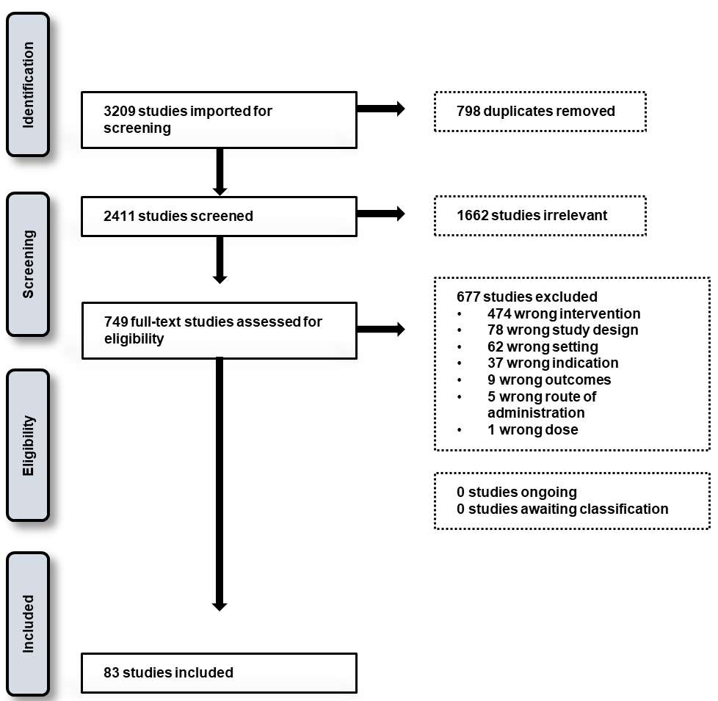
Supplementary Figure 1: PRISMA flow chart showing the number of retrieved articles from the databases.

Supplementary Table 1. Broad classification of adult collection methods

Collection method as stated by the author | Reclassification into broader categories
Artificial shelter, pit shelter, aspiration, hand capture/catch/collection, mouth aspiration, outdoor collection, outdoor resting collection, total | Aspirations targeting resting mosquitoes
All animal baited traps | Host-seeking animal baited traps
Human baited traps, human landing catches | Host-seeking human baited traps
CDC light traps, biogents sentinel traps, commercial trap (mosquito magnet can) | Host-seeking mechanical traps
Window exit traps, emergent traps, resting boxes, entrance trap | Passive traps
Pyrethrum spray catch | Pyrethrum spray catch

Supplementary Table 2. Reclassified breeding grounds.

Breeding grounds as stated by the articles | Reclassification into broader categories
Abandoned car wash, broken buckets damaged boats, discarded aluminum pots, discarded plastic containers, discarded vehicle parts, tires | Discarded human goods
Barrels, birkas, cement tanks, concrete water containers, concrete water tanks, construction water storage reservoirs, drinking water pools, fountains, metal containers, open sintex tanks, plastic containers, steel drums, temporary water storage reservoirs, water reservoirs, water storage tanks, water tanks, wells | Water reservoirs
Rural mountains, foothills, mountainous areas | Dry vegetated areas
Clay beds, non-vegetative areas | Non-vegetated areas
Coast plains, irrigation water pools, tree holes, irrigated sites, ponds, vegetative areas | Wet vegetated areas
Drainage, flooding sewage ponds, pits, unused wells, waste ponds | Wastewater

Supplementary Table 3. Reclassified chemical insecticides into broader categories.

Chemical/Biological Control/Insecticide/Larvicide | Broader Category
Adult
Alpha-cyhalothrin, alpha-cypermethrin, cyfluthrin, cypermethrin, deltamethrin, etofenprox, lambda-cyhalothrin, permethrin | Pyrethroid
Bendiocarb, propoxur | Carbamate
Dichlorodiphenyltrichloroethane, dichloro-diphenyl-dichloroethane, dieldrin, methoxychlor | Organochlorine
Chlorfenapyr | Pyrroles
Fenitrothion, malathion | Organophosphate
Larvae
Bacillus sphaericus, Bacillus thuringiensis israelensis | Bacterial larvicides
Beauveria bassiana | Microbial fungi
Gambusia affinis, Aphanius dispar, and Poecilia reticulata), Aplocheilus blockii | Biological control (larvivorous fish)
Dichlorodiphenyltrichloroethane | Organochlorine
Chlorpyriphos, fenitrothion, fenthion, malathion, temephos | Organophosphate
Cyfluthrin, deltamethrin, etofenprox, lambda-cyhalothrin permethrin | Pyrethroid

