Supplementary Information

Supplementary Table 1. CLIP 3D printed IVR fabrication. Theoretical and experimental values for human-size and macaque-size IVRs fabricated in SIL 30.

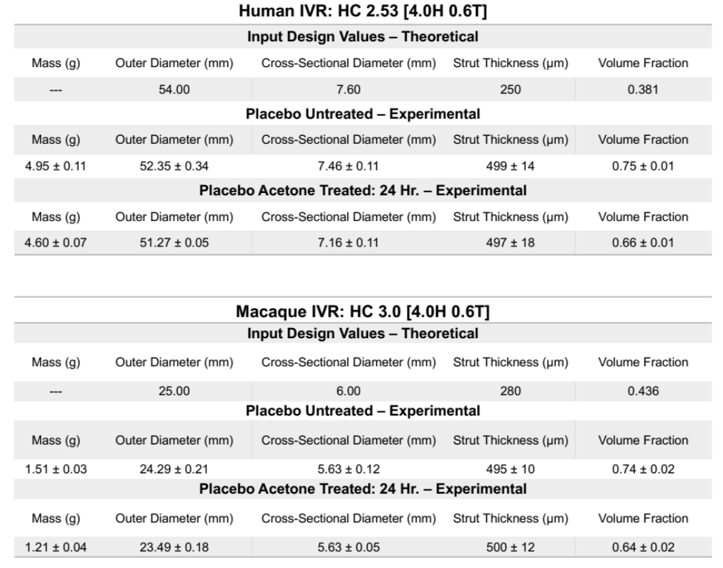
Supplementary Table 2. Weight-based drug loading equations and chemical properties for dapivirine, pritelivir, and levonorgestrel.
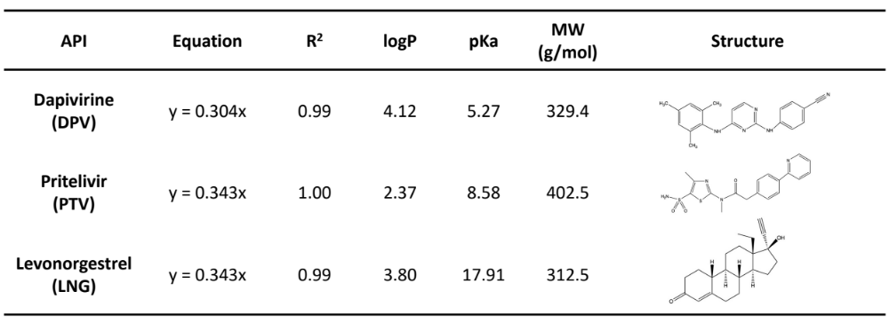
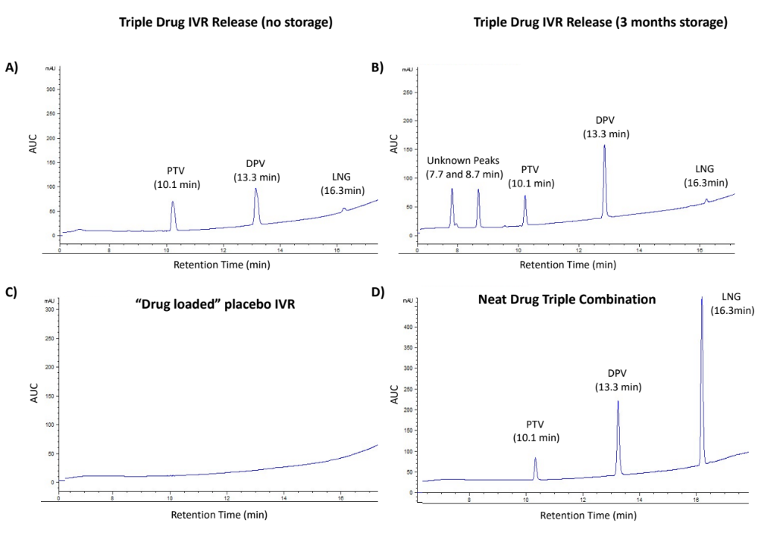
Supplementary Figure 1. HPLC chromatograms identifying source of unknown degradation peaks. A) Release sample from triple-drug IVR with release study started at t=0. B) Release sample from triple-drug IVR with release study started after t=3 months of storage in the accelerated humidity chamber (40°C/75% RH). C) Placebo IVR that has been prepared like a drug-loaded IVR but no API was included. D) Neat API in triple combination stored in the accelerated humidity chamber (40°C/75% RH) for t=3 months.

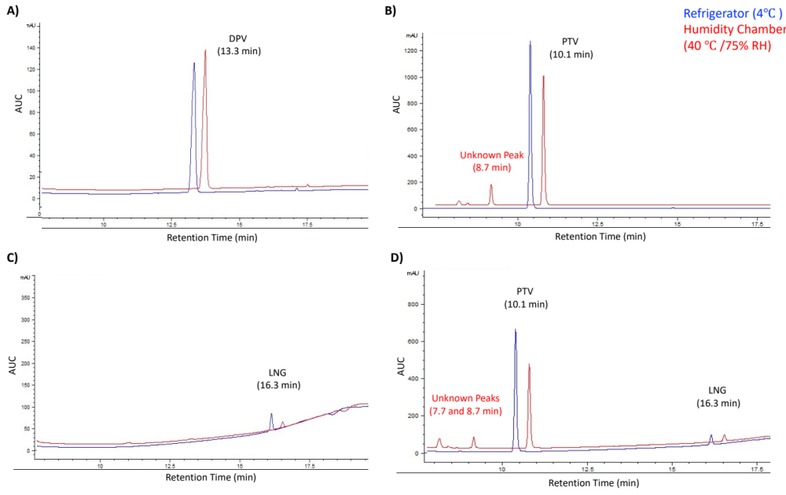
Supplementary Figure 2. HPLC chromatograms comparing IVRs after storage in 4°C/ or in the accelerated stability conditions (40°C/75% RH) for t= 3 months. A) DPV individually loaded. B) PTV individually loaded. C) LNG individually loaded. D) PTV and LNG co-formulated.

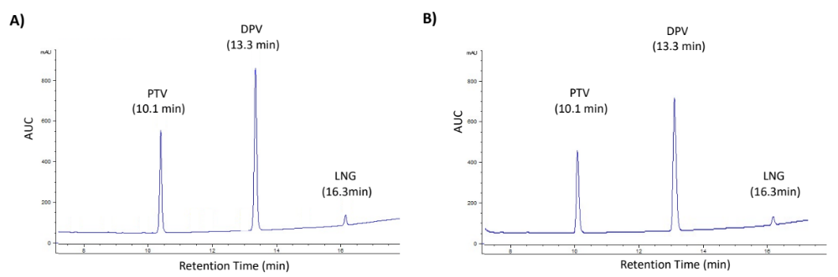
Supplementary Figure 3. HPLC chromatograms comparing triple-drug IVRs after storage in 4°C/ for A) 3 months and B) 6 months.
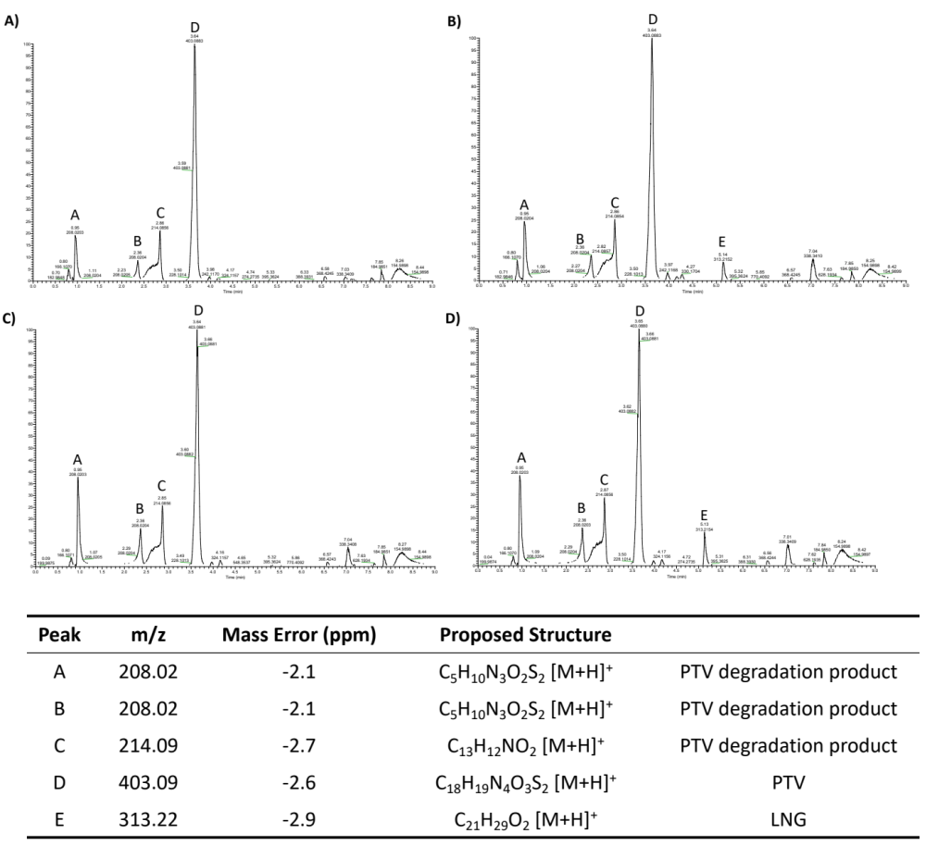
Supplementary Figure 4. Mass spectrometry analysis to understand the composition of the unknown degradation peaks. Peaks A-E are associated with a proposed structure. Peaks A and B on the chromatograms are the same product protonated differently. A) PTV individually loaded and stored under accelerated stability conditions (40°C/ 75% RH) for 3 months. B) PTV and LNG co-formulated and stored at 40°C/ 75% RH for 3 months. C) PTV individually loaded and stored at 40°C/ 75% RH) for 6 months. D) PTV and LNG co-formulated and stored at 40°C/ 75% RH) for 6 months.
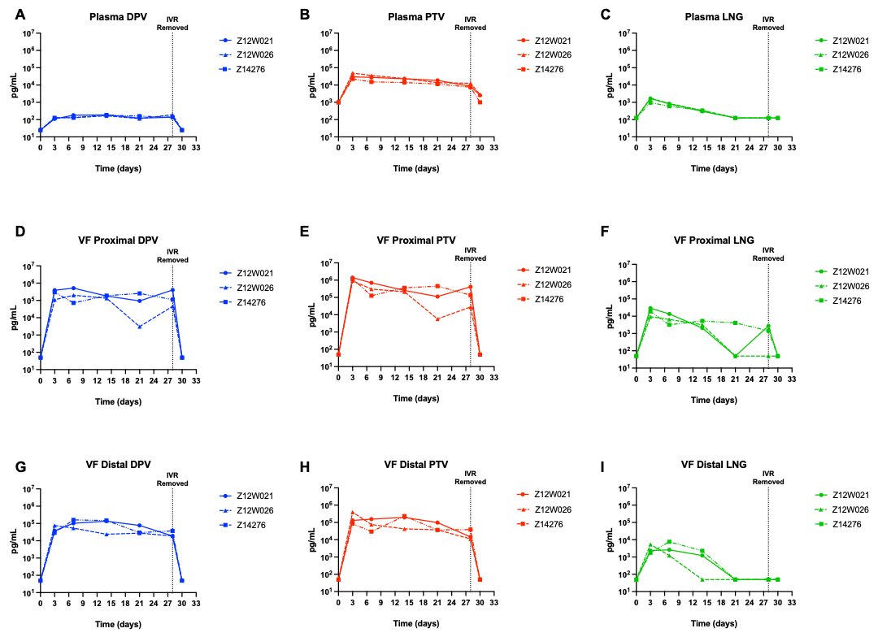
Supplementary Figure 5. Plasma concentrations of DPV, PTV, and LNG plotted for individual macaques. (A-C) Plasma concentrations of DPV, PTV, and LNG plotted for individual macaques (n=3). (D-F) Proximal vaginal fluid concentrations of DPV, PTV, and LNG plotted for individual macaques (n=3). (G-I) Distal vaginal fluid concentrations of DPV, PTV, and LNG plotted for individual macaques (n=3).

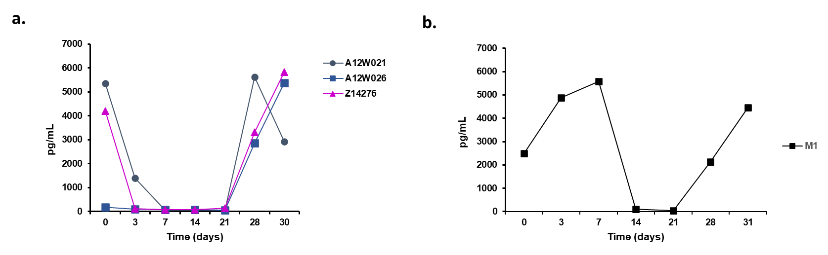
Supplementary Figure 6: Plasma progesterone measurements in macaques that received the 3D IVR: a. The plasma progesterone was measured prior to ring insertion (day 0), and days 3, 7, 10, 14, 21, 28 after ring insertion. A post ring removal measurement was done at day 30. The individual cycling patterns of the three different macaques are shown by unique symbols. b. Representative progesterone measurement in a normally cycling macaque with no contraceptive modality (not a part of this study).
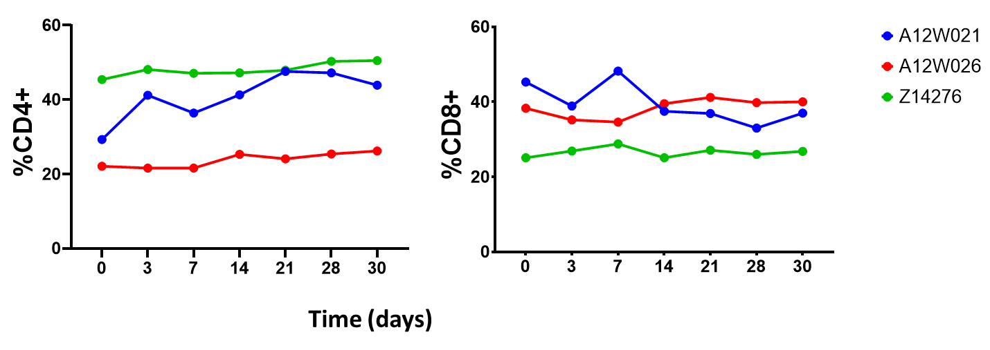
Supplementary Figure 7: Systemic CD4 and CD8 T cell frequencies in macaques that received the 3D IVR: Detection of systemic CD4+ and CD8+ T cells were found to be consistent in all the three macaques while the ring releasing the three drugs were present in the macaques and post removal.

Supplementary Table 3. Metrics for in vivo testing of the triple-drug IVR in pigtail macaque. A) Weights of n=3 macaque used in the study. B) Dosing per animal based on API loaded (mg) onto the IVR and weight (kg) of each macaque respectively.
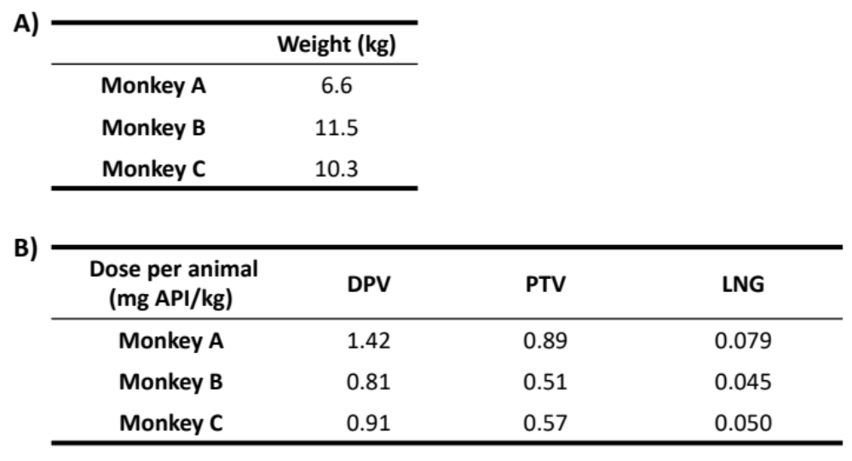

Supplementary Table 4. The pharmacokinetic results for each API from the in vivo study. Median concentrations for the group (n=3) for plasma and vaginal fluid (proximal and distal) are listed for each API across all time points.

