Table S1. Descriptive statistics for nationally-normed Private Well Water Climate Impact Index (PWWCII) variables
Variable* | PWWCIIs included in | n | Mean (standard deviation) | Median | Min-Max
Annualized drought frequency | Drought, Overall | 56,525 | 18.02 (21.24) | 8.56 | 0-130.28
Probability arsenic concentration exceeds 10 µg/L in private well water | Drought, Overall | 56,525 | 0.08 (0.12) | 0.04 | 0.01-0.99
Annualized coastal flooding frequency | Flood, Overall | 56,525 | 0.42 (1.18) | 0 | 0-4.51
Annualized hurricane frequency | Flood, Overall | 56,525 | 0.06 (0.08) | 0.01 | 0-0.44
Annualized riverine flooding frequency | Flood, Overall | 56,525 | 1.96 (1.93) | 1.5 | 0-12.67
Nitrate concentration (mg/L) in private well water | Flood, Overall | 56,521 | 1.10 (2.00) | 0.34 | 0.0002-27.66
Probability of wildfire | Wildfire, Overall | 56,525 | 0.0006 (0.002) | 0.00004 | 0-0.07
Social vulnerability index (national) | Drought, Flood, Wildfire, Overall | 56,294 | 7.15 (2.14) | 7.08 | 0.84-13.29
Percent of population on private well water | Drought, Flood, Wildfire, Overall | 56,525 | 0.16 (0.25) | 0.03 | 0.00007-1
*See Table 1 for detailed description of variables

Table S2A-D. Evaluation: examination of index correlation and convergent and divergent validity
- Spearman Correlations between variable percentiles used in each PWWCII
 | Drought percentile | Arsenic percentile | Riverine flooding percentile | Coastal flooding percentile | Hurricane percentile | Nitrate percentile | Wildfire percentile | SVI percentile | Percent well population percentile
Drought percentile | 1.00
Arsenic percentile | -0.15* | 1.00
Riverine flooding percentile | 0.02* | -0.05* | 1.00
Coastal flooding percentile | -0.03* | -0.06* | 0.11* | 1.00
Hurricane percentile | -0.13* | -0.38* | 0.13* | 0.46* | 1.00
Nitrate percentile | 0.24* | 0.15* | 0.03* | -0.16* | -0.26* | 1.00
Wildfire percentile | 0.44* | -0.31* | 0.14* | 0.01* | 0.02* | 0.04* | 1.00
SVI percentile | 0.21* | -0.03* | -0.15* | -0.03* | 0.01 | 0.05* | -0.06* | 1.00
Percent well population percentile | -0.10* | -0.10* | 0.01* | -0.11* | 0.01 | -0.16* | 0.40* | -0.15* | 1.00
*=statistically significant at p<0.05

- Spearman correlations between component percentiles and PWWCII percentiles
 | Population Characteristics percentile | Drought PWWCII score percentile | Flood PWWCII score percentile | Wildfire PWWCII score percentile | Overall PWWCII score percentile
Population Characteristics percentile | 1.00 | 0.66** | 0.64** | 0.79** | 0.69**
Drought Hazards percentile | -0.02** | 0.66** | N/A | N/A | N/A
Flood Hazards percentile | -0.13** | N/A | 0.59** | N/A | N/A
Wildfire Hazard percentile | 0.27** | N/A | N/A | 0.76** | N/A
Overall Hazards percentile | -0.01** | N/A | N/A | N/A | 0.64**
**=statistically significant at p<0.001
N/A=not applicable

- Divergent Spearman Correlations between telephone service and PWWCII score percentile
 | Owner and renter occupied housing units with telephone service^
Drought PWWCII score percentile | -0.10***
Flood PWWCII score percentile | 0.00
Wildfire PWWCII score percentile | 0.00
Overall PWWCII score percentile | -0.02***
***=statistically significant at p<0.0001
^sum of 2008-2012 ACS variables QZAE003 and QZAE012

- Convergent Spearman Correlations between Climate Vulnerability Index (CVI) Score and PWWCII score percentile
 | CVI Score
Drought PWWCII score percentile | 0.38**
Flood PWWCII score percentile | 0.55**
Wildfire PWWCII score percentile | 0.43**
Overall PWWCII score percentile | 0.52**
**=statistically significant at p<0.001

Table S3A-D. Estimated private well water population living in the nationally-normed Private Well Water Climate Impact Index (PWWCII) categories by Continental United States (CONUS) climate regions.*

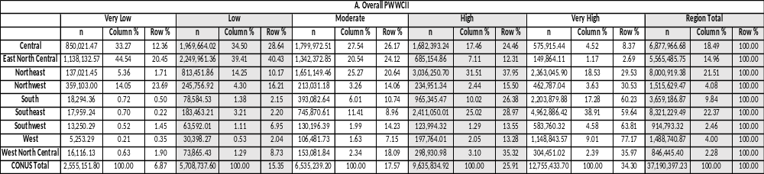
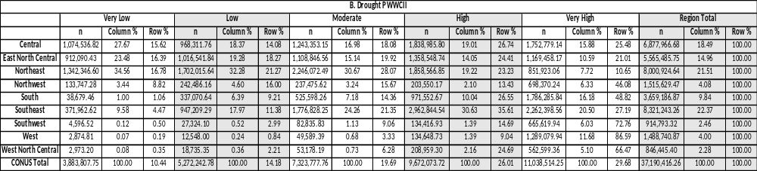

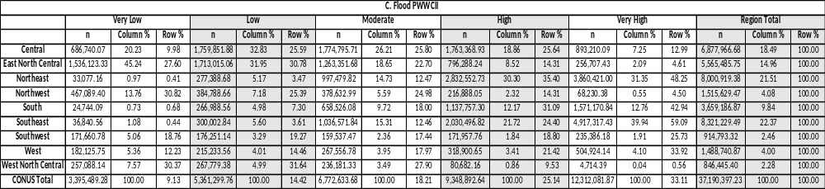
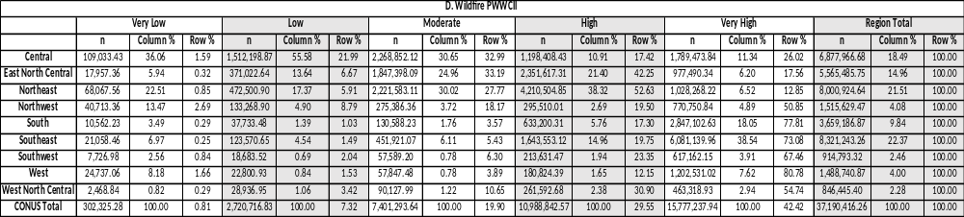

*Column % = within PWWCII category; Row % = within region/CONUS

Table S4A-D. Estimated total population within Continental United States (CONUS) living in the nationally-normed Private Well Water Climate Impact Index (PWWCII) categories and no PWW population census tracts by race/ethnicity

- Overall PWWCII
 | Total | Hispanic | NH White | NH Black | NH American Indian and Alaskan Native | NH Asian | NH Native Hawaiian and Other Pacific Islander | NH Other | NH Two or more races
No PWW population | 57,862,497 | 13,415,105 | 27,422,761 | 10,847,015 | 249,651 | 4,424,549 | 94,562 | 152,999 | 1,255,855
Very Low | 47,790,142 | 3,988,402 | 35,976,704 | 3,828,348 | 198,832 | 2,677,537 | 56,508 | 81,639 | 982,172
Low | 49,112,760 | 5,538,980 | 35,398,080 | 4,660,456 | 211,104 | 2,257,312 | 49,500 | 100,948 | 896,380
Moderate | 50,011,442 | 7,558,177 | 33,647,984 | 5,624,597 | 243,606 | 1,939,065 | 47,675 | 97,812 | 852,526
High | 50,393,797 | 7,891,979 | 33,718,064 | 5,986,370 | 342,226 | 1,507,454 | 49,049 | 86,157 | 812,498
Very High | 51,191,050 | 11,844,342 | 29,764,487 | 6,610,253 | 888,139 | 1,101,602 | 48,567 | 79,551 | 854,109

- Drought PWWCII
 | Total | Hispanic | NH White | NH Black | NH American Indian and Alaskan Native | NH Asian | NH Native Hawaiian and Other Pacific Islander | NH Other | NH Two or more races
No PWW population | 57,862,497 | 13,415,105 | 27,422,761 | 10,847,015 | 249,651 | 4,424,549 | 94,562 | 152,999 | 1,255,855
Very Low | 49,533,974 | 3,851,704 | 38,504,447 | 3,575,512 | 144,632 | 2,435,326 | 31,857 | 89,248 | 901,248
Low | 50,731,204 | 5,371,403 | 36,002,194 | 5,689,561 | 199,643 | 2,359,759 | 49,877 | 107,304 | 951,463
Moderate | 50,506,468 | 6,496,739 | 33,898,575 | 6,722,914 | 289,470 | 2,017,661 | 52,673 | 102,652 | 925,784
High | 49,420,749 | 7,936,335 | 32,180,721 | 6,528,511 | 347,897 | 1,466,961 | 52,158 | 84,342 | 823,824
Very High | 48,315,603 | 13,166,120 | 27,927,478 | 4,193,591 | 902,272 | 1,203,347 | 64,734 | 62,574 | 795,487

- Flooding PWWCII
 | Total | Hispanic | NH White | NH Black | NH American Indian and Alaskan Native | NH Asian | NH Native Hawaiian and Other Pacific Islander | NH Other | NH Two or more races
No PWW population | 57,862,497 | 13,415,105 | 27,422,761 | 10,847,015 | 249,651 | 4,424,549 | 94,562 | 152,999 | 1,255,855
Very Low | 48,339,913 | 5,351,162 | 35,469,932 | 3,313,651 | 346,212 | 2,740,566 | 65,181 | 77,519 | 975,690
Low | 49,577,713 | 6,439,918 | 35,427,096 | 4,003,009 | 386,315 | 2,259,232 | 56,899 | 86,539 | 918,705
Moderate | 49,686,995 | 6,948,263 | 34,261,597 | 5,255,004 | 354,723 | 1,863,801 | 47,200 | 91,081 | 865,326
High | 49,798,198 | 7,582,658 | 33,337,506 | 6,035,163 | 359,434 | 1,514,530 | 46,375 | 92,712 | 829,820
Very High | 51,096,372 | 10,499,879 | 30,009,188 | 8,103,197 | 437,223 | 1,104,841 | 35,644 | 98,256 | 808,144

- Wildfire PWWCII
 | Total | Hispanic | NH White | NH Black | NH American Indian and Alaskan Native | NH Asian | NH Native Hawaiian and Other Pacific Islander | NH Other | NH Two or more races
No PWW population | 57,862,497 | 13,415,105 | 27,422,761 | 10,847,015 | 249,651 | 4,424,549 | 94,562 | 152,999 | 1,255,855
Very Low | 48,339,913 | 5,351,162 | 35,469,932 | 3,313,651 | 346,212 | 2,740,566 | 65,181 | 77,519 | 975,690
Low | 49,577,713 | 6,439,918 | 35,427,096 | 4,003,009 | 386,315 | 2,259,232 | 56,899 | 86,539 | 918,705
Moderate | 49,686,995 | 6,948,263 | 34,261,597 | 5,255,004 | 354,723 | 1,863,801 | 47,200 | 91,081 | 865,326
High | 49,798,198 | 7,582,658 | 33,337,506 | 6,035,163 | 359,434 | 1,514,530 | 46,375 | 92,712 | 829,820
Very High | 51,096,372 | 10,499,879 | 30,009,188 | 8,103,197 | 437,223 | 1,104,841 | 35,644 | 98,256 | 808,144

Table S5A-D. Percent of total Continental United States (CONUS) population living in the nationally-normed Private Well Water Climate Impact Index (PWWCII) categories and no PWW population census tracts by sex and age.
- Overall PWWCII
 | Total | Male | Female | Under Age 5 | Age 5 to 24 | Age 25 to 64 | Age 65 & older
No PWW population | 15.60 | 18.77 | 19.00 | 19.22 | 19.22 | 19.17 | 16.88
Very Low | 16.03 | 15.52 | 15.68 | 14.80 | 15.27 | 15.95 | 15.27
Low | 16.32 | 16.00 | 16.06 | 15.37 | 15.73 | 16.13 | 16.61
Moderate | 16.45 | 16.32 | 16.33 | 16.24 | 16.35 | 16.23 | 16.70
High | 16.71 | 16.49 | 16.41 | 16.46 | 16.38 | 16.26 | 17.36
Very High | 18.89 | 16.91 | 16.52 | 17.91 | 17.06 | 16.27 | 17.18

B. Drought PWWCII
 | Total | Male | Female | Under Age 5 | Age 5 to 24 | Age 25 to 64 | Age 65 & older
No PWW population | 18.89 | 18.77 | 19.00 | 19.22 | 19.22 | 19.17 | 19.17
Very Low | 16.17 | 16.07 | 16.26 | 14.76 | 15.42 | 16.52 | 16.52
Low | 16.56 | 16.48 | 16.64 | 15.81 | 16.21 | 16.73 | 16.73
Moderate | 16.49 | 16.45 | 16.52 | 16.34 | 16.36 | 16.49 | 16.49
High | 16.13 | 16.20 | 16.07 | 16.42 | 16.33 | 15.91 | 15.91
Very High | 15.77 | 16.04 | 15.51 | 17.45 | 16.46 | 15.18 | 15.18

C. Flood PWWCII
 | Total | Male | Female | Under Age 5 | Age 5 to 24 | Age 25 to 64 | Age 65 & older
No PWW population | 18.89 | 18.77 | 19.00 | 19.22 | 19.22 | 19.17 | 16.88
Very Low | 15.78 | 15.78 | 15.78 | 15.36 | 15.54 | 16.10 | 15.18
Low | 16.18 | 16.17 | 16.19 | 15.70 | 16.05 | 16.19 | 16.66
Moderate | 16.22 | 16.24 | 16.20 | 16.01 | 16.18 | 16.11 | 16.83
High | 16.25 | 16.28 | 16.24 | 16.19 | 16.13 | 16.10 | 17.18
Very High | 16.68 | 16.77 | 16.59 | 17.52 | 16.87 | 16.33 | 17.26

D. Wildfire PWWCII
 | Total | Male | Female | Under Age 5 | Age 5 to 24 | Age 25 to 64 | Age 65 & older
No PWW population | 18.89 | 18.77 | 19.00 | 19.22 | 19.22 | 19.17 | 16.88
Very Low | 15.17 | 15.08 | 15.27 | 14.96 | 15.06 | 15.51 | 14.17
Low | 16.62 | 16.50 | 16.75 | 16.30 | 16.65 | 16.65 | 16.62
Moderate | 16.84 | 16.81 | 16.86 | 16.76 | 16.93 | 16.73 | 17.12
High | 16.26 | 16.32 | 16.20 | 16.26 | 16.18 | 16.08 | 17.21
Very High | 16.22 | 16.52 | 15.92 | 16.50 | 15.97 | 15.87 | 18.00

Figure S1. Simple Ordinal Regression Models: Empirical Cumulative Logits for PWWCII types by Climate Region and Race/Ethnicity
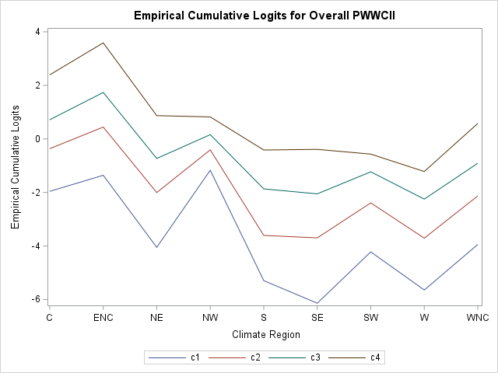
Figure Abbreviations: Central (C), East North Central (ENC), Northeast (NE), Northwest (NW), South (S), Southeast (SE), Southwest (SW), West (W), West North Central (WNC)
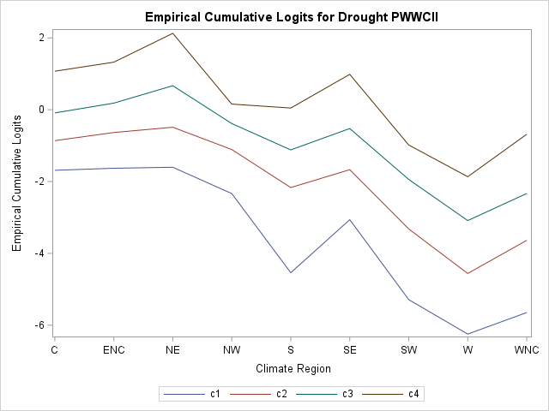

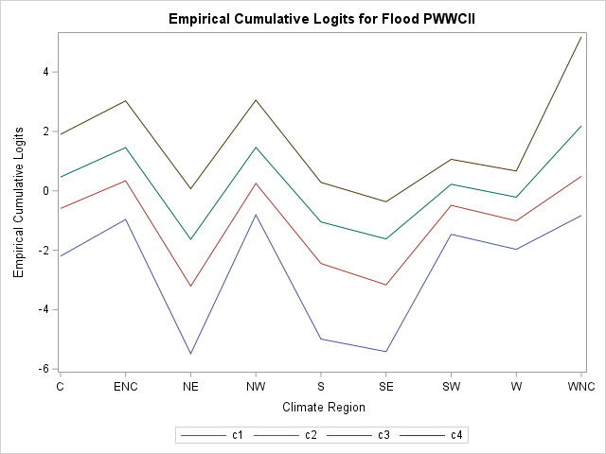

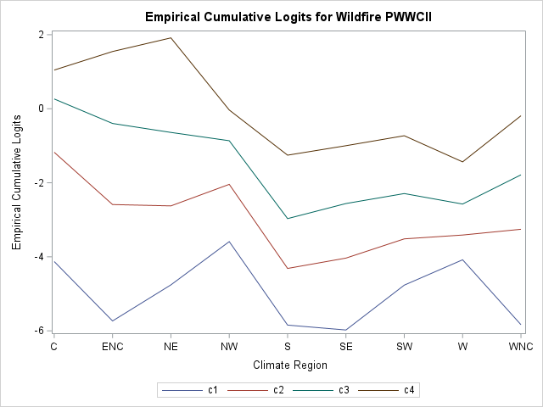

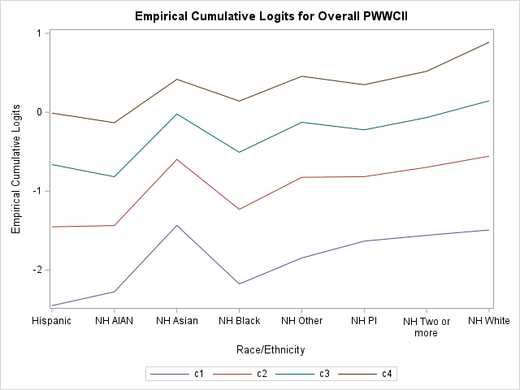
Figure Abbreviations: Non-Hispanic (NH), American Indian and Alaska Native (AIAN), PI (Pacific Islander)
