Study Protocol
Title: Using Virtual Technologies to Prevent Injuries in Adolescents with TBI
Sponsor and Award Information:
Center for Injury Research and Policy at Nationwide Children’s Hospital through Grant Number R49CE003074 from the Centers for Disease Control and Prevention
Study Team
Principal Investigator:
Sarah Anderson, OTD, OTR/L, PhD Student Health and Rehabilitation Sciences, The Ohio State University
Address: 453 W 10th Ave, Atwell Hall Suite 406, Columbus, OH, 43210
Phone: (610) 737-4187
Email: anderson.3097@osu.edu; sarah.anderson@osumc.edu
Co-PI:
Amy Darragh, PhD, OTR/L, FAOTA, Associate Professor and Occupational Therapy Division Director, The Ohio State University
Address: 453 W 10th Ave, Atwell Hall Suite 406, Columbus, OH, 43210
Phone: (614) 293-3760
Email: darragh.6@osu.edu; amy.darragh@osumc.edu
Co-Is: In-kind support and consultation will be provided by the following team:
Steve Lavender, PhD, Associate Professor, Integrated Systems Engineering, The Ohio State University
Carolyn Sommerich, PhD, Associate Professor, Integrated Systems Engineering, The Ohio State University
Celia Wills, PhD, RN, Associate Professor, Nursing, The Ohio State University
Jennifer Lundine, PhD, SLP, Research Scientist, Nationwide Children’s Hospital
Barbara Polivka, PhD, RN, Professor, Associate Dean of Research, University of Kansas Medical Center

Project Summary:
Traumatic brain injury (TBI) is the leading cause of death and disability among children and adolescents. Common sequelae include physical, cognitive, and behavioral impairments that may disrupt adolescents’ developing independence. Despite greater risk for repeated injury on discharge from hospital, little is known about injuries related to their performance of everyday activities in the home. Virtual simulation technologies have demonstrated efficacy and feasibility for use in training and rehabilitation and can be particularly engaging for adolescents. The proposed pilot study seeks to increase the home safety of adolescents by improving their ability to identify and respond to common household hazards (e.g. fire safety, household chemicals, trip hazards) using a virtual simulation training system (HH-VSTS). Our team developed the HH-VSTS to train home healthcare workers to identify and respond to health and safety hazards in client homes. We seek to modify and test this system for use with adolescents with TBI. To this end, it is critical that we identify safety hazards and concerns for adolescents with TBI in home environments (Aim 1) and identify adaptations to the HH-VSTS to improve relevancy and usability for adolescents with TBI (Aim 2). Using a mixed-methods, participatory approach, we will engage multiple stakeholders (adolescents with TBI, caregivers, and clinicians) in interviews, activities, and HH-VSTS testing. Data from this project will supply critical preliminary data for a larger study that will modify and test the effectiveness of the HH-VSTS in promoting safe performance of everyday activities in the home among adolescents with TBI.

Introduction:
Background
Over 145,000 children and adolescents live with substantial and lasting cognitive and motor impairments as a result of traumatic brain injury (TBI).^{1,2} Referred to as the “silent epidemic,” TBI occurrence is highest among adolescents aged 15-19 and can result in a wide range of cognitive and functional impairments that persist beyond the acute phase of injury.³ As a result, adolescents with TBI often are unable to return to their daily routines or manage their needs on discharge from hospital to home.^{1,4,5} Adolescence is a period of increased independence and development of skills needed for independent living.^{1,6,7} Adolescents with TBI must prepare for transition to increased independence in self-management and daily living, but motor and cognitive changes pose challenges with learning/relearning tasks and performing them safely.^{1,5,8,9} In fact, adolescents with TBI are at risk of injuries such as falls and burns on return home and while performing everyday life activities.^{10,11}
Significance
Approximately 37,000 children experience a traumatic brain injury (TBI) each year primarily due to motor vehicle accidents, falls, and sports-related injuries.^{3,12} These children and adolescents with TBI are at a much higher risk for developing motor, cognitive, behavioral, social, and adaptive functioning deficits, which can remain undetected and emerge later in life, manifesting in poor academic performance, social isolation, behavioral issues, and difficulties with employment, relationships, and the law.^{1,3} They are also at greater risk for a second brain injury.⁴ Existing research shows there are gaps in clinical care for children and adolescents with brain injuries during their transition and following discharge from hospital to home, school, or community settings.^{4,13} A primary concern for this population is their safety and functional performance; however, limited research exists on safety hazards for adolescents returning home following discharge.
To this end, there is a critical knowledge gap in our understanding of safety hazards placing these adolescents at risk and a need for effective interventions to support their health and safety in the home. Virtual technologies have demonstrated efficacy and usability in training home healthcare workers to identify and respond to hazards within the home and have shown some positive effects in the rehabilitation of cognitive deficits for adults with TBI.^{14,15} The proposed study will contribute essential information about safety hazards and will determine requirements for adapting the HH-VSTS for adolescents with TBI for home hazard safety training.
This research will also include the acquired brain injury (ABI) population, an “umbrella” diagnosis that includes other diagnoses such as stroke, anoxic brain injury, TBI, and other events.¹⁶ In doing so, we will improve the generalizability of this research to other similar populations with similar neurologic functional limitations. Given similar cognitive, physical, and functional impairments, it is likely these youth experience similar health and safety challenges in the home environment. From a practical perspective, this will provide more perspectives about the current HH-VSTS program, increase our recruitment pool, and perhaps allow us to uncover potential differences that might exist between groups to help inform our future research.
This project will provide the crucial preliminary data for submission of an R01 to adapt and test the HH-VSTS as a means to prevent injuries in adolescents with ABI as they resume everyday life activities following injury. This innovative research will add to a burgeoning area of scientific study examining the use of virtual gaming technologies with adolescents with ABI, contributing a unique focus on safety in the home setting. We will identify safety concerns and hazards as well as modifications needed to adapt the HH-VSTS for adolescents with ABI. Findings from this study will yield two manuscripts and data will support an R01 grant submission to adapt the HH-VSTS to train adolescents with ABI in home safety hazard recognition and response.
Innovation
This highly innovative project will adapt the HH-VSTS for use with adolescents with ABI. We have established the efficacy, usefulness, and usability of the HH-VSTS with home healthcare workers. We will demonstrate proof of concept for adolescents with ABI through assessment of safety concerns from multiple perspectives and evaluation of design considerations from our intended user-group. Further, we are applying the HH-VSTS in a novel way to solve an understudied problem in adolescents with ABI. In addition, we will apply a user-centered, participatory approach to assess the design consideration of virtual gaming technologies to health and safety training adolescents with ABI. Finally, we have a well-established multidisciplinary team, with a long history of collaboration, grant submissions, and presentations/publications, of occupational therapy, speech therapy, engineering, occupational health, and nursing, that will engage through paid and in-kind effort to the project to ensure a broad and diverse perspective.
Overall Objective and Hypothesis
The overall objective of this research is to improve safety outcomes for adolescents with ABI. To this end, we will adapt and test our highly innovative, game-based, home healthcare virtual simulation training system (HH-VSTS) to teach adolescents with ABI how to identify and respond to safety hazards in their homes. Our research team created the efficacious and usable HH-VSTS to train home healthcare workers (HHW) to identify and respond to hazards (e.g. fire, biohazards, slip/trip) they encounter in client homes.¹⁴ The HH-VSTS is readily adaptable for adolescents with ABI. It capitalizes on video gaming technologies that appeal to adolescents and has substantial potential for engaging and effective safety training in this population.^{1,17} The proposed study will yield critical information necessary for the adaptation of the HH-VSTS for adolescents with ABI, including the priority safety concerns of stakeholder groups (parents, healthcare workers, individuals with ABI) and modifications necessary to improve the appeal and relevancy of the HH-VSTS.
Aims
Aim 1: Identify safety hazards and concerns for adolescents with ABI in the home environment.
Research Questions:
- What are the priority safety concerns during performance of everyday activities in the home for individuals with ABI, their caregivers, and their healthcare providers?
- To what extent does the current HH-VSTS require content adaptation to address these priorities?
Aim 1 will use a qualitative approach to determine stakeholder perceptions of priority safety hazards encountered by adolescents with ABI at home. When integrated with epidemiological injury data, this will inform the modification of the existing HH-VSTS to ensure it is relevant for adolescents with ABI.
Aim 2: Identify adaptations to the HH-VSTS that will improve the user experience for adolescents with ABI.
Research Questions:
- How do adolescents with ABI perceive the usability, usefulness, and desirability of the current HH-VSTS?
- What adaptations must be made to increase the usability, usefulness, and desirability of the HH-VSTS for adolescents with ABI?
Aim 2 will use a mixed-methods approach to gather quantitative (the Usefulness, Usability, and Desirability Assessment) and qualitative (Focus Groups and Interviews) data regarding the HH-VSTS. Data will inform future modifications of the HH-VSTS to improve usability, usefulness, and desirability for adolescents with ABI.

Methods:
Design
The study will use a mixed-methods user-centered participatory approach incorporating grounded theory to 1) determine the priority health and safety concerns of stakeholders and 2) assess essential HH-VSTS training elements for usability, usefulness, and desirability.
Participants
Eligibility Criteria
For inclusion, study participants must:
- Fit the criteria for one of three stakeholder groups:
  - be an adolescent with an ABI between the ages of 12 – 19 (ABI diagnosis per medical record or self-report for those recruited via word of mouth or community)
  - OR parent/caregiver over the age of 18 of an adolescent with an ABI
  - OR a health professional over the age of 18 involved in discharge planning and community re-integration of adolescents with ABI.
- Participants must be able to speak and read English and be able to answer researcher questions (verbally or through typing).
- Participants who wish to complete Aim 1 and/or Aim 2 study procedures online must:
  - Have access to a computer or smart device with reliable internet access and power source, a microphone, speakers/headphones, and video camera.
  - Have access to a private/comfortable and quiet space to participate from.
- Participants who wish to complete Aim 1 and/or Aim 2 study procedures in-person must have the means to transport themselves to/from Atwell Hall (OSUWMC) or NCH.
Eligibility Screening
Dr. Lundine, Dr. Darragh, and Dr. Anderson will screen the eligibility of potential participants. For participants who will be identified through medical record review at NCH, initial eligibility screening will be conducted at the time of identification. Eligibility criteria will be confirmed and other eligibility factors, such as ability to participate in the study, will be screened during recruitment of potential participants over phone, email, or in-person. For participants who will be identified through other means at other community settings, eligibility of potential participants will be screened during recruitment of potential participants over phone, email, or in-person.
Recruitment
Forty-five individuals, representing three stakeholder groups identified in Figure 1, will be recruited from the community and Nationwide Children’s Hospital (NCH). Participants will be identified through multiple means including: medical record review and informational flyers placed and distributed by Nationwide Children’s Hospital through collaboration with our colleague Dr. Lundine, as well as through recruitment at community support groups, outpatient rehabilitation, and local health facilities. Medical record review and recruitment at NCH will be conducted by Dr. Lundine, Dr. Darragh, and Dr. Anderson. NCH recruitment information will be shared with partners via approved secure file-sharing cloud service (DropBox). Eligible individuals who are current inpatients or outpatients at NCH will receive an informational flyer and an informational opt-out letter. Unless informed otherwise, research personnel will contact these participants within one or two weeks of identification.
Recruitment will also occur by email, phone, fliers, and social media. Snowball sampling to recruit a convenience sample of stakeholders will also be used: potential participants will be encouraged to refer others they feel are appropriate for the study. We intend to recruit parent-adolescent dyads when possible, however will not limit participation of these two stakeholder groups solely to dyads for maximum flexibility.
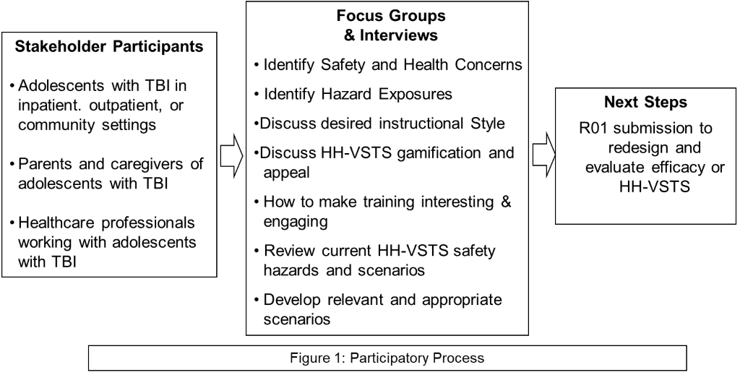
Incentives
Each participant who completes part or all the study session(s) will receive an Amazon e-gift card in amounts of $25.00 or $50.00. We will use participant emails to distribute these. Participants who complete Aim 1 study procedures will receive $25.00 and will receive an additional $25.00 upon completion of Aim 2 procedures. These will be distributed after the session as a singular $50.00 amount if both Aims are completed during the same session, or separately if the participant only completes the Aim 1 procedures. Participants who need to complete Aim 2 study procedures at a separate time will receive the additional $25.00 upon completion of the Aim 2 session. Participants who withdraw or fail to follow-up after completion of the Aim 1 session will not receive the additional $25.00.
Participants who complete the optional follow-up session will receive an additional $25.00 gift card, leading to a potential total of $75.00
In the case where a participant does not have an email, they will be mailed a physical gift card upon completion of Aim 1, Aim 2, or optional follow-up session procedures and will be informed to expect delays in distribution. This method will require participant names and mailing addresses for distribution.
Gift card receipts will be completed by research personnel for each one distributed.
Consent
All participants will review and sign informed consent, parental permission, and/or assent as appropriate, using processes approved by Nationwide Children’s Hospital’s Institutional Review Board. All adolescents with ABI will sign an assent form, and questions regarding their understanding of the study procedures will be provided if need be. The consent/assent/permission documents describe the study purpose, procedures, risks, benefits, incentives, data privacy, participant rights, and voluntary nature of the research. They also detail the use of audio recording for in-person sessions and audio and video recording for online Zoom sessions.
Participants may complete the consent process in-person at NCH or Atwell Hall (OSU), or remotely through Zoom or phone. All participants will receive the consent documentation to review ahead of time if possible. Participants consented in-person will sign two copies of the approved consent/assent/parental permission forms and receive a copy for their records. A waiver of consent documentation will be obtained for those consenting remotely through Zoom or phone, who will indicate consent verbally and/or in text chat. Upon initiating each study session recording, all participants will confirm their consent/assent/permission to participate. Both in-person and online participants will receive the same consent/assent/parental permission documents and these documents will be used as the verbal scripts.
Participants must complete the consent/assent/permission process prior to engaging in any other study activities, however, they may choose to complete consent at the time of recruitment or at another time after recruitment. All participants recruited should be consented and complete study activities within 2-4 weeks of recruitment, however, it is possible to extend this window on an individual basis.
Withdrawal of Subjects
Participants will be withdrawn from the research if they explicitly state intention for withdrawal, or if they fail to follow-up with research personnel after 3 attempts to contact them regarding any incomplete study procedures or materials.
Upon withdrawal from the study, all participants who have not received a gift card, who should get one, will be sent one or given one. Already collected participant data, consent forms, and gift card receipts will be kept, analyzed, and stored securely.
If participants are withdrawn by the researchers or if they choose to withdraw from the study, the data associated with their de-identified ID will be included in analysis and this attrition will be reported through intent-to-treat analysis.
Measures
All data will be collected via paper documents or RedCap, and all data will be ultimately entered into RedCap via the participants and/or study personnel.
All participants will complete a questionnaire about demographic/background characteristics. Pediatric ABI participants and caregivers of pediatric ABI participants will also complete the Pediatric Glasgow Outcome Scale – Extended (GOS-E Peds), a gold-standard developmentally appropriate interview-based functional outcome measure for TBI, with research personnel. This measure has been previously validated for this population and will be used to determine severity of injury for pediatric participants in this study.¹⁸
Aim 1 Measures
Aim 1 focus group/interview question topics are in Table 1. Participants will be asked to describe their everyday activities and any concerns about or experiences with potential threats to their safety within the physical home environment. In addition, they will rate the frequency and severity of these perceived hazards on a two-axis scale (Figure 2). This method, previously successfully implemented by the research team, will be used to assess the usefulness, or relevance, of the current HH-VSTS hazards, and to identify gaps, that is topics that will need to be added to the adolescent ABI version. Perceived hazards will be compared with scientific literature on injuries in the home for this population, to develop a prioritized hazard list. Participants will also complete a Hazard questionnaire to determine what hazards and potential resulting injuries they are concerned about for themselves/this population in the home.
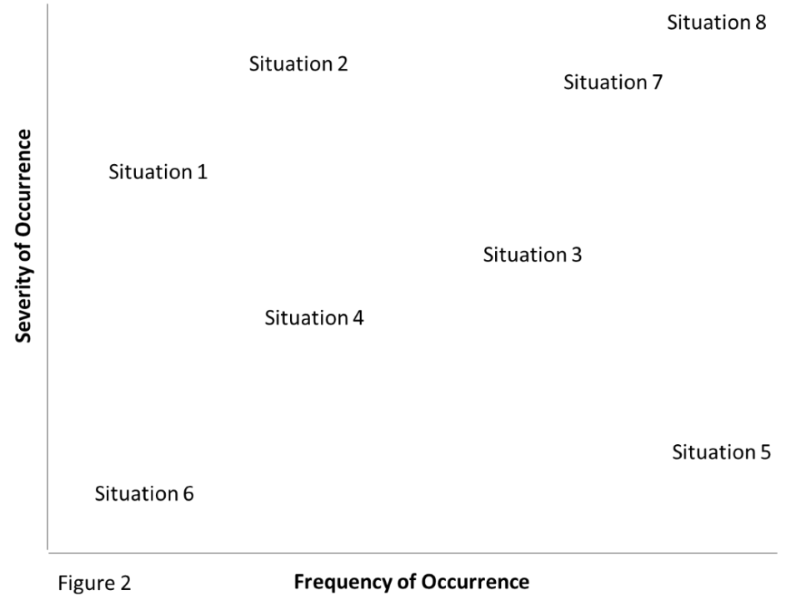
Table 1. Focus Group/Interview Question Topics
Aim 1
Understanding environment and activity: e.g. design, structure of home; activities performed in a typical day; activities performed independently/without supervision
Activity performance: e.g. current challenges with performing activities; challenges with activity performance
Safety concerns and Hazards: e.g. concerns for your/the child’s safety at home; primary safety considerations for discharge recommendations; most relevant or important safety hazards
Aim 2
Usability: e.g. using the game; is content understandable; HH-VSTS strengths, limitations, concerns
Usefulness: e.g. content and its relevance to you/your child/adolescents with ABI; recommendations for additions and removals
Desirability: e.g. appeal of HH-VSTS; recommendations to make it more engaging or fun.

Aim 2 Measures
Aim 2 focus group/interview question topics are in Table 1. Usability, usefulness, and desirability (UUD) of the HH-VSTS will be assessed using individual interviews, behavioral observations, and our study-specific UUD assessment tool to fully assess the usability and appeal of the HH-VSTS, and understand potential modifications. The current UUD survey tool gathers data on the usability (ease of use) (9 items), usefulness (value, relevance, and applicability) (10 items), and desirability (overall appeal or interest) (4 items) of the HH-VSTS, and will be customized to include items specific to the ABI population. Items are rated on a five-point Likert-type scale. We used this instrument successfully in the development and testing of the HH-VSTS.¹⁴ Subjective experiences and perceptions will be assessed in interviews. Investigators will document observations of usability issues; e.g., system hardware challenges, selecting hazards. To provoke discourse, participants will be shown/demonstrated and/or try some parts of the HH-VSTS (e.g., through pre-recorded video, screen capture, etc.).
Optional Follow-Up Session Measures
Prior to the optional follow-up session (for Children and Caregiver participants who previously participated during IPR and have since been discharged), participants will complete the Follow-Up Demographics questionnaire, the GOS-E Peds, and the Hazard Checklist. The follow-up session will contain additional focus group/interview questions about 1) the change in child’s functional ability and performance, 2) the transition from hospital to home and any ongoing services received, 3) any changes in home and community safety concerns and the current concerns, 4) any present/ongoing challenges being faced and supports that are helping, and 5) looking forward: the anticipated road to recovery and current goals. The frequency and severity rating of hazards will also be completed again via the Hazard Matrix used in Aim 1.
Setting
Data will be collected either in-person or online through a web-based video-conferencing software (Zoom). In-person data collection will occur either at NCH or at The Ohio State University Wexner Medical Center in Atwell Hall. Participants will be responsible for their own travel and parking expenses. Online data collection will occur via Zoom web-conferencing software.
Procedures
Focus Group/ Interview Scheduling
Group and/or individual interviews (in-person or online) will be conducted to capture the range of activities and associated safety concerns of these stakeholder groups. While we anticipate saturation will be achieved with interviews of approximately fifteen people in each stakeholder group, interviews will continue until saturation is achieved. For adolescents with ABI, groups will be structured with two to five individuals (a smaller group size is suggested to accommodate potential cognitive challenges). Participants will be placed into two distinct age groups for focus groups and interviews whenever possible: ages twelve to fourteen, and ages fifteen to seventeen. This will create groups of individuals at relatively similar stages of development and maturation.
Separate parent group/individual interviews will be run simultaneously, though a parent/child dyad group may be facilitated upon request. Healthcare workers can participate individually or in a group of up to 8. Individuals with ABI and family will have the option of completing Aim 2 activities individually at another time if the length of the group session is physically or cognitively challenging. Group interviews are the preferred method of data collection, but individual interviews will be completed if scheduling becomes a challenge.
Child and Caregiver participants who completed Aim1 study procedures during their inpatient rehabilitation stay will have the option of completing an additional follow-up session at a later time upon discharge from the hospital. They may decide to participate in this additional setting while consenting to participate or at a later time. They will be informed of this optional follow-up session during the consent process and after completion of Aim 1 and/or Aim 2 study procedures. If they are or may be interested in participating in a follow-up session, they may be scheduled immediately or contacted at a later time via phone/email/text as desired to schedule a follow-up session.
Data Collection Procedures
Each focus group will last approximately 2-2.5 hours. Research personnel will ensure that all measures distributed to participants prior to the session (i.e., demographics questionnaire, Hazards questionnaire, GOS-E peds) have been completed, or these will be completed prior to/during the discussion period. Initially, the facilitator will ask questions about everyday activities, hazards the participants think might be related to those activities, and any they actually have encountered in the home environment. Participants will be asked to identify their top 3-5 hazards, to establish stakeholder priorities (total = 40 - 60 minutes). After a short break, participants will be shown a module in the HH-VSTS and will be asked to provide feedback to UUD items, through discussion and through the UUD measure. In addition, all participants will have the opportunity to try the game during the group session, should they choose (40 – 60 minutes). All focus groups and individual interviews will be audio/video recorded. All participants across stakeholder groups will have the option of completing Aim 1 and 2 activities individually, should scheduling or fatigue preclude participation in a single session. Participants who wish to try the HH-VSTS for Aim 2 will also have the option of scheduling a separate time to complete that in-person.
Child and Caregiver participants who completed Aim 1 study procedures during IPR will have the option to participate in a follow-up session after discharge from the hospital. Participants will complete several measures prior to or during the session (i.e., follow-up demographics questionnaire, GOS-E peds, Hazards questionnaire). This session will run similar to Aim 1 study procedures (about 40-60 minutes): It will consist of a separate set of focus group questions regarding transition home and changes in activity performance and safety concerns. It will also include the hazard rating activity mentioned previously.
Duration
Each focus group or interview will last approximately 2-2.5 hours. All study procedures will take place on the participant’s own time before the session (e.g., some surveys), or during a single 2-2.5-hour session unless fatigue or scheduling require activities to be split into multiple sessions (anticipated maximum of 3 sessions). This circumstance would lead to multiple smaller sessions with a combined total time of approximately 2.5 hours. All interviews/focus groups will be completed within a period of 4 months. All three stakeholder groups will have approximately the same duration.
Additionally, Child and Caregiver participants who completed Aim 1 study procedures during IPR will have the option to participate in a focus group/interview follow-up session (~60 min.) after discharge from the hospital.
Participant Information
No PHI will be collected from participants as part of data collection. All identifiers collected during data collection will be destroyed and all documentation de-identified. All identifiers collected for recruitment and incentive distribution purposes will be destroyed following their completion in the study and distribution of the gift cards. The only documentation with remaining identifiers will be consent forms and gift card receipt forms.
Data Management
All physical data collected will be stored in secured filing cabinets in Dr. Darragh’s office in Atwell Hall 406, or lab in Atwell Hall 158. Documents with identifiers such as consent forms and gift card receipts will be stored separately from de-identified documents. All digital data will be stored on a RedCap project and a secure server behind the OSU firewall, on a secure OSUMC computer. Likewise, identified and de-identified digital documents will be stored separately.
Data Analyses
Demographics will be descriptively analyzed in SPSS-PC. Quantitative UUD and hazard data will be entered into an SPSS-PC database for descriptive analysis (e.g., frequency tables, medians, bar charts). Qualitative interviews will be transcribed and analyzed using the method of constant comparison. Two analysts independently will identify key categories and codes iteratively. Consensus on codes and categories (verified through percent agreement analyses: >85% required) will yield a final coding structure. Final themes will be confirmed by consensus and triangulated with additional data sources as follows: Aim 1 with epidemiologic injury data and frequency/severity ratings; Aim 2 with UUD assessment and observations.
Adverse or Unexpected Events
There is no greater than minimal risk for participating in this study. The risk is no greater than that experienced in everyday life both in-person or online. There is some risk when conducting activities online, but all efforts will be made to ensure data security. There is also some risk when participating in focus groups with others. These potential risks involve a break of data and participant confidentiality.
Due to the currently ongoing COVID-19 pandemic, most research activities will be conducted remotely and online. If preferred by participants and/or necessary for data collection, activities may occur in-person. For any in-person activities, all current safety guidelines and procedures by OSU and/or NCH will be followed. Only researchers will have access to study data and documents, and all will be stored on RedCap, an OSUMC server, and in a secured filing cabinet. All participants will be instructed and encouraged to keep all information shared during focus groups confidential.
Benefits to Participation
Participants may learn something new about home safety hazard identification and management for themselves and/or their loved ones. Participants may also learn something about innovative technology solutions. Participants may also meet others who share and validate their experiences and concerns.
This research has the potential to impact all adolescents with acquired brain injury by identifying common home safety risks for this population and solutions for managing those risks through interviews with primary stakeholders. It will also provide insight into the usability of innovative virtual simulations usable by this population.
Proposed Timeline
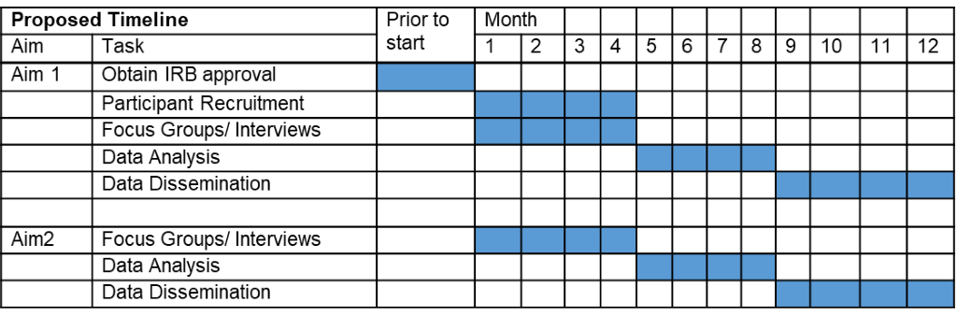
Dissemination and Reporting of Results
We plan to publish two papers, one addressing each aim, in journals of rehabilitation science and/or virtual simulations to disseminate our findings of safety concerns and virtual simulation appeal for this population. These data will also be submitted to several regional, national, and/or international conferences in our fields.
Future Directions
Data from this study will serve as preliminary data for an R01 submission through NIH to modify and test HH-VSTS for adolescents with ABI. This research has the potential to improve health and safety for adolescents with ABI as they begin to increase independence and prepare for independent living.
References:
1. Centers for Disease Control and Prevention. Report to congress: The management of traumatic brain injury in children: Opportunities for action. National Center for Injury Prevention and Control; Division of Unintentional Injury Prevention. 2018:1-90.
2. Zaloshnja E, Miller T, Langlois JA, Selassie AW. Prevalence of long-term disability from traumatic brain injury in the civilian population of the united states, 2005. J Head Trauma Rehabil. 2008;23(6):394-400. https://www.ncbi.nlm.nih.gov/pubmed/19033832. Accessed Apr 21, 2020. doi: 10.1097/01.HTR.0000341435.52004.ac.
3. Centers for Disease Control and Prevention. Report to congress on traumatic brain injury in the united states: Epidemiology and rehabilitation. National Center for Injury Prevention and Control; Division of Unintentional Injury Prevention. 2015:1-72.
4. Lindsay S, Hartman LR, Reed N, Gan C, Thomson N, Solomon B. A systematic review of hospital-to-school reintegration interventions for children and youth with acquired brain injury. PLoS One. 2015;10(4):e0124679. doi: 10.1371/journal.pone.0124679.
5. Semrud-Clikeman M. Pediatric traumatic brain injury: Rehabilitation and transition to home and school. Appl Neuropsychol. 2010;17(2):116-122. https://www.ncbi.nlm.nih.gov/pubmed/20467952. Accessed Apr 21, 2020. doi: 10.1080/09084281003708985.
6. Santelli JS, Smith Rogers A, Rosenfeld WD, et al. Guidelines for adolescent health research. A position paper of the society for adolescent medicine. J Adolesc Health. 2003;33(5):396-409. https://www.ncbi.nlm.nih.gov/pubmed/14596961. Accessed Apr 21, 2020.
7. Petersen AC, Leffert N. Developmental issues influencing guidelines for adolescent health research: A review. J Adolesc Health. 1995;17(5):298-305. https://www.ncbi.nlm.nih.gov/pubmed/8924434. Accessed Apr 21, 2020. doi: 10.1016/1054-139x(95)00184-t.
8. Clasby B, Hughes N, Catroppa C, Morrison E. Community-based interventions for adolescents following traumatic brain injury: A systematic review. NeuroRehabilitation. 2018;42(3):345-363. https://www.ncbi.nlm.nih.gov/pubmed/29660966. Accessed Apr 21, 2020. doi: 10.3233/NRE-172385.
9. Leopold A, Lourie A, Petras H, Elias E. The use of assistive technology for cognition to support the performance of daily activities for individuals with cognitive disabilities due to traumatic brain injury: The current state of the research. NeuroRehabilitation. 2015;37(3):359-378. https://www.ncbi.nlm.nih.gov/pubmed/26518531. Accessed Apr 21, 2020. doi: 10.3233/NRE-151267.
10. Seel RT, Macciocchi S, Velozo CA, et al. The safety assessment measure for persons with traumatic brain injury: Item pool development and content validity. NeuroRehabilitation. 2016;39(3):371-387. https://www.ncbi.nlm.nih.gov/pubmed/27497470. Accessed Apr 21, 2020. doi: 10.3233/NRE-161369.
11. Gielen AC, McDonald EM, Shields W. Unintentional home injuries across the life span: Problems and solutions. Annu Rev Public Health. 2015;36:231-253. Accessed Apr 21, 2020. doi: 10.1146/annurev-publhealth-031914-122722.
12. Kurowski BG, Wade SL, Kirkwood MW, et al. Association of parent ratings of executive function with global- and setting-specific behavioral impairment after adolescent traumatic brain injury. Arch Phys Med Rehabil. 2013;94(3):543-550. https://www.ncbi.nlm.nih.gov/pubmed/23131527. Accessed Apr 21, 2020. doi: 10.1016/j.apmr.2012.10.029.
13. Seabury SA, Gaudette É, Goldman DP, et al. Assessment of follow-up care after emergency department presentation for mild traumatic brain injury and concussionresults from the TRACK-TBI study. JAMA Network Open. 2018;1(1):e180210. doi:10.1001/jamanetworkopen.2018.0210.
14. Polivka BJ, Anderson S, Lavender SA, et al. Efficacy and usability of a virtual simulation training system for health and safety hazards encountered by healthcare workers. Games for Health Journal. 2019;8(2):121-128. http://doi.org/10.1089/g4h.2018.0068.
15. Manivannan S, Al-Amri M, Postans M, Westacott LJ, Gray W, Zaben M. The effectiveness of virtual reality interventions for improvement of neurocognitive performance after traumatic brain injury: A systematic review. The Journal of Head Trauma Rehabilitation. 2019;34(2):E52-E65. https://journals.lww.com/headtraumarehab/FullText/2019/03000/The_Effectiveness_of_Virtual_Reality_Interventions.15.aspx?casa_token=8cj40zfMXLwAAAAA:GrtlXZq9W_1NNm0W87VlP32KtRdoT4VtAmUDkbhr59JI2_ueJ8saiwBmbpW_c_vQzaRx6pO0C71Hod1hnUOfJ_Y. Accessed Apr 14, 2020. doi: 10.1097/HTR.0000000000000412.
16. Brain Injury Association of America. (n.d.). Brain injury overview. https://www.biausa.org/brain-injury/about-brain-injury/basics/overview
17. Zayeni D, Raynaud J, Revet A. Therapeutic and preventive use of video games in child and adolescent psychiatry: A systematic review. Frontiers in psychiatry. 2020;11:36. https://www.ncbi.nlm.nih.gov/pubmed/32116851. doi: 10.3389/fpsyt.2020.00036.
18. Beers, S.R., Wisniewski, S.R., Garcia-Filion, P., Tian, Y., Hahner, T., Berger, R.P., Bell, M.J. and Adelson, P.D., 2012. Validity of a pediatric version of the Glasgow Outcome Scale–Extended. Journal of neurotrauma, 29(6), pp.1126-1139.

