eTable 1. Search strategy for key focus areas addressed in the guidelines
Medline via Ovid
- exp Colitis, Ulcerative/
- ((ulcerative adj2 colitis) or (colitis adj2 gravis)).tw,kw
- 1 or 2
- exp Mercaptopurine/
- exp Azathioprine/
- (6-Mercaptopurine or 6-MP or me?captopurin# Puri#ethol or Purixan or azothioprine or Azathioprine or Azasan or Im?uran or imurel).tw,kw
- exp METHOTREXATE/
- (Methotrexate or Otrexup or Rasuvo or Rheumatrex or Trexall or MTX or Amethopterin or mexate).tw,kw.
- exp Antibodies, Monoclonal/
- exp Infliximab/
- exp Adalimumab/
- exp Sphingosine 1 Phosphate Receptor Modulators/
- exp Janus Kinase Inhibitors/
- exp Ustekinumab/
- exp Interleukin-12/
- exp Interleukin-23/
- (infliximab* or renflexis or "monoclonal antibody cA2" or "MAb CA2" or inflectra or remicade).tw,kw.
- (adalimumab* or humira or cyltezo or (D2E7 adj2 antibody)).tw,kw.
- (golimumab or CNTO-148 or "CNTO 148" or simponi).tw,kw.
- (vedolizumab or entyvio or MLN0002 or MLN02 or "MLN-0002" or "MLN-02").tw,kw.
- (ozanimod or RPC1063 or zeposia or estrasimod).tw,kw.
- (tofacitinib or xeljanz or jakvinus or "CP 690,550" or CP690550 or "CP-690550" or "CP 690550" or "CP-690,550").tw,kw.
- (upadacitinib or "(3S,4R)-3-ethyl-4-(3H-imidazo(1,2-a)pyrrolo(2,3-e)pyrazin-8-yl)-N-(2,2,2-trifluoroethyl)-1-pyrrolidinecarboxamide" or "ABT-494" or rinvoq).tw,kw.
- (GLPG0634 or filgotinib).tw,kw.
- (ustekinumab or stelara or "CNTO 1275" or "CNTO-1275").tw,kw.
- ("Interleukin-12" or "Natural Killer Cell Stimulatory Factor" or "IL-12" or "IL 12" or "Cytotoxic Lymphocyte Maturation Factor" or "interleukin 12" or IL12 or "edodekin alfa").tw,kw.
- ("Interleukin-23" or "Interleukin 23" or "IL-23").tw,kw.
- (mirikizumab or "LY-3074828" or LY3074828).tw,kw
- (risankizumab* or "ABBV-066" or skyrizi or "BI 655066" or "BI-655066").tw,kw.
- (guselkumab or tremfya or "CNTO 1959" or "CNTO-1959").tw,kw.
- exp Immunologic Factors/
- ((immunologic* adj1 factor*) or (immune adj1 factor*) or biomodulator* or immunomodulator* or (biological adj2 modifier*)).tw,kw
- exp Mesalamine/
- (5-ASA or "5-aminosalicylic acid" or asacol* or mesalamine or mesalazine or mesasal or "5 aminosalicylate" or fivasa or canasa or delzicol or lialda or pentasa or rowasa or octasa or apriso or sfrowasa or dipentum or colazal or mezavant).tw,kw
- or/4-34
- 3 and 35
- (exp Child/ or exp Infant/ or exp Adolescent/) not exp Adult/
- 36 not 37
- exp animals/ not exp humans/
- 38 not 39
- limit 40 to english language
- (systematic review or meta-analysis).pt.
- meta-analysis/ or systematic review/ or meta-analysis as topic/ or systematic review as topic/ or "meta analysis (topic)"/ or "systematic review (topic)"/ or exp technology assessment, biomedical/ or network meta-analysis/
- ((systematic* adj3 (review* or overview*)) or (methodologic* adj3 (review* or overview*))).ti,ab,kf,kw.
- (met analy* or metanaly* or "technology assessment*" or HTA or HTAs or "technology overview*" or "technology appraisal*").ti,ab,kf,kw.
- ("meta regression*" or metaregression*).ti,ab,kf,kw.
- (meta-analy* or metaanaly* or "systematic review* " or "biomedical technology assessment* " or "bio-medical technology assessment*").mp,hw.
- Randomized Controlled Trial.pt.
- controlled clinical trial.pt
- exp Randomized Controlled Trials as Topic/
- Randomized Controlled Trial/ or Randomization/ or Random Allocation/ or Double-Blind Method/ or Double Blind Procedure/ or Double-Blind Studies/ or Single-Blind Method/ or Single Blind Procedure/ or Single-Blind Studies/ or Placebos/ or Placebo/
- (placebo or randomly or randomi#ed).ab
- trial.ti,ab
- ((singl* or doubl* or tripl* or trebl*) adj (blind* or dumm* or mask*)).ti,ab,hw,kf,kw.
- or/42-54
- 41 and 55
- Case reports.pt
- Comment.pt
- Editorial.pt
- or/57-59
- 56 not 60
- ..dedup 61
- epidemiologic studies/
- cohort studies/
- longitudinal studies/
- follow-up studies/
- prospective studies/
- retrospective studies/
- (cohorts or longitudinal or prospective or retrospective).ti,ab,kf
- (observational adj (study or studies)).ti,ab,kf
- (cohort adj (study or studies or analy*)).ti,ab,kf
- or/63-71
- 41 and 72
- Case reports.pt
- Comment.pt
- Editorial.pt
- or/74-76
- 73 not 77
- ..dedup 78
- 62 or 79
Embase via Ovid
- exp ulcerative colitis/
- ((ulcerative adj2 colitis) or (colitis adj2 gravis)).tw,kw
- 1 or 2
- exp mercaptopurine/
- exp azathioprine/
- (6-Mercaptopurine or 6-MP or me?captopurin# Puri#ethol or Purixan or azothioprine or Azathioprine or Azasan or Im?uran or imurel).tw,kw
- exp methotrexate/
- (Methotrexate or Otrexup or Rasuvo or Rheumatrex or Trexall or MTX or Amethopterin or mexate).tw,kw.
- exp monoclonal antibody/
- exp infliximab/
- exp adalimumab/
- exp sphingosine 1 phosphate receptor modulator/
- exp Janus kinase inhibitor/
- exp ustekinumab/
- exp interleukin 12/
- exp interleukin 23/
- (infliximab* or renflexis or "monoclonal antibody cA2" or "MAb CA2" or inflectra or remicade).tw,kw.
- (adalimumab* or humira or cyltezo or (D2E7 adj2 antibody)).tw,kw.
- (golimumab or CNTO-148 or "CNTO 148" or simponi).tw,kw.
- (vedolizumab or entyvio or MLN0002 or MLN02 or "MLN-0002" or "MLN-02").tw,kw.
- (ozanimod or RPC1063 or zeposia or estrasimod).tw,kw.
- (tofacitinib or xeljanz or jakvinus or "CP 690,550" or CP690550 or "CP-690550" or "CP 690550" or "CP-690,550").tw,kw.
- (upadacitinib or "(3S,4R)-3-ethyl-4-(3H-imidazo(1,2-a)pyrrolo(2,3-e)pyrazin-8-yl)-N-(2,2,2-trifluoroethyl)-1-pyrrolidinecarboxamide" or "ABT-494" or rinvoq).tw,kw.
- (GLPG0634 or filgotinib).tw,kw.
- (ustekinumab or stelara or "CNTO 1275" or "CNTO-1275").tw,kw.
- ("Interleukin-12" or "Natural Killer Cell Stimulatory Factor" or "IL-12" or "IL 12" or "Cytotoxic Lymphocyte Maturation Factor" or "interleukin 12" or IL12 or "edodekin alfa").tw,kw.
- ("Interleukin-23" or "Interleukin 23" or "IL-23").tw,kw.
- (mirikizumab or "LY-3074828" or LY3074828).tw,kw
- (risankizumab* or "ABBV-066" or skyrizi or "BI 655066" or "BI-655066").tw,kw.
- (guselkumab or tremfya or "CNTO 1959" or "CNTO-1959").tw,kw.
- exp immunologic factor/
- ((immunologic* adj1 factor*) or (immune adj1 factor*) or biomodulator* or immunomodulator* or (biological adj2 modifier*)).tw,kw
- exp mesalazine/
- (5-ASA or "5-aminosalicylic acid" or asacol* or mesalamine or mesalazine or mesasal or "5 aminosalicylate" or fivasa or canasa or delzicol or lialda or pentasa or rowasa or octasa or apriso or sfrowasa or dipentum or colazal or mezavant).tw,kw
- or/4-34
- 3 and 35
- (exp child/ or exp adolescent/ or exp infant/) not exp adult/
- 36 not 37
- exp animals/ not exp humans/
- 38 not 39
- limit 40 to english language
- exp "systematic review"/
- exp meta analysis/
- exp network meta-analysis/
- (systematic* adj3 (review* or overview*)).ti,ab,kf,kw.
- ("met analy*" or metanaly*).ti,ab,kf,kw.
- ("meta regression*" or metaregression*).ti,ab,kf,kw.
- (meta-analy* or metaanaly* or "systematic review*").mp,hw.
- exp randomized controlled trial/
- exp controlled clinical trial/
- exp randomization/
- exp double blind procedure/
- exp single blind procedure/
- exp placebo/
- (placebo or randomly or randomi#ed).ab
- trial.ti,ab
- ((singl* or doubl* or tripl* or trebl*) adj1 (blind* or dumm* or mask*)).ti,ab,hw,kf,kw.
- or/42-57
- 41 and 58
- article.pt
- review.pt
- 60 or 61
- 59 and 62
- ..dedup 63
- exp cohort analysis/
- longitudinal study/
- clinical study/
- retrospective study/
- prospective study/
- exp Randomized controlled trials/
- 69 not 70
- or/65-68,71
- (cohorts or longitudinal or prospective or retrospective).ti,ab,kf.
- (observational adj (study or studies)).ti,ab,kf.
- (cohort adj (study or studies or analy*)).ti,ab,kf.
- Or/72-75
- 41 and 76
- Article.pt
- 77 and 78
- “case report”.ti
- 79 not 80
- ..dedup 81
- 64 or 82
Cochrane Library via Wiley
- MeSH descriptor: [Colitis, Ulcerative] explode all trees
- ((ulcerative NEAR/2 colitis) OR (colitis NEAR/2 gravis)):ti,ab,kw
- #1 OR #2
- MeSH descriptor: [Mercaptopurine] explode all trees
- MeSH descriptor: [Azathioprine] explode all trees
- ("6-Mercaptopurine" OR "6-MP" OR mercaptopurine OR Purinethol OR Purixan OR azothioprine OR Azathioprine OR Azasan OR Imuran OR imurel):ti,ab,kw
- MeSH descriptor: [Methotrexate] explode all trees
- (Methotrexate OR Otrexup OR Rasuvo OR Rheumatrex OR Trexall OR MTX OR Amethopterin OR mexate):ti,ab,kw
- MeSH descriptor: [Antibodies, Monoclonal] explode all trees
- MeSH descriptor: [Infliximab] explode all trees
- MeSH descriptor: [Adalimumab] explode all trees
- MeSH descriptor: [Sphingosine 1 Phosphate Receptor Modulators] explode all trees
- MeSH descriptor: [Janus Kinase Inhibitors] explode all trees
- MeSH descriptor: [Ustekinumab] explode all trees
- MeSH descriptor: [Interleukin-12] explode all trees
- MeSH descriptor: [Interleukin-23] explode all trees
- (infliximab* OR renflexis OR "monoclonal antibody cA2" OR "MAb CA2" OR inflectra OR remicade):ti,ab,kw
- (adalimumab* OR humira OR cyltezo OR (D2E7 NEAR/2 antibody)):ti,ab,kw
- (golimumab OR CNTO-148 OR "CNTO 148" OR simponi):ti,ab,kw
- (vedolizumab OR entyvio OR MLN0002 OR MLN02 OR "MLN-0002" OR "MLN-02"):ti,ab,kw
- (ozanimod OR RPC1063 OR zeposia OR estrasimod):ti,ab,kw
- (tofacitinib OR xeljanz OR jakvinus OR "CP 690,550" OR CP690550 OR "CP-690550" OR "CP 690550" OR "CP-690,550"):ti,ab,kw
- (upadacitinib OR "(3S,4R)-3-ethyl-4-(3H-imidazo(1,2-a)pyrrolo(2,3-e)pyrazin-8-yl)-N-(2,2,2-trifluoroethyl)-1-pyrrolidinecarboxamide" OR "ABT-494" OR rinvoq):ti,ab,kw
- (GLPG0634 OR filgotinib):ti,ab,kw
- (ustekinumab OR stelara OR "CNTO 1275" OR "CNTO-1275"):ti,ab,kw
- ("Interleukin-12" OR "Natural Killer Cell Stimulatory Factor" OR "IL-12" OR "IL 12" OR "Cytotoxic Lymphocyte Maturation Factor" OR "interleukin 12" OR IL12 OR "edodekin alfa"):ti,ab,kw
- ("Interleukin-23" OR "Interleukin 23" OR "IL-23"):ti,ab,kw
- (mirikizumab OR "LY-3074828" OR LY3074828):ti,ab,kw
- (risankizumab* OR "ABBV-066" OR skyrizi OR "BI 655066" OR "BI-655066"):ti,ab,kw
- (guselkumab OR tremfya OR "CNTO 1959" OR "CNTO-1959"):ti,ab,kw
- MeSH descriptor: [Immunologic Factors] explode all trees
- ((immunologic* NEAR/1 factor*) OR (immune NEAR/1 factor*) OR biomodulator* OR immunomodulator* OR (biological NEAR/2 modifier*)):ti,ab,kw
- MeSH descriptor: [Mesalamine] explode all trees
- ("5-ASA" OR "5-aminosalicylic acid" OR mesalamine OR mesalazine OR mesasal OR "5 aminosalicylate" OR fivasa OR canasa OR delzicol OR lialda OR pentasa OR rowasa OR octasa OR apriso OR sfrowasa OR dipentum OR colazal OR mezavant OR asacol*):ti,ab,kw
- {OR #4-#34}
- #3 AND #35
- MeSH descriptor: [Child] explode all trees
- MeSH descriptor: [Infant] explode all trees
- MeSH descriptor: [Adolescent] explode all trees
- {OR #37-#39}
- MeSH descriptor: [Adult] explode all trees
- #40 NOT #41
- #36 NOT #42
- MeSH descriptor: [Animals] explode all trees
- MeSH descriptor: [Humans] explode all trees
- #44 NOT #45
- #43 NOT #46

eTable 2. Interpretation of the Certainty in Evidence of Effects Using the Grading of Recommendations Assessment, Development and Evaluation Framework

Certainty | Description
High | We are very confident that the true effect lies close to that of the estimate of the effect.
Moderate | We are moderately confident in the effect estimate. The true effect is likely to be close to the estimate of the effect, but there is a possibility that it is substantially different.
Low | Our confidence in the effect estimate is limited. The true effect may be substantially different from the estimate of the effect.
Very Low | We have very little confidence in the effect estimate. The true effect is likely to be substantially different from the estimate of effect.

eFigure 1. Forest plot summarizing efficacy of INFLIXIMAB for induction and maintenance of remission in patients with moderate-severe ulcerative colitis

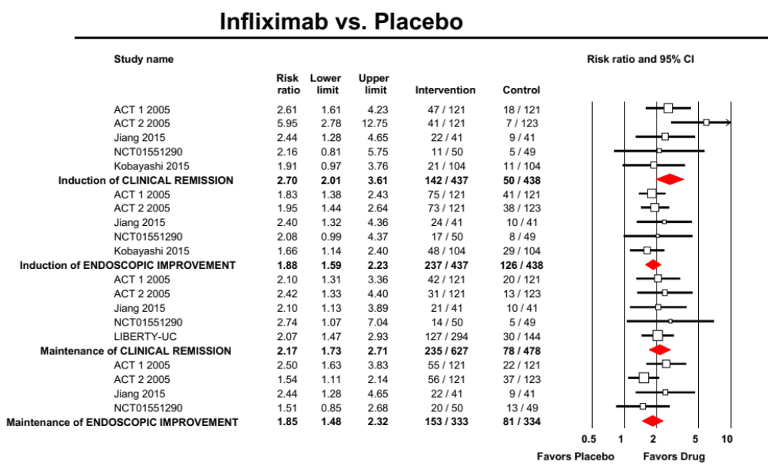

eFigure 2. Forest plot summarizing efficacy of ADALIMUMAB for induction and maintenance of remission in patients with moderate-severe ulcerative colitis

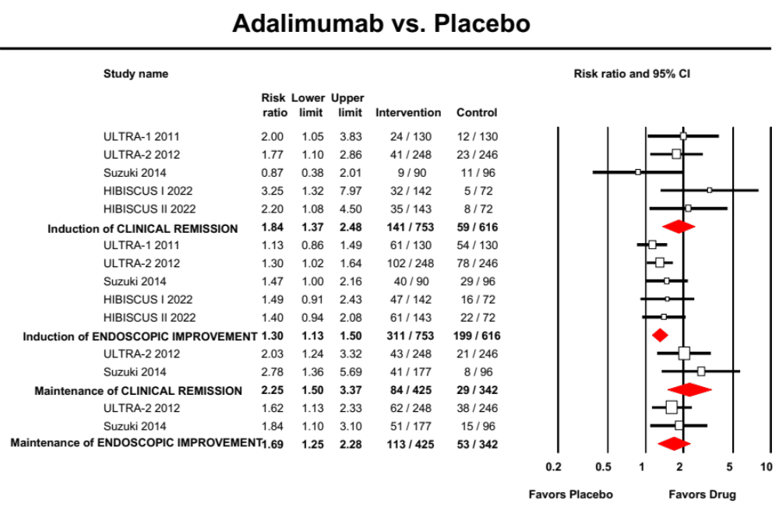

eFigure 3. Forest plot summarizing efficacy of GOLIMUMAB for induction and maintenance of remission in patients with moderate-severe ulcerative colitis

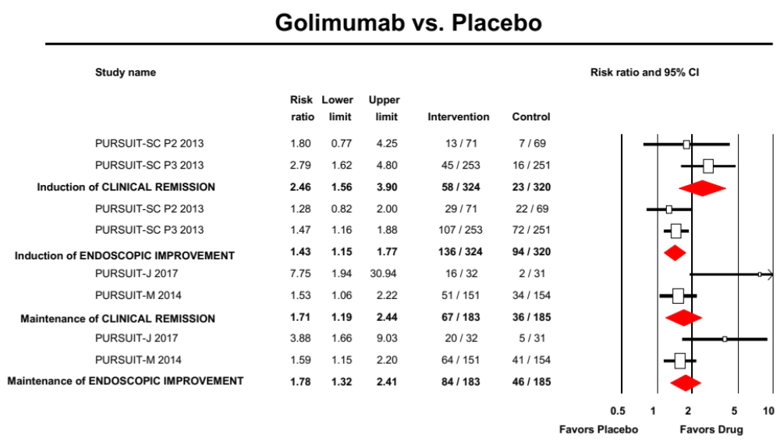

eFigure 4. Forest plot summarizing efficacy of VEDOLIZUMAB for induction and maintenance of remission in patients with moderate-severe ulcerative colitis

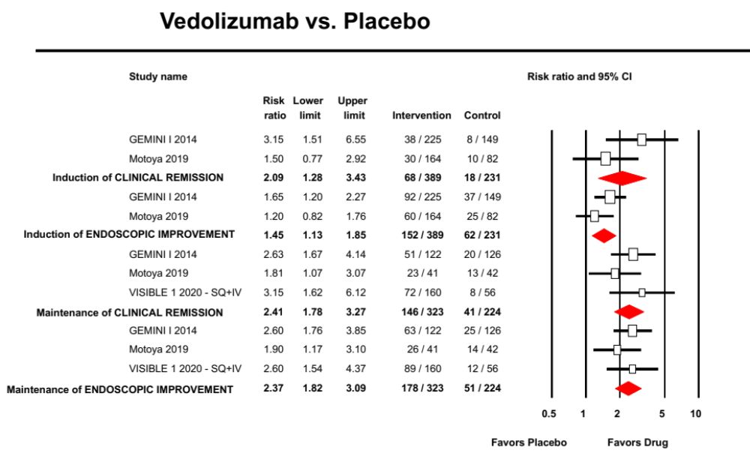

eFigure 5. Forest plot summarizing efficacy of OZANIMOD for induction and maintenance of remission in patients with moderate-severe ulcerative colitis

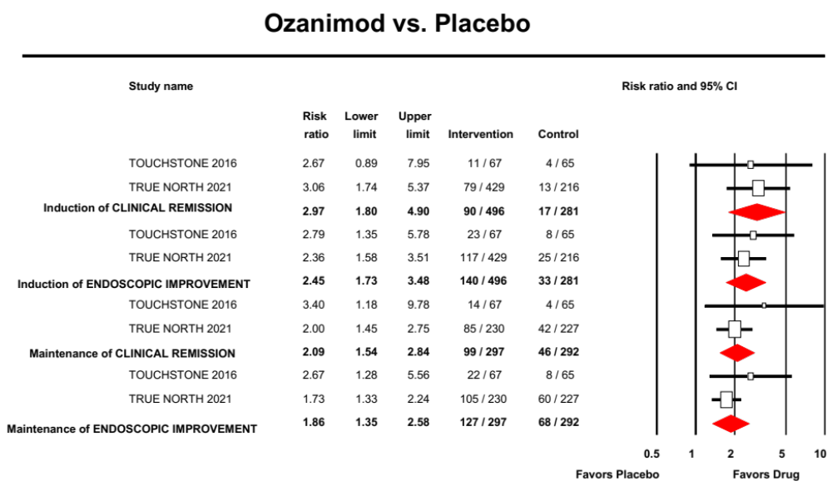

eFigure 6. Forest plot summarizing efficacy of ETRASIMOD for induction and maintenance of remission in patients with moderate-severe ulcerative colitis

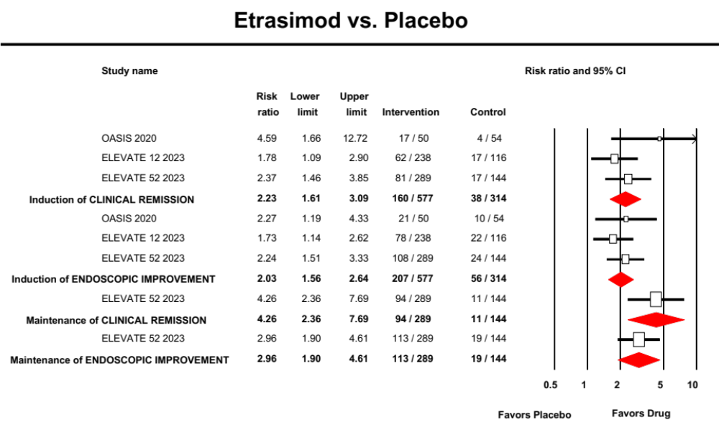

eFigure 7. Forest plot summarizing efficacy of TOFACITINIB for induction and maintenance of remission in patients with moderate-severe ulcerative colitis

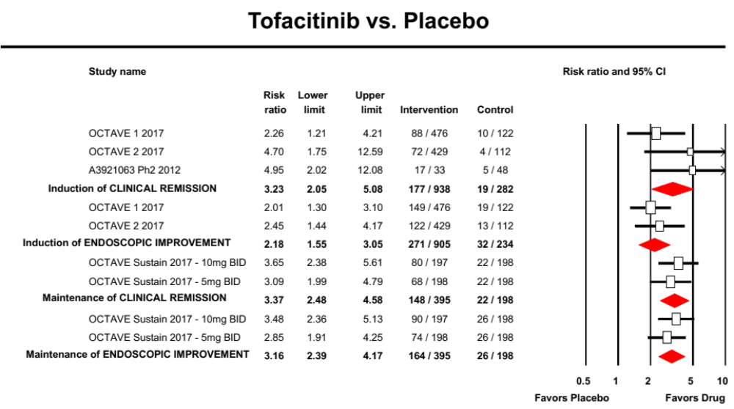

eFigure 8. Forest plot summarizing efficacy of UPADACITINIB for induction and maintenance of remission in patients with moderate-severe ulcerative colitis

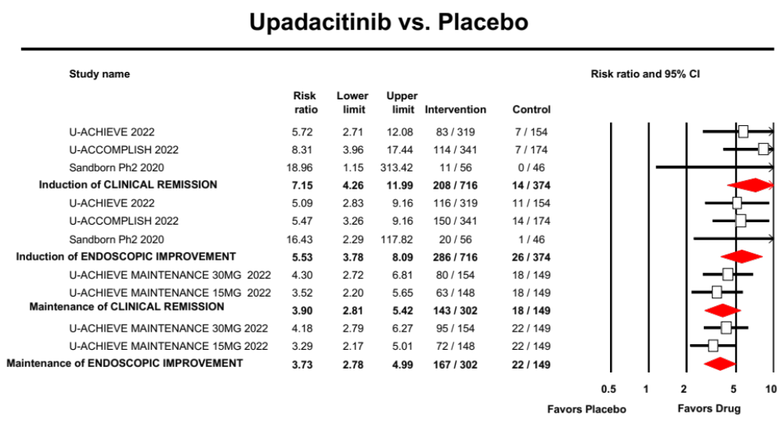

eFigure 9. Forest plot summarizing efficacy of FILGOTINIB for induction and maintenance of remission in patients with moderate-severe ulcerative colitis

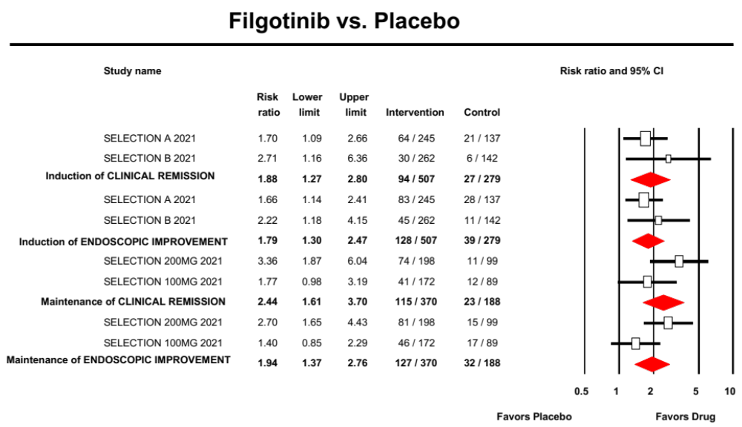

eFigure 10. Forest plot summarizing efficacy of USTEKINUMAB for induction and maintenance of remission in patients with moderate-severe ulcerative colitis

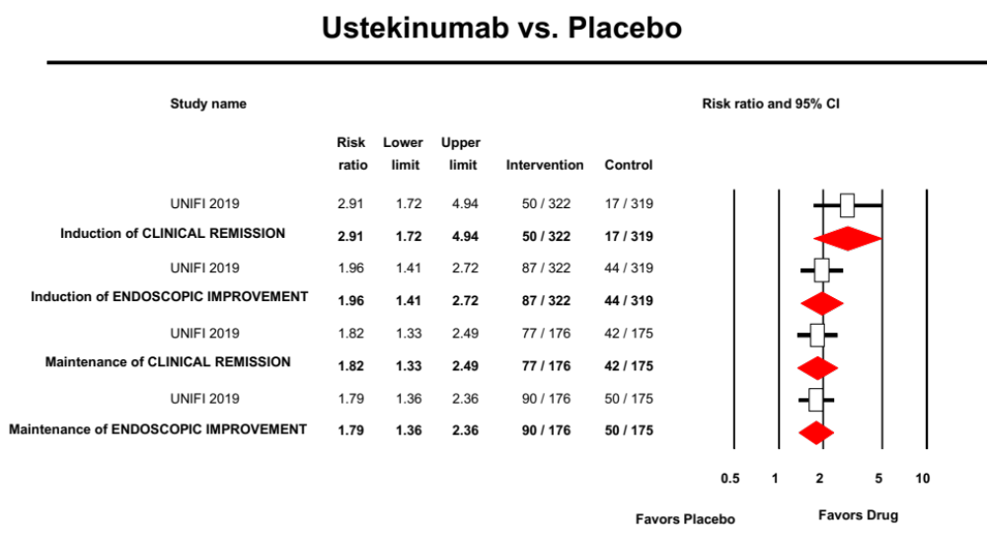

eFigure 11. Forest plot summarizing efficacy of MIRIKIZUMAB for induction and maintenance of remission in patients with moderate-severe ulcerative colitis

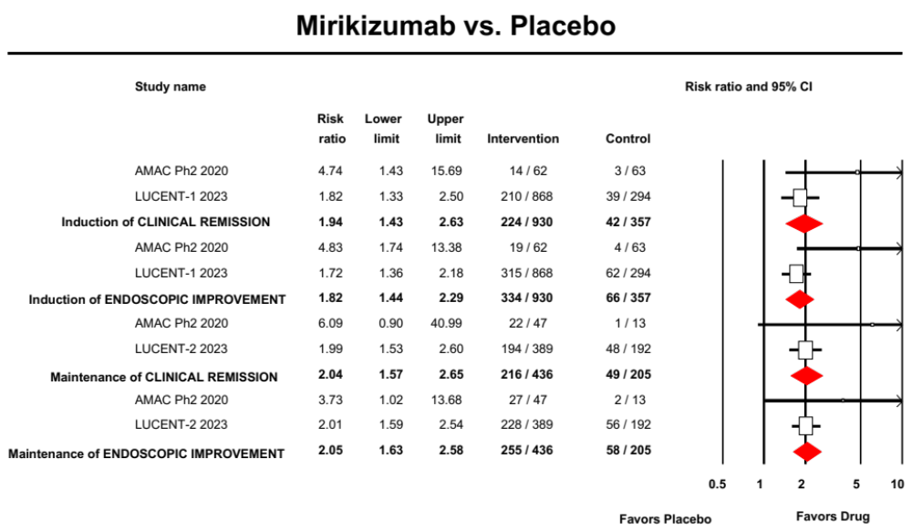

eFigure 12. Forest plot summarizing efficacy of RISANKIZUMAB for induction and maintenance of remission in patients with moderate-severe ulcerative colitis

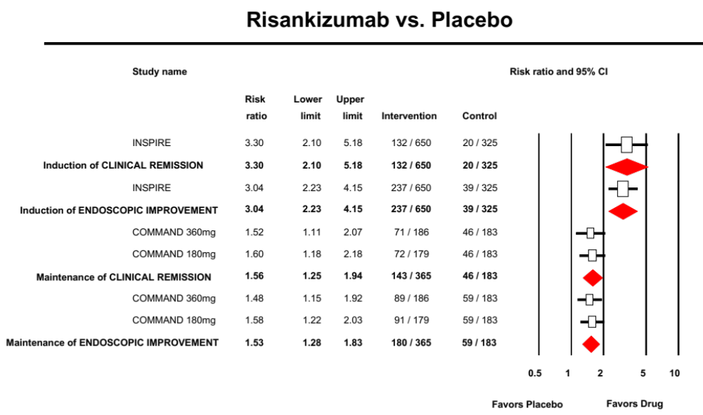

eFigure 13. Forest plot summarizing efficacy of GUSELKUMAB for induction and maintenance of remission in patients with moderate-severe ulcerative colitis

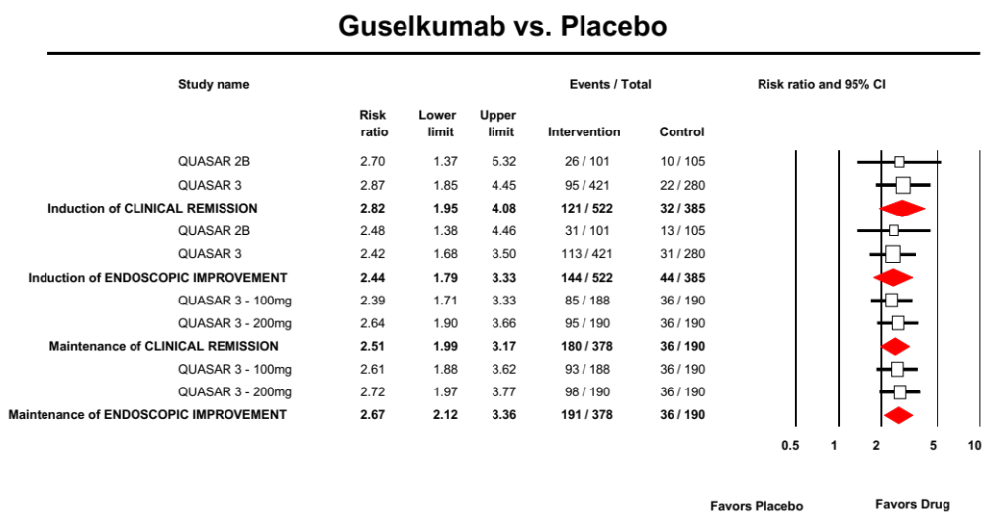

eFigure 14. Forest plot summarizing efficacy of THIOPURINES for (A) achieving remission and (B) preventing relapse in patients with moderate-severe ulcerative colitis

A.
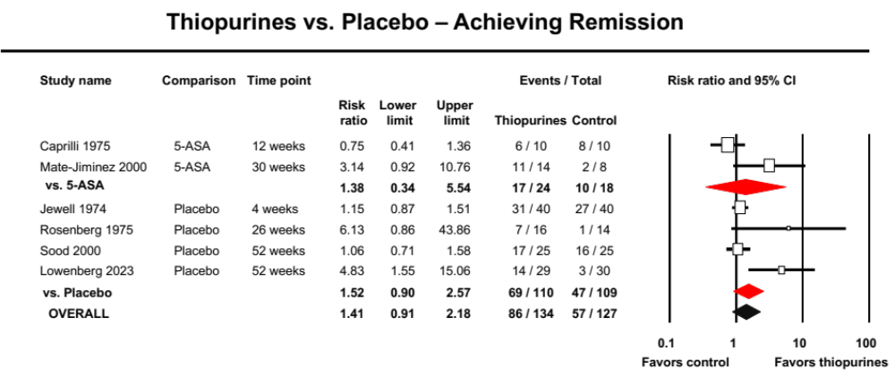

B. 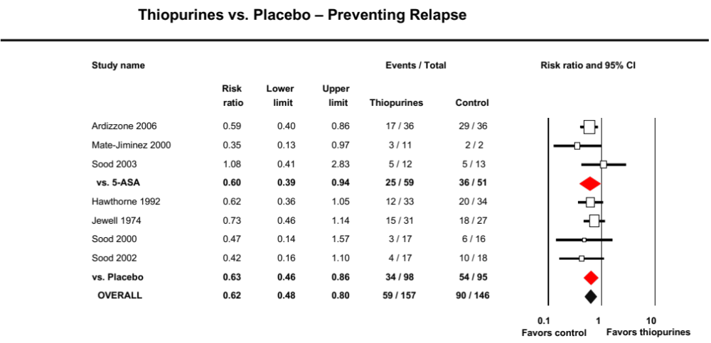

eFigure 15. Forest plot summarizing efficacy of METHOTREXATE for (A) achieving remission and (B) preventing relapse in patients with moderate-severe ulcerative colitis

A.
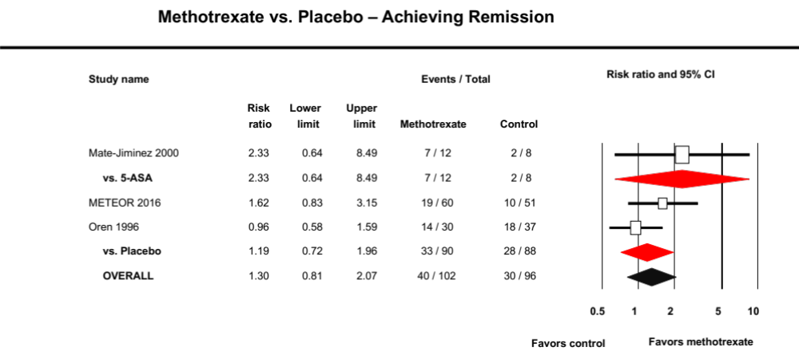

B.

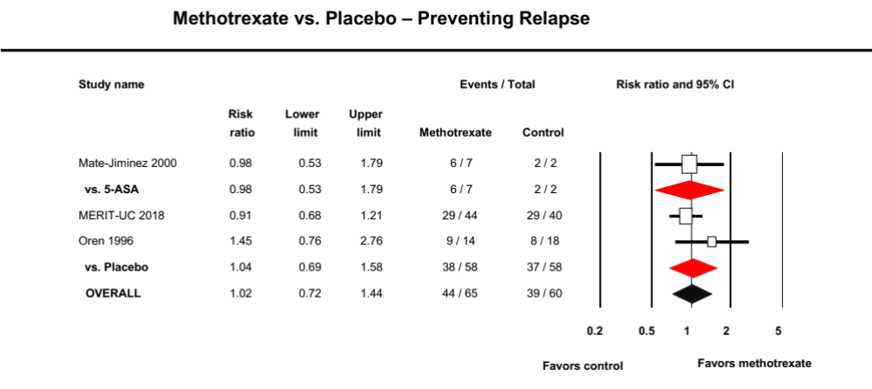

eFigure 16. Forest plot summarizing efficacy and safety of stopping immunomodulator (and continuing biologic monotherapy) vs. continuing combination therapy in patients with moderate-severe ulcerative colitis in steroid-free remission on combination therapy [Yellow highlight denotes study in which 43% patients had ulcerative colitis; all other trials included patients with Crohn’s disease]

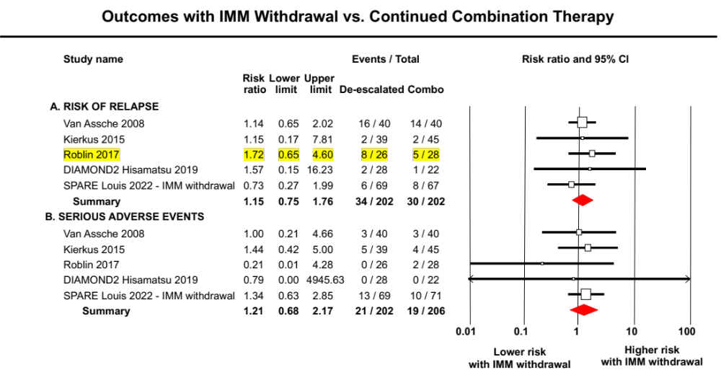

eFigure 17. Forest plot summarizing efficacy and safety of stopping biologics (and continuing immunomodulator monotherapy) vs. continuing combination therapy in patients with moderate-severe ulcerative colitis in steroid-free remission on combination therapy [Yellow highlight denotes studies in which most or all patients had ulcerative colitis; all other trials included patients with Crohn’s disease]

