Supplementary Information
Characterizing dynamic atmosphere generation system performance for analytical method development
Amos Doepke, Robert P. Streicher, Peter B. Shaw, Ronnee Andrews, Dawn R. Farwick, Emily G. Westbrook, Jennifer L. Roberts, Paula F. O’Connor, Angela L. Stastny, Pramod S. Kulkarni
Contents:
Supplementary Figures S1, S2, and S3
Supplementary Tables S1, S2, and S3

Supplementary Figures
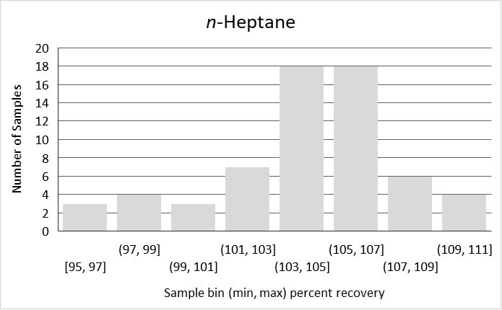
Figure S1. Histogram of the percent recovery from samples of a 40 ppmv n-heptane atmosphere.

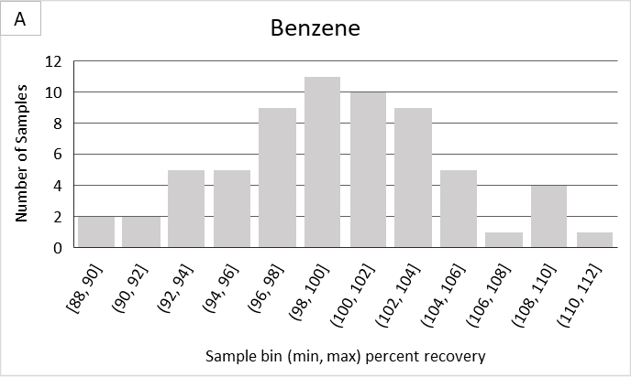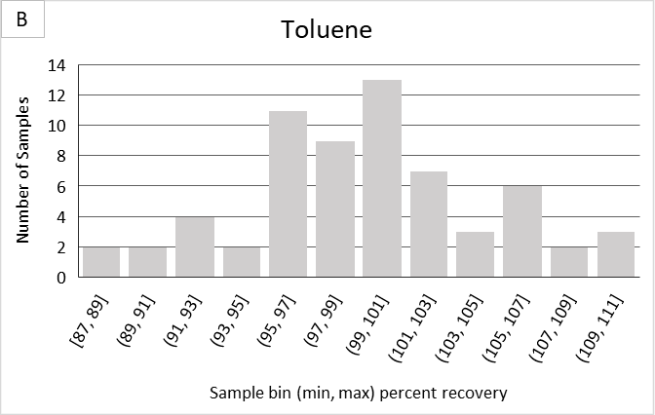

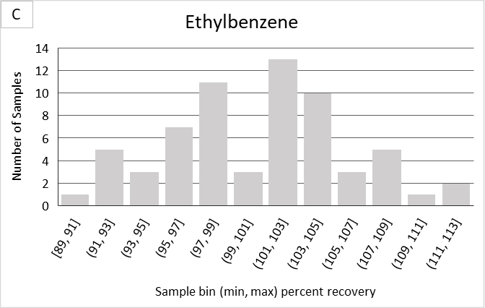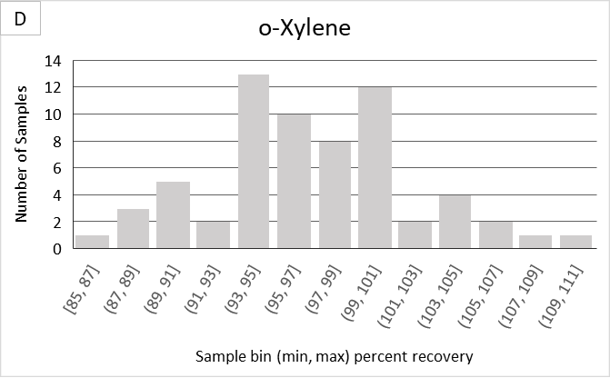
Figures S2 A through D. Histogram of the percent recovery from samples of a 0.1 ppmv BTEX atmosphere with (A) benzene, (B) toluene, (C) ethylbenzene, and (D) o-xylene.

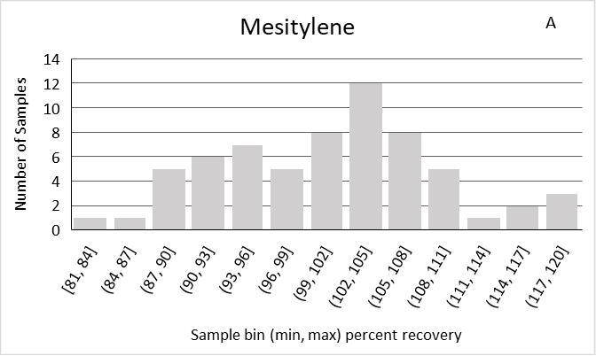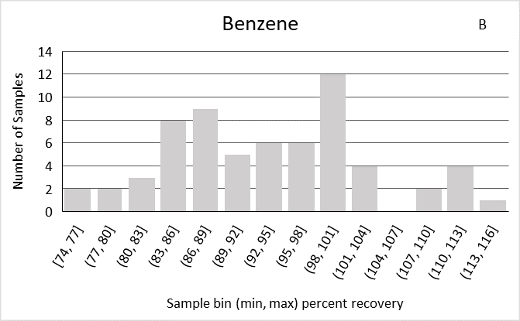

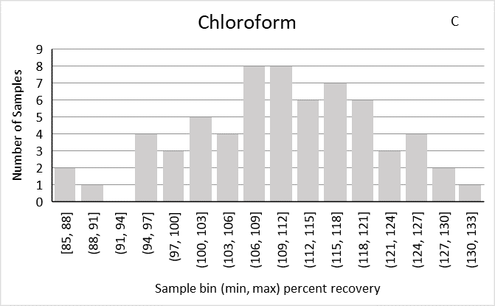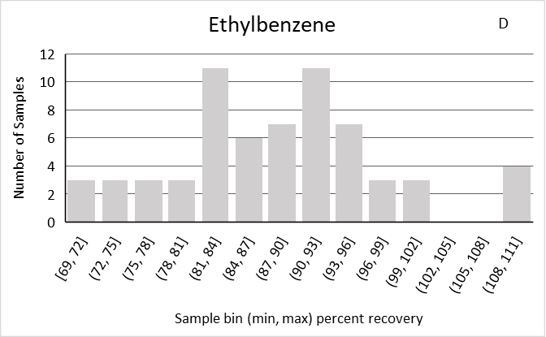

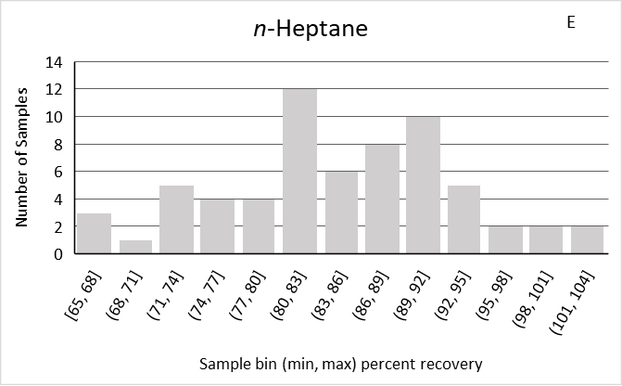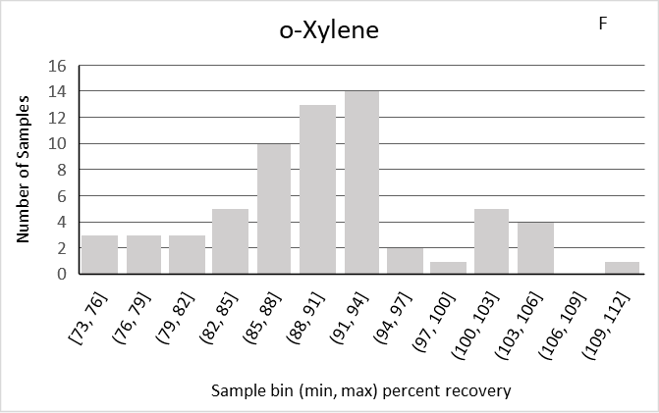

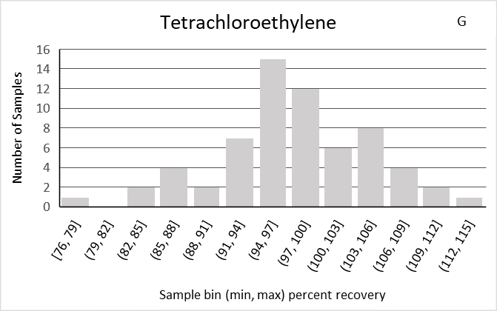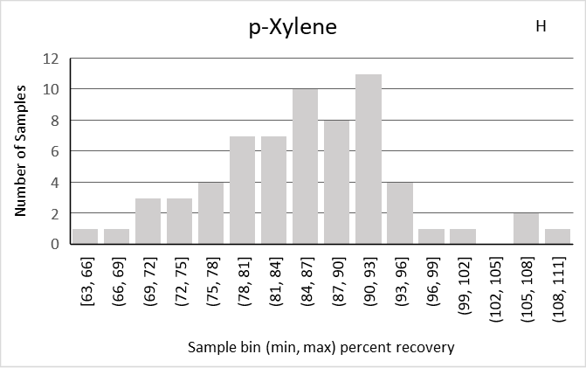

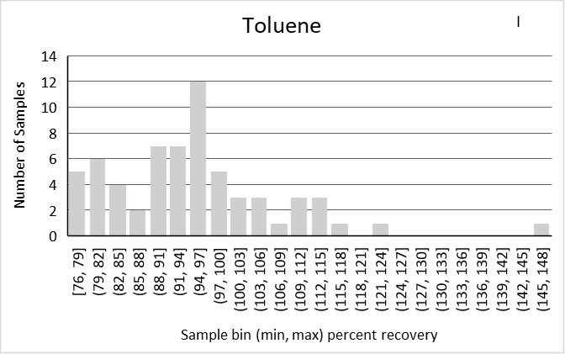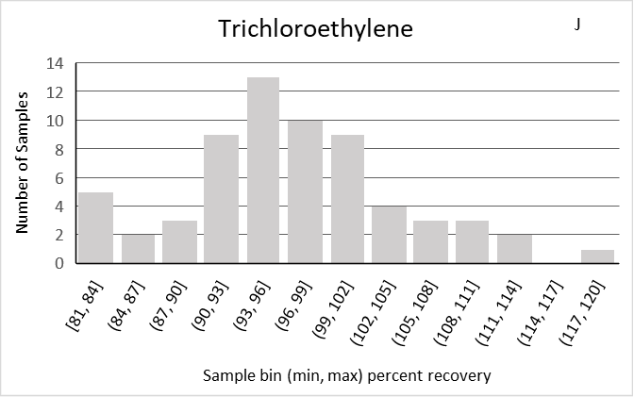
Figures S3 A through J. Histogram of the percent recovery from samples of a 0.1 ppmv atmosphere of a 10 VOC mixture of (A) mesitylene, (B) benzene, (C) chloroform, (D) ethylbenzene, (E) n-heptane, (F) o-xylene, (G) tetrachloroethylene, (H) p-xylene, (I) toluene, and (J) trichloroethylene.

Supplementary Tables

Table S1. Table of recovery from replicates of analyst spikes and sample replicates. Laboratory control spike (LCS), blind spike (BS) and sample replicates (SR). Two LCS were done denoted, LCS1,X and LCS2,X, where the X represents the replicated number, such that LCS1,2 represents the second replicate injection of the first LCS.
Analysis | Compound | LCS1,1 | LCS1,2 | LCS2,1 | LCS2,2 | LCS Target
n-heptane | Heptane | 3.61 | 3.62 | 3.61 | 3.46 | 3.40
BTEX | Benzene | 4.14 | 4.20 | 4.12 | 4.20 | 4.37
BTEX | Ethyl benzene | 4.26 | 4.19 | 4.19 | 4.06 | 4.33
BTEX | o-Xylene | 4.05 | 4.09 | 4.09 | 4.15 | 4.36
BTEX | Toluene | 4.17 | 4.10 | 4.09 | 4.15 | 4.33
10 VOC | mesitylene | 4.38 | 4.32 | 4.47 | 4.35 | 4.32
10 VOC | Benzene | 4.52 | 4.61 | 4.49 | 4.50 | 4.37
10 VOC | Chloroform | 4.49 | 4.43 | 4.94 | 4.48 | 4.47
10 VOC | Ethylbenzene | 4.41 | 4.45 | 4.35 | 4.36 | 4.34
10 VOC | Heptane | 3.68 | 3.69 | 3.55 | 3.71 | 3.40
10 VOC | o-Xylene | 4.53 | 4.43 | 4.32 | 4.45 | 4.39
10 VOC | Perchloroethylene | 4.97 | 5.02 | 5.06 | 5.05 | 4.86
10 VOC | p-Xylene | 4.54 | 4.41 | 4.34 | 4.44 | 4.31
10 VOC | Toluene | 4.52 | 4.56 | 4.47 | 4.55 | 4.34
10 VOC | Trichloroethylene | 4.53 | 4.51 | 4.34 | 4.33 | 4.39

Table S1 continued
Analysis | Compound | BS1,1 | BS1,2 | BS2,1 | BS2,2 | BS3,1 | BS3,2 | BS Target
n-heptane | Heptane | 6.87 | 6.92 | 6.94 | 7.22 | n/a | n/a | 6.8
BTEX | Benzene | 8.27 | 8.24 | 8.75 | 8.65 | n/a | n/a | 8.74
BTEX | Ethyl benzene | 8.18 | 8.22 | 8.75 | 8.67 | n/a | n/a | 8.67
BTEX | o-Xylene | 8.25 | 8.29 | 8.77 | 8.77 | n/a | n/a | 8.73
BTEX | Toluene | 8.2 | 8.21 | 8.74 | 8.70 | n/a | n/a | 8.67
10 VOC | mesitylene | 8.62 | 9.16 | 9.06 | 8.94 | 8.39 | 8.64 | 8.64
10 VOC | Benzene | 8.64 | 9.30 | 9.14 | 9.06 | 8.82 | 9.03 | 8.74
10 VOC | Chloroform | 8.57 | 8.77 | 8.77 | 8.60 | 9.01 | 8.45 | 8.93
10 VOC | Ethylbenzene | 8.54 | 8.87 | 8.98 | 8.85 | 8.65 | 8.66 | 8.67
10 VOC | Heptane | 7.17 | 7.44 | 7.51 | 7.49 | 7.10 | 7.23 | 6.80
10 VOC | o-Xylene | 8.59 | 9.24 | 8.76 | 8.99 | 8.52 | 8.80 | 8.79
10 VOC | Perchloroethylene | 10.0 | 10.3 | 9.72 | 10.1 | 10.0 | 9.99 | 9.72
10 VOC | p-Xylene | 8.71 | 9.28 | 8.97 | 9.05 | 8.67 | 8.89 | 8.61
10 VOC | Toluene | 8.82 | 9.34 | 9.19 | 9.27 | 8.90 | 9.13 | 8.67
10 VOC | Trichloroethylene | 8.72 | 8.93 | 9.16 | 8.92 | 8.68 | 8.43 | 8.78

Table S1 continued
Analysis | Compound | SR1,1 | SR1,2 | SR1 Target | SR2,1 | SR2,2 | SR2 Target
n-heptane | Heptane | 286 | 285 | 252.4 | 446 | 436 | 439.04
BTEX | Benzene | 1.96 | 1.98 | n/a | 2.06 | 1.95 | n/a
BTEX | Ethyl benzene | 2.69 | 2.73 | n/a | 2.91 | 2.68 | n/a
BTEX | o-Xylene | 2.66 | 2.68 | n/a | 2.81 | 2.60 | n/a
BTEX | Toluene | 2.31 | 2.35 | n/a | 2.51 | 2.34 | n/a
10 VOC | mesitylene | 6.35 | 6.05 | n/a | 6.41 | 6.13 | n/a
10 VOC | Benzene | 4.04 | 3.98 | n/a | 3.83 | 3.89 | n/a
10 VOC | Chloroform | 5.37 | 5.68 | n/a | 5.64 | 5.66 | n/a
10 VOC | Ethylbenzene | 5.23 | 5.09 | n/a | 5.33 | 5.33 | n/a
10 VOC | Heptane | 5.40 | 5.21 | n/a | 5.16 | 5.10 | n/a
10 VOC | o-Xylene | 5.46 | 5.24 | n/a | 5.33 | 5.17 | n/a
10 VOC | Perchloroethylene | 7.86 | 8.30 | n/a | 8.39 | 8.26 | n/a
10 VOC | p-Xylene | 5.40 | 5.31 | n/a | 5.45 | 5.06 | n/a
10 VOC | Toluene | 4.59 | 4.57 | n/a | 4.71 | 4.56 | n/a
10 VOC | Trichloroethylene | 7.76 | 6.63 | n/a | 6.79 | 6.18 | n/a

Table S2. Table of percent recovery for analysis of laboratory control spikes during the sample analysis of a generated atmosphere of a mixture of 10 VOCs.
Analyte | % Recovery
Mesitylene | 101.8
Benzene | 103.0
Chloroform | 102.7
Ethylbenzene | 101.4
Heptane | 105.9
o-Xylene | 100.1
Perchloroethylene | 103.3
p-Xylene | 102.7
Toluene | 104.4
Trichloroethylene | 101.4

Table S3. Pooled RSD of the laboratory control spike replicates (${\overline{\text{S}}}_{\text{rLCS}}$), the blind spike replicates (${\overline{\text{S}}}_{\text{rBS}}$) and sample replicates (${\overline{\text{S}}}_{\text{rSR}}$) for each of the analytical sets.
compound | $${\overline{\text{S}}}_{\text{rLCS}}$$ | $${\overline{\text{S}}}_{\text{rBS}}$$ | $${\overline{\text{S}}}_{\text{rSR}}$$
n-heptane | 0.0213 | 0.0201 | 0.0115
benzene | 0.0120 | 0.0060 | 0.0279
toluene | 0.0178 | 0.0052 | 0.0418
ethyl benzene | 0.0088 | 0.0024 | 0.0390
o-xylene | 0.0112 | 0.0024 | 0.0361
mesitylene | 0.0153 | 0.0397 | 0.0329
benzene | 0.0099 | 0.0449 | 0.0108
chloroform | 0.0493 | 0.0409 | 0.0281
ethylbenzene | 0.0047 | 0.0235 | 0.0136
n-heptane | 0.0221 | 0.0238 | 0.0188
o-Xylene | 0.0186 | 0.0484 | 0.0256
tetrachloroethylene | 0.0051 | 0.0280 | 0.0283
p-Xylene | 0.0185 | 0.0397 | 0.0380
toluene | 0.0099 | 0.0365 | 0.0163
trichloroethylene | 0.0025 | 0.0266 | 0.0915

