Supplemental Material

Applying Finite Mixture Models to Quantify Respirable Dust Mass in Coal and Metal–Nonmetal Mines Using Fourier Transform Infrared Spectroscopy

Andrew T. Weakley¹*, David A. Parks², and Arthur L. Miller²
¹University of California Davis Health, Sacramento, California, USA
²National Institute for Occupational Safety and Health (NIOSH), Spokane, Washington, USA

*Corresponding author email: weak5174@gmail.com

Supporting material presents additional details related to the exploratory principal component analysis (Section S1), redundancy of the “cassette type” gating variable in the Method of Expert’s (MoE) model (S2), percentage bias statistics for the tested models (S3), and the PLS score plot used as predictors in all calibrations (S4).

Contents
S1 PCA eigenvectors and score plots 3
Figure S1: Eigenvectors (sometimes referred to colloquially as loadings) for the first and second principal components (PCs). 3
Figure S2: Eigenvectors for PC3 and PC4. 4
Figure S3: Eigenvectors for PC5 and PC6. 5
Figure S4: The first two principal component scores. 6
Figure S5: Second and third principal component scores illustrating the close association between mine type (A) and cassette type (B) 7
S2 Redundancy of “cassette type” gate variable 8
Table S1: Contingency Table for Mine and Cassette Type Gating variables. 8
S3 Median percentage bias by mine type for all models tested 9
Table S2: Median percentage bias and 95% bootstrap confidence intervals for each model tested 9
S4 PLS score plots 10
Figure S6: Distribution of spectra on the first and second PLS components (A). 10
S5 Outlier Properties for Mixture of Expert Models…………………………………………….11
Table S7: Descriptive statistics for outliers flagged by all MoE cluster models…………………….…11

S1 PCA eigenvectors and score plots
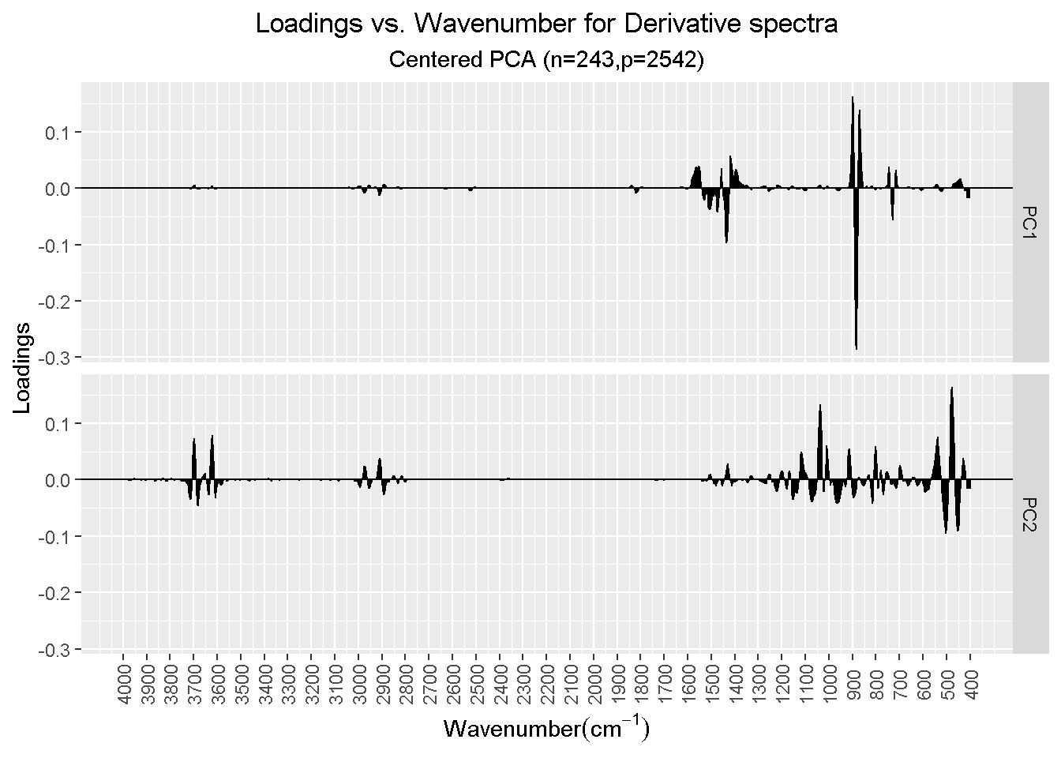
Figure S1. Eigenvectors (sometimes referred to colloquially as loadings) for the first and second principal components (PCs). These PCs explain 68.9% and 10.1% of the spectral variance, respectively. PC1 is clearly tracking variations in calcium carbonate absorption as indicated by (negative) loadings around 715 cm^{–1}, 875 cm^{–1}, and ~1450 cm^{–1}.⁴⁴ PC2 loads absorption from organics (3000–2800 cm^{–1}) as well as geologies rich in silica- and clay-bearing materials (3750–35505 cm^{–1}, ~1050–700 cm^{–1}, ~450 cm^{–1}).^{45,46} Note that features are derived from second derivative spectra such that spectral minima generally correspond to peak maxima in absorption spectra.⁴⁷ Furthermore, PC2 are actually inverted such that maxima are here shown as minima in second-derivative spectra (and vice-versa) due to rotation ambiguity in PCA solutions. Score plots (presented below) will indicate whether the solution has been adjusted (negated) for rotation ambiguity.
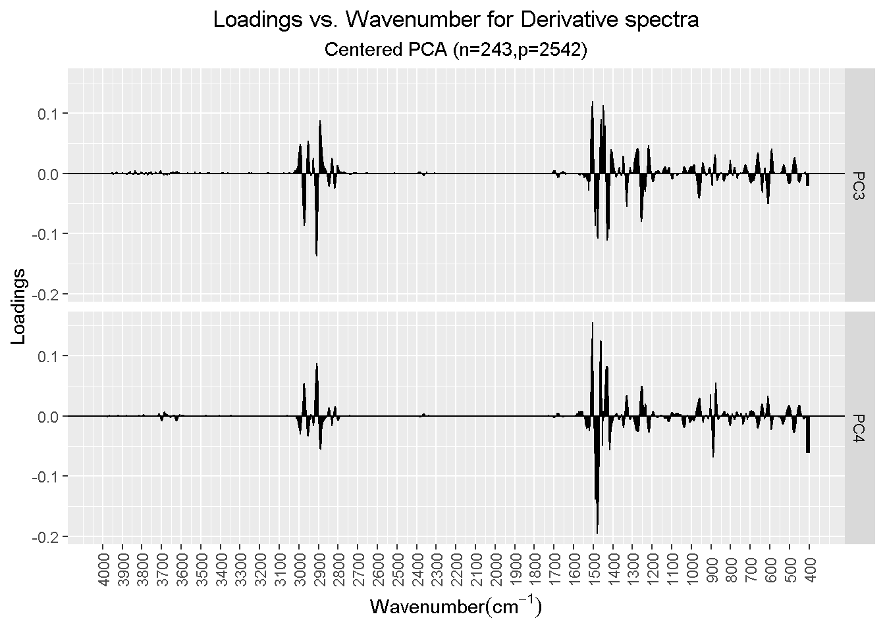Figure S2. Eigenvectors for PC3 and PC4. Loadings exhibit a mixture of mineral and organic. Components explain 6.3% and 5.8% of the spectral variance, respectively.
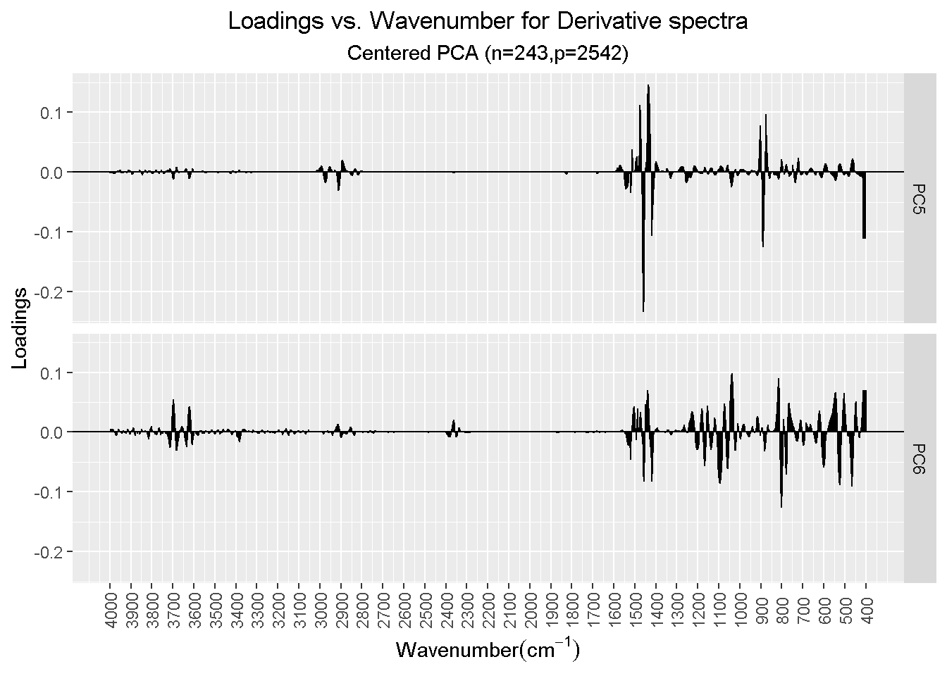Figure S3. Eigenvectors for PC5 and PC6. Loadings exhibit a mixture of mineral, organic, vapor (“noise” above 3750 cm^{–1}), and chamber background (CO₂ features near 2350 cm^{–1}). These PCs explain only 2.3% 1.6% of the spectral variance, respectively.

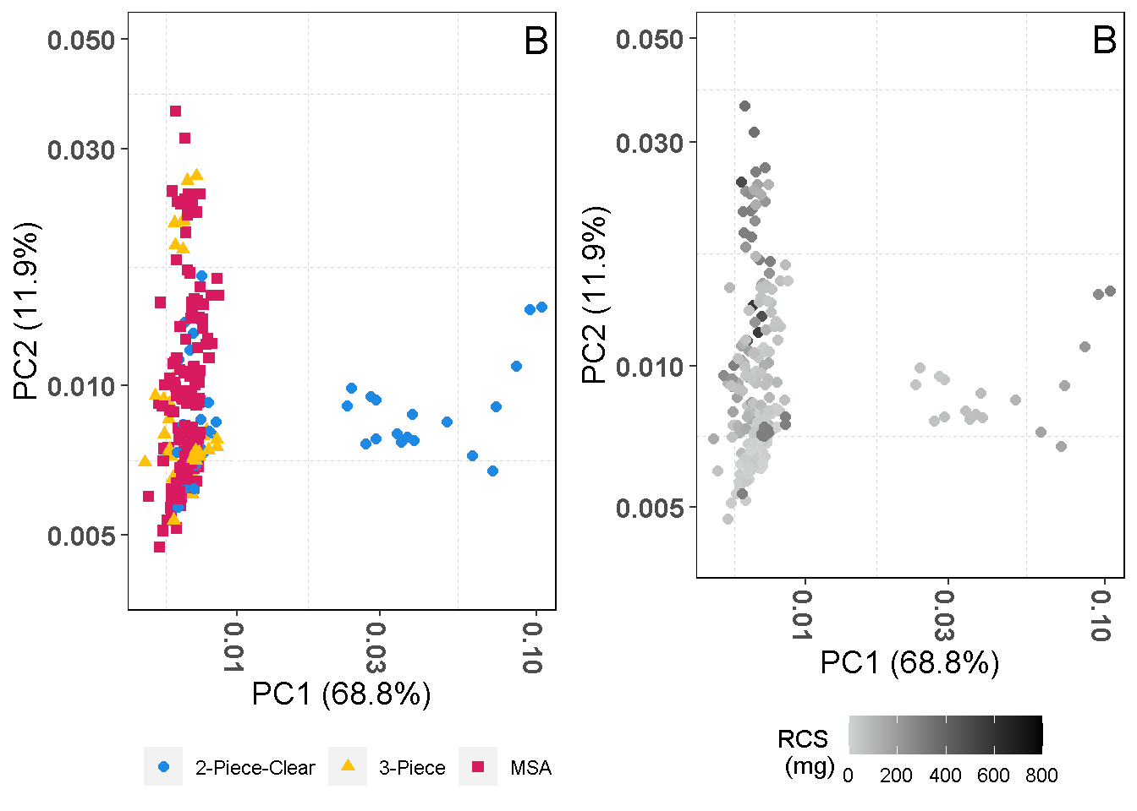
Figure S4. The first two principal component scores pseudo- and false-colored on cassette type (A) and respirable crystalline silica (RCS) mass (B).
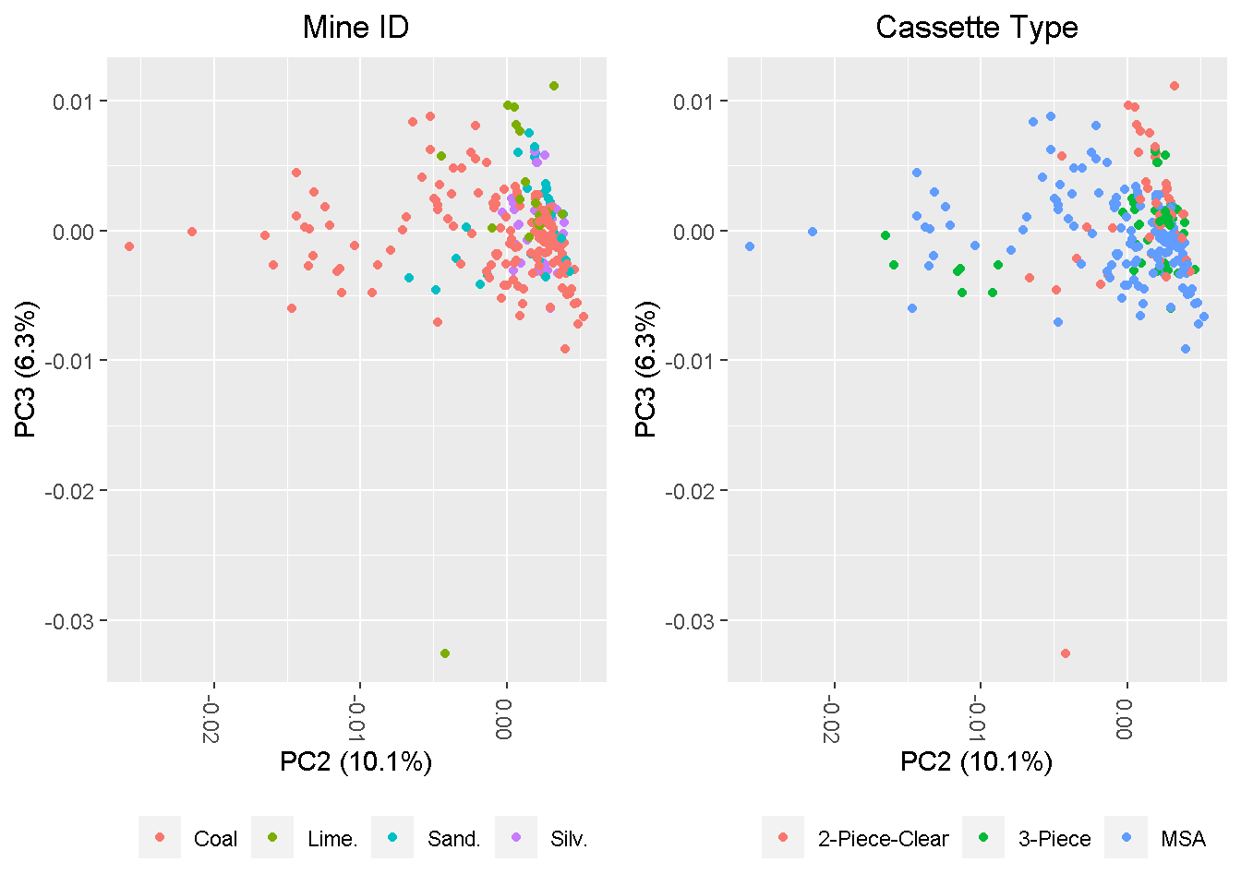
Figure S5. Second and third principal component scores illustrating the close association between mine type (A) and cassette type (B). This is explored in more detail in Section S2 below. Note also that PC3 is likely dominated by a limestone mine outlier.

S2 Redundancy of “Cassette Type” Gate Variable
The strong substitutability of cassette type for mine type (a.k.a., redundancy) becomes clear using a contingency table (shown below in Table S1). Briefly, one sees that the “coal mine” category of the “mine type” variable (row 1) is a very good substitute for the “MSA cassette” category in the “cassette type” variable (column 2, and vice-versa) as ~90% of all coal samples are collected on MSA cassettes and samples from no other mine type use MSA cassettes for sampling. Furthermore, as MSA coal mine samples comprise half the training (and test) set data this tends to dominate the Cramer’s V statistic (φ_{c}) discussed in the main paper as well as determines the redundancy of the “cassette type” variable used for cluster modeling. Note also that a simple way to understand the Cramer’s V statistic, and covariate substitutability in general, is in the context of a contingency table. For example, a perfect association (φ_{c} = 1) between the “mine type” and “cassette type” variables would have resulted if the 10, three-piece coal samples were moved to the MSA category.
Table S1 also clearly shows that adding together the “limestone” and “sandstone” categories act as a perfect substitute for “2-piece clear” cassettes (column 1); again, due to the fact that no other mine samples were collected on two-piece cassettes. Finally, a moderate substitution effect in the case of three-piece cassettes (column 2) is observed as 69% of silver mine samples are collected on three-piece cassettes with the remaining used for coal mine samples.

Table S1. Contingency table for mine and cassette type gating variables (Cramer’s V (φ_{c}) = 0.902).
 | 2-Piece-Clear | 3-Piece | MSA
Coal | 0 | 10 | 90
Limestone | 12 | 0 | 0
Sandstone | 21 | 0 | 0
Silver | 0 | 23 | 0

A secondary implication of the strong association between “mine” and “cassette type” is the difficulty in statistically parsing a “mine bias” from a “cassette/deposition bias.” Regardless, we regard the impact of cassette type as likely small for these multivariate models for the following reasons. The first pertains to the lack of anything resembling a deposition effect on the PCA and PLS scores (Figures 1 and S6). If present, we would expect to see samples cluster according to cassette type, and the eigenvectors/loadings will show no obvious pattern of absorption linked to aerosol infrared bands. As the PLS components used for calibration are correlated strongly to sample mass and no clear grouping of samples by cassette type exist on PLS and PCA scores, we tentatively conclude that a deposition/cassette effect is negligible compared to the geologic factors linked to dust source (“mine type”).

S3 Median Percentage Bias by Mine Type for All Models Tested
Table S2. Median percentage bias and 95% bootstrap confidence intervals for each model tested in the study, decomposed by mint type. Bias significantly different than zero are denoted by asterisks.
Mine | N | PLS | MOE [1] (Expert Only) | MOE [2] (Mine) | MOE [2] (Mine, Cassette)
Coal | 56 | 2.7 (–4.8, 8.2) | 0.2 (–8.5, 1.2) | –0.6 (–11.5, 2.6) | –1.1 (–16.0, 0.4)
Limestone | 7 | 6.5* (1.3, 12.4) | –0.3 (–5.8, 1.6) | 0.9 (–12.3, 3.2) | 0.2 (–15.1, 1.5)
Sandstone | 12 | 30.3* (17.1, 64.4) | 14.2* (11.2, 35.2) | 5.7 (–26.0, 39.7) | –7.2 (–38.5, 19.2)
Silver | 12 | –1.7 (–5.9, 19.7) | –9.0 (–9.3, 5.5) | –7.6 (–29.3, 5.8) | –6.3 (–38.2, 0.6)

S4 PLS Score Plots
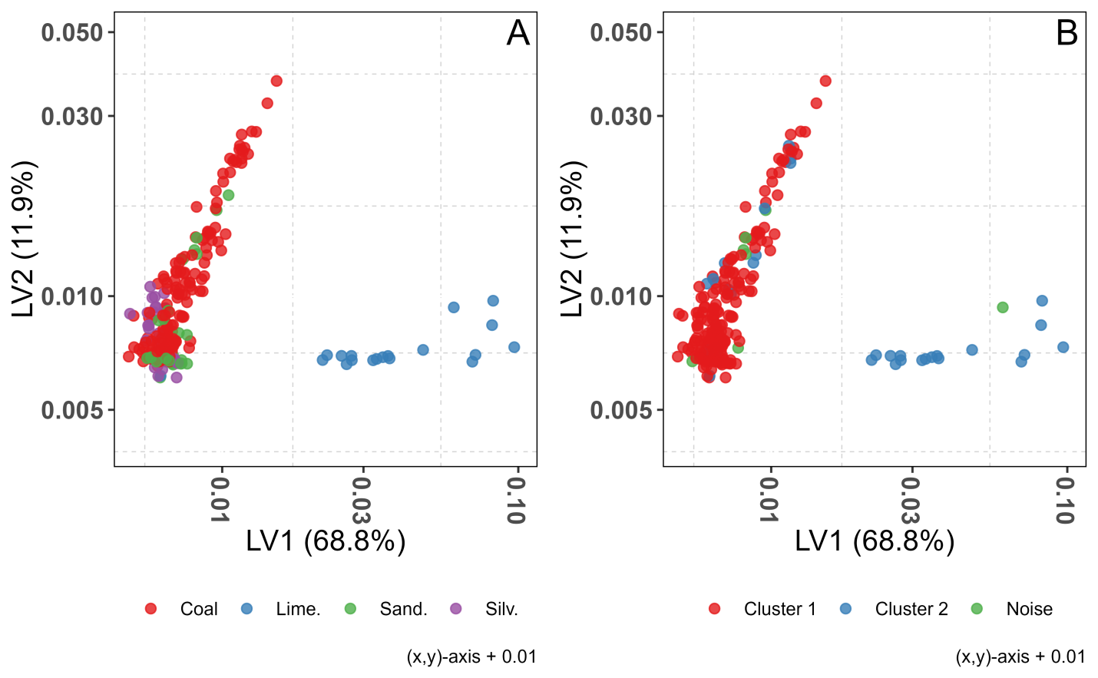Figure S6. Distribution of spectra on the first and second PLS components (A). PLS performs a clear rotation of the first two components extracted by PCA as indicated by the similar grouping of samples. The MoE solution using the “mine type” gating variable identified a two-cluster solution on the PLS components (B). Limestone mine samples dominated the second cluster while the majority of the other samples fell into cluster 1. Scores were plotted on a log scale after adding a small constant (0.01).

S5 Outlier Properties for Mixture of Expert Models
Table S7. Descriptive statistics for outliers flagged by all MoE cluster models (All), cluster models gated variables (Gate Only), and outliers unique to the MoE model using both gate variables. Percentiles for sample mass and RCS content are also calculated to aid interpretation.
Model(s) | Mine type | Cassettes | Mass percentile | RCS percentile | RCS/Mass
All | Sandstone | 2-Piece-Clear | 92% | 99% | 36%
All | Sandstone | 2-Piece-Clear | 91% | 98% | 25%
All | Coal | 3-Piece | 90% | 96% | 20%
All | Limestone | 2-Piece-Clear | 100% | 86% | 3%
All | Coal | 3-Piece | 72% | 9% | 1%
Gate Only | Sandstone | 2-Piece-Clear | 67% | 99% | 74%
Gate Only | Sandstone | 2-Piece-Clear | 63% | 97% | 71%
"Mine and Cassette" Only | Coal | MSA | 74% | 73% | 9%
"Mine and Cassette" Only | Coal | MSA | 60% | 2% | 0%
"Mine and Cassette" Only | Coal | 3-Piece | 64% | 8% | 1%
"Mine and Cassette" Only | Coal | 3-Piece | 62% | 5% | 0%
"Mine and Cassette" Only | Coal | 3-Piece | 62% | 4% | 0%
"Mine and Cassette" Only | Coal | 3-Piece | 59% | 6% | 1%

