Supplementary Table 1. ICD-10 codes used to define acute respiratory illness.
Acute Respiratory Illness Description | ICD-10 Codesª
Influenza Pneumonia | J09.X1, J10.0, J10.00, J10.01, J10.08, J11.0, J11.00, J11.08
Other Viral Pneumonia | J12.* (excluding J12.81 and J12.82)
Bacterial Pneumonia | J13, J14, J15.*, J16.*, J17, J18.*
Influenza Disease | J09.*, J10.1, J10.2, J10.8*, J11.1, J11.2, J11.8* (excluding J09.X1)
Acute Respiratory Distress Syndrome | J80
COPD Exacerbation | J44.1^{b}
Asthma Exacerbation | J45.21, J45.22, J45.31, J45.32, J45.41, J45.42, J45.51, J45.52, J45.901, J45.902
Respiratory Failure | J96.0*, J96.2*, R09.2, J96.9*
Other Acute Lower Respiratory Tract Infections | B97.4, J20.*, J21.*, J22, J40, J44.0^{b}, J41.*, J42, J43.*, J47.*, J85, J85.0, J85.2, J85.3, J85.1, J86.*
Sinusitis | J01.*, J32.*^{b}
Acute Upper Respiratory Tract Infections | J00.*, J02.*, J03.*, J04.*, J05.*, J06.*
Acute Respiratory Illness Signs and Symptoms | R04.2, R05, R05.1, R05.2, R05.4, R05.8, R05.9, R06.00, R06.02, R06.03, R06.1, R06.2, R06.8, R06.81, R06.82, R06.89, R07.1, R09.0*, R09.01, R09.02, R09.1, R09.2, R09.3, R09.8*
Abbreviations: ICD-10 = International Classification of Diseases, Tenth Revision
ª All ICD-10 codes with * include all child codes under the specific parent code.
^{b} Denotes ICD code is used only for adults aged ≥18 years.
Supplementary Table 2. ICD-10 codes used to define underlying medical conditions and immunocompromising conditions.
Underlying Medical Condition | ICD-10 Codesª
Respiratory Condition | J45.*, J40.*^{b}, J41.*^{b}, J42.*^{b}, J43.*^{b}, J44.*^{b}, D86.0, E84.*, E88.01, J47.*, J60^{b}, J61^{b}, J62.*^{b}, J63.*^{b}, J64^{b}, J65^{b}, J66.*, J67.0, J67.1, J67.2, J67.3, J67.4, J67.5, J67.6, J67.7, J67.8, J68.*, J70.*, J81.1, J84.*, J95.*, J96.1, J99.*, P26.*, P27.*, B39.*, B40.0, B40.2, B41.0, B44.0, B44.1 , B45.*, B46.0, A15.*, A31.0, G47.3*^{c}, P27.0^{c}, P27.1^{c}, P27.8^{c}, P27.9^{c}, Q34.*^{c}, Q30.*^{c}, Q31.*^{c}, Q32.*^{c}, Q39.*^{c}, Q79.0^{c}, J45.901^{c}, J45.902^{c}, J45.909^{c}
Cardiovascular Condition | I50.*, I21.*, I22.*, I23.*, I24.*, I25.*, I10.*, I11.*, I13.*, I15.*, I01.*, I02.0, I05.*, I06.*, I07.*, I08.*, I09.*, I26.*, I27.*, I28.*, I31.*, I34.*, I35.*, I36.*, I37.*, I42.*, I43.*, I44.*, I46.*, I48.*, I51.0, I51.1, I51.2, I51.3, I51.5, I51.7, I51.8*, I51.9, I52.*, I97.0, I97.1*, M31.0, M31.1*, M31.2, M31.4, M31.6, M31.7, M31.8, M31.9, Z95.*, Z98.61, I71.*, I72.*, I73.*, I74.*, I75.*, I79.*, Q20.*^{b}, Q21.*, Q22.*, Q23.*, Q24.*, Q25.*, Q26.*, Q27.0, Q27.3*, Q27.4, Q27.8, Q27.9, Q28.*, Q33.*^{c}, P29.30, Q89.3^{b}
Cerebrovascular Condition | I60.*, I61.*, I63.*, I62.*, I68.*, I69.*
Neurological and/or Musculoskeletal Condition | F01.*^{b}, F02.*^{b}, F03.*^{b}, G30.*^{b}, H49.81*, M12.0*, M36.0, E75.02, E75.19, E75.4, F71.*, F72.*, F73.*, F84.2, G10.*, G11.*, G12.*, G13.*, G14.*, G20.*, G21.*, G23.*, G24.*, G25.*, G26.*, G31.*, G32.*, G35.*, G36.*, G37.*, G40.*, G45.*, G46.*, G60.*, G61.*, G62.*, G63.*, G64.*, G70.*, G71.*, G73.*, G80.*, G81.*, G82.*, G83.*, G90.3, G91.*, G93.*, G94.*, G95.*, G99.2, P91.*, Q00.*, Q01.*, Q02.*, Q03.*, Q04.*, Q05.*, Q06.*, Q07.*, Q76.*, Q77.*, Q78.*, Q79.1*, Q79.2*, Q79.3*, Q79.4*, Q79.5*, Q79.6*, Q79.8*, Q79.9*, Q85.*, Q87.4*, Q91.*, Q92.*, Q93.*, Q96.*, R41.*, R53.2, R54.*, Q90.*, R56.*^{c}, P90^{c}, P91.0^{c}, P52.*^{c}, E70.*^{c}, E71.*^{c}, E72.*^{c}, E74.*^{c}, E75.2*^{c}, E76.*^{c}, E77.*^{c}, E78.*^{c}, E79.*^{c}, E80.*^{c}, P70.*^{c}, P71.*^{c}, P72.*^{c}, P74.*^{c}, P94.*^{c}
Hematologic Condition | D55.*, D56.0, D56.1, D56.2, D56.4, D56.5, D56.8, D56.9, D57.0*, D57.1, D57.2*, D57.4*, D57.8*, D58.*, D59.*, D60.*, D61.*, D64.0, D64.1, D64.2, D64.3, D64.4, D64.8*, D65.*, D66.*, D67.*, D68.*
Endocrine Condition | E10.*, E11.*, E08.*, E09.*, E13.*, E00.*, E01.*, E03.*, E05.*, E06.*, E15.* , E16.*, E20.*, E21.*, E22.*, E23.*, E24.*, E25.*, E26.*, E27.*, E28.*, E29.*, E31.*, E32.*, E34.*, E70.*^{b}, E71.*^{b}, E72.*^{b}, E74.*^{b}, E75.2*^{b}, E76.*^{b}, E77.*^{b}, E78.*^{b}, E79.*^{b}, E80.*^{b}, E83.*, E85.*, E88.02, E88.09, E88.1, E88.2, E88.3, E88.4*, E88.8*, E88.9
Renal Disease | I12.*, I13.* N01.*, N02.*, N03.*, N04.*, N05.*, N06.*, N07.*, N08.*, N11.*, N14.*, N15.*, N16.*, N18.*, N25.*, N26.*, N28.*, Q27.1, Q27.2, Q60.*, Z49.*, Z91.15, Z94.0, Z99.2
Gastrointestinal and Hepatic Condition | B18.*, I81.*, I85.*, K70.*, K71.*, K72.*, K73.*, K74.*, K75.*, K76.*, K77.*, K50.*^{c}, K51.*^{c}, K52.*^{c}
Clinical Obesity | E66.*, Z68.3, Z68.4
Clinical Underweight | R63.6, F50.0*, E40.*, E41.*, E42.*, E43.*, E44.*, E45.*, E46.*
Other Underlying Conditions | P07.*^{c}, R62.*^{c}, Z93.0^{c}, Z93.1^{c}, Z99.0^{c}, Z99.11^{c}, Z99.81^{c}, Z99.89^{c}
Immunocompromising Conditions | Hematological Malignancy: C81.*, C82.*, C83.*, C84.*, C85.*, C86.*, C88.*, C90.*, C91.*, C92.*, C93.*, C94.*, C95.*, C96.*, D46.*, D61.0*, D61.2, D61.9, D70.0, D71.*  Solid Malignancy: C00.*-C80.*, C7A.*, C7B.*, Z51.0, Z51.1*, C4A.*  Transplant: T86.0*, T86.1*, T86.2*, T86.3*, T86.4*, T86.5*, T86.81*, T86.85*, D47.Z1, Z48.2*, Z94.*, Z98.85  Rheumatologic/inflammatory disorders: D86.*, E85.1, E85.2, E85.3, E85.4, E85.8*, E85.9, G35.*, J67.9*, L40.54, L40.59, L93.0*, L93.2*, L94.*, M05.*, M06.*, M07.*, M08.*, M30.*, M31.3*, M31.5*, M32.*, M33.*, M34.*, M35.3*, M35.8*, M35.9*, M46.*, T78.40*  Other intrinsic immune condition of immunodeficiency: D27.9, D72.89, D80.*, D81.0, D81.1, D81.2, D81.4, D81.5, D81.6, D81.7, D81.8*, D81.9, D82.*, D83.*, D84.*, D87.89, D89.0, D89.1, D89.3, D89.4*, D89.8*, D89.9, K70.3*, K70.4*, K72.*, K74.3, K74.4, K74.5, K74.6, N04.*, R18.0
Abbreviations: ICD-10 = International Classification of Diseases, Tenth Revision
ª All ICD-10 codes with * include all child codes under the specific parent code.
^{b} Denotes ICD code is used only for adults aged ≥18 years.
^{c} Denotes ICD code is used only for children and adolescents aged <18 years.
Supplementary Table 3. Influenza vaccine product by site and age group.
 |  | Total | Site A | Site B | Site C | Site D | Site E | Site F | Site G | 6m-17 years | 18-64 years | 65+ years
Vaccine Product | CVX Code | N  (Col %) | N  (Col %) | N  (Col %) | N  (Col %) | N  (Col %) | N  (Col %) | N  (Col %) | N  (Col %) | N  (Col %) | N  (Col %) | N  (Col %)
Live Attenuated Influenza Vaccine (FluMist) | 149 | 649  (0.5) | 0  (0.0) | 6  (0.1) | 28  (0.2) | 14  (0.0) | 183  (2.1) | 351  (0.8) | 67  (0.5) | 599  (2.9) | 50  (0.1) | 0  (0.0)
Standard-Dose Inactivated (Afluria, Fluarix, FluLaval, Fluzone) | 150, 158, 161 | 56767 (43.5) | 2156 (41.6) | 1613 (14.2) | 5575 (35.9) | 15069 (44.8) | 1452 (16.3) | 24294 (56.7) | 6608 (50.8) | 18471 (88.0) | 33489 (76.9) | 4807  (7.3)
Recombinant Influenza Vaccine (Flublok) | 185 | 1404  (1.1) | 42  (0.8) | 0  (0.0) | 426  (2.8) | 59  (0.2) | 102  (1.2) | 167  (0.4) | 608  (4.7) | 0  (0.0) | 989  (2.3) | 415  (0.6)
Cell Culture Based (Flucelvax) | 171, 186 | 5396  (4.1) | 63  (1.2) | 3  (0.0) | 1217  (7.8) | 84  (0.3) | 2582 (29.0) | 228  (0.5) | 1219  (9.4) | 1395  (6.6) | 3753  (8.6) | 248  (0.4)
High-Dose Inactivated (Fluzone High-Dose) | 197 | 39097 (30.0) | 2777 (53.6) | 1  (0.0) | 4884 (31.5) | 9286 (27.6) | 1386 (15.6) | 17396 (40.6) | 3367 (25.9) | 10  (0.1) | 277  (0.6) | 38810 (58.9)
Adjuvanted (Fluad) | 205 | 17662 (13.5) | 28  (0.5) | 2562 (22.6) | 3064 (19.7) | 8170 (24.3) | 3038 (34.1) | 147  (0.3) | 653  (5.0) | 1  (0.0) | 160  (0.4) | 17501 (26.6)
Other | ª | 1089  (0.8) | 41  (0.8) | 2  (0.0) | 218  (1.4) | 201  (0.6) | 91  (1.0) | 272  (0.6) | 264  (2.0) | 45  (0.2) | 457  (1.1) | 587  (0.9)
Unknown/Missing | n/a | 8377  (6.4) | 76  (1.5) | 7165 (63.1) | 107  (0.7) | 746  (2.2) | 69  (0.8) | 0  (0.0) | 214  (1.7) | 477  (2.3) | 4402 (10.1) | 3498  (5.3)
ª Includes any of the following additional influenza vaccine CVX codes: 15, 16, 111, 123, 125, 126, 127, 128, 135, 140, 141, 144, 151, 153, 155, 160, 166, 168, 194, 200, 201, 202, 231.

Supplementary Table 4. Vaccine effectiveness^{q} by age group and by time^{b} since vaccination stratified by influenza virus type and care setting.
 | Emergency Department or Urgent Care Encounters |  |  | Hospitalizations
 | Cases  Number vaccinated / total (%) | Controls  Number vaccinated / total (%) | Vaccine effectiveness (95% CI)ª | Cases  Number vaccinated / total (%) | Controls  Number vaccinated / total (%) | Vaccine effectiveness (95% CI)ª
Influenza A
By age and time since vaccination
6 months-4 yrs | 657/3449 (19%) | 10028/26845 (37%) | 59 (55 - 63) | 14/77 (18%) | 819/1983 (41%) | 69 (48 - 83)
14-59 days^{b} | 188/3449 (5%) | 3182/26845 (12%) | 64 (58 - 69) | 6/77 (8%) | 251/1983 (13%) | 54 (4 - 81)
60-119 days | 291/3449 (8%) | 3585/26845 (13%) | 61 (56 - 66) | 4/77 (5%) | 285/1983 (14%) | 80 (53 - 93)
≥120 days | 178/3449 (5%) | 3261/26845 (12%) | 48 (38 - 56) | 4/77 (5%) | 283/1983 (14%) | 70 (25 - 90)
5-17 yrs | 1491/8087 (18%) | 7005/26183 (27%) | 41 (37 - 45) | 41/164 (25%) | 388/1156 (34%) | 23 (-15 - 49)
14-59 days | 395/8087 (5%) | 1843/26183 (7%) | 53 (47 - 58) | 10/164 (6%) | 90/1156 (8%) | 28 (-45 - 67)
60-119 days | 753/8087 (9%) | 2398/26183 (9%) | 37 (31 - 43) | 19/164 (12%) | 120/1156 (10%) | 26 (-27 - 59)
≥120 days | 343/8087 (4%) | 2764/26183 (11%) | 34 (25 - 42) | 12/164 (7%) | 178/1156 (15%) | 12 (-74 - 58)
18-49 yrs | 2794/17388 (16%) | 17714/71473 (25%) | 45 (42 - 47) | 147/852 (17%) | 1897/7315 (26%) | 44 (32 - 55)
14-59 days | 610/17388 (4%) | 4443/71473 (6%) | 55 (51 - 59) | 30/852 (4%) | 449/7315 (6%) | 56 (35 - 71)
60-119 days | 1478/17388 (9%) | 6482/71473 (9%) | 40 (37 - 44) | 78/852 (9%) | 665/7315 (9%) | 39 (21 - 53)
≥120 days | 706/17388 (4%) | 6789/71473 (9%) | 41 (36 - 46) | 39/852 (5%) | 783/7315 (11%) | 43 (19 - 61)
50-64 yrs | 2283/7461 (31%) | 13294/32265 (41%) | 39 (36 - 43) | 322/1221 (26%) | 4421/12279 (36%) | 38 (28 - 46)
14-59 days | 450/7461 (6%) | 2979/32265 (9%) | 52 (47 - 57) | 62/1221 (5%) | 1025/12279 (8%) | 48 (32 - 61)
60-119 days | 1275/7461 (17%) | 4899/32265 (15%) | 33 (28 - 38) | 169/1221 (14%) | 1565/12279 (13%) | 33 (20 - 44)
≥120 days | 558/7461 (7%) | 5416/32265 (17%) | 39 (32 - 45) | 91/1221 (7%) | 1831/12279 (15%) | 37 (19 - 51)
≥65 yrs | 3784/6954 (54%) | 36358/56147 (65%) | 36 (32 - 39) | 1462/3104 (47%) | 24127/41513 (58%) | 35 (29 - 40)
14-59 days | 585/6954 (8%) | 7358/56147 (13%) | 51 (47 - 56) | 236/3104 (8%) | 4992/41513 (12%) | 45 (36 - 53)
60-119 days | 2044/6954 (29%) | 13202/56147 (24%) | 31 (27 - 36) | 738/3104 (24%) | 8445/41513 (20%) | 32 (25 - 39)
≥120 days | 1155/6954 (17%) | 15798/56147 (28%) | 29 (23 - 35) | 488/3104 (16%) | 10690/41513 (26%) | 31 (22 - 39)
Influenza B
By age and time since vaccination
6 months-4 yrs | 109/1232 (9%) | 10028/26845 (37%) | 81 (77 - 85) | 5/36 (14%) | 819/1983 (41%) | 76 (44 - 91)
14-59 days | 31/1232 (3%) | 3182/26845 (12%) | 75 (64 - 84) | 2/36 (6%) | 251/1983 (13%) | 65 (-13 - 93)
60-119 days | 46/1232 (4%) | 3585/26845 (13%) | 81 (74 - 86) | 2/36 (6%) | 285/1983 (14%) | 73 (15 - 95)
≥120 days | 32/1232 (3%) | 3261/26845 (12%) | 85 (79 - 90) | 1/36 (3%) | 283/1983 (14%) | 87 (41 - 99)
5-17 yrs | 448/4797 (9%) | 7005/26183 (27%) | 72 (68 - 75) | 3/68 (4%) | 388/1156 (34%) | 91 (75 - 98)
14-59 days | 49/4797 (1%) | 1843/26183 (7%) | 83 (77 - 88) | 0/68 (0%) | 90/1156 (8%) | N/A
60-119 days | 182/4797 (4%) | 2398/26183 (9%) | 72 (66 - 76) | 3/68 (4%) | 120/1156 (10%) | 73 (26 - 93)
≥120 days | 217/4797 (5%) | 2764/26183 (11%) | 67 (61 - 72) | 0/68 (0%) | 178/1156 (15%) | N/A
18-49 yrs | 589/8148 (7%) | 17714/71473 (25%) | 75 (72 - 77) | 30/312 (10%) | 1897/7315 (26%) | 68 (54 - 79)
14-59 days | 67/8148 (1%) | 4443/71473 (6%) | 85 (80 - 88) | 3/312 (1%) | 449/7315 (6%) | 80 (47 - 95)
60-119 days | 252/8148 (3%) | 6482/71473 (9%) | 75 (72 - 78) | 3/312 (1%) | 665/7315 (9%) | 64 (41 - 80)
≥120 days | 270/8148 (3%) | 6789/71473 (9%) | 69 (65 - 73) | 3/312 (1%) | 783/7315 (11%) | 68 (44 - 84)
50-64 yrs | 75/697 (11%) | 13294/32265 (41%) | 81 (75 - 85) | 21/122 (17%) | 4421/12279 (36%) | 61 (35 - 78)
14-59 days | 8/697 (1%) | 2979/32265 (9%) | 87 (76 - 94) | 4/122 (3%) | 1025/12279 (8%) | 55 (-20 - 89)
60-119 days | 37/697 (5%) | 4899/32265 (15%) | 78 (69 - 85) | 8/122 (7%) | 1565/12279 (13%) | 64 (24 - 86)
≥120 days | 30/697 (4%) | 5416/32265 (17%) | 81 (73 - 87) | 9/122 (7%) | 1831/12279 (15%) | 61 (17 - 84)
≥65 yrs | 106/316 (34%) | 36358/56147 (65%) | 67 (56 - 75) | 37/134 (28%) | 24127/41513 (58%) | 66 (50 - 78)
14-59 days | 11/316 (3%) | 7358/56147 (13%) | 77 (56 - 89) | 4/134 (3%) | 4992/41513 (12%) | 75 (37 - 93)
60-119 days | 50/316 (16%) | 13202/56147 (24%) | 60 (43 - 73) | 17/134 (13%) | 8445/41513 (20%) | 56 (27 - 76)
≥120 days | 45/316 (14%) | 15798/56147 (28%) | 69 (54 - 79) | 16/134 (12%) | 10690/41513 (26%) | 71 (50 - 84)
Abbreviations: CI = confidence interval
ª Vaccine effectiveness was estimated using logistic regression models comparing the odds of vaccination between cases and controls; models adjusted for site, calendar day, patient age, and race/ethnicity with calendar day and age treated as natural cubic splines with 4 degrees of freedom.
^{b} Time since vaccination was calculated as the number of days between the index date for encounter, defined as the earliest date of the most recent influenza test or the date of the emergency department or urgent care visit or hospital admission, and the date of influenza vaccination.

Supplementary Figure 1. A) Exclusion flow diagram for hospitalizations; B) Exclusion flow diagram for emergency department / urgent care encounters.
Abbreviations: IP = inpatient; ED/UC = emergency department / urgent care; ARI= acute respiratory illness
A)
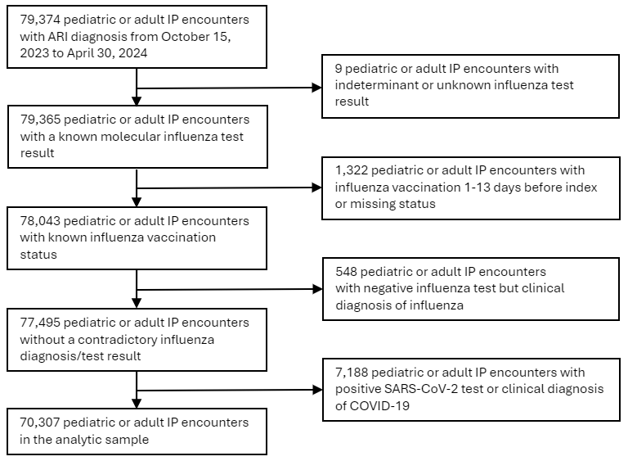

B)
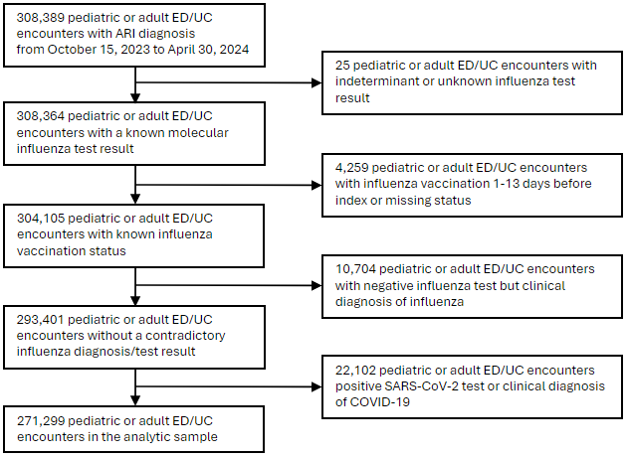

Supplementary Figure 2. A) Influenza-positive hospitalizations and percent positivity by week among children aged 6 months-17 years; B) Influenza-positive hospitalizations and percent positivity by week among adults aged ≥18 years C) Influenza-positive emergency department / urgent care encounters and percent positivity by week among children aged 6 months-17 years; D) Influenza-positive emergency department / urgent care encounters and percent positivity by week among adults aged ≥18 years
Abbreviations: ED/UC = emergency department / urgent care; MMWR = Morbidity and Mortality Weekly Report calendar week
A) 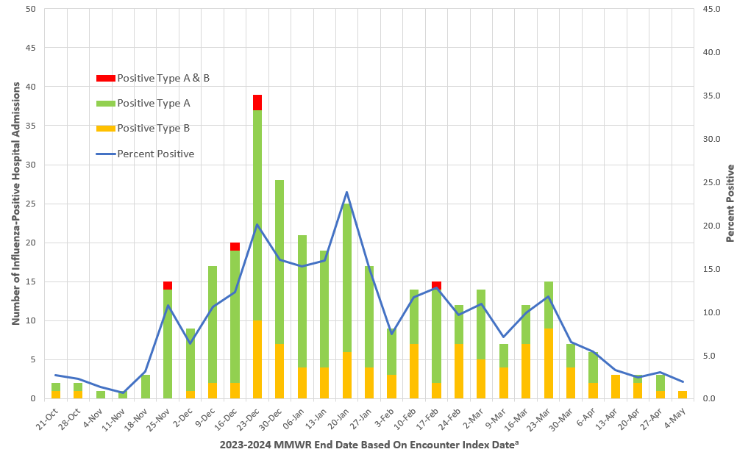
B)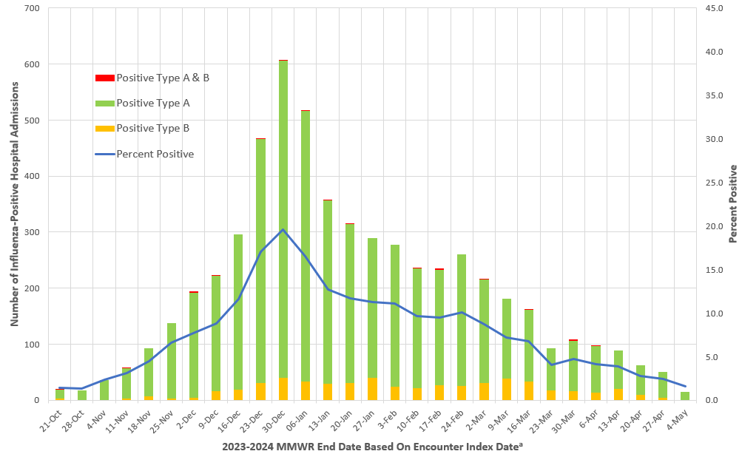
C)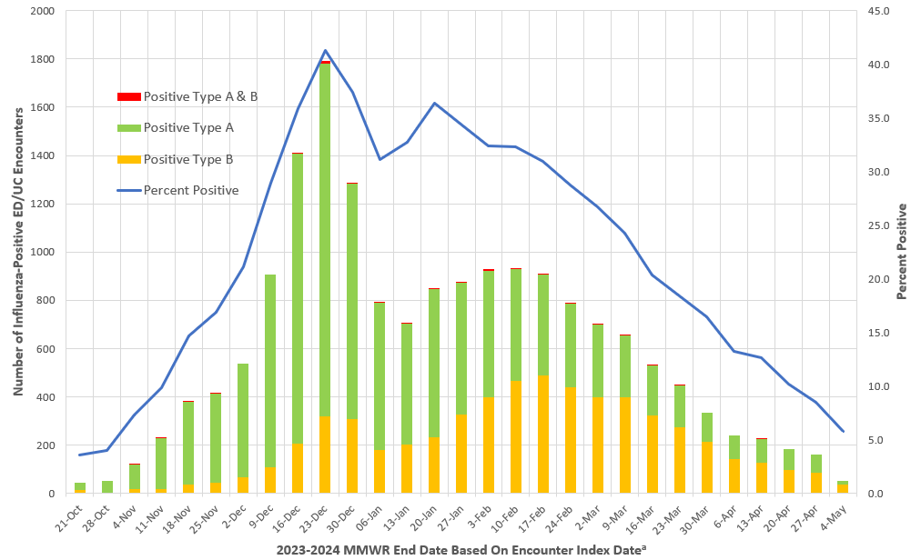
D) 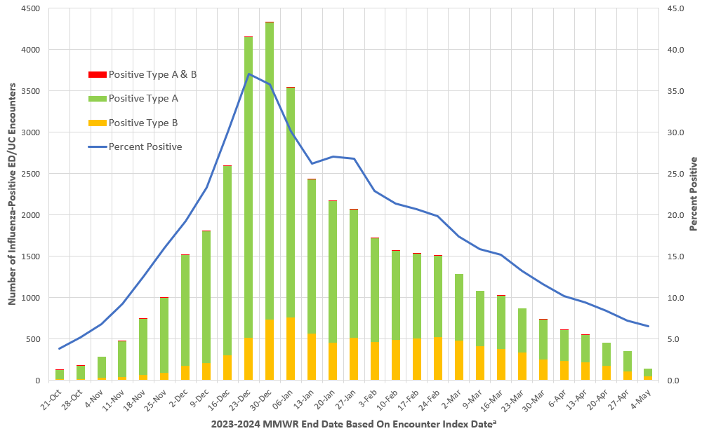ª Encounter Index Date defined as the earliest date of the most recent influenza test or the date of the ED/UC visit or hospital admission.

