Hospital-level variation in cardiac rehabilitation metrics

Lisa M. Pollack, PhD, MPH, MPT¹; Anping Chang, MS, MPH¹; Michael P. Thompson, PhD^{2,3};
Steven J. Keteyian, PhD⁴; Haley Stolp, MPH¹; Hilary K. Wall, MPH¹; Laurence S. Sperling, MD^{1,5}; Sandra L. Jackson, PhD, MPH¹

Affiliations
¹ Division for Heart Disease and Stroke Prevention, National Center for Chronic Disease
Prevention and Health Promotion, Centers for Disease Control and Prevention, Atlanta,
Georgia, USA
² Department of Cardiac Surgery, Michigan Medicine, Ann Arbor, MI
³ Center for Healthcare Outcomes and Policy, University of Michigan, Ann Arbor, MI
⁴ Division of Cardiovascular Medicine, Henry Ford Health, Detroit, Michigan
⁵ Emory Clinical Cardiovascular Research Institute, Atlanta, Georgia

*Corresponding author: Lisa M. Pollack, PhD, MPH, MPT, Division for Heart Disease and
Stroke Prevention, National Center for Chronic Disease Prevention and Health Promotion,
Centers for Disease Control and Prevention; 4770 Buford Hwy, Atlanta, Georgia, 30341;
qkz8@cdc.gov; Tel: (770) 488-6721

Appendix Figure 1. Data Attrition Diagram [A-B]

A. Hospital-level
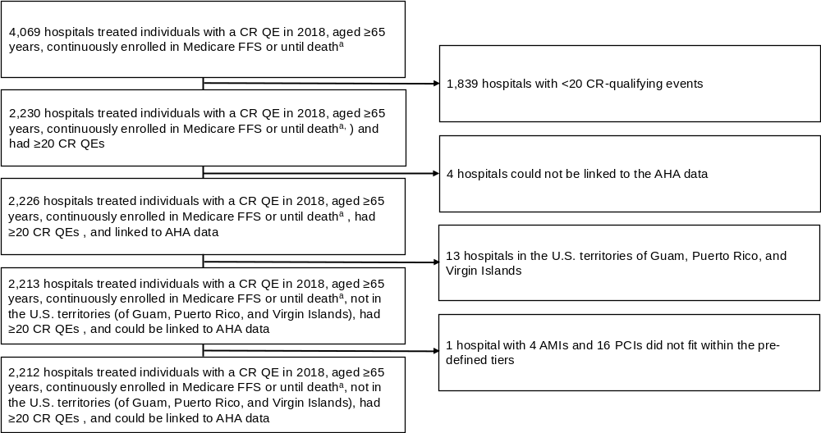
Abbreviations: CR, cardiac rehabilitation; QE, qualifying event

ª We obtained hospital-level characteristics from fiscal year 2018 AHA Annual Survey Database for 4,052 hospitals; we used AHA data from fiscal years 2016 (4 hospitals) and 2017 (13 hospitals) when hospitals could not be linked to Medicare using the 2018 data, and 4 hospitals could not be linked at all.

B. Individual-level
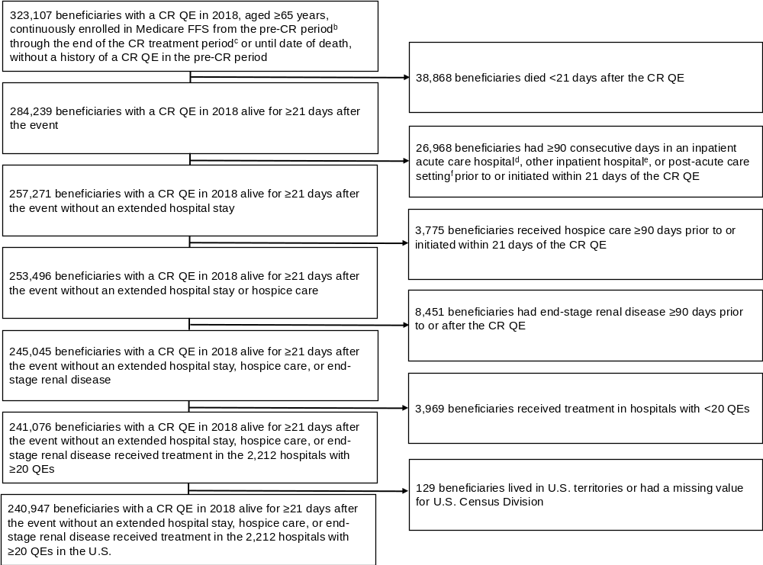
Abbreviations: CR, cardiac rehabilitation; QE, qualifying event

ª CR QE includes an acute myocardial infarction (AMI) event or coronary artery bypass graft (CABG) or percutaneous coronary
intervention (PCI) procedure
^{b} The pre-CR period was from 90 days before the CR-qualifying event through the end of the CR treatment period in line with the
Million Hearts® Outpatient CR use surveillance methodology¹⁷
^{c} The CR treatment period was from 365 days and 36 weeks after the CR-qualifying event in line with the Million Hearts® Outpatient
CR use surveillance methodology¹⁷
^{d} Inpatient acute care hospital (inpatient prospective payment system reimbursed hospital, critical access hospital)
^{e} Other inpatient hospital (inpatient psychiatric facility, other hospital type [e.g., cancer center])
^{f} Post-acute care setting (long-term care hospital, inpatient rehabilitation facility, skilled nursing facility, home health)

Appendix Figure 2. Study Timeline
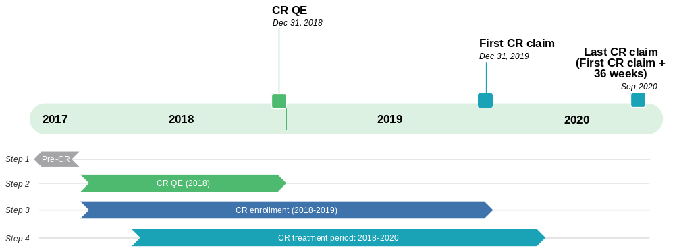
Abbreviations: CR, cardiac rehabilitation; QE, qualifying event

This study examines CR QEs that occurred in 2018
- Earliest CR-qualifying event: Jan 1, 2018
- Latest CR-qualifying event: Dec 31, 2018
CR enrollment can occur within 365 days of the CR QE index date (i.e., CR QE hospital discharge date):
- Earliest CR enrollment date: Jan 1, 2018 (i.e., if CR QE = Jan 1, 2018)
- Latest CR enrollment date: Dec 31, 2019 (i.e., if CR QE = Dec 31, 2018)
Beneficiaries have 36 weeks from CR enrollment (1st CR claim) to finish 36 CR sessions. The CR treatment period is defined from the 1st CR claim + 36 weeks:
- Earliest CR treatment period range (Jan 1, 2018 + 36 weeks): Jan 1, 2018-Sep 10, 2018
- Latest CR treatment period range (Dec 31, 2019 + 36 weeks): Dec 31, 2018-Sep 9, 2020
Appendix Table 1: Diagnosis and procedural codes [A-B]
A. Cardiac rehabilitation qualifying events
AMIª
ICD-10-CM DX | I21.0, I21.01, I21.02, I21.09, I21.1, I21.11, I21.19, I21.2, I21.21, I21.29, I21.3, I21.4, I21.9,  I21.A1, I21.A9, I22.0, I22.1, I22.2, I22.8, I22.9
CABG
ICD-10-PCS | 0210^{b}, 0211^{b}, 0212^{b}, 0213^{b},  02700^{c}, 02710^{c}, 02720^{c}, 02730^{c}, 02C00^{c}, 02C10^{c}, 02C20^{c}, 02C30^{c}
CPT/HCPCS | 33510, 33511, 33512, 33513, 33514, 33516, 33533, 33534, 33535, 33536, S2205, S2206, S2207, S2208, S2209
PCI^{d}
ICD-10-PCS | 02703^{c}, 02704^{c}, 02713^{c}, 02714^{c}, 02723^{c}, 02724^{c}, 02733^{c}, 02734^{c}, 02C03^{c}, 02C04^{c}, 02C13^{c}, 02C14^{c}, 02C23^{c}, 02C24^{c}, 02C33^{c}, 02C34^{c},  3E07017, 3E070PZ, 3E07317, 3E073PZ
CPT | 92920, 92924, 92928, 92933, 92937, 92941, 92943, 92975
B. Cardiac rehabilitation claims^{e}
Standard and Intensive CR
HCPCS/Revenue Center | 93797, 93798, G0422, G0423, 0943
Abbreviations: AMI, acute myocardial infarction; CABG, coronary artery bypass graft; CPT, Current Procedural Terminology;
CR, cardiac rehabilitation; DX, diagnosis; HCPCS, Healthcare Common procedure Coding System; ICD-10-CM, International
Classification of Diseases, 10th edition, Clinical Modification; PCI, percutaneous coronary intervention; PCS, procedure coding
system; PR, procedural
ª Coded first or second listed ICD-10-CM diagnosis code
^{b} Includes all codes with these as the first four identifiers
^{c} Includes all codes with these as the first five identifiers
^{d} PCI includes percutaneous transluminal coronary angioplasty [PTCA] or coronary stenting and same-day discharge after an
outpatient PCI
^{e} A CR session is defined has having one of the HCPCS codes when billed with place of service codes of 11 (services provided in a
physician’s office), 19 (off campus-outpatient hospital), or 22 (on campus-outpatient hospital)

Appendix Table 2. Characteristics of patients with a CR-qualifying event in 2018 treated at U.S. hospitals by tier of cardiac care, Medicare FFS CCW Administrative and Claims data (2018-2020) and AHA (2016-2018) data
 | All  Patients  (N=240,947) |  | Comprehensive care availableª  (n=189,674) |  | AMI/PCI care  Available^{b}  (n=41,679) |  | AMI-only care  Available^{c}  (n=9,594) |  | p-value^{d}
 | N | % | N | % | N | % | N | %
CR-qualifying event
AMI with CABG and PCI | 797 | 0.3 | 774 | 0.4 | 23 | 0.1 | ^{e} | ^{e} | <.0001
AMI with CABG | 11,987 | 5.0 | 11,850 | 6.3 | 124 | 0.3 | 13 | 0.1 | <.0001
AMI with PCI | 59,039 | 24.5 | 46,536 | 24.5 | 12,298 | 29.5 | 205 | 2.1 | <.0001
AMI only | 89,284 | 37.1 | 59,068 | 31.1 | 20,988 | 50.4 | 9,228 | 96.2 | <.0001
CABG with PCI | 354 | 0.2 | 347 | 0.2 | ^{e} | ^{e} | ^{e} | ^{e} | <.0001
CABG only | 34,841 | 14.5 | 34,601 | 18.2 | 222 | 0.5 | 18 | 0.2 | <.0001
PCI only | 44,645 | 18.5 | 36,498 | 19.2 | 8,017 | 19.2 | 130 | 1.4 | <.0001
Age group, years
65-70 | 69,633 | 28.9 | 57,068 | 30.1 | 10,956 | 26.3 | 1,609 | 16.8 | <.0001
71–75 | 56,734 | 23.6 | 46,068 | 24.3 | 9,111 | 21.9 | 1,555 | 16.2 | <.0001
76–80 | 46,866 | 19.5 | 37,394 | 19.7 | 7,838 | 18.8 | 1,634 | 17.0 | <.0001
81–85 | 34,594 | 14.4 | 26,349 | 13.9 | 6,496 | 15.6 | 1,749 | 18.2 | <.0001
>85 | 33,120 | 13.8 | 22,795 | 12.0 | 7,278 | 17.5 | 3,047 | 31.8 | <.0001
Sex
Male | 144,457 | 60.0 | 117,777 | 62.1 | 22,396 | 53.7 | 4,284 | 44.7 | <.0001
Female | 96,490 | 40.1 | 71,897 | 37.9 | 19,283 | 46.3 | 5,310 | 55.4 | <.0001
Race and ethnicity
Non-Hispanic White | 207,271 | 86.0 | 164,437 | 86.7 | 34,973 | 83.9 | 7,861 | 81.9 | <.0001
Non-Hispanic Black | 13,425 | 5.6 | 9,702 | 5.1 | 2,932 | 7.0 | 791 | 8.2 | <.0001
Hispanic | 9,557 | 4.0 | 7,093 | 3.7 | 1,935 | 4.6 | 529 | 5.5 | <.0001
Non-Hispanic Asian and Pacific Islander | 4,578 | 1.9 | 3,472 | 1.8 | 879 | 2.1 | 227 | 2.4 | <.0001
Other/Unknown | 6,116 | 2.5 | 4,970 | 2.6 | 960 | 2.3 | 186 | 1.9 | <.0001
Dual Medicare and Medicaid coverage
No dual enrollment | 218,516 | 90.69 | 173,701 | 91.58 | 37,037 | 88.86 | 7,778 | 81.07 | <.0001
Partial/Full dual enrollment | 22,431 | 9.31 | 15,973 | 8.42 | 4,642 | 11.14 | 1,816 | 18.93 | <.0001
Urbanicity of residence^{c}
MSA, population ≥50,000 | 183,869 | 76.3 | 144,984 | 76.4 | 32,092 | 77.0 | 6,793 | 70.8 | <.0001
MSA, population 10,000-50,000 | 31,889 | 13.2 | 23,727 | 12.5 | 6,252 | 15.0 | 1,910 | 19.9 | <.0001
Rural area, population <10,000 | 25,189 | 10.5 | 20,963 | 11.1 | 3,335 | 8.0 | 891 | 9.3 | <.0001
U.S. Census Division
New England | 14,032 | 5.8 | 10,273 | 5.4 | 2,193 | 5.3 | 1,566 | 16.3 | <.0001
Middle Atlantic | 31,351 | 13.0 | 23,019 | 12.1 | 6,052 | 14.5 | 2,280 | 23.8 | <.0001
South Atlantic | 40,209 | 16.7 | 32,932 | 17.4 | 6,209 | 14.9 | 1,068 | 11.1 | <.0001
East North Central | 18,370 | 7.6 | 15,011 | 7.9 | 3,104 | 7.5 | 255 | 2.7 | <.0001
East South Central | 53,828 | 22.3 | 41,366 | 21.8 | 10,618 | 25.5 | 1,844 | 19.2 | <.0001
West North Central | 17,650 | 7.3 | 14,729 | 7.8 | 2,484 | 6.0 | 437 | 4.6 | <.0001
West South Central | 25,746 | 10.7 | 21,433 | 11.3 | 3,911 | 9.4 | 402 | 4.2 | <.0001
Mountain | 14,132 | 5.9 | 11,199 | 5.9 | 2,785 | 6.7 | 148 | 1.5 | <.0001
Pacific | 25,629 | 10.6 | 19,712 | 10.4 | 4,323 | 10.4 | 1,594 | 16.6 | <.0001
 | Mean | SD | Mean | SD | Mean | SD | Mean | SD | p-value
Age (Mean), years | 76.1 | 7.7 | 75.7 | 7.5 | 77.0 | 8.1 | 80.4 | 8.8 | <.0001
Abbreviations: AMI, acute myocardial infarction; Centers for Medicare and Medicaid Services (CMS); Chronic Conditions Data Warehouse (CCW); CABG, coronary artery bypass graft surgery; CR, cardiac rehabilitation; FFS, fee-for-service; Metropolitan statistical area (MSA); PCI, percutaneous coronary intervention

ª Hospitals that performed ≥10 CABG and ≥10 PCI procedures (i.e., AMI, CABG, and PCI care available)
^{b} Hospitals that performed ≥10 PCI procedures but <10 CABG procedures (i.e., AMI and PCI care available)
^{c} Hospitals that performed <10 CABG and <10 PCI procedures (i.e., AMI only care)
^{d} Chi-square tests were used to compare differences in proportions for categorical variables by tier of cardiac care; Kruskal-Wallis tests
were used to compare differences in medians for continuous variables by tier of cardiac care using SAS PROC NPAR1WAY.
^{e} Cell sizes <11 cannot be reported

Appendix Figure 3. Hospital-level CR enrollment ª (%) by tier of cardiac care and U.S. Census Division, median (IQR) ^{b-d}

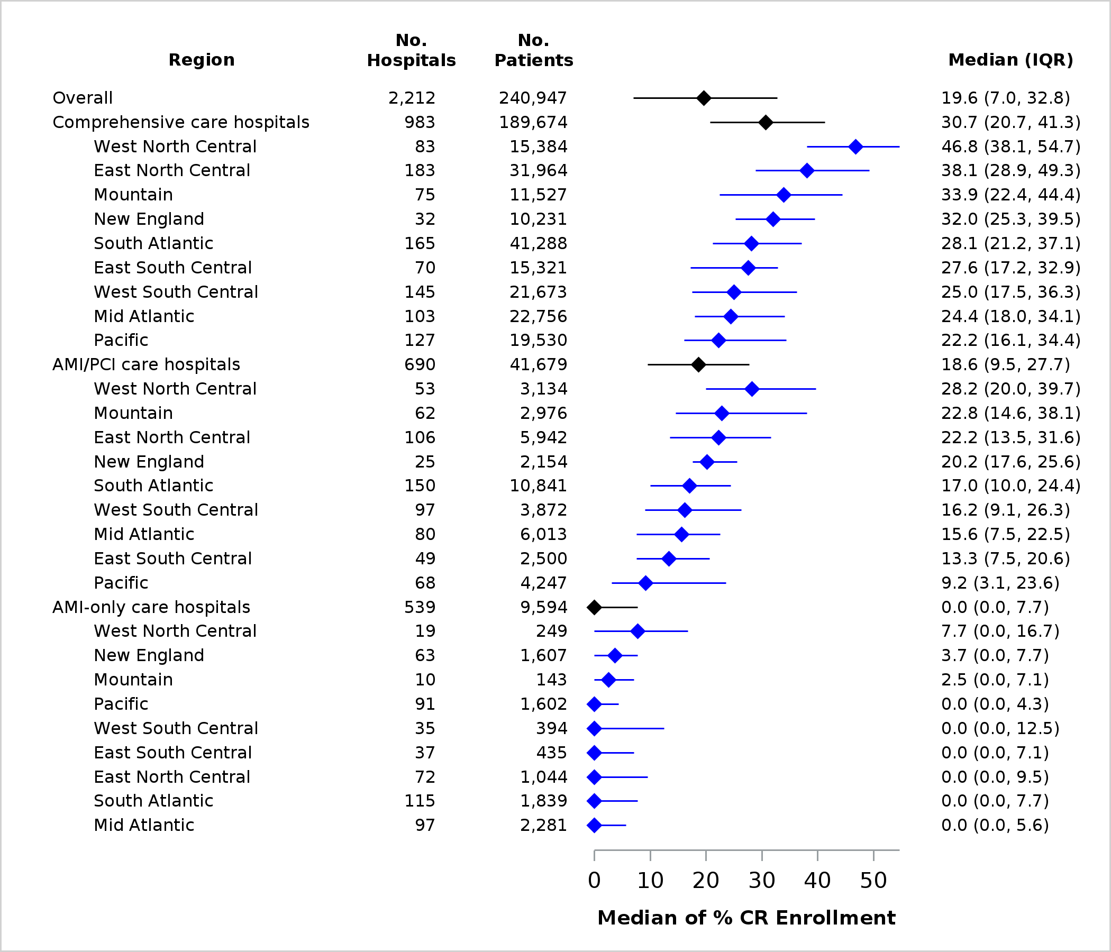
Abbreviations: AMI, acute myocardial infarction; CABG, coronary artery bypass graft surgery; CR, cardiac rehabilitation; IQR,
interquartile range; No., number; PCI, percutaneous coronary intervention

ª CR enrollment: Number of beneficiaries who attended ≥1 CR session within 365 days of the CR-qualifying event out of the number
of CR-qualifying events within the measurement period.
^{b} Hospitals that performed ≥10 CABG and ≥10 PCI procedures (i.e., AMI, CABG, and PCI care available)
^{c} Hospitals that performed ≥10 PCI procedures but <10 CABG procedures (i.e., AMI and PCI care available)
^{d} Hospitals that performed <10 CABG and <10 PCI procedures (i.e., AMI only care)

Appendix Figure 4. Hospital-level time to CR enrollment ª (days) by tier of cardiac care and U.S. Census Division, median (IQR) ^{b-d}

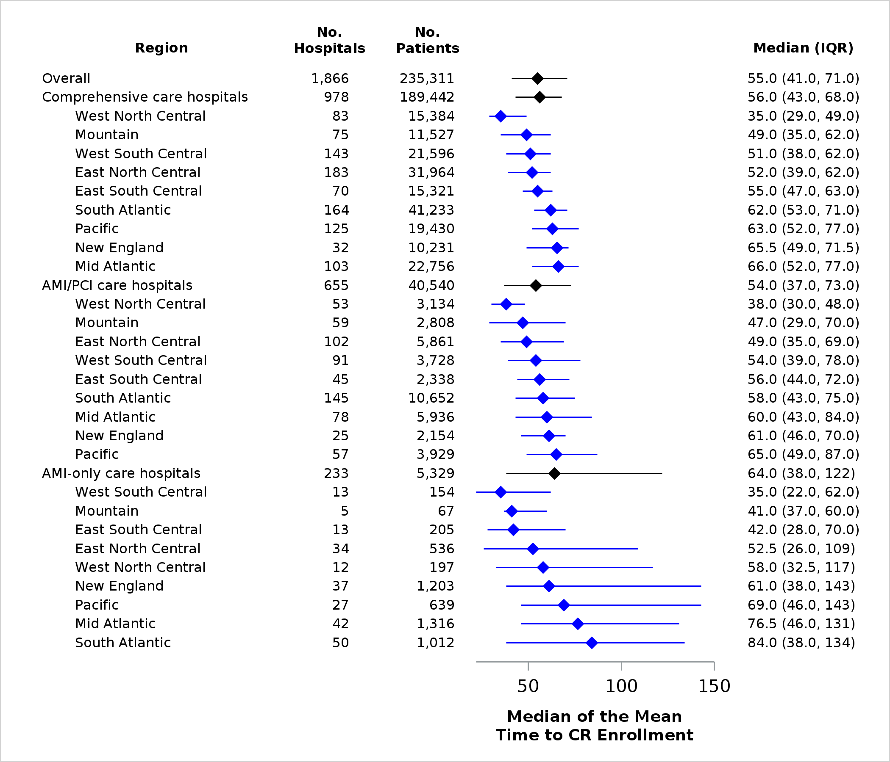

Abbreviations: AMI, acute myocardial infarction; CABG, coronary artery bypass graft surgery; CR, cardiac rehabilitation; IQR,
interquartile range; No., number; PCI, percutaneous coronary intervention

ª Time to CR enrollment: Time in days from the CR-qualifying event index date or hospital discharge date after index event to the first
CR session date.
^{b} Hospitals that performed ≥10 CABG and ≥10 PCI procedures (i.e., AMI, CABG, and PCI care available)
^{c} Hospitals that performed ≥10 PCI procedures but <10 CABG procedures (i.e., AMI and PCI care available)
^{d} Hospitals that performed <10 CABG and <10 PCI procedures (i.e., AMI only care)

Appendix Figure 5. Hospital-level number of CR sessions ª by tier of cardiac care and U.S. Census Division, median (IQR) ^{b-d}

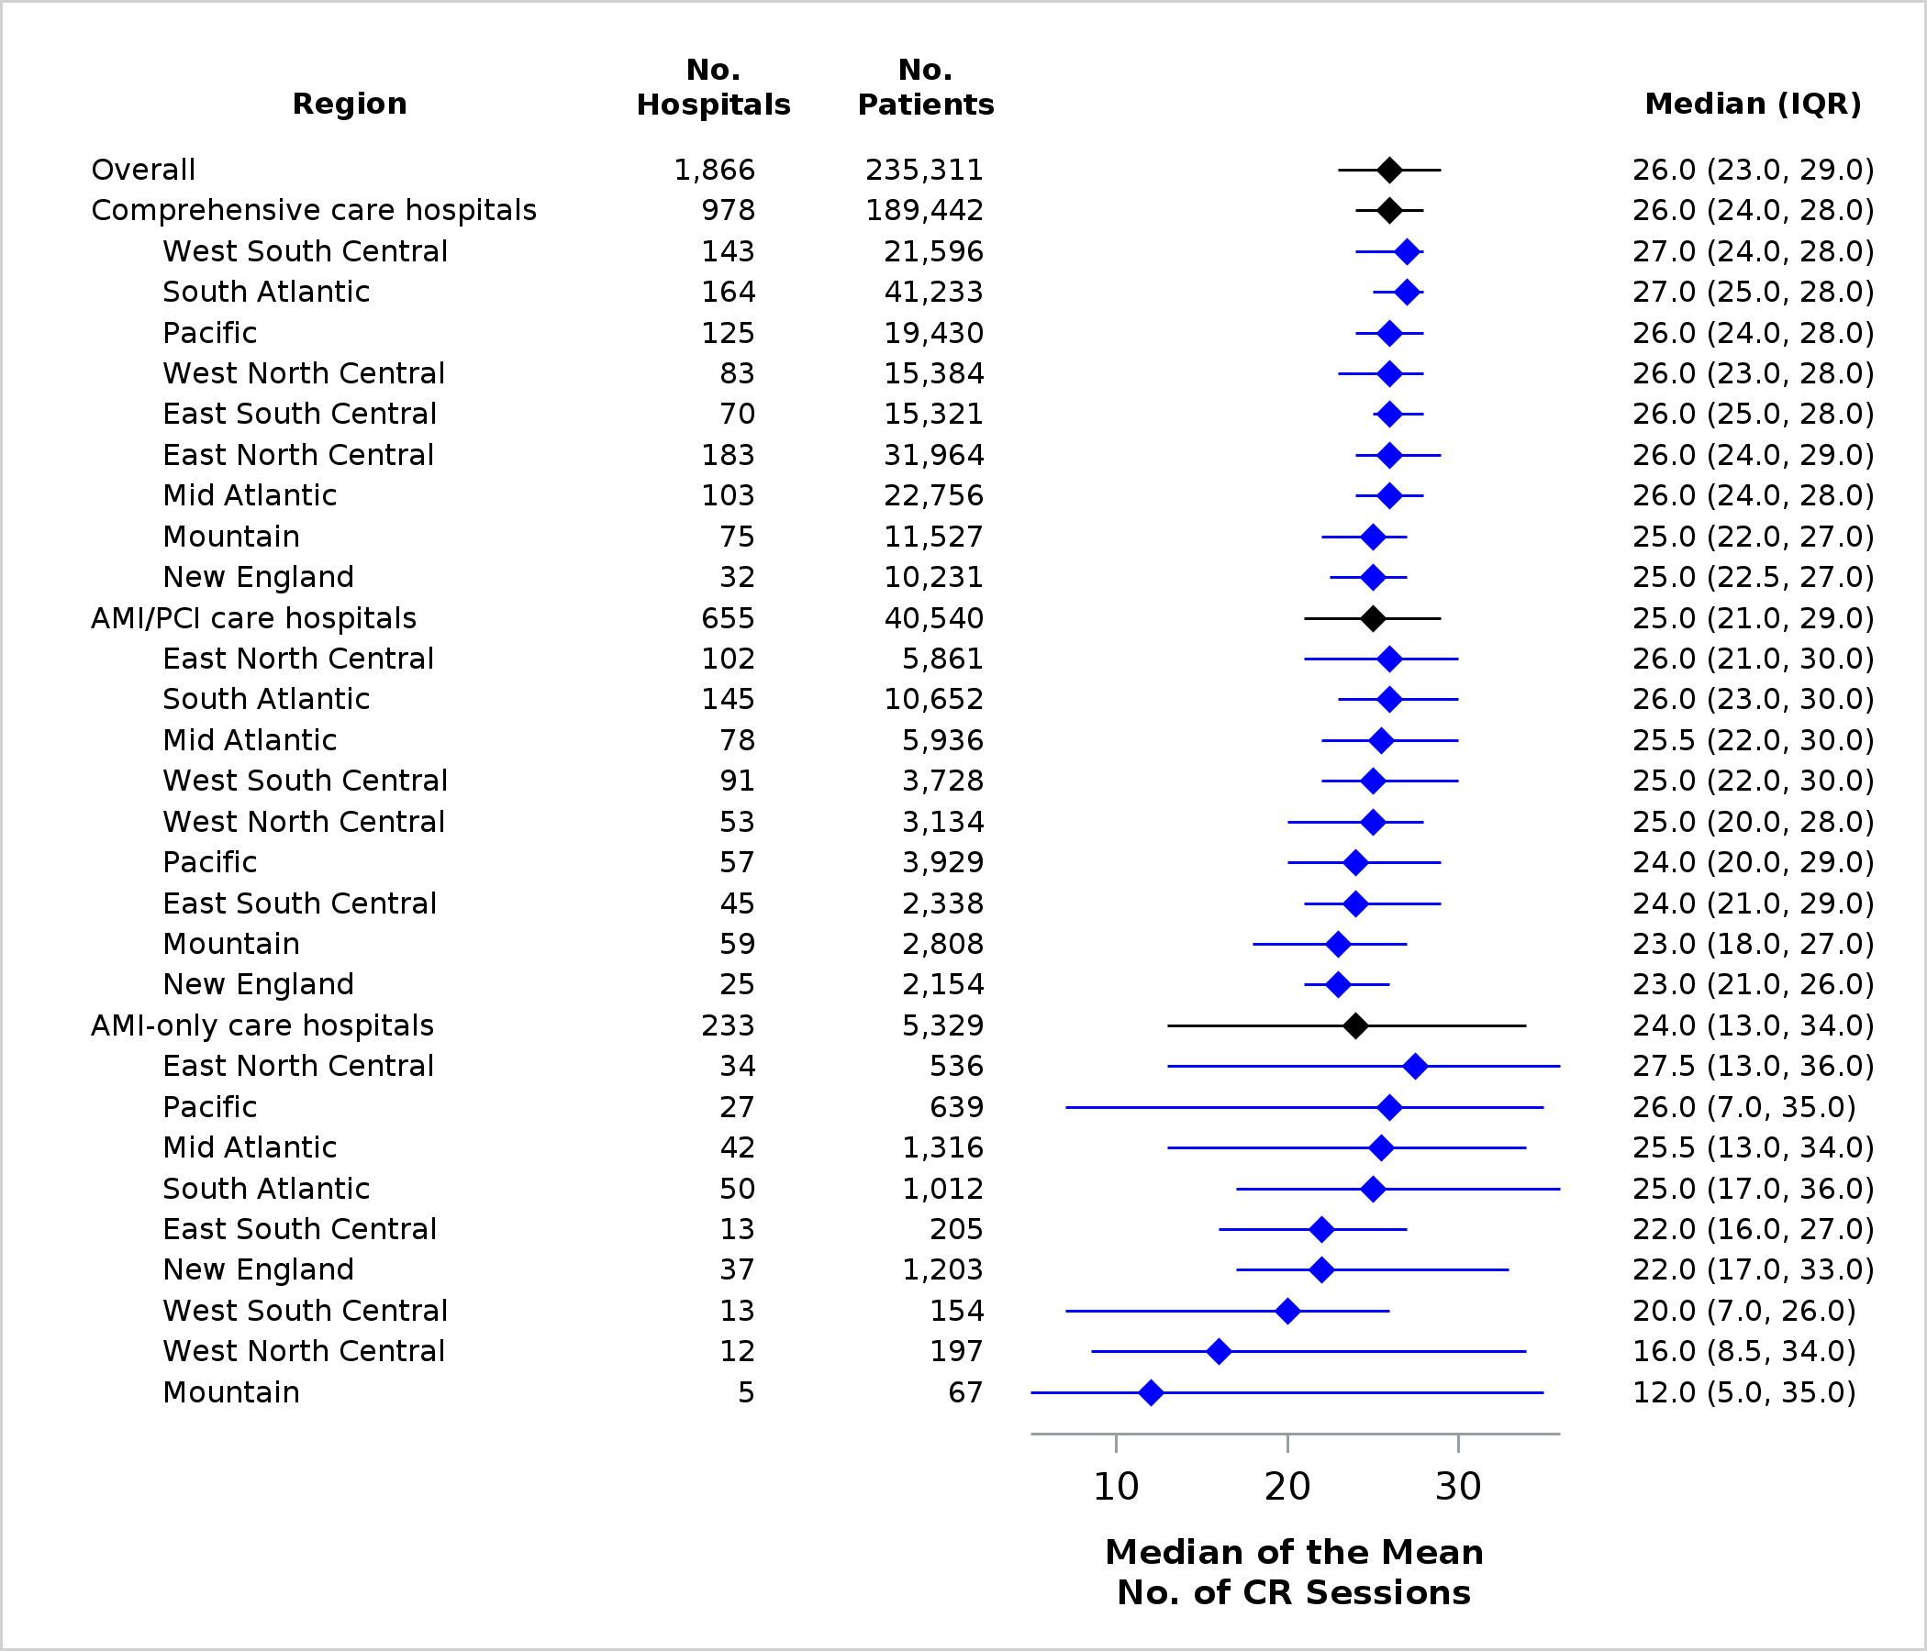

Abbreviations: AMI, acute myocardial infarction; CABG, coronary artery bypass graft surgery; CR, cardiac rehabilitation; IQR,
interquartile range; No., number; PCI, percutaneous coronary intervention

ª Number of CR sessions: Number of CR sessions attended within 36 weeks of the first CR session date.
^{b} Hospitals that performed ≥10 CABG and ≥10 PCI procedures (i.e., AMI, CABG, and PCI care available)
^{c} Hospitals that performed ≥10 PCI procedures but <10 CABG procedures (i.e., AMI and PCI care available)
^{d} Hospitals that performed <10 CABG and <10 PCI procedures (i.e., AMI only care)

Appendix Figure 6. Hospital-level CR completion ª (%) by tier of cardiac care and U.S. Census Division, median (IQR)^{b-d}

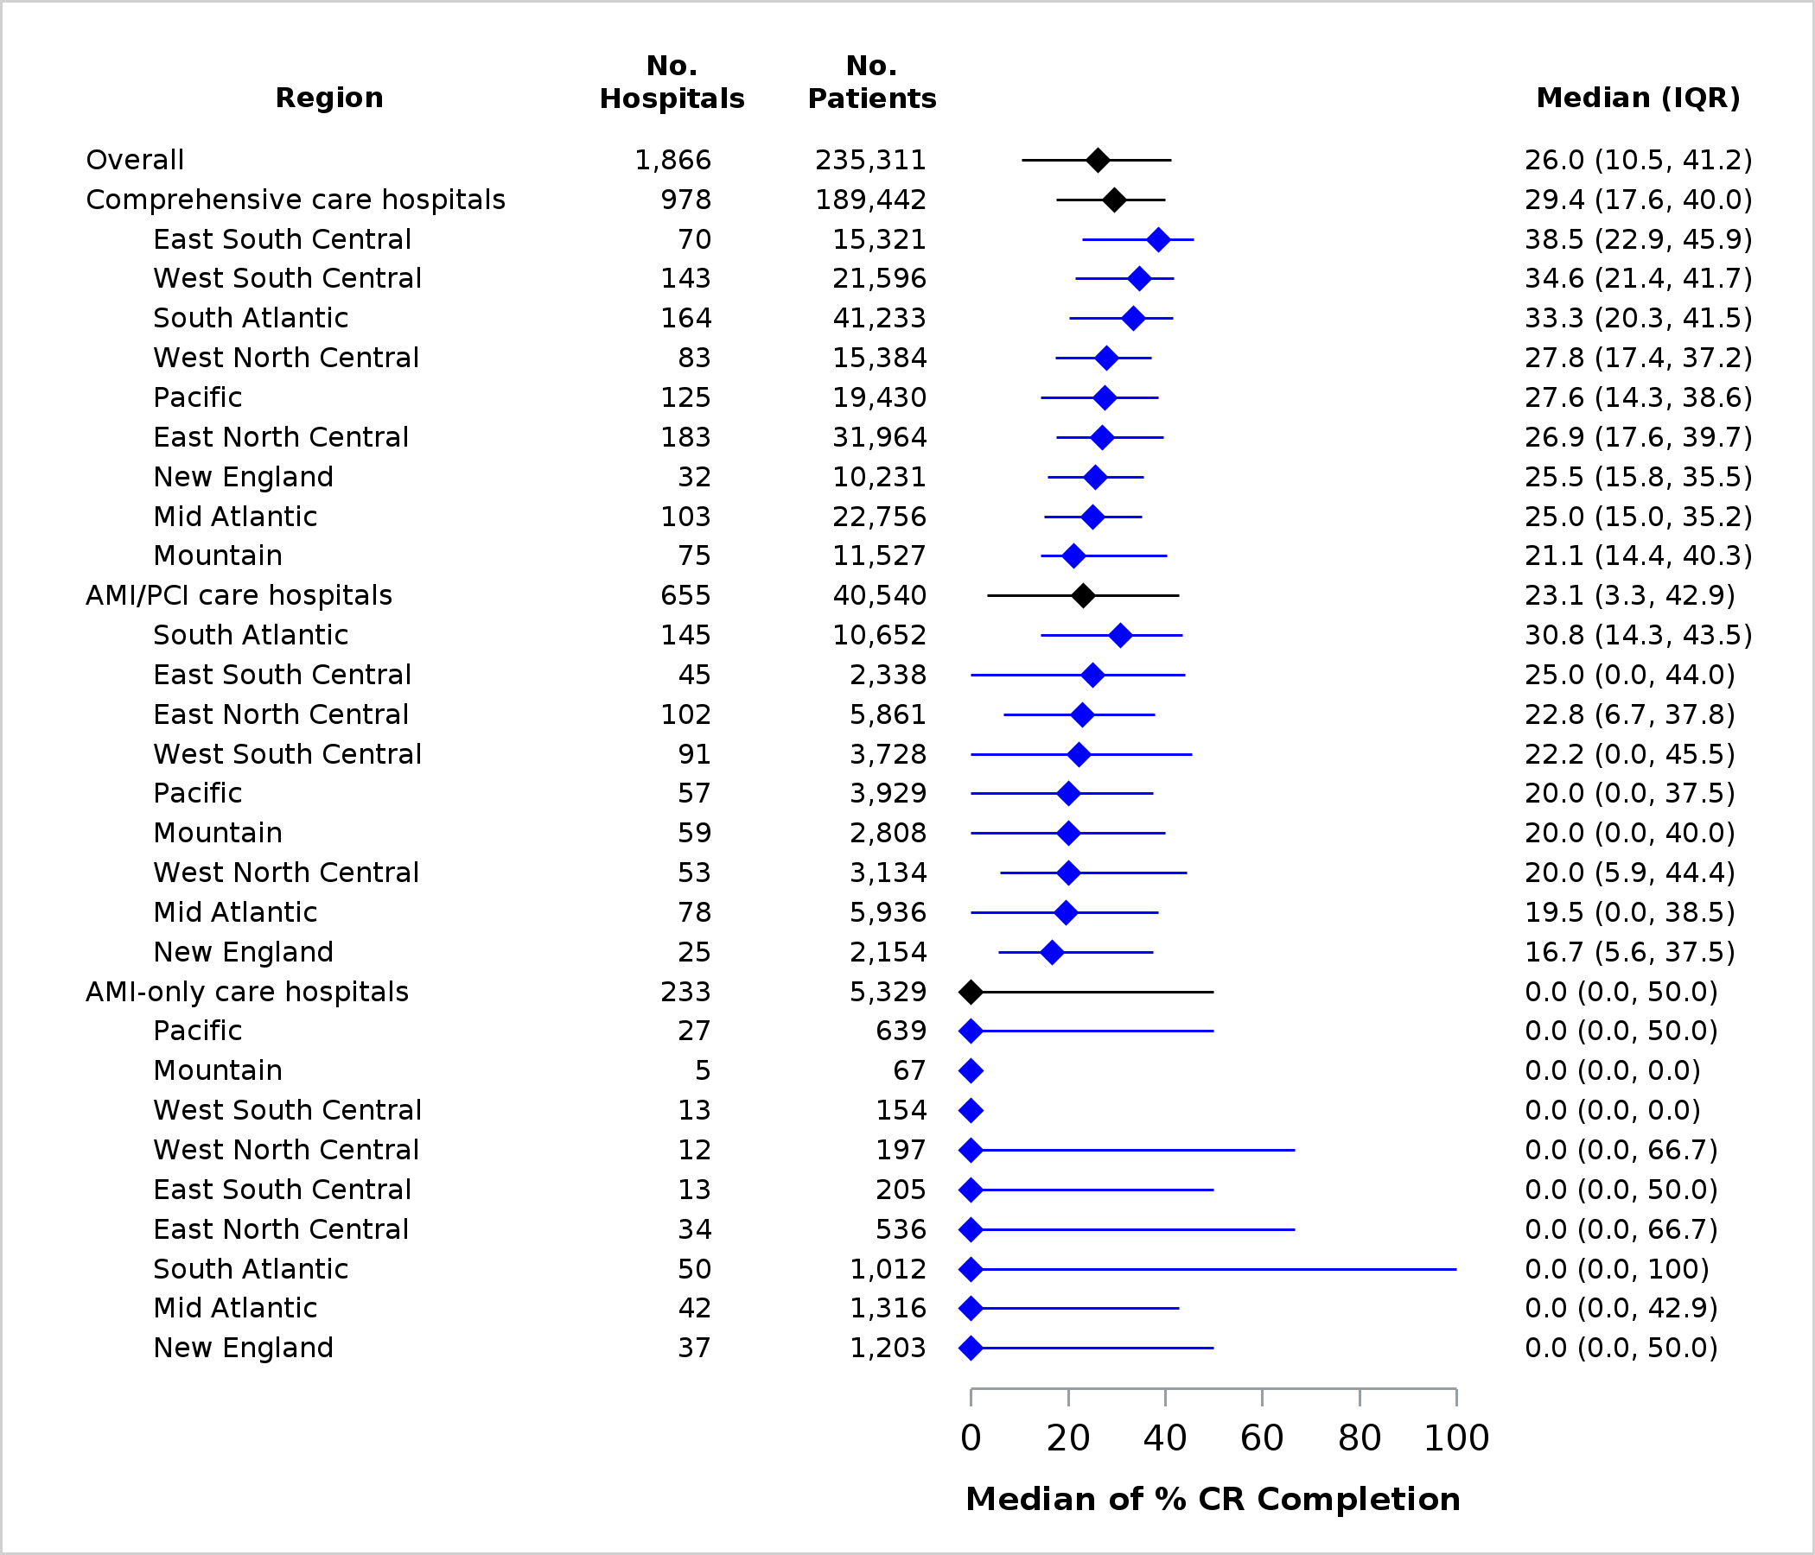
Abbreviations: AMI, acute myocardial infarction; CABG, coronary artery bypass graft surgery; CR, cardiac rehabilitation; IQR,
interquartile range; No., number; PCI, percutaneous coronary intervention

ª CR completion: Number of individuals who attended ≥36 CR sessions within 36 weeks of the first CR session date out of the number
of individuals who enrolled in CR.
^{b} Hospitals that performed ≥10 CABG and ≥10 PCI procedures (i.e., AMI, CABG, and PCI care available)
^{c} Hospitals that performed ≥10 PCI procedures but <10 CABG procedures (i.e., AMI and PCI care available)
^{d} Hospitals that performed <10 CABG and <10 PCI procedures (i.e., AMI only care)

Appendix Table 3: Hospital-level CR enrollment ª (%) by tier of cardiac care and U.S. Census Division
 | No. Hospitals | No. Patients | Mean | SD | Median | IQR | Min | Max
All Hospitals | 2,212 | 240,947 | 21.1 | 16.5 | 19.6 | 25.8 | 0.0 | 75.9
Comprehensive care available ^{b} | No. Hospitals | No. Patients | Mean | SD | Median | IQR | Min | Max
All comprehensive care hospitals | 983 | 189,674 | 31.3 | 14.2 | 30.7 | 20.6 | 0.0 | 75.9
New England | 32 | 10,231 | 32.4 | 10.3 | 32.0 | 14.2 | 13.1 | 52.7
Middle Atlantic | 103 | 22,756 | 26.0 | 11.0 | 24.4 | 16.1 | 2.7 | 57.4
South Atlantic | 165 | 41,288 | 29.4 | 12.1 | 28.1 | 15.9 | 0.0 | 58.3
East North Central | 183 | 31,964 | 38.5 | 13.4 | 38.1 | 20.4 | 10.4 | 73.1
East South Central | 70 | 15,321 | 25.9 | 10.8 | 27.6 | 15.7 | 2.3 | 49.5
West North Central | 83 | 15,384 | 45.9 | 12.9 | 46.8 | 16.6 | 16.7 | 75.9
West South Central | 145 | 21,673 | 26.9 | 13.7 | 25.0 | 18.8 | 0.0 | 63.2
Mountain | 75 | 11,527 | 33.8 | 14.2 | 33.9 | 22.1 | 7.7 | 68.5
Pacific | 127 | 19,530 | 24.7 | 12.7 | 22.2 | 18.3 | 0.0 | 55.6
AMI/PCI care available ^{c} | No. Hospitals | No. Patients | Mean | SD | Median | IQR | Min | Max
All AMI/PCI care hospitals | 690 | 41,679 | 19.6 | 13.1 | 18.6 | 18.1 | 0.0 | 72.7
New England | 25 | 2,154 | 21.1 | 6.4 | 20.2 | 7.9 | 5.3 | 33.9
Middle Atlantic | 80 | 6,013 | 15.7 | 9.7 | 15.6 | 15.0 | 0.0 | 40.0
South Atlantic | 150 | 10,841 | 17.8 | 10.7 | 17.0 | 14.4 | 0.0 | 49.3
East North Central | 106 | 5,942 | 23.3 | 14.6 | 22.2 | 18.1 | 0.0 | 72.7
East South Central | 49 | 2,500 | 14.7 | 10.3 | 13.3 | 13.1 | 0.0 | 45.8
West North Central | 53 | 3,134 | 30.7 | 14.2 | 28.2 | 19.7 | 5.3 | 63.6
West South Central | 97 | 3,872 | 18.4 | 12.5 | 16.2 | 17.2 | 0.0 | 52.0
Mountain | 62 | 2,976 | 25.5 | 15.4 | 22.8 | 23.5 | 0.0 | 70.0
Pacific | 68 | 4,247 | 13.4 | 12.1 | 9.2 | 20.5 | 0.0 | 47.5
AMI-only care available ^{d} | No. Hospitals | No. Patients | Mean | SD | Median | IQR | Min | Max
All AMI-only care hospitals | 539 | 9,594 | 4.5 | 7.4 | 0.0 | 7.7 | 0.0 | 75.0
New England | 63 | 1,607 | 4.9 | 5.8 | 3.7 | 7.7 | 0.0 | 23.3
Middle Atlantic | 97 | 2,281 | 3.4 | 5.5 | 0.0 | 5.6 | 0.0 | 37.5
South Atlantic | 115 | 1,839 | 4.2 | 5.9 | 0.0 | 7.7 | 0.0 | 28.6
East North Central | 72 | 1,044 | 6.6 | 11.4 | 0.0 | 9.5 | 0.0 | 75.0
East South Central | 37 | 435 | 5.1 | 8.6 | 0.0 | 7.1 | 0.0 | 33.3
West North Central | 19 | 249 | 8.5 | 8.7 | 7.7 | 16.7 | 0.0 | 30.0
West South Central | 35 | 394 | 5.6 | 8.6 | 0.0 | 12.5 | 0.0 | 35.7
Mountain | 10 | 143 | 6.3 | 10.3 | 2.5 | 7.1 | 0.0 | 33.3
Pacific | 91 | 1,602 | 2.4 | 4.8 | 0.0 | 4.3 | 0.0 | 26.3
Abbreviations: AMI, acute myocardial infarction; CABG, coronary artery bypass graft surgery; CR, cardiac rehabilitation; IQR, interquartile range; Max, maximum; Min, minimum; No., number; PCI, percutaneous coronary intervention; SD, standard deviation

ª CR enrollment: Number of beneficiaries who attended ≥1 CR session within 365 days of the CR-qualifying event out of the
number of CR-qualifying events within the measurement period.
^{b} Hospitals that performed ≥10 CABG and ≥10 PCI procedures (i.e., AMI, CABG, and PCI care available)
^{c} Hospitals that performed ≥10 PCI procedures but <10 CABG procedures (i.e., AMI and PCI care available)
^{d} Hospitals that performed <10 CABG and <10 PCI procedures (i.e., AMI only care)

Appendix Table 4: Hospital-level time to CR enrollmentª (days) by tier of cardiac care and U.S. Census Division
 | No. Hospitals | No. Patients | Mean | SD | Median | IQR | Min | Max
All Hospitals | 1,866 | 235,311 | 62.7 | 39.2 | 55.0 | 30.0 | 1.0 | 352.0
Comprehensive care available ^{b} | No. Hospitals | No. Patients | Mean | SD | Median | IQR | Min | Max
All comprehensive care hospitals | 978 | 189,442 | 57.1 | 21.2 | 56.0 | 25.0 | 9.0 | 217.0
New England | 32 | 10,231 | 63.2 | 16.2 | 65.5 | 22.5 | 40.0 | 107.0
Middle Atlantic | 103 | 22,756 | 66.9 | 20.9 | 66.0 | 25.0 | 23.0 | 128.0
South Atlantic | 164 | 41,233 | 64.8 | 21.3 | 62.0 | 18.0 | 25.0 | 217.0
East North Central | 183 | 31,964 | 51.7 | 16.4 | 52.0 | 23.0 | 9.0 | 117.0
East South Central | 70 | 15,321 | 56.8 | 21.7 | 55.0 | 16.0 | 29.0 | 188.0
West North Central | 83 | 15,384 | 40.5 | 17.5 | 35.0 | 20.0 | 14.0 | 110.0
West South Central | 143 | 21,596 | 52.9 | 20.0 | 51.0 | 24.0 | 23.0 | 137.0
Mountain | 75 | 11,527 | 48.4 | 15.6 | 49.0 | 27.0 | 9.0 | 75.0
Pacific | 125 | 19,430 | 66.2 | 22.3 | 63.0 | 25.0 | 18.0 | 191.0
AMI/PCI care available ^{c} | No. Hospitals | No. Patients | Mean | SD | Median | IQR | Min | Max
All AMI/PCI care hospitals | 655 | 40,540 | 61.8 | 39.4 | 54.0 | 36.0 | 8.0 | 349.0
New England | 25 | 2,154 | 60.5 | 19.5 | 61.0 | 24.0 | 32.0 | 100.0
Middle Atlantic | 78 | 5,936 | 66.2 | 31.5 | 60.0 | 41.0 | 19.0 | 181.0
South Atlantic | 145 | 10,652 | 68.2 | 48.2 | 58.0 | 32.0 | 16.0 | 349.0
East North Central | 102 | 5,861 | 55.7 | 30.8 | 49.0 | 34.0 | 11.0 | 219.0
East South Central | 45 | 2,338 | 60.7 | 28.6 | 56.0 | 28.0 | 18.0 | 142.0
West North Central | 53 | 3,134 | 39.3 | 14.4 | 38.0 | 18.0 | 8.0 | 81.0
West South Central | 91 | 3,728 | 65.4 | 46.4 | 54.0 | 39.0 | 14.0 | 334.0
Mountain | 59 | 2,808 | 50.7 | 28.8 | 47.0 | 41.0 | 12.0 | 148.0
Pacific | 57 | 3,929 | 78.9 | 51.6 | 65.0 | 38.0 | 17.0 | 263.0
AMI-only care available ^{d} | No. Hospitals | No. Patients | Mean | SD | Median | IQR | Min | Max
All AMI-only care hospitals | 233 | 5,329 | 88.6 | 72.6 | 64.0 | 84.0 | 1.0 | 352.0
New England | 37 | 1,203 | 94.1 | 77.1 | 61.0 | 105.0 | 11.0 | 315.0
Middle Atlantic | 42 | 1,316 | 98.5 | 71.2 | 76.5 | 85.0 | 21.0 | 297.0
South Atlantic | 50 | 1,012 | 94.3 | 66.1 | 84.0 | 96.0 | 16.0 | 271.0
East North Central | 34 | 536 | 79.4 | 76.7 | 52.5 | 83.0 | 5.0 | 271.0
East South Central | 13 | 205 | 63.7 | 47.7 | 42.0 | 42.0 | 26.0 | 180.0
West North Central | 12 | 197 | 80.0 | 65.3 | 58.0 | 84.5 | 14.0 | 207.0
West South Central | 13 | 154 | 62.7 | 87.9 | 35.0 | 40.0 | 1.0 | 344.0
Mountain | 5 | 67 | 51.6 | 33.9 | 41.0 | 23.0 | 15.0 | 105.0
Pacific | 27 | 639 | 101.4 | 83.5 | 69.0 | 97.0 | 14.0 | 352.0
Abbreviations: AMI, acute myocardial infarction; CABG, coronary artery bypass graft surgery; CR, cardiac rehabilitation; IQR,
interquartile range; Max, maximum; Min, minimum; No., number; PCI, percutaneous coronary intervention; SD, standard
deviation

ª Time to CR enrollment: Time in days from the CR-qualifying event index date or hospital discharge date after index event to the
first CR session date.
^{b} Hospitals that performed ≥10 CABG and ≥10 PCI procedures (i.e., AMI, CABG, and PCI care available)
^{c} Hospitals that performed ≥10 PCI procedures but <10 CABG procedures (i.e., AMI and PCI care available)
^{d} Hospitals that performed <10 CABG and <10 PCI procedures (i.e., AMI only care)

Appendix Table 5: Hospital-level number of CR sessions ª by tier of cardiac care and U.S. Census Division
 | No. Hospitals | No. Patients | Mean | SD | Median | IQR | Min | Max
All Hospitals | 1,866 | 235,311 | 25.0 | 6.6 | 26.0 | 6.0 | 1.0 | 71.0
A. Comprehensive care available ^{b} | No. Hospitals | No. Patients | Mean | SD | Median | IQR | Min | Max
All comprehensive care hospitals | 978 | 189,442 | 25.9 | 3.9 | 26.0 | 4.0 | 5.0 | 71.0
New England | 32 | 10,231 | 24.7 | 3.3 | 25.0 | 4.5 | 16.0 | 29.0
Middle Atlantic | 103 | 22,756 | 25.9 | 3.1 | 26.0 | 4.0 | 18.0 | 33.0
South Atlantic | 164 | 41,233 | 26.3 | 4.0 | 27.0 | 3.0 | 5.0 | 41.0
East North Central | 183 | 31,964 | 26.3 | 3.2 | 26.0 | 5.0 | 16.0 | 33.0
East South Central | 70 | 15,321 | 25.7 | 3.7 | 26.0 | 3.0 | 13.0 | 35.0
West North Central | 83 | 15,384 | 25.3 | 3.6 | 26.0 | 5.0 | 17.0 | 34.0
West South Central | 143 | 21,596 | 26.1 | 3.5 | 27.0 | 4.0 | 12.0 | 36.0
Mountain | 75 | 11,527 | 24.4 | 3.5 | 25.0 | 5.0 | 16.0 | 33.0
Pacific | 125 | 19,430 | 26.0 | 5.7 | 26.0 | 4.0 | 9.0 | 71.0
B. AMI/PCI care available ^{c} | No. Hospitals | No. Patients | Mean | SD | Median | IQR | Min | Max
All AMI/PCI care hospitals | 655 | 40,540 | 24.6 | 6.8 | 25.0 | 8.0 | 1.0 | 41.0
New England | 25 | 2,154 | 24.0 | 4.9 | 23.0 | 5.0 | 18.0 | 40.0
Middle Atlantic | 78 | 5,936 | 25.5 | 6.1 | 25.5 | 8.0 | 6.0 | 37.0
South Atlantic | 145 | 10,652 | 25.3 | 6.8 | 26.0 | 7.0 | 1.0 | 37.0
East North Central | 102 | 5,861 | 24.8 | 6.8 | 26.0 | 9.0 | 1.0 | 39.0
East South Central | 45 | 2,338 | 23.8 | 7.9 | 24.0 | 8.0 | 1.0 | 40.0
West North Central | 53 | 3,134 | 24.0 | 6.2 | 25.0 | 8.0 | 1.0 | 36.0
West South Central | 91 | 3,728 | 25.0 | 7.2 | 25.0 | 8.0 | 3.0 | 41.0
Mountain | 59 | 2,808 | 22.7 | 6.8 | 23.0 | 9.0 | 1.0 | 36.0
Pacific | 57 | 3,929 | 23.7 | 6.7 | 24.0 | 9.0 | 7.0 | 36.0
C. AMI-only care available ^{d} | No. Hospitals | No. Patients | Mean | SD | Median | IQR | Min | Max
All AMI-only care hospitals | 233 | 5,329 | 22.8 | 12.1 | 24.0 | 21.0 | 1.0 | 51.0
New England | 37 | 1,203 | 23.5 | 10.9 | 22.0 | 16.0 | 4.0 | 49.0
Middle Atlantic | 42 | 1,316 | 22.8 | 12.1 | 25.5 | 21.0 | 1.0 | 37.0
South Atlantic | 50 | 1,012 | 25.1 | 11.8 | 25.0 | 19.0 | 1.0 | 51.0
East North Central | 34 | 536 | 23.4 | 12.7 | 27.5 | 23.0 | 2.0 | 36.0
East South Central | 13 | 205 | 21.1 | 9.5 | 22.0 | 11.0 | 3.0 | 36.0
West North Central | 12 | 197 | 20.3 | 14.4 | 16.0 | 25.5 | 3.0 | 48.0
West South Central | 13 | 154 | 17.7 | 10.5 | 20.0 | 19.0 | 1.0 | 30.0
Mountain | 5 | 67 | 17.6 | 16.4 | 12.0 | 30.0 | 1.0 | 35.0
Pacific | 27 | 639 | 21.9 | 13.6 | 26.0 | 28.0 | 1.0 | 37.0
Abbreviations: AMI, acute myocardial infarction; CABG, coronary artery bypass graft surgery; CR, cardiac rehabilitation; IQR,
interquartile range; Max, maximum; Min, minimum; No., number; PCI, percutaneous coronary intervention; SD, standard
deviation

ª Number of CR sessions: Number of CR sessions attended within 36 weeks of the first CR session date.
^{b} Hospitals that performed ≥10 CABG and ≥10 PCI procedures (i.e., AMI, CABG, and PCI care available)
^{c} Hospitals that performed ≥10 PCI procedures but <10 CABG procedures (i.e., AMI and PCI care available)
^{d} Hospitals that performed <10 CABG and <10 PCI procedures (i.e., AMI only care)

Appendix Table 6: Hospital-level CR completion ª (%) by tier of cardiac care and U.S. Census Division
 | No. Hospitals | No. Patients | Mean | SD | Median | IQR | Min | Max
All Hospitals | 1,866 | 235,311 | 28.1 | 22.8 | 26.0 | 30.7 | 0.0 | 100.0
Comprehensive care available ^{b} | No. Hospitals | No. Patients | Mean | SD | Median | IQR | Min | Max
All comprehensive care hospitals | 978 | 189,442 | 29.4 | 15.4 | 29.4 | 22.4 | 0.0 | 100.0
New England | 32 | 10,231 | 26.0 | 13.1 | 25.5 | 19.7 | 2.7 | 55.7
Middle Atlantic | 103 | 22,756 | 25.0 | 14.4 | 25.0 | 20.2 | 0.0 | 60.9
South Atlantic | 164 | 41,233 | 31.5 | 14.1 | 33.3 | 21.2 | 0.0 | 77.8
East North Central | 183 | 31,964 | 28.7 | 15.2 | 26.9 | 22.1 | 0.0 | 68.4
East South Central | 70 | 15,321 | 35.7 | 15.1 | 38.5 | 23.0 | 0.0 | 64.7
West North Central | 83 | 15,384 | 27.9 | 15.1 | 27.8 | 19.8 | 0.0 | 71.4
West South Central | 143 | 21,596 | 33.0 | 15.1 | 34.6 | 20.2 | 0.0 | 68.8
Mountain | 75 | 11,527 | 25.7 | 14.7 | 21.1 | 25.8 | 0.0 | 56.4
Pacific | 125 | 19,430 | 27.9 | 17.6 | 27.6 | 24.3 | 0.0 | 100.0
AMI/PCI care available ^{c} | No. Hospitals | No. Patients | Mean | SD | Median | IQR | Min | Max
All AMI/PCI care hospitals | 655 | 40,540 | 27.0 | 24.6 | 23.1 | 39.5 | 0.0 | 100.0
New England | 25 | 2,154 | 20.8 | 17.6 | 16.7 | 31.9 | 0.0 | 60.0
Middle Atlantic | 78 | 5,936 | 25.7 | 27.1 | 19.5 | 38.5 | 0.0 | 100.0
South Atlantic | 145 | 10,652 | 31.5 | 24.0 | 30.8 | 29.2 | 0.0 | 100.0
East North Central | 102 | 5,861 | 26.0 | 23.8 | 22.8 | 31.2 | 0.0 | 100.0
East South Central | 45 | 2,338 | 29.4 | 28.5 | 25.0 | 44.0 | 0.0 | 100.0
West North Central | 53 | 3,134 | 25.8 | 23.8 | 20.0 | 38.6 | 0.0 | 100.0
West South Central | 91 | 3,728 | 27.9 | 26.4 | 22.2 | 45.5 | 0.0 | 100.0
Mountain | 59 | 2,808 | 24.0 | 23.3 | 20.0 | 40.0 | 0.0 | 100.0
Pacific | 57 | 3,929 | 22.8 | 21.6 | 20.0 | 37.5 | 0.0 | 100.0
AMI-only care available ^{d} | No. Hospitals | No. Patients | Mean | SD | Median | IQR | Min | Max
All AMI-only care hospitals | 233 | 5,329 | 25.7 | 38.2 | 0.0 | 50.0 | 0.0 | 100.0
New England | 37 | 1,203 | 28.2 | 35.9 | 0.0 | 50.0 | 0.0 | 100.0
Middle Atlantic | 42 | 1,316 | 20.8 | 34.7 | 0.0 | 42.9 | 0.0 | 100.0
South Atlantic | 50 | 1,012 | 35.2 | 44.4 | 0.0 | 100.0 | 0.0 | 100.0
East North Central | 34 | 536 | 31.3 | 41.4 | 0.0 | 66.7 | 0.0 | 100.0
East South Central | 13 | 205 | 20.5 | 27.3 | 0.0 | 50.0 | 0.0 | 66.7
West North Central | 12 | 197 | 30.6 | 43.7 | 0.0 | 66.7 | 0.0 | 100.0
West South Central | 13 | 154 | 1.5 | 5.5 | 0.0 | 0.0 | 0.0 | 20.0
Mountain | 5 | 67 | 0.0 | 0.0 | 0.0 | 0.0 | 0.0 | 0.0
Pacific | 27 | 639 | 22.1 | 39.3 | 0.0 | 50.0 | 0.0 | 100.0
Abbreviations: AMI, acute myocardial infarction; CABG, coronary artery bypass graft surgery; CR, cardiac rehabilitation; IQR,
interquartile range; Max, maximum; Min, minimum; No., number; PCI, percutaneous coronary intervention; SD, standard deviation

ª CR completion: Number of individuals who attended ≥36 CR sessions within 36 weeks of the first CR session date out of the
number of individuals who enrolled in CR.
^{b} Hospitals that performed ≥10 CABG and ≥10 PCI procedures (i.e., AMI, CABG, and PCI care available)
^{c} Hospitals that performed ≥10 PCI procedures but <10 CABG procedures (i.e., AMI and PCI care available)
^{d} Hospitals that performed <10 CABG and <10 PCI procedures (i.e., AMI only care)

Appendix Table 7. CR metrics by tier of cardiac care, stratified by CR-indication
 | Comprehensive care  availableª  n=189,674 | AMI/PCI care  available^{b}  n=41,679 | AMI-only care  available^{c}  n=9,594 | p-value
Enrollment, n (%)
AMI Only | 8.6 | 6.4 | 3.8 | <.0001
PCI only | 27.2 | 26.0 | N/A | 0.0194
AMI with PCI | 37.4 | 37.2 | N/A | 0.7147
Time to Enrollment, median (IQR)
AMI Only | 48.0 (24.0, 96.0) | 49.0 (25.0, 101.5) | 60.0 (34.5, 123.0) | <.0001
PCI only | 35.0 (19.0, 64.0) | 34.0 (20.0, 62.0) | N/A | 0.9672
AMI with PCI | 30.0 (18.0, 54.0) | 31.0 (19.0, 55.0) | N/A | 0.1015
No. Sessions, median (IQR)
AMI Only | 26.0 (12.0, 35.0) | 28.0 (13.0, 36.0) | 27.5 (10.0, 36.0) | 0.3784
PCI only | 27.0 (12.0, 36.0) | 28.0 (13.0, 36.0) | N/A | 0.5488
AMI with PCI | 29.0 (15.0, 36.0) | 29.0 (15.0, 36.0) | N/A | 0.5436
Completion, n (%)
AMI Only | 24.5 | 25.7 | 21.7 | 0.3356
PCI only | 25.7 | 25.2 | N/A | 0.6257
AMI with PCI | 28.0 | 27.0 | N/A | 0.3664
ª Hospitals that performed ≥10 CABG and ≥10 PCI procedures (i.e., AMI, CABG, and PCI care available)
^{b} Hospitals that performed ≥10 PCI procedures but <10 CABG procedures (i.e., AMI and PCI care available)
^{c} Hospitals that performed <10 CABG and <10 PCI procedures (i.e., AMI only care)

Appendix Table 8. Association between tier of cardiac care with CR metricsª
 | AMI Only | PCI Only | AMI with PCI
 | Odds Ratio  (95% CI) | Odds Ratio  (95% CI) | Odds Ratio  (95% CI)
Enrollment^{b}
Comprehensive care | 2.01 (1.76, 2.29) | 1.12 (1.04, 1.20) | 1.02 (0.97, 1.07)
AMI/PCI care | 1.56 (1.38, 1.77) | Reference | Reference
AMI-only care | Reference | N/A | N/A
Time to Enrollment^{c}
Comprehensive care | -17.48 (-22.97, -6.34) | 13.57 (-11.03, 69.35) | -13.27 (-21.00, 1.87)
AMI/PCI care | -13.98 (-20.08, -2.20) | Reference | Reference
AMI-only care | Reference | N/A | N/A
No. Sessions^{d}
Comprehensive care | -0.44 (-1.64, 1.21) | -2.65 (-6.21, 3.03) | 3.13 (-0.29, 7.62)
AMI/PCI care | 0.40 (-0.89, 2.14) | Reference | Reference
AMI-only care | Reference | N/A | N/A
Completion^{c}
Comprehensive care | 0.68 (0.50, 0.93) | 0.93 (0.81, 1.07) | 1.02 (0.93, 1.13)
AMI/PCI care | 0.80 (0.60, 1.08) | Reference | Reference
AMI-only care | Reference | N/A | N/A
Abbreviations: AMI, acute myocardial infarction; CR, cardiac rehabilitation; No., number; PCI, percutaneous coronary intervention
ª Bolded cells indicate statistical significance, p value <0.05; Controlled for age, sex, race and ethnicity, U.S. Census Region, and hospital characteristics (urbanicity, hospital ownership, cardiac intensive care, cardiac rehabilitation, teaching status, hospital size) in all models.
^{b} Enrollment: Generalized linear mixed models with binary distribution and logit function
^{c} Time to enrollment: Generalized linear mixed models with normal distribution and identity
function (among those enrolled in CR)
^{d} No. Sessions: Generalized linear mixed model with normal distribution and identity function
(among those enrolled in CR)
^{e} Completion: Generalized linear mixed model with binary distribution and logit function (among
those enrolled in CR)

Appendix Table 9. Comprehensive care hospitals stratified by hospital size
 | Comprehensive care Hospitalsª  (N=983) |  | Small  (<200 beds)  (n=157) |  | Medium  (200-499 beds)  (n=572) |  | Large  (≥500 beds)  (n=254) |  | p-value^{b}
 | N | % | N | % | N | % | N | %
Hospital Characteristics
Urbanicity
Metropolitan | 938 | 95.42 | 142 | 90.45 | 544 | 95.10 | 252 | 99.21 | 0.0002
Micropolitan | 41 | 4.17 | 13 | 8.28 | 26 | 4.55 | ^{c} | 0.79 | 0.0009
Rural | ^{c} | ^{c} | ^{c} | ^{c} | ^{c} | ^{c} | ^{c} | ^{c} | 0.1356
Hospital Region
Northeast | 135 | 13.73 | 18 | 11.46 | 67 | 11.71 | 50 | 19.69 | 0.0060
New England | 32 | 3.26 | ^{c} | 2.55 | 18 | 3.15 | ^{c} | 3.94 | 0.7241
Middle Atlantic | 103 | 10.48 | 14 | 8.92 | 49 | 8.57 | 40 | 15.75 | 0.0062
Midwest | 266 | 27.06 | 49 | 31.21 | 156 | 27.27 | 61 | 24.02 | 0.2758
East North Central | 183 | 18.62 | 31 | 19.75 | 113 | 19.76 | 39 | 15.35 | 0.3003
West North Central | 83 | 8.44 | 18 | 11.46 | 43 | 7.52 | 22 | 8.66 | 0.2859
South | 380 | 38.66 | 51 | 32.48 | 217 | 37.94 | 112 | 44.09 | 0.0546
South Atlantic | 165 | 16.79 | ^{c} | 3.18 | 99 | 17.31 | 61 | 24.02 | <.0001
East South Central | 70 | 7.12 | ^{c} | 3.82 | 42 | 7.34 | 22 | 8.66 | 0.1705
West South Central | 145 | 14.75 | 40 | 25.48 | 76 | 13.29 | 29 | 11.42 | 0.0002
West | 202 | 20.55 | 39 | 24.84 | 132 | 23.08 | 31 | 12.20 | 0.0006
Mountain | 75 | 7.63 | 16 | 10.19 | 45 | 7.87 | 14 | 5.51 | 0.2097
Pacific | 127 | 12.92 | 23 | 14.65 | 87 | 15.21 | 17 | 6.69 | 0.0027
Hospital Ownership
For profit | 181 | 18.41 | 57 | 36.31 | 106 | 18.53 | 18 | 7.09 | <.0001
Nonprofit | 716 | 72.84 | 91 | 57.96 | 425 | 74.30 | 200 | 78.74 | <.0001
Public (government) | 86 | 8.75 | ^{c} | 5.73 | 41 | 7.17 | 36 | 14.17 | 0.0015
Teaching Status
Teaching | 188 | 19.13 | ^{c} | 0.64 | 46 | 8.04 | 141 | 55.51 | <.0001
Nonteaching | 795 | 80.87 | 156 | 99.36 | 526 | 91.96 | 113 | 44.49 | <.0001
Cardiac intensive care hospital
Yes | 688 | 69.99 | 85 | 54.14 | 372 | 65.03 | 231 | 90.94 | <.0001
No | 182 | 18.51 | 43 | 27.39 | 129 | 22.55 | ^{c} | 3.94 | <.0001
Hospital non-respondents | 113 | 11.50 | 29 | 18.47 | 71 | 12.41 | 13 | 5.12 | 0.0001
Cardiac rehabilitation hospital
Yes | 798 | 81.18 | 117 | 74.52 | 461 | 80.59 | 220 | 86.61 | 0.0083
No | 72 | 7.32 | 11 | 7.01 | 40 | 6.99 | 21 | 8.27 | 0.7990
Hospital non-respondents | 113 | 11.50 | 29 | 18.47 | 71 | 12.41 | 13 | 5.12 | 0.0001
 | Median | IQR | Median | IQR | Median | IQR | Median | IQR
Total hospital beds | 343 | 283 | 156 | 60 | 314 | 135 | 657 | 275 | <.0001
ICU beds for CVD | 10 | 20 | ^{c} | 10 | ^{c} | 15 | 20 | 18 | <.0001
Abbreviations: AHA, American Hospital Association; AMI, acute myocardial infarction; CCW, Chronic Conditions Warehouse;
CABG, coronary artery bypass graft surgery; CR, cardiac rehabilitation; CVD, cardiovascular disease; FFS, fee-for-service; ICU,
intensive care unit; IQR, interquartile range; PCI, percutaneous coronary intervention

ª Hospitals that performed ≥10 CABG and ≥10 PCI procedures (i.e., AMI, CABG, and PCI care available)
^{b} Chi-square tests were used to compare differences in proportions for categorical variables by tier of cardiac care; Kruskal-Wallis tests
were used to compare differences in medians for continuous variables by tier of cardiac care using SAS PROC NPAR1WAY.
^{c} Cells sizes <11 and cannot be reported

Appendix Figure 7. Hospital-level metrics among comprehensive care hospitals (N=983)ª by hospital size^{b} [A-D]

A. CR enrollment (%)^{c}

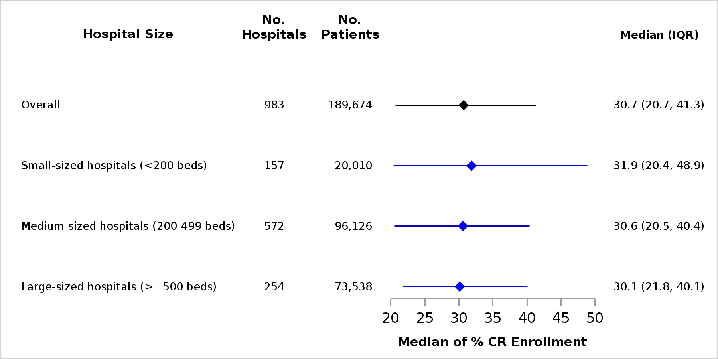

B. Time to enrollment (days)^{d}

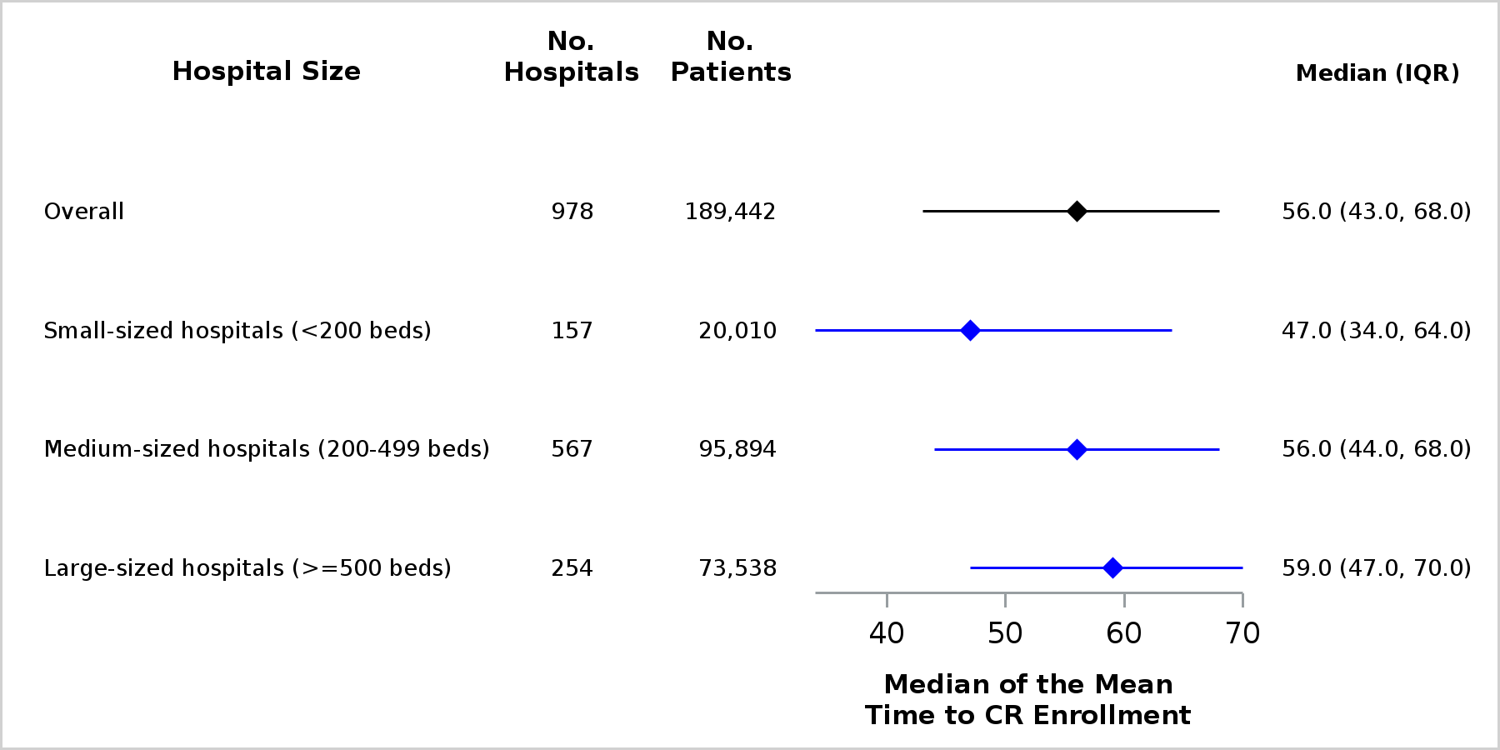

C. Number of CR sessions (n)^{e}

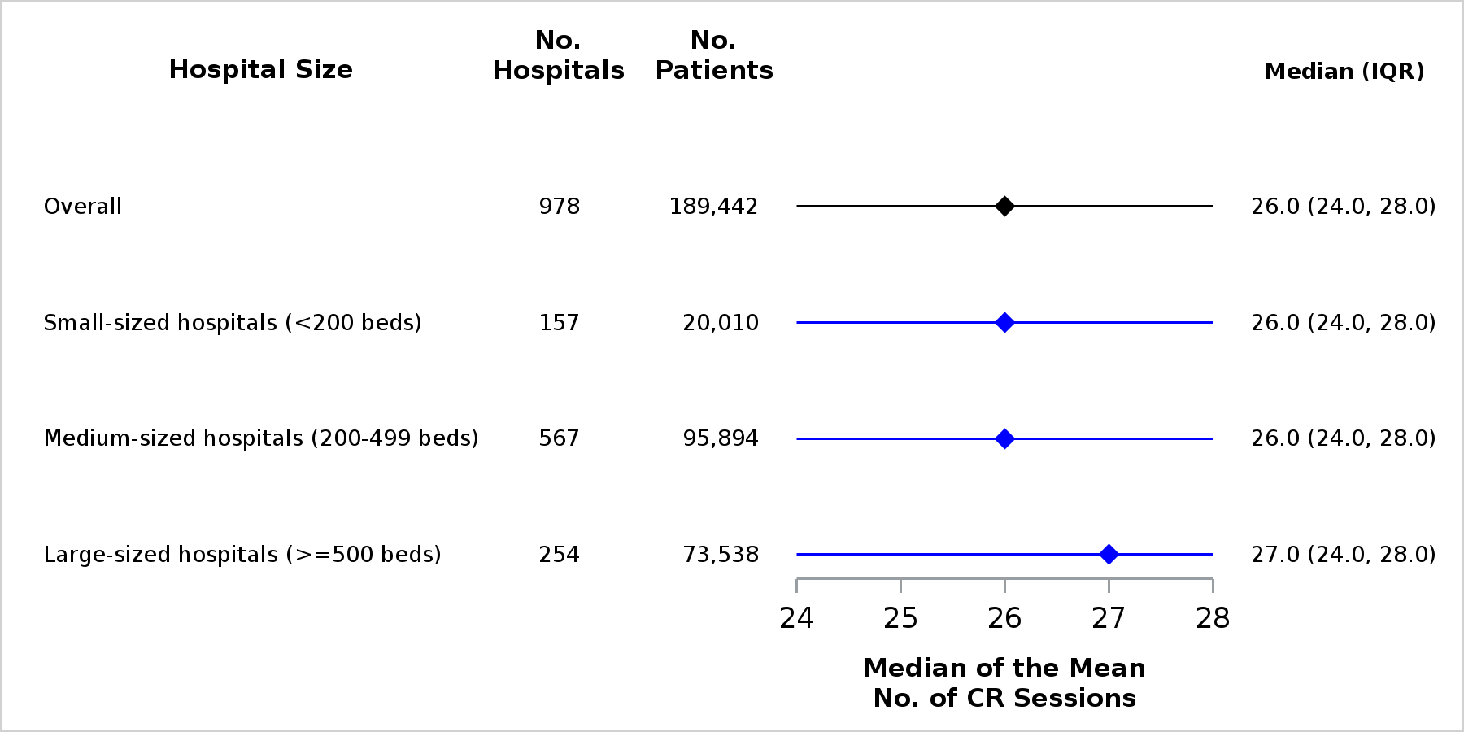

D. CR completion (%)^{f}

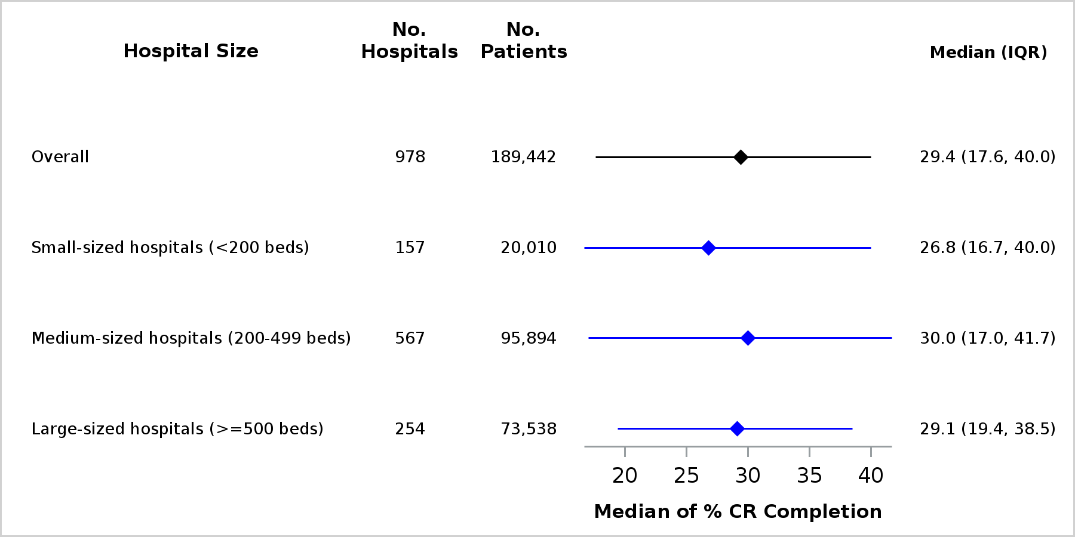

Abbreviations: CR, cardiac rehabilitation; IQR, interquartile range; No., number

ª Hospitals that performed ≥10 CABG and ≥10 PCI procedures were defined as AMI, CABG, and PCI care hospitals (i.e., comprehensive care hospitals).
^{b} Small (<200 beds), medium (200-499 beds), and large (>=500 beds)
^{c} CR enrollment: Number of beneficiaries who attended ≥1 CR session within 365 days of the CR-qualifying event out of the
number of CR-qualifying events within the measurement period. CR enrollment was statistically significantly different by hospital size, p<0.0001.
^{d} Time to CR enrollment: Time in days from the CR-qualifying event index date or hospital discharge date after index event to the
first CR session date. Time to CR enrollment was statistically significantly different by hospital size, p=0.0008.
^{e} Number of CR sessions: Number of CR sessions attended within 36 weeks of the first CR session date. Number of CR sessions was statistically significantly different by hospital size, p<.0001.
^{f} CR completion: Number of individuals who attended ≥36 CR sessions within 36 weeks of the first CR session date out of the
number of individuals who enrolled in CR. CR completion was statistically significantly different by hospital size, p<.0001.

Appendix Table 10. Patient- and hospital-level factors associated with CR metrics among comprehensive care hospitals (N=983)ª
 | CR Enrollment ^{b}  Odds Ratio  (95% CI) | Time to Enrollment, days ^{c}  Difference in Means  (95% CI) | No. of Sessions ^{d}  Difference in Means  (95% CI) | Completion ^{e}  Odds Ratio  (95% CI)
Age (years)
≤70 | Reference | Reference | Reference | Reference
71–75 | 1.00 (0.98, 1.03) | 1.20 (0.1, 2.6) | 0.80 (0.5, 1.1) | 1.12 (1.07, 1.17)
76–80 | 0.86 (0.83, 0.88) | 4.70 (3.1, 6.6) | 0.80 (0.5, 1.2) | 1.12 (1.07, 1.18)
81–85 | 0.65 (0.63, 0.67) | 7.10 (4.9, 9.7) | 0.60 (0.2, 1.0) | 1.16 (1.09, 1.24)
>85 | 0.37 (0.35, 0.38) | 9.70 (6.4, 13.7) | -0.40 (-0.9, 0.1) | 0.95 (0.86, 1.05)
Sex
Female | 0.84 (0.82, 0.86) | 6.40 (4.8, 8.2) | -1.60 (-1.8, -1.5) | 0.83 (0.80, 0.87)
Male | Reference | Reference | Reference | Reference
Race and ethnicity
Non-Hispanic White | Reference | Reference | Reference | Reference
Non-Hispanic Black | 0.66 (0.63, 0.70) | 11.60 (7.9, 16.0) | 0.00 (-0.5, 0.7) | 0.99 (0.90, 1.10)
Hispanic | 0.53 (0.50, 0.57) | 4.50 (1.3, 8.5) | -0.40 (-1.0, 0.3) | 0.99 (0.88, 1.11)
Non-Hispanic Asian | 0.60 (0.55, 0.66) | 7.10 (2.5, 12.8) | -0.70 (-1.5, 0.2) | 0.98 (0.83, 1.15)
Other/Unknown | 0.95 (0.89, 1.02) | -0.50 (-2.8, 2.4) | 0.00 (-0.5, 0.6) | 0.97 (0.87, 1.07)
CR-qualifying event type
AMI with CABG and PCI | 11.64 (10.05, 13.49) | -23.10 (-26.4, -18.3) | 3.60 (2.2, 5.2) | 1.79 (1.46, 2.20)
AMI with CABG | 10.86 (10.36, 11.39) | -22.70 (-22.9, -22.3) | 2.40 (1.8, 3.0) | 1.35 (1.24, 1.47)
AMI with PCI | 5.75 (5.56, 5.96) | -32.90 (-31.6, -34.1) | 1.30 (0.9, 1.8) | 1.19 (1.10, 1.27)
AMI only | Reference | Reference | Reference | Reference
CABG with PCI | 14.19 (11.38, 17.68) | -26.20 (-30.8, -19.3) | 2.50 (0.8, 4.6) | 1.28 (0.95, 1.74)
CABG only | 14.19 (13.67, 14.74) | -26.80 (-26.2, -27.3) | 2.70 (2.2, 3.2) | 1.36 (1.26, 1.46)
PCI only | 3.60 (3.47, 3.74) | -20.60 (-20.9, -20.1) | 0.10 (-0.2, 0.6) | 1.02 (0.95, 1.11)
Bed Size
Small (<200 beds) | Reference | Reference | Reference | Reference
Medium (200-499 beds) | 0.84 (0.81, 0.87) | 11.40 (8.8, 14.4) | 0.40 (0.0, 0.8) | 1.08 (1.02, 1.15)
Large (>=500 beds) | 0.84 (0.80, 0.87) | 11.70 (8.9, 15.0) | 0.40 (0.0, 0.8) | 1.05 (0.98, 1.13)
Hospital ownership
For profit | 0.76 (0.73, 0.80) | 6.80 (4.0, 10.3) | -0.40 (-0.8, 0.1) | 1.07 (0.99, 1.17)
Nonprofit | 1.00 (0.96, 1.04) | 3.00 (1.1, 5.2) | -0.20 (-0.5, 0.2) | 1.02 (0.95, 1.09)
Public | Reference | Reference | Reference | Reference
U.S. Census region
Northeast | 0.95 (0.92, 0.99) | 8.70 (6.0, 11.8) | 0.80 (0.4, 1.3) | 1.02 (0.95, 1.09)
Midwest | 1.80 (1.74, 1.86) | -10.60 (-10.9, -10.1) | 1.30 (0.9, 1.7) | 1.18 (1.11, 1.25)
South | 0.92 (0.89, 0.95) | 1.50 (-0.1, 3.4) | 1.70 (1.3, 2.2) | 1.49 (1.41, 1.57)
West | Reference | Reference | Reference | Reference
Urbanicity
Urban | 1.74 (1.42, 2.13) | -2.60 (-9.4, 8.2) | 0.20 (-1.5, 2.3) | 0.99 (0.70, 1.41)
Rural | Reference | Reference | Reference | Reference
Cardiac Intensive Care
No | 1.10 (1.07, 1.14) | -4.30 (-5.3, -3.2) | -0.10 (-0.4, 0.2) | 0.97 (0.92, 1.03)
Yes | Reference | Reference | Reference | Reference
Cardiac Rehabilitation
No | 0.71 (0.67, 0.74) | 2.50 (0.2, 5.3) | -0.30 (-0.7, 0.2) | 0.97 (0.88, 1.05)
Yes | Reference | Reference | Reference | Reference
Teaching Status
Teaching | 1.04 (1.01, 1.07) | 4.00 (2.4, 5.9) | 0.20 (0.0, 0.5) | 1.00 (0.95, 1.05)
Nonteaching | Reference | Reference | Reference | Reference
Abbreviations: AMI, acute myocardial infarction; CABG, coronary artery bypass graft surgery; CR, cardiac rehabilitation; No., number; PCI, percutaneous coronary intervention

ª Bolded cells indicate statistical significance, p value <0.05.
^{b} Generalized linear mixed model with binary distribution and logit function to examine hospital-level factors associated with CR
enrollment.
^{c} Generalized linear mixed model with gamma distribution and log-link function to examine hospital-level factors associated with
time to enrollment (among hospitals with enrollment).
^{d} Generalized linear mixed model with gamma distribution and log-link function to examine hospital-level factors associated with
number of sessions attended (among hospitals with enrollment).
^{e} Generalized linear mixed model with binary distribution and logit function to examine hospital-level factors associated with CR
completion (among hospitals with enrollment).

