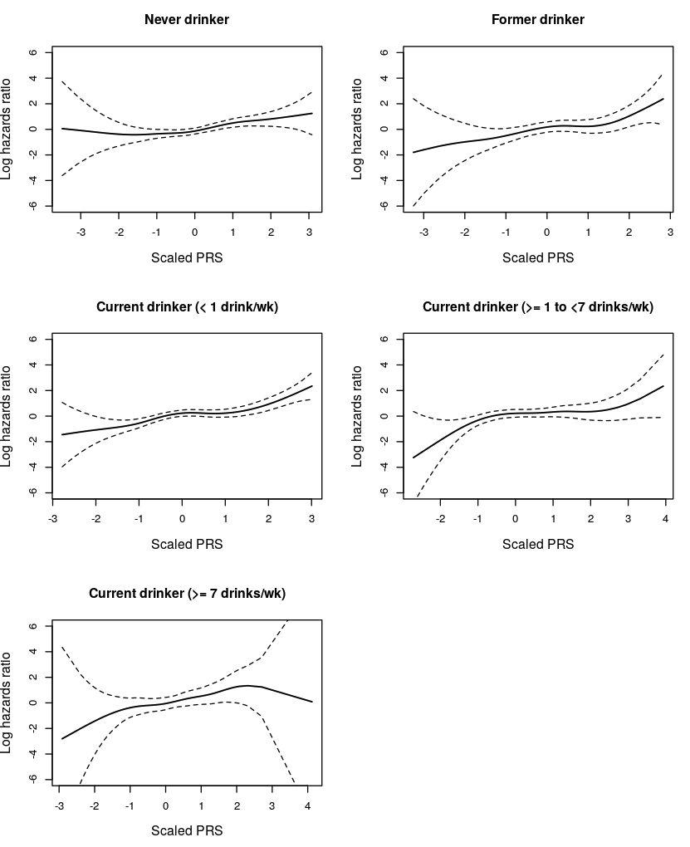

Supplementary Figure S5. Natural logarithm hazard ratios of breast cancer for P-spline term scaled 313-SNP PRS with 4 degrees of freedom estimated by fully-adjusted Cox proportional hazards model stratified by alcohol consumption category among White women in ARIC (1990-2015). This plot assesses the association between continuous 313-SNP PRS and breast cancer incidence among White women, stratified by alcohol consumption category: Never drinker, Former drinker, Current drinker with < 1 drink/week, Current drinker with ≥ 1 to < 7 drinks/week, and Current Drinker with ≥ 7 drinks/week. The analysis utilizes a model with penalized spline (P-spline) terms with 4 degrees of freedom for PRS, adjusted for age, height, body mass index, waist-to-hip ratio, education level, physical activity, cigarette smoking status, total caloric intake, folic acid intake, diabetes status, age at menarche, history of hormone replacement therapy use, history of oral contraceptive use, and breast-feeding status.

