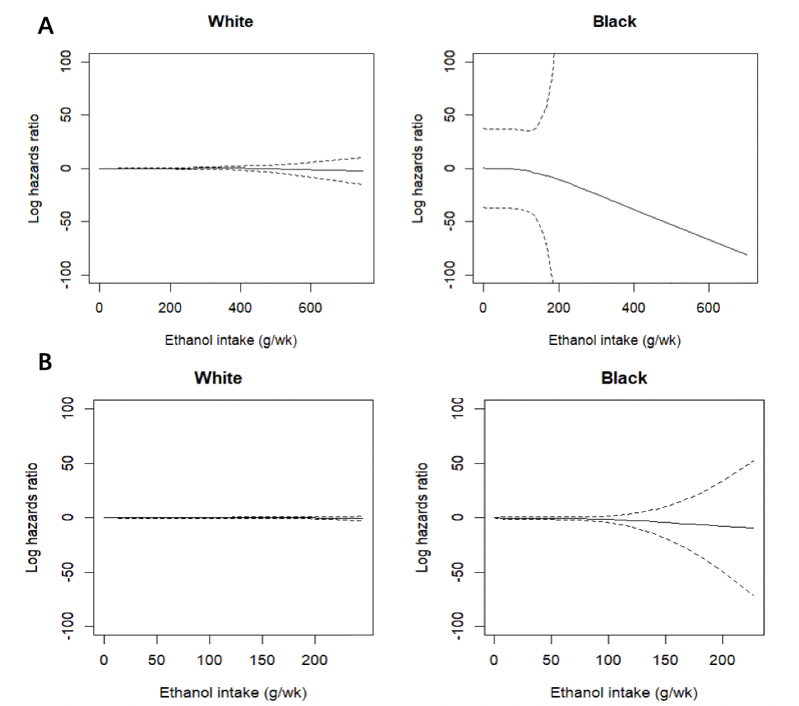

Supplementary Figure S4. Natural logarithm hazard ratios of breast cancer for P-spline term current ethanol intake with 4 degrees of freedom estimated by fully-adjusted Cox proportional hazards model in ARIC (1990-2015). This plot evaluates whether the association between current ethanol intake and breast cancer incidence is linear on the natural logarithm scale. The analysis uses a model with penalized spline (P-spline) terms with 4 degrees of freedom for current ethanol intake, adjusted for age, height, body mass index, waist-to-hip ratio, education level, physical activity, cigarette smoking status, total caloric intake, folic acid intake, diabetes status, age at menarche, history of hormone replacement therapy use, history of oral contraceptive use, and breast-feeding status.
A: Panel A shows the full distribution of ethanol intake on the x-axis. P-values for likelihood ratio tests comparing null model (including continuous ethanol intake and main covariates) to full model (including P-spline term ethanol intake with 4 degrees of freedom and main covariates) were 0.82 for White women and 0.91 for Black women. The wide confidence interval for Black women is due to no breast cancer case among women who drink > 180 g/week
B: Panel B shows the truncated distributions (< 250 g/week) of ethanol intake on the x-axis. P-values for likelihood ratio tests comparing null model (including continuous ethanol intake and main covariates) to full model (including P-spline term ethanol intake with 4 degrees of freedom and main covariates) were 0.66 for White women and 0.88 for Black women

