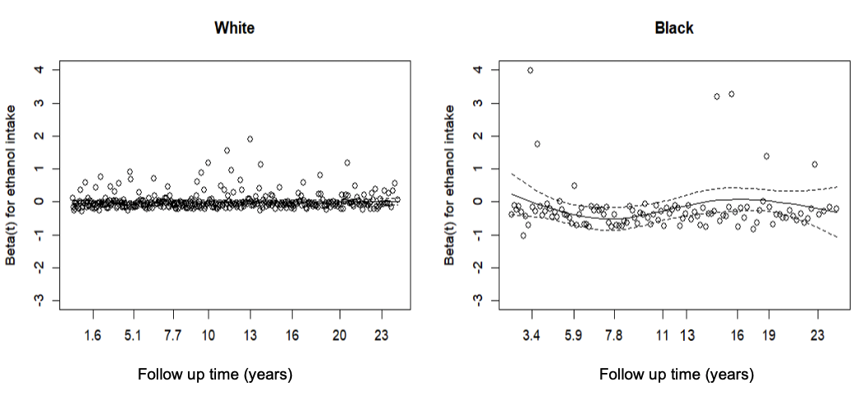
Supplementary Figure S2. Time-dependent coefficients of current ethanol intake for breast cancer incidence estimated by fully adjusted Cox proportional hazards model in ARIC (1990-2015). This plot examines the proportional hazards assumption for current ethanol intake by assessing whether the time-dependent coefficients remain horizontal for White and Black women, adjusting for age, height, body mass index, waist-to-hip ratio, education level, physical activity, cigarette smoking status, total caloric intake, folic acid intake, diabetes status, age at menarche, history of hormone replacement therapy use, history of oral contraceptive use, and breast-feeding status.

